Meeting Notes
SAS Workspace Owner One-on-One: Thomas Herold (Model Risk Management)
Item | Detail
Meeting date | Friday, October 23, 2026 (recording started about 12:00 PM)
Format | Short one-on-one; Kelly shared the invite, the SAS workspace list, the initiative slides, and the survey template
BDL | Kelly (led), Jake
Workspace owner | Thomas Herold, Model Risk Management (MRM), CMOR group; formerly in RMG
Purpose | Introduce the SAS exit initiative, review Thomas's workspace, and explain the survey before next week's larger kickoff

Note on the transcript
Auto-generated transcript. SAS is transcribed "SaaS". Small talk before the call and the trailing "hello"s are left out. Readings used: 1SASGRID ("one SAS Grid"), SAS Grid 1 ("SAS G1", the old mortgage platform), Viya, 9SAS (auto), PyFarm, RMG. Confirmed: Thomas Herold; CMOR is Thomas's group (transcribed "C-more"); the workspace he shared in chat is /workspace/unload/cmor_ccdscoe on 1SASGRID.

1. Summary
Kelly and Jake met Thomas Herold, who owns one tracked SAS workspace: a roughly 8 GB folder on SAS Grid 1, the old mortgage platform, at about 33–35% usage. Thomas says MRM doesn't need SAS at all and doesn't think anyone still uses that folder. He'll confirm by getting a list of its data sets, after which it can likely be retired.
Thomas also shared a second workspace in the chat that isn't on the list: CMOR's main unload folder, /workspace/unload/cmor_ccdscoe on 1SASGRID. It's a restricted transport site where SAS developers drop model input and output files. MRM picks them up, moves them to PyFarm for validation testing, and the files are deleted after about two weeks. Its absence may point to a gap in the SAS inventory for restricted workspaces.
BDL will send the SharePoint survey covering both workspaces and look into why the second one is missing. Thomas: "I can't wait to be off of SAS completely."

2. Background shared with Thomas
- Kelly and Jake are from the Corporate Risk Data Management and Governance team (BDL).
- Senior leadership is prioritizing a SAS exit strategy: short term, remove storage that's no longer needed; long term, migrate off SAS.
- BDL is talking to workspace owners about purpose, number and type of users, and the data held, to start building an exit strategy.
- A larger call with all workspace owners is next week. These one-off calls are for owners BDL already knows, such as people in model risk management.

Two tracks
- Track 2, storage cleanup: validate empty or low-usage workspaces (under 60%) and find a path off them. Thomas's workspace is about 33–35%.
- Track 1, exit readiness: this takes longer. Who uses the workspace downstream, and does it support any use cases or regulatory reports?

3. Thomas's workspaces
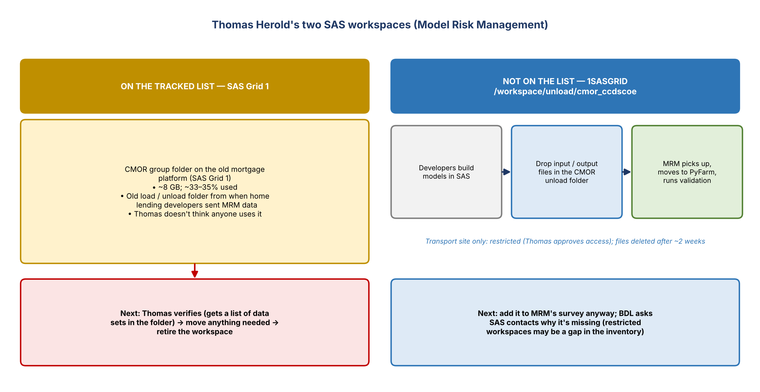
Figure 1. The tracked workspace vs. the one missing from the list

How MRM uses SAS
- MRM itself doesn't need any SAS workspace. Its developers build models in SAS, so they have to send MRM their SAS files.
- Developers drop input and output files in the CMOR unload folder (/workspace/unload/cmor_ccdscoe) on 1SASGRID. MRM picks them up, moves them into its own environment (PyFarm), and runs validation tests.

Workspace 1: on the tracked list (SAS Grid 1)
- The CMOR group's folder, about 8 GB. Back in RMG they had petabytes, so this is small.
- Probably the old load/unload folder for SAS Grid 1, the old mortgage platform, from when home lending developers sent MRM data. Those developers now push data to /workspace/unload/cmor_ccdscoe on 1SASGRID instead.
- Thomas doesn't think anyone uses it. If nothing is active, it can be removed. He'll get someone to list the data sets in the folder to confirm.

Workspace 2: shared in chat, NOT on the list (1SASGRID)
- /workspace/unload/cmor_ccdscoe: CMOR's main SAS folder, the unload site Thomas owns. He regularly gets notifications to approve access to it.
- Very restricted: Thomas approves every access request.
- It's a transport site only. Files are kept a couple of weeks and then deleted, so nothing should sit there long.
- Not marked confidential as far as he knows.

Why it might be missing
- The list isn't BDL's; it comes from the SAS team's repository of workspace owners.
- BDL has already found errors (wrong or outdated owners) and frequent changes.
- Someone BDL met earlier this week said restricted workspaces may be left out when details are pulled. That may explain this one.
- Thomas suggested tracking it down, since it may reveal a gap in the list BDL was given.

Environments in the list
Environment | What Thomas said
1SASGRID | Where CMOR's main unload folder (/workspace/unload/cmor_ccdscoe) lives
Viya | Their AI server
9SAS | Auto SAS
SAS Grid 1 | The old mortgage platform (legacy); where the tracked folder is

4. Survey
- Jake has set up the template as a SharePoint site, so a link will be sent instead of an Excel file.
- BDL fills in the workspaces (both, including the one not on the CDO/SAS list). Thomas provides downstream users, any use cases (models, regulatory reports), a brief description, and the exit strategy.
- For the SAS Grid 1 folder, the likely outcome is to move any needed data elsewhere and retire the workspace.

5. Action items
Action | Owner | Notes
Send the SharePoint survey link, with both workspaces | Kelly / Jake
Get a list of data sets in the SAS Grid 1 folder; confirm whether anything is still used | Thomas | Expected unused
Retire the SAS Grid 1 workspace (after moving anything needed) | Thomas with BDL | Pending confirmation
Complete survey details for both workspaces | Thomas
Ask SAS contacts why /workspace/unload/cmor_ccdscoe (restricted, 1SASGRID) is missing from the list | Kelly / Jake | Possible inventory gap

