Meeting Notes
Consumer Annual Recertification: SAS Valuation Data and Collections Data Sources
Item | Detail
Meeting date | Tuesday, October 13, 2026 (recording started about 11:31 AM)
Format | Working call requested by consumer before deciding data source statuses in ADMF
Consumer domain | Rupali (ran the ADMF review and shared her screen), Srivinas (consumer data lead; joined shortly after the start)
Risk domain | Kelly and Jake (risk model use cases)
People referenced | Bill Wells (consumer data portfolio owner), Maksim (ADS strategy lead for the move-the-line portfolio), Kristen (BDL), Amy (domain executive), Michelle Moore (OC-1 approver), Kevin, Narishani (approved the delinking), Abhilash and Enshelman (ADS strategy leads), Puneet and Julie
Purpose | Decide the annual recertification status of two data sources feeding risk models: SAS data for valuation modeling, and collections

Note on the transcript
Auto-generated transcript; speakers aren't labeled, so attributions are inferred. Confirmed spellings: Srivinas (transcribed "Shrivas"), Maksim (transcribed "Maxim"/"Maxine"), CDO (transcribed "CBO"), SAS AMART (risk's name for the SAS valuation data), AMDS (also transcribed "ADSM" and "ADMS"), Cards ADS (transcribed "card SAS"/"Cod Services ADS"), and YOM Interface (transcribed "YAM"). Readings used: Kristen (also "Christian"), Dremio ("my dream"), OC-1. Unclear: ECAR, "move the line" (an org change), and "FML program."

1. Executive summary
Consumer is running its annual recertification of data sources in ADMF and initially proposed marking the SAS data source for valuation modeling as not approved, because under a September policy change a manual data source now needs OC-1 approval (Michelle Moore) to be conditionally approved. Kelly objected: the source was previously conditionally approved, tagged in ADMF, and linked to risk models, and its data sets were cancelled by consumer in error, since Maksim, whose sign-off drove the change, doesn't own the SAS source. Not approved would also hurt risk's scorecard, and there's no other place to get the data.
Srivinas said cancellation doesn't change the outcome, because recertification re-reviews everything from scratch under the new policy, and asked to move forward without dwelling on it. Both sides agreed to pursue conditional approval: risk (Kelly and Jake) will gather the controls that have mitigated risk on this source for about two years, consumer will build the justification (including Bill Wells' statement that the strategic ADS won't arrive until around 2028), and the case goes through the ABO, Bill Wells and Maksim, the BDL (Kristen), the domain executive (Amy), and then OC-1. Srivinas will also ask Maksim whether the SAS data sets can be remapped to AMDS, a standard application that avoids OC-1.
For collections, the data set stays mapped for now. Maksim confirmed AMDS doesn't cover it; Kelly and Jake are checking whether YOM Interface or ECAR is the right application before any delinking.

2. Background
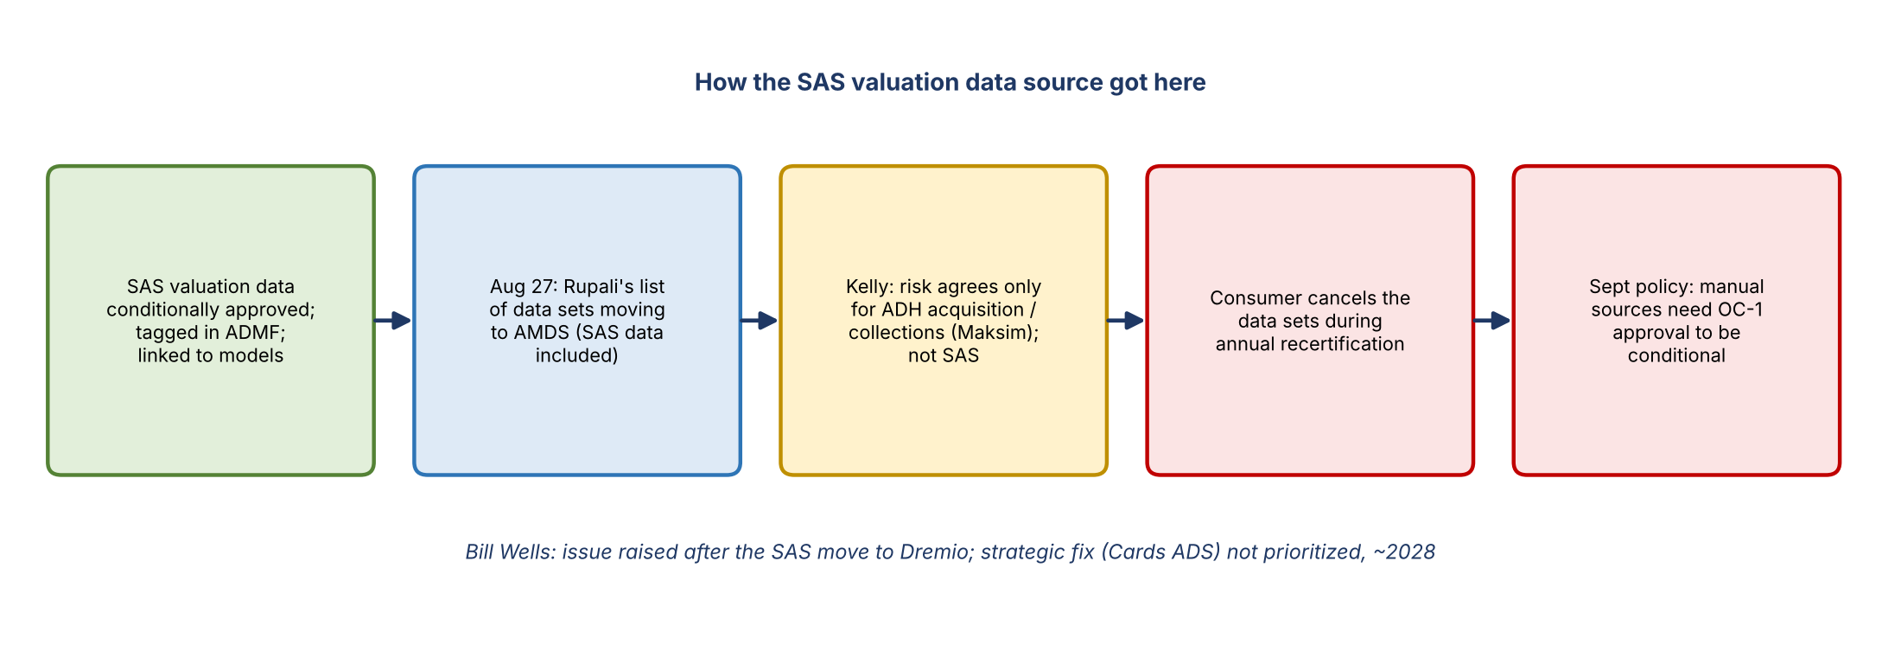
Figure 1. How the SAS valuation data source reached this point
- The SAS data for valuation modeling (SAS AMART) has fed risk models for a long time and was conditionally approved, tagged in ADMF, and linked to the models.
- Other manual sources (e.g., ADH acquisition collections) went through the CDO approval process and received a "no contest," allowing conditional approval. Kelly expected the same here, noting finance and risk had both been comfortable with conditional approval.
- On August 27, Rupali emailed a list of data sets expected to move to AMDS. Kelly replied that risk was comfortable delinking the ADH acquisition and collections data sets under Maksim, but never agreed to the SAS data, which Maksim doesn't own.
- Consumer cancelled the data sets as part of annual recertification. Rupali explained that delinking doesn't require the ABO's approval; Maksim said the SAS data aligned to AMDS, and the use case approver (Narishani) agreed without raising concerns.
- Bill Wells' email: an issue was raised after the SAS data moved to Dremio. The eventual solution is a Cards ADS (owned by Maksim) that will consolidate SAS and analytical data science data, but it isn't prioritized and won't land within six months (it's showing around 2028). Corrective actions will focus on higher-tier use cases.
- Bill Wells only recently took over Maksim's portfolio through an org change ("move the line") from risk.

3. The disagreement
Both sides agreed on the path forward, but they don't agree on how the situation arose.
Risk (Kelly) | Consumer (Srivinas, Rupali)
The source was already conditionally approved; nothing about it has caused problems | Annual recertification re-reviews every source from scratch, not based on last year's status
The data sets were cancelled without risk's knowledge or proper process | Cancellation doesn't matter: the source would go through re-approval anyway
Maksim never owned the SAS source, so his approval shouldn't have driven cancellation | Maksim repeatedly said these were his data sets; consumer acknowledged an ABO mix-up but says the main reason was moving data sets to the application they belong to
The error should be on record, even though there's no need to dwell on it | Srivinas has emails showing the SAS data sets were on the list, but asked to focus on approval rather than relitigate
Not approved would hurt risk's scorecard; risk may escalate to senior leadership before any ADMF status change | Under the September policy, manual sources need OC-1 approval to be conditional, for every manual source

Srivinas stressed he has no personal stake in the outcome and set up this call specifically to talk it through with risk before deciding. Kelly agreed not to muddy the waters and to collaborate.

4. Status options
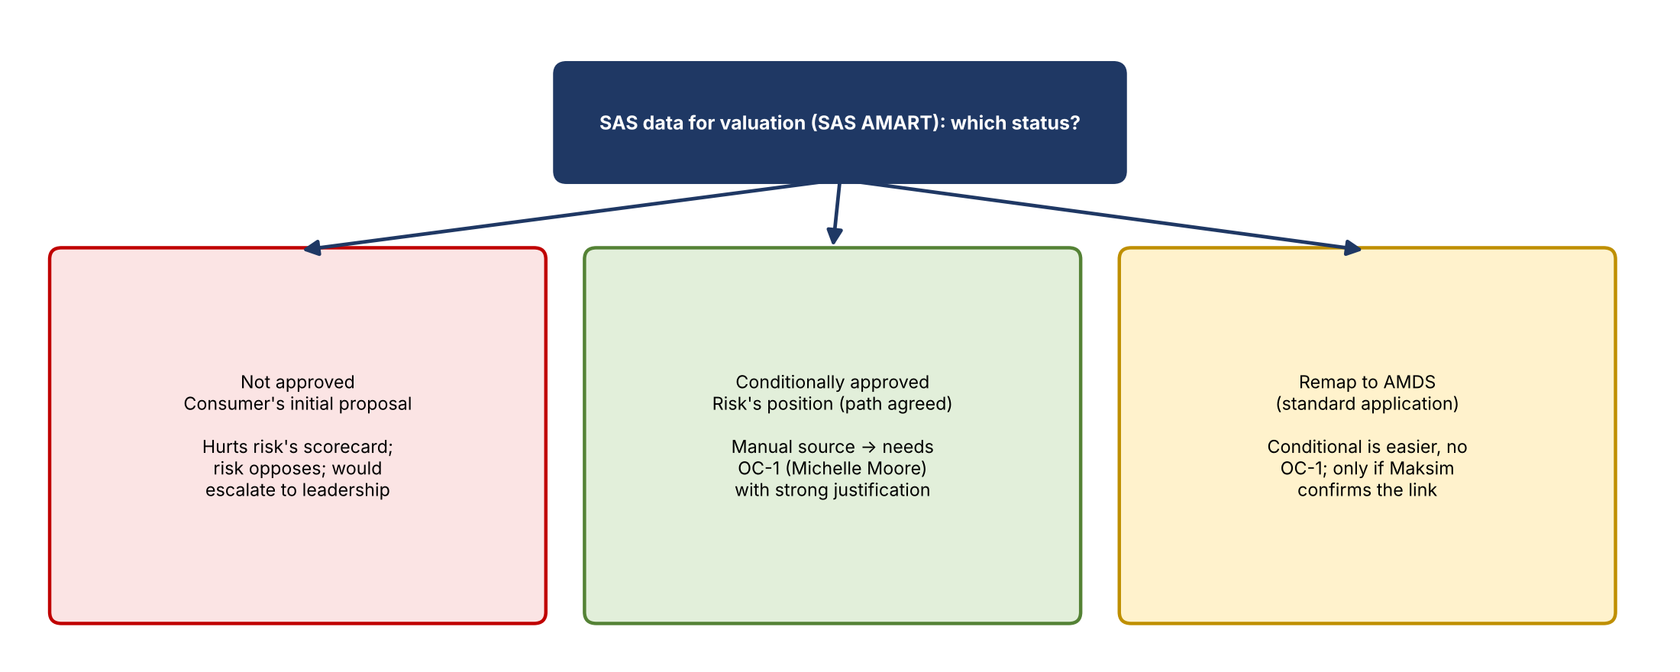
Figure 2. Status options for the SAS valuation data
- Not approved: consumer's initial proposal, with the non-adherence extended. Risk opposes it because of the scorecard impact and because there's no alternative source.
- Conditionally approved: the agreed path. As a manual data source, it now needs OC-1 approval from Michelle Moore, which requires a strong justification from both domains and from Bill Wells.
- Remap to AMDS: if Maksim confirms the SAS data sets belong to the broader AMDS, they could be remapped there. AMDS is a standard application, so conditional approval is easier and doesn't need OC-1 or escalation.

5. Path to conditional approval
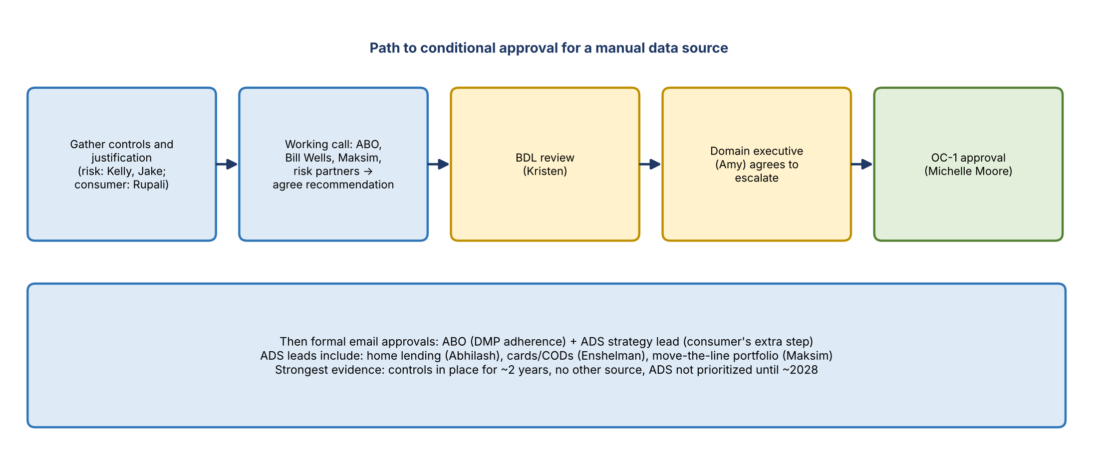
Figure 3. Approval path
- Gather evidence. Risk collects the controls on its model use cases that have mitigated this source's risk (in place about two years). Consumer gathers details from Bill Wells.
- Build the justification and a presentation. Strongest points: controls in place for about two years, no better source available, and the strategic ADS isn't prioritized (around 2028). Each approval level will probe for gaps, so answers need to be ready, and Bill Wells may be questioned too.
- Hold a working call with the ABO, Bill Wells, Maksim, and risk (Kelly and Jake) to agree the recommendation before asking anyone to approve, to avoid changing the status twice.
- BDL review with Kristen.
- Domain executive Amy decides whether to take it to OC-1.
- OC-1 approval from Michelle Moore.
- Formal email approvals from the ABO, the ADS strategy lead, and the BDL as needed.

Consumer's two-approval practice
- The ABO approves for data management policy adherence.
- Consumer also reviews with ADS strategy leads for each product area, a practice requested last year by its data portfolio owners (Puneet, Bill Wells, Julie) during the FML program. Examples: home lending (Abhilash), cards/CODs (Enshelman), and the move-the-line portfolio (Maksim).
- This applies to both initial implication and annual recertification decisions.

6. Collections data source
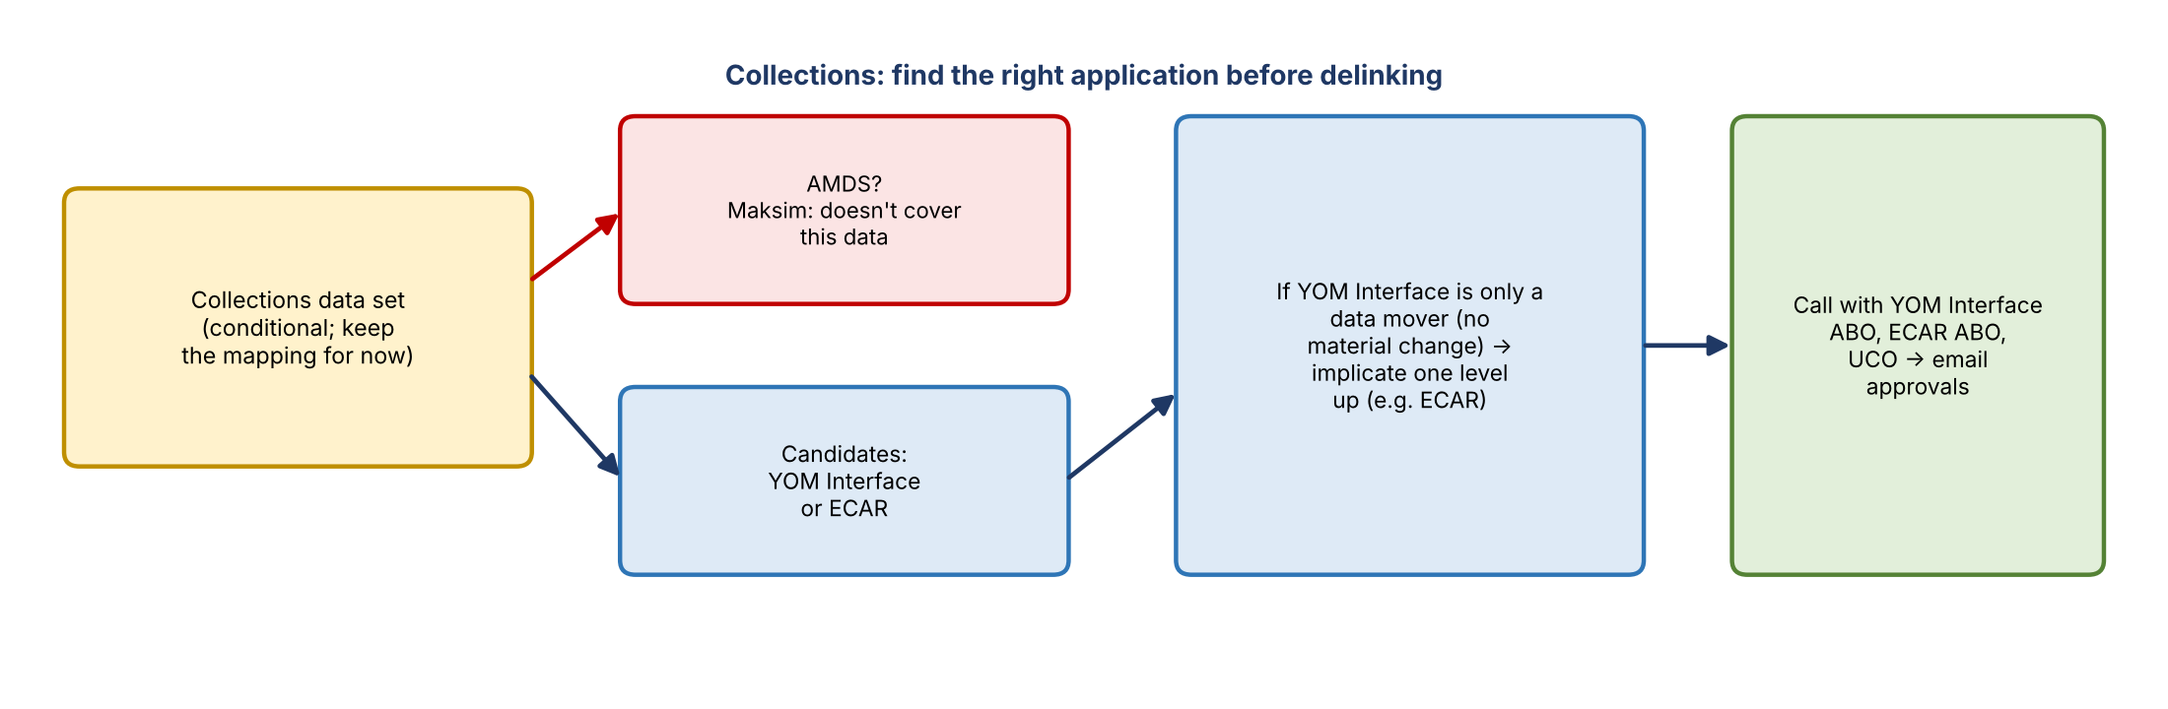
Figure 4. Collections next steps
- Collections is still implicated in ADMF in conditional use and is in scope for annual recertification. Rupali asked whether it could be replaced with AMDS, which would give conditional approval without OC-1.
- Kelly asked to keep the data set mapping: Maksim confirmed AMDS doesn't cover that specific data. Kelly and Jake are checking which application does; it's likely YOM Interface or ECAR.
- Srivinas: if YOM Interface only moves data, they should implicate one level up. If it's ECAR (a standard application), implicate ECAR. Aggregation, calculation, or preparation is fine as long as there's no material change.
- Plan: Kelly and Jake work with the risk modeling team first, then bring in the YOM Interface ABO, the ECAR ABO, and the use case owner. If there's no material change, get email approval from the ABO and use case owner, then implicate the higher-level application.

7. Decisions
- Pursue conditional approval for the SAS valuation data source, not non-approval.
- Don't change its ADMF status until the recommendation is agreed in the working call.
- Keep the collections data set mapping until the right application is confirmed.

8. Action items
Action | Owner | Notes
Collect control and mitigation details for risk model use cases of the SAS valuation data | Kelly and Jake | Controls in place ~2 years
Gather details from Bill Wells (alternatives, timing, controls) | Rupali / Srivinas | Cards ADS ~2028
Build the justification and presentation | Consumer with risk | Anticipate questions at each level
Ask Maksim whether the SAS data sets belong to AMDS | Srivinas | Remap if so
Set up the working call with ABO, Bill Wells, Maksim, Kelly, Jake | Consumer | Agree recommendation first
Take the recommendation through BDL, Amy, and OC-1 | Consumer | Then formal email approvals
Confirm whether collections comes from YOM Interface or ECAR | Kelly and Jake | With risk modeling
Hold a call with YOM Interface ABO, ECAR ABO, and the use case owner | Kelly and Jake, then consumer | Email approvals if no material change
Share the screen materials and emails | Rupali | Requested at close

9. Open questions and risks
- Will OC-1 (Michelle Moore) accept a conditional approval for a manual source under the new policy?
- Do the SAS valuation data sets genuinely belong to AMDS?
- Which application, YOM Interface or ECAR, is the right source for collections?
- Will the scorecard impact require escalation to senior leadership if conditional approval fails?
- Will the Cards ADS be prioritized sooner than 2028?

