Meeting Notes
Decommissioned Non-Prod Databases Feeding CORS: Defect vs. Non-Adherence
Item | Detail
Meeting date | Tuesday, October 13, 2026 (recording started about 1:01 PM)
Format | Working call to decide how to cover the issue under data management policy
Attendees | Kevin (ADS strategy and defects), Brian, Jake, Ryan, and a governance contact from the affected credit risk area who explained the background (name not stated; works with Paul)
People referenced | Paul Skok (pushing for policy coverage), Paul Romanelli (Ping's former org), Ping (CID; preferred a non-adherence), Tony Tang (found the problem), Greg Schrader (leaving the bank at month end), Holly, and a contact who couldn't give a remediation date
Purpose | Decide whether a non-adherence, non-approved source, or defect is needed for models that depend on decommissioned non-prod databases

Note on the transcript
Auto-generated transcript; speakers aren't labeled, so attributions are inferred. Confirmed: CORS (transcribed "cores," "Coors"), CIBAPP, FCRM ("FICRUM"), and non-adherent sourcing ("non-inherent sourcing"). Reading used: DMP ("DNP"). Unclear: 1AQ (also "one at OAQ"; the CIB application whose non-prod environment held the databases), MCRM and ECRM (the risk areas whose databases are being inventoried), "TIS definition," and "pre-vet" (an issue pre-vetting step).

1. Executive summary
About two to three weeks ago, IT decommissioned three databases that sat in a non-production environment of 1AQ (a CIB application). They'd been set up around ten years ago, and IT didn't know they were in use. The data flowed into CORS production and was used by about six models (for development and calibration) and related controls. A workaround copies the data into other databases, so no control runs or model runs have been missed.
The question was how to cover this under data management policy. Ping preferred a non-adherence (non-approved sourcing). Kevin said that's the worst option: it would count against every use case on the scorecard, and non-production data is outside DMP scope. CORS is already the conditional ADS for these models. The group agreed a low-severity defect is the best fit. It fits the old defect definition still in effect during the policy transition, it isn't material to the models, and compensating controls are in place.
Jake will log the defect with the defect team. Brian will talk to Paul. A meeting with the CORS side will build a remediation plan: move the data into CORS non-prod now, then into CORS prod (no timeline yet). Separately, the governance contact is inventorying all databases across the risk area to find others in lower environments.

2. What happened
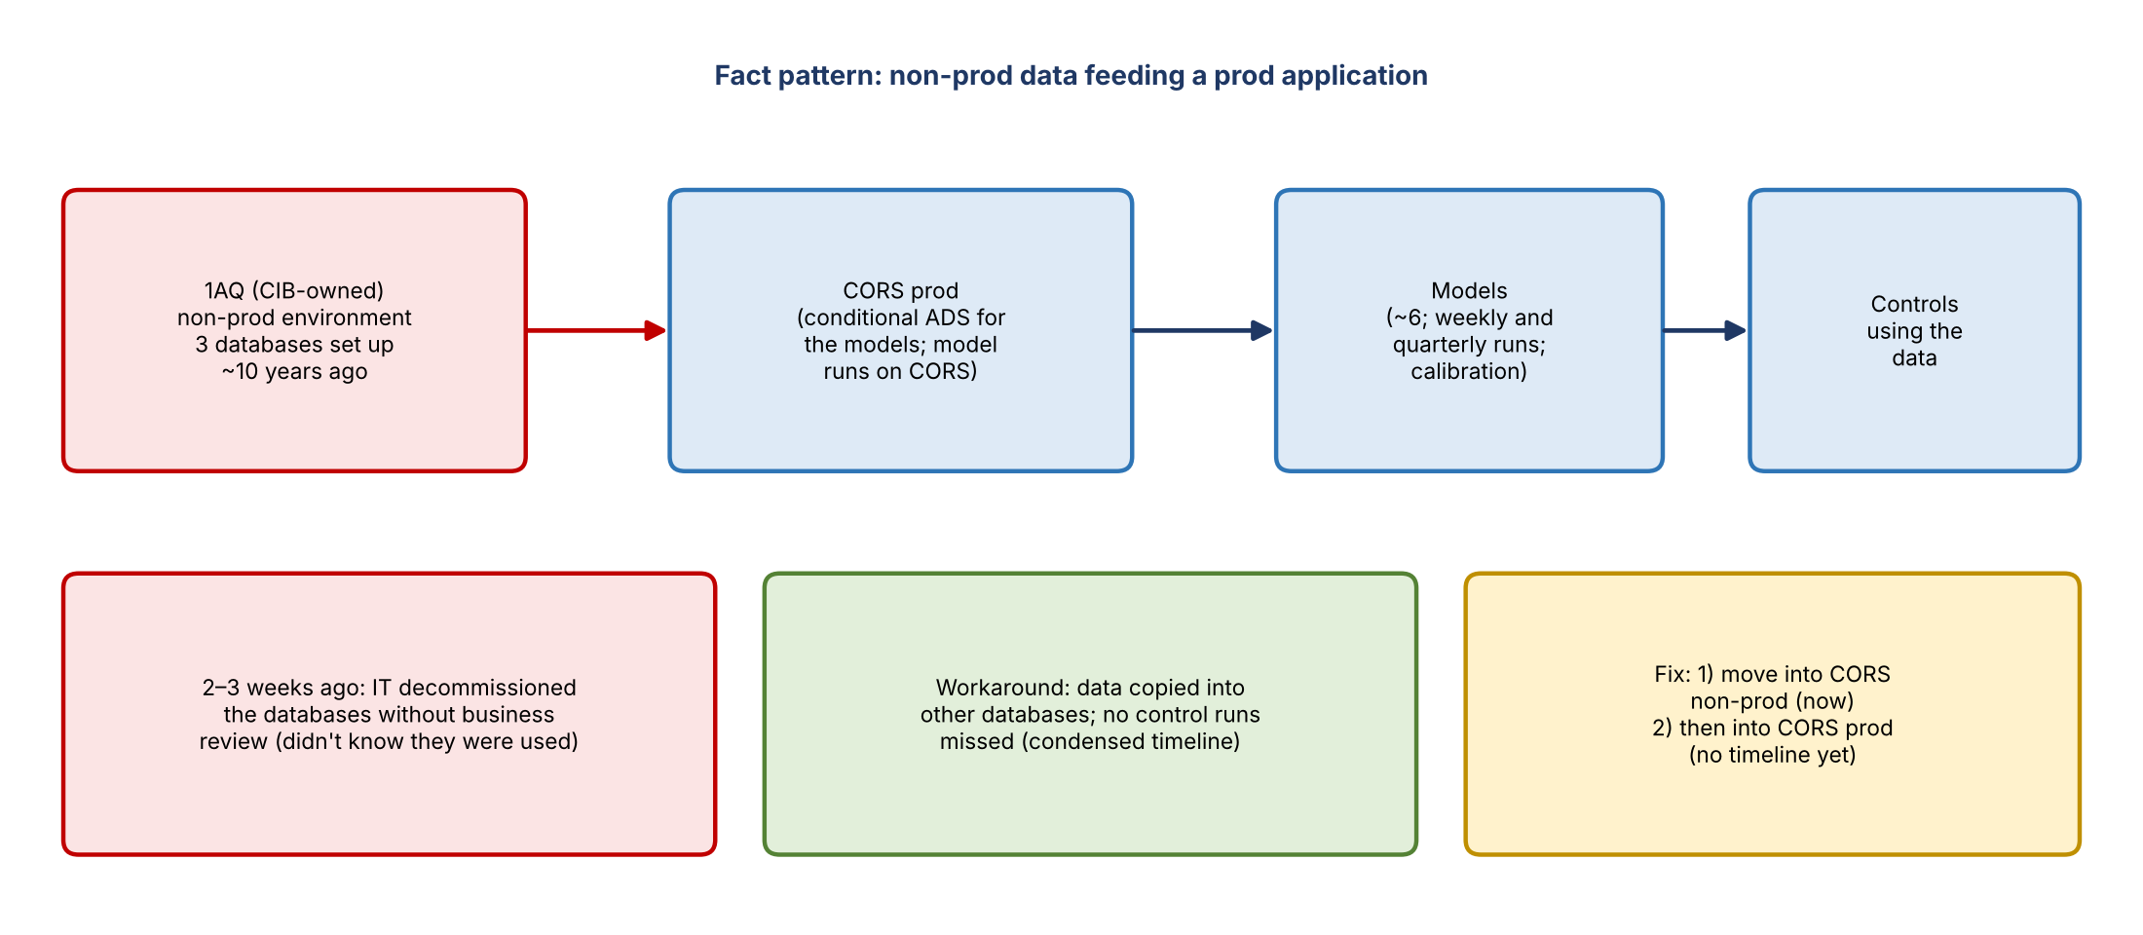
Figure 1. Fact pattern and fix
- Three databases were in a lower-level (non-production) environment, not prod. They were set up roughly ten years ago; the person responsible later moved on, and nothing changed.
- About two to three weeks ago, IT decommissioned them without any review or approval from the business line, saying they didn't know the databases were in use because they weren't in prod.
- It surfaced when Tony Tang couldn't access a database and IT told him it had been decommissioned, before any model actually failed.
- Fact pattern: 1AQ's non-prod environment fed CORS prod. 1AQ is CIB-owned and is a conditional ADS for a number of models; Brian confirmed CIB ownership.

Impact so far
- Controls that use the databases have a workaround (data copied into other databases), so no control executions will be missed, though they'll run on a condensed timeline.
- No model has failed. One model runs weekly; it ran last week and will run this week using the workaround. The other is quarterly and is being worked on.
- The table on screen from the email thread listed the impacted models, their use cases, and the checks in place; it didn't show data problems.

Ownership dispute
- The business says it's IT's problem; IT says it's only responsible for production. No one wants to own it, so no issue has been opened, though one was previously raised in pre-vetting.
- Ping is in CID now. He used to sit in Paul Romanelli's organization, until about a year ago when development was split from governance and developers moved to the front line.

3. How the models source their data
- Kevin: for tier 1 and tier 2 models, CORS is tagged as the ADS because the models run on it. CDO guidance says the application a model runs on becomes its conditional ADS.
- Non-production data isn't in scope of data management policy, which makes this a gray area: the models already have an ADS, and the problem data is non-prod data that reaches CORS.
- The data is used for model development and calibration, not each model run. In theory, bad calibration data could produce a poorly calibrated model, but the models are getting data from the right source; the issue is that the data entering CORS comes from a lower environment.

4. Choosing the disposition
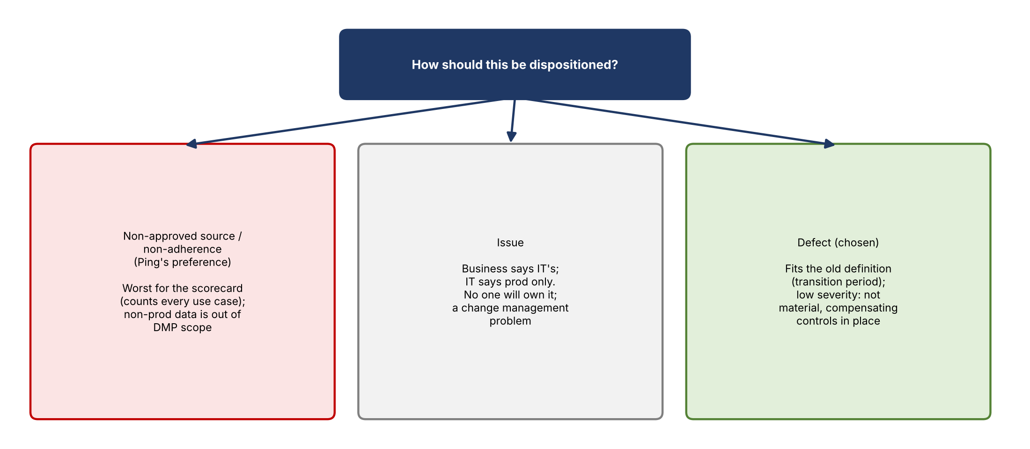
Figure 2. Disposition options
Option | For | Against
Non-approved source / non-adherence | Ping's preference; Paul wanted policy coverage | Scorecard counts every affected use case, not one item; non-prod data is out of DMP scope; it doesn't fit
No action, with a written assessment | Kevin could document why it isn't a defect or an unapproved source | Paul and others want something tracked for coverage if anyone asks
Defect (chosen) | One trackable item; fits the old definition (still in effect during transition); easier to explain; tactical and strategic remediation are clear | Under the new definition a defect must have impacted the model, and this was caught first

- Severity: low. It isn't material to the models, and compensating controls are in place. Kevin and the group wouldn't support raising it higher.
- Issue vs. defect: Kevin sees an underlying change management issue (IT changing things without notice). If it were an issue, every strategic application would need this control. Brian noted CIBAPP recently fought off an issue after shutting off a prod feed that affected FCRM, which escalated to the top of the house.
- Remediation framing: tactical remediation is the current workaround; strategic remediation is getting the data into production. Root cause analysis is done (change management).

5. Root cause application
- The true root cause is 1AQ (non-prod 1AQ feeding CORS prod).
- Kevin's proposal: name CORS as the root cause application, because it sources from a non-prod environment and the fix is getting the data into CORS prod. This is the cleanest approach and avoids involving CIB.
- A defect needs a primary owner; risk would likely take that role. Kevin will confirm with the rest of the defect team.
- Greg Schrader (CIB) hasn't been involved and is leaving the bank at the end of the month; Holly is still there for now.

6. Database inventory
- The governance contact is working to identify every database across the broader risk area ("MCRM," not just "ECRM"), whether in prod or a lower environment, and to either move lower-environment ones to prod or define the controls they need.
- This mirrors the existing enterprise sandbox issue, but at the database level, and isn't an issue itself.
- Five different people in IT have said they have no way to produce that inventory.

7. Remediation timeline
- Immediate: move the databases from where they are now into a lower environment within CORS.
- Later: move them into CORS production.
- No date yet. A contact asked on one or two calls couldn't say when the data would reach prod.

8. Decisions
- Disposition as a low-severity defect, not a non-adherence or non-approved source.
- Tactical remediation is the workaround; strategic remediation is moving the data into prod.
- Proposed root cause application: CORS (to be confirmed with the defect team).

9. Action items
Action | Owner | Notes
Log the defect with the defect team and get a number | Jake | Low severity
Confirm root cause application and primary owner | Kevin with the defect team | CORS proposed
Explain to Paul why a defect is the better disposition | Brian | Brian owns the follow-up
Schedule a meeting with the CORS side (and Paul) to build the remediation plan | Kevin's team / governance contact | Document and track to completion
Get a target date for moving data into CORS non-prod and prod | CORS / technology | No date yet
Continue the database inventory across the risk area | Governance contact | IT can't produce it yet

10. Open questions
- When will the data reach CORS non-prod and then prod?
- Who is the primary owner, and will CIB need to be involved if 1AQ is named?
- Will Ping and Paul accept a defect instead of a non-adherence?
- How many other databases across the risk area sit in lower environments?
- Should the change management gap (IT decommissioning without business review) become an issue?

