Meeting Notes
Pillar Deck Review: Restructuring the Pillars for Jacqueline
Item | Detail
Meeting date | Tuesday, October 13, 2026 (two recordings: about 3:10 PM and 3:46 PM, same meeting)
Format | Internal working session reviewing the AI-drafted pillar deck
Attendees | Kevin, Vic, Jake
People referenced | Jacqueline (back Thursday), Jennifer (ORM), Nick (financial crimes), Yaginesh (FCRM product), Thaugn (business analyst), Ryan, Mike Giardina, Jen, Jordan (EGRC owner), Taylor (Tandems), Manav (technology), Kathy and Lindsay (peer leads), Prasanta
Purpose | Review the pillar deck drafted from the October 8 working session, refine the pillars, and plan the version to take to Jacqueline

Note on the transcript
Two auto-generated recordings of one meeting, combined. Speakers aren't labeled, so attributions are inferred. Off-topic conversation and comments about individual colleagues are left out. Confirmed spellings applied: ORCAP, BUSCRT, FCTDS, CORS, ERAFT. Readings used: FCRM ("FICRAM"), Credit 360 ("360," "Credit 362"), Mike Giardina ("Gior"). Confirmed: Yaginesh (FCRM product; transcribed "YAG") and Thaugn (transcribed "THON"). "GRD" is likely eGRC. Unclear: "LeCrine" and the "four blocker" tracker format from Vic's previous employer. Staffing items here were described as internal and not to be shared with the wider team yet.

1. Executive summary
Kevin, Vic, and Jake reviewed the AI-drafted pillar deck. Kevin liked slide 6 (three pillars with DPC readiness underneath) as the grounding slide, plus slide 4 (order of work, phases 1–5) and slide 7 (pillars mapped to phases). The main outcome is a restructure.
- Pillar 1 becomes foundation tooling on the plane: the intake tool, DataHub, business glossary and data source dictionaries, lineage tools, and DQ (ADA), plus assessing current-state tooling. The team acts as product managers of the plane, telling technology what to build.
- Pillar 2 stays the existing RDS baseline: reconcile and migrate. Credit 360 and FCTDS current-state analysis belong here.
- Pillar 3 becomes data intake, analysis, and sourcing: old Pillars 1 and 3 merged into one decision tree, with a workstream per prioritized use case (FCI, Sentinel, ORM AI, and later EGRC).
Kevin wants one owner per pillar with weekly status updates, workstream-level trackers with RAG status, and an ORM roadmap as the example. Vic and Jake will rework the deck tomorrow; Kevin is moving tomorrow's call so he can see it first. Jacqueline is back Thursday, and Kevin has a one-on-one Friday. The first conversation with her should align on the pillars, then on which boxes belong to Kevin, Kathy, and Lindsay, and only then on people.

2. Deck walkthrough
Slide | Feedback
Slide 4: order of the work | Liked. Phases one through five, ending with AI data use ready. The pillars fit into the phases
Slide 5: rules | Internal only; drop from the deck
Slide 6: three pillars | The best grounding slide. AI use cases are the overarching driver; DPC readiness runs in parallel and isn't called a pillar
Slide 7: pillars to phases | Shows which phases each pillar leads or supports
Pillar 1 slides | Title "risk data foundation" sounded like data already sourced. The real meaning was "know risk data by knowing all its usage." Led to the restructure
ORCAP-first slide | Informational for the team: ORCAP has the most control, BUSCRT is upstream-dependent (Credit 360 work already underway), FCTDS is aggregators only
Prioritization example | Uses rough numbers except ORM's six high-priority sources
Roles slide | Good; keep internal. Bring to Jacqueline only after the pillars are aligned
DPC readiness slides | Don't build new tracking; keep updating Ryan's timeline slide and show it as the dependency underneath everything
EGRC slide | Make it a future Pillar 3 workstream

3. The restructured pillars
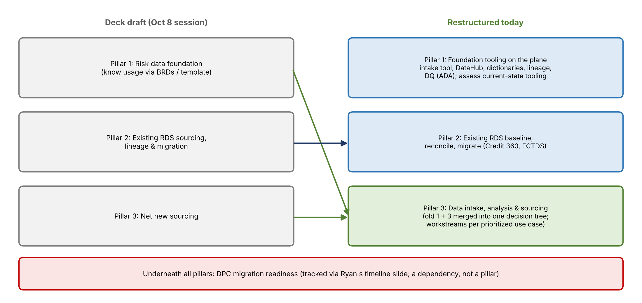
Figure 1. From the draft pillars to the restructured pillars

Why the change
- Vic and Jake found old Pillar 1 (understand usage via BRDs) and Pillar 3 (net new sourcing) hard to separate; in practice they run in tandem.
- Kevin proposed combining them into one decision tree: a request comes in, it's analyzed to see whether the data exists, and it then goes down the right path.
- That frees Pillar 1 for something new and urgent: the tools needed to do the work. Today Kevin uses Copilot in Excel on Ryan's RDS dumps, which isn't sustainable.

Pillar 1: Foundation tooling on the plane
- Intake tool (Jake's UI), so the team isn't living in spreadsheets.
- DataHub up and running: business glossary, data source dictionaries for applications, review of upstream data source dictionaries.
- Lineage tools that manage the hops.
- ADA built out for data quality work.
- Assess current-state tooling, which has never been done: what's being pulled into RDS, why, and what happens to it; put guardrails on the RDS request intake so new requests are routed to the right Pillar 3 lead.
- The team doesn't build these, but acts as product manager of the plane. Jacqueline would take the asks to Manav ("build these 10 things in DPC"), and the team escalates when Pillar 1 slips, since that slows Pillars 2 and 3.
- Pillar 1 and Pillar 3 depend on each other for requirements; Pillar 1 needs the Pillar 3 leads plus Mike to drive the requirements to tech.

Pillar 2: Existing RDS baseline, reconcile, migrate
- Dig into what's already in RDS: how many raw tables, whether they're used, and build a clean, reusable baseline instead of ad hoc pulls.
- Credit 360 belongs here, since it's already in RDS. Don't ask Credit 360 to fill out the intake template; analyze what's there instead.
- Includes FCTDS current-state analysis and planning moves from non-strategic to strategic sources.
- Feels like a body of work someone can run largely independently, made easier once Pillar 1 tools exist.

Pillar 3: Data intake, analysis, and sourcing
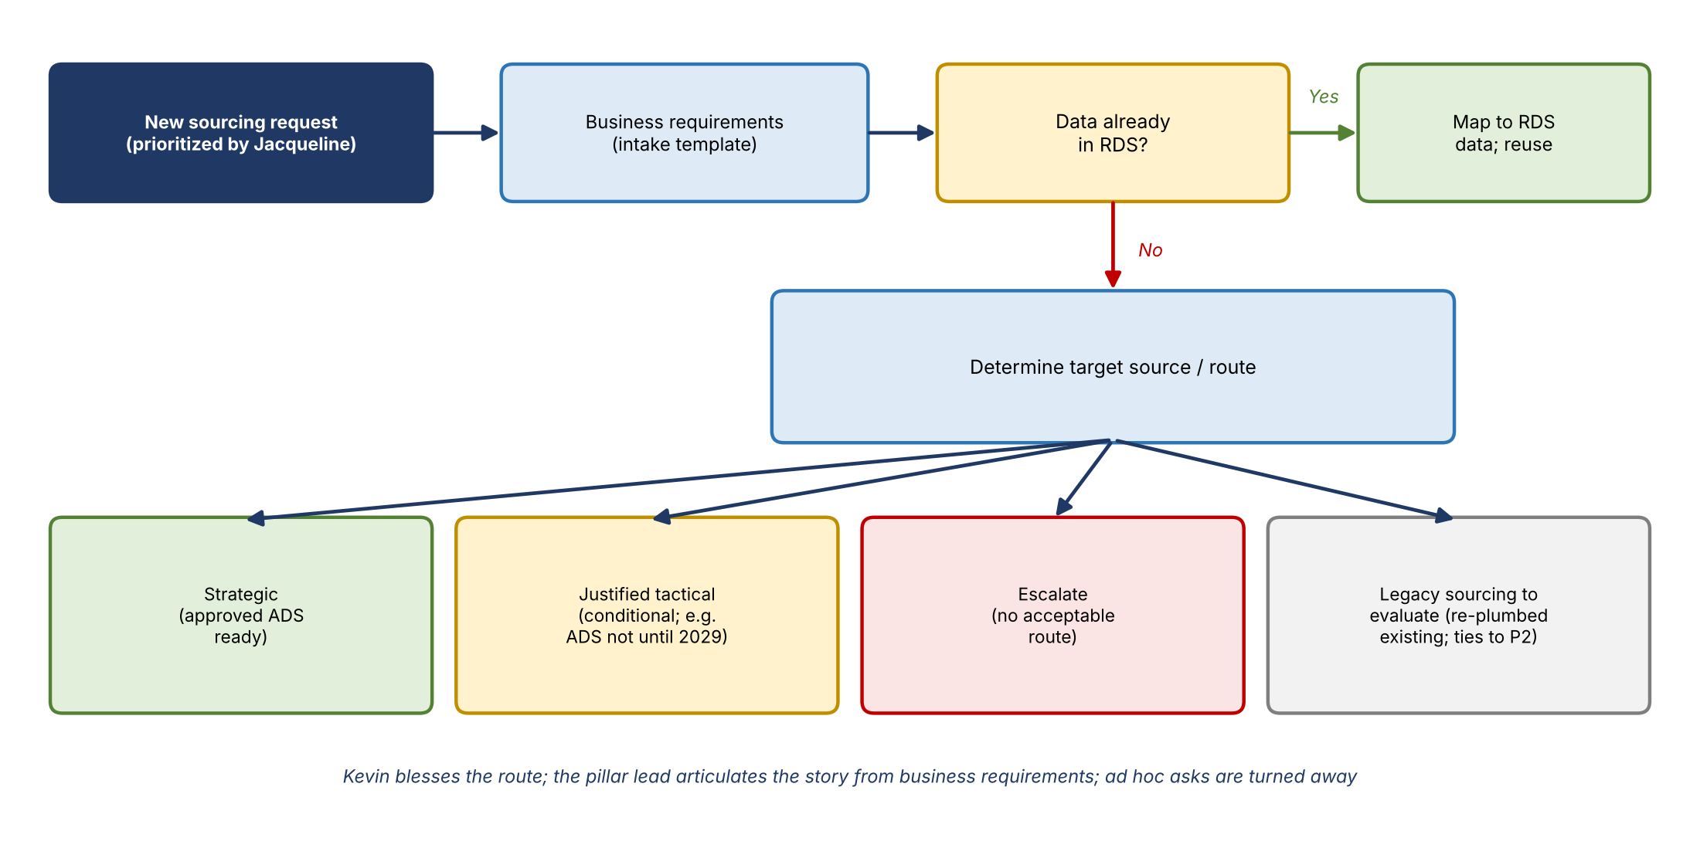
Figure 2. Pillar 3 decision tree
- For new sourcing initiatives that Jacqueline prioritizes: get business requirements first (the template), check whether the data is in RDS, and if not, determine the target source and route.
- Routes: strategic, justified tactical, escalate, plus a fourth category for legacy sourcing that needs evaluation (existing sourcing being re-plumbed), which overlaps with Pillar 2.
- Name ideas: "data intake and analysis" or "data intake, analysis, and sourcing"; not "net new."
- Kevin won't ignore upstream ADSs, but he'll make the call on what's acceptable for the data plane. The pillar lead should tell the story from the business requirements, and ad hoc or unnecessary requests can be declined.

4. Priority use cases
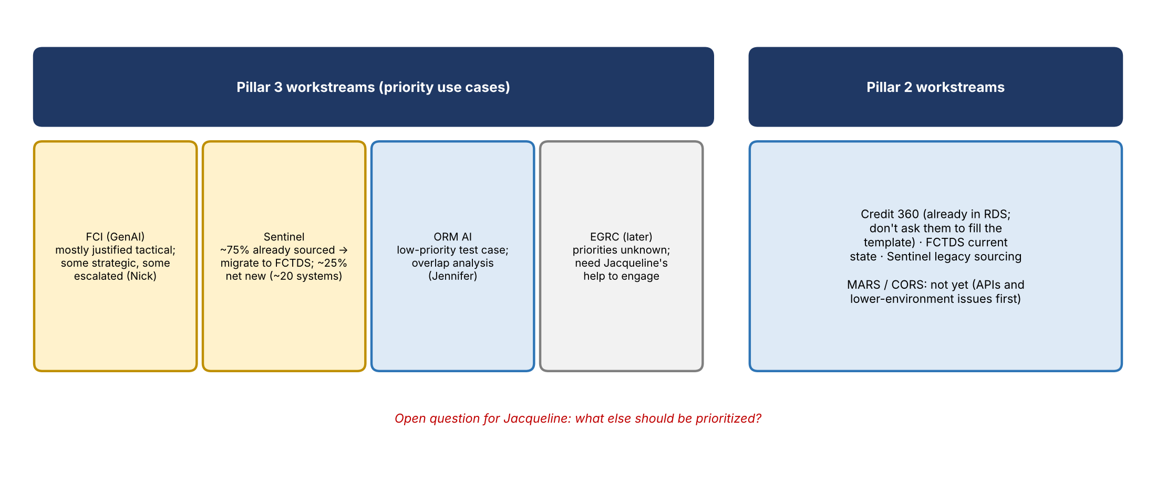
Figure 3. Workstreams under Pillars 2 and 3
Use case | Status from the discussion
FCI (GenAI) | Being sourced mostly through justified tactical routes, with some strategic and some escalated. Nick is working it. Prioritize FCI's use cases rather than waiting for FCTDS to be ready for everything. Kevin has slides on this to share
Sentinel | Uses existing sourcing where available; only net new sources were pursued. Roughly 75% of the data was already in financial crimes' FCDS and is being migrated into FCTDS (so it's in place for DPC); roughly 25% (about 20 extra systems) is new to FCRM. Get a summary from Yaginesh and Nick. The legacy part also touches Pillar 2
ORM AI | Low-priority test case; overlap analysis underway with Jennifer
EGRC | Future workstream; see Section 6
Credit 360 | Pillar 2, not Pillar 3
MARS / CORS | Not yet: they need to resolve their APIs and lower-environment issues first

- Next question for Jacqueline: besides FCI, Sentinel, and ORM AI, what else should the team prioritize? Kevin wants to avoid looking like nothing is happening for credit risk.
- Kevin's critique of financial crimes requirements: requesters say "I need these elements" without saying when or why. Scenario requirements (e.g., an investigator needing a system only for deposits) should be built into the conformance layer or the AI prompt, so the AI pulls from the conformed zone rather than raw, duplicated data.

5. Roles and ownership (internal)
- Kevin's model: one owner per pillar, a weekly status meeting where each lead covers what went well, what didn't, and how to move forward.
Role | Responsibilities
Product area lead | Owns a pillar end to end; scope and priorities with the business owner; roadmap and RAG tracker; runs phase gates; decides or escalates the sourcing route
Business analyst | Gets into the data: element requirements from BRDs, mapping to RDS PDEs and CDO subjects; should know their area's data. Some already exist in the business areas, e.g., Thaugn for Credit 360

Pillar | Proposed people
Pillar 1 | Pillar 3 leads (Vic, Jake) plus Mike for requirements. Jen was floated as a possible Pillar 1 lead, with Vic and Jake supporting and her also owning a Pillar 3 workstream; she needs exposure to ADS conversations to ramp up
Pillar 2 | Ryan and Mike leading; Prasanta possibly. eGRC (transcribed "GRD") was also mentioned as likely fitting Pillar 2, though later in the meeting EGRC was placed as a Pillar 3 workstream
Pillar 3 | Most of the team; project-based workstreams with sub-owners. Vic and Jake lead; Nick supports (financial crimes)

- Over time Kevin will need business-domain experts (e.g., commercial, consumer). For an ORCAP-first phase, Mike Giardina covers it.
- Jake told Vic he doesn't want to lead a pillar, since he'd lose time for the hands-on work.
- Sequence with Jacqueline: align on pillars, then on what goes in Kevin's, Kathy's, and Lindsay's boxes, then on people. Keep the roles slide out of the team-wide version for now.

6. EGRC
- Jordan owns EGRC and has said Jacqueline gets all of its data, so it isn't a friction point like credit risk or financial crimes.
- What's unknown is EGRC's priorities and sourcing needs. Tandems is partly understood via Taylor; IRP, PMT, and SNAP are not. SNAP (audit) and PMT (policy) may not belong to risk.
- Tandems has its own S3 bucket that persists data; open question whether the future state is individual application buckets or one EGRC bucket.
- Kevin will ask Jacqueline who to talk to. EGRC will be a Pillar 3 workstream; Kevin joked that Vic should own it.

7. Tracking and cadence
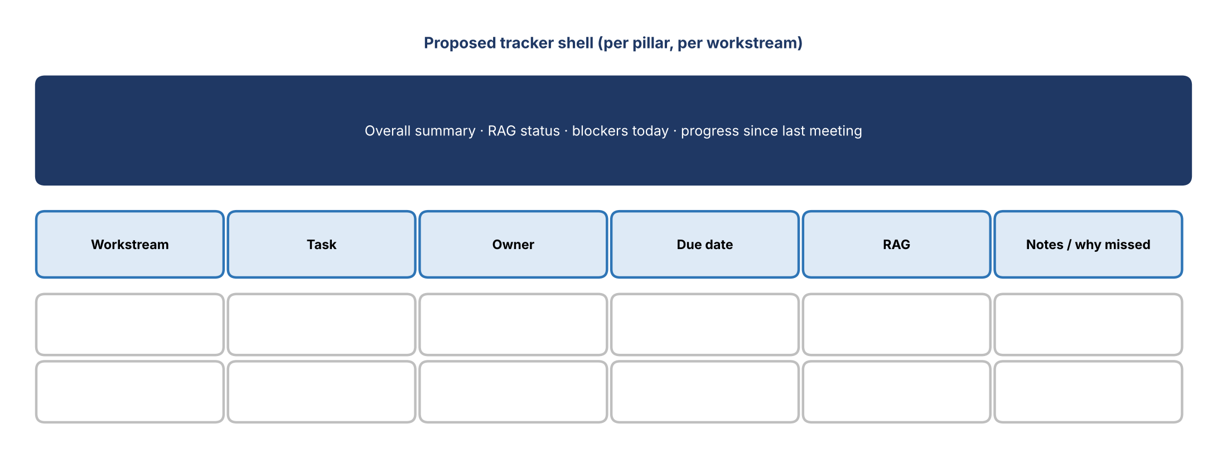
Figure 4. Proposed tracker shell
- Each pillar has workstreams, each with tasks, owners, due dates, and RAG status, plus an overall summary, current blockers, and progress since the last meeting. If a task slips, discuss why.
- Build a template shell; use the ORM roadmap as the example (baseline now, prioritized delivery in 2027). Steps may differ by workstream (e.g., FCI vs. ORM AI). Lindsay could help with tracking.
- Jacqueline's cadence: two 30-minute meetings a week, a Monday kickoff and a Thursday recap. Kevin will run something similar with his leads.

8. Revised deck plan
- Slide 6 overview: three pillars with DPC migration underneath (before and after DPC, the pillars still apply).
- Each pillar: about two slides, an introduction and a detail slide. Expand Pillar 1's current-state assessment.
- Example workstreams under Pillar 3: FCI, Sentinel, ORM AI, and EGRC later.
- An ORM roadmap / project plan example slide.
- DPC readiness: reuse Ryan's timeline slide as the dependency view.
- Feed the existing deck and these notes back into the AI to rearrange; drop what's not needed. The last AI draft came out clean.

9. Decisions
- Pillar 1 = foundation tooling and current-state tooling assessment.
- Pillar 2 = existing RDS baseline, reconcile, migrate (includes Credit 360).
- Pillar 3 = data intake, analysis, and sourcing, with use-case workstreams.
- DPC readiness underpins everything; track it through Ryan's existing slide.
- Keep roles and staffing internal for now.

10. Action items
Action | Owner | Notes
Rework the deck with the new pillar structure | Vic and Jake | Tomorrow
Move tomorrow's call to review the refreshed version first | Kevin | —
Share FCI slides (strategic / tactical / escalate breakdown) | Kevin | For Pillar 3
Get a Sentinel sourcing summary | Vic / Jake with Yaginesh and Nick | Existing vs. new sources
Build a tracker shell and an ORM roadmap example | Vic and Jake | Workstreams, tasks, RAG
Ask Jacqueline who to talk to about EGRC | Kevin | When she's back
Align with Jacqueline on pillars, then boxes, then people | Kevin | Thursday / Friday one-on-one

11. Open questions
- What else does Jacqueline want prioritized beyond FCI, Sentinel, and ORM AI?
- How will the work split across Kevin's, Kathy's, and Lindsay's teams?
- Who leads Pillar 1, and how quickly can tooling (intake UI, DataHub) be delivered?
- What are EGRC's sourcing requirements, and which EGRC applications belong to risk?
- When can MARS and CORS be addressed?

