Meeting Notes
Semantic Certification for Risk on DataHub
Item | Detail
Meeting date | Friday, October 9, 2026 (recording started about 2:32 PM)
Format | Follow-up session with a DataHub demo and UI mockup
Target-state team | Nitin (set context), Nirav (leads semantic certification for finance; ran the demo), Yashica (joined late; target-state vision)
Risk side | Mike (DCF ABO), Vic, and others
Not present | Kevin; Ryan
People referenced | Anand (builds the DataHub utilities and connectors), Lakshna (technology contact for ERA), CADS partner team
Purpose | Show how finance is setting up semantic certification on DataHub and plan how risk will adopt the same structure, starting with ERA

Note on the transcript
Auto-generated transcript; speakers aren't labeled, so attributions are inferred. Readings used: Yashica (confirmed earlier), Anand (transcribed "Anant"; spelling still unconfirmed), CADS ("CADs"), ORCAP, DPC, ADMF, DCF. Unclear: "ERA" (also "one ERA"; the first risk application), Lakshna (also "Lakshana"), and "AIDP" (a CDO tool that may propose definitions). The person asking about domains vs. CDO subject areas is likely Vic.

1. Executive summary
Risk will adopt the semantic certification approach finance is building on DataHub, starting with ERA and trailing finance so it can learn from finance's rollout. Nirav demoed DataHub with finance's CADS: glossary terms (logical names and descriptions) are imported from ADMF and assigned to assets (tables) and physical elements (columns), with column-level lineage. A product-area owner certifies that each assignment is correct, and any change triggers recertification.
Technical metadata gets into DataHub automatically when loads run on DPC, through utilities and connectors from Anand's team plus an enrichment step. Because this DataHub version can't run an edit, review, and certify workflow, the team is building a separate UI that stores interim state in a SQL database; final certified definitions go into the DataHub data canvas, with an agent on top.
For risk, the steps are: get ERA's technical metadata into DataHub (which depends on DPC; wave 1 is about October 30), gather business definitions, then overlay certification. Mike suggested ORCAP as an easier pilot because operational risk data has more existing descriptions. AI-proposed definitions, which Kevin asked for, are on the roadmap with no timeline. Next steps: draft the plan (priority app and steps), set a standing meeting, and share a summary since Kevin couldn't attend.

2. Key terms
Term | Meaning from the meeting | Note
Semantic certification | An owner certifies that the glossary term assigned to an element or asset is correct and compliant | Recertify on change
Glossary term | Logical name and description for an element; standardized across product areas and the enterprise | Imported from ADMF
Asset | A target table in DataHub | CADS has 7 so far
Physical element | A column in an asset | —
Domain / subdomain | DataHub's nested classification; names are configurable | Plus applications, data products, tags
Enrichment | Process after loads that adds views, tables, SQL, pipelines, and asset descriptions in DataHub | Built by Anand's team
Data canvas | Target-state view where certified business and technical metadata are stitched together | With an agent
ADMF | Source of truth for logical glossaries | Covers tier 1/2 only
ERA | First risk application for semantic certification | Name unconfirmed

3. Why this matters
- The enterprise wants glossary terms (logical names and descriptions) standardized at the product and enterprise level, with a product-area owner certifying each assignment against product policy and governance.
- Any change, including upstream changes in how data is sourced, can ripple to every asset that consumes an element. DataHub's lineage gives one place to see that.
- Yashica: the goal is keeping the business context of data as it flows between systems: what each element means and what a combined data set means. The tool should translate technical lineage, data flows, and transformations into business language. Business glossary and data set definitions are the first step.

4. DataHub demo (finance CADS)
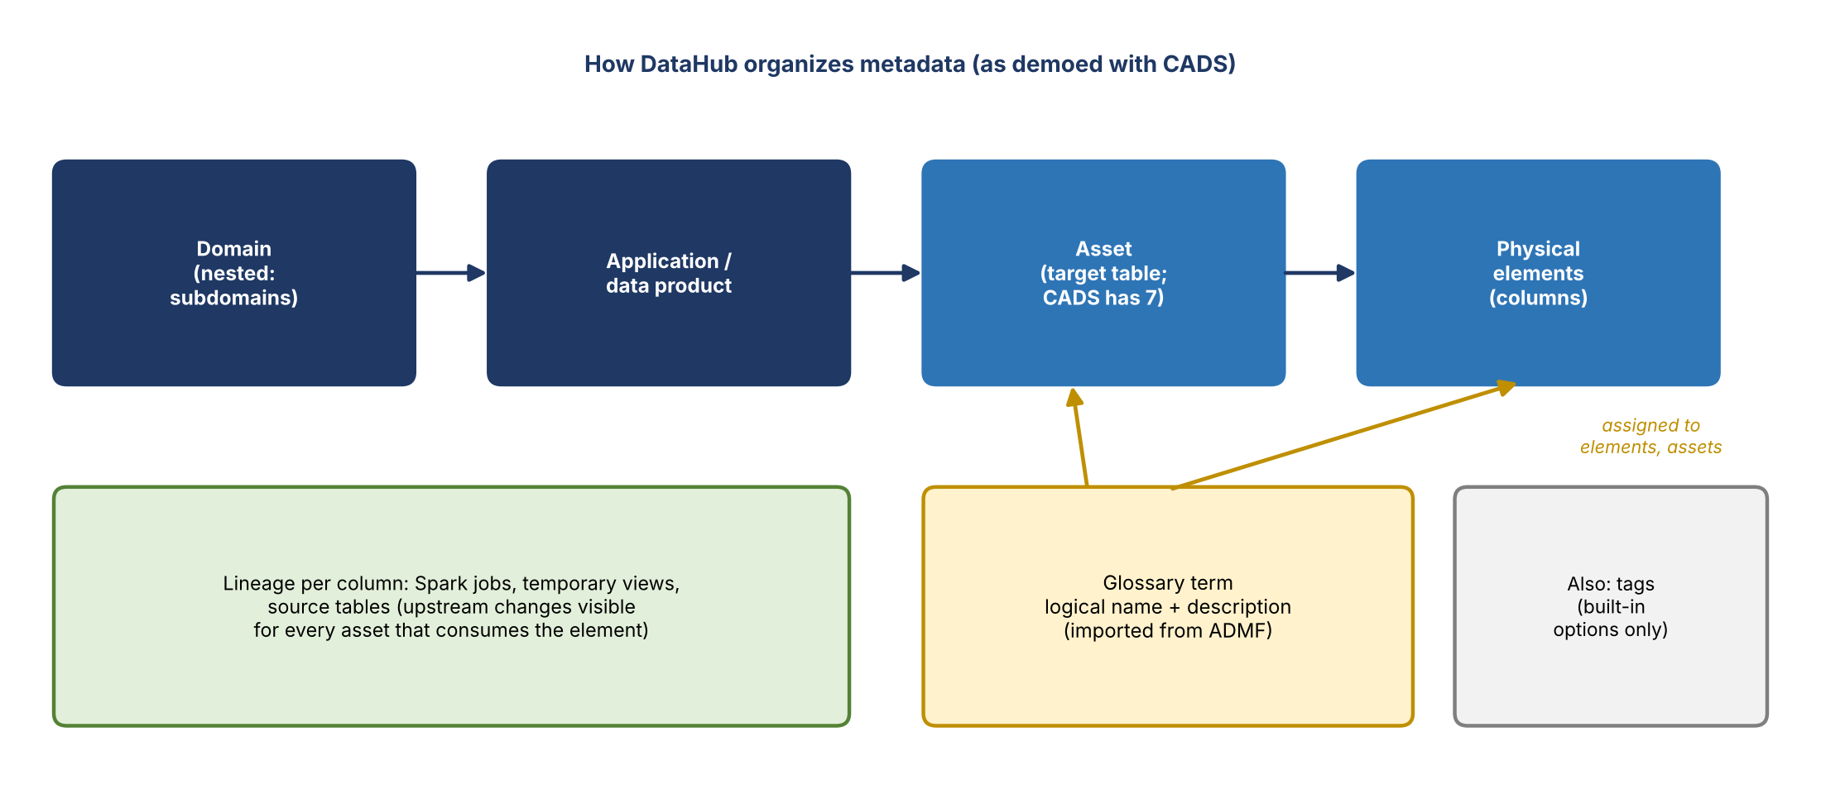
Figure 1. DataHub metadata structure
- Glossary terms (e.g., account ID, counterparty type code) are imported from ADMF and can be updated from their source.
- CADS is the sample: seven assets so far, such as the commercial instrument table. Each asset needs its own logical name and description; its columns are the physical elements.
- Business users select a column and assign a glossary term, which brings its logical name and description.
- The lineage view shows, for a column such as instrument record type code, where it's sourced from: Spark jobs, temporary views, and source tables, expandable to element level.
- The business checks that the chosen term matches the column's intent everywhere it's sourced, so everyone interprets it the same way.

How technical metadata gets in
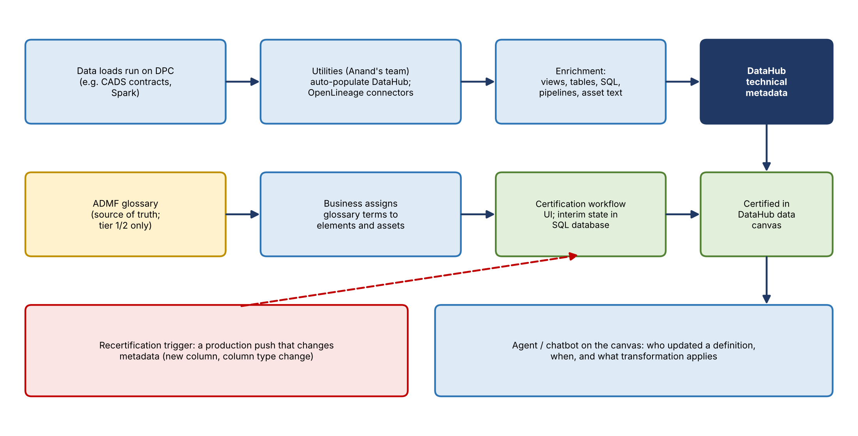
Figure 2. End-to-end flow
- CADS uses contracts that load data from upstream through staging and conformance zones via Spark.
- On DPC, utilities from Anand's team automatically populate DataHub, and OpenLineage connectors plus an enrichment process add temporary views, physical tables, SQL, pipelines, and eventually asset-level descriptions.
- Domain, subdomain, application, and data product must be predetermined and tagged at load.
- Done so far: the CADS partner ran sample contracts in DPC dev, lineage loaded into DataHub, and the connectors ran the enrichment.

5. Domains vs. CDO subject areas
- Vic asked why DataHub uses domains and subdomains instead of the CDO's data classification (subject categories, groups, and areas), which CDO is pushing all proposed ADSs to adopt.
- His concern: much of the data on the data plane will come from ADSs outside risk, so it won't fit neatly into a risk (or finance) subdomain.
- Nirav: DataHub's built-in options are domains (nestable), applications, data products, and tags, and they can't be modified. Names are fully configurable. Any other classification could live in the team's database and UI, or in DataHub's documentation section; the team is still exploring.
- Anand's future-state slide (shown Wednesday) uses domains such as corporate finance, financial risk, non-financial risk, and financial crimes, with product areas as subdomains.
- Current goal: configure the options and confirm the UI can pull them through DataHub's APIs.

6. Certification UI (mockup)
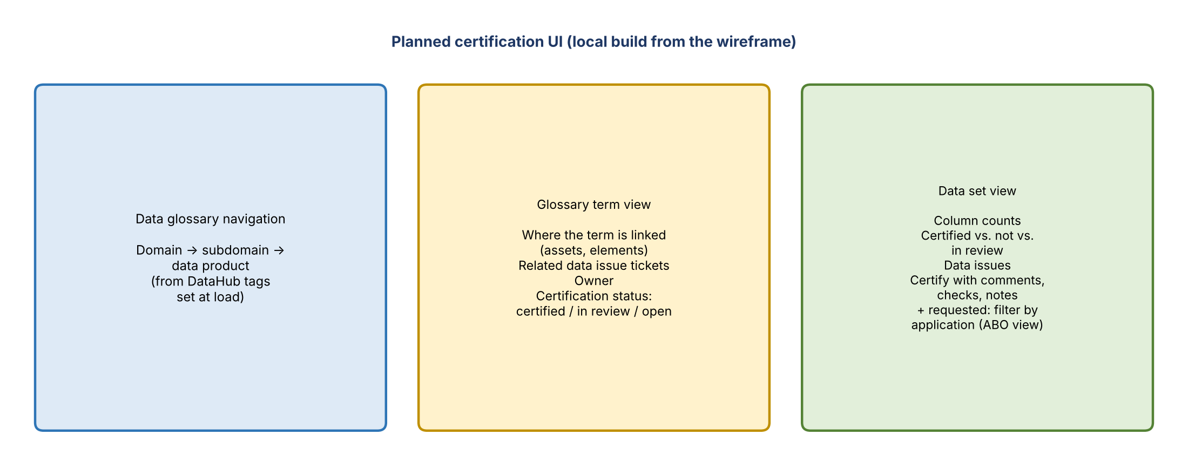
Figure 3. Planned UI views
- A developer is building the UI locally from the wireframe. The focus is the data glossary.
- Glossary term view: shows every asset and element the term is linked to (e.g., a term loan rate used in commercial loans and GL), related data issue tickets, the owner, and certification status (certified, in review, open items).
- Data set view: for an asset such as commercial instrument, shows total columns, how many are certified, not certified, or in review, and data issues.
- Workflow: users certify from the UI, add comments, record checks they verified, and add notes.
- Storage: this DataHub version can't support a data steward editing a definition, the owner reviewing it, and then certifying. So the interim state lives in a SQL database, and final certified definitions and asset descriptions are stitched into the data canvas. Status may also show in DataHub as tags or labels via enrichment.
- Mike's request: an application-level filter, since an ABO is responsible for the application's data dictionary and needs to see what's certified and what needs review.

7. Plan for risk
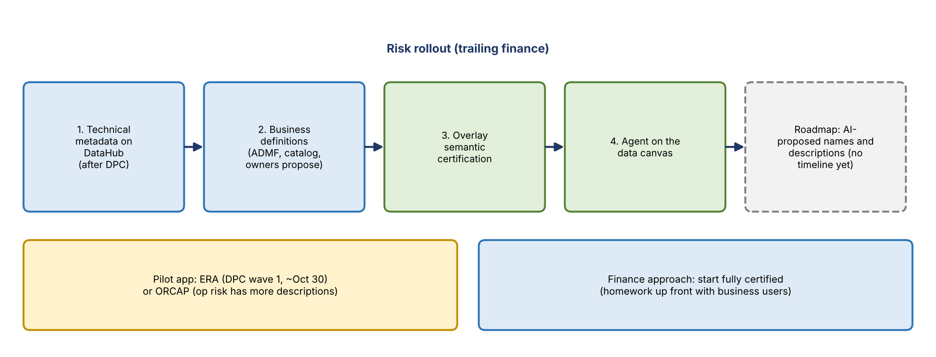
Figure 4. Risk rollout
- Scope for now is business metadata; technical metadata is a separate step.
- Load ERA's technical metadata (columns, lineage, documentation) into DataHub.
- Gather business definitions. The team isn't building a definition-proposal tool yet, so definitions come from ADMF or similar sources.
- Overlay semantic certification.
- An agent or chatbot on the data canvas answers questions like when a definition was updated, who updated it, and what transformation applies.

Dependencies and pilot choice
- Work on ERA paused because it depends on DPC. Lakshna (ERA's technology contact) is aware.
- These applications move to DPC in wave 1, around October 30, per the DPC deck (Ryan to confirm).
- Options: do groundwork before ERA lands on DPC, or pilot another application. Mike suggested ORCAP, since operational risk data has more descriptions than credit risk data; to be discussed with Kevin.

Where definitions come from
- Mike: creating the metadata is the most important part. The business definitions in DCF's data catalog can help, but the catalog likely has no descriptions for ERA; check with Lakshna's team.
- ADMF covers only tier 1 and 2 use cases, so many elements will have no description. The UI can also be used to ask assigned owners or stewards to propose definitions.
- The team offered to show how Treasury provided its metadata and how Nirav is working with finance.

Process design
- Finance starts with everything certified, doing the homework up front with business users. Recertification is triggered by a production push that changes metadata (new column, column type change).
- They'll help Mike define risk's consumers, process, and when users should certify.
- Certification will enforce data management policy requirements for business element names and descriptions (e.g., no abbreviations) through deterministic checks. Mike will resend the ADMF tool's checks to the group.

8. AI-proposed definitions
- Mike asked for a timeline for AI proposing names and descriptions for elements that lack them, which was Kevin's initial requirement.
- Answer: on the roadmap, no timeline. Ideas: start from industry-standard risk data dictionary definitions, and have an agent use ADMF to propose definitions with a confidence level for users to review and certify.
- The MVP is deliberately mostly deterministic, since less generative AI makes MRM review easier.
- CDO is building a tool for this (possibly "AIDP"), but if DataHub is the main tool for risk and finance, Mike wants it built into DataHub.

9. Decisions
- Risk will follow finance's semantic certification approach on DataHub, trailing finance.
- ERA is the intended first application, unless a pilot such as ORCAP is chosen.
- Business metadata comes first; the MVP stays mostly deterministic.
- A standing meeting will cover DataHub and DCF topics.

10. Action items
Action | Owner | Notes
Draft next steps toward a risk semantic certification plan | Nitin / target-state team | Priority app, steps, plan
Set up a standing meeting | Nitin | DCF or DataHub topics
Summarize this session and share it | Nitin / team | Kevin and others missed it
Discuss pilot choice (ERA vs. ORCAP) with Kevin | Mike / Nitin | Based on description coverage
Confirm DPC wave 1 timing for ERA | Ryan | ~October 30
Check ERA definitions with Lakshna's team | Mike / Nitin | Catalog likely lacks them
Resend the ADMF tool's checks | Mike | To this group
Add an application-level (ABO) filter to the UI | Nirav's team | Mike's request
Add AI-proposed definitions to the roadmap | Yashica / Nirav | No timeline yet
Show how Treasury and finance provided metadata | Target-state team | For Mike

11. Open questions
- How will DataHub domains reconcile with CDO subject categories and areas, especially for data from non-risk ADSs?
- Which risk application is the pilot, and when is it on DPC?
- Where will definitions come from for elements outside tier 1/2 use cases?
- Who are risk's certifiers, and should risk start fully certified like finance?
- When will AI-proposed definitions be available, and will they live in DataHub or a CDO tool?

