Meeting Notes
Workshop Prep with Technology: The DPC Stack, Access Personas and What the Migration Covers
Item | Detail
Meeting date | Thursday, November 12, 2026 (recording started about 2:01 PM; ran a few minutes over)
Format | Technology walked through its draft day-1 workshop deck (about 12 slides; got to about slide 6). A follow-up hour is set for Friday 11/13
Corporate risk | Jacqueline (joined 11 minutes late), Kevin, Jake
Technology | Eric, Moshin (presented the deck), Ananth, Kedar (invited)
Referenced | Gwen, Steve, Gina, Jordan (eGRC), Jeff, Shyam (eGRC personas), Lizzie (Tandems), Eric Kahn (Apex, audit), Dana (screening), Arun
Purpose | Review technology's draft day-1 workshop slides on DPC, so Jacqueline can explain them and the materials fit the workshop

Note on the transcript
Auto-generated transcript with no speaker labels; attributions come from context. Small talk at the start (an email outage and market news) is left out. Readings used: Moshin ("Mohsen"), Ananth ("Anand", "Anantan"), Dremio ("Dreamio", "Dremu"), Hortonworks ("Hot OnWorks"), StorageGRID ("storage grid"), ACID ("asset"), BUSCRT ("BuzzCard", "BusCard"), ORCAP ("RCAP"), SHRP ("SHARP"), GSMOS ("Gizmos"), AIDA (pronounced "Ada"), RAU ("REU"). Confirmed: Shyam ("Sham"), DERA (FCRAM; also heard "E-RAM"), FCDS, Ficrosoft ("VercoSoft"), FCP and FCCP, Aura. Unsure: "Centerprise", "Dremio was bought by SAP", and "Superset, aka Trino" (as said; Superset is a BI tool and Trino a query engine).

1. Summary
- Workshop day 1: everyone on the same page about what DPC is, what's migrated and what's left, and what the tooling brings. Gina's, Jordan's and Jeff's groups will present their priorities. Day 2 covers overlap and the new data engagement model. The output is 2027 initiatives that get to target state by end of 2027 (Eric had thought mid-2028).
- The DPC stack: bottom to top, it stores data (S3 with Iceberg and a metastore), processes it (Spark on OCP, with compute separate from storage), governs and protects it (Ranger, DataHub, AIDA, data contracts) and serves it (Dremio, JupyterHub, APIs). Tech will mark which tools users will actually touch, and will demo DataHub and Aura at the workshop.
- Access: Ranger policies will control who sees what. Shyam is defining eGRC personas (starting with IRP), with separate efforts for Tandems and Apex. Policies need to work for humans, defined agents, and AI acting on a user's behalf. After the workshop, these strands need to come together.
- Migration scope: for everything on Hortonworks, risk is done on Nov 19 (14 applications, mainly the three tenants: BUSCRT, ORCAP, FCTDS). Applications fed by those tenants move with them. Other systems either integrate with DPC, get replaced (e.g. GSMOS), or come in separate waves (Tandems, Apex). Kevin's slide should be split into those categories.
- Domains and overlap: tech framed risk as three domains (non-financial risk, financial risk, financial crimes). Jacqueline asked Kevin for a visual of where data lands today, with an estimate of the overlap.

2. What the workshop needs from technology
- Kevin had briefed Moshin but not Eric; the request was for slides that could be dusted off.
- Jacqueline's aim for day 1: talking to different groups, some understand DPC and the tooling well and others think "we're not going to do that". So: what is DPC, what's migrated, what's yet to migrate, and what are the benefits of the tooling?
- Day 2: changes to the data engagement model, connecting the dots on earlier work, showing where Kevin, Jake and James have already found overlap in data needs, and how to take advantage of it through the common data plane.
- Output: landing in DPC doesn't mean the job is done. Layer the 2027 work to reach roughly target state by end of 2027. Eric had assumed mid-2028, and noted it keeps evolving: "get comfortable with being uncomfortable", with a priority list refined over time.
- Day 1 speakers: tech, plus someone from Gina's, Jordan's and Jeff's groups. Jordan is with eGRC (Eric had thought finance).
- Moshin: glad eGRC and financial crimes are coming. In discussions at Steve and Gwen's table they say "data plane" even if they haven't heard "DPC"; it's the same foundation, and this connects it across groups.
- The deck was put together quickly with AI and will be cleaned up before the workshop.

3. The DPC stack (slide 2)
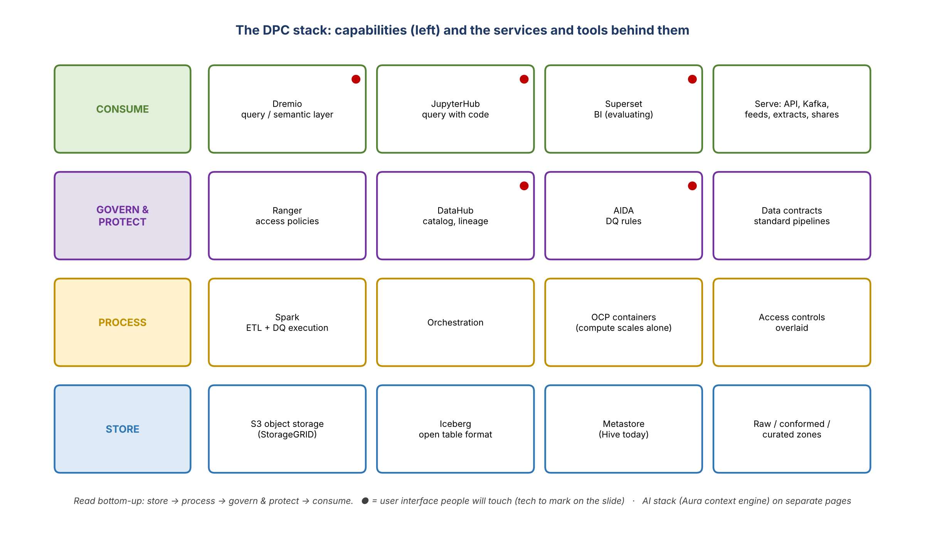
Figure 1. Capabilities and tools in DPC (● = tools users will interact with)
- The whole stack is DPC, or the data plane. It's not just storage or processing; it includes governance, metadata capture and consumption, which should be standardized.
- The capability column on the left reads bottom-up: store, process, govern and protect, consume. The white boxes are the services and tools that deliver each capability.
- Not every tool is used by end users. Users never touch S3; they reach the data through the consumption layer. Training would be on Dremio for direct queries, and on APIs and Kafka for serving data to applications.

Store
- S3 object storage (StorageGRID): where the data sits. Eric: think of it as a NAS, very cheap and fast, but it needs a format on top to be reached efficiently. The analogy: S3 is a folder (a "bucket") where files of every shape get dropped.
- Iceberg: an industry-standard open table format, the default in all three zones (raw, conformed, curated). It gives a table-like structure; ACID operations (update and delete, which Hortonworks lacks); snapshots and "time travel" (seeing the data as of a point in time) without duplicating it; and portability (move the data, not the format, if the engine changes). Without a standard format, RDS ended up with variants and duplicates. Users won't notice it, but it changes the foundation. It's applied by default; nobody decides each time.
- Metastore (Hive today): a catalog that presents the files as databases, tables and rows, so data can be queried. It's "a bunch of pointers": for rows 1–5 it knows which file to read, without scanning 10,000 records. It's not the query engine.
- Once data lands in DPC, nothing else needs doing for storage. How data lands is covered by contract-based agreements (e.g. bringing data from Hogan), under governance.

Process (briefly)
- Compute is separated from storage: either can grow without the other. In Hortonworks, scaling compute meant scaling storage too.
- This is where ETL and orchestration happen. Spark is the processing engine (where tools like Informatica were used before). Access controls are also applied here.
- DPC runs on OCP containers, fully open source, with no physical tie to a vendor. It scales vertically and horizontally, scaling in and out in milliseconds. Eric called it one of the more advanced compute setups built internally, and "a big leap forward" for efficiency and cost.
- Vulnerabilities: once finance and risk use the same frameworks, there's one place to fix vulnerabilities instead of chasing 15,000 people. It controls sprawl. "We're getting crushed"; this gives a path out, though not immediately.

Govern and protect
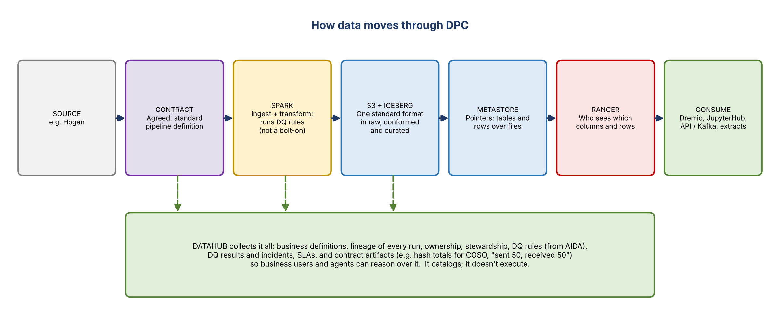
Figure 2. How data moves through DPC, and what DataHub captures
- Ranger: both the framework to define access policies and the enforcement on the data plane: who sees which columns, attributes and rows. It's "the front door" and will go through many iterations, growing and then thinning out.
- DataHub: "nothing more than a catalog", but an important one, and key to making data AI-ready. It holds business definitions and how they relate; lineage for everything run on the platform (and outside it, with access to the sources and code); data assets, ownership, stewardship, DQ rules and SLAs. It stores the DQ rules AIDA defines and publishes DQ results and incidents, so business users and agents can reason on them. It doesn't execute DQ: Spark runs the rules during pipeline processing, so DQ isn't a bolt-on.
- Today, listing every data product in RDS would take a "humanitarian effort" because there was no catalog strategy. DataHub still has to be organized into the right domains, subdomains and tags. DataHub will be shown at the workshop next week.
- AIDA: the DQ rules tool (pronounced "Ada"). Jacqueline is already familiar with it and with DataHub.
- Data contracts (Eric): run pipelines in a way that records which transformation applies to which data assets, so duplication across the ecosystem shows up. That was the original purpose, and it has broadened. Contracts also generate the artifacts audits and COSO controls need automatically. Example: CR360 sends data from point A to point B and must write a hash total ("sent 50, received 50"). Today a developer pulls the evidence for auditors; on DPC every transfer generates it in a set place. DQ output lands for DataHub the same way. There are 15 ways of doing this today, being consolidated into one. "Just standardization."
- Jacqueline's analogy: her grandfather's note cards of directions, the same steps written the same way every time. She welcomed it after struggling to find out what happens between Hogan sending data and GSMOS receiving it.
- Aura: a context engine left off the slide on purpose. It belongs to a consolidated AI tech stack that will be shown on separate pages, including how agentic capabilities connect to these tools. Jacqueline will make time for it, since being ready for Aura and the context engine is a big day-2 benefit. Tech will demo DataHub and Aura and keep a running list.

Consume
- Dremio: the query engine and semantic layer for querying data directly. Eric said it was bought by SAP (unverified) and that eventually DPC will move off it. Superset is being evaluated as the alternative: query plus simple visualizations for business users (Eric called it "Superset, aka Trino").
- JupyterHub: for querying with code, e.g. a Python script.
- Serving: APIs, direct feeds, extracts ("which I hate") and file shares.
- Request: mark the boxes that have a user interface people in the room will use (e.g. a user icon), and say which type of user each is for.

4. Access personas and policies
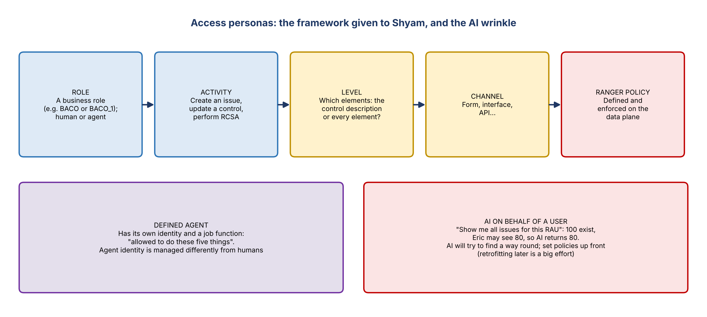
Figure 3. The persona framework and the AI wrinkle
- Moshin's example (eGRC): IRP is being built as the target platform for RCSA and RAU management. A persona (agent or human) accessing data has policies; e.g. an ORBO for one line of business shouldn't see issues aligned to another business's ORBO. That policy is built here and enforced through Ranger.
- Who's working on it: Shyam is defining personas and data access for all of eGRC, starting with IRP. Lizzie's team is doing Tandems control testing (Tandems isn't on DPC yet and uses separate S3, with plans to bring it in). Eric Kahn's team is defining policies for Apex (audit). It's fragmented today.
- Next step after the workshop: bring Shyam's persona work together with the data already on DPC (from Eric's team) and future data, and derive the Ranger policies for non-financial risk data. This consolidated conversation hasn't happened yet.
- Policies can conflict and "back you into a corner". Don't over- or under-control.
- The framework given to Shyam: a business role (call it BACO or BACO_1; tech isn't attached to the names) can perform activities (create an issue, update a control, perform RCSA) at a level (only the control description, or every element), through a technical channel (a form, an interface). Moshin admitted he can't tell an ORBO from a BACO from a technology lens.
- Jacqueline: keep personas generic ("analyst", not "IT&V analyst"). Otherwise there'll be 20 that later collapse into five with tweaks.
- Agents: personas can be human or agentic. The technical foundation for agents to access data exists, but agent identity is managed very differently from human identity.
- Eric: a defined agent (its own identity, a set job) is one thing. "Agentifying" the data, where a user asks AI a question, is different: AI should answer within the user's own entitlements. E.g. "show me all issues for this RAU": there are 100, Eric can see 80, so it shows 80. AI tools will poke holes trying to give the full answer, so policies must be tight and defined up front. Retrofitting them later would be a big effort.

5. What the migration covers (slide 4)
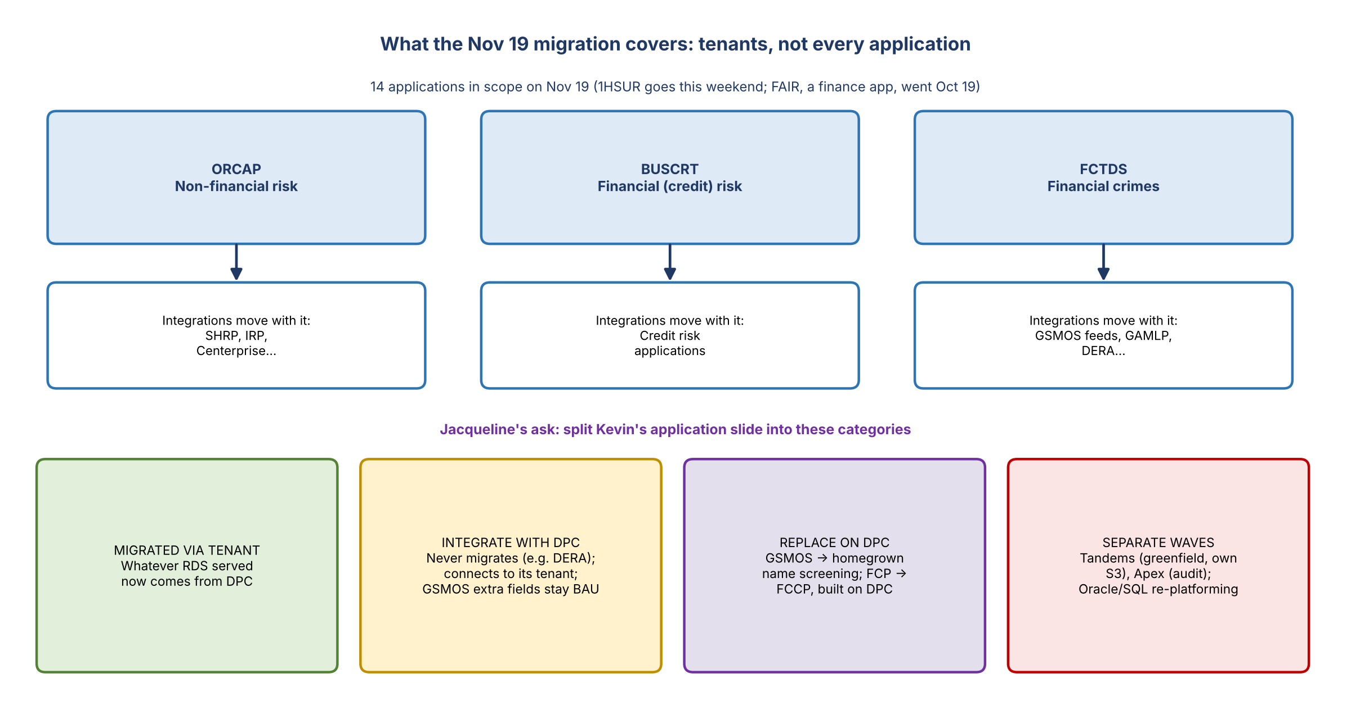
Figure 4. Tenants, their applications, and the four categories
- Jacqueline: there's no roadmap of what moves when and what's left to prioritize. If asked whether risk is done moving to DPC, her answer today is no.
- Eric: for everything on Hortonworks, risk is done on the 19th. 1HSUR goes this weekend and everything else next weekend. FAIR (finance) went on October 19. About 14 applications are in scope for the 19th, mainly BUSCRT, ORCAP and FCTDS, the three large tenants.
- Waves: Tandems (greenfield, never on RDS, on non-DPC S3) and Apex aren't part of leaving Hortonworks, but will be migrated separately. Applications on Oracle or SQL Server (e.g. around IRP) will be re-platformed to DPC over time.

Tenants vs applications (Moshin)
- The "applications" migrating are tenants in RDS: FCTDS supports financial crimes, ORCAP supports operational risk and compliance, and BUSCRT supports credit risk. Each serves many applications. FCTDS serves GSMOS, GAMLP and others; ORCAP serves SHRP, IRP, Centerprise and others.
- Migrating the tenants migrates those integrations. E.g. DERA (FCRAM, financial crime risk assessment) will never move to DPC, but it connects through FCTDS, so it's covered.
- Kevin's pushback: GSMOS and others (Ficrosoft) aren't downstream of FCTDS today; they're piped in separately. Moshin agreed it's a mix. Whatever is part of FCTDS has migrated; anything else will have to integrate with DPC. GSMOS's additional fields continue as BAU for now.
- Eric: FCTDS is "kind of a dumping ground" now and will evolve. DPC is the target state for all applications, but not on day one. If FCP is replaced by FCCP, FCCP is built entirely on DPC. GSMOS will be replaced by a homegrown customer name screening application (decision made; work with Dana's team), anchored on DPC with FCTDS as its tenant, including historical data. Customer screening work rolling out this year and early next uses FCTDS.
- So there will be some non-target-state systems on the side for a while, by design.
- Action: Kevin to share his slide in the chat so tech agrees, and split it into categories: integrate now; stay off for a while and integrate, then sunset and replace with a new solution.

6. From tenants to domains (slide 5)
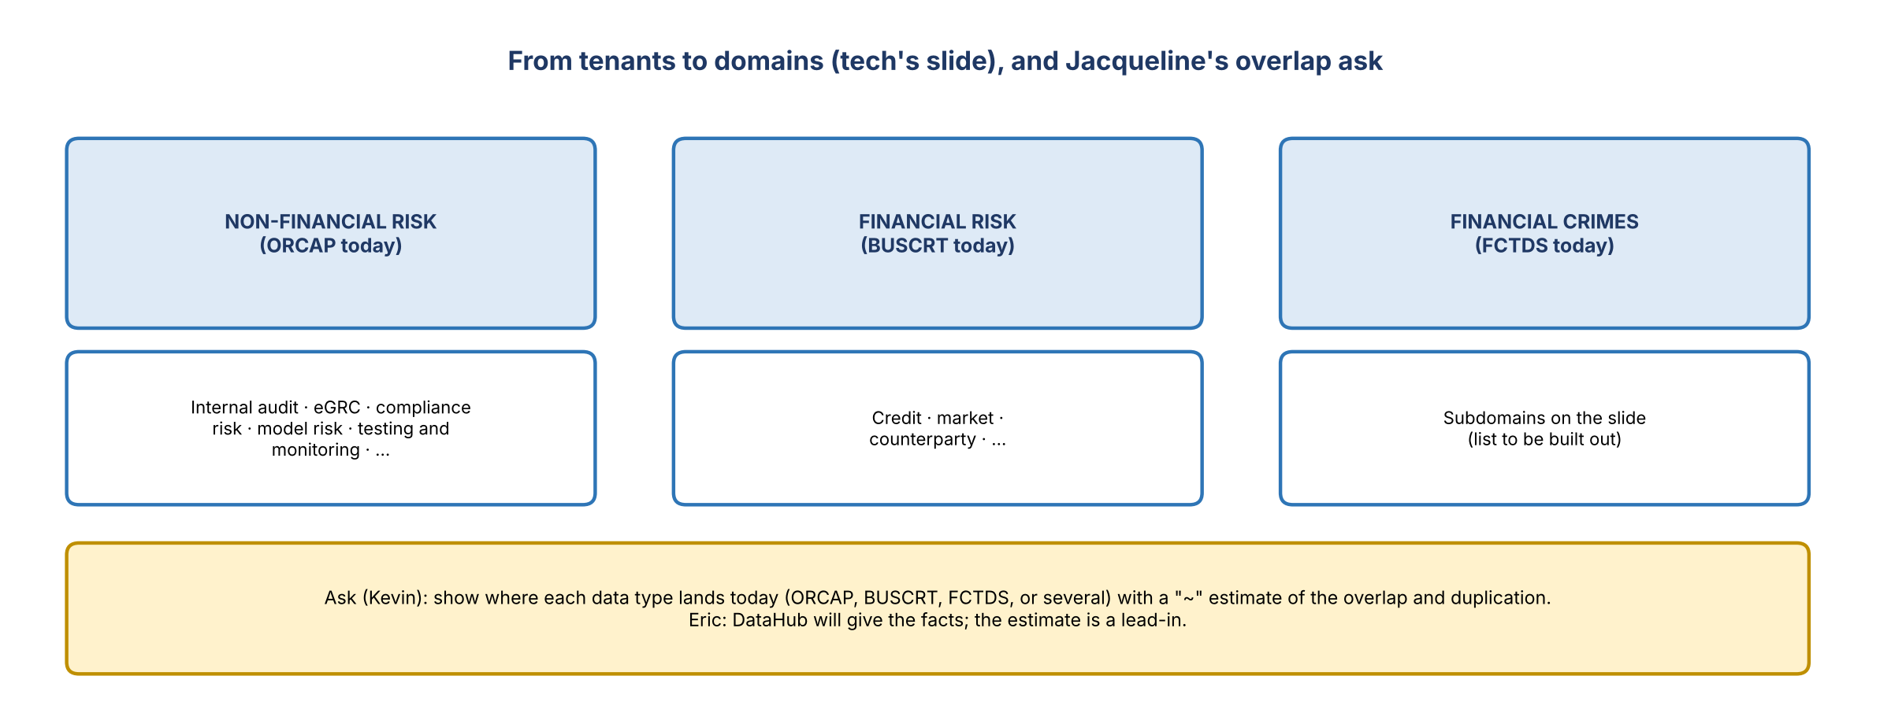
Figure 5. Three domains, and the overlap visual Jacqueline asked for
- Moshin avoided the word "tenants" in the deck and framed it as domains. Risk is three domains: non-financial risk (ORCAP today), financial risk (BUSCRT) and financial crimes (FCTDS).
- Subdomains: non-financial risk covers internal audit, eGRC, compliance risk, model risk, testing and monitoring, and more. Financial risk covers credit, market and counterparty. Financial crimes has its own list. The aim is to show how the tenant approach translates into domains, which matters for the slides that follow.
- Jacqueline's ask (Kevin): a visual of where data lands today (FCTDS and FCDS, a bit of both, ORCAP, BUSCRT), showing known duplication with a rough "~" estimate. "Tell me if it's impossible."
- Eric: DataHub will give the facts. An estimate can't be governed and risks rebuilding the same problems. Agreed: show the estimate as the lead-in ("we can argue about it all day, but the facts are the facts"), then let DataHub settle it.
- Jacqueline had to leave for another call. The group picks up tomorrow (Friday 11/13) for another hour.

7. Action items
Action | Owner | Notes
Clean up the day-1 deck (written quickly with AI) | Moshin / Eric / Ananth | Before the workshop
Mark the user-facing tools on the stack slide (user icon, user type) | Ananth / Moshin
Add the AI stack and Aura pages; prepare DataHub and Aura demos | Moshin / Ananth | Keep a running list
Share Kevin's application slide in the chat for tech to agree | Kevin
Split the application slide into categories (integrate now / integrate then sunset and replace) | Kevin / Jake
Visual of where data lands today, with an estimate of the overlap | Kevin / Jake | Lead-in; DataHub confirms the facts
Share the list of the ~14 applications in scope for Nov 19 | Eric
Bring Shyam's persona work, Tandems, Apex and DPC data together to derive Ranger policies | Moshin / Eric / Jacqueline | After the workshop
Continue the deck review | All | Friday 11/13, one hour

8. Open questions
- Is end of 2027 or mid-2028 the target state?
- What's the full list of systems that integrate, get replaced, or move in later waves, and when?
- Who owns the consolidated access policy model across eGRC, Tandems, Apex and financial crimes?
- How will agent identities be managed, and how will AI be held to each user's entitlements?
- When will DPC move off Dremio, and to what?

