Meeting Notes
Workshop Deck Working Session: Slide Edits and the Data Overlap Analysis
Item | Detail
Meeting date | Thursday, November 12, 2026 (recording started about 3:07 PM, right after the call with technology)
Format | Internal working session; edited the workshop deck live and agreed the overlap analysis
Attendees | Kevin, Jake, Vic
Referenced | Jacqueline (reviewing the deck), Mike (Fuse example), Mike G (to receive the notes), Ryan (the "Ryan file")
Purpose | Act on Jacqueline's feedback from the technology call: trim the deck, and plan the data overlap visual she asked for

Note on the transcript
Auto-generated transcript with no speaker labels; attributions come from context. Personal chat is left out. Readings used: BUSCRT ("bus car"), Dremio ("Dreamio"), RFDIR ("Rifter"), Kevin ("Ken"), slide 23 ("Psy23"), Copilot ("pro pilot"), "deck v9" ("V9 format"). "8/30" as an as-of date (heard "8,000"). Unsure: the slide numbers (they were being renumbered during the call); and the source names FNDD, BMG, 1DWH, C2T and Fuse as heard.

1. Summary
- Jacqueline's asks from the tech call: fix one slide, and show the data overlap visually (her "swag" of where data lands and how often it's duplicated). Her only feedback so far is "too many slides". She also wants named presenters and the decision needed for each slide.
- Overlap analysis (Vic): use the Ryan file, not the PDE sourcing file. Parse each RDS table name for its source application and group by tenant (ORCAP, FCTDS, BUSCRT, other). Then show pie charts of how many tenants source each application, with examples like FNDD (three times) and BMG (twice). It's due for tomorrow afternoon's session, not tonight.
- Deck edits: removed the Dremio and Power BI mention, the old August slide, the open questions slide and the priorities slide (25). Combined two slides into the new slide 35. Removed speaker notes and renumbered. Kevin will ping the deck to Jacqueline on Teams, since email was down.
- Jake: write the notes from the technology call and send them to Mike G.

2. The overlap visual
- Vic had mocked up a slide. Kevin suggested replacing its left side ("what type of data we need today") with what was just discussed with tech: how much overlap exists today, e.g. between financial crimes and BUSCRT.

Which file to use
- Vic's PDE sourcing file: lists data sources from current-state analysis and highlights when another area asks for the same source (e.g. FCTDS). It covers tier 1 and tier 2 use cases (reports, models, BSA/AML), data subjects, and 184 sources used, which may be cross-platform. It doesn't break out more than two platforms.
- Why it won't work: for credit risk, the PDE source is just CAR or ERA, mapped to a subject area like "credit risk metrics". Financial crimes, by contrast, lists the actual ADSs outside risk. So overlap can't be worked out from the PDE sourcing.
- Use the Ryan file: the list of what's in RDS today. Vic had previously mapped its tables to applications (for the RFDIR work and the "what we already have" data-sources-across-platforms file).

How to build it
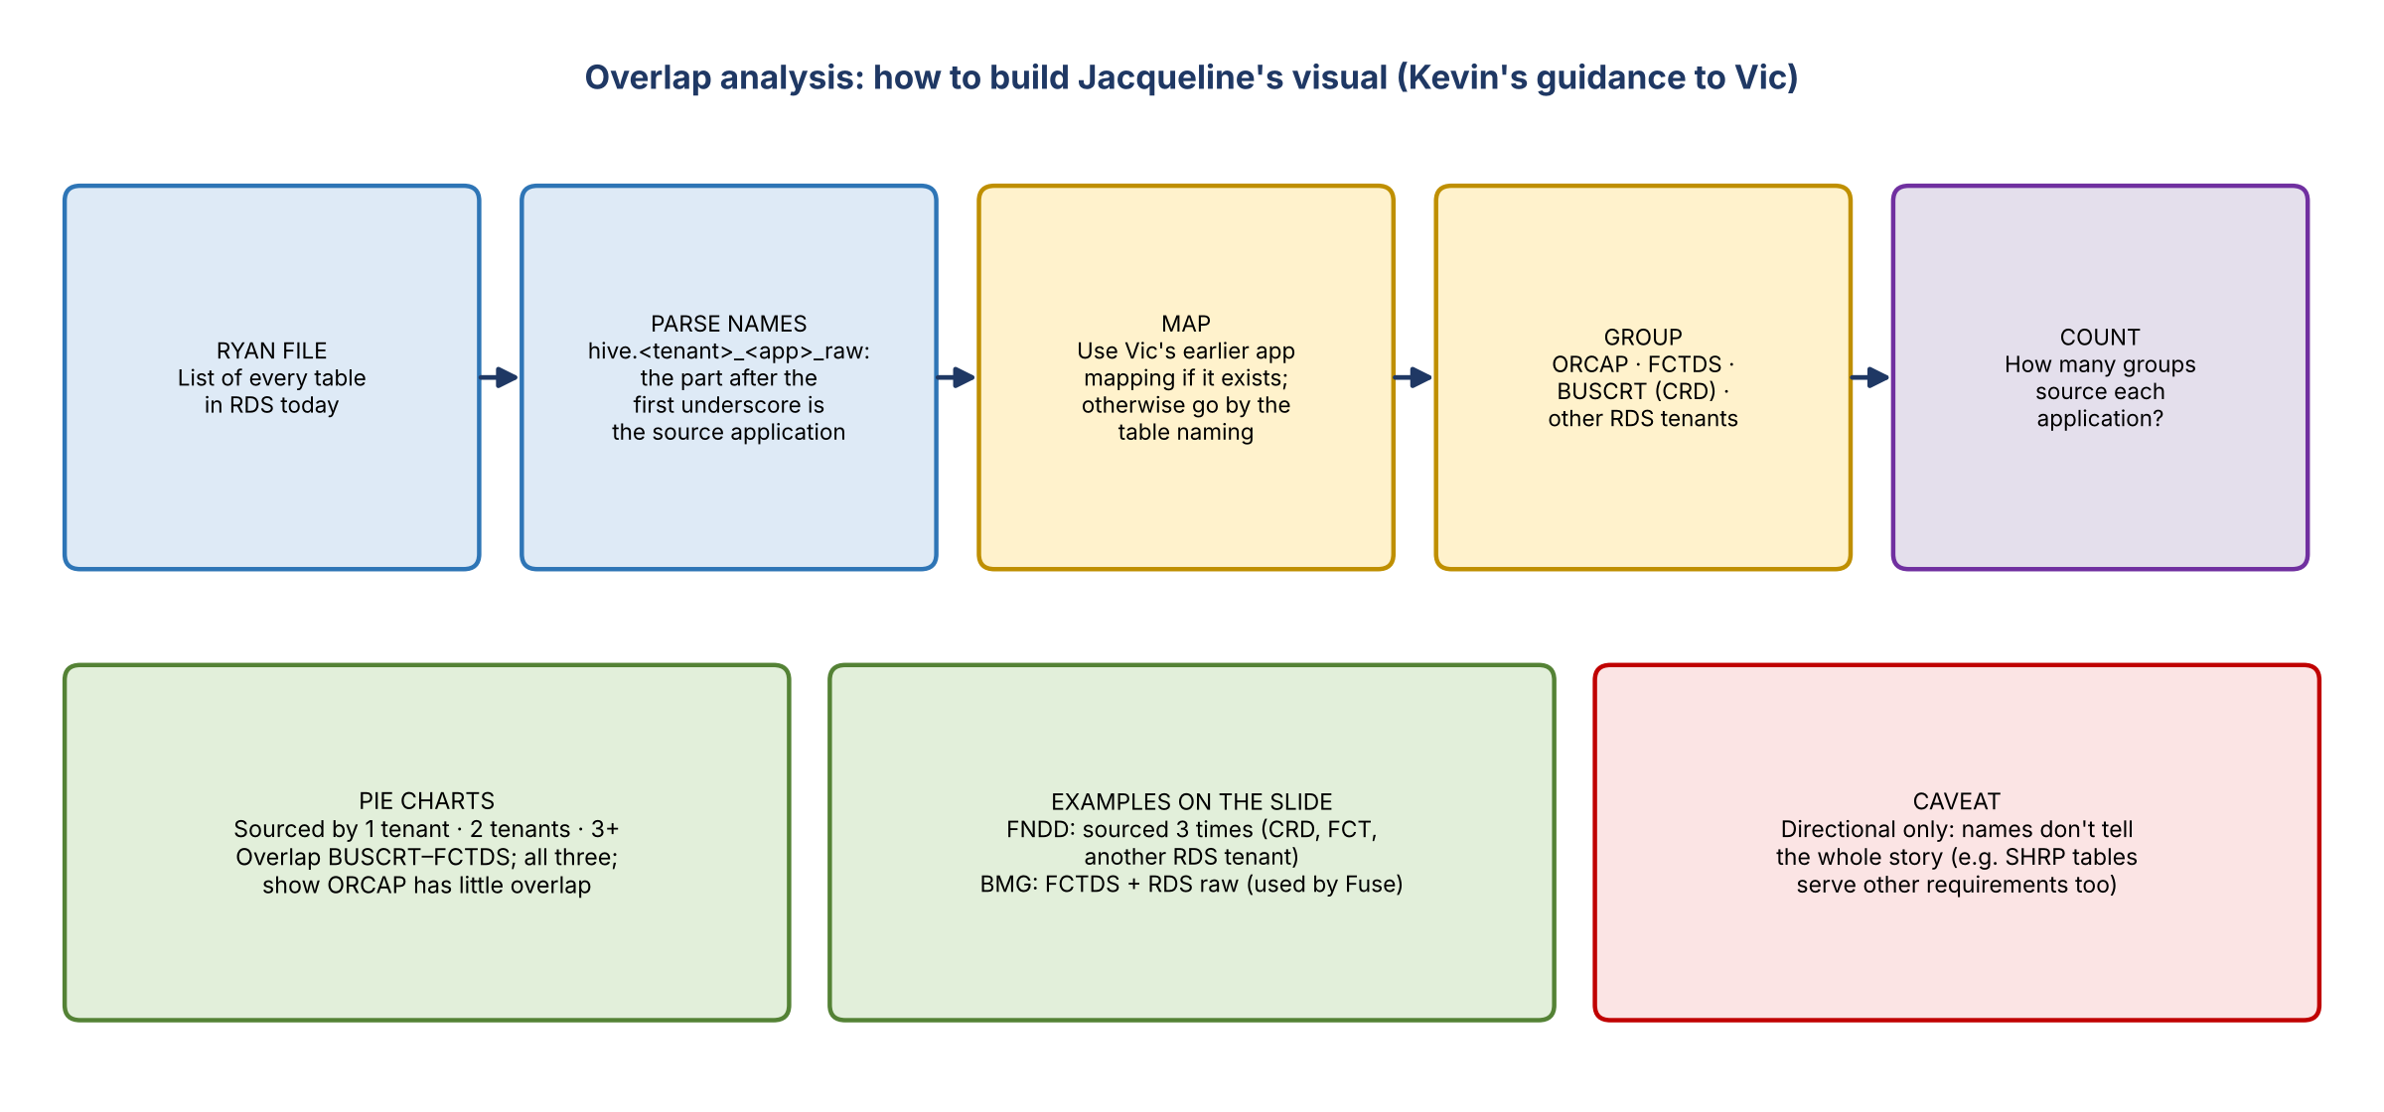
Figure 1. Method for the overlap visual
- Parse the table names: in hive.<tenant>_<application>_raw, the part after the first underscore names the source application (e.g. FCT_C2T_raw). Use Vic's earlier application mapping if it exists; otherwise go by the naming.
- Four groups only: ORCAP, FCTDS, BUSCRT (CRD) and "other RDS tenant" (anything else).
- Pie charts: sources used by one tenant, two tenants, or three or more. Highlight overlap between BUSCRT and FCTDS and across all three, and show that ORCAP has little overlap with anything.
- Single-tenant sources: an opportunity: check whether anyone else needs that data, and whether RDS already has it complete, before sourcing more.
- Caveat: directional only. Names don't tell the whole story; e.g. SHRP tables also serve other requirements, which only someone who knows would spot.
- This becomes a new slide in the overall deck. It isn't needed tonight, since the deck isn't discussed until tomorrow afternoon.

Examples
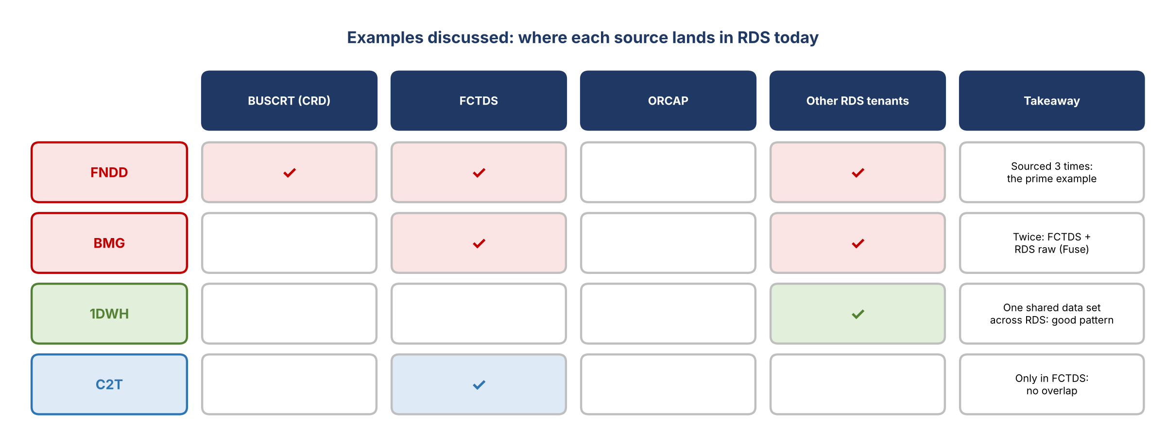
Figure 2. Examples of the same source landing in several places
- FNDD: sourced into credit risk (CRD), FCT and another RDS tenant, three separate times. "A perfect example of what Jacqueline was trying to highlight."
- BMG: sourced into FCTDS and also into RDS as a raw table that Fuse uses (per Mike), so twice.
- 1DWH: one common data set used across the whole RDS platform, the good pattern.
- C2T: only in FCT, so no overlap.
- The real work comes later: finding the data sets and deciding whether each overlap is the same data or different, and why. Hopefully the data subjects are solid.

3. Deck edits made
Change | Detail
Removed the Dremio and Power BI mention | The derived ADS discussion hasn't happened yet
Deleted the old August version of a slide | Its numbers were out of date; Vic has an older copy saved
Slide 23 (sources) | Left as is; no update needed. Both sides are as of 8/31 (8/30 was also mentioned); the newer demand count (~486 sources requested) grew through the team's analysis and files from BUSCRT
Deleted the open questions slide | Questions will come up in discussion
Guidance boxes kept; two added | Kevin wants presenters' names on each slide (not just "tech"), plus the decision Jacqueline needs from each slide, as she asked
Scrapped slide 25 (priorities) | It would tell groups their priorities right after asking for them. Kevin can raise points in discussion instead
New slide 35 | Combines the former slides 36 and 37
Removed speaker notes | Slide 23 had notes in the v9 file
Renumbered slides | Copilot struggled with it; done manually
- Kevin will ping the deck to Jacqueline on Teams (email was down) so she can start reviewing. He'll count the placeholder slides to reassure her about the length.

4. Action items
Action | Owner | Notes
Write notes from the technology call and send them to Mike G | Jake | Done separately
Build the overlap analysis and pie-chart slide from the Ryan file | Vic | For tomorrow afternoon
Send the trimmed deck to Jacqueline on Teams | Kevin | Email down
Add presenter names and decisions to each slide | Kevin / Jake
Wait for Jacqueline's feedback before further changes | Team | Friday

