Meeting Notes
Data Plane Introduction: ADS Strategy, RDS, and the Common Risk Data Plane
Item | Detail
Meeting date | Monday, October 5, 2026 (recording started about 10:01 AM)
Format | Introductory walkthrough with slides shared by Jake
Presenting team | Kevin (leads; ADS strategy), Vic and Jake (ADS strategy, Kevin's team), Ryan (Terry's team; RDS framework product owner)
New to the space | James (boomerang, about 11 years cumulative at the bank; tech, project coordination, business architecture, product management) and Matt. Both are winding down Article 7 work and moving into data conversations.
People referenced | Jacqueline (data plane vision); Mosin (architect); Terry Harper (ORCAP owner); Gwen; Jordan (now owns EGRC); Amber Schmidlin's team and Panos (EGRC architecture); Manav (ERAFT technology); Eric (DPC technology lead); Ryan Klein (legacy RDS); Vinay Purohit (built iSearch); Scott (CLO domain); Fikram; Michael
Purpose | Give James and Matt background on the data plane: where ADS strategy stands today, what RDS is, how EGRC fits, and what Jacqueline envisions

Note on the transcript
Auto-generated transcript; speakers are not labeled, so attributions are inferred. Confirmed spellings: BUSCRT (transcribed "buzz cart"), FCTDS, ORCAP, CARET (also "Carrot"), WCIS (transcribed "WICUS"/"Wikus"), CIMADS (transcribed "SIM ADS"), ORP (its future name is IRP), ERAFT, and Manav (also "Manoff"). DataHub is written for "data hub." "ECRLT" is read as the customer risk rating model.

1. Executive summary
This was an onboarding conversation for James and Matt. The headline: the data plane doesn't exist yet. It is a concept Jacqueline introduced in August, and it will only start to be real once the RDS platform finishes migrating from Hadoop to DPC, targeted for mid-November.
Kevin walked through the CDO's ADS framework (systems of record → transactional → aggregator → derived ADSs), corporate risk's five current ADSs (ORCAP, BUSCRT, and FCTDS on RDS; MARS and CORES outside it), and EGRC, the planned SHARP replacement. James added deep context on why customer data is so hard: Hogan CIS holds every customer, Consumer and Commercial have declared separate customer ADSs (CIMADS and WCIS), and corporate functions now holds customers it doesn't acknowledge.
Jacqueline's vision is a common risk data plane: the team sources data centrally, once, and organizes it into non-overlapping categories (the "pineapple, kiwi, banana" placeholders). The team's role would expand from governance and defect administration into owning the plane, including sourcing, metadata, lineage, controls, and actually fixing defects. The group agreed that the lift-and-shift migration is risky and that the real work is rationalizing data afterward: do we still need it, and does it need to take the same path?

2. Introductions
- James: a boomerang with about 11 cumulative years at the bank, having worked in every business line except CSBB, across technology, project coordination, business architecture, and product management. Describes himself as a problem solver. Expects to keep getting pulled into Article 7 audit calls.
- Matt: from the same side of the team as James, also moving into data conversations as Article 7 winds down.
- Vic and Jake: Kevin's ADS strategy people. Everyone else on Kevin's team works on defects; the ADS strategy team is being built up slowly.
- Ryan: on Terry's team (a peer of Kevin's) and the go-to person for how things work today. He is the framework product owner for RDS.

3. Key terms
Term | Meaning from the meeting | Note
Data plane | Jacqueline's concept (August) for a common place where all risk data is sourced once and shared; architects describe it as a plane built on S3 buckets | Not an industry term; doesn't exist yet
ADS | Authorized/approved data source; the CDO's target-state data sourcing construct | Built on BAM applications
Conditional ADS | Today's best source for a Tier 1/Tier 2 use case, identified by going one hop back | Must migrate to target-state ADSs
BAM | Application inventory; ADSs are defined as BAM applications | RDS is not in BAM
RDS | A platform with multiple tenants, not an application | Hosts ORCAP, BUSCRT, FCTDS
ORCAP | Operational Risk and Compliance approved Provisioning point; legacy of the APP era | Owned by Terry Harper
BUSCRT | Credit risk derived ADS, functionally "Credit Risk 360"; formerly CAR | Confirmed spelling
FCTDS | Target financial crimes derived ADS; several FC ADSs will merge into it | Some data still in FCDS
MARS / CORES | Two CIB CRO-owned derived ADSs supported by CIB technology | Not on RDS
CARET | Downstream of ORCAP; does non-financial risk reporting and calculations | Confirmed spelling; being retired via shift-left
EGRC | Enterprise Governance, Risk and Compliance; planned one-stop risk platform | Came with Gwen; Jordan owns
ORP | The SHARP replacement within EGRC | Confirmed; future name is IRP. Not built yet
SHARP | Current issues platform (on Archer) | Must be retired by Q1 next year
Hogan CIS | Customer system of record holding every customer; owned by Consumer | Being retired
CIMADS / WCIS | Consumer's and Commercial's declared customer ADSs | Confirmed spellings; how they merge is unresolved
ECN / RRN | Enterprise customer number vs. relationship reference number (Wachovia legacy) | RRNs worked like WCIS IDs
iSearch | Patented bridge between ECNs and WCIS IDs (built by Vinay Purohit) | —
DPC | Data private cloud; risk's new platform (provider: Nexus One) | Replacing Hadoop/Hortonworks
DataHub | Third-party metadata, lineage, and semantic layer to be built on top of DPC | Not yet in use in risk or in BAM
EDQDM | Centralized defect tool | Team administers the process
IHUB | Hub through which commercial onboarding systems load account and transaction data | ~1,400 raw tables sourced
ERAFT | Enterprise risk and finance technology organization (under Manav) | Confirmed spelling

4. Where ADS strategy stands today

The CDO framework
Kevin's team has historically told the corporate risk ADS story to the CDO team. The CDO framework defines a target-state path, which the bank has been on for roughly one year; each domain is on its own journey.
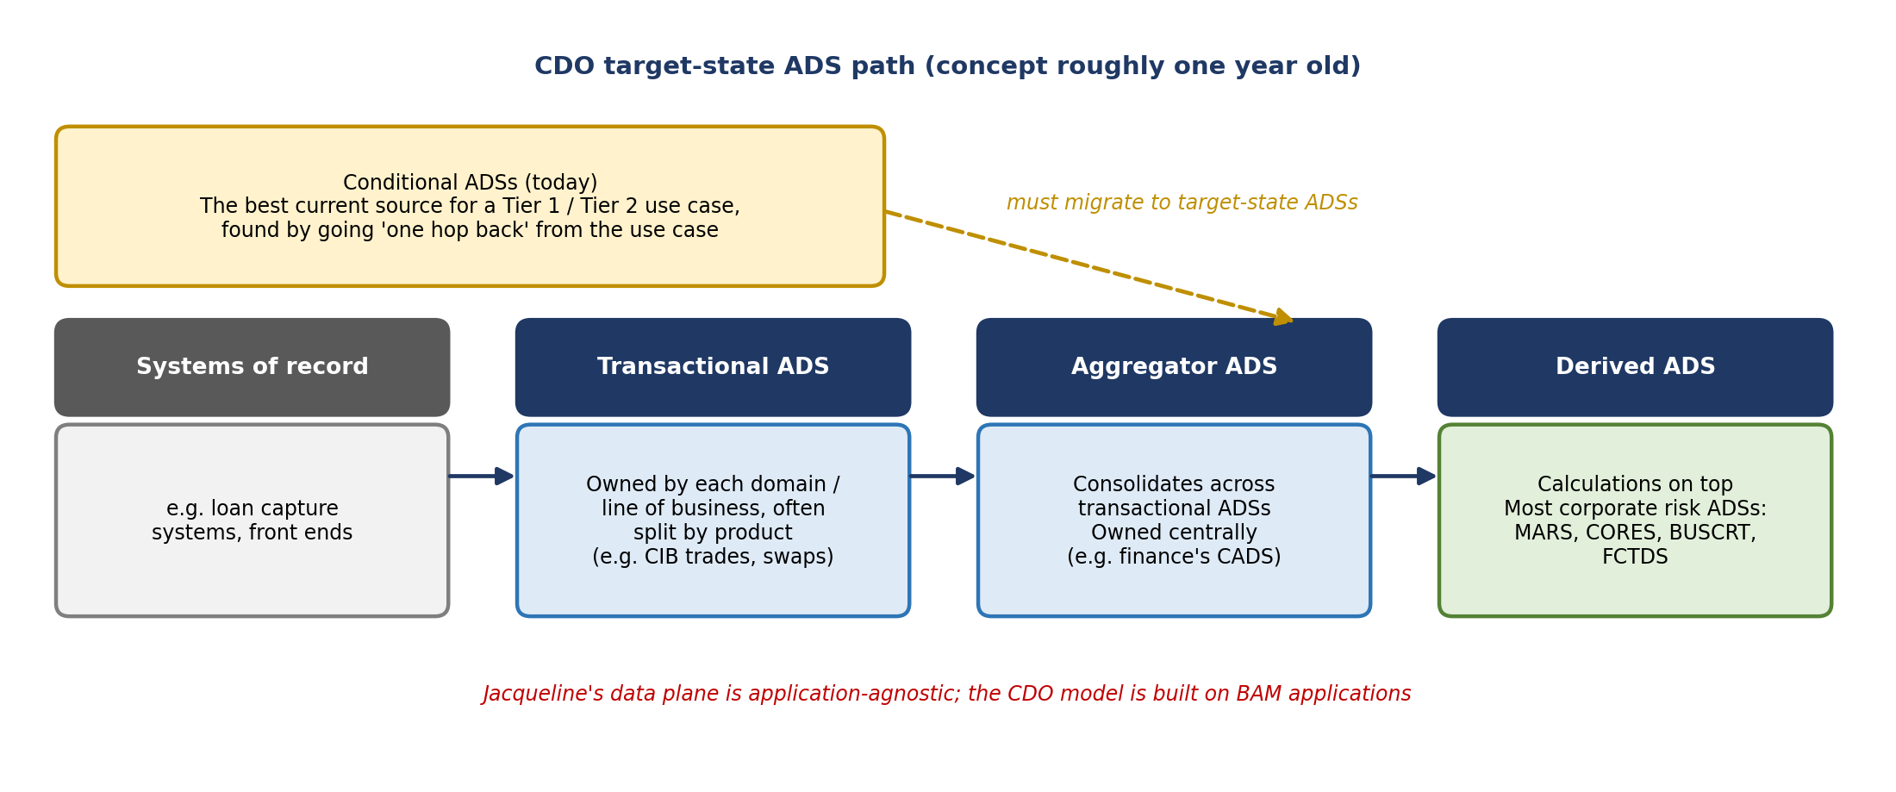
Figure 1. CDO target-state ADS path and today's conditional ADSs
- Systems of record: front-end systems such as loan capture.
- Transactional ADS: owned by each domain and aggregating that domain's SORs, usually split by product (for example, all CIB trades in one application, swaps in another). "Transactional" means business transactions, not just credits and debits. Most are still being built.
- Aggregator ADS: consolidates data across transactional ADSs (for example, consumer and commercial loans into one loan view). Typically owned by central teams in corporate functions or finance; CADS is finance's aggregator ADS.
- Derived ADS: where most corporate risk ADSs sit, because they run calculations: MARS, CORES, BUSCRT, and FCTDS.
- Conditional ADSs: data management policy currently relies on these: the best place to get data for a Tier 1 or Tier 2 use case today, often the same source used for 15 years. They need to migrate to target-state ADSs.
Kevin noted a tension: the CDO model is built on BAM applications, while Jacqueline's data plane is application-agnostic ("just data on a plane"). He asked for help educating Jacqueline on the BAM application construct and needs to keep working on how to map her view onto actual applications.

Corporate risk's five ADSs and RDS
RDS is often called "the ADS for corporate risk," but there is nothing called RDS in BAM. It is a platform with multiple tenants. Jake built the slide below from conversations, since no one on the team owns these applications.
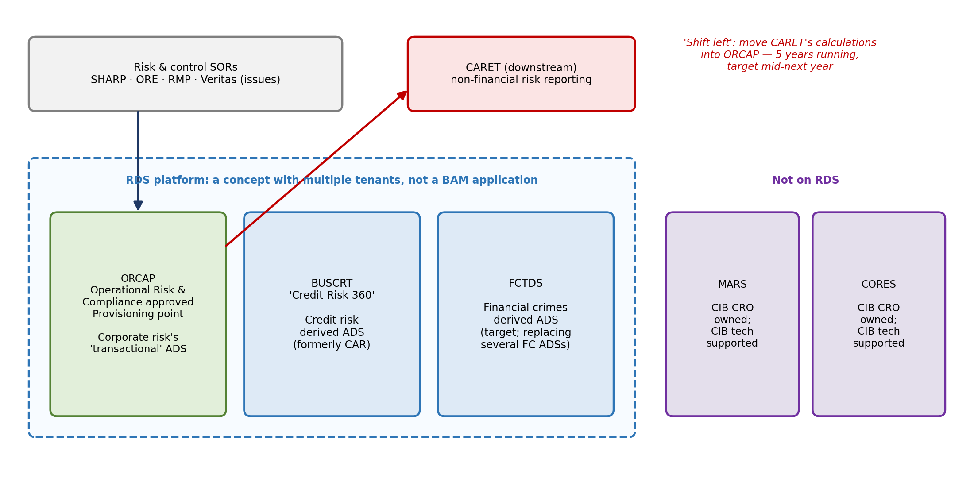
Figure 2. Corporate risk's five ADSs and the ORCAP → CARET flow
ADS | Role | Details
ORCAP | Corporate risk's "transactional" ADS | Aggregates risk and control SORs (SHARP, ORE, RMP, and issues data now in Veritas) for non-financial-crimes, non-credit-loss risk. Built two data management policies ago as an APP; owned by Terry Harper, who was its ABO when it was centralized in DMI and kept it when CDO federated. Still aggregates systems that moved to the control management organization.
BUSCRT | Credit risk derived ADS | Functional name "Credit Risk 360"; historically CAR. Target-state credit risk ADS.
FCTDS | Financial crimes derived ADS | Target into which several financial crimes ADSs will be consolidated.
MARS | CIB CRO derived ADS | Not on RDS. Supported by CIB technology, not Manav's organization. Well controlled (COSO, IT&V scrutiny). Would be unnecessary if CIB solved its own ADS strategy, but very hard to unwind.
CORES | CIB CRO derived ADS | Same as MARS. Gwen knows both well.

- CARET and the shift-left: CARET sits downstream of ORCAP and produces the dashboards that feed non-financial risk reporting. A shift-left effort to move CARET's calculations into ORCAP (so ORCAP becomes the provisioning point for all downstream consumers) has run for at least five years without finishing. It is now supposed to finish by the middle of next year because CARET has to go away.
- Skepticism: one of the new attendees said ETL inside an ADS is reasonable, but they have never seen one team manage both ETL and calculations well, which may explain why the shift-left hasn't happened.
- Context: this was the strategy before Jacqueline arrived, and it can all be broken up.
- Replumbing the past: BUSCRT and FCTDS should only source from business transactional or aggregator ADSs, but those don't exist yet. So the team is replumbing what CAR and FCDS received today into the new applications, "rebuilding the sins of the past."

5. EGRC
EGRC (Enterprise Governance, Risk and Compliance) came with Gwen and is now owned by Jordan. Kevin thinks of it as the SHARP replacement, but it is meant to be a one-stop shop for everything a risk professional does: RCSA, risk, controls, issues, and more.
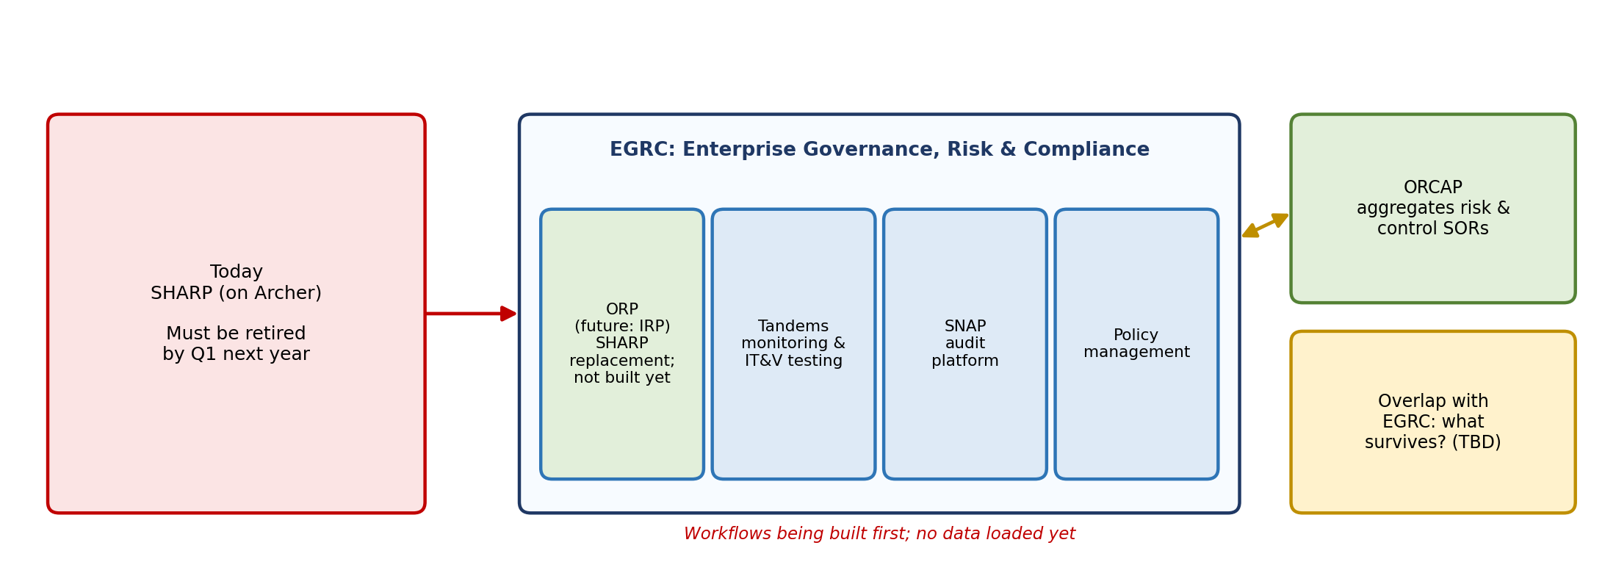
Figure 3. EGRC target architecture (from the EGRC Confluence page)
- The target architecture shows EGRC as four BAM applications: ORP (the SHARP replacement, which doesn't exist yet; its future name is IRP), Tandems (monitoring and IT&V testing), SNAP (audit), and policy management. Including audit and policy management means EGRC spans more than risk.
- The architecture came from the EGRC Confluence page, likely from Amber Schmidlin's team, and may be out of date. Jordan and Panos were involved but didn't know the page existed until the team showed them.
- They are building workflows first and haven't put data into EGRC. SHARP (and Archer) must be retired by Q1 next year.
- Open question raised by James: how can they test workflows without data, and how can they retire SHARP by Q1 without the data in place? No one knew.
- There is overlap between ORCAP and EGRC in target state; what survives and how they relate still has to be worked out.

6. The customer data problem
James asked where basic customer demographic data (name, address, date of birth, TIN, country of citizenship or incorporation) will live, since everyone needs it but it isn't really risk data.
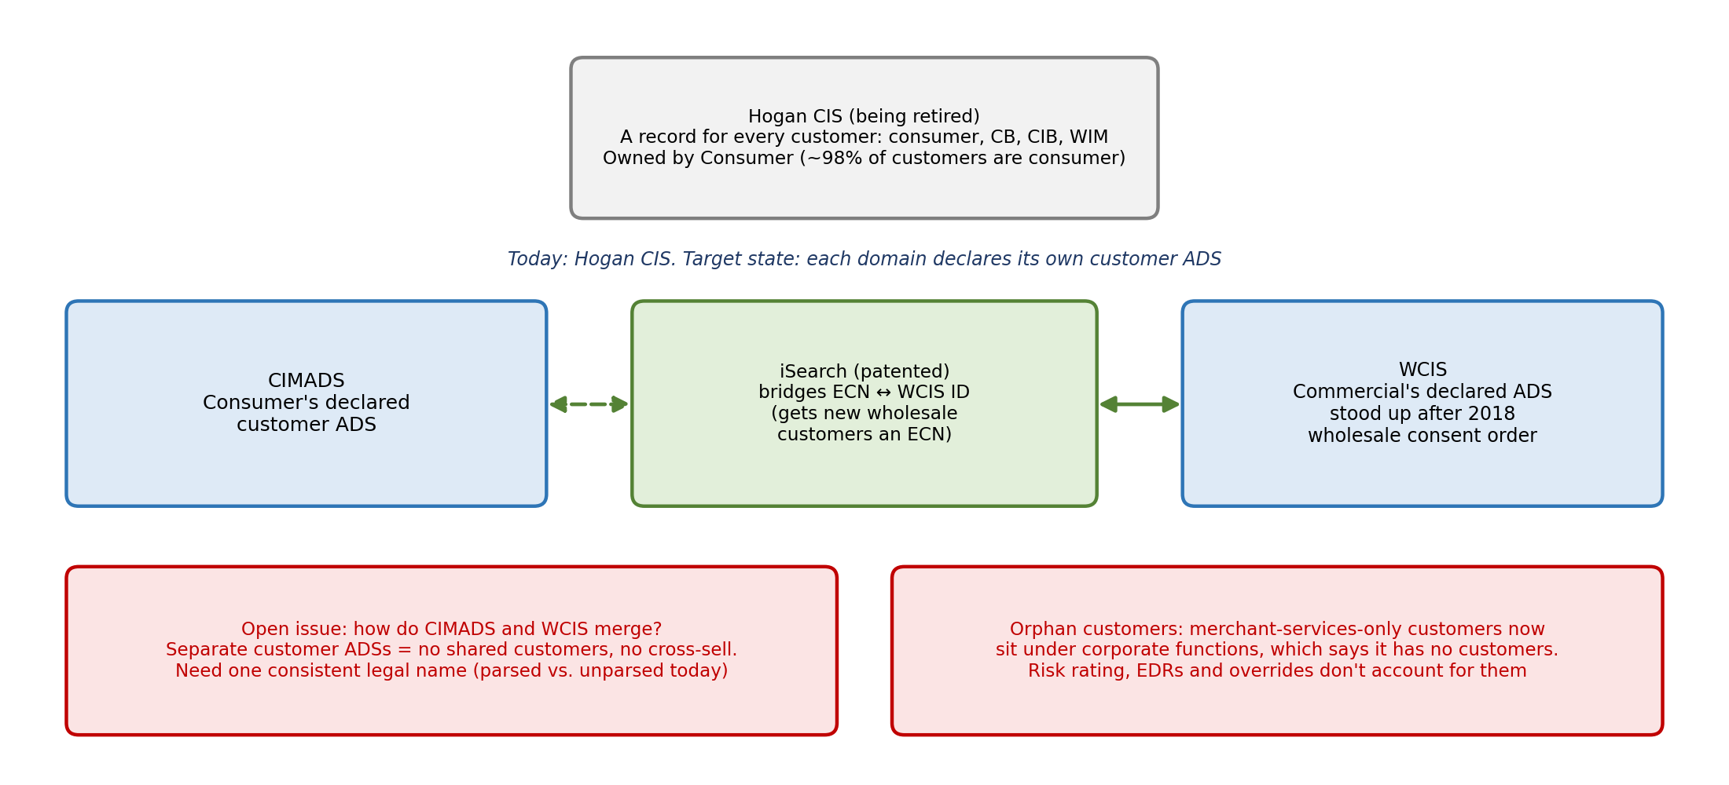
Figure 4. Customer data landscape and open issues
- Hogan CIS: holds a record for every customer (WIM, CB, CIB, and consumer), but it is owned by Consumer. About 98% of customers are consumer customers, but CIB tends to be the loudest voice. Hogan CIS is being retired (the COBOL skills problem goes away).
- WCIS: after the 2018 wholesale consent order, when the bank couldn't produce a list of wholesale customers, wholesale created its own customer system of record. This came after the Wells–Wachovia merger, where ECNs and RRNs had to be mapped together; RRNs (relationship reference numbers) behaved like WCIS IDs. Every WCIS customer has an ECN and a Hogan CIS record, but wholesale only began actively using ECNs last year.
- iSearch: a patented tool built by Vinay Purohit that bridges ECNs and WCIS IDs and issues ECNs to new wholesale customers.
- Declared ADSs: Consumer declared CIMADS and Commercial declared WCIS. How they interact and merge is unresolved.
- Deposits: almost all customers have a deposit product, which is largely a consumer product, but wholesale and WIM offer their own deposit products under different product codes.
- Consistency: every platform needs the customer's legal name, and it must be the same everywhere. Today some domains use parsed names and others don't. This is a source of the data defects the team works on.
- James's position: keeping account systems of record separate is fine (and global customers need their own), but separate customer ADSs mean the bank can't share customers or cross-sell, which contradicts how it is chartered.
Kevin said his team lacks the business expertise to push back on upstream domains about their declared ADSs and wants James involved. He will send the enterprise list of 76 ADSs (each line of business's declared target ADSs) so James can review it by domain and identify where to push back.

Domains and the corporate functions problem
- Domains are the big five lines of business (CIB, Commercial, WIM, CSBB, and Consumer Lending, now combined with CSBB), plus risk, finance, and corporate functions. The slide shown was older.
- Corporate functions is a catch-all for everything that isn't risk, finance, or a line of business. It is being broken up: there is now a CLO domain (Scott), HR has its own domain, and GPL, which moved into finance, may become its own domain. Employee and third-party data reasonably warrant separate domains.
- Merchant services now sits under corporate functions, whose leadership says (as recently as about a month ago) that it has no customers. But some merchant-services-only customers exist. Their financial crimes risk management has been farmed out to a team in COO, which already did this for affiliates and reinsurance companies.
- Customer risk rating models, event-driven reviews, and risk rating overrides don't account for this segregation. It surfaced during Article 7 when WCIS showed customers as corporate functions customers because AUs had been moved (with more moves planned).
- Possible fix: a qualifier where merchant services clients only count as customers if they settle through Wells Fargo (otherwise the bank is just a pass-through). James suggested working with Fikram on this.

7. The common risk data plane
This view came from a slide Jake built in about an hour after a meeting with Jacqueline. The team has used it several times and believes it is close to what she described.
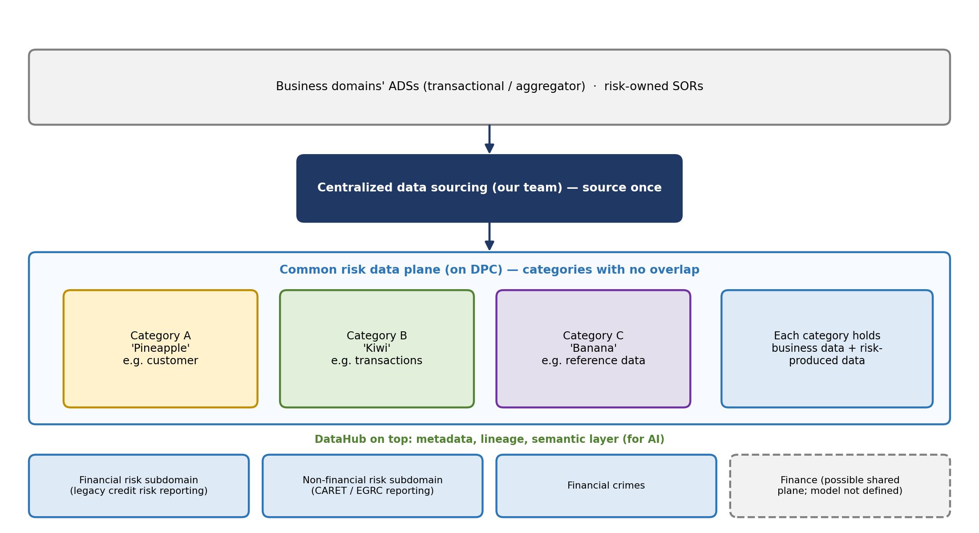
Figure 5. Common risk data plane concept
- Centralized sourcing: today each application's ABO or tech partner sources its own data, with known duplication and overlap (RDS has a common landing zone used by both FCTDS and BUSCRT for some data). In the vision, Kevin's team sources data centrally, once.
- Organized by data, not risk stripe: instead of a credit risk ADS and a financial crimes ADS, land all customer data, transactions, and reference data (product and subproduct codes, country codes) once so every risk consumer uses the same set.
- Categories: Jacqueline's placeholders are pineapple, kiwi, and banana (categories A, B, C). The team couldn't define the grain yet (for example, is transactions one category, or deposits and loans separately?), so categories will be defined after looking at the data. Guiding principle: no overlap between categories.
- Risk-produced data: each category holds both business data and data that risk produces and distributes back out.
- Finance: finance needs much of the same business data (daily P&L, 10-K, regulatory reporting), so the plane may eventually be shared with finance. The operating model isn't defined; for now, assume the risk data plane is standalone.

Worked example: customer risk rating
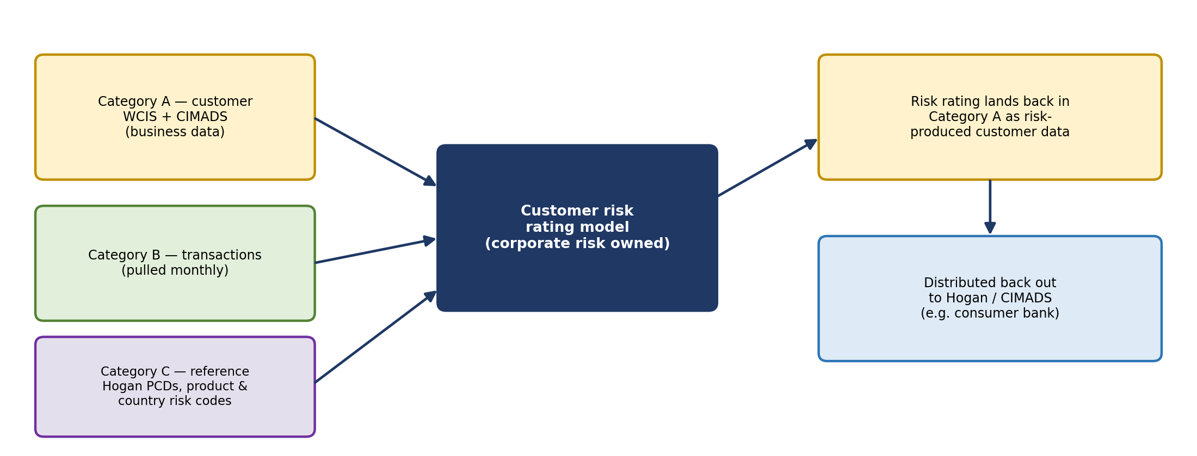
Figure 6. How the customer risk rating model would use the data plane
WCIS and CIMADS data land in category A. The corporate-risk-owned rating model runs, drawing transactions from category B monthly and reference data from category C (Hogan PCDs for product code translation and risk level, country risk). The resulting rating lands back in category A as risk-produced data and is distributed to systems such as Hogan or CIMADS. James agreed the model is a good illustration because it draws on many categories.

Fitting credit risk in
Kevin finds the model intuitive for financial crimes but harder for credit risk, which organizes by line of business: it lands, curates, and conforms commercial data to produce a commercial allowance number, and separately does the same for consumer. Kevin believes the split is mostly by SOR (IHUB is the commercial source), though some consumer loans sit on IHUB. James suggested the split may use the loan purpose code (commercial vs. consumer purpose), which is required for government reporting and affects rates. Example: a WIM customer buying a $15 million private jet gets a consumer-purpose loan on AFS, a commercial loan system, because no consumer system handles deals that large. The team will ask the credit risk team.

8. Migration to DPC
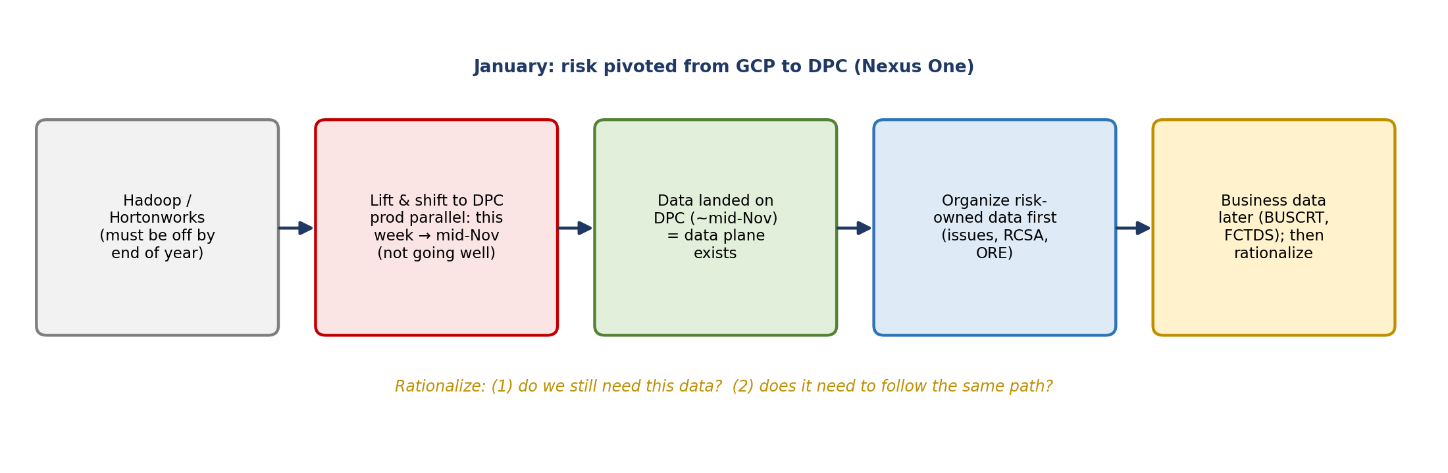
Figure 7. Migration and phasing toward the data plane
- Platform decision: risk was fully committed to GCP at the start of the year. In January, technology switched to DPC (data private cloud), provided by Nexus One. The group suspected cost savings and questioned whether the vendor will survive if integration proves hard.
- Ownership: DPC's technology lead, Eric, reports to Manav. He was the legacy finance technology lead, built CADS, and took over the risk and finance platform when ERAFT merged. Ryan Klein led the legacy RDS team; the DPC decision came after Eric took over.
- Deadline: the Hadoop Hortonworks platform must be retired by the end of this year.
- Status: a pure lift and shift with no redesign. Production parallel runs from later this week through mid-November before cutover. The BUSCRT and ORCAP teams are testing their migrations; Ryan attends as RDS framework product owner. It is "not going well."
- Data plane milestone: Kevin considers the data plane to exist once all data has moved from Hadoop to DPC, targeted for mid-November. Then the real work begins.
- Concerns: scalability (the bank never deletes data), and whether starting fresh would have been easier. James's analogy: moving a finished jigsaw puzzle to a new table, changing it into a puzzle with different shapes, and hoping it reassembles the same.

IHUB as an example of the scale
- About 1,400 raw IHUB tables are sourced into BUSCRT. Somewhere between the 70s and 104 commercial onboarding systems load account and transaction data through IHUB.
- Finance uses IHUB's curated data sets, but credit risk modeling and reporting source raw tables, effectively replicating IHUB's raw zone. Credit risk says it needs the data and IHUB has no plan to curate it, but no one has analyzed whether all 1,400 tables (or maybe 600) are needed.
- James questioned why IHUB is still an intermediary; it was stood up for wholesale for lack of alternatives, which doesn't make it the right architecture now. The IHUB team has lost many long-tenured people, making the work harder.

Rationalizing the data
Vic tied this to Jacqueline's direction: question legacy processes and data. James framed it as two questions: do you still need this data, and does it still need to follow the same path (can hops be removed with the new technology)? Vic added that common data should be pushed to the owning domains, such as CIB, rather than risk deriving it. James stressed that categorization and context matter: a great ADS is useless if consumers don't understand what's in it or how to pull it.

Phasing
- First, finish the migration and land the data on DPC.
- Then organize risk-owned data first (issues management, RCSA, ORE), which Kevin feels he can categorize relatively easily.
- Business data will take longer: BUSCRT is copying over its existing commercial and consumer categories, and FCTDS hasn't sourced all its data yet (much still lives in FCDS). It needs to be organized to serve risk reporting, financial crimes, and models.

9. The team's future role
Jacqueline has said Kevin's team will become the central corporate risk data strategy and management team that owns the data plane: getting data onto it, metadata and lineage, tools, and controls.
Area | Today | Future (per Jacqueline)
Governance | Doing it | Continues
Defect management | Administering the process: getting defects into EDQDM and managing them through it | Actually fixing defects: running DQ rules, analysis, root cause
Data sourcing | Federated to each application's ABO/tech partner | Centralized in Kevin's team
Metadata and lineage | — | Owned by the team, via DataHub on DPC
Plane tools and controls | — | Owned by the team
Using the data | — | Not the team: financial risk subdomain (legacy credit risk reporting), non-financial risk subdomain (legacy CARET / EGRC), and financial crimes

- DataHub: ERAFT says DataHub will be built on top of DPC for metadata, lineage, documentation, and the semantic layer important for AI. Ryan confirmed it's a third-party tool not yet used in risk, and James noted it isn't in BAM.
- CDO tooling: CDO is pushing enterprise tools such as Qualytics; risk chose to go its own way with DPC. (Michael would know more.)

10. Decisions and agreements
- Treat the data plane as a concept until the DPC migration completes; it exists once data lands (target mid-November).
- For now, plan the risk data plane as standalone; the risk–finance overlap is a later conversation.
- Start organizing with risk-owned data, then move to business data.
- Bring James into conversations with upstream domains about their declared ADSs, especially customer data.

11. Action items
Action | Owner | Notes
Send the deck to James and Matt | Kevin / Jake | Requested at close
Send the enterprise list of 76 ADSs (Excel) | Kevin | Each line of business's declared target ADSs
Review the 76 ADSs by domain to find overlaps and where to push back | James | Focus on customer data (CIMADS vs. WCIS)
Follow up offline on recurring meetings James and Matt should join | James and Kevin | Kevin to get them included
Ask the credit risk team how commercial vs. consumer data is split | Kevin's team | SOR-based or loan purpose code?
Help educate Jacqueline on the BAM application construct | Kevin (with James/Matt) | Bridge the data plane and ADS views
Define a qualifier for corporate functions / merchant services customers | James, with Fikram | Settlement-based customer definition
Work out ORCAP vs. EGRC overlap in target state | TBD | What survives
Share a status update on the derived ADSs | Kevin's team | Offered during the meeting

12. Open questions and risks
- Will the DPC migration hit mid-November? It is reportedly not going well, and Hortonworks must be retired by year-end.
- Will DPC and Nexus One scale to the bank's data volumes, and will the vendor survive?
- How will EGRC test workflows and retire SHARP by Q1 without data?
- Who owns enterprise customer data, and how will CIMADS and WCIS reconcile?
- How should the corporate functions customers be risk rated?
- Can CARET really be retired by mid-next year after five years of shift-left?
- Does credit risk need all ~1,400 raw IHUB tables?
- How will categories be defined so they don't overlap and serve credit risk, financial crimes, and models?
- How will risk and finance share the plane, and under what operating model?

13. Other notes
- Kevin has been at the bank about five years; the CARET shift-left was underway when he joined.
- The group joked about vendors being chosen through personal connections rather than industry standing.
- James offered to keep having these conversations; the team said they're happy to meet whenever.

