Meeting Notes
What Data Do Risk's ADSs Distribute? (CDO Inventory Request)
Item | Detail
Meeting date | Monday, October 19, 2026, 2:30 PM
Format | Working call; Ryan's RDS spreadsheet and EMH reviewed on screen
CDO side | Sasi (set up the call; collecting ADS distribution data from every domain)
Risk side | Kevin, Mike, Jake; Ryan joined near the end
Purpose | CDO wants to know what data each of risk's five ADSs distributes today, at whatever level the domain tracks it, to design a simpler way to track ADS progress next year

Note on the transcript
Auto-generated transcript. Speakers aren't labeled; attributions come from context. Confirmed: Sasi (transcribed "Stassi"/"Asi"), Mars, and conformed (transcribed "confirmed"/"conformance"). Readings used: BUSCRT (transcribed "BuzzCard"/"bus card"), FCTDS (transcribed "SCTDS"), CORS ("Crisp / Cores"), EMH, and CR360. Unsure: "WIM" (the other domain Sasi cited), "reprovisioning back to car" (BUSCRT data going back to which system), "Shreyser", "Mark Every System", and "WorkApp" (heard while EMH was on screen).

1. Summary
Sasi is going to every domain to find out what data their ADSs distribute today: all of it, not only tier 1 and tier 2, at whatever level the domain tracks it. Domains describe this differently, and ADMF doesn't capture it. CDO wants a middle-ground template so that next year ADS progress can be tracked at the subject area or logical data set level, since certification is defined in terms of logical data sets. This is only collection and analysis for now, with no reporting.
Agreed approach for risk's five ADSs:
- Definition: "distributed" means any downstream consumption (application, report, or model), and anything the ADS is responsible for provisioning even if no one uses it yet.
- ORCAP, BUSCRT, FCTDS: Ryan's spreadsheet was shared on the call. For ORCAP, count the conformed zone only (about 25,000 rows), because conformed tables feed the curated views. For BUSCRT and FCTDS, count curated schemas only (about 2,600 and 205). Both are still being built and distribute little.
- Mars and CORS: Kevin doesn't have access, so Mike will try to pull their conformed tables from EMH. EMH doesn't tag tables by zone, so this may take more than a day or two.
- Format: Excel is fine. Subject-area mapping at a high level comes later.

2. Why CDO is asking
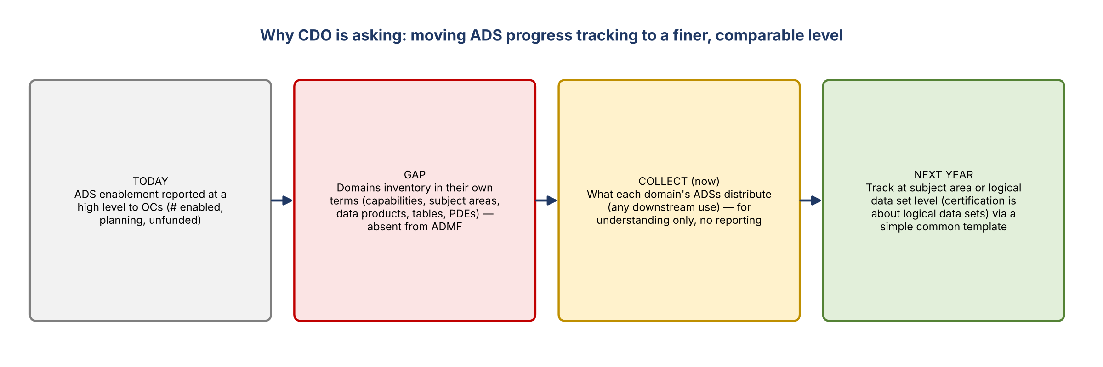
Figure 1. The problem CDO is trying to solve
- Domains describe what they distribute in different terms: high-level capabilities, subject areas, data products, tables, PDEs. They also track it in their own inventories, not in ADMF.
- For example, WIM can give subject areas, data products, the tables or curated views they provision, and PDEs, both as counts and names. Commercial gave the same kind of answer today.
- Today ADS enablement is reported to OCs at a very high level: how many ADSs are enabled, planned, or not funded. Not every domain is as mature as risk, which already talks in subject areas.
- Next year CDO wants to move to the subject area or logical data set level. Certification is all about logical data sets, which have nothing to do with use cases or tiers.
- The goal is to see where domains roughly line up on these constructs and find a template they can fill in easily next year instead of a big manual exercise. Sasi isn't after individual rows.
- Kevin asked what it's for: only collecting for now. Nothing goes into official reporting; if that changes, Sasi will show the team first.

3. What "distribution" means for risk
- Sasi said ADSs still in development (e.g. CR360) are fine to include.
- Risk is different because the other domains are lines of business. Risk is mostly a net consumer of data.
- ORCAP's subject areas today are the same ones it will provision as a strategic ADS.
- BUSCRT and FCTDS provision data for one or two specific use cases. They're derived ADSs, so their data goes straight to reports rather than to other applications.
- Sasi's clarification: distribution includes data in scope to distribute even if no one uses it yet. It covers both data sent to other applications and data available for reporting, i.e. any downstream use: application, report, model, or anything else.
- Kevin: that's almost everything in our conformed layer, so we'll give you everything there. Sasi: if that's what's ready for distribution and what you're responsible for, that's what she needs.
- Correction: it's not just ready to distribute, it's already distributed today. Sasi: even better.
- Mapping tables to subject areas is possible at a high level. To be done later.
- For domains without built ADSs, e.g. consumer lending (in progress) or deposits (doesn't exist yet), CDO is still working it out; they won't have much.

4. Risk's five ADSs
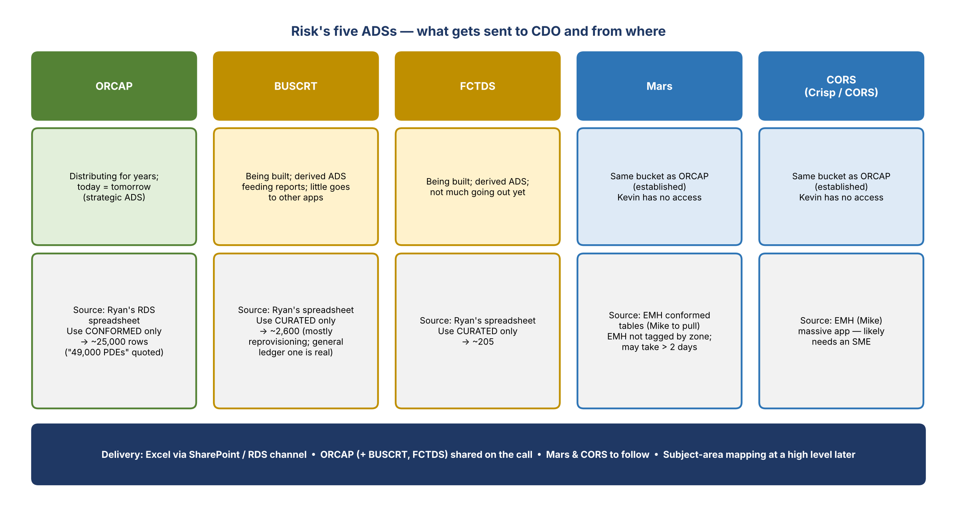
Figure 2. What risk is providing for each ADS
ADS | Status | What to provide / source
ORCAP | Distributing for years; what it distributes today is what it will distribute tomorrow | Ryan's spreadsheet; conformed zone only. The team said ORCAP distributes about 49,000 PDEs; the conformed filter gave about 25,000 rows.
BUSCRT | Being built; distributes little today | Ryan's spreadsheet; curated schemas only (~2,600). Most is reprovisioning, not going to another application. The general ledger feed is the one actually provisioned. Treat with caution.
FCTDS | Being built; little goes out today | Ryan's spreadsheet; curated schemas only (~205). Treat with caution.
Mars | Same bucket as ORCAP (established) | Mike to pull conformed tables from EMH. Kevin has no access.
CORS (Crisp / CORS) | Same bucket as ORCAP (established) | Mike to pull from EMH. It's a massive application, so one person likely can't answer and an SME will be needed.

- Kevin asked whether he could skip BUSCRT and FCTDS. In the end, both were included in the shared file with caveats.

5. Looking at EMH
- The team opened EMH on screen and searched for CORS ("Crisp / CORS") and Mars. Both have multiple systems or instances.
- EMH has the underlying tables and the reporting views, but it doesn't label tables as raw, conformed, or curated the way Ryan's RDS work does. The team would need to talk to someone to work out which are the distributed views.
- EMH isn't up to date for every ORCAP schema, so use Ryan's spreadsheet for ORCAP instead.
- Kevin suggested working with the use case team to know which views. Sasi doesn't need use cases (only what goes downstream) but would take them if available.

6. Avoiding double counting
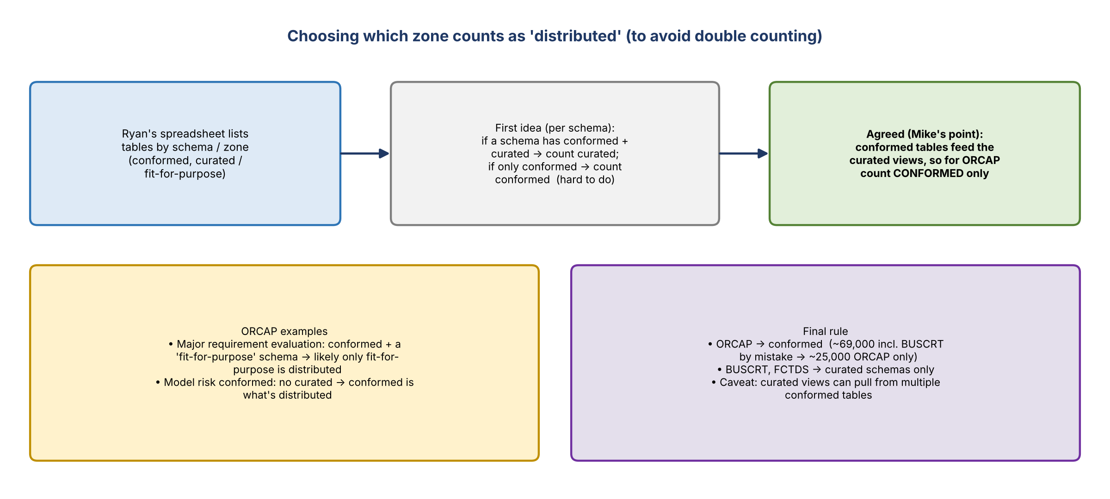
Figure 3. How the team settled on which zone to count
- Ryan's spreadsheet (which Sasi had already added the ADS to) lists tables by schema and zone.
- First idea: per schema, if there's both a conformed and a curated version, count the curated one, since that's probably what's distributed; if there's only conformed, count conformed. It's tricky to do schema by schema.
- ORCAP examples: Major requirement evaluation has a conformed schema and a matching "fit-for-purpose" schema; likely only fit-for-purpose is distributed. Model risk conformed has no curated version, so conformed is what's distributed.
- Caveat: a curated view can pull from several conformed tables.
- Agreed (Mike's point): conformed tables are usually what build the curated views, so to de-dupe ORCAP, count conformed only. It's rare that curated pulls from elsewhere. Sasi will apply the logic.
- Filtering ORCAP to conformed gave about 69,000 at first, but BUSCRT was still in the filter. Removing it gave about 25,000 for ORCAP.
- Final rule: ORCAP uses conformed; BUSCRT and FCTDS use curated schemas only. Posted in the chat.

7. Side discussion: requirements on every element
- The risk side joked about the 49,000 PDEs: next CDO will ask for a data source dictionary for all of them, mapping to higher-level constructs, and DQ checks on every one.
- Sasi: these discussions have sparked some thinking at CDO about whether every requirement needs to apply to every kind of element.

8. Ryan's spreadsheet
- Ryan joined as the problem was being solved. His file "saved us again".
- He built it after Sasi asked last week. He held off sharing until he knew what it was for, because he didn't want to put his name on it otherwise.
- Kevin called it the most perfect thing, "no offense to Ryan's work, but offense to how [the app] was set up".
- Sasi: if risk can't provide this, probably nobody can.

9. Decisions
# | Decision
1 | Distribution = any downstream consumption (app, report, model), including in-scope data not yet used
2 | ORCAP: use conformed zone only (de-dupe; conformed feeds curated); about 25,000 rows
3 | BUSCRT and FCTDS: use curated schemas only; caveat that both are still being built
4 | Mars and CORS: pull from EMH (Mike); will take longer
5 | Excel is the format; no official reporting; subject-area mapping later at a high level

10. Action items
Action | Owner | Notes
Apply the de-dupe logic to Ryan's file (ORCAP conformed; BUSCRT and FCTDS curated) and start analysis | Sasi | Has enough to get started
Send the ORCAP Excel (and BUSCRT / FCTDS) via SharePoint / RDS channel | Kevin / Mike | Today; link already shared on the call
Pull conformed tables for Mars and CORS from EMH; find SMEs who know which are distributed | Mike (with Kevin) | May take more than a day or two
Map distributed tables to subject areas at a high level | Risk team | Later
Share anything before it goes into official reporting | Sasi | Not planned

11. Open questions
- Which Mars and CORS tables and views are actually distributed downstream, given that EMH doesn't tag zones?
- Will CDO standardize on subject areas or logical data sets for 2027 ADS tracking?
- How will tracking work for ADSs still being built (BUSCRT, FCTDS)?
- Will CDO relax requirements (data source dictionary, DQ checks) for some kinds of elements?

