Meeting Notes
Semantic Certification for Risk: Architecture, DataHub Structure & Open Questions
Item | Detail
Meeting date | Monday, October 19, 2026
Format | Follow-up call. Jay shared screenshots of finance's DataHub, then the host walked through the live DataHub UI.
Host / risk tech side | Nitin (host; leads semantic certification for risk), Jay Soni (AIDM team; helping on risk), Jieman (architecture questions)
Semantic certification build team | Yashica, Nirav
Business side | Nathan, Michael / Mike, Kevin; Terry referenced
Referenced | Anand (for the architecture follow-up), the finance and treasury implementations
Purpose | Pick up open questions from the last semantic certification call, confirm the team's understanding of how it will work for risk, and settle the high-level architecture before going into detail

Note on the transcript
Auto-generated transcript; speakers aren't labeled, so attributions come from context. Confirmed: Jieman (transcribed "Jitman"/"Jamin"/"Jin Min"/"Jim"/"Jimin") and Yashica (transcribed "Yashika"/"Ashika"/"Jessica"/"Yasu"/"Yashiga"). Name readings: "Nitin" (also transcribed "Sydney"), "ERAFT" (transcribed "ERAP"/"eRAFT"), "FR 2052a" (transcribed "2052A"). DataHub was also transcribed "Data Home"/"Theta Hub". Unsure: "Nathan" vs. Nitin in a few places, "FDMO / FTMO Touchstone", "ADMF card operation" (a domain shown in DataHub), and "CAD" ("treasury and finance for CAD").

1. Summary
Jay showed how finance's pilot looks in DataHub. Finance migrated a small data set, commercial instruments, with 245 columns, and glossary terms are tagged to columns. Stewards and owners manage terms through a portal, with SQL Server as a temporary store.
The group then worked through the architecture:
- DataHub is the golden source for physical metadata, logical metadata, glossary terms, descriptions, and the mappings between them.
- SQL Server holds only in-progress certification work plus the workflow history (who did what, when). Items are archived once certified, so at launch it's empty.
- Reporting ("show me every glossary term and physical element under this domain") is handled by a research agent on top of DataHub.
- Domains in DataHub follow CDO's categorization: subject area group, subject area category, subject area. Shared risk and finance data gets its own domain.
Jieman challenged the design and argued SQL Server should be the store of record and reporting layer. Yashica said DataHub stays the golden source and offered a deeper session with Anand. Certification won't start from scratch: definitions are agreed before launch and marked certified, and the workflow then handles recertification on four triggers. Kevin posted the ORCAP pilot data set in the chat.

2. Introductions and framing
- The host recapped: last call ended on semantic certification and how it'll be done. This call picks up the follow-up questions, plays back the team's understanding, and asks new questions. Corrections welcome.
- Jay Soni works with the AIDM team, is helping on semantic certification for risk, and has some exposure to finance's implementation.

3. Finance's DataHub implementation (Jay)
- The DataHub home page lists domains. Under the finance domain, finance migrated a small data set called commercial instruments, from DPC.
- Every asset migrated from DPC is listed under its domain. Opening commercial instruments shows its columns: 245 so far.
- Columns with a glossary term show it, along with the owner, the domain, and when the term was tagged.
- Finance is building an "FDMO Touchstone" management portal where data stewards and owners can create, edit, modify, and delete glossary terms.
- A SQL Server sits in between as temporary storage before terms are written to DataHub.

4. Where risk data sets will sit
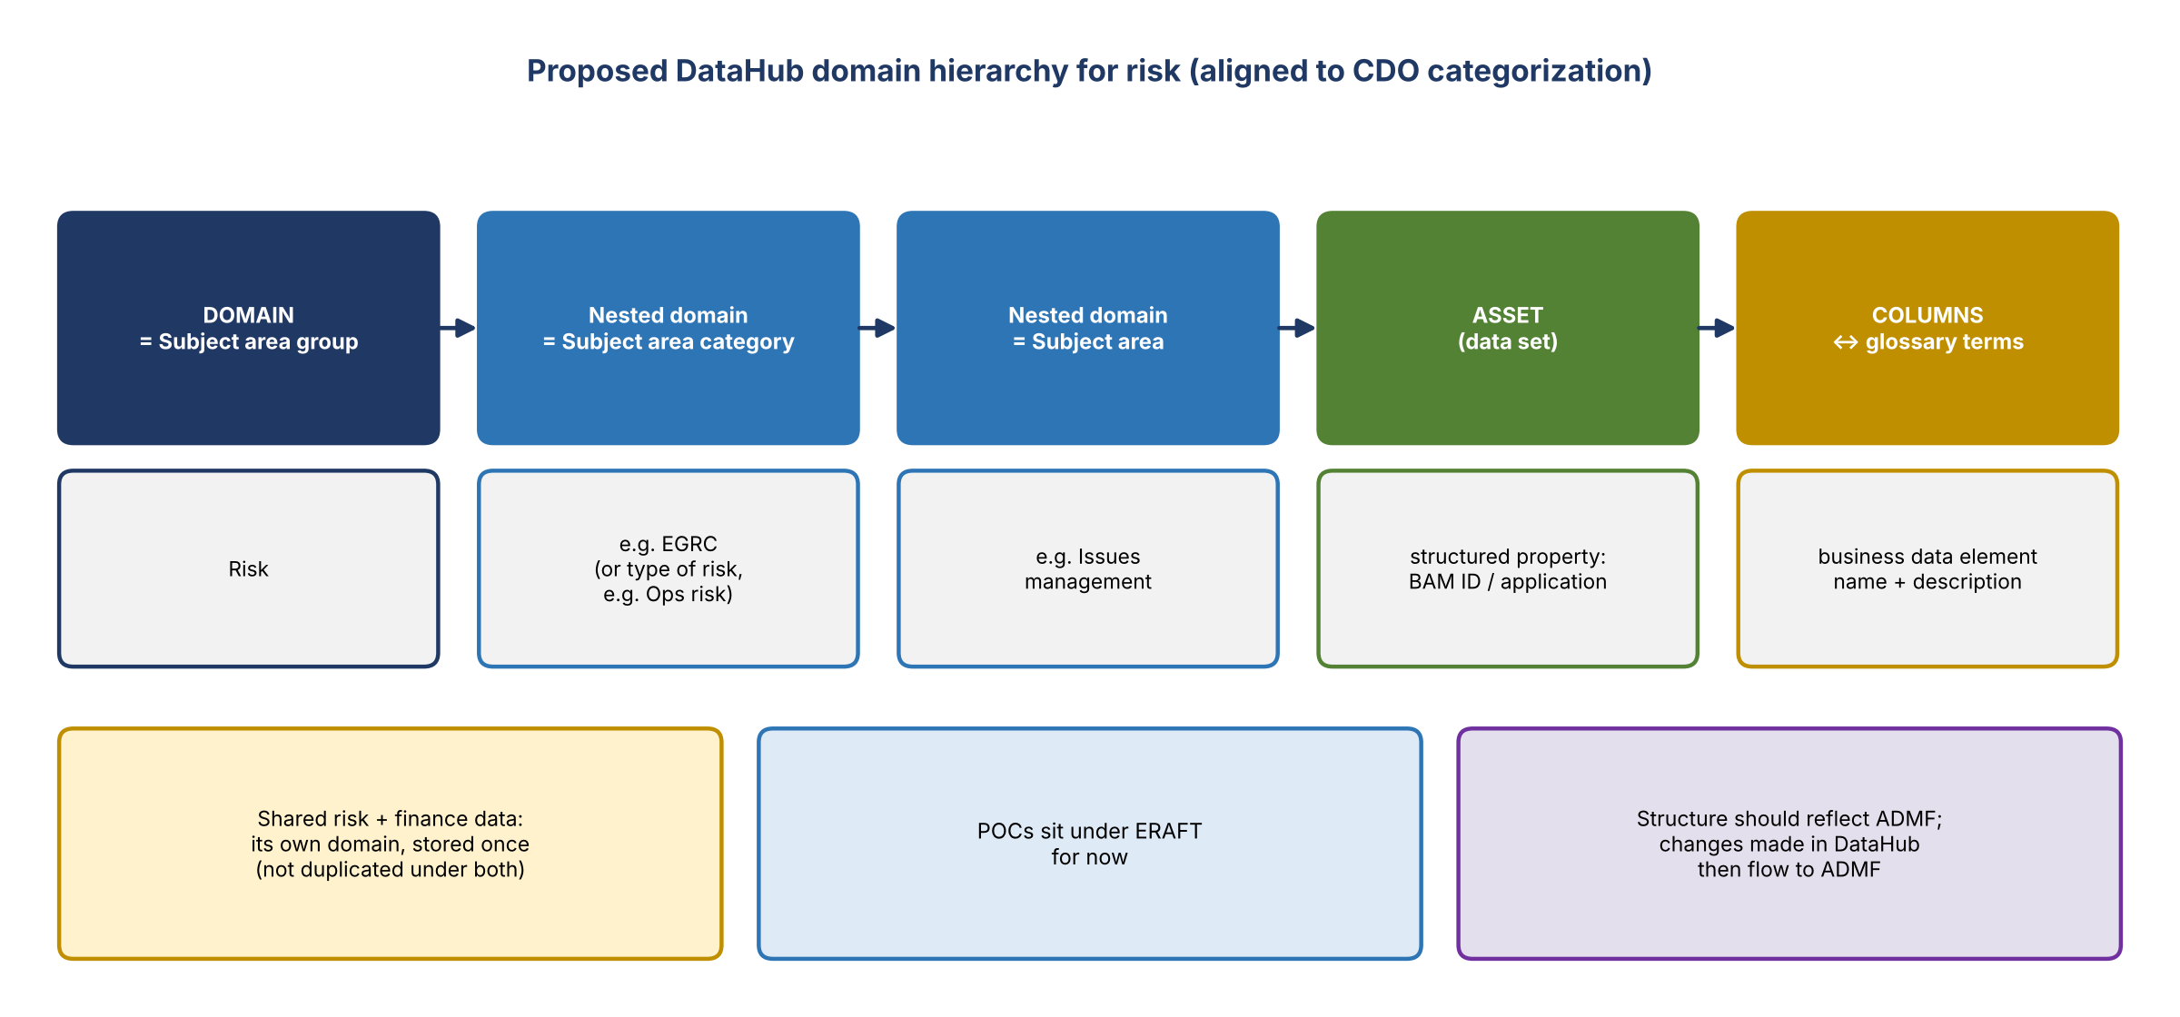
Figure 1. Proposed domain hierarchy and placement
- Host's understanding: risk applications will have several data sets in DPC, and those data sets will be brought into DataHub and shown there. Confirmed.
- Shared data (Nathan): risk and finance share some data. It should sit in a shared domain and exist in DataHub once, not twice.
- Current placement: POCs sit under ERAFT for now. Target: under risk, then type of risk (e.g. Ops risk), then the application or asset. Each asset carries the BAM ID as a custom structured property.
- Hierarchy (Mike): align with CDO's categorization: subject area group, then subject area category, then subject area. That's a domain plus two nested domains. Example: Risk, then EGRC, then issues management.
- Risk-owned data sits under risk. Shared data shouldn't sit under either risk or finance; it gets its own place.
- Source of the structure: it should reflect ADMF. But changes are meant to be made in DataHub and flow to ADMF, so ADMF effectively stores them afterward. Jieman confirmed his understanding.
- The team needs business confirmation on whether the structure comes from ADMF or is defined as data comes in. Financial risk and financial crimes would sit under a risk line item, not separately next to corporate finance.

5. Architecture: where the mapping lives
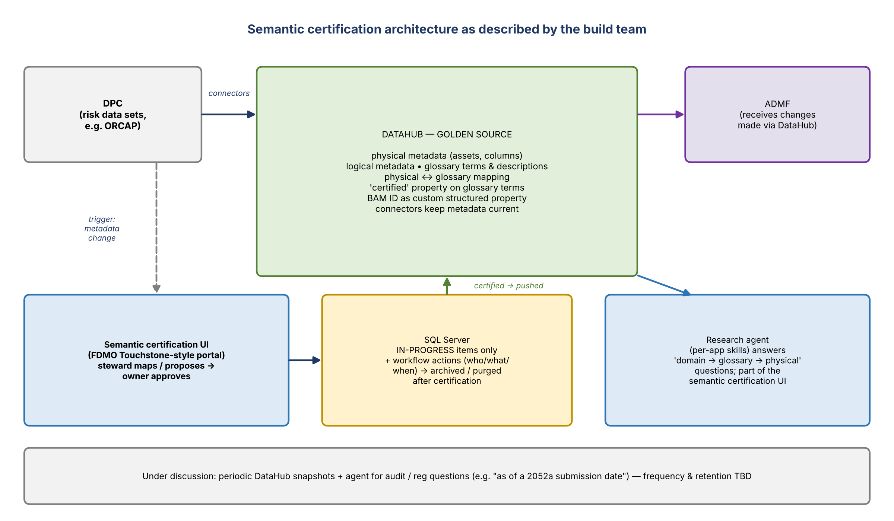
Figure 2. Architecture as described by Nirav and Yashica

Jieman's framing
- The core of semantic certification is mapping business glossary terms to physical data elements in DataHub.
- Big decisions first: (1) a workflow is needed (people map in an interface, it goes through approval, and approval finalizes the mapping); (2) where should the mapping data live: DataHub, ADMF (where glossaries come from), or a separate semantic certification platform?

Answers (Nirav and Yashica)
- Mapping lives in DataHub. Every physical element carries its glossary terms there.
- Workflows are being drafted: what the data owner and data steward do, and which scenarios trigger events. They'll be presented for input.
- Certification metadata goes in their own SQL Server, because DataHub can't store it. That covers who did what and when in the workflow, and the history for audit.
- Lifecycle (Yashica): when physical metadata changes (e.g. a new column), the steward maps it to a glossary term, possibly proposing a new term or description, and the data owner approves. While in progress it's not a certified truth, so it's held in SQL Server. Once certified, it's sent to DataHub.
- SQL Server holds only in-progress recertification details; after certification items go to archive. At ORCAP launch, DataHub starts with physical metadata, logical metadata, and glossary terms already tagged certified, and SQL Server is empty.
- Jieman: so SQL Server is a temporary working playground, and the complete mapping lives in DataHub. Understood.

Why not certify directly in DataHub?
- The host asked why the DataHub view, which allows adding and editing, can't be used to certify directly.
- DataHub can show that something is certified, via a "certified" property on the glossary term. But it can't hold an in-progress version alongside the certified one, or route a review from steward to owner. Hence the separate SQL Server for the interim process.

6. Glossary vs. domains
- Glossary = business terms: business data element names and descriptions aligned to columns. It's how business metadata is stored in DataHub.
- Every data set brought in should show its columns and their terms in the glossary.
- Why have domains separately? It's just how DataHub splits them. Conceptually, domain is the top level, subdomain the second, and the glossary holds the business terms in each subdomain. Domains also work as a filter.
- Navigation was shown with "ADMF card operation", which appears both as a domain and in the glossary, so it acts as the filter.
- From an asset, the columns view shows the mapped glossary term, tabs for lineage and glossary terms, and the term's definition when you scroll right or hover. This connects physical data, metadata, and glossary descriptions in one view.
- Host: from now on start from the glossary rather than domains, though both routes work.

7. Reporting for business users
- Jieman's question: a business user like Kevin wants to pick a domain and see every subdomain, every glossary term, and every application, data set, and physical element mapped to it. How is that pulled from DataHub?
- Answer: a research agent on top of DataHub, released as part of semantic certification. A skill is being built for each app so the agent can answer questions about a particular app or element.
- Jieman's reading, confirmed: the reporting layer is the agent. Ask it a question and it answers, inside the semantic certification UI.
- Mike: in the target state most users won't use the DataHub UI itself, but the UI being built. Yashica: both will be enabled.

8. Jieman's challenge: SQL Server as the true store
Jieman's proposal | Yashica's response
Make SQL Server the true store: all mappings, workflows and history, and the whole glossary by domain and subdomain. Certify and report there, and flow certified data into DataHub as the operational layer. | DataHub has strong capabilities for connecting domains and storing everything, plus connectors that keep metadata current. That's why it's the golden source; outside components only fill gaps.
Analogy: banks don't report off operational systems. They extract to a data mart or analytic store. DataHub is great operationally but not best suited to slice-and-dice semantic reporting by domain. | DataHub is current-state metadata management. For compliance, audit, and regulatory needs, the plan is periodic DataHub snapshots with an agent on top, e.g. "for the 2052a submitted as of Oct 1, how was total inflows calculated?" Snapshot frequency and retention are still being discussed.
 | Keep dependence on external stores low, since moving data out of DataHub adds latency. This has been discussed thoroughly. Offered a session with Anand and others to go through Jieman's questions.

9. Does every attribute need certifying?
- Host's question: if a data set has 100 attributes and upstream already provides good definitions for about 75, do we only certify the other 25, or all 100?
- Yashica: before launch, the team does the homework. Using existing ADMF definitions or industry standards, it works with business partners to agree a list of definitions from a consumption point of view, and tags those certified in DataHub.
- After that, only the four trigger points (technical release or metadata update) start the workflow. That's recertification, not starting from scratch.
- This is how they've approached treasury and finance so far. If risk wants a different approach, e.g. a best guess that then goes through semantic certification review, that can be discussed.

10. Decisions and confirmations
# | Decision / confirmation
1 | DataHub is the golden source for physical-to-glossary mappings, glossary terms, and descriptions
2 | SQL Server holds only in-progress certification items and workflow history; items are archived after certification; empty at launch
3 | Certified status is shown in DataHub through a "certified" property on glossary terms
4 | Domain hierarchy follows CDO: subject area group, subject area category, subject area; assets carry the BAM ID as a structured property
5 | Shared risk and finance data is stored once, in its own domain
6 | Reporting and question answering go through the research agent (per-app skills) in the semantic certification UI; the DataHub UI stays available
7 | Pre-launch: agreed definitions are loaded as certified; the workflow handles recertification on four triggers
8 | Pilot uses the ORCAP data set Kevin posted in the chat

11. Action items
Action | Owner | Notes
Use the ORCAP pilot data set from Kevin's chat message and come back with questions | Nitin / Jay | Pilot for risk
Set up time with Nirav to review the approach being taken | Nitin / Jay
Present the drafted steward and owner workflows and trigger scenarios for input | Nirav / Yashica
Hold the architecture deep-dive (DataHub vs. SQL Server as store, reporting) with Anand | Yashica / Jieman | Offered on the call
Confirm the risk domain structure: from ADMF or defined at load; subject area group, category, subject area | Business (Mike / Kevin / Terry) | Including the shared risk and finance domain
Decide whether risk follows the pre-agreed-definitions approach or a different one | Business with Yashica | Treasury and finance used pre-agreed
Define snapshot frequency and retention for audit | Build team | Still being discussed

12. Open questions
- Does the risk domain structure come from ADMF, or is it defined in DataHub and pushed to ADMF?
- How exactly will shared risk and finance data be organized and owned?
- Can the research agent meet business reporting needs, or is an analytical store still needed (Jieman's concern)?
- Snapshot frequency and retention for audit and regulatory questions.
- Pre-agreed certified definitions vs. reviewing everything through the workflow for risk.

