Meeting Notes
Y14 Schedule D: Risk Model Outputs Confirmation (Risk BDL)
Item | Detail
Meeting date | Monday, October 19, 2026, 2:30 PM (about a 30-minute call)
Format | Call run by the Risk BDL (Business Data Leaders, data management and governance) with the model owners and data providers; meeting invite and Schedule D elements shown on screen
Risk BDL side | Kelly (facilitator) and Jake
Model / data side | Buna Padir (model owner for almost all the models), Raylene (owner of 14041), Michael Gonzalez (retail data providers for the Basel submission), Michael Teel (Michael's team; produces the data file)
Referenced | William Ren (model developer; not on the call), Bhupinder (co-owner of 14041), Brad Meyer (responsible for Y14), Andrea Cadillac (reports to Brad Meyer)
Purpose | (1) Model owners acknowledge that their models feed Y14 Schedule D. (2) Start identifying which model outputs feed which Schedule D elements, for the use case documentation the data management policy requires.

Note on the transcript
Auto-generated transcript that starts as Kelly introduces the BDL team. Speakers aren't labeled; attributions come from context. Confirmed: Kelly (facilitator; addressed as "Ken"), Bhupinder (transcribed "Vupinder"), William Ren (transcribed "William Wren"), Brad Meyer, Michael Teel (transcribed "Mike Teal"), Basel Share, CCS calculation, and SME (transcribed "schmieze"). Readings used: FFIEC 101 (transcribed "FFIC 101") and NDM (transcribed "NDM"/"MDM"). Unsure: Buna Padir, Raylene, Andrea Cadillac, the "zone calculation" on the Axiom path, and model numbers 14041 and 14437 (14437 was used as a made-up example).

1. Summary
The finance domain owns the Y14 use case. It told the risk domain that a specific set of risk models feeds Y14 Schedule D, and listed the Schedule D data elements they feed. The Risk BDL ran this call to get the model owners' acknowledgment and to start mapping outputs to elements.
Results:
- Acknowledgment: all the listed models feed Y14 Schedule D. They're unsecured-portfolio models (credit cards, personal lending, business card). Buna Padir owns almost all of them; Raylene owns the dual-purpose model 14041.
- What feeds Schedule D: Michael Gonzalez's team sends a monthly file with PD, LGD, and EAD straight from the model outputs. The files are mainly for FFIEC 101 (RWA / Basel capital) but are also used for Y14. Every listed model feeds every listed element.
- Open question: how the Y14 team actually pulls the data. It is believed to come from Basel Share via the legacy DCS path, not Axiom. The answer decides how the use case is documented.
- Next: the Risk BDL contacts Andrea Cadillac (Brad Meyer's Y14 team), then works with Michael and Michael Teel on an element-level map of model output fields to Schedule D elements.

2. Purpose and background
- Use cases have requirements under the data management policy. Y14 is owned by the finance domain.
- The finance domain told the risk domain that specific risk models feed Schedule D, and gave the Schedule D data elements those models feed.
- Two asks:
- Model owners confirm they know their models feed Y14 Schedule D, and agree.
- Identify exactly which model outputs feed which Schedule D elements.

3. Model ownership
Model(s) | Owner / role
Most of the listed models (unsecured portfolio: credit cards and similar) | Buna Padir, model owner
14041: dual-purpose model used for business card and personal lines / personal lending | Raylene, owner; co-owner with Bhupinder
Model development | William Ren, developer. Not on the call: he only works on development and doesn't know how the outputs are used
Model outputs and data file | Michael Gonzalez (retail data providers for the Basel submission) and Michael Teel, who produces the physical file

- Acknowledgment: confirmed. All the listed models feed Y14 Schedule D.

4. How the outputs reach Y14
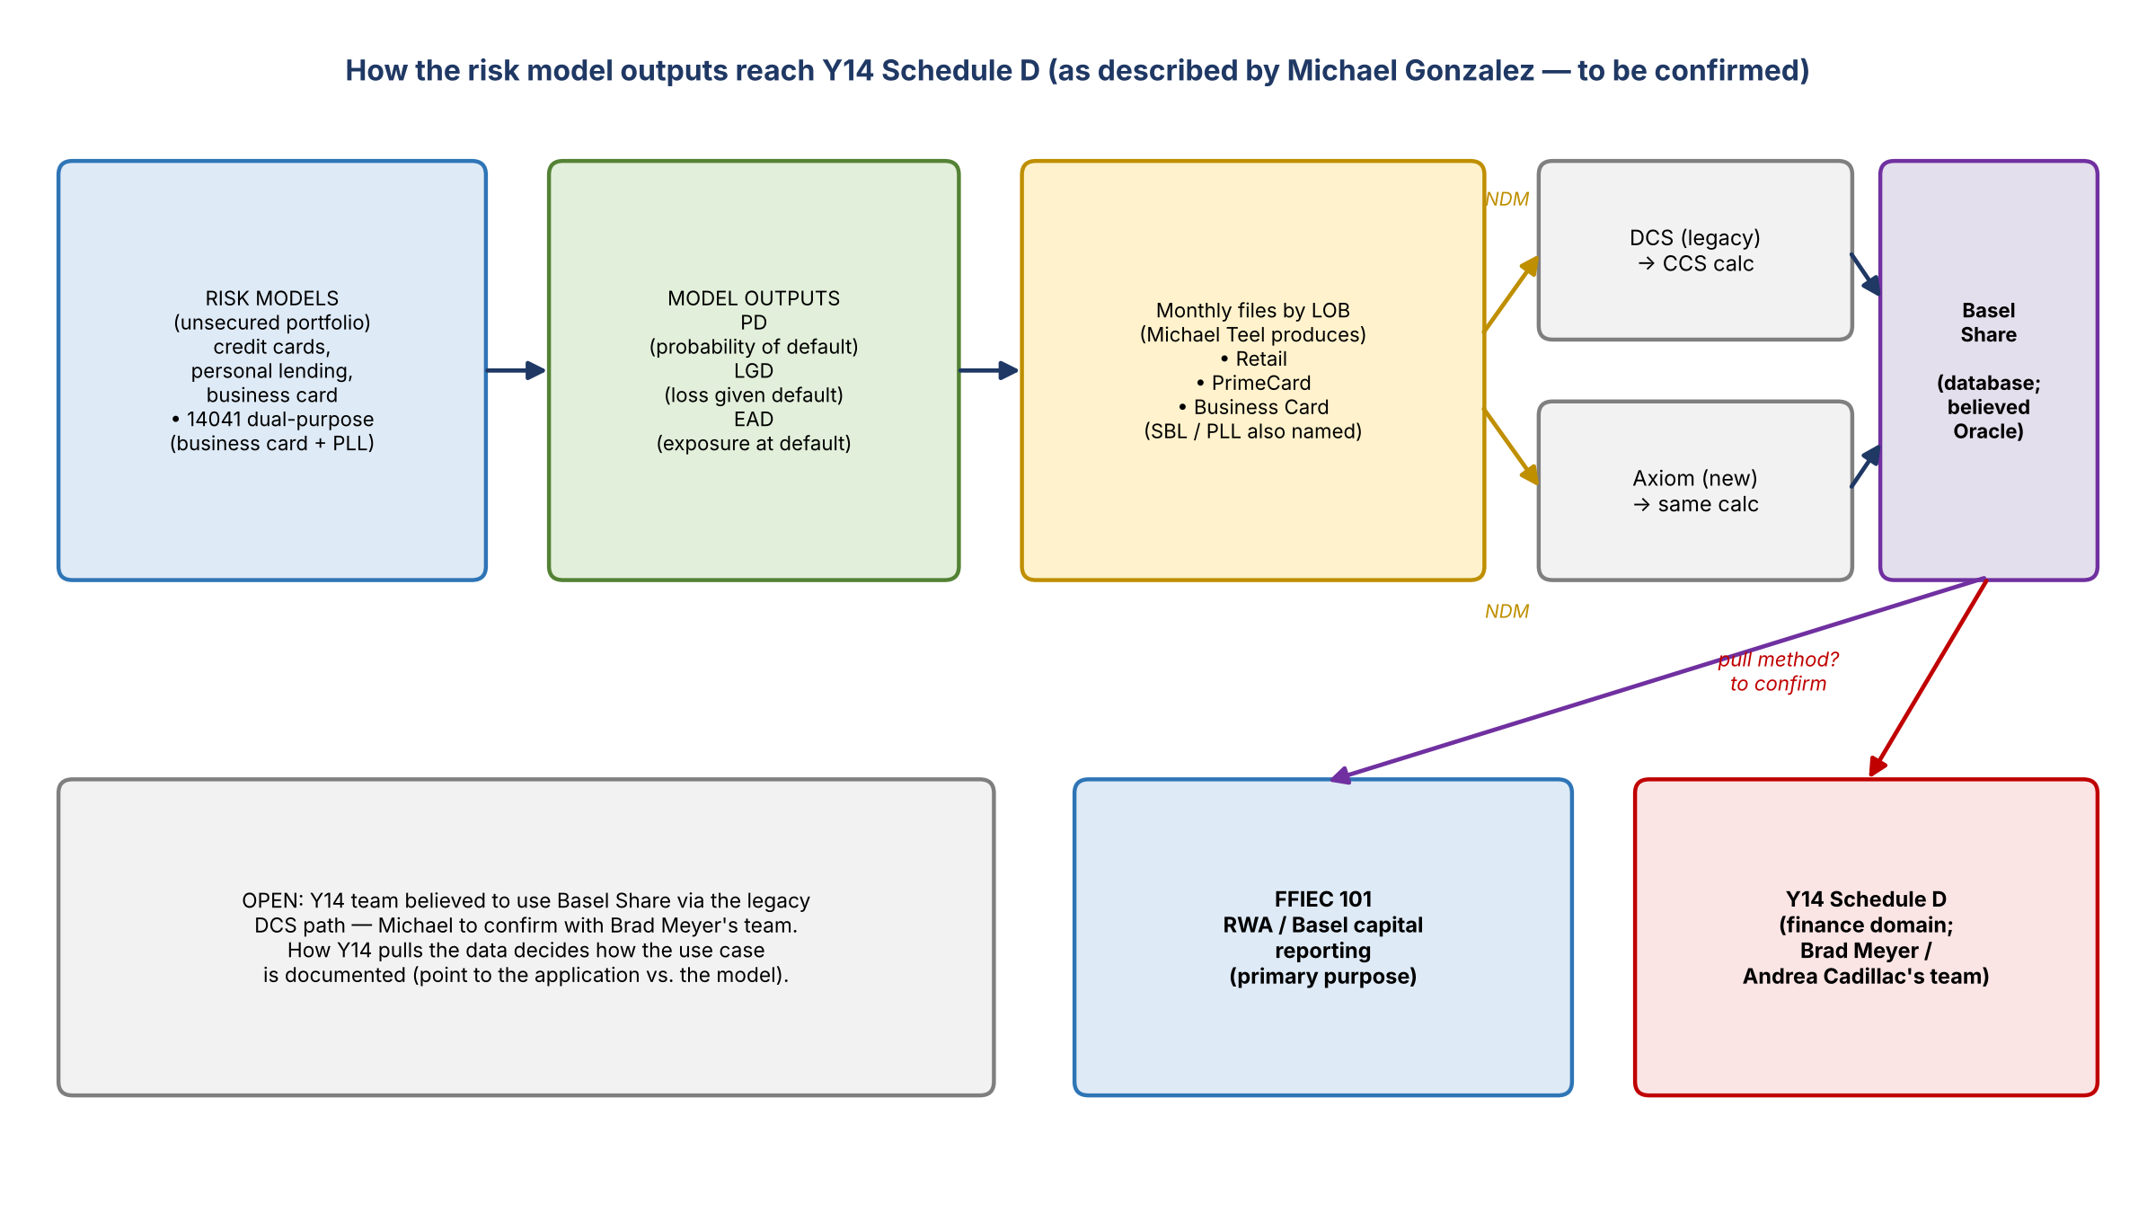
Figure 1. Data path as described on the call; the Y14 pull method is still to be confirmed

What is sent
- Michael Gonzalez's team provides retail data for the Basel submission. The original and primary purpose is FFIEC 101 reporting, i.e. all the RWA and Basel capital reporting.
- The same data is used in Y14, specifically PD (probability of default), LGD (loss given default), and EAD (exposure at default).
- The team sends the file every month, with those elements taken straight from the model outputs.
- Michael: all the listed models feed all the listed Schedule D elements. Kelly noted that on screen.

Files by line of business (Michael Teel)
- There isn't a separate file per model for every model, but there are for some.
- Files are split by LOB. Three of the models are retail, in one file. PrimeCard and Business Card ("SBL") are separate files. PLL was also named.
- The three LOBs confirmed on the call: Retail, PrimeCard, and Business Card.

Where the data lands
- The files are NDM'd. Legacy path: NDM to DCS, where the CCS calculation runs, landing in Basel Share. New path: NDM to Axiom, which does the same calculation itself (not through DCS), also landing in Basel Share.
- Basel Share is a database platform where data lands for consumption for different purposes. Michael believes it's Oracle.
- Michael believes the Y14 team uses Basel Share through the legacy DCS process, not Axiom. His team only knows where it places the file, not how Y14 retrieves it. He'll confirm with Brad Meyer's team.
- Michael noted they're in a transition to approved data sourcing on different systems and platforms, so he isn't sure how the Y14 team pulls the data today.

5. How this affects the documentation
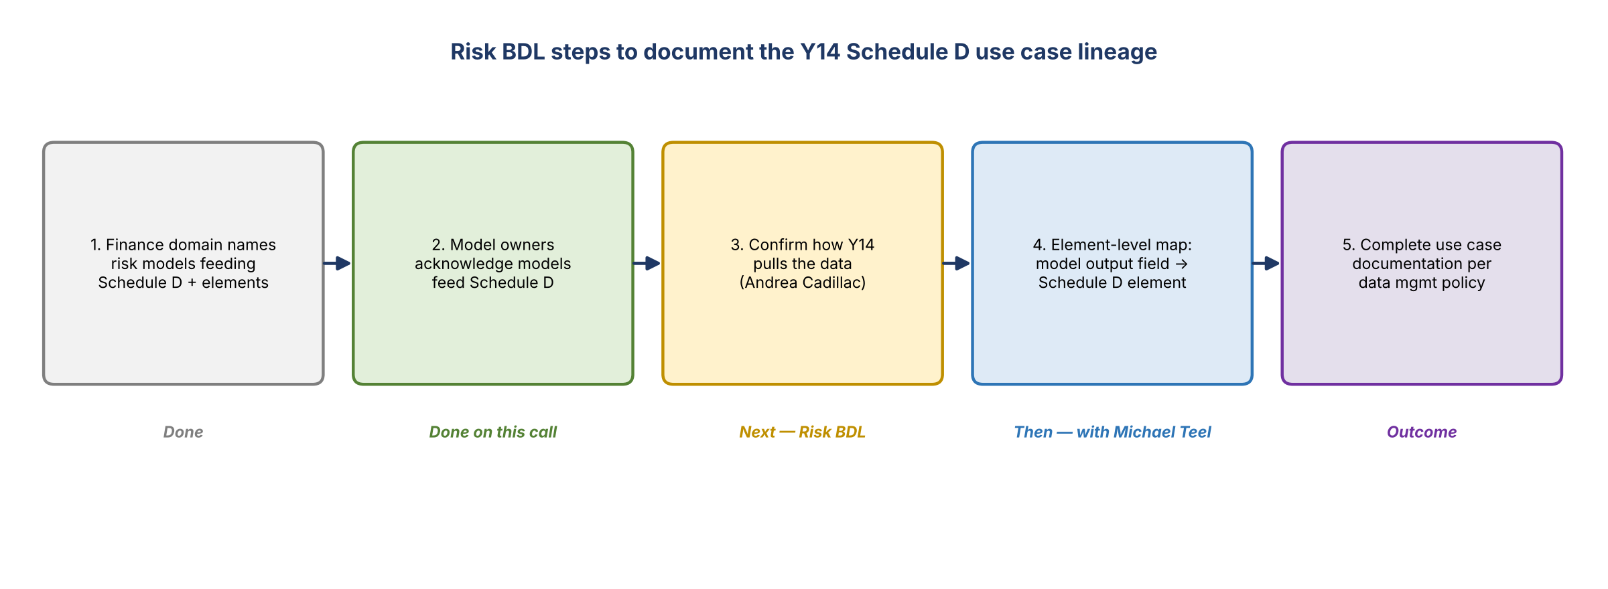
Figure 2. Steps to finish the Y14 Schedule D use case documentation
- How Y14 pulls the data decides how the models are documented as feeding the Y14 schedule.
- If the model outputs sit in an application, the documentation usually points to the application Y14 pulls from. That changes how the data elements are identified.
- The BDL needs element-level mapping: for each model, the output field name and which Schedule D element it feeds.
- Michael clarified this means the field names where PD, LGD, and EAD sit, and so on. Michael Teel's team has all of it.
- Two options were offered: (a) Michael's team shares the file and the BDL works out the elements per model, or (b) the developers or model SMEs provide the exact elements per model. The BDL is flexible.

Example Kelly gave (illustrative only)
Model | Output field | Schedule D element fed
14437 (made-up example) | "ABC" (e.g. PD field) | Matching Schedule D PD element
Each listed model | LGD field name | Schedule D LGD element
Each listed model | EAD field name | Schedule D EAD element

6. Decisions and confirmations
# | Decision / confirmation
1 | Model owners confirmed all the listed models feed Y14 Schedule D
2 | Every listed model feeds every listed Schedule D element (PD, LGD, EAD)
3 | Mapping will be done at the element level (model output field to Schedule D element)
4 | Next contact is the Y14 team (Andrea Cadillac, under Brad Meyer) to confirm how the data is pulled, before the element mapping

7. Action items
Action | Owner | Notes
Contact Andrea Cadillac to learn how Schedule D pulls the data (Basel Share, DCS, or Axiom) | Risk BDL (Kelly / Jake) | She'll route to whoever does the pull
Confirm with Brad Meyer's team where Y14 retrieves the file | Michael Gonzalez | Believed Basel Share via legacy DCS
Share the monthly file / layout so the BDL can identify elements per model | Michael Gonzalez / Michael Teel | Or have developers or SMEs list elements
Provide field names for PD, LGD, EAD, etc. per model | Michael Teel's team | For the element-level map
Build the element-level mapping and finish the use case documentation | Risk BDL | After the Y14 pull method is confirmed

8. Open questions
- Does the Y14 team pull from Basel Share via DCS (legacy) or Axiom, or somewhere else?
- Is Basel Share its own application (BAM ID) or a database inside another application? This affects which application the documentation points to.
- Does each LOB file (Retail, PrimeCard, Business Card) map cleanly to specific models, including the dual-purpose 14041?
- Which output field names hold PD, LGD, and EAD for each model?

