Meeting Notes
Data Plane Applications: BAM Certification, ABO Roles & Broad Data Access
Item | Detail
Meeting date | Friday, October 30, 2026 (recording started about 10:30 AM)
Format | Team working session; Jordan shared BAM and completed certifications live
Team | Kevin (lead), Mike (Michael), Jordan, Ryan, Sekar, Jared, Jake
Referenced | Terry (former ABO), Debbie (tech owner, to confirm), Gina, Miles and Utkarsh (monitoring and testing), Suresh, Jignesh, Frank, Jacqueline
Purpose | Complete the BAM certifications for ORCAP, RFDIR and DCF, reset application ownership after Terry, and discuss a request for broad data access

Note on the transcript
Auto-generated transcript; speakers aren't labeled, so attributions come from context. Readings used: RFDIR ("Rifter"), CARET ("Carrot"), Dremio ("Remio"), ORCAP ("ORCAPP"/"ORCAV"), BUSCRT, TSDS ("TDSD"), BSA/AML. A BAM question field naming the bank's employees is described here as "bank employees". Small talk (weekend plans, a team lunch) is left out. Confirmed: Sekar (transcribed "SACAR"/"stay car"/"Akar"). Unsure: Debbie, Utkarsh, Miles, Suresh, Jignesh, Frank, "Beacon", the service account names (TISRM_API, "RFDSTP"), "MUBA", "RFDS", and whether the certification is annual or semi-annual.

1. Summary
The team completed the pending BAM certifications for ORCAP, with Jordan finishing RFDIR offline; Mike had already done DCF. Ownership was reset after Terry's departure.
- Kevin's model: Mike is the ABO for all three data plane applications (ORCAP, RFDIR, DCF), with an alt ABO for each who effectively runs the application day to day: Jordan for ORCAP, Ryan for DCF, and eventually Sekar for RFDIR.
- Sekar couldn't be found in BAM, probably because he needs an AIMS role, so Jordan stays as RFDIR's alt ABO for now.
- How this squares with the enterprise ABO guidelines is for next week.
Jared raised giving AI teams broad Dremio access to everything in ORCAP and RFDIR. The entitlements exist. Kevin is fine with access for self-serve discovery, but not with AI running on a Dremio service account with no visibility. He'd rather have a UI over RDS, or DataHub. No decision was made. For the immediate request from Miles' team, Jared will mirror the new service account's access to what monitoring and testing already has.
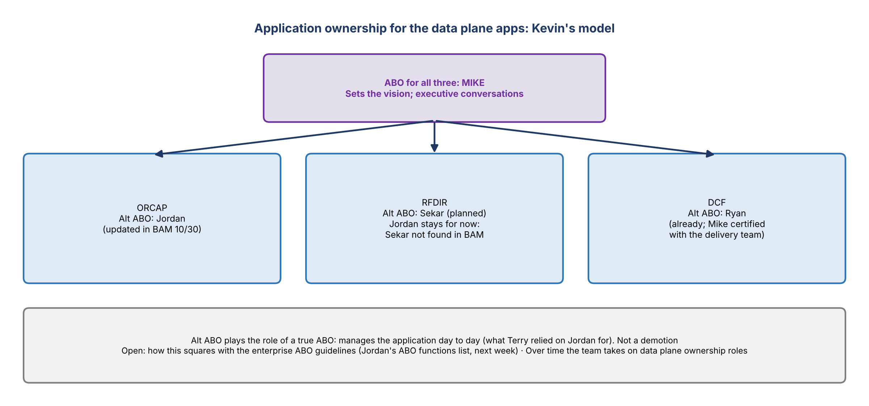
Figure 1. Application ownership for the data plane apps

2. BAM certification
- For ABOs it's small and simple; technology does most of the certification. Jordan had two certifications pending.
- Yellow dots on the left in BAM mark the sections that need certification; the down arrows show which. Use certification mode to certify. Anything can be edited in BAM at any time.
- BAM was slow ("as slow as ADMF"); refresh the screen if it hangs.
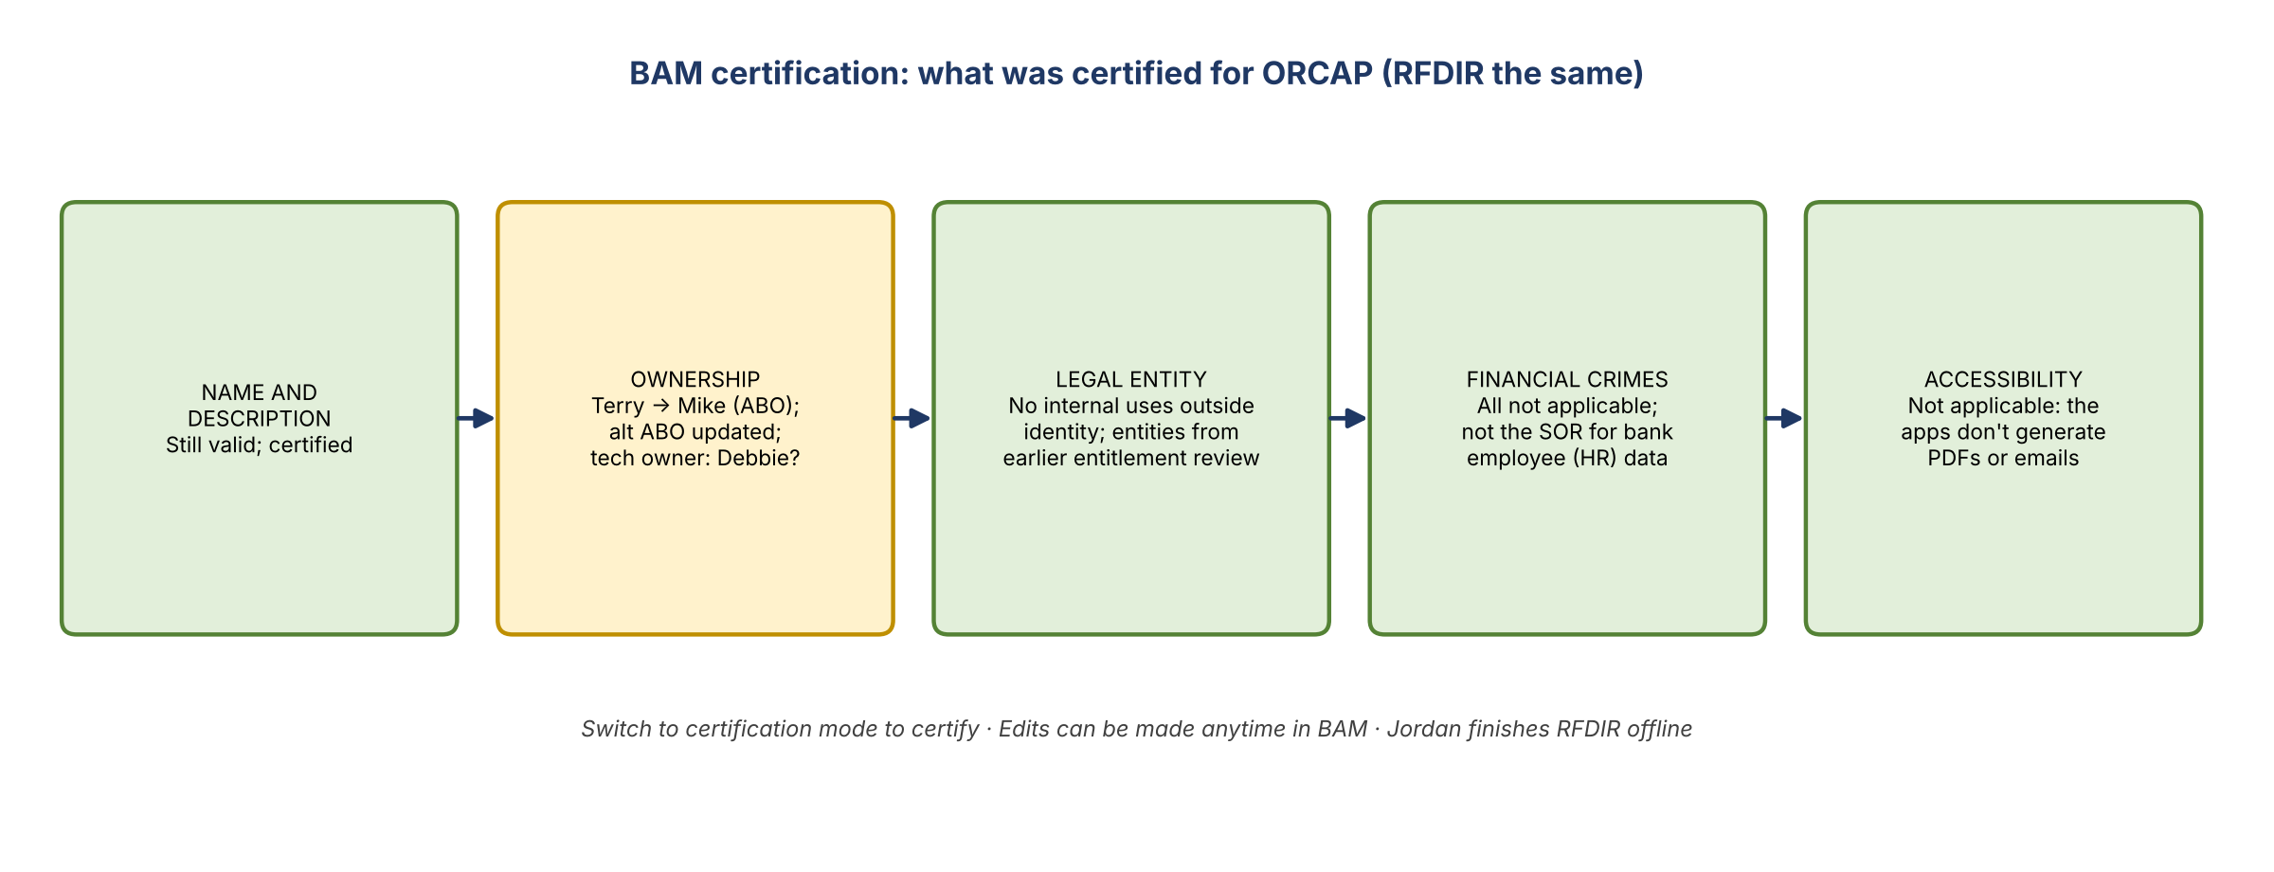
Figure 2. What was certified for ORCAP (RFDIR the same)

Name and description
- Already certified for ORCAP: the name and description are still valid.
- Renaming ORCAP: Kevin would like to rename it eventually. If CARET shifts left and runs in DPC, the combination of CARET and ORCAP may become something new, and whether CARET stays as the dashboards is open. Nobody knew whether renaming needs approval beyond updating BAM.
- Making the data plane a single application is still the longer-term plan, not near term.

Ownership
- Terry was still listed. Changed to Mike as ABO.
- ORCAP: Mike as ABO; Jordan stays alt ABO. Submitted.
- RFDIR: Mike as ABO. Kevin asked Sekar to be alt ABO ("Sure"), but Sekar's name didn't appear, likely because he needs an AIMS role for ABO or alt ABO. Jordan stays for now; Sekar needs to get up to speed on RFDIR first anyway.
- DCF: Mike already did the certification together with the delivery team.
- The technology manager ownership is submitted separately by technology. Confirm Debbie is the right person.

Risk and compliance sections
- Legal entity: internal uses not provisioned through identity: no. The legal entities using the application came from a review Terry and Jordan did with a group that went through all the entitlements. Certified; DCF says the same.
- Financial crimes: everything not applicable, including the unique identifier sources and the bank employee (HR) data question. The apps aren't the system of record. Gina had these questions added to BAM to flag applications that should be in BSA/AML lineage but aren't. Kevin briefly hesitated because ECRLT data sits in RFDIR, but agreed not applicable is right, and said RFDIR may not need to exist as an application at all eventually.
- Accessibility: not applicable. The question is whether the app generates digital content such as PDFs, emails or attachments.
- RFDIR's answers are the same as ORCAP's. Jordan will complete it offline. Kevin wanted to double-check the RFDIR financial crimes tagging; it matches.

3. ABO and alt ABO roles
- Kevin appreciated Jordan's ABO functions write-up, and set out his view.
- ABO (Mike, for RFDIR, ORCAP and DCF): sets the vision for the platform and drives executive conversations about what the application is and does, plus some day-to-day duties.
- Alt ABO: plays the role of a true ABO and manages the application. Jordan took on much of the work Terry relied on him for; Kevin wants to take that further. Not a demotion. Jordan, Sekar and Ryan share alt ABO duties across the three applications. Ryan is already DCF's alt ABO; Sekar has been an ABO or alt ABO before, but not in risk.
- Ryan's question: how does this square with the enterprise ABO guidelines? To be worked out from what Jordan sent.
- Over time the team will grow into ownership of the data plane. How roles and accountability work in practice matters more to Kevin than how ownership looks in BAM. It aligns with the three pillars, which Kevin will share with the team.
- Kevin: "you guys are my data plane team"; he'll be asking a lot of questions as he learns.

4. Broad data access for AI teams (Jared)
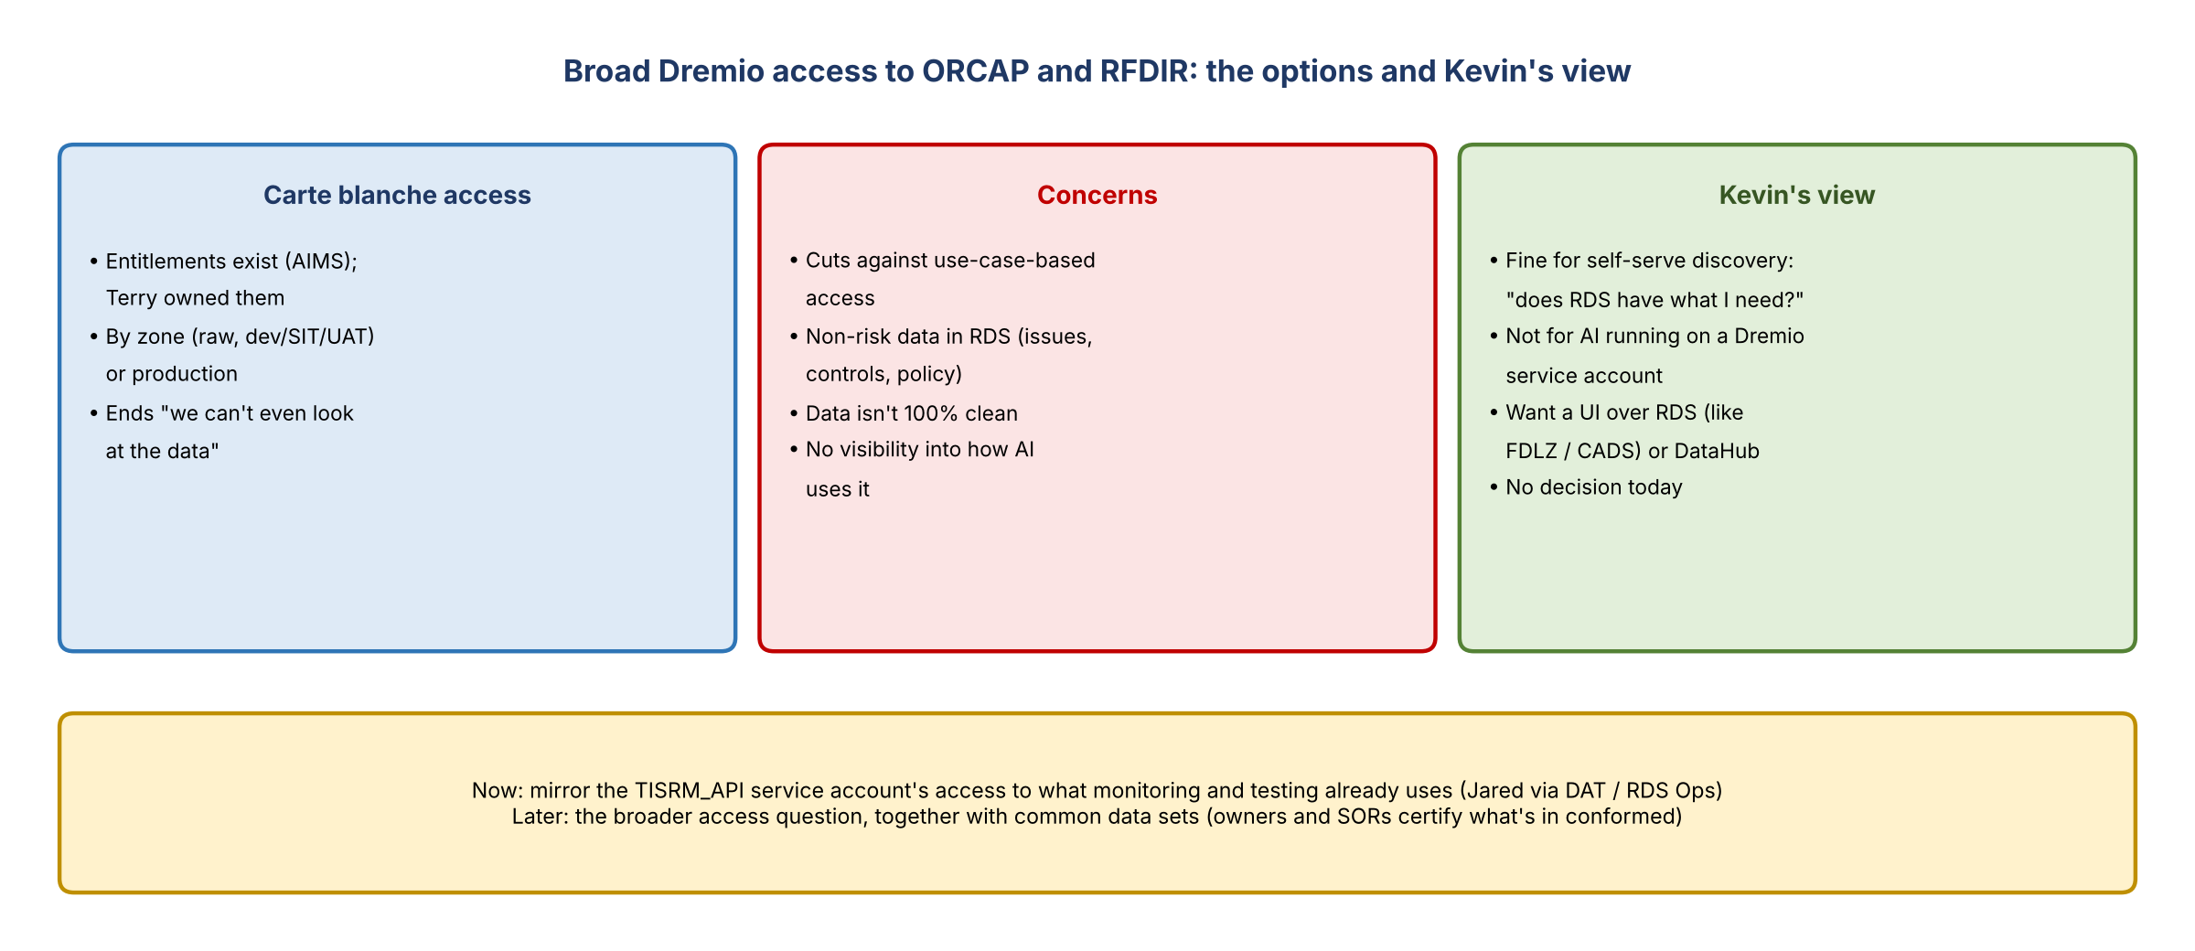
Figure 3. Broad Dremio access: the options and Kevin's view

The idea
- Give AI teams Dremio access across everything in ORCAP and RFDIR, so they can look under the covers. It could be by zone (raw, dev/SIT/UAT) or production. UAT data may be made up or real depending on the data set, so production is what's useful.
- It would end the finger-pointing that people "can't even look at the data" to work out what they need.
- The entitlements exist: AIMS entitlements for broad access to ORCAP and RFDIR. Terry owned them. No use cases have had it; some internal team members have it to query data across the platform.

Concerns
- It cuts against the principle of access by use case: what do you actually need to look at?
- Is it "risk for risk"? The line is blurry: RDS holds non-risk data too (control management, policy, issues). Kevin has long asked why the team still owns the issues ADS if issues management is no longer a second-line function. Three and a half years of that.
- It removes any eyes on who looks at what, and ORCAP and RFDIR aren't 100% clean.
- Mitigation ties to the common data sets work: data owners and SORs certify that what's in conformed is accurate, so the team isn't blamed for exposing the wrong data.

The current request (Miles' team)
- Monitoring and testing (Utkarsh, on one of Miles' teams) gave a new service account, TISRM_API, and asked for about a dozen data subjects, probably 20+ data sets, in ORCAP and RFDIR.
- Monitoring and testing already has Dremio or API access to these through other service accounts (e.g. Suresh worked with RDS Ops). Different people on the team ask for the same thing without knowing, then come back weeks later saying they asked a month ago.
- Jared's concern: not every requester on that team is strong.
- Next step: Jared asks DAT and RDS Ops to mirror TISRM_API's access to what monitoring and testing used before (possibly "RFDSTP"). No rush from their side.

Kevin's view
- Fine with access for investigation: can people self-serve to see whether RDS has what they need?
- Not fine with AI connecting to RDS carte blanche through a Dremio service account, with no visibility into how it's used.
- Better: a UI on top of RDS, like FDLZ and CADS have. DataHub's researcher would help with discovery, though it reads metadata, not the actual data. Broad access might be an interim solution until then.
- Not deciding today. Keep talking; it partly goes with the common data set discussion.
- Ryan: the table list he gave Kevin came from a Dremio query on the information schema, which needs access to the RDS database, not to each table. The catalogs are also mostly accurate.

5. Next steps
Action | Owner | Notes
Complete RFDIR's BAM certification | Jordan | Offline; same answers as ORCAP
Confirm the technology owner submission (Debbie?) | Jordan
Get Sekar an AIMS role so he can be RFDIR's alt ABO; transition him | Kevin / Sekar / Jordan
Mirror the TISRM_API service account's access | Jared | Via DAT and RDS Ops
Discuss alt ABO responsibilities against the enterprise guidelines | Kevin, team | Next week, using Jordan's list
Share the three pillars with the team | Kevin
Revisit broad access with the common data set discussion | Kevin, Jared
Cover the rest of Jordan's seven items | Team | Next week; none critical

6. Open questions
- Does renaming ORCAP need approval beyond BAM? What will ORCAP plus CARET be called?
- How do the alt ABO responsibilities fit the enterprise ABO guidelines?
- Should AI teams get broad Dremio access before a UI or DataHub exists?
- Should the team still own the issues ADS?

