Meeting Notes
Investment Planning Reframe: Platform Modernization and Data Governance Automation
Item | Detail
Meeting date | Monday, November 2, 2026 (ended when the team call started)
Format | Working session on the investment-planning slide; walked through the reframed deck and an older deck
Team | Jake, Mike, the session lead (who reworked the framing with Jacqueline from about 8 a.m.), and other team members
Referenced | Gwen (CAO executive, presenting), Derek (approver), Jacqueline, Kevin, Ryan, Yashica’s team, Kovalchuk (requested missed-feed detection)
Purpose | Decide what goes in the two boxes, Platform Modernization and Data Governance Automation, so Gwen can explain the headcount ask to Derek

Note on the transcript
Auto-generated transcript; speakers aren’t labeled, so attributions come from context, and the session lead isn’t named. System names are corrected: BUSCRT (transcribed “Buzzcart”), RFDIR (“Rifter”), ORCAP (“ORCAT”), AIDA (“Ada”/“IDA”), Yashica (“Yaksha”). Unsure: Kovalchuk (kept as heard), “Kevin’s does it” (unclear) and the headcount, which was stated as 65 and later as 55. The call ended mid-discussion when the team call started.

1. Summary
The investment-planning ask, discussed about two months ago but never properly reviewed, is back because Gwen has to present it to Derek. Technology owns the funding decision, but the team still has to explain the ask well enough for Derek to approve roughly $10M. The first draft was “Copilot garbage,” so the session lead and Jacqueline reframed the headcount as funding two initiatives: Platform Modernization (build the capabilities on the common data plane and make data AI ready) and Data Governance Automation (use those capabilities to run governance more efficiently and consistently).
Agreed:
- The headcount is framed “for the purposes of Derek”: what it achieves across the two initiatives, not how each person maps to a box.
- Financial Crimes line: “Support Financial Crimes commitments by enhancing data quality monitoring capabilities,” measured as 100% reduction in manual report creation.
- The “80% of data sources will have automated DQ monitoring” metric doesn’t work. It will be reframed as coverage of elements and feeds.
- Governance Automation also covers a governance reporting layer, automated DCF onboarding and an ADMF feedback-loop integration.
- Data contracts sit under “modernized data management tooling” (Platform). Don’t claim DSAs are being eliminated.
- Get words on the page now and wordsmith later; Copilot is fine for polish.
Still open: the headcount figure, the 60% migration estimate and its denominator, what the 50% AI-ready figure measures, and the DQ coverage baseline. The group will circle back after the team call.
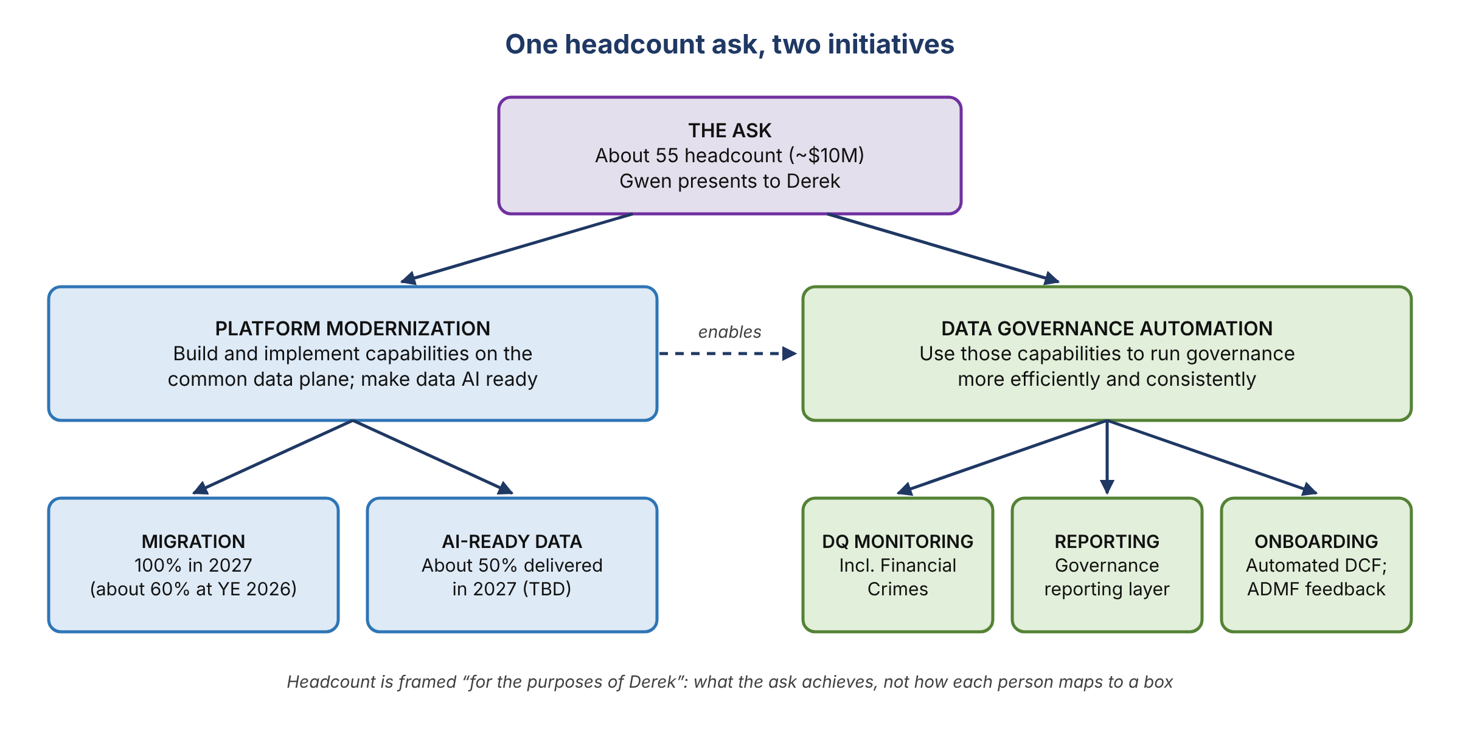
Figure 1. How the headcount ask maps to the two initiatives and their proposed outcomes

2. Why this came back
- Investment planning was discussed about two months ago and “never got reviewed correctly.” It resurfaced because Gwen has to present it to Derek.
- Someone objected that technology owns this and the team doesn’t decide any of it. The reply: the team still has to explain it to Derek so he’ll say “yes, give us $10 million.”
- The screenshot shared in the chat earlier was “a bunch of Copilot garbage.” The session lead and Jacqueline had been reframing it since about 8 a.m.
- The box contents need to combine everything the team is doing across both categories, including Mike’s roughly 20 headcount (some of them intake-tool people).
- Aside: asked how much time the AI tooling has saved, Jake said “a ridiculous amount.” The team built a deck from scratch that looked ready for senior executives in under 48 hours.

3. Platform Modernization
Definition: build and implement capabilities and solutions on the common data plane.

Scope
- The migration to DPC, getting set up with AIDA and DataHub, and the semantic layer.
- Derek won’t follow the technical detail, so the message is: we’ll have all the data we need, and we’ll make it AI ready, a term he understands.
- Automating business metadata (names and descriptions) through the data management tool, and the semantic certification process Yashica’s team is working on, are already covered here under “implement modernized data management tooling.”

Migration target: 60% at year end, 100% in 2027
- Proposed: 100% of the migration complete, with 60% done by the end of this year.
- Rationale: BUSCRT, FCTDS and ORCAP / RFDIR would make up about 60% of what needs to be on the common data plane, meaning everything in the DPC environment at year end. One participant first heard this as “ORCAP and RFDIR are 60%”; it was clarified.
- Challenge: “I thought the requirement was for RDS.” The session lead had raised the same point.
- Older deck: shows a separate data center migration exit, with 46 headcount in 2027 aligned to continuing exits. Whether those apps land on DPC is unclear, but that is what the 100% is meant to capture. Several teams still have DCMS migration work left.

Naming: DPC or common data plane
- DCF has already migrated but isn’t on DPC, so “migration to DPC” isn’t accurate for everything.
- DPC was used as a generic term because the team originally talked about “the data plane” or “a common data plane.” The working meaning is “they’re in the cloud, regardless of which cloud.” Better wording is welcome.

AI-ready data: about 50% in 2027
- In 2027, running an AI prompt over issues management data should have all the context it needs on the common data plane.
- The 50% was openly called a placeholder (“we’ll figure it out”).

4. Data Governance Automation
Definition: use these capabilities to execute governance activities more efficiently and consistently. Each item is written as what we’re solving for, plus its value. Leadership likes “from → to” statements.

Financial Crimes DQ commitments
- New wording: “Support Financial Crimes commitments by enhancing data quality monitoring capabilities.” If you don’t want to say DCF, say “data quality monitoring capabilities.”
- Someone else had added a percentage to this line, and the group thought it was hard to justify (“this one’s dumb”).
- The example that unlocked it: how long does the quarterly report take to produce? That gets automated.
- Kovalchuk asked for a way to spot when an expected feed doesn’t arrive. That capability is being built.
- Some human involvement remains, but getting the data and building the analysis will no longer be manual.
- Agreed metric: 100% reduction in manual report creation.

DQ monitoring coverage (the 80% metric)
- Existing line: “80% of data sources will have automated data quality monitoring.” Nobody remembered the denominator; the best guess was applications in RDS (RFDIR, ORCAP, BUSCRT and FCTDS, first counted as five, then four).
- Monitoring means expanding the number of applications DCF covers, since not everything has automated monitoring today.
- Enforcement: the recent org announcement puts the team in charge, but only for what’s on DPC. So the denominator became everything on DPC.
- Conclusion: “a nonsensical number.” The real measure is coverage: the share of elements and feeds that need monitoring and have it. There’s no baseline (“from when?”), so it’s parked for rework.
Application | Current state | Gap
RFDIR | Has monitoring | —
ORCAP | Has monitoring | Level 2 checks needed because of implications
FCTDS | Covered; everything has to go on DCF; data movement checks are on DCF | Level 2s: some exist for RDS, more being built
BUSCRT | Level 1s only; no Level 2 data-element checks onboarded | Level 2s needed
All | Target state not ready | Build Level 2s now and get them in for ADS certification

Intake tool and governance reporting
- The intake tool should show what data is actually in RDS. One view: build an intake tool that runs from intake all the way through data contract creation. The group noted the two boxes “blur together” here.
- Target state has no reporting capability for data governance: DataHub has no reporting layer. Today’s reporting is in Power BI off the intake tool and DCF.
- Split: the tooling itself is Platform; developing the reporting layer is Governance Automation.

Faster DCF onboarding
- “Faster onboarding” was listed as a value with nothing it was solving for. Now: reduce manual DCF onboarding effort through automation.
- It won’t be fully automated. The group liked onboarding triggered by a DataHub event in target state.

ADMF feedback loop
- Kevin likes Mike’s comment: automate the feedback loop with the central data governance team by building integrations with the Automated Data Management Framework (ADMF) tool.

5. Data contracts
Raised because nothing in the Governance box mentioned data contracts. The group placed them under “implement modernized data management tooling” in Platform.
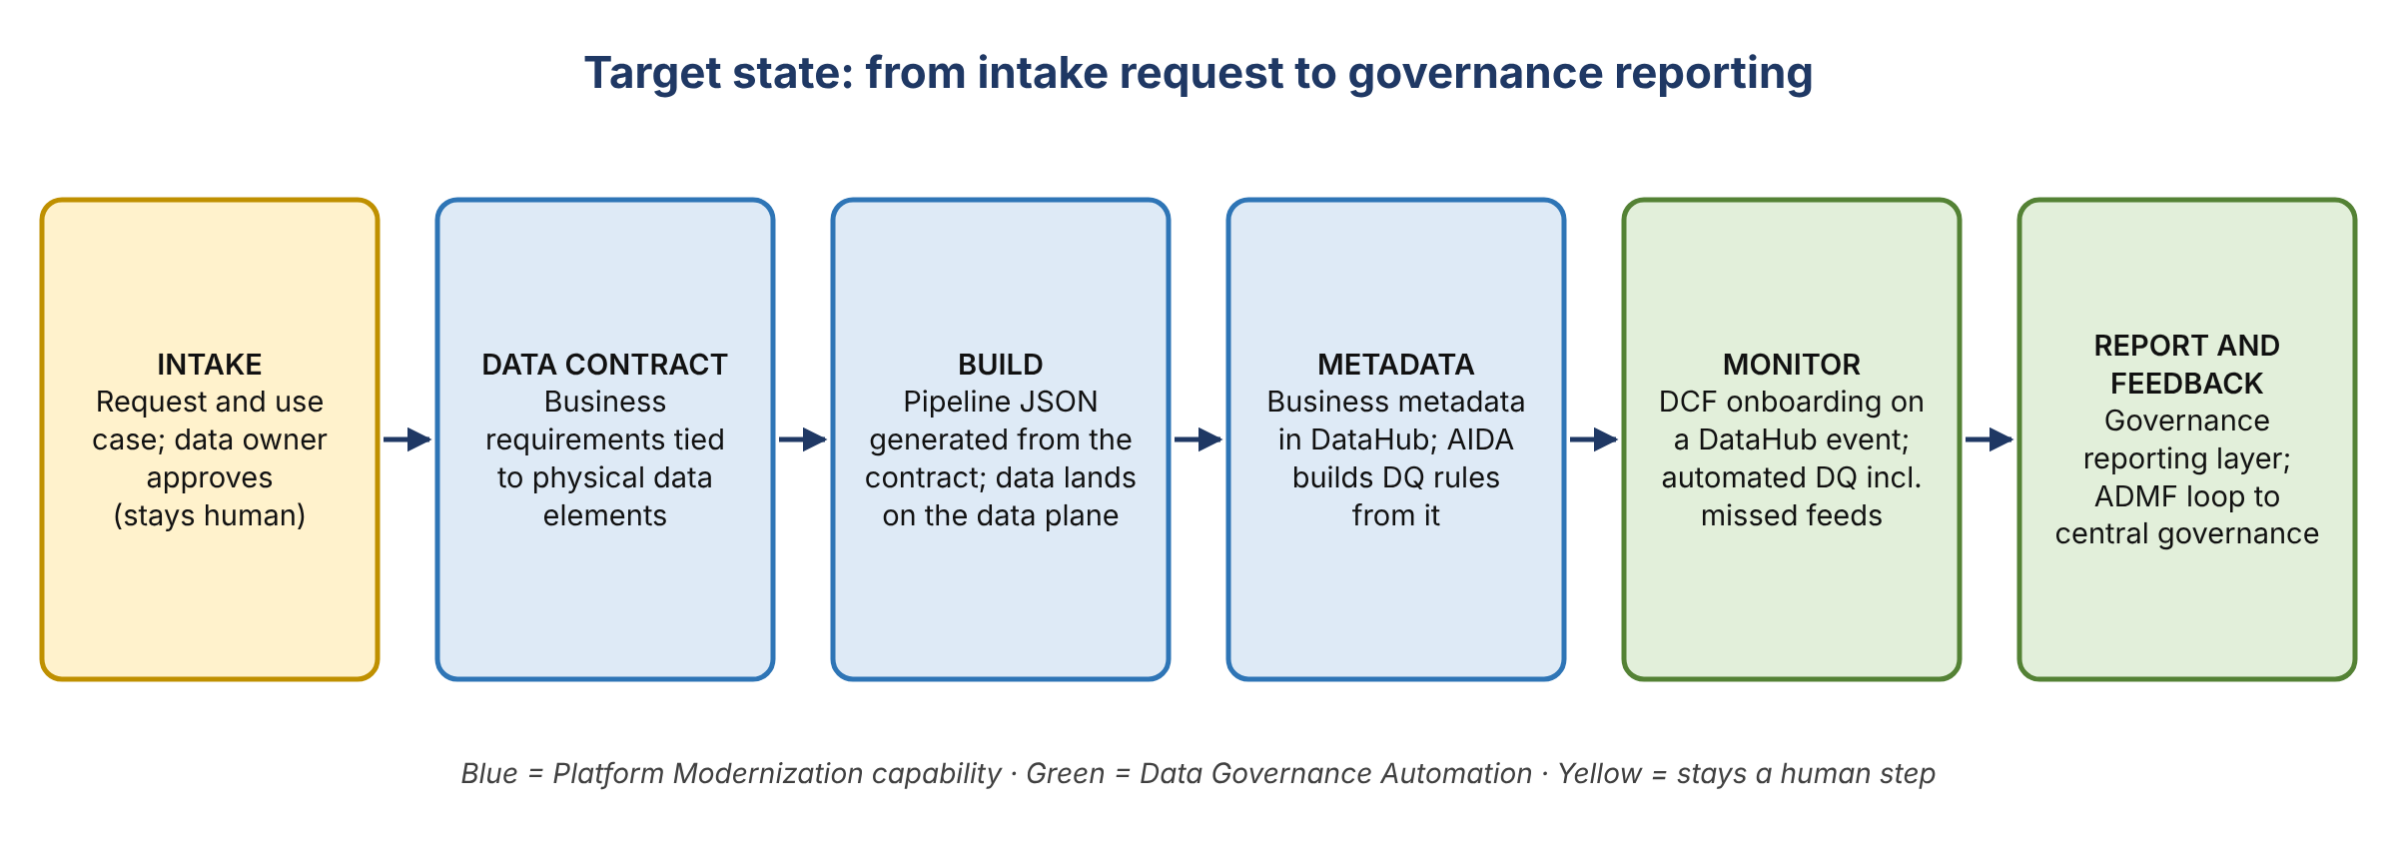
Figure 2. Target state, from intake request through data contract, DataHub and AIDA to monitoring and reporting
- No baseline: data contracts don’t exist today, so there’s no “reduced from.” Frame the benefit as “from existing to established.”
- Value: automate data pipeline creation. Per Ryan, today’s process combines the DSA with configuring the JSONs; the contract would automate both.
- Caution: don’t say “eliminating data sharing agreements.” DSAs were already folded into the intake tool, and many people think they’re gone. The agreement no longer has its own name; it’s part of the intake request.
- Still human: the team has to contact the data owner, who approves use of their data for the use case. General Use Datasets don’t remove that at first, because owners still have to agree to their data being used.
- Why it matters: contracts capture the business requirements tied to physical data elements, which become business metadata in DataHub. The researcher tool is only accurate if that metadata is good. Today the team doesn’t require business requirements from data owners, and it needs to.
- Better metadata also improves AIDA’s DQ controls, since AIDA reads DataHub metadata and profiles the data.
- What it is: a workflow process. FDLZ already has a contract portal; get a demo before deciding whether to build or reuse.
- Ideal end state: merge the intake tool with a UI that creates the pipeline JSONs, so developers no longer hand-code them.
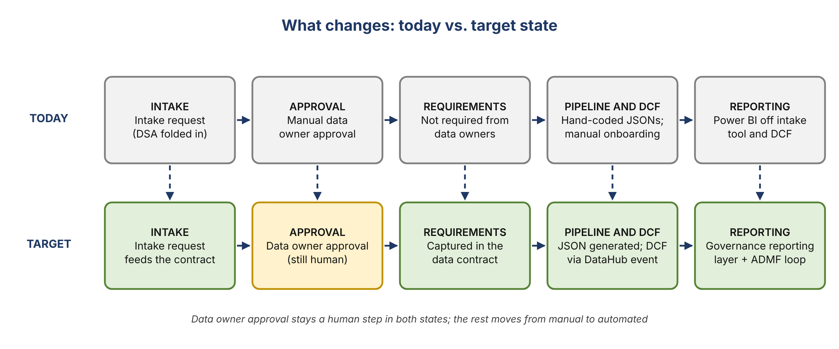
Figure 3. What changes from today to the target state

6. Draft slide content
Words for the two boxes, ready to wordsmith. TBD items aren’t ready for Derek.

Platform Modernization
What we’re solving for | Value
Migrate in-scope applications to the common data plane | 100% complete in 2027 (about 60% at YE 2026)
Make data AI ready: semantic layer, business metadata and semantic certification on AIDA and DataHub | About 50% of AI-ready data delivered in 2027 (TBD)
Implement modernized data management tooling, including data contracts | Data contracts go from not existing to established; automated pipeline creation

Data Governance Automation
What we’re solving for | Value
Support Financial Crimes commitments by enhancing data quality monitoring capabilities, including missed-feed detection | 100% reduction in manual report creation
Expand automated DQ monitoring across everything on the common data plane | Coverage of elements and feeds (metric and baseline TBD)
Develop a governance reporting layer in target state | Replaces manual Power BI reporting off the intake tool and DCF (TBD)
Reduce manual DCF onboarding through automation, triggered by DataHub events | Faster onboarding (TBD)
Automate the feedback loop with central data governance through an ADMF integration | TBD

7. Action items
No owners or dates were set before the call ended.
Action | Owner | Notes
Circle back after the team call to finish both boxes | Team
Rewrite the Financial Crimes line with the new wording | Not assigned | Offered during the call
Confirm the headcount: 65 or 55 | Not assigned
Validate the 60% migration estimate and its denominator | Not assigned | RDS apps, everything on DPC or all data center exits
Rework the DQ coverage metric with a baseline | Not assigned | Parked in the call
Define what the 50% AI-ready figure measures | Not assigned | Placeholder today
Get a demo of the FDLZ contract portal | Not assigned | Build or reuse decision
Wordsmith the final copy before it goes to Gwen | Not assigned | Copilot is fine

8. Open questions
- Keep “DPC”, or say “common data plane” / “cloud”, given DCF has migrated but isn’t on DPC?
- What value statements go with the reporting layer, DCF onboarding and the ADMF integration?
- How should the intake tool and data contracts be shown, since they sit across both boxes?
- Build our own data contract workflow, or reuse the FDLZ portal?

