Meeting Notes
SAS Exit Deck: Working Through Jacqueline's Comments
Item | Detail
Meeting date | Tuesday, November 3, 2026 (recording started about 10:31 AM)
Format | Short working session; John edited the deck live
Program side | John (editing the deck), Matt (relayed Jacqueline's preferences)
Corporate risk BDL | Kevin, Kelly, Jake
Referenced | Jacqueline (reviewer), Gwen, the Brian Schiffer org
Purpose | Work through Jacqueline's five comments on the first SAS exit deck and agree the edits before sending it back

Note on the transcript
Auto-generated transcript; speakers aren't labeled, so attributions come from context. Small talk is left out. One line is unclear: "And then tomorrow goes off track" (possibly that the survey milestone goes off track if it isn't done by tomorrow), and the as-of date discussed ("10 through") is unclear.

1. Summary
Jacqueline came back with five comments on the SAS exit deck, which the team counted as a win. Kevin had already addressed many of them. The group agreed these edits:
- Slide 1: drop the description, owner and date block, which repeats the title area. Refocus the key updates on survey progress and the heavy hitters on allocation, leading with the Brian Schiffer org. Mark the survey milestone at risk, keep the overall status on track, and update the as-of date.
- Track 1 / track 2 slide: Jacqueline asked what the tracks meant. They'll be explained in commentary instead, and the slide will likely go away.
- Survey response slide: counts updated (now 24% complete), Gwen shown in a lighter blue at 100%, fonts matched, and commentary added summarizing the responses so far.
- Appendix: another slide moves there, per her comment. The main deck becomes slides 1–3.
Matt explained that Jacqueline hates showing a project yellow or red. With a one-year runway the project stays on track, and individual tasks can show at risk. John will make the edits, ping the chat for a check, and send the deck back.
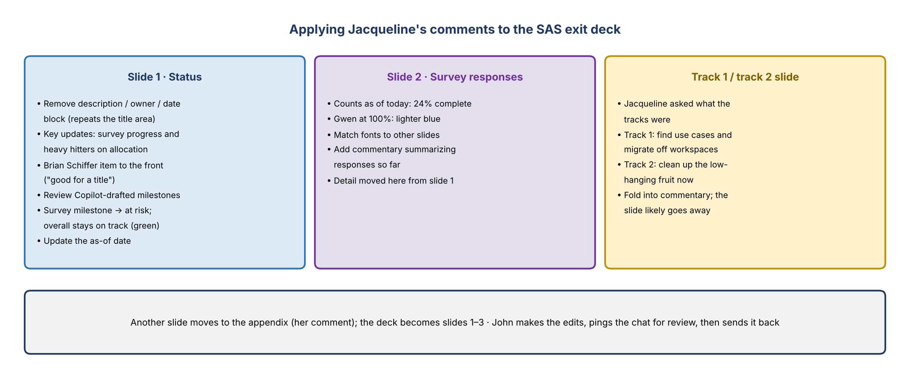
Figure 1. Applying Jacqueline's comments to the SAS exit deck

2. Slide 1: status
- Notes about the percentages are cleared. Counts are updated as of today; the survey is now at 24% complete.
- Survey milestone: change "complete surveys" to at risk. Agreed.
- Remove the description, owner and date section. Jacqueline thinks it repeats what's right below the slide title. Deleting it also frees up space.
- Key updates: make them about survey progress and the heavy hitters on allocation. Move the Brian Schiffer item to the front; Jacqueline said it's good enough for a title. Other detail moves to the survey response slide.
- Milestones: John added milestones (drafted with Copilot). They're directionally correct; the team should review them and send feedback.
- As-of date: update it (raised near the end; "good call").
- Overall status: stays on track. The team isn't trending at risk overall.

3. Track 1 / track 2 slide
- Jacqueline asked what track 1 and track 2 were, and there wasn't a great answer for her.
- What was meant: track 1 identifies the use cases and builds a way to migrate away from each workspace entirely. Track 2 cleans up the low-hanging fruit in the meantime.
- Agreed: build that into the commentary and likely remove the slide. The bottom of the slide was already split out into its own slide.

4. Survey response slide
- Gwen's org is 100% complete, so it shows in a lighter blue.
- Make the fonts match the other slides.
- Add commentary summarizing the responses received so far at the bottom. The Brian Schiffer item and any other heavy hitters go on the front page instead.

5. Deck structure
- Jacqueline said one slide looked like an appendix slide. Agreed.
- Drop slide 2 and go with slides 1, 2 and 3. If she wants the appendix version later, it can be added. Jake had already made the change.
- A piece was accidentally left on a slide while edits were being made; John will remove it and spread the content out so it's bigger.

6. How Jacqueline likes status reported
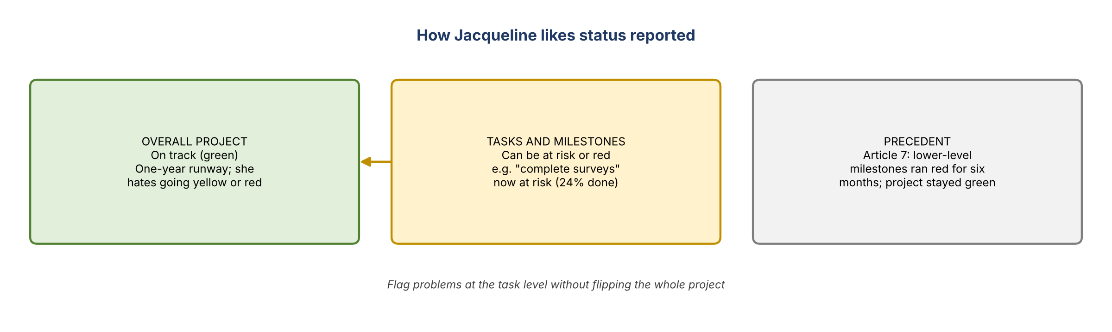
Figure 2. Project status vs task status
- Matt: she hates going yellow or red. With a one-year runway, she won't flip the project yet.
- If a task is at risk but the project is still trending green, that's how she likes it.
- Precedent: on Article 7, lower-level milestones and subtasks ran red for six months while the overall project stayed green.

7. Next steps
Action | Owner | Notes
Make the agreed edits to slides 1–3 and move the appendix slide | John
Review the Copilot-drafted milestones and send feedback | Team
Write commentary for the survey response slide and explain the two tracks in commentary | John / Kevin
Ping the updated deck in the chat for a final check | John
Send the deck back to Jacqueline | John

