Meeting Notes
SAS Workspace Owner Session: Brian Schiffer Org (coordinated by AJ)
Item | Detail
Meeting date | Friday, October 30, 2026
Format | Working session for SAS workspace owners in the Brian Schiffer org; AJ shared the workspace list and his usage-file approach
Corporate risk data management and governance | Kelly
Brian Schiffer org | AJ (coordinator; owns 4 locations), Daniel (11 workspaces), John, David McCall (joined late; 2 locations), Kelsey, Julia, Leopold
Referenced | Jim (FinCrime), Jennifer, Thomas Harold (former RMG, now MRM), Mike, BICC SAS, Technology
Purpose | Confirm who owns each workspace, unblock the corporate risk SAS survey, and agree how to retire and consolidate workspaces and Unix groups

Note on the transcript
Auto-generated transcript; speakers aren't labeled, so attributions come from context. SAS is also transcribed "SaaS". Personal remarks are left out. Unsure: "SaaScrit FC" (the team AJ said holds many of the org's workspaces), "Tri-C" (who requested access for the inventory work), "Kenny" (probably Kelly, who sent the survey email), workspace names MA10 and MA11, and "TenAltJS". The speaker who answered the change-management question isn't clear; Leopold had the floor just before.

1. Summary
Owners in the Brian Schiffer org met to work through the corporate risk SAS survey. Most of them inherited workspaces through reorgs and move lines, so they don't know what's in them or who depends on them. Kelly laid out how to handle unknown workspaces, and AJ walked each owner through their list. The org's inventory has grown from about 80 to about 86 locations as more turn up.
Agreed:
- Owners confirm their workspace lists and complete the survey; results are due early next week.
- Workspaces nobody can explain go through ask, escalate, then a pause-access test before retirement.
- AJ pulls Technology's usage files for anyone who asks, into a shared review folder.
- David McCall's two locations will be retired; AJ's two abandoned locations are candidates too.
- RFM Unix groups owned outside RFM get transferred to the RFM AU, then consolidated.
Leopold set the direction: a business need for SAS remains for now, so consolidate the footprint first and move off SAS over the next few years. AJ wants 2–3 more people and the cleanup done in 3–4 months.
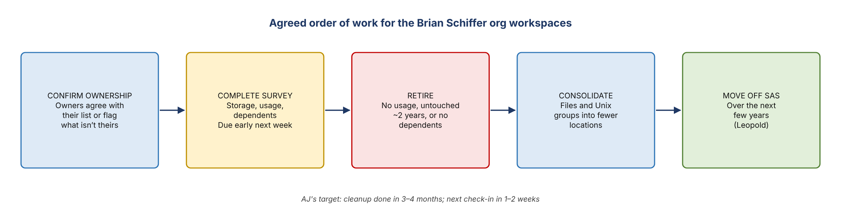
Figure 1. Agreed order of work for the Brian Schiffer org workspaces

2. Kelly's overview
- Kelly is in corporate data management and governance. Her team had presented the effort on the Brian Schiffer team's family call.
- The survey collects, for every workspace in the bank: storage allocation, downstream usage, who relies on it, and what it supports (models, reports, analytics and so on).
- Owners are expected to know their workspaces, but often don't. Workspaces change hands through reorgs and move lines.
- Usage reporting is still being worked out. SAS has some text files showing the last user to modify data, but nothing consistent across all workspaces.
- If an owner can't answer, coordinate within their org first; someone there may know what it's used for.

3. Workspaces nobody can explain
Kelly described a common pattern and three ways to handle it, in order:
- Ask within the org. For workspaces AJ acquired, ideally someone in his organization knows the purpose and dependents.
- Escalate to the SAS platform team to help identify the data in the workspace.
- Pause access. Downstream SAS users lose visibility of the workspace. If that breaks something people rely on, access is turned back on. If nothing breaks and there are no dependencies, the workspace is tracked for retirement.
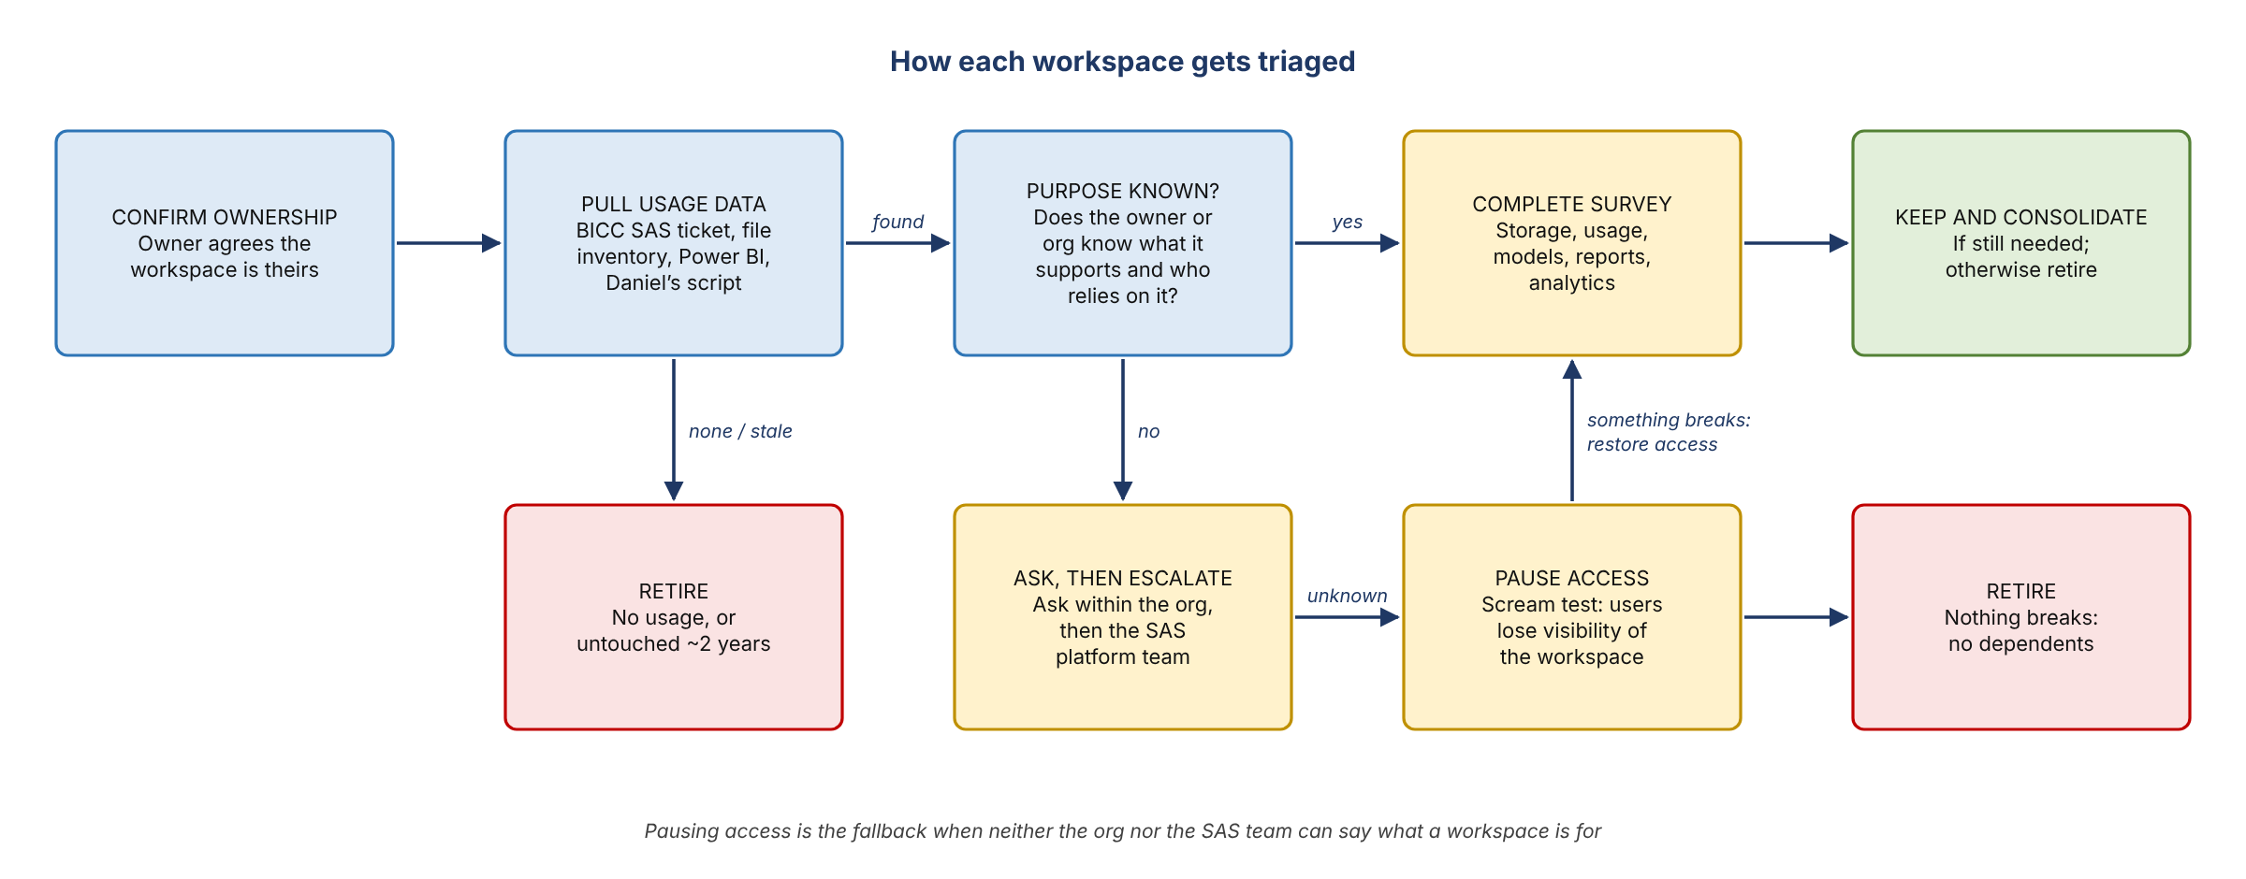
Figure 2. How each workspace gets triaged

4. Finding out who uses a workspace

BICC SAS tickets
- One attendee used these in the earlier SAS reduction push this year, which cut space by roughly 50% and licenses by more.
- Open a ticket saying you own the workspace and need file usage reporting. It returns file owners and last-modified dates.
- With that, contact file owners: tell them they have data there and ask them to delete what they don't need. Described as the most helpful source.

SAS Power BI report
- Needs an entitlement. The link was posted in the meeting chat.
- High level, with a Workspace Users page. It shows Unix groups rather than named users, because SAS access mostly runs through groups.
- Some domains were hard to find (an attendee on auto couldn't see it at first).

Technology file inventory and AJ's review folder
- Technology gave Kelly and AJ the ability to download usage and file inventories for the org's locations.
- AJ pulled the file for one of his new locations and used AI to summarize who uses it and which Unix groups appear.
- Of his 4 locations, only 1 had usage data. Two had been abandoned for about 2 years and could be retired; one had no data at all.
- He is building a shared review folder with a subfolder per owner and will move each owner's text files there. Owners don't have to do the AI breakdown themselves.

Daniel's script
- Daniel has code that lists users and their latest modified date per location, which he uses to contact them.
- AJ asked whether it could be shared across the team for all workspaces; that wasn't settled.
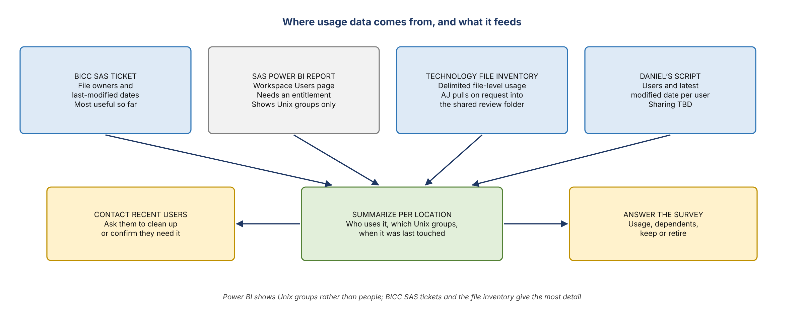
Figure 3. Where usage data comes from, and what it feeds

5. Walking the owner list
AJ started from the list he confirmed with Kelly and Kelsey as sitting under Brian, noting it may not be complete. He asked owners whether they agree with their lists, and whether to verify individually or together.
- Daniel: owns 11 workspaces. Survey done for 8. Can't complete MA10 and MA11 because his access request from the day before hasn't gone through. No other help needed.
- John: fine with his list; will research and give feedback and a recommendation. Asked AJ to supply the usage files.
- David McCall: joined late. Owner of two locations; both can be retired. Data dates to about 2012 and nothing needs migrating. No retirement tickets yet; AJ will help, using Kelly's notes.
- Jim (FinCrime): not on the call but in the office; AJ will follow up.
- Kelsey: ownership signed off.
- Jennifer: still listed as a current owner; invited for background on her drives. If none, the team proceeds on its own.
- Other locations: AJ asked whether anyone knows of locations that should move into or out of Brian's org. No one named any; most are found when something breaks.

6. Unix group cleanup
- AJ: a single drive he pulled had many Unix groups, and each location has its own. He asked whether a master list exists for RFM, and proposed one or two groups based on real business need, with files repointed to them.
- Ownership drift: many RFM groups are still owned by Thomas Harold, who moved from RMG to MRM about 2–3 years ago. The ownership didn't move with him. Each group carries four entitlements: primary and secondary, for production and QA.
- Legacy groups: some users still hold groups from jobs several roles back, no longer tied to their location or system.
- Why it matters: with different groups, people in the same org can't move, delete or back up each other's files without a ticket.
- John: groups exist for a reason and are needed as long as data sits under them. Agreed to transfer groups that show up in the org's workspaces to the RFM AU, then consolidate, unless segregation is required.
- Not in scope: root and SAS service accounts, which the team doesn't control.
- Sequence: survey first, retire what isn't needed, then clean up files and groups.
- No one knew of a master Unix group list; the history left with the people who set them up.
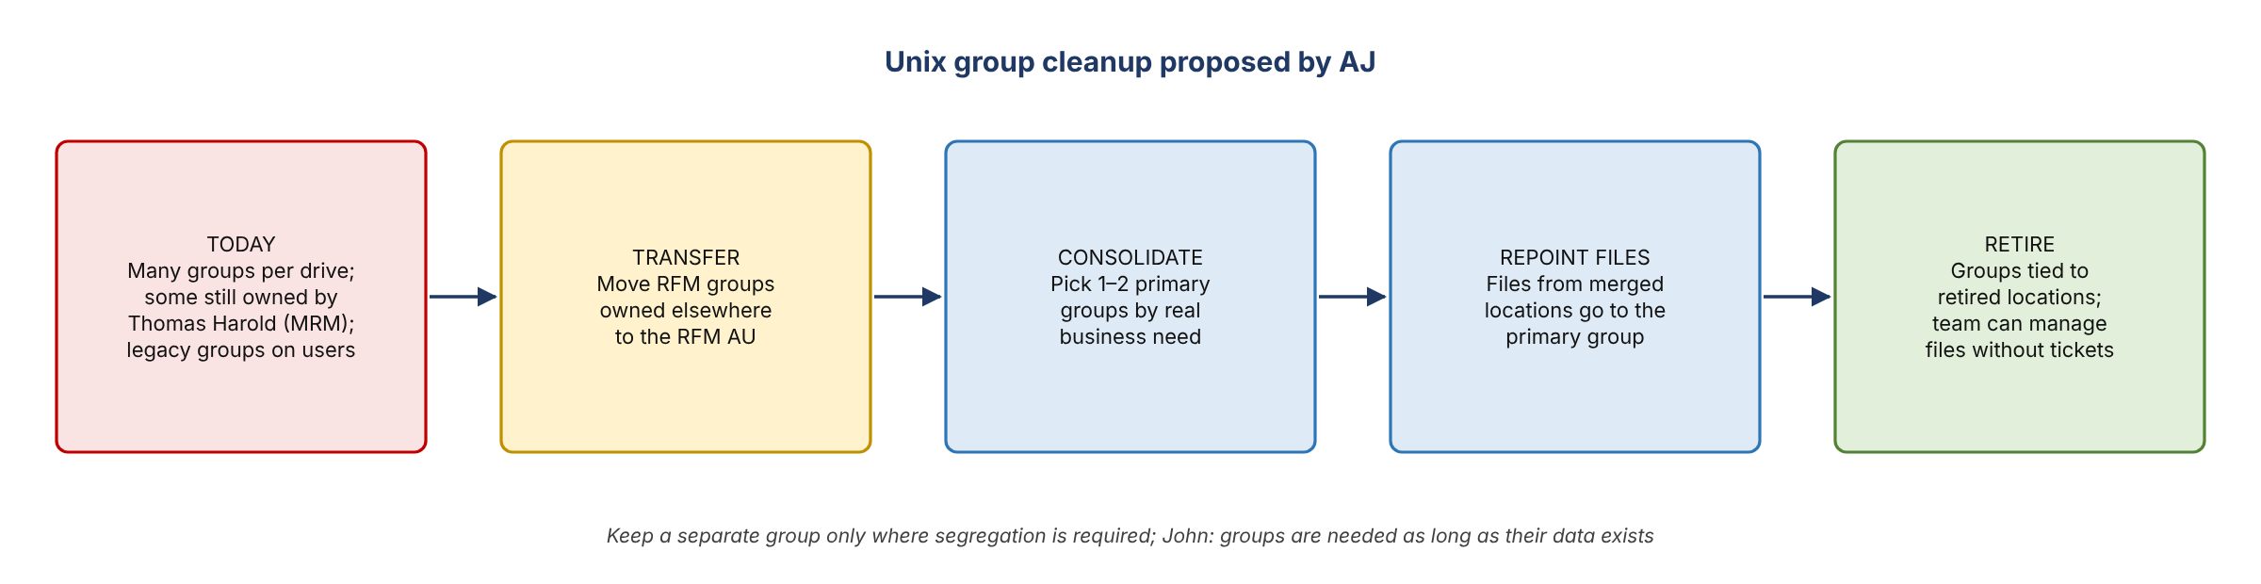
Figure 4. Unix group cleanup proposed by AJ

7. Change management for moved sources
- Question: if server consolidation moves the data a pipeline sources from, is a change request needed, and what evidence?
- Answer: it's a configuration change, treated as non-triggering. Log it through change management.
- Evidence: pull data from the new location and compare it with data pulled from the old one. If it's identical, stop testing and close the change. It's the same as changing any data source.
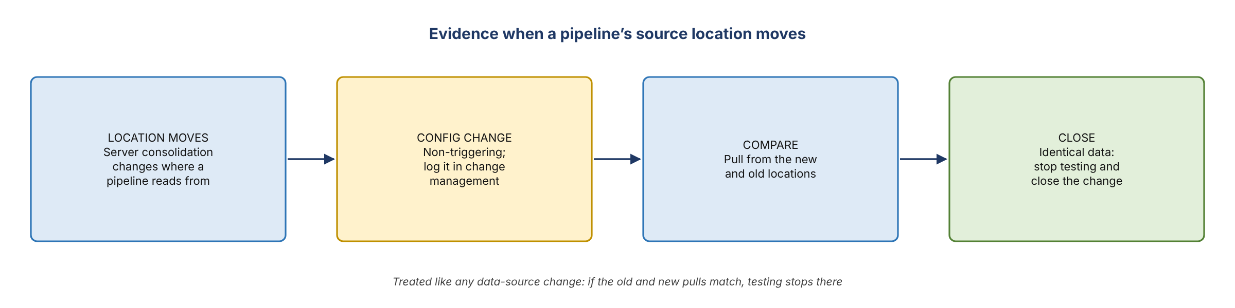
Figure 5. Evidence when a pipeline’s source location moves

8. Timing and direction
- Kelly: survey results are wanted by early next week. Senior leadership wants costs down as soon as possible; there's no firmer date, and the work depends on the SAS technology partners.
- AJ: wants the cleanup done in the next 3–4 months and asked for 2–3 more people. He'll set up another session next week or the week after.
- Leopold: there will still be a business need for SAS. For now, consolidate the footprint and let go of what isn't needed, then move things out over the next few years.

9. Action items
Action | Owner | Notes
Confirm your workspace list and complete the survey | All owners | Early next week
Set up the shared review folder and pull usage files on request | AJ | One subfolder per owner
Send John his usage files | AJ
Open retirement tickets for David McCall's two locations | AJ / David | Using Kelly's notes
Follow up with Jim (FinCrime) and Jennifer | AJ
Get access to MA10 and MA11 and finish those surveys | Daniel
Share the usage script with the team, if possible | Daniel
Retire the two abandoned locations | AJ | No usage in about 2 years
Transfer RFM Unix groups owned outside RFM to the RFM AU | Team | After the survey
Request 2–3 more people for the cleanup | AJ
Schedule the progress review | AJ | Next week or the week after

10. Open questions
- Is there an existing process for reviewing user access on these workspaces? AJ asked; no one answered.
- Is there a master list of RFM Unix groups, and how many groups share the Thomas Harold ownership problem?
- Which locations belong in or out of Brian's org that aren't on the list yet?
- Can Daniel's script be shared across the team?
- What is the official completion date for the SAS reduction?

