Meeting Notes
SAS Workspace Owner Call: Chris and Tara (CBL CRO)
Item | Detail
Meeting date | Monday, November 2, 2026 (recording started about 2:01 PM)
Format | Workspace owner call; Kelly shared the overview deck, workspace list and survey
Corporate risk data management and governance | Kelly (presenter), Jake
CBL CRO (Mike Vanny's org) | Chris (Christopher; owns 8 SAS workspaces), Tara (Chris's leader)
Referenced | Gwen, Sandy Moy (CBL CRO workspace process), Michelin Peters, Craig (owns one workspace), Rochelle, the Brian Schiffer org
Purpose | Walk Chris through the SAS survey for his eight workspaces and agree how his answers align with CBL CRO's own workspace process

Note on the transcript
Auto-generated transcript; speakers aren't labeled, so attributions come from context. SAS is also transcribed "SaaS"; Brian Schiffer as "Shipper". Personal remarks are left out. Unsure: Michelin Peters (also "Micheline"), Sandy Moy, Mike Vanny, Craig, Rochelle, Megan, "likely owned by truly" (probably the front line), "MROs" (regulatory actions; possibly MRAs or consent orders), and the risk terms KEI, CMA and KFI. Tara asked which executive is driving this; the answer isn't clear in the recording.

1. Summary
Kelly started walking Chris through the corporate risk SAS survey for the eight workspaces he owns. Chris has just returned from leave. Tara paused it: CBL CRO (Mike Vanny's org) sent an email this morning, from Sandy Moy's team, about its own workspace process. She doesn't want Chris answering one-off in a way that differs from CBL CRO's overall message, especially since some workspaces may move to the front line after the April move the line.
Agreed:
- Kelly keeps sending the survey.
- Chris checks with Sandy's team so his answers line up.
- Chris is the delegate for Craig's one workspace as well.
- Kelly will email both and tell Craig that Chris can answer for him.
Tara warned that switching off SAS would hit front-end decision engines, loss forecasting and auto. Rebuilds carry regulatory obligations, so a shutdown would need formal risk treatment. Kelly agreed and said that message goes back to senior leadership: the team is collecting information, and nothing is being turned off soon.
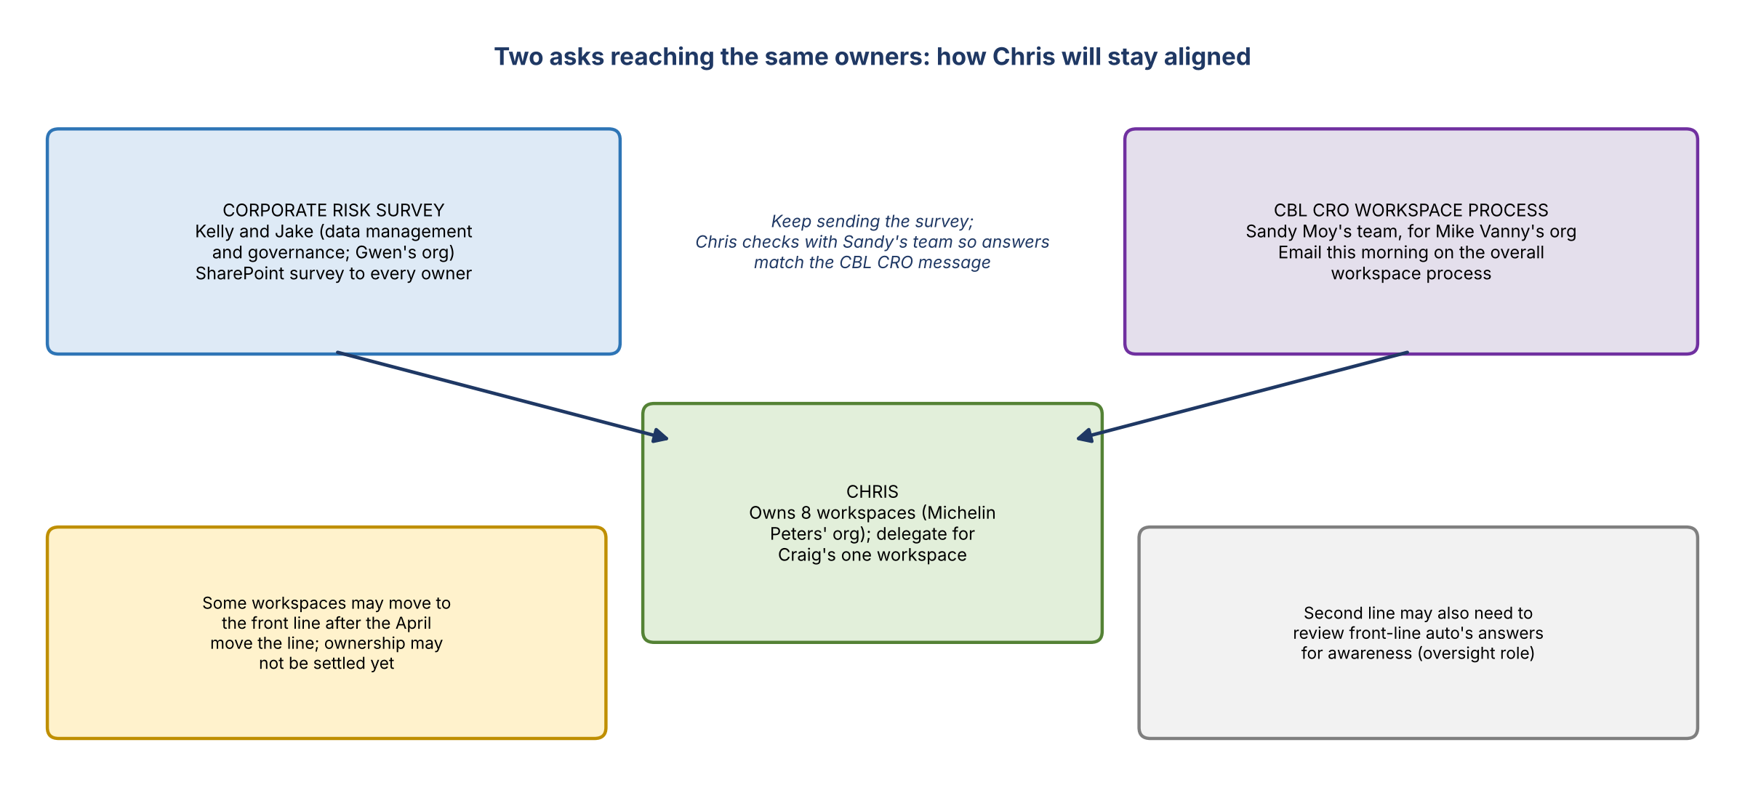
Figure 1. Two asks reaching the same owners, and how Chris will stay aligned

2. Kelly's overview
- Chris owns eight SAS workspaces.
- Kelly and Jake are part of corporate risk data management and governance, rolling up to Gwen. It's a top-of-house initiative.
- Short term: storage and access cleanup, because there's no clean picture of which workspaces feed which use cases, regulatory reports or models.
- Long term, also in the survey: whether owners have a path to migrate off SAS. If so, collect details; if not, that's fine.
- The SharePoint survey follows the call for the owner to fill out.

3. Tara: align with CBL CRO first
- Sandy Moy emailed this morning about the overall workspace process. Tara asked whether this effort runs at the CBL CRO level, and whether they should work through Sandy's team, which represents Mike Vanny's org.
- She doesn't want Chris answering one-off when leadership in Mike's org may have a holistic response, or commenting on auto CRO in a way that differs from CBL CRO's message.
- Some workspaces may need to move to the front line after the April move; for those, CBL CRO won't decide what happens because it doesn't own them.
- Kelly: the survey is specific to corporate risk and is going to all the CRO groups. There's a swirl, with various leaders reaching out to workspace owners, so this likely goes hand in hand with CBL CRO's effort. CBL CRO hasn't been approached holistically; the Brian Schiffer org was (about 85 workspaces), working through a central team.
- Agreed: Chris contacts Sandy's team to stay in lockstep. Kelly keeps sending what she's sending. Tara looped Chris onto the email.

Ownership in Michelin Peters' org
- Most workspaces are owned by Chris. One is owned by Craig, who will likely defer to Chris; it's probably really owned by the front line.
- The survey's first question is whether you should be the owner, because reorgs and line moves have left stale ownership.
- Kelly offered to let someone else answer as delegate. Tara: Chris is the one she trusts to review SAS ownership, so Chris is the delegate, including for Craig.

Second-line oversight
- Tara raised whether her team should also review front-line auto's responses. It would be oversight and awareness: the front line has technology and usage oversight, while her team is a catch-all for all risks and needs to know what's there.
- She compared it to Rochelle reviewing issues and incidents, then pulling in BACO, ORBO or other partners; data management risk sits here too.

4. The survey and follow-up
- The survey checks ownership (or who should own it, e.g. the front line), downstream usage, who relies on it, whether it's still active, and the exit strategy and timeframe if there is one. No exit strategy is fine; this is investigative.
- Craig: invited to the owner kickoff last Monday (10/26), but their team was at an onsite in Charlotte that week. He hasn't answered the survey yet. There are over 60 workspace owners in total.
- Timing: senior leadership wanted results this week, which isn't feasible for Chris. Sooner is better, and the team will work with them as they research.
- Kelly will send the survey to Chris and Craig, note that Chris can be Craig's delegate, and share supporting information. Questions go to Kelly or Jake.

5. Concerns about SAS going away
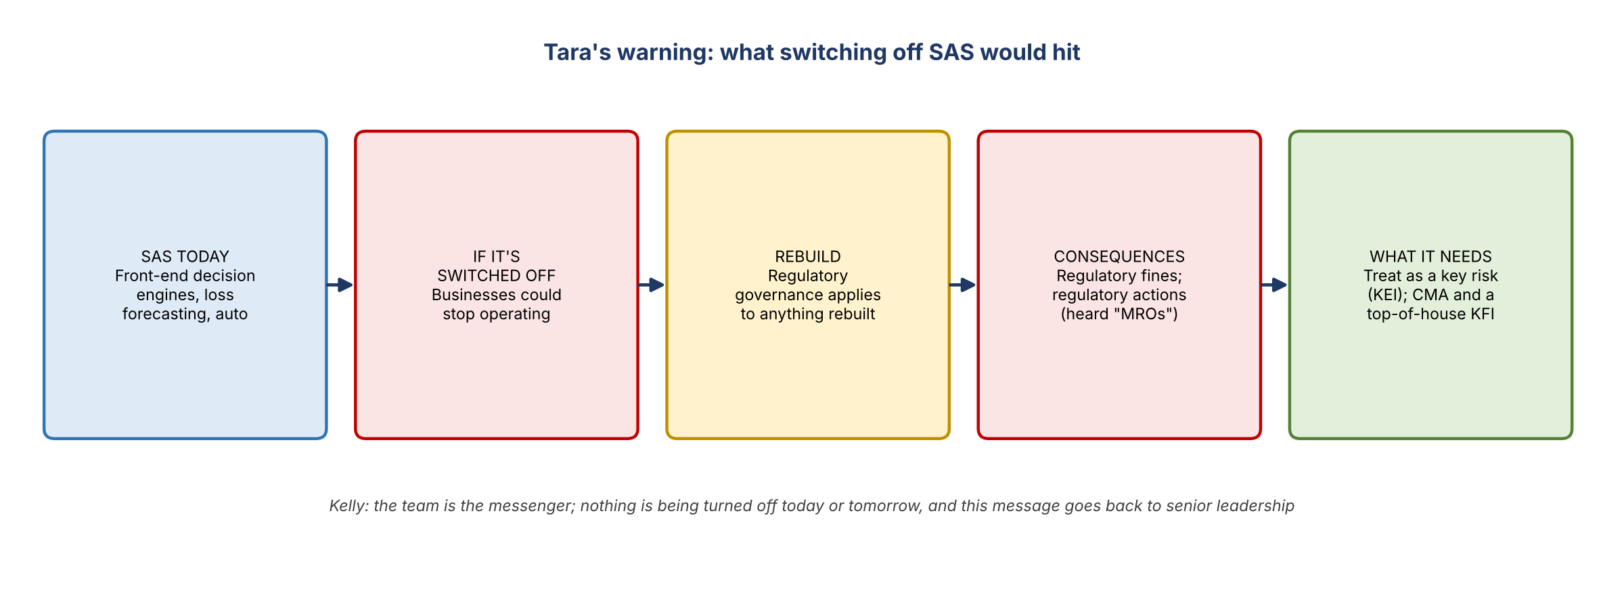
Figure 2. Tara's warning: what switching off SAS would hit
- Chris: will any action be taken right away from the responses? Kelly: no. The team consolidates results, builds a plan and takes it to senior leadership. Losing SAS access across the bank is a possibility, but not today or tomorrow, and SAS is still available.
- Dependencies (Tara and Chris): front-end decision engines run on SAS. Pulling the plug could shut businesses down. Loss forecasting and auto can't just be turned off. Anything rebuilt falls under regulatory governance, with the risk of regulatory fines and regulatory actions (heard "MROs").
- Kelly: the aim is to reduce SAS cost and footprint, not to turn it off tomorrow. SAS is one of corporate risk's most expensive line items, and this comes up every few months. The team is the messenger, and many owners don't know they own locations or no longer need the allocation.
- Tara on the April move the line: moving people from the second to the first line means untangling what's intertwined: have the controls moved, and how do they work? Chris may own something only because the front line hasn't decided what to do with it yet. Workspaces support regulatory reporting and customer production, so they can't be broken.
- Tara: switching off SAS would be a fundamental system change and a key risk (KEI) for the enterprise. It would need a CMA and a KFI opened at the top of the house.
- Kelly: a fair and valid call-out. The message to senior leadership is that SAS is critical across the bank and can't be turned off overnight. More to come.

6. Action items
Action | Owner | Notes
Send the survey to Chris and Craig; tell Craig that Chris can be his delegate | Kelly
Contact Sandy Moy's team to align survey answers with the CBL CRO workspace process | Chris
Complete the survey for the eight workspaces (and Craig's) | Chris | As soon as feasible
Consider second-line review of front-line auto's responses | Tara / Chris | Awareness
Take the dependency and regulatory concerns back to senior leadership | Kelly / Jake

7. Open questions
- How does the CBL CRO workspace process (Sandy Moy's team) relate to the corporate risk survey?
- Which workspaces move to the front line after the April move the line, and who owns them now?
- Would an exit require a CMA and a top-of-house KFI, and who would open them?

