Meeting Notes
Corporate Risk SAS Usage & Storage Cost Reduction: Kickoff
Item | Detail
Meeting date | Tuesday, October 20, 2026 (recording started about 2:00 PM)
Format | Last-minute kickoff. Jacqueline framed it and then stepped away. Jason shared the CDO Confluence page and dashboard; Vic shared Kevin's team's slides; Kelly walked through the draft questionnaire.
Attendees | Jacqueline (sponsor), Tammy and Jason (analysis), Kevin (Legacy BDL team; SME lead), Vic, Kelly, Jake, James (consumer lending SME), Matt and John (program drivers)
Referenced | Gwen (budget owner who raised the cost), Amy Pitch (prior work in Jeff Goldsmith's area), Anand (CDO SAS team contact)
Purpose | Assess current-state SAS usage and storage across corporate risk: who uses it, how, how critical it is, and each owner's exit strategy. Cut cost quickly where allocations are unused, and track it centrally to completion.

Note on the transcript
Auto-generated transcript; speakers aren't labeled, so attributions come from context. SAS is sometimes transcribed "SaaS". Readings used: Jacqueline ("Jack"), Goldsmith (confirmed earlier), PyFarm, Minerva, DMP. Non-work chat at the start (office moves) is left out. Confirmed: Amy Pitch, Analytical Data House (ADH), AMART, Article 7, AVA 3.0, and CDO's cost basis (1 PB = 1,000,000 GB ≈ $720,000 per year, 2025 basis). Unsure: "Jeff" (the person who raised annual usage; may be James) and the access request system for the dashboard (transcribed "aims").

1. Summary
SAS cost has come up as a hot topic every few months. Gwen saw nearly $2 million a month for SAS storage allocation in her budget and asked what it was paying for. Jason's analysis of July to September data found corporate risk has the most allocated SAS storage in the enterprise but uses only about 46% of it, unchanged since May. Many workspaces sit near 0%. CDO confirmed that storage allocation, not entitlements, drives the cost.
Jacqueline asked the team to:
- document who uses each workspace, how, and how critical it is;
- capture each owner's exit strategy, and help build one where none exists;
- track it all centrally to the end.
Kevin's team (Vic, Kelly, Jake) has already linked the 166 workspaces to known models:
- 8 workspaces are confirmed to feed Tier 1 and Tier 2 models, covering 30 Minerva models.
- Another 37 Minerva models are deployed on SAS.
- 96 workspaces are under 60% used, and 48 are under 1%.
Next steps: turn the draft Excel questionnaire into a SharePoint form, add James's suggested questions, and circulate it on 10/21 for Jacqueline's approval. Then survey the 64 workspace owners while taking quick wins on unused allocation in parallel.

2. Jacqueline's framing and ask
- Assess current-state needs for usage and storage across all corporate risk SAS solutions. Tammy and Jason's work is the starting point.
- Document key data points: who uses each workspace, how, and how critical it is. For example, someone who only plays around in free time vs. someone who needs it for day-to-day work.
- Exit strategy: it's fine if owners don't know theirs, or don't have one. "That's where we're really going to earn our keep": help them document it and, if needed, support execution centrally.
- Track centrally until it's done. "If it takes two years, it takes two years", though she doesn't expect that much time. There's no shot clock, but sooner is better.
- Challenge long-dated target dates and inconsistencies. For example, if most groups pick one target platform and two pick a different one, ask why.
- Reach out to Amy Pitch, who's already done some of this in Jeff Goldsmith's space. Kevin is copied on that thread and has a call with her tomorrow. Where information already exists, start there.

Proposed roles
Who | Role
Kevin | Lead overall as SME on how this is set up
James | Consumer lending knowledge of how SAS is used; helps challenge responses
Matt and John | Drive it as a small program: project plan with milestones, tasks, owners, and dates; status reporting; follow up with non-responsive owners
Tammy and Jason | Baseline analysis, CDO dashboard, CDO contact (Anand)
Kevin's team (Vic, Kelly, Jake) | Workspace-to-model mapping, questionnaire, owner outreach

- Ask from Jacqueline: go through the table in the invite, make any changes, and send it around with next steps.

3. Baseline analysis (Tammy and Jason)
- Tammy credited the work to Jason. Gwen questioned a budget line of nearly $2 million a month (as Tammy understood it) for storage allocation, and Jason was asked to dig in.
- Jason reviewed 90 days of data (July, August, September) at workspace level, not user level.
- Utilization: corporate risk uses about 46% of its allocated storage, roughly unchanged since May. Changes mostly reflect people moving teams, not active management by workspace owners.
- Compared with the rest of the enterprise, corporate risk has the most allocated storage, so that's where most of the savings are.
- Storage, not entitlements: the team first looked at entitlements, but CDO confirmed most savings come from storage allocation.
- Many workspaces have very low utilization, some close to 0%, where a lot of storage could be recovered.

Sources (links in the chat and invite)
- CDO Confluence page on SAS: platform storage and cost estimates. Cost is hard to pin down because it's lumped in with other technology platforms on the line item.
- CDO's estimate (2025 basis): 1 PB (1,000,000 GB) of on-prem storage costs about $720,000 per year across all storage platforms. Multiply by 4 to cover snapshots and BCP environments, so effectively about $2.88M per PB of allocation per year.
- CDO dashboard, updated monthly: storage reports, entitlements and users per workspace, and a SAS use case inventory. The September report is out and shows little change. Access is requested through a link on the Confluence page.

Monthly vs. annual view
- Usage figures in the deck are one month: each workspace's allocation vs. what it used that month.
- Someone raised that some groups run a process only once a year, so a 12-month window is needed. The dashboard can show the full year and drill down to line of business and team.
- Q1 looked higher. Possibly year-end crunch, but mainly a big move: a Consumer Lending CRO team owning large workspaces (Analytical Data House (ADH), AMART, Acquisitions, Collections) moved to the consumer line of business and took them along.
- Last year CDO's allocation to risk was about $60 million. They thought this year's was cut in half, but it's still too high.
- Tammy: maybe allocate for a given quarter when there's a spike, instead of holding a high allocation all year.

4. What Kevin's team already knows
- Kevin introduced himself (Legacy BDL team). CDO used to come to his team yearly for help allocating costs back to the business. Is that allocation what's being tracked? Jason didn't know the original number; the topic began as "SAS is very expensive" and he used CDO's estimate.
- His team documented lineage for Tier 1 and Tier 2 use cases under the data management policy. All Minerva models are DMP use cases, and risk rank maps to tier (risk rank 1 = Tier 1, etc.). The policy requires documenting the one-hop-back source. That's about 100 models in corporate risk.
- That work identified several SAS environments as one-hop-back sources, so the team already knows something about how they're used.
- Some workspaces are required and need an exit plan rather than being cut off. But the low-utilization ones are no-brainers to question: do you know you have this space? Are you using it? Can it be consolidated into one of the hundreds of other corporate risk spaces?
- Jason agreed: allocations were often requested for a single project or use case setup and never reduced, because owners didn't know it cost anything.
- Jason offered to connect the team with the CDO team. He works with Anand, who responds quickly.

5. Kevin's team's proposal (Vic's slides)
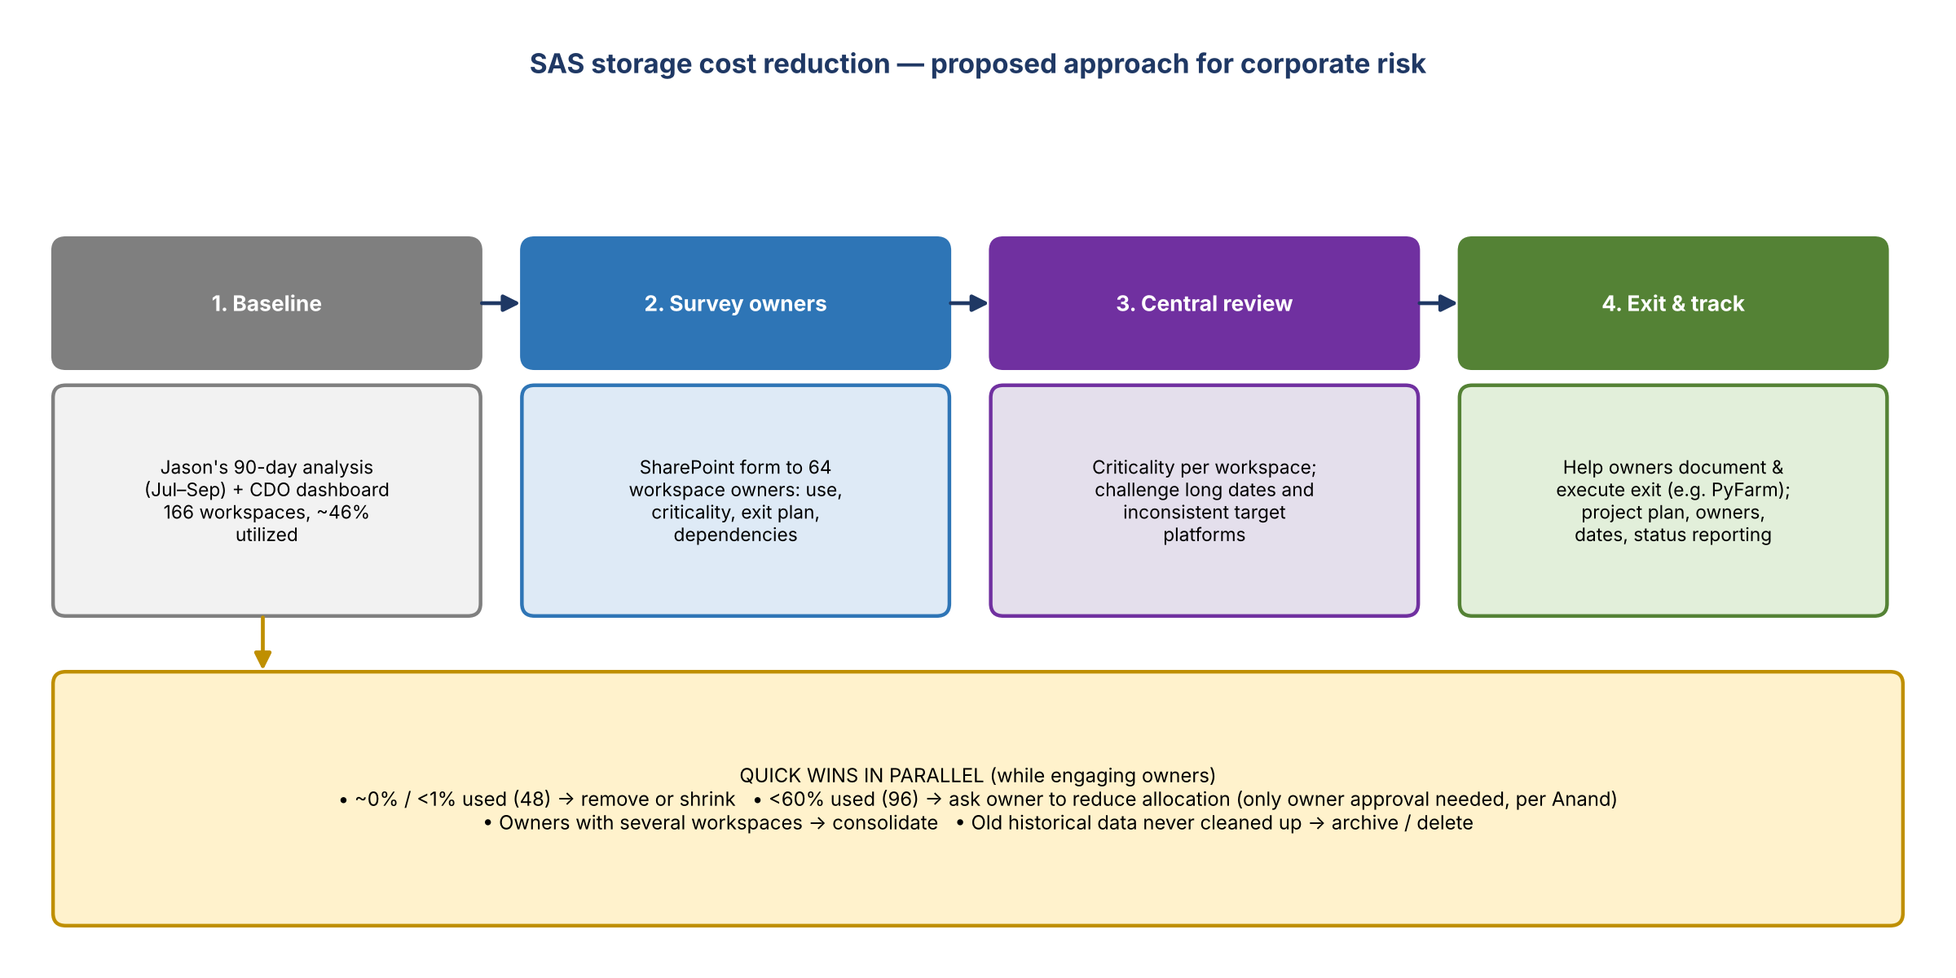
Figure 1. Proposed approach, with quick wins running in parallel

Observations
- Several individual owners have multiple workspaces. Could they consolidate into one? That's another quick win.
- They'd assumed entitlements drove cost, but CDO said storage does.

Survey (slide 3)
- Ask every owner what the workspace is used for, whether there's already a plan to move off it, and what dependencies block that. Example: moving may force a model revalidation, which an owner may prefer to time with the next scheduled one in two years.
- Then work out the path forward per workspace.

Quick wins in parallel
- Near 0%: remove it or reduce the allocation.
- Per Anand, reducing an allocation only needs the workspace owner's approval. While engaging owners, ask those under 60% whether it can be reduced.
- Ask whether it's years of historical data no one cleaned up, or data actually used regularly (e.g. quarterly).

Link to models (slide 4)
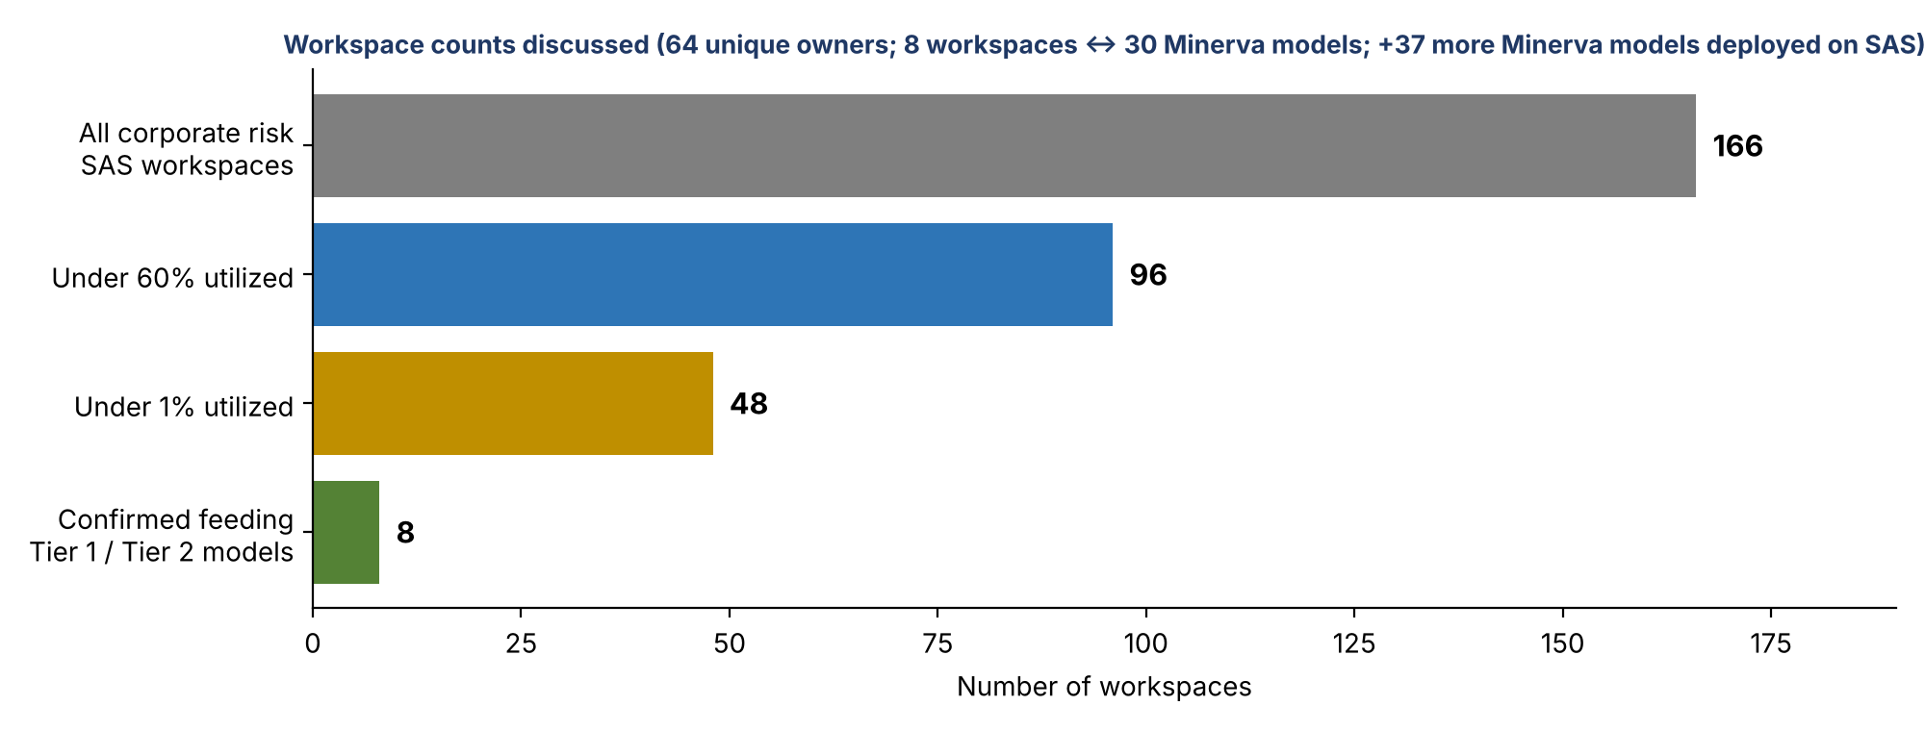
Figure 2. Workspace counts from the team's analysis
- From the lineage work, 8 of the 166 workspaces are confirmed to feed a Tier 1 or Tier 2 model today, covering 30 models in Minerva. These are clearly important; next is finding the path and timeline to move them.
- Another 37 Minerva models look like they're deployed on SAS. They probably account for some of the remaining 158 workspaces. Ask those model owners for their workspace to complete the mapping.
- Then ask owners of workspaces that don't map to a model what they're used for.
- 96 workspaces are under 60% utilized and 48 under 1%. Both will be covered in the questionnaire.

6. Questionnaire (Kelly)
- Draft built in Excel from Jason's data, with columns added and made as user-friendly as possible.
- Format feedback: people respond better to a click-through SharePoint form than an Excel file. The team can build one easily once the fields are agreed.
Field | Notes
Use case name and description | What the workspace is used for
Number of users | If known
Exit strategy planned? (Y/N) | If yes: the plan, target (another application or environment), and timeframe
If no exit strategy | Context to help the team build a plan
NEW: ad hoc vs. scheduled vs. both | James's suggestion
NEW: shared with others or individual? | The named owner may just be whoever signed up
NEW: tied to a regulatory or critical deliverable? | E.g. control reports. The AVA 3.0 model for Article 7 under the formal agreement was built in SAS and runs there (financial crimes)

- Once responses are in, Kevin's team reviews criticality per workspace and how to help each one migrate as quickly as possible.
- Scale: 166 workspace rows and 64 unique owners ("60-some"), about 10 columns. Most owners already know Kelly from DMP compliance and lineage work, so outreach won't come out of left field.
- Are all workspaces tied to a use case? Unknown. 8 are confirmed. Many are likely tied to a model, given the overlap between workspace owners and model owners.

Why this isn't just "move to PyFarm"
- Corporate risk's plan is to get off SAS and onto PyFarm, the model execution engine.
- But much of the data aggregation models need happens in SAS today, so moving model code to PyFarm isn't enough. The data in these environments has to be understood.
- In the meantime, cutting gigabyte allocations makes sense while each workspace's plan is worked out.

7. Timeline
- Someone asked whether anyone on the call helped set the timeline in the invite. No. Jacqueline put targets on paper as placeholders.
- The invite showed a due date of 10/21, which is why the team built the Excel template today.

8. Decisions
# | Decision
1 | Focus savings on storage allocation (CDO confirmed it drives cost), not entitlements
2 | Survey all 166 workspaces (64 owners) through a SharePoint form rather than Excel
3 | Add questions on ad hoc vs. scheduled use, sharing, and regulatory or critical ties
4 | Take quick wins in parallel: remove or shrink near-0% workspaces, ask owners under 60% to reduce, consolidate multi-workspace owners
5 | Review usage over a 12-month window as well as monthly, to catch annual processes
6 | Run as a small tracked program (Matt and John) with Kevin as SME lead

9. Action items
Action | Owner | Notes
Convert the questionnaire into a SharePoint form and add James's three questions | Kevin's team (Kelly / Vic / Jake) | Socialize 10/21
Get Jacqueline's sign-off on the form and start outreach per the invite | Kevin | After review
Update the invite table (roles, dates) and send it around with next steps | Kevin / team | Jacqueline's ask
Call Amy Pitch about her work in Jeff Goldsmith's space | Kevin | Tomorrow (10/21)
Ask the 37 SAS-deployed Minerva model owners for their workspace | Kevin's team | Complete the workspace-to-model map
Ask owners of workspaces under 60% / under 1% to reduce or remove allocation | Kevin's team | Owner approval only (per Anand)
Build project plan (milestones, tasks, owners, dates) and status reporting | Matt and John
Connect the team with Anand / CDO SAS team; share dashboard access | Jason
Review 12-month usage per workspace for annual processes | Jason / team | Dashboard supports it

10. Open questions
- What is the actual dollar cost? Nearly $2M a month cited, CDO's PB-based estimate, and last year's ~$60M allocation.
- Which workspaces support regulatory or formal agreement deliverables (e.g. AVA 3.0) and must be protected for now?
- Can allocations flex by quarter for seasonal spikes?
- How do target platforms (PyFarm, others) handle the data aggregation done in SAS today?
- What realistic timeline can replace the placeholder dates?

