Meeting Notes
1HSUR Information Barrier Use Case: DMP Documentation Status
Item | Detail
Meeting date | Tuesday, October 27, 2026 (recording started about 10:31 AM)
Format | Recurring status call; Manish shared the tracker and the draft lineage mapping
BDL / governance | Manish (lead), Wissall (analysis); Jake's ADS team referenced
Business | Gilbert (business lead), Bernie (1HSUR data SME), Amanda (reports up to Gilbert and Eugene). Brian out.
Referenced | Kevin Moody and Jake (ADS team, DCF ingestion data), Kathy, Kim, Naga (PTO to Nov 12), Philip Thomas, Suma and Michael (1HSUR business analysts), Eugene
Purpose | Update the business on the information barrier surveillance use case's DMP artifacts, the cross-domain tickets, and the upstream lineage work, and agree next steps and timing

Note on the transcript
Auto-generated transcript. Speakers aren't labeled; attributions come from context. Confirmed: Wissall (transcribed "Wissall"), RAU 7657 (transcribed "REU"), PDEs ("PDs"), DQ dimensions (transcribed "TQ dimensions"), TSDS (Trade Surveillance Data Store), EDCC, 1HSUR (transcribed "OneSUR"/"HSUR"), CIBAPP (transcribed "TPD"). Other system names and tracker row numbers are as heard.

1. Summary
Manish walked Gilbert, Bernie and Amanda through the tracker for the information barrier surveillance use case on 1HSUR. On the use side:
- The DQ dimensions data dictionary update is with Bernie for approval.
- Procedures are in progress pending final sources.
- RAU 7657 is confirmed.
- The adjustment template confirms there are no manual data adjustments.
For upstream sourcing:
- Cross-domain intake tickets are open with CIB, COO and HR.
- EMH has onboarded all 1HSUR metadata.
- Using DCF ingestion data from Jake's team, Manish's team built a skeleton curated-to-ingestion mapping, but needs 1HSUR SMEs to confirm real lineage.
- A suspected 1TIS source turned out to be a false lead.
Gilbert pushed for a verified PDE list before engaging upstream, so they aren't sent "on a wild goose chase", and for a more granular plan with intermediate dates.
Targets:
- Bernie reviews data discovery by end of week.
- SME working session Thursday or Friday.
- Upstream PDE mapping by end of 2026.
- Upstream controls by Q1 2027.
- Policy deadline end of 2027.

2. Tracker status
Item | Status | Notes
Data dictionary: DQ dimensions | With Bernie for approval | Accuracy dimension changed to the standard format; minor changes. Bernie will try to approve by end of week; then submit through the tool.
Procedures ("DEXA") | In progress | Everything reviewed except the sources, data sets and PDEs to list, which may still change
RAU | Confirmed | RAU 7657 is the right one to tag
Adjustment template | Ready (in the email) | Confirms no manual adjustments to output data (see below); Bernie to review
PDEs, use case asset mapping, ADS | In progress | Cross-domain tickets opened for CIB, COO and HR; BDL following updates
Data discovery (rows 6–7) | With Bernie | Review by end of this week
PDE work, distribute side (rows 8–10) | Not started | Upstream DSDs, EDCC, data source lineage; owned by CIB / HR / COO; target end of year
Fit-for-purpose attestation | Last step | After use and distribute documentation; templates and approvals in ADMF

- Access: Gilbert asked how to open the request links (Jira). Manish will email the entitlements to request, along with the minutes.

Adjustment template clarified
- Manish: the requirement is about manually changing output data for the report (e.g. changing 120 to 80), not normal derivations or aggregations.
- Bernie: upstream data lands in their tables, transformations run, and final results go into a curated table that feeds the rules engine scenarios. Data is derived or reshaped to meet rules engine needs and stay consistent in the curated table, but there are no manual interventions like that.

3. Upstream lineage work
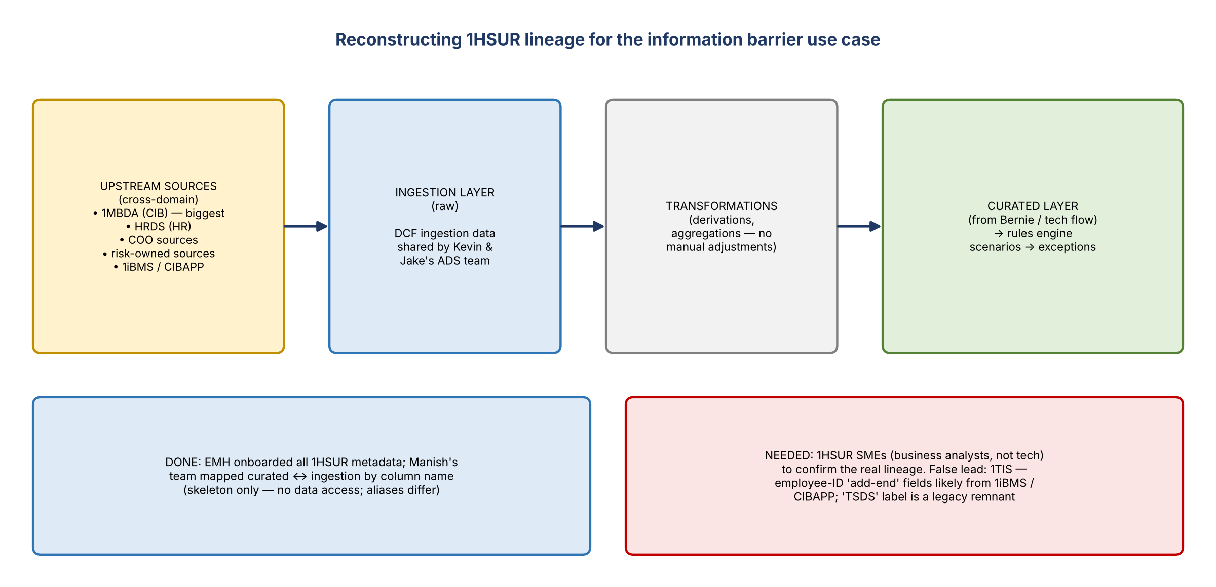
Figure 1. How the team is reconstructing lineage
- Good news: the EMH team onboarded all 1HSUR metadata into EMH.
- Manish and Wissall are comparing Bernie's curated-layer PDEs with the 1HSUR metadata in EMH. Kevin and Jake's ADS team shared ingestion-layer data for 1HSUR from DCF.
- They're aligning curated to ingestion by column names, but without data access and with differing aliases it's only a high-level skeleton. It still gives them something concrete to show upstream teams.
- Ask: someone from 1HSUR to connect the dots. Bernie: it doesn't need to be technology. Business analysts who know the 1HSUR layers and flows front to back, rules engines included, can help.
- Bernie welcomes input on their data flows: "1HSUR is kind of complicated, a lot of moving parts."

The 1TIS question
- The analysis matched an "add-end" field in the curated layer (from barrier-cross details and WFS execution tables) to 1TIS trades and alert extract fields in the ingestion layer, so a ticket was raised to include 1TIS. It can be removed if wrong.
- Bernie and Gilbert: 1TIS isn't a data provider; it's a tool (thought to be for rates or FX). It never appeared in their CSA dependencies.
- Background (Gilbert): TSDS (Trade Surveillance Data Store) was created in compliance and used by both compliance and CIB trade surveillance. After the split, TSDS moved to the front line and compliance moved its pieces to 1HSUR, so the "TSDS" schema label is a remnant.
- The fields are the employee IDs of the person crossing the barrier and the person executing the trade. Bernie thinks that data actually comes from 1iBMS and CIBAPP. Conclusion: likely coincidence; no feed from 1TIS.
- Escalation offer (Bernie): if COO pushes back or things get murky because of CSQR, loop him in.

4. Distribute side and dependencies
- ADS, mapping, PDEs, and the downstream DSDs, EDCC and data source lineage all depend on identifying the right upstream sources, data sets and PDEs.
- Upstream artifacts are owned and completed by the CIB, HR and COO teams at the data source and distribute level, which is why they're "not started".
- Trigger: once cross-domain teams link their data sets to the information barrier use case, they're formally implicated and their clock starts. BDL can work in parallel to get about 90% of ingestion-layer knowledge ready before meeting their PDLs, ABOs and tech teams.
- The biggest connection is 1MBDA (CIB). Risk-owned sources and HRDS were already communicated.
- SLAs (Amanda): cross-domain teams have their own timelines. Under the new policy, use and distribute must be complete by end of 2027. BDL aims to finish its PDE work by December and push PDL teams to finish DSD controls and checks by Q1 2027.

5. Gilbert's ask: concrete, granular timeline
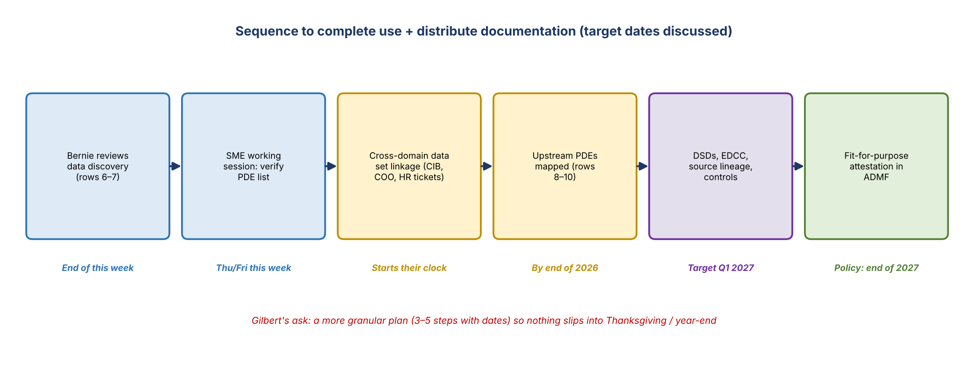
Figure 2. Working sequence and target dates
- The PDE list is the input upstream teams use to map their data, so the business must review it first or upstream gets sent on a wild goose chase (e.g. 1TIS).
- He wants a level below the tracker: three to five steps, in sequence, with dates, so the business can do its part on time. If the business took three weeks, it'd be mid-November; then Thanksgiving, then year-end.
- Amanda has a granular tracker she used with Kathy and reports up to Gilbert and Eugene. She'll connect with Manish (or Kim) to align.
- Manish: BDL has no blockers and can start the analysis immediately. With good responses from CIB, rows 8–10 can finish by end of year.

6. SMEs and scheduling
- Can Bernie's team pull together what's needed within a week or two? Potentially, yes.
- Naga is on PTO until November 12, leaving tomorrow. Philip Thomas helped last time. Suma and Michael, business analysts who know the data mapping, may be best.
- Their tech team is locked up in a DPC cutover to a new data cloud through end of November, so business analysts will help instead.
- Agreed: Manish schedules an initial working session Thursday or Friday this week; Bernie forwards it to the right people. Goal: a verified PDE list to take upstream.

7. Action items
Action | Owner | Notes
Approve the DQ dimensions data dictionary update | Bernie | End of week
Review data discovery (rows 6–7) and the adjustment template | Bernie | End of week
Send meeting minutes plus Jira entitlement instructions | Manish | Today or tomorrow
Schedule the SME working session (Thu/Fri) | Manish | Bernie forwards to Suma / Michael / others
Present lineage observations; verify the PDE list | Manish / Wissall with 1HSUR SMEs
Remove 1TIS from the intake if confirmed not a source | Manish
Build a granular plan (3–5 steps with dates) to year-end | Manish with Amanda (and Kim) | Within 1–2 weeks
Track cross-domain tickets (CIB, COO, HR); keep Gilbert, Bernie, Amanda informed | Manish | Loop Bernie in on COO/CSQR pushback
Finish procedures once sources are final | Manish / team

8. Open questions
- Which upstream sources and PDEs actually feed the curated layer (1MBDA, HRDS, COO, 1iBMS / CIBAPP)?
- When will cross-domain teams link their data sets, starting their clock?
- Can rows 8–10 realistically finish by year-end with the DPC cutover and holidays?

