Meeting Notes
CR360 Data Quality Rules Agent Demo (Use Cases 1702 & 2552)
Item | Detail
Meeting date | Tuesday, October 27, 2026 (recording started about 9:32 AM, just after the intro)
Format | Demo; slides, then live walkthroughs of the business UI, the developer tool, and Dremio results
Presenters | Jeff W. (business / CR360 data quality), Tarun (technology), Zaid (technology; Dremio)
Others | Thaugn (RADAR side), Scott, an AIDA team member, BDL attendees (Jake and team); questioners not always identifiable
Purpose | Show the AI rules agent built to migrate and create data quality rules for CR360, and discuss how it relates to AIDA

Note on the transcript
Auto-generated transcript that starts just after the intro. Speakers aren't labeled; attributions come from context. Confirmed: Tarun (also transcribed "Teron"), Jeff W., Dremio (transcribed "Dreamio"), use case 2552 (heard "2.5.5.2"). Readings used: Thaugn (transcribed "Thawne"), AIDA (transcribed "ADA"/"IDA"), CR360 / RADAR, Tachyon keys. Unsure: Zaid, Scott, "Jack" (person who asked about monitoring), "CAR" (legacy Teradata platform, possibly CARET), "FRY" (likely FR Y-series home lending rules), and "T63".

1. Summary
Jeff W. and Tarun demoed use case 1702, a gen AI rules agent built for CR360, the new credit risk data platform. It migrates thousands of data quality rules from the legacy Teradata platform ("CAR") and will also create new ones.
- The business user enters a target table to pull its DDL, describes the rule and its legacy logic, and the AI writes Dremio SQL.
- The user tests it in UAT against the legacy code and submits a Jira ticket with a standard spreadsheet.
- Developers use a dev tool to upload and load the rules into the repository. The platform's bulk engine executes them, and results flow through Dremio into Power BI.
Testing is still manual. Use case 2552, a testing agent that generates synthetic data and test plans, exists as a local prototype. The solution has already put about 400 auto loan rules into production. For comparison, 500 home lending rules took 18 months without AI in 2023.
Asked how it relates to AIDA:
- This agent uses only schema metadata, no profiling.
- It codes rules the business defines rather than suggesting new ones.
- It was built earlier, out of necessity for the migration.
All agreed to keep comparing the two tools for synergies and avoid duplication as both mature.

2. The use case
- Goal: use AI to automate and speed up the end-to-end data quality lifecycle for CR360: develop rules, generate the code, test, send a Jira to tech, and tech implements.
- The legacy platform ("CAR") on Teradata has thousands of rules to migrate, and new rules are also being developed. The process was very manual.
- Converter or creator? Someone thought these were two separate applications. They're one rules agent that will do both. Today it's mainly used for conversion. Next, they'll standardize how rules are described so AI can generate new rules from a business description plus the schema.

3. Architecture and flow
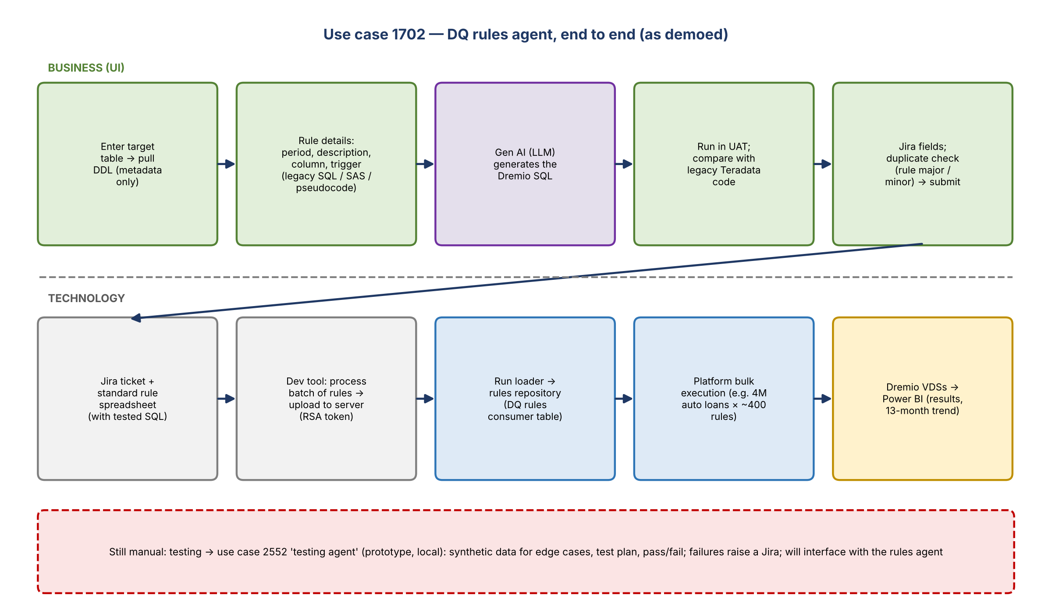
Figure 1. End-to-end flow; business above the dotted line, technology below
- Business uses a standardized rule template across auto loans, home lending, GL and commercial.
- Previously, a developer read each rule, hand-wrote the conversion code, and ran the spreadsheet through the execution platform.
- The execution platform comes from the platform team and handles bulk execution, e.g. about 400 rules each run against 4 million auto loans.
- Gen AI is one small part of the overall solution: it generates the code, and everything else is the team's integration.
- Results are read by Dremio VDSs or queries and fed into Power BI dashboards.

4. Demo: business user (Jeff)
- App options: Create rules (main business use), Test rules (not functional yet; a separate prototype runs locally), and Process batch of rules (mostly for tech, to convert many rules at once).
- Enter the target table to fetch its DDL. That metadata is the key context for the model.
- Enter the rule: period date, rule description, target column, and trigger condition. The trigger can be legacy SQL, pseudocode, SAS, or any logic.
- The AI analyzes the logic against the metadata and generates Dremio SQL for the new platform. Example rule: accounts charged off but still showing an outstanding amount.
- Optionally run the generated query to test it, and run the legacy code on the legacy Teradata environment to compare. The example had no failures, so no rows returned.
- Fill in the required Jira fields (e.g. rule type, rule major and minor), optionally add more rules, then submit. The app checks whether the rule already exists by rule major and minor, then creates the Jira ticket with the logic and the new SQL.
- Many rules can go in one session and one Jira ticket. Only one was shown for time.

5. Demo: developer side (Tarun, Zaid)
- The Jira ticket appears on the developers' board with an attachment: the same standard spreadsheet as today, now including tested code.
- Dev-only tool (not deployed to QA or production): Process batch of rules. Upload the file, set the period date, process rules. The code that developers used to write by hand now arrives already tested on good data in UAT.
- Upload the file from the desktop to the server (RSA token), then run the loader, which writes to the rules repository the system executes from. The tool returns the job ID for troubleshooting. All of this used to be manual.
- Zaid in Dremio: queried the DQ rules consumer table by subject area ("demo") and showed Jeff's rule with its metadata and generated SQL. A previous batch execution of 32 rules showed one row per rule with period date, pass and fail counts, and thresholds. Execution takes about five minutes, so it wasn't run live.
- Those results feed the Power BI dashboards, including 13-month trending.

6. Testing agent (use case 2552, prototype)
- Testing is the main manual step left.
- Prototype (running locally): take the generated logic, have the agent build a test plan, and generate synthetic data covering edge conditions. Example: 32 synthetic records, expecting 31 pass and 1 fail, with failed and passed conditions and the output.
- Output is currently JSON, which is hard to read; that will change.
- It will connect to the rules agent. If a test fails, it raises a Jira to the tech team in the same workflow.
- Expected to be usable for all DQ rules needed in CR360.
- Monitoring: the testing agent is for the development phase. Production monitoring and trending happen in Power BI.

7. How it relates to AIDA
Aspect | CR360 rules agent | AIDA (as discussed)
Inputs to the LLM | Schema metadata only (table and column names, DDL) plus the user's instructions. No profiling service. | Can use data profiles. Can also be set to send only the schema (per the AIDA team member).
Who defines the rule | The business user defines it; AI only writes the code | AI suggests rules the business may not have thought of; users choose
Migration | Converts legacy rules to the new platform | Not available for migration today
Scope | Gen AI for code, plus the full integrated cycle (Jira, loader, bulk execution, Dremio, Power BI) | Available for all tenants on RDS and DPC
Complexity | Single-table rules, complex joins, time dimension, thresholds | n/a

Why it was built (Jeff, Tarun, Thaugn)
- Thaugn questioned whether AIDA was even an option for the RADAR side when this started.
- Timing: it was built before AIDA was fully available, while the team waited a long time for Tachyon keys. It was built as a migration aid.
- Necessity: home lending ("FRY") took about 18 months for 500 rules in 2023 without AI. Auto loans had to deliver 400 rules in four months.
- Result: about 400 auto loan rules are already in production through this solution. The tool itself stays in pre-production; only the generated code goes to production.

Outcome
- Someone noted they'll eventually be asked why one tool is used over another already in production.
- Agreed: compare the two tools for synergies and remove duplication as they mature. The rules agent may eventually be replaced by AIDA. Keep evaluating as AI tools iterate.
- The dev URL can be shared and currently has no entitlements, so anyone can try it.

8. Action items
Action | Owner | Notes
Share the rules agent dev URL with interested attendees | Tarun / Jeff | No entitlements needed
Hold a separate session to demo the testing agent (2552) in full | Jeff / Tarun | Out of time today
Integrate the testing agent with the rules agent; improve the output format | Jeff / Tarun
Standardize rule descriptions so the agent can generate new rules | Jeff / business
Compare the rules agent and AIDA for synergies and duplication | Jeff, AIDA team, BDL | Ongoing

