Meeting Notes
Restarting the Data Strategy with Technology: Deep Dives, Wireframe Session & Workshop
Item | Detail
Meeting date | Wednesday, October 28, 2026 (recording started about 11:37 AM)
Format | Short planning call, after Jacqueline's quick call with technology earlier today
Attendees | Jacqueline (lead), Kevin, Jake. No one is named on the recording; Jacqueline and Kevin are inferred from context
Technology | Eric and Moshin (whiteboarding at the workshop; deep dives), Amber (eGRC technology)
Owners and business | Jeff Goldsmith, Deepen (transcribed "Dippin"), Dana, Gina; for eGRC, Jordan and Panos (Chad mentioned)
Program | James, and John (builds and tracks the plan)
Also referenced | Steve (met today), MA (scheduler), an outside guest leading a CB/CIB data marketplace effort
Purpose | Pick the data strategy work with technology back up: decide what to ask technology, line up three deep dives, and set dates for an internal wireframe session (Tue 11/3) and a two-half-day workshop (Tue–Wed 11/17–18)

Note on the transcript
Auto-generated transcript. Speakers aren't labeled and no one is named on the recording, so attributions come from context. The lead is taken to be Jacqueline: Kevin's leader, who works with John and James and takes asks to technology. The third attendee is taken to be Kevin. Please confirm both. Readings used: Moshin (transcribed "Mosin"/"Mohsen"), RFDIR ("Rifter"), SHRP ("Sharpe"/"Sharp"), eGRC ("EGRC"), IT&V ("ITMV"), Jeff Goldsmith ("Goldsmith"), CR360 / Credit Risk 360 (now RADAR), CADS ("CADs"), data flow ("data float"). Unsure: Deepen ("Dippin"), Dana (possibly Dana Parks), Gina, Amber, Jordan, Panos, Chad, Steve, MA, "EPO", CAR, IRP's full name, the CB/CIB "Marketplace" name, and "before the 11-8" (read as before 11/8). Small talk and personal plans are left out.

Handle with care
Section 6 has a view shared in confidence ("Internal only"), and a few rows in Sections 11–13 refer to it. Remove them before sharing beyond the core team. The agenda document has none of it.

Contents
1 Summary · 2 Why the data strategy is restarting · 3 "What is DPC?" · 4 The plan · 5 The three technology deep dives · 6 Risk and finance data (internal) · 7 eGRC and data ownership · 8 The 11/3 wireframe session · 9 Who's involved · 10 Decisions · 11 Action items · 12 Open questions · 13 Prep considerations · 14 Plain-English glossary · 15 Agendas · Appendix: context from earlier notes

1. Summary
Jacqueline had a quick call with technology earlier today. Technology wants to pick the data strategy conversations back up. They had gone on the back burner, which Jacqueline owned: the team has kept doing good work, but she hadn't had time to get into the details. She's re-engaging now and wants the team to be more direct with technology about what's needed. She'll also ask foundational questions, starting with "what is DPC?"
The group agreed a sequence:
- Three deep dives with technology, next week (some this week if technology has the materials): DPC and the target state architecture; tooling and "AI ready"; data access, ownership and stewardship.
- An internal session on Tue 11/3, 1–5 PM to wireframe the data strategy and assign the work, with James, John (to build and track the plan) and an outside guest running a similar data marketplace effort in CB/CIB.
- A workshop over two half days, Tue 11/17 and Wed 11/18, 1–5 PM. Thanksgiving week was considered and dropped. By then the team needs a detailed data strategy.
Two problems came up that the strategy has to solve:
- Risk and finance can't see each other's data. Each has its own Dremio instance, so the two sides can't be compared (for example, to test whether finance already has what CR360 provides). Meanwhile finance still gets much of what it needs from risk today (for example, CAR feeding the Y14 schedules).
- Ownership on a platform. Technology wants "capabilities and platform, not applications" (for example, building IRP, the SHRP replacement, on DPC). But data ownership is enforced through applications and their ABOs today. How a data owner is defined on the plane is open.
Jake will join every call with technology as translator. He'll turn the three deep dives into a clear list and ask MA to schedule them.
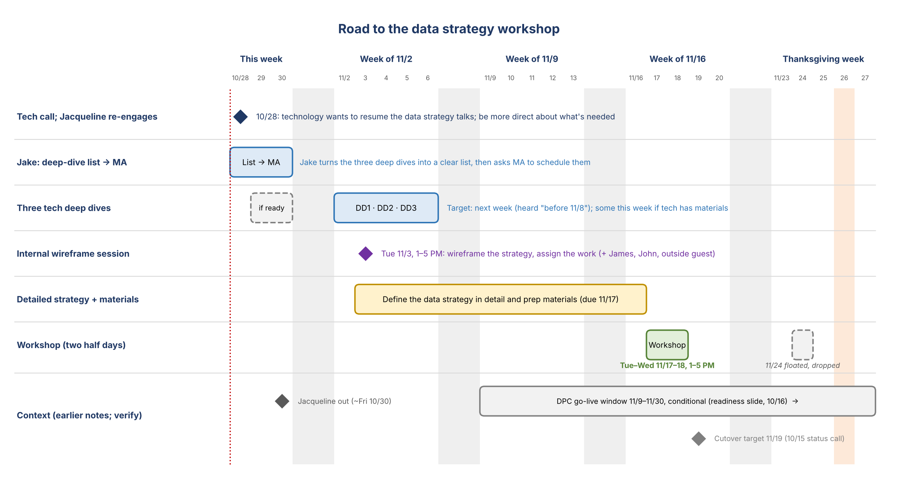
Figure 1. Road to the workshop
At a glance | Outcome
Trigger | Technology wants to resume the data strategy conversations
Approach | Be more direct with technology about what's needed; ask the foundational questions
Deep dives | Three, next week (heard "before 11/8"); some this week if technology is ready
Internal session | Tue 11/3, 1–5 PM: wireframe the strategy and assign the work
Workshop | Tue 11/17 and Wed 11/18, 1–5 PM (two half days, 8 hours)
Due by 11/17 | A detailed data strategy and workshop materials
Jake | Translator on every technology call; owns the deep-dive list and scheduling through MA

2. Why the data strategy is restarting

What Jacqueline said
- She had a quick call with technology today. Technology wants to pick up the data strategy conversations from before, which had been put on the back burner.
- She owned the delay. The team has been doing really good work; she just hadn't had time to devote to the details. She's getting re-engaged now.
- She wants the team to be "a little bit more direct with technology" about what things are needed.
- Some of this will be foundational knowledge for her, and she'll ask basic questions. She wants technology to explain things in their own words, starting with what DPC is.
"I want us to be a little bit more direct with technology of, like, what things are needed."

Jake's role
- Jake explained one of technology's points in plain terms on the call, and Jacqueline found it very helpful.
- She wants Jake on every call with technology from now on, so she can turn to him to translate what technology says.

Context from earlier notes
• The team's working draft is the Risk Data Sourcing Strategy deck (v6.2, 10/16). Goal: trusted, reusable risk data for AI, reporting and analytics on one data plane. Three functional areas: Governance & Enablement, Data Plane Rationalization, and Demand Intake & Sourcing.
• 10/15: requirements sent to technology had been "falling on deaf ears", and technology kept cancelling the meeting on the team's DataHub priorities. The intake tool and DataHub asks were to go to technology for Jacqueline to back with Manav.
• 10/16: Kevin's leader asked to read the deck in detail and ask questions.

3. "What is DPC?" Jacqueline's foundational questions
Jacqueline understands DPC conceptually but wants technology to say it plainly:
"This is what DPC is for [the company], and this is when we are going to be done."
- When is it done? She's heard end of September, then end of October, and now "a couple of weeks", even though it's already the end of October.
- What's been delivered, and what's still to be delivered?
- "Compute and storage are now separate." She was just told this. What does it mean? Should she care, or was it more of a technical fix: separating things so processing doesn't hit a snag?
- Answer on the call: Jake confirmed it's mainly the technical point. Jacqueline: "That was incredibly helpful."
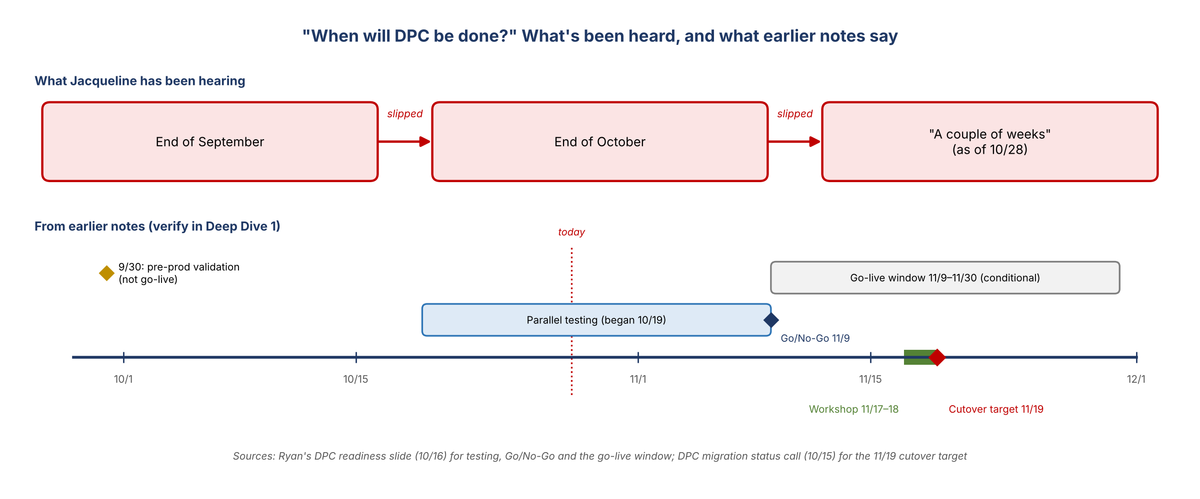
Figure 2. DPC timing: what Jacqueline has heard vs. what earlier notes say (verify in Deep Dive 1)
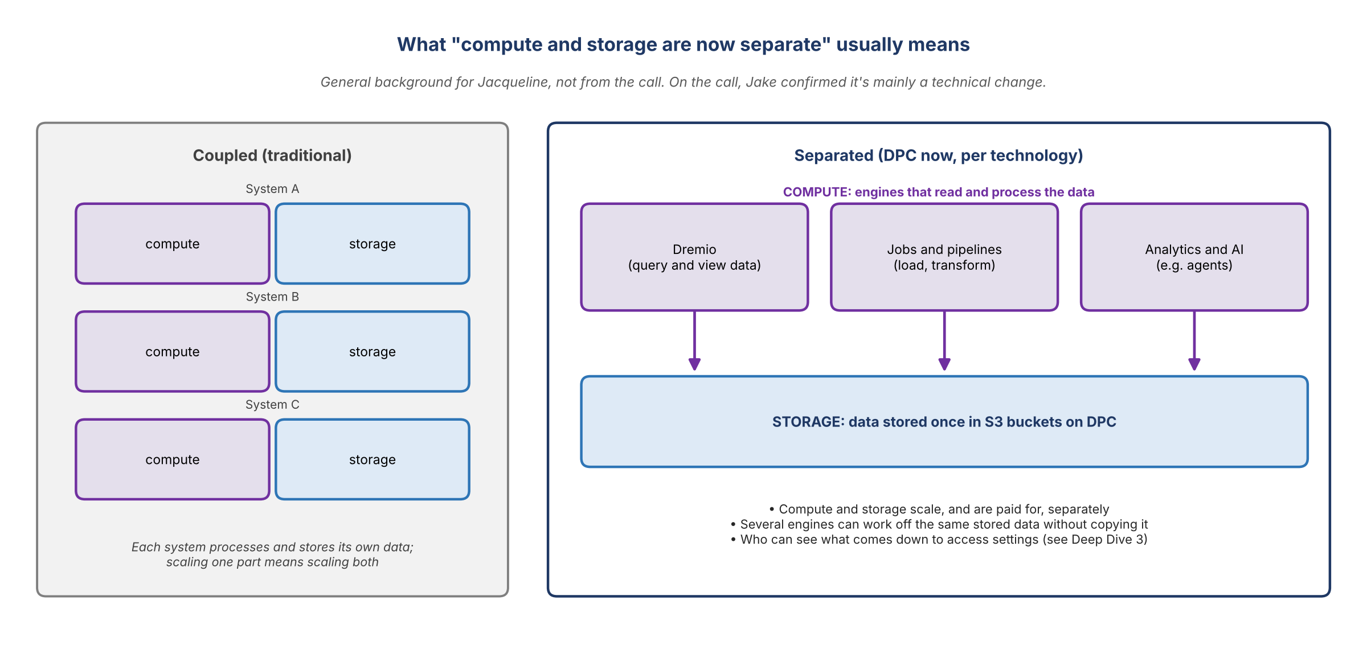
Figure 3. General background on separating compute from storage (not from the call)
Plain-English version for Jacqueline (general background, not from the call)
• Storage is where the data sits. On DPC, that's S3 buckets. Compute is the engines that read and work on the data: Dremio for querying and views, jobs that load and transform data, analytics and AI.
• Separating the two lets each grow, and be paid for, on its own. Several engines can work off the same stored data without copying it.
• Why it may matter to us: if data is stored once, whether risk can see finance data is mostly about access settings, not about moving data. Worth testing in Deep Dive 3.

4. The plan: deep dives, wireframe session, workshop
Figure 1 shows the sequence. Technology walkthroughs come first, to prep the team; the internal session wireframes the strategy; the workshop works through it with technology and the owners.

Choosing the workshop dates
Option | What was said | Outcome
Week of 11/23 (e.g. Tue 11/24) | Thanksgiving week. It would have to be virtual, since it isn't fair to ask people to travel that week | Dropped
The week before (Tue 11/17, Wed 11/18) | Folks will be in town, but there are competing ("dueling") workshops that week | Chosen, as two half days so people can attend both
Time of day | The monthly risk AI discussion runs 12–1 | 1–5 PM on both days
Length | Two half days is eight hours. Is that enough? "I think so." | Eight hours
Format | Jacqueline asked whether virtual would be fruitful with this group. Whiteboarding with Eric and Moshin would be good | Leaning in person; not explicitly confirmed

- Jacqueline will put placeholders on calendars.

Prep expectations
- Before 11/17 the team has to prep materials and define a data strategy "to be rather detailed". There's more time than the two days the team had last time.
- First, get in a room to talk it through, wireframe what we want, and assign out how we'll do it. That's the Tue 11/3 session (Section 8). It can't be sooner because Jacqueline is out around Friday.
- The deep dives all have to happen next week for the workshop to be productive. Some could even happen this week if technology has the materials.
"Otherwise, we'll squeeze ourselves."

5. The three technology deep dives
Jacqueline grouped the asks into three deep dives with technology and asked Jake to make them make sense. For each one, below: what was raised on the call, the context the team already has, and what the team needs out of it.
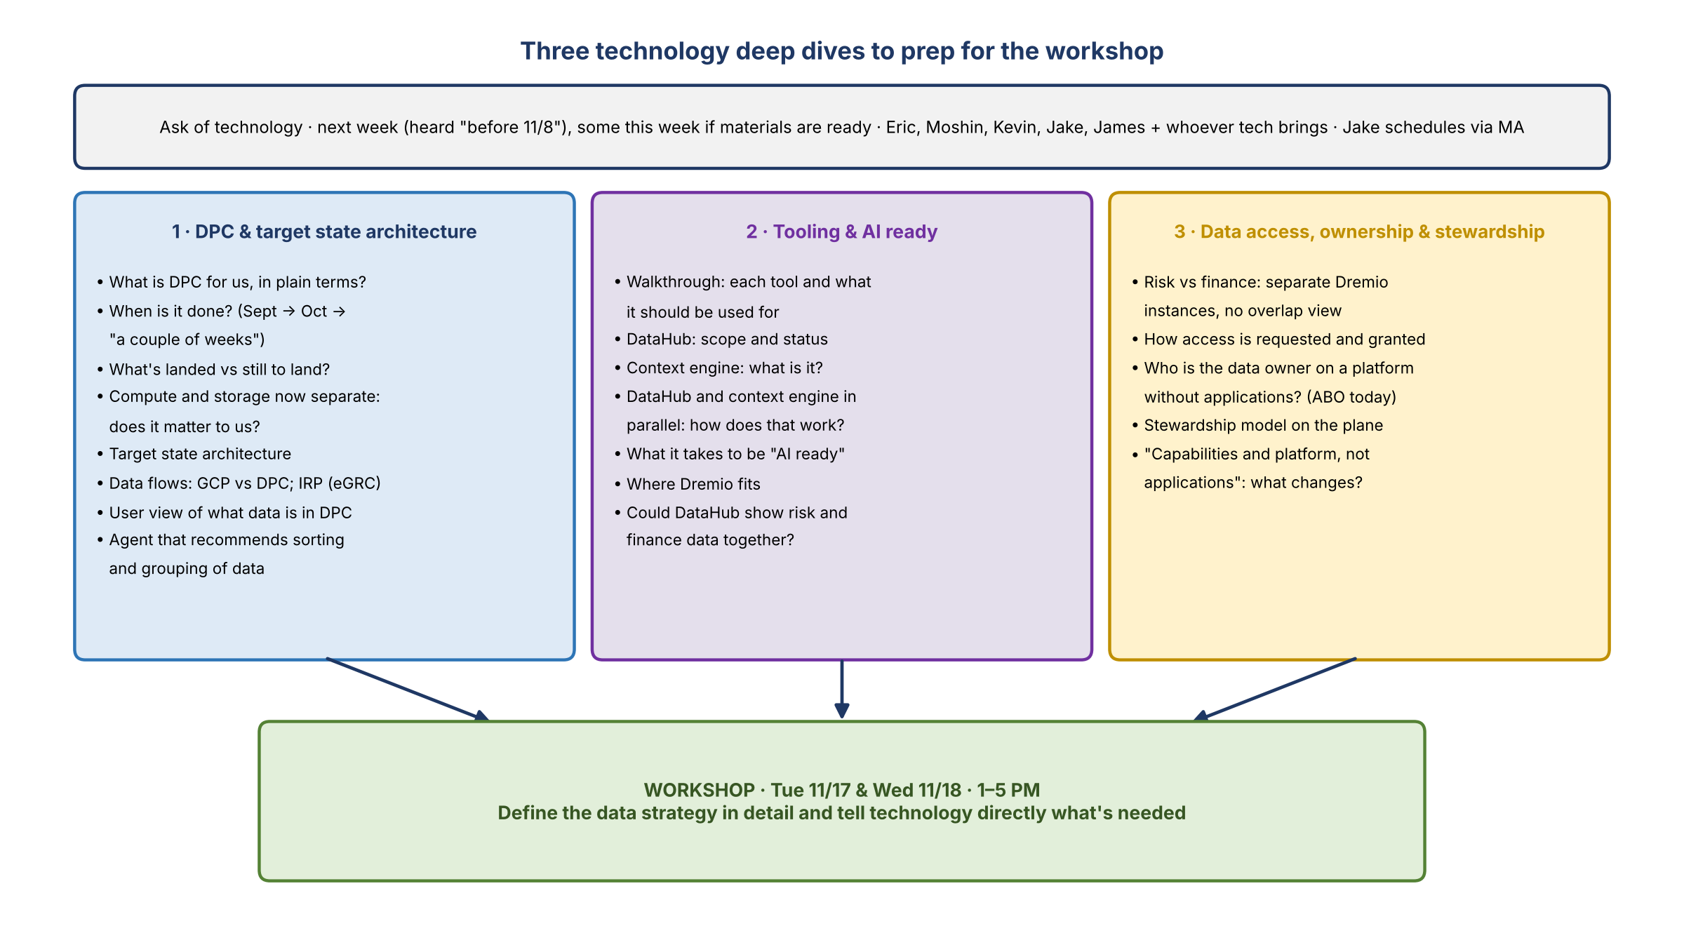
Figure 4. The three deep dives and what each needs to answer

Deep Dive 1: DPC and the target state architecture

Raised on the call
- What DPC is for the company, and when it will be done.
- What's been landed in DPC and what's still to land.
- The target state architecture.
- Data flows: what sits on GCP versus DPC, and the data flow for IRP (the eGRC piece).
- Technology mentioned a visual "user view" of what data exists in DPC. Jacqueline wants to see it.
- Technology also talked about building an agent that recommends how to sort and group data. Jacqueline wants to know what that's about.

Context we already have (earlier notes)
- DPC readiness (Ryan, 10/16): parallel testing began 10/19; Go/No-Go 11/9; go-live window 11/9–11/30, conditional. Cutover target 11/19 (10/15 status call).
- The team's DPC landing plan: data lands in source-aligned folders, is assessed and sequenced, then organized into data categories after migration. A sorting and grouping agent could help with that last step.
- CDO's Ryan said cloud platforms have native harvesting and lineage (DataHub on DPC, Dataplex on GCP).

What we need out of it
- A one-page, plain-English DPC explainer with dates that Jacqueline can reuse.
- A dated list of what's landed and what's next.
- Architecture and data-flow diagrams (GCP vs DPC; IRP).
- A look at the user view, and a description of the sorting and grouping agent.

Deep Dive 2: Tooling and "AI ready"

Raised on the call
- Technology talks about all these tooling options. The team needs a walkthrough of what each tool is and what it should be used for. Jacqueline's analogy: knowing it's a hammer isn't enough; is it a sledgehammer or a trim hammer?
- Tooling and "AI ready" are probably the same conversation. Both came back to DataHub plus the "context engine".
- DataHub is definitely a tool. The context engine was new: the speaker hadn't heard of it until technology mentioned it on today's call.
- It sounded like DataHub comes first, then the context engine. But asked whether you need one before the other, technology said no: they can be done in parallel. How does that work?
- "AI ready" was pinged to Jake in chat during the technology call; check that chat for detail.

Context we already have (earlier notes)
- The deck's Governance & Enablement area covers DataHub (glossaries, dictionaries, metadata), lineage, data quality (AIDA) and standards. Interim tooling: RDS extracts, Dremio views, Excel and Copilot.
- CDO frames "data context" (metadata plus a few other things) as what AI needs, with Bridget sponsoring CDO to own it. Is technology's context engine related?
- Kevin's earlier gap: DPC data needs descriptions to enable DataHub, but DataHub can't create descriptions (10/16 CDO demo).
- Finance already runs semantic certification on DataHub (for CADS); risk plans to follow, ORCAP first, once DPC is live.

What we need out of it
- A tool map: each tool, what it's for, who uses it, status and owner.
- How DataHub and the context engine fit together, and why they can run in parallel.
- A working definition of "AI ready" and what it takes for risk data.

Deep Dive 3: Data access, ownership and stewardship

Raised on the call
- Data access is "a big thing": data owners, data stewardship and access.
- Risk and finance overlap: separate Dremio instances mean neither side can see the other's data (Section 6).
- Ownership is enforced through applications today (the ABO's responsibilities). With technology building "capabilities and platform, not applications", how is the data owner defined on the plane? (Section 7)
- Jacqueline's notes on this one were squeezed into a corner ("something about data access and data stewardship"), so Jake is to firm up the scope.

Context we already have (earlier notes)
- "Finance/Risk Dremio alignment" is driving issue #8 on the DPC readiness slide, escalated to the architect the week of 9/14.
- The semantic certification workflow on DataHub has draft steward and owner journeys (10/16), a starting point for stewardship on the plane.
- The deck positions Governance & Enablement as the data plane's overall governance owner.

What we need out of it
- How access is requested and granted on the plane, and whether cross-domain views are possible.
- Options for seeing risk and finance data side by side.
- Technology's view of ownership and stewardship roles without applications.

Deep-dive logistics
Item | Detail
When | Next week (heard "before the 11-8", read as before Sunday 11/8). Some could happen this week if technology has the materials
Who | Eric, Moshin, Kevin, Jake and James, plus whoever technology wants to bring
Scheduling | Jake reaches out to MA. Jacqueline will send her name; she goes by "MA"
Agendas | Drafts are in the companion agenda document

6. Risk and finance data: the overlap question
Internal only
This section includes a view shared in confidence. Don't share it beyond the core team.

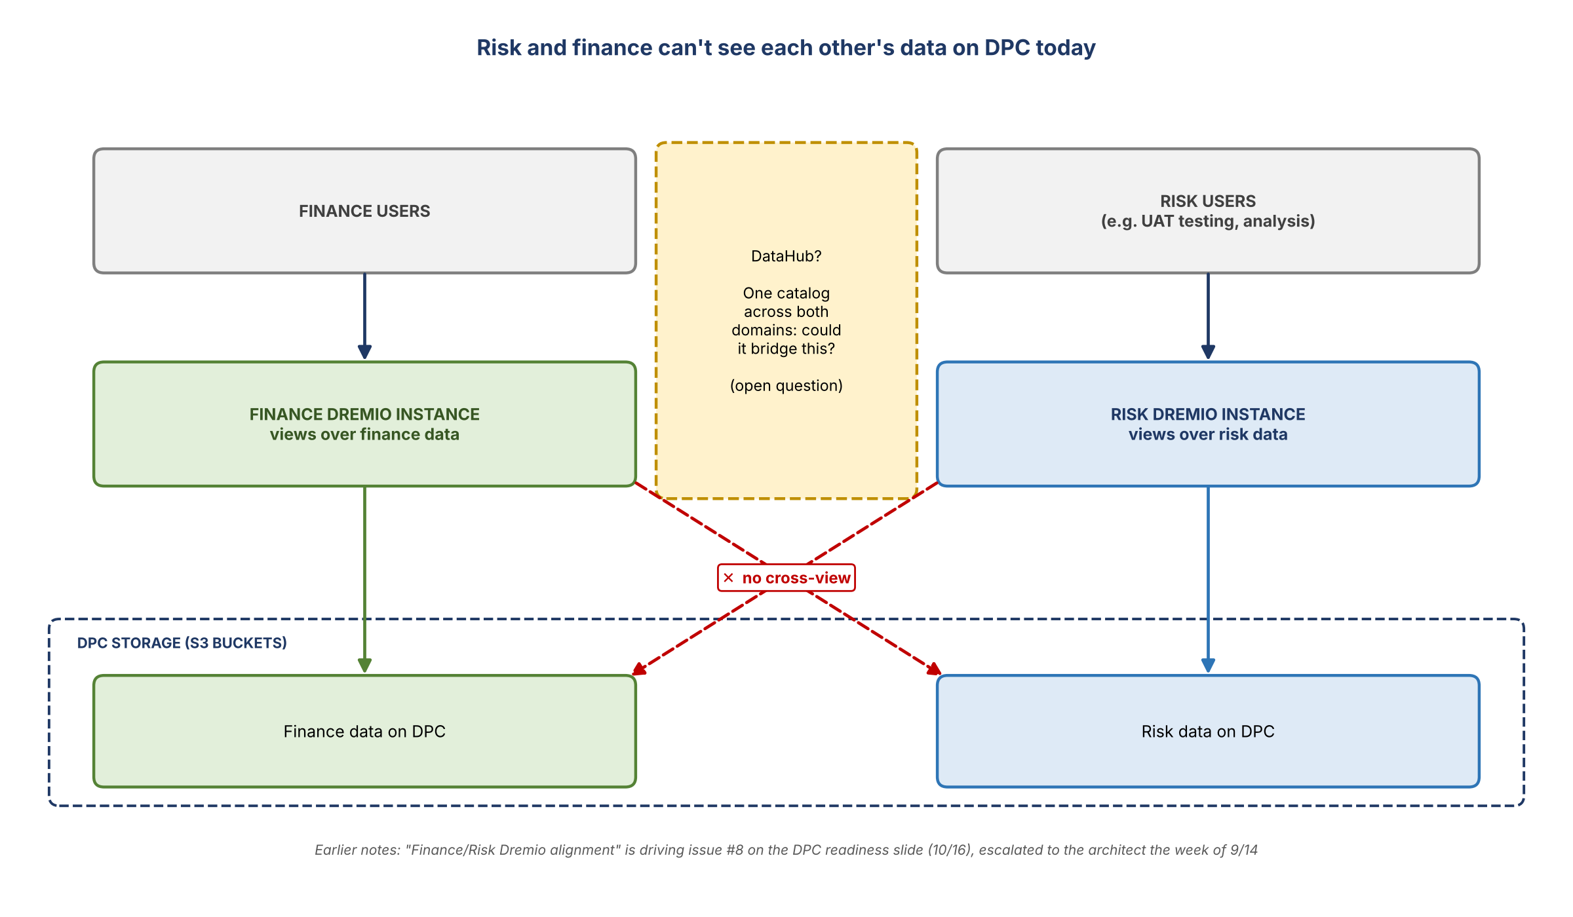
Figure 5. Separate Dremio instances mean no cross-view of risk and finance data

The problem
- Dremio is how the team views the data in DPC's S3 buckets, for example during UAT testing.
- Finance has its own Dremio instance and risk has its own. Risk can't see finance data, and finance can't see risk's.
"How do we ever do the overlap between risk and finance data given the tools that we have?"
- Maybe DataHub solves it, but no one knows yet. It's an open question the team can't quite get its hands around.

Why it matters
- Eric keeps saying CR360 isn't needed because finance has all the data it needs. Without seeing both sides, the team has no way to pressure-test that.
"I have no way to pressure test that unless I can see both sides."

Internal only: shared in confidence
• From a conversation with Steve today: his team isn't getting what it needs from technology. It was shared in confidence. Keep it in mind and don't overshare.
• It changed Jacqueline's view of what's going on.
• Kevin: it helps explain something that hadn't made sense. Much of what finance needs, it still gets from risk today (below).

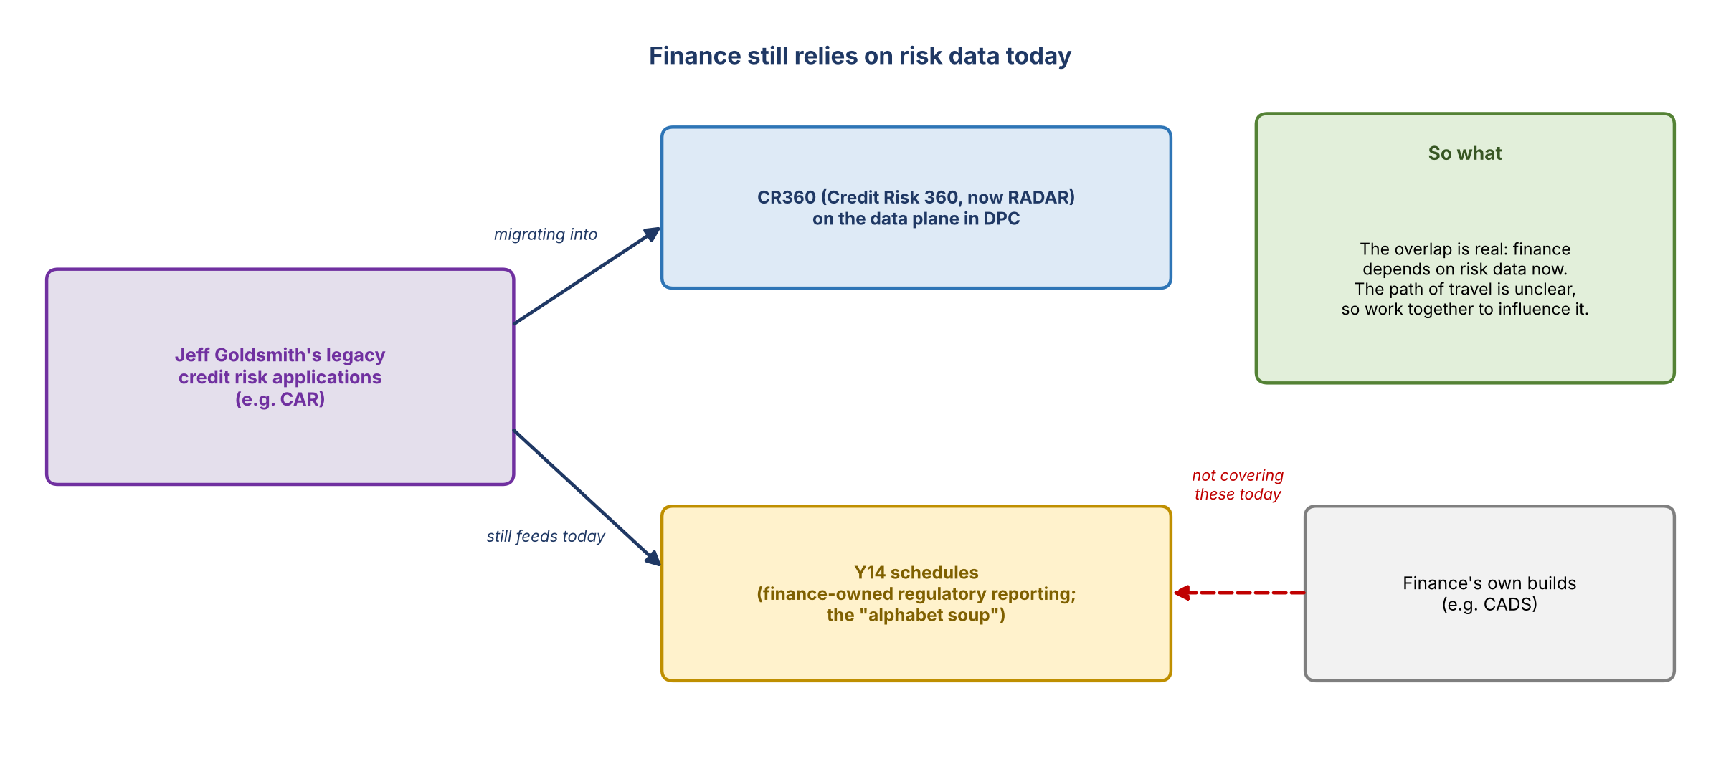
Figure 6. Finance still relies on risk data today

What finance still gets from risk
- Jeff Goldsmith's legacy applications, such as CAR, are being migrated into CR360 (Credit Risk 360, now RADAR) on the data plane in DPC.
- But CAR still provides data to the Y14 schedules ("all the alphabet soup"). That isn't being solved by CADS or whatever finance has built internally.
- Finance seems to think there will be significant overlap. Given what finance actually gets today and the path of travel, the message was: let's work together to influence this the right way.

The relationship with finance
- There's a good relationship to forge and a lot of opportunity to work together. What it ends up looking like isn't clear yet.
"I'm still interested. I just don't know what it's going to be."

Context from earlier notes
• Finance owns the Y14 use case; risk models feed Y14 Schedule D (10/19).
• Finance's CADS is already on DataHub with semantic certification (10/9).
• The OCI daily estimate used interim views in the finance Dremio space that won't carry into DPC (10/26).

7. Platform, not applications: eGRC and data ownership
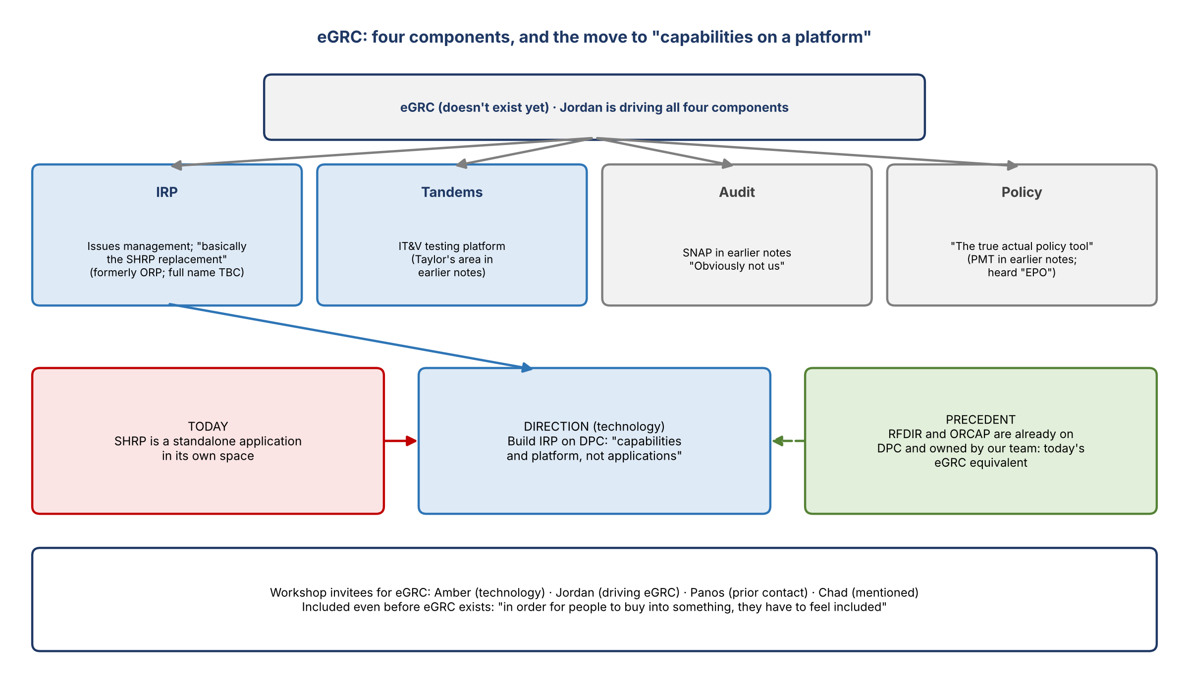
Figure 7. eGRC's components and the move to capabilities on a platform

eGRC's components
Asked who the eGRC equivalents are, the group named Amber from technology for the technology side. The business side took a moment: Jordan, then Chad, then back to Jordan, who is driving all of the components. Jordan and Panos are the likely contacts; Panos is who the speaker had talked to before.
Component | Heard on the call | Earlier notes (10/8)
IRP | Issues management ("issues, risks…"; full name to get). "Basically the SHRP replacement." Discussed on today's technology call | The SHRP replacement, formerly ORP, for issues management
Tandems | The IT&V testing platform (transcribed "ITMV") | Tandems (IT&V testing); Taylor handles it
Audit | "Obviously not us" | SNAP (strategic audit platform)
Policy | "The true actual policy tool"; heard "EPO" | PMT (policy management tool)

- Technically, our team owns ORCAP and RFDIR today. With no eGRC yet, we're the current-state equivalent.
- Jacqueline will include the eGRC folks anyway, so they feel part of it:
"In order for people to buy into something, they have to feel included."

IRP and the platform model
- The data flow discussion also covered IRP. As understood, technology is building the SHRP replacement on DPC. Just as RFDIR and ORCAP are on DPC today, eGRC would live there rather than as a standalone application in a different space, the way SHRP is today.
- Technology wants it to be "capabilities and platform, not applications."

Context from earlier notes
• 10/13: Kevin was to ask Jacqueline who to talk to about eGRC. This call names Amber (technology), Jordan and Panos.
• 10/13: Tandems has its own S3 bucket; still open whether eGRC ends up with one bucket per application or one eGRC bucket.
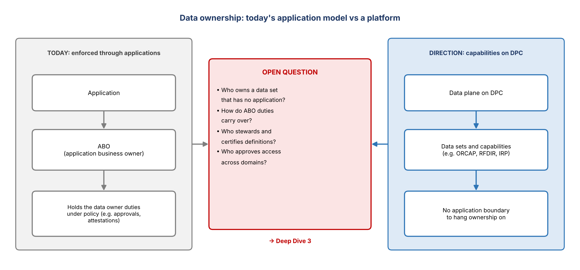
Figure 8. The data ownership question

The data ownership question
"The whole data owner concept is enforced at this company through applications... how do we define what that is on the plane?"
- Today, the application business owner (ABO) carries the data owner responsibilities.
- On a platform of capabilities there's no application to hang that on. Who owns a data set, who stewards it, and who approves access all need defining. This goes to Deep Dive 3 and the workshop.

8. The Tue 11/3 wireframe session and the outside perspective
Item | Detail
When | Tue 11/3, 1–5 PM. Four hours booked; everyone gets time back if it finishes early
Purpose | Walk through what the team believes the data strategy needs to be, wireframe it, and assign out the work before 11/17
Who | Our team ("whoever you guys think needs to be there"), James, John, and an outside guest dialing in
Invite | Jacqueline sends it; the team forwards it to others
John's role | Build out the plans and keep the team on track. Jacqueline: "he's really good at it"

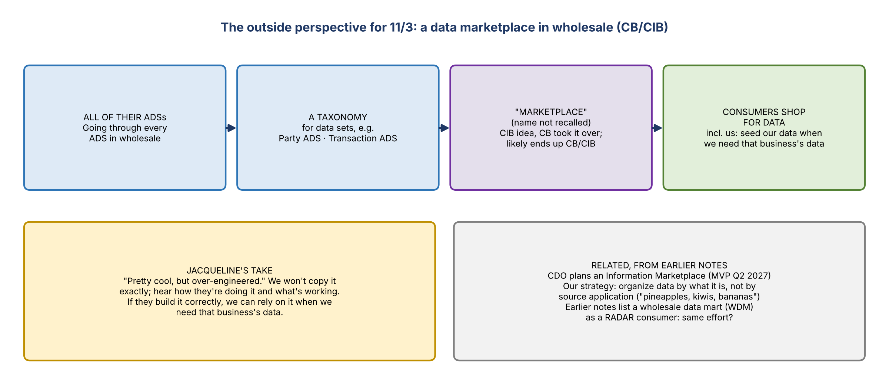
Figure 9. The CB/CIB data marketplace idea

The outside guest
- A contact of Jacqueline's, based in New York, who was in Charlotte this week.
- His group is doing something very similar, which they call a data mart in wholesale. They're going through all of their ADSs and organizing them into things like a party ADS and a transaction ADS.
- They're building a taxonomy for how they classify data sets. Jacqueline: "pretty cool, but over-engineered." The team won't necessarily do the same, but should hear how they're doing it.
- They call it "Marketplace" something (she couldn't recall the name). It started as a CIB idea; CB took it over and it will probably end up as CB/CIB. He inherited it.
- If they build it correctly, the team can rely on it to help seed its own information when it needs that business's data.
- Jacqueline's aside: soon everyone will have a marketplace, and we'll all just be shopping for data.

Context from earlier notes
• CDO plans an Information Marketplace (MVP Q2 2027) to make data discoverable and automate provisioning (10/16).
• The team's own principle: organize data by what it is, not by source application ("pineapples, kiwis, bananas").
• Earlier notes list a wholesale data mart (WDM) as a downstream RADAR consumer; worth checking whether it's the same effort.

9. Who's involved
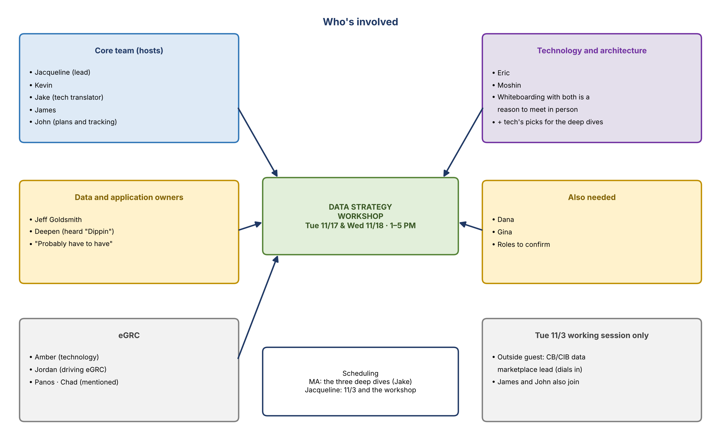
Figure 10. Who's involved
Name | Role or context | Involvement | How sure
Jacqueline | Meeting lead; re-engaging on the data strategy | Sends the 11/3 invite, workshop placeholders and MA's name | Inferred (not named on the recording)
Kevin | Jake's manager; the team owns ORCAP and RFDIR | Deep dives; workshop | Inferred
Jake | Translator on technology calls | Deep-dive list; scheduling via MA | Present
James | Program partner | 11/3 session; deep dives | Named
John | Program driver | Builds and tracks the plan from 11/3 | Named
Eric | Technology; earlier notes have Eric Bland, risk technology covering finance and risk | Workshop whiteboarding; deep dives | Named; surname from earlier notes
Moshin | Risk architecture; reports to Chris Cryan (10/28 SAS notes) | Workshop whiteboarding; deep dives | Named
Jeff Goldsmith | Owner of legacy credit risk applications such as CAR | Workshop ("probably have to have") | Named as "Goldsmith"
Deepen | Transcribed "Dippin"; possibly Deepen from the 10/26 OCI notes | Workshop ("probably have to have") | Unsure
Dana | Possibly Dana Parks (risk technology, per earlier notes) | Workshop ("need to have") | Unsure
Gina | Role not stated | Workshop ("need to have") | Unsure
Amber | eGRC technology | Workshop | Named
Jordan | Driving the eGRC components (eGRC owner in earlier notes) | Workshop | Named
Panos | eGRC contact the speaker had talked to before | Workshop | Named
Chad | Briefly suggested as the eGRC business contact | Possibly | Named
Steve | Met today; shared a view in confidence | Context only | Named
MA | Scheduler; goes by "MA" | Schedules the deep dives | Named
Outside guest | Leads the CB/CIB data marketplace effort; New York | 11/3 session (dial-in) | Not named

10. Decisions
# | Decision | Detail
1 | Pick the data strategy work with technology back up | Jacqueline is re-engaging; the team is to be more direct with technology about what's needed
2 | Run three technology deep dives first | DPC and target state; tooling and AI ready; data access, ownership and stewardship. Next week, some this week if technology is ready
3 | Workshop on Tue 11/17 and Wed 11/18, 1–5 PM | Two half days (8 hours), the week before Thanksgiving; avoids the 12–1 monthly risk AI discussion
4 | Internal wireframe session on Tue 11/3, 1–5 PM | Our team plus James, John and an outside guest
5 | Include eGRC stakeholders | Amber, Jordan and Panos, even though eGRC doesn't exist yet
6 | Jake joins every technology call | As translator
7 | Deep-dive attendees | Eric, Moshin, Kevin, Jake and James, plus technology's picks
8 | Scheduling | Jake through MA for the deep dives; Jacqueline handles the rest

11. Action items
Action | Owner | Due | Notes
Send Jake MA's name | Jacqueline | ASAP
Turn the three deep dives into a clear list | Jake | This week | Draft in Section 5 and the agenda document
Ask MA to schedule the three deep dives | Jake | This week | For next week; earlier if technology has materials
Invite Eric, Moshin, James and technology's picks | Jake (via MA) | With scheduling | Kevin and Jake attend
Put workshop placeholders on calendars (Tue 11/17 and Wed 11/18, 1–5 PM) | Jacqueline | This week
Send the Tue 11/3, 1–5 PM working session invite | Jacqueline | This week | Team forwards to James, John and the outside guest
Get IRP's full name | Kevin (likely) | Before the workshop | "I will get that"
Confirm workshop invitees | Jacqueline / Kevin | With placeholders | Eric, Moshin, Jeff Goldsmith, Deepen, Dana, Gina, Amber, Jordan, Panos
Decide in person or virtual | Jacqueline | Before invites go out | Whiteboarding with Eric and Moshin favors in person
Wireframe the data strategy and assign the work | Team | Tue 11/3
Build out the plan and keep the team on track | John | From 11/3
Prepare materials and define the data strategy in detail | Team | By Tue 11/17
Keep Steve's comment in confidence | All | Ongoing | Don't overshare

12. Open questions
Theme | Question | Where it gets answered
DPC | What is DPC for the company, in plain terms, and when will it be done? | Deep Dive 1
DPC | What's been landed so far, and what's still to land? | Deep Dive 1
DPC | Does compute and storage being separate change anything for us? | Deep Dive 1
DPC | What's the target state architecture? | Deep Dive 1
DPC | What sits on GCP vs DPC, and how does data flow between them? | Deep Dive 1
DPC | What's IRP's data flow, and is eGRC being built on DPC? | Deep Dive 1
DPC | What will the user view of DPC data show, and when? | Deep Dive 1
DPC | What will the sorting and grouping agent do? | Deep Dive 1
Tooling | What tools are on offer, and what is each for? | Deep Dive 2
Tooling | What is the context engine? | Deep Dive 2
Tooling | How can DataHub and the context engine proceed in parallel? | Deep Dive 2
Tooling | What does it take for risk data to be "AI ready"? | Deep Dive 2
Access | How can risk and finance see overlapping data with separate Dremio instances? Could DataHub help? | Deep Dive 3 (and 2)
Access | How is access requested and granted on the plane? | Deep Dive 3
Ownership | Who is the data owner on a platform without applications, and how do ABO duties carry over? | Deep Dive 3; workshop
Ownership | What's the stewardship model? | Deep Dive 3; workshop
eGRC | What's IRP's full name? Who's the eGRC business contact: Jordan, Panos or Chad? | Kevin / Jacqueline
Workshop | In person or virtual? | Jacqueline
11/3 | Who is the outside guest, and what is the marketplace called? | Jacqueline
People | What are Deepen's, Dana's and Gina's roles? | Jake to confirm
Internal | Does finance really have the data CR360 provides? What will the risk–finance relationship look like? | Needs a both-sides view (Deep Dive 3)

13. Prep considerations (not discussed on the call)
These are Jake's prep points, drawn from this call and earlier notes. They weren't discussed on the call.
Consideration | Why | Suggested move
Deep dives must land next week | Jacqueline: "otherwise, we'll squeeze ourselves"; the strategy is due 11/17 | Ask MA for all three in one request; send agendas and pre-read asks with the invites; offer this week for any session that's ready
Technology bandwidth | DPC's go-live window (11/9–11/30) and the 11/19 cutover overlap the workshop week (earlier notes) | Ask in Deep Dive 1 who'll be tied up and when; confirm Eric's and Moshin's availability for 11/17–18 early
A plain answer to "what is DPC" | Jacqueline wants it in plain terms, with an end date | Ask technology for a one-page explainer with landed vs to-land dates; Jake translates
Make the overlap question concrete | The CR360 claim can't be pressure-tested without both sides | Ask for a demo: can anyone see both the finance and risk spaces (Dremio or DataHub)? Ask for the status of DPC issue #8
Start ownership from what exists | Ownership on the plane is open | Bring the DataHub steward and owner journeys and today's ABO duties to Deep Dive 3
Avoid duplicate tools | Context engine vs CDO's data context; CB/CIB marketplace vs CDO's Information Marketplace; Eric's harvesting tools vs CDO's AIDP | Ask how each relates in Deep Dive 2 and on 11/3
eGRC alignment | Component lists differ between notes (policy as "EPO" vs PMT; audit vs SNAP); IRP's full name is unknown | Confirm with Jordan and Panos; consider inviting Taylor (Tandems)
Workshop logistics | In person helps whiteboarding; competing workshops that week; the 12–1 monthly risk AI discussion | Book a room with whiteboards plus a dial-in; send pre-reads by Fri 11/13
Confidential input | Steve's comment was shared in confidence | Keep it out of shared materials; the agenda document has none of it
Use the tech-call chat | "AI ready" and data flow were pinged to Jake during the technology call | Fold those notes into the Deep Dive 1 and 2 questions

14. Plain-English glossary
For Jacqueline's foundational questions. "General" means standard industry meaning, not something said on the call.
Term | Plain English | Basis
DPC | The new data cloud platform where the risk data plane lives. Data is migrating there from RDS. Full name to confirm in Deep Dive 1 | Earlier notes
Data plane ("the plane") | The shared, governed layer of risk data on DPC: source once, govern centrally, reuse across risk | Team deck
Compute vs storage | Storage is where data sits; compute is the processing that reads and works on it. Separating them lets each scale on its own | General
S3 bucket | Cloud object storage; where data on DPC is stored | Call
Dremio | The query and view layer over the S3 data. Finance and risk each have their own instance today | Call
UAT | User acceptance testing: the business checks results before go-live | General
DataHub | Metadata catalog on DPC: glossary, data dictionaries, lineage. Finance uses it for semantic certification | Earlier notes
Context engine | Mentioned by technology; not yet explained. May relate to the "data context" AI needs (metadata plus more) | Call (unclear)
AI ready | Technology's term for data prepared (with metadata and context) so AI can use it. To define in Deep Dive 2 | Call (unclear)
GCP | Google Cloud Platform. Some risk workloads run there (e.g. PyFarm) | Earlier notes
Data flow | How data moves between platforms and systems (e.g. GCP and DPC; into IRP) | Call
Target state architecture | The intended end-state design of the platforms and how data moves between them | General
Tenant | A separately managed area on a shared platform (e.g. a team's space on DPC) | General
eGRC | The planned governance, risk and compliance platform: IRP, Tandems, audit and policy. Doesn't exist yet | Call
IRP | eGRC's issues management piece; the SHRP replacement (formerly ORP). Full name to confirm | Call; earlier notes
SHRP | Today's standalone issues application, to be replaced by IRP | Call; earlier notes
Tandems | eGRC's IT&V testing platform | Call; earlier notes
SNAP / PMT | eGRC's audit (SNAP) and policy (PMT) pieces in earlier notes; policy was heard as "EPO" on this call | Earlier notes
ORCAP / RFDIR | Risk applications already on DPC, owned by our team | Call
CR360 / RADAR | Credit Risk 360, now called RADAR: the credit risk data platform moving from RDS to DPC | Earlier notes
CAR | A legacy credit risk application (Jeff Goldsmith's) being migrated into CR360; still feeds the Y14 schedules | Call
Y14 schedules | The Fed's FR Y-14 regulatory reporting (stress-testing data). Finance owns the Y14 use case | General; earlier notes
CADS | Finance's internally built data store, already on DataHub | Earlier notes
ADS | An enterprise-designated data set (CDO lists 76 strategic ADSs), e.g. a party ADS or a transaction ADS | Call; earlier notes
Taxonomy | A standard way to classify data sets (e.g. by party or transaction) | General
Data marketplace | A place to find and request data. CB/CIB is building one; CDO plans an Information Marketplace (MVP Q2 2027) | Call; earlier notes
ABO | Application business owner. Holds the data owner responsibilities for an application's data under today's policy | Call; earlier notes
Data owner / steward | Owner: accountable for a data set. Steward: manages its definitions and quality day to day | General
Wireframe | A rough outline of something before the detail is filled in | General

15. Agendas
Full drafts are in the companion document, Data Strategy Sessions: Draft Agendas. Summary:
Session | When | Length | Focus
Deep Dive 1: DPC and target state | Next week (by Fri 11/6) | 60 min (proposed) | What DPC is, timeline, landed vs to land, architecture, data flows, user view, sorting agent
Deep Dive 2: Tooling and AI ready | Next week | 60 min (proposed) | Tool walkthrough, DataHub and the context engine, AI readiness
Deep Dive 3: Data access, ownership and stewardship | Next week | 60 min (proposed) | Access, risk and finance visibility, ownership and stewardship on the plane
Internal wireframe session | Tue 11/3, 1–5 PM | 4 hours | Outside perspective, wireframe, workshop design, assignments
Workshop | Tue 11/17 and Wed 11/18, 1–5 PM | 2 × 4 hours | Day 1: where we are and where we're going. Day 2: how we'll run it and what we need

Appendix: Context drawn from earlier notes
Background used in the context boxes. None of it was discussed on this call; verify anything that matters.
Source | Date | What it adds
Risk Data Sourcing Strategy deck (v6.2) | 10/16 | Goal and functional areas; intake tool and DataHub asks for technology; DPC readiness dates; driving issue #8 (Finance/Risk Dremio alignment); eGRC as a future use case
Working session: risk data sourcing pillars | 10/8 | eGRC's four applications: IRP (SHRP replacement, formerly ORP), PMT, Tandems, SNAP
RADAR DPC migration status | 10/8 | Wholesale data mart (WDM) listed as a downstream RADAR consumer
Pillar deck review | 10/13 | Jordan owns eGRC; Taylor handles Tandems; Tandems's S3 bucket; Kevin to ask Jacqueline who to talk to about eGRC
Data plane pillars team review | 10/15 | Requests to technology "falling on deaf ears"; DataHub priority meetings cancelled
DPC migration status call | 10/15 | Production parallel from 10/19; cutover target 11/19
CDO metadata harvesting demo | 10/16 | "Data context" for AI (Bridget sponsoring); Information Marketplace MVP Q2 2027; DataHub on DPC still to be built; Eric Bland and Dana Parks in risk technology
Semantic certification sessions | 10/9, 10/16, 10/19 | Steward and owner journeys on DataHub; finance's CADS on DataHub
Y14 Schedule D confirmation | 10/19 | Finance owns the Y14 use case
OCI daily estimate | 10/26 | Interim views in the finance Dremio space; Deepen
SAS exit acceleration | 10/28 | Moshin is in risk architecture and reports to Chris Cryan; John and James's program roles

