Meeting Notes
FRM Data Management Landscape, RDS Ownership & FRC Entitlements (with Heather)
Item | Detail
Meeting date | Wednesday, October 28, 2026 (recording started about 1:32 PM)
Format | Discussion; Kevin shared in chat the applications feeding FRM's tier 1 use cases
Corporate risk / DMI | Kevin Moody, Brian (his team supports tier 1 use case documentation), Jake (reports to Kevin; data sourcing)
FRM | Heather (Finance Risk Management, under Coulson; reports to Linda, now under Nicole; represents Nicole at domain council)
Referenced | Nicole, Coulson (FRM CRO), Linda, Chris Youse and Brian Claire (finance frontline; data sourcing), Eric Nelson (credit risk reporting), Daisy Liu (FRM models), Terry (former RDS owner)
Purpose | Heather gathering a corporate risk view of FRM's data management obligations for Nicole: are there gaps beyond what finance frontline does? Also RDS ownership and FRC entitlement cleanup

Note on the transcript
Auto-generated transcript. Speakers aren't labeled; attributions come from context. Confirmed: Chris Youse (transcribed "Yowes"/"Yowse"), Brian Claire, Daisy Liu, FFPA (fit-for-purpose attestation; transcribed "FFBA"), ART requests, Essbase (transcribed "S-Base"). Unsure: Coulson (also "Colson"), Eric Nelson, ARIA / ERI (Linda's program), Lattice, ADA (a finance data source, not the AIDA tool), MRD APP, BAM, and "Kajam". The speaker who said they own everything DMP-related wasn't identified.

1. Summary
Heather, now in Finance Risk Management (FRM) after the CIRM split, was asked by Nicole to map FRM's data management obligations. FRM tends to piggyback on finance frontline, and Nicole wants to know whether corporate risk-specific initiatives are being missed.
Kevin and Brian's answer: FRM is in good shape under the data management policy.
- FRM owns two tier 1 use cases; Brian's team supports their documentation.
- All of their approved data sources sit in finance; FRM owns none. The handful of EUCTs aren't approved data sources, so they carry only tier 3 requirements.
- Fit-for-purpose attestation (FFPA) for the two use cases is close, waiting on data set approvals from CDO.
- No known defects in the space, but Nicole has never reported any through the monthly Power App, which may be a gap worth digging into.
DMI only sees sources feeding tier 1 and tier 2 use cases, so the broader FRM data landscape is a question for Coulson's directs and finance (Brian Claire on Chris Youse's team).
Separately, Kevin is now the owner of RDS following Terry's departure. FRC (foundational risk components) data, which should have been retired a year ago, still has entitlement requests. Pending ART requests naming Terry will be left in place while Kevin's team reassigns all of Terry's entitlements.

2. RDS ownership and FRC entitlements
- RDS: Kevin is now the RDS owner (Terry has left). FRCs are still in RDS and should be the first thing to go; they were supposed to be retired a year ago.
- FRC background: the FRC program ran under CIRM and was fully disbanded around March–April. People still email that they weren't told the corporate risk hierarchy was changing.
- Stray entitlements: Heather still receives entitlement requests for FRC data. A few stragglers were recently submitted to change ownership to Terry, plus an MRD APP entitlement Terry had made Heather the owner of. Kevin's team got a batch on Monday; Jake confirmed they appear on the team's report of items Terry approves.
- Decision: leave Heather's pending ART requests as they are for now. Kevin's team is reassigning all of Terry's entitlements and will decide who takes what.
- Offer: Heather will help with RDS and the FRC cleanup. She was product owner for an RDS tech team for about five years.

3. Nicole's ask: FRM's data management footprint
- FRM is Coulson's org (Finance Risk Management). It tends to follow whatever finance frontline does. Nicole wants to confirm there are no gaps for corporate risk data initiatives, i.e. anything Coulson should be doing as FRM CRO.
- Heather is also getting work from Eric Nelson (credit risk reporting) via Nicole.
- Heather had recently sent data source owners and use case owners a heads-up about role-based training following last month's policy updates. Nicole then asked what they all do.
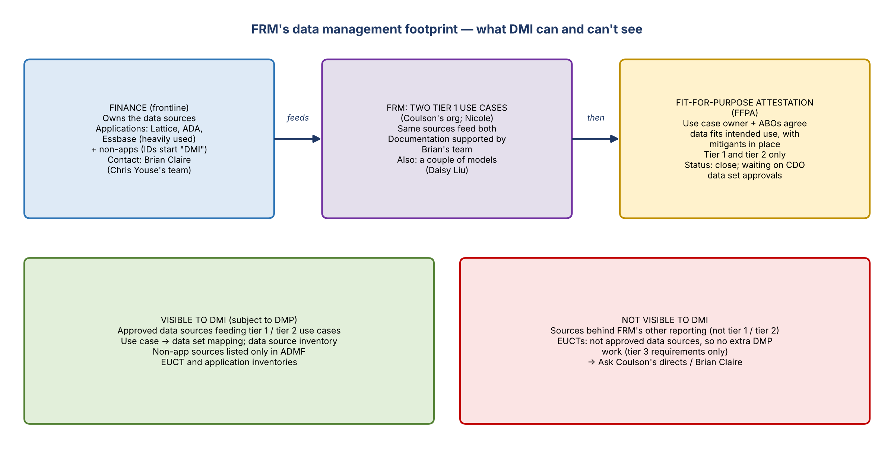
Figure 1. FRM's footprint and what DMI can see

What FRM owns
- Two tier 1 use cases. Brian's team supports all of their documentation.
- No approved data sources. All sources feeding the use cases are in finance. There are a handful of EUCTs, but EUCTs aren't approved data sources. Only approved data sources require additional work under the data management policy, so that work sits with finance.
- A couple of models, with Daisy Liu.
- No FRM applications: they all pull from finance.

Fit-for-purpose attestation (FFPA)
- The final step of the data management work: the use case owner and the ABOs agree the data can be used for its intended purpose, with risk mitigants in place.
- Applies to tier 1 and tier 2 use cases.
- Brian: close for FRM's two, but held up waiting on data set approvals from CDO.

Limits of DMI's visibility
- DMI can only say which data sources feed tier 1 and tier 2 use cases. Sources used for other FRM reporting aren't visible to DMI. They'd fall under tier 3 requirements.
- DMI does have EUCT and application inventories, but the work only covers tier 1 and tier 2 feeders.
- Heather will tell Nicole she can provide what DMI knows of Coulson's data landscape (sources, tier 1 and tier 2 use cases). For the rest, ask Coulson's directs.

Inventories Heather can use
- Use case inventory and data source inventory (Heather already has data source owners and use case owners).
- Use case to data set mapping. ADMF reporting is less useful because data sources can't be tagged in ADMF.
- For more granularity: the model and EUCT inventories, though only implicated items are captured.
- Applications in chat (Kevin): the applications feeding the tier 1 and tier 2 use cases today. Includes Essbase, which finance relies on heavily. Heather asked whether there's a systematic connection to it or just spreadsheets being loaded; reports are prepared from finance spreadsheets. The same sources appear in both use cases, e.g. Lattice and ADA.
- Data source IDs containing "DMI" indicate a non-application. The ID is the data source's, not the use case's.
- Get names from ADMF rather than BAM; non-apps are listed only in ADMF.

4. Defects
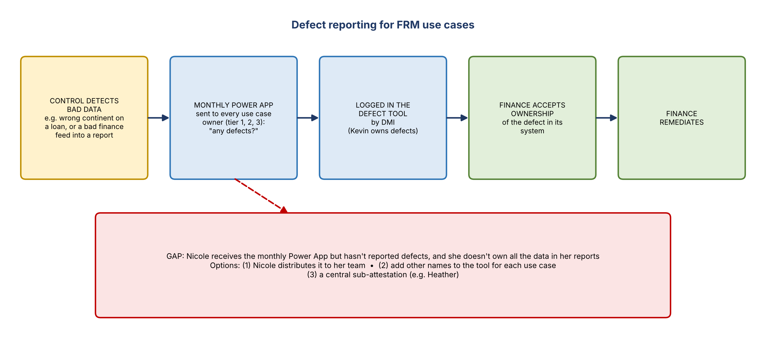
Figure 2. Defect reporting flow and the gap
- No known defects in Coulson's space, and no DMP gaps. Nicole asks this at every domain council and is told she's fine.
- Monthly Power App: every month all use case owners (tier 1, 2 and 3) are asked whether they have defects to report. Nicole receives it but hasn't reported any.
- Nicole doesn't own all the data feeding the reports she's listed as owning. Options:
  - Nicole distributes the Power App within her team.
  - Add other names to the tool for each use case, pushing it down a level.
  - Someone like Heather does a central sub-attestation.
- What counts as a defect: a data quality defect. Example: someone fat-fingers the continent as Europe instead of North America when onboarding a loan. Also bad data in a report from finance, caught by FRM's own controls.
- Process: FRM reports it, DMI logs it in the tool, finance accepts ownership of the defect and remediates its system.
- Heather: this may be one area to dig into.

5. Roles and contacts
- Heather now represents Nicole at domain council and recaps for her what Nicole and Coulson will care about.
- DMI side: one participant owns everything DMP-related; Kevin owns defects. Reach out directly with questions.
- Jake reports to Kevin and supports his data sourcing work.
- Finance contacts: Brian Claire on Chris Youse's team is the data sourcing person and very helpful. Heather already sent Chris Youse a note.
- Heather offered to liaise with Coulson's org, which usually went through Nicole.

6. Action items
Action | Owner | Notes
Contact Brian Claire (Chris Youse's team) on finance's data sourcing and FRM's other reporting | Heather
Send the use case inventory, data source inventory and use case to data set mapping | Kevin / Brian | Can be sent offline
Pull non-app data source names from ADMF | Heather
Recap for Nicole: no DMP gaps; what DMI can and can't see | Heather | Rest goes to Coulson's directs
Consider how to route the monthly defect Power App beyond Nicole | Heather / Kevin | Distribute, add names, or sub-attest
Finish fit-for-purpose attestation for the two tier 1 use cases | Brian's team | Waiting on CDO data set approvals
Reassign Terry's entitlements, including the FRC stragglers and MRD APP | Kevin / Jake | Leave Heather's pending ART requests for now
Help with RDS and the FRC retirement | Heather | Offered

7. Open questions
- What data sources sit behind FRM's reporting beyond the two tier 1 use cases?
- Who takes over each of Terry's entitlements, and when can FRC data be retired from RDS?
- When will CDO approve the data sets blocking the fit-for-purpose attestation?

