Meeting Notes
SAS Exit Acceleration: Planning the Next Two Weeks
Item | Detail
Meeting date | Wednesday, October 28, 2026 (recording started about 2:00 PM)
Format | Working session; the program side shared and edited a status and timeline slide live
Corporate risk BDL | Kevin, Kelly, Jake
Program side | John, Matt, James (newly working with the BDL team on this)
Referenced | Jacqueline (executive driving the acceleration), Kiran (head of model risk management), Manav (head of the technology team), Brian Schiffer (modeling), Moshin (risk architecture; reports to Chris Cryan, lead architect), Tammy
Purpose | React to Jacqueline's push to accelerate the SAS exit to about a year, agree what can be done by 11/13, and plan reporting for her new weekly Fast Exit update

Note on the transcript
Auto-generated transcript. Speakers aren't labeled; attributions come from context. SAS is transcribed "SaaS"; PyFarm as "Pyform". Confirmed: Kiran (transcribed "Kiran"), Manav, Moshin (transcribed "Mosin"/"Moshin"). GAMLP is thought to be the Oracle product. Unsure: Chris Cryan, Tammy, Bridget, the GCP model execution application (name not captured), Minerva, "Mission Mondays" and "Taxco Thursdays" (meeting series), "develop a plan with the RNNs", ECRM, and the 1.37% figure on the status slide.

1. Summary
Jacqueline called a meeting earlier this week to accelerate the SAS exit from potentially 18+ months to about a year, and wants the initial tasks done within two weeks. The understanding is an enterprise-wide exit ("a full divorce from SAS"). Corporate risk is expected to report on, or have line of sight to, workspaces outside corporate risk, but not necessarily manage them.
BDL's position: the survey and discovery work can be accelerated, but the migration itself isn't in BDL's control. Models are the long pole because they need model validation, though the purely technical conversion could likely be faster than 18 months.
The group agreed to move as fast as possible, lay out a realistic timeline, and let leaders push back if they need it sooner.
The two-week plan, with 11/13 as the backstop:
- Kickoffs and survey: done.
- Survey responses: due 11/3.
- Consolidation: 11/5.
- Exit strategy gaps: moved to 11/11.
- Themes and the no-plan list for tech: by 11/13.
Early signal: most owners have no exit plan and don't know their options. Dependencies on workspaces outside corporate risk are a major unknown.
Next steps:
- Matt and James will design a tranching approach.
- Reporting will be built for Jacqueline's new weekly Fast Exit update (Tuesdays, 2 PM ET), with a prep session Monday.

2. The acceleration ask
- Jacqueline pulled the group into a meeting (Monday or Tuesday) on accelerating the SAS exit from potentially 18+ months to a year, with the initial tasks done in the next two weeks.
- Scope: James understood it as enterprise-wide, everything off SAS. Corporate risk would likely report on, or have line of sight to, other areas without managing them; this can be reconfirmed.
- What Kevin heard on an earlier call with Kiran (head of model risk management), Manav (head of technology) and Brian Schiffer (modeling):
  - A workspace supporting a model could have up to 18 months, versus analytics or dashboarding use cases.
  - Leadership wants off as soon as possible.
  - The real drop-dead date might be 2028, when the SAS contract is renegotiated.
- Counterpoint: the program side doesn't believe a renegotiation is happening. They'd heard the contract could be ended at any time. Manav reportedly said he'd handle it if told to cut SAS off immediately. They'll ping Moshin to confirm.
- Jacqueline may also be escalating to push the team to lay out a plan.
- Agreed approach: go as fast as possible, state realistically what can be done, and let leaders decide whether it must be quicker.

3. Feasibility: why models are the long pole
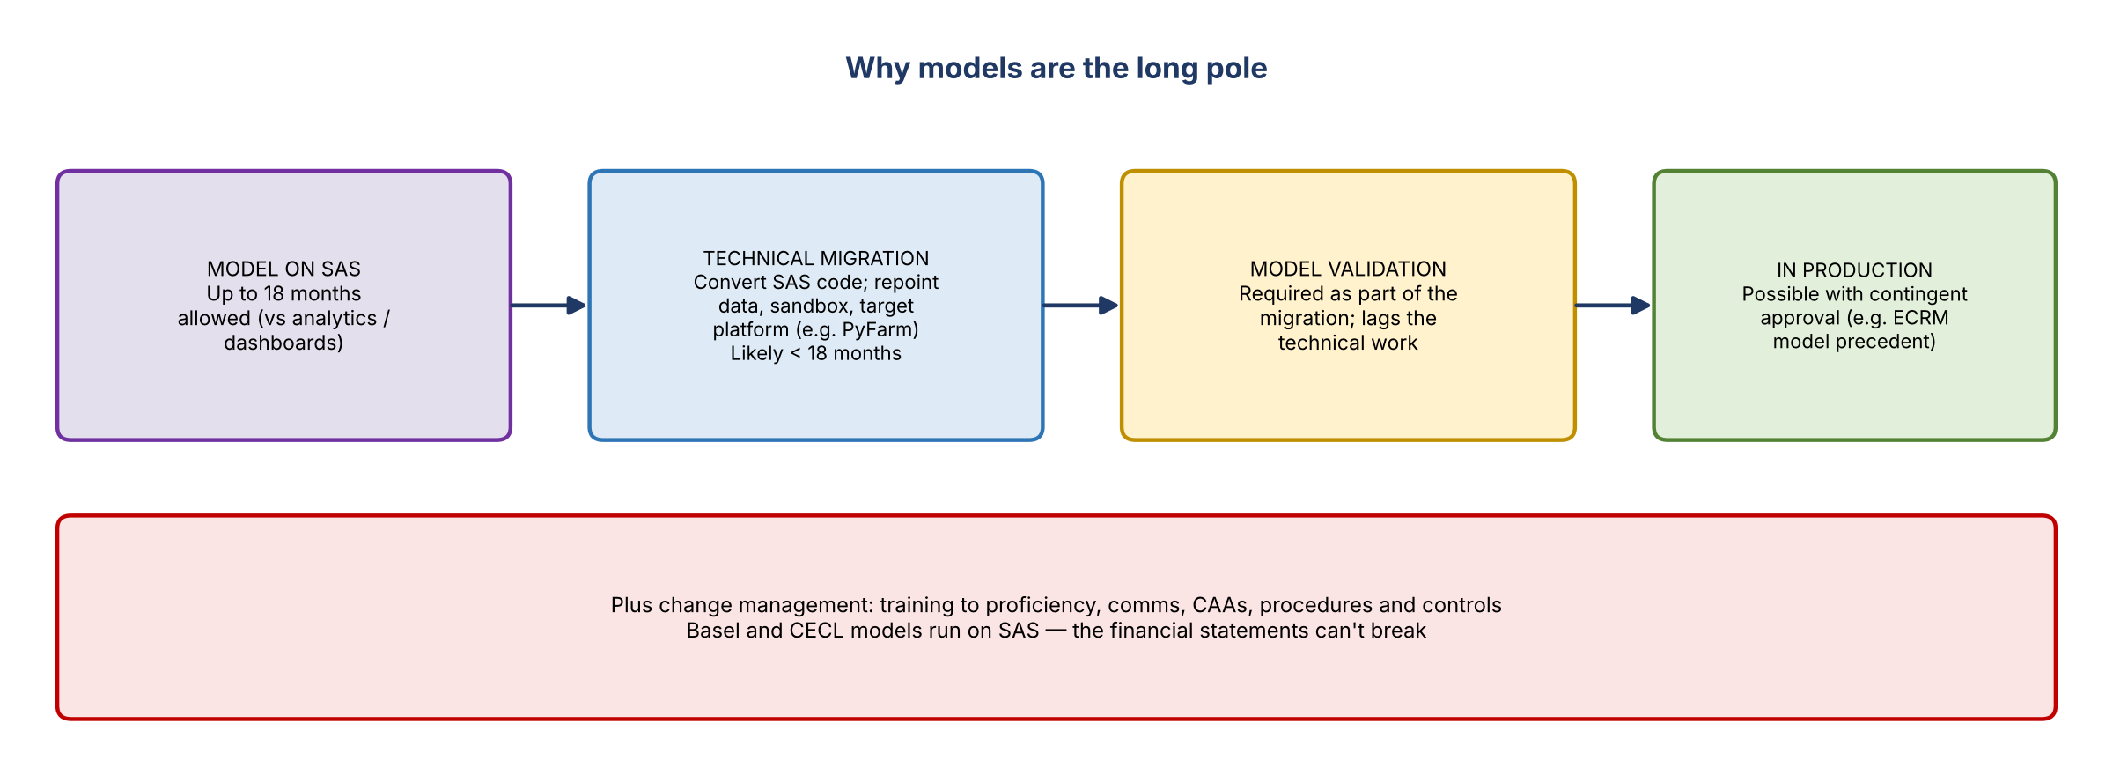
Figure 1. Model migration path and constraints
- BDL can accelerate the survey and discovery timeline, but not owners' actual move off SAS.
- Models must go through model validation as part of the migration.
- From a purely technical view, converting SAS code to another language and repointing data, sandboxes and targets could likely be done in under 18 months. Validation would lag.
- Models can be used before full validation with contingent approval. It's frowned upon, but there's precedent: the ECRM model was approved with contingency.

4. Status and two-week plan
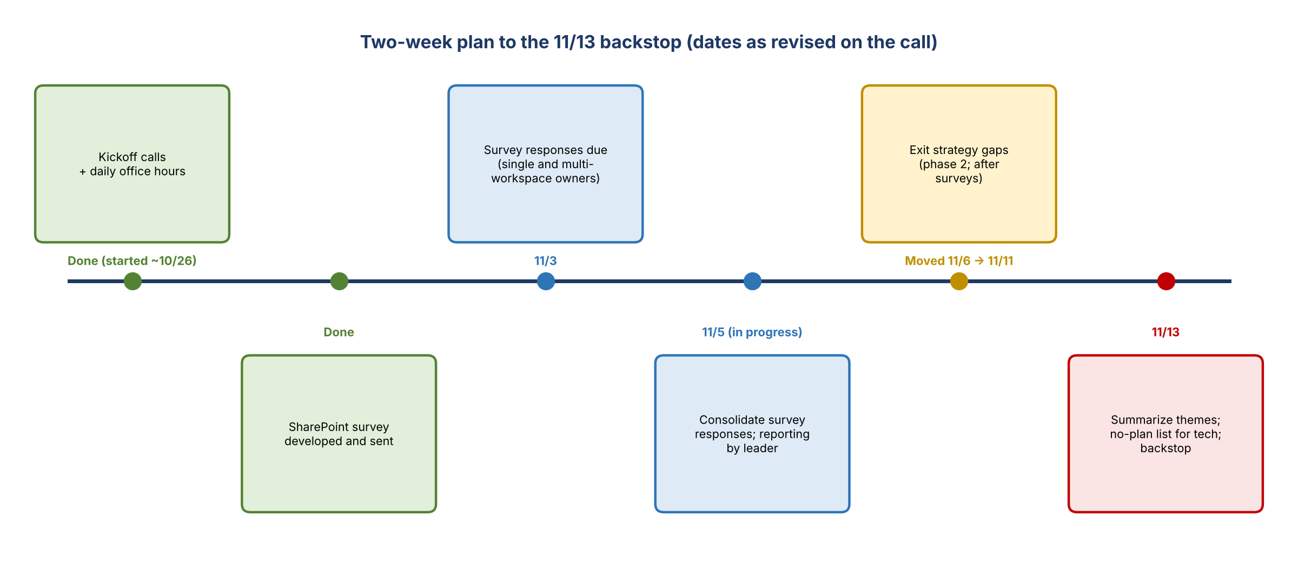
Figure 2. Plan to the 11/13 backstop
Task | Date / status | Notes
Kickoff calls with workspace owners | Done | Started about two days ago
Daily office hours | Ongoing | Three or four people joined yesterday with good questions
Develop the survey | Done | SharePoint survey instead of the original Excel template (Tammy's recommendation)
Survey responses due | 11/3 | About 40 single-workspace owners; about 25–26 workspaces held by multi-workspace owners (individual kickoffs held; migration plan per workspace)
Consolidate survey responses | 11/5 (in progress) | Completion reporting by leader; reminders to respond by 11/3
Exit strategy gaps | Moved from 11/6 to 11/11 | Needs surveys in first (phase 2); a single day after consolidation wasn't enough
Summarize themes; no-plan list for tech | Target 11/13 | Needs tech's help on what to do with workspaces that have no plan, and timelines

- Reduction to date: the status slide shows a 1.37% reduction achieved.
- Stale ownership: at least 10 cases so far where the owner has no idea what's in the workspace or needs to change the owner. CDO's ownership reporting isn't well maintained; owners moved roles and point elsewhere. This applies to workspaces, not licenses.
- Themes to summarize: models with a plan, models without a plan, analytics with a plan, and so on.

5. Early findings: few plans, little awareness of options
- So far, not many people have a plan to get off SAS. Most intend to keep using it until forced.
- A few are actively migrating to PyFarm (Python).
- Owners don't know their options; it's a common question.
- Financial Crimes example: a GCP application was meant to be the target-state model execution platform. For transaction monitoring models, Financial Crimes had discussed an Oracle product: GAMLP (believed to be Oracle), where about five models moved. Financial Crimes is now considering AI to consolidate and replace models, and data for two transaction monitoring models is being loaded into FCTDS so AI can work on it. Most are still on SAS today.
- No roadshow on alternatives yet: not that anyone is aware of, and not by BDL. It could run alongside the survey since there are only two or three options.
- Can owners be pigeonholed? Analytics teams likely can. Models are different. Precedent: analytics users were told to move to the data lake as Teradata is retired, with no choice offered.

6. Tranching the population
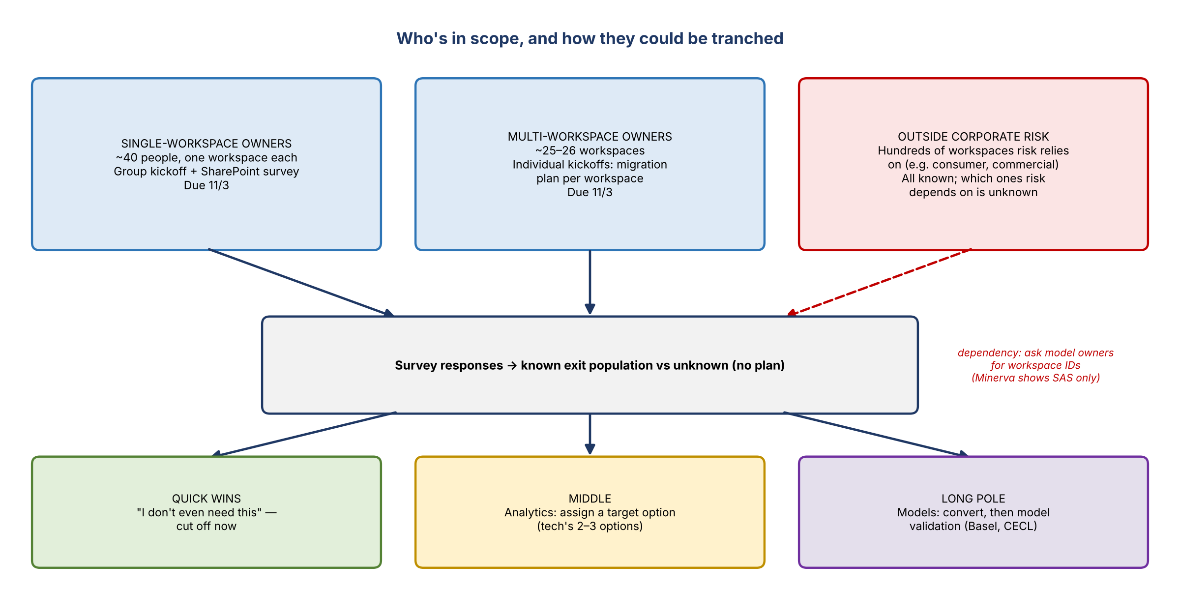
Figure 3. Populations in scope and a possible tranching
- Split into a known exit population and an unknown one, then tranche into waves. Either assign a solution or hold war rooms to find what works.
- Tech proposed a few options in a deck sent yesterday, including moving code into GitHub repos. Group each type of SAS environment by which option applies.
- Expected shape: quick wins ("I don't even need this; cut it off tomorrow"), a long tail that will take a long time, and a middle.

Dependencies outside corporate risk (raised by Kiran)
- Hundreds of workspaces outside corporate risk feed risk work, e.g. consumer data (moved to the consumer line of business) and some commercial. If they're shut off, risk is impacted, so those owners need to know about the dependency.
- The survey asks owners to flag dependencies on other owners' workspaces; results are expected to be mixed.
- Minerva shows whether a model uses SAS, but not which workspace. Idea: ask model owners for the workspace ID.
- The full list of workspaces is available, but not which ones risk depends on (probably most). This could need a separate survey since it reaches different people.

7. Change management
- Plan for training and comms. SAS users must be trained to proficiency on new tools. Some have only incrementally modified a program written years ago (e.g. eight years), so expect a learning curve that affects timing.
- Also CAAs, procedures and controls, making sure people can still deliver their work.
- All Basel and CECL models run on SAS; the financial statements can't break.

8. Governance and reporting
- Jacqueline's Fast Exit update: a new weekly series, Tuesdays at 2 PM ET, with executives. Build reporting for it.
- Chris Cryan is lead architect (possibly finance and risk). Moshin reports to him and covers risk specifically.
- Kevin attends "Mission Mondays" and "Taxco Thursdays", where Jacqueline will hear updates and John and James can pick up items.
- Cadence: ad hoc check-ins rather than a fixed weekly meeting for now. BDL will send reporting regularly.
- Prep: tight reporting before the first Fast Exit update. The group meets Monday to prepare.

9. Action items
Action | Owner | Notes
Confirm the contract position and timeline (no renegotiation vs 2028) | Program side (ping Moshin)
Reconfirm scope: report on vs manage workspaces outside corporate risk | James / program side | If needed
Send completion reporting by leader and reminders | Kelly / Jake | Due 11/3
Follow up with multi-workspace owners on per-workspace plans | Kelly / Jake | Due 11/3
Consolidate survey responses; share results | Kelly / Jake | 11/5
Identify exit strategy gaps | BDL / program side | 11/11
Summarize themes; produce the no-plan list for tech | BDL with tech | 11/13
Design a tranching approach (quick wins, middle, long pole); map tech's options | Matt / James
Work out how to identify dependencies outside corporate risk (model owner workspace IDs, possible separate survey) | BDL / program side
Build reporting for the Tuesday 2 PM Fast Exit update | BDL / program side | Prep meeting Monday
Schedule the Monday prep meeting | Program side | Around Kevin's schedule
Factor training, comms, CAAs and controls into the plan | Program side

10. Open questions
- Is the deadline about a year, 18 months for models, or tied to a 2028 contract date?
- Is corporate risk accountable for workspaces outside corporate risk, or only for reporting on them?
- Which of tech's options apply to models versus analytics, and who will educate owners on them?
- How will dependencies on workspaces outside corporate risk be identified?

