Meeting Notes
SAS Platform Reporting, Ownership & Retention (with Mary & Anand)
Item | Detail
Meeting date | Tuesday, October 27, 2026 (recording started about 11:06 AM, partway in)
Format | Working session; Mary and Anand shared the file inventory extracts, the L2 Confluence / Power BI reports, and the owner verification survey
SAS platform / CDO | Mary Tucker (SAS platform owner; 24 years supporting it), Anand (SAS reporting)
Corporate risk | Kevin, Kelly, Jake, AJ
Referenced | Kim Fisher (CDO cost allocations), Steven Schweinfurth (manages the 1SASGRID owner verification list), Norm
Purpose | Find out what SAS reporting exists to identify the users of each workspace, how to retire workspaces safely, how retention and archive work, and how to fix stale ownership

Note on the transcript
Auto-generated transcript that starts mid-conversation. Speakers aren't labeled; attributions come from context. SAS is transcribed "SaaS". Confirmed: Steven Schweinfurth, NGDC (Next Generation Data Center), Mary Tucker. Readings used: 1SASGRID ("one SAS Grid"/"one task"/"one test"), SAS Grid 1, 9SAS (Auto SAS), ELIDs, CRM 050 (records retention code).

1. Summary
Mary and Anand showed that much of what the team needs already exists. Mary's file inventory extracts cover every SAS file system: about 30 GB for the whole 8 PB platform, one file per file system on SharePoint. Each record has the created date, last-accessed date, owner (ELID) and size. Anand's monthly workspace details report has the LOB hierarchy and workspace path. Joining the two on path shows who has created or updated files in each workspace in the last 13 months and who uses the most space.
Limits:
- The extracts show owners, not readers.
- Workspace-to-user mapping exists only for 1SASGRID.
- The other platforms control access through Unix groups, and that list isn't published yet.
Safe retirement: block access for a period before deleting (a "scream test"). The SAS team won't delete files; owners must, and a workspace can only be retired once it's empty.
Archive isn't the cost problem: cold, gzipped, about 80% cheaper, 10-year retention, no deletions yet.
Ownership fixes for 1SASGRID go through the owner verification SharePoint survey. Mary will send the link, and Kelly and AJ can update it on owners' behalf. Kim Fisher (CDO) handles cost allocations. Mary will share the file inventory report with Kevin, Kelly and Jake.

2. File inventory extracts (Mary)
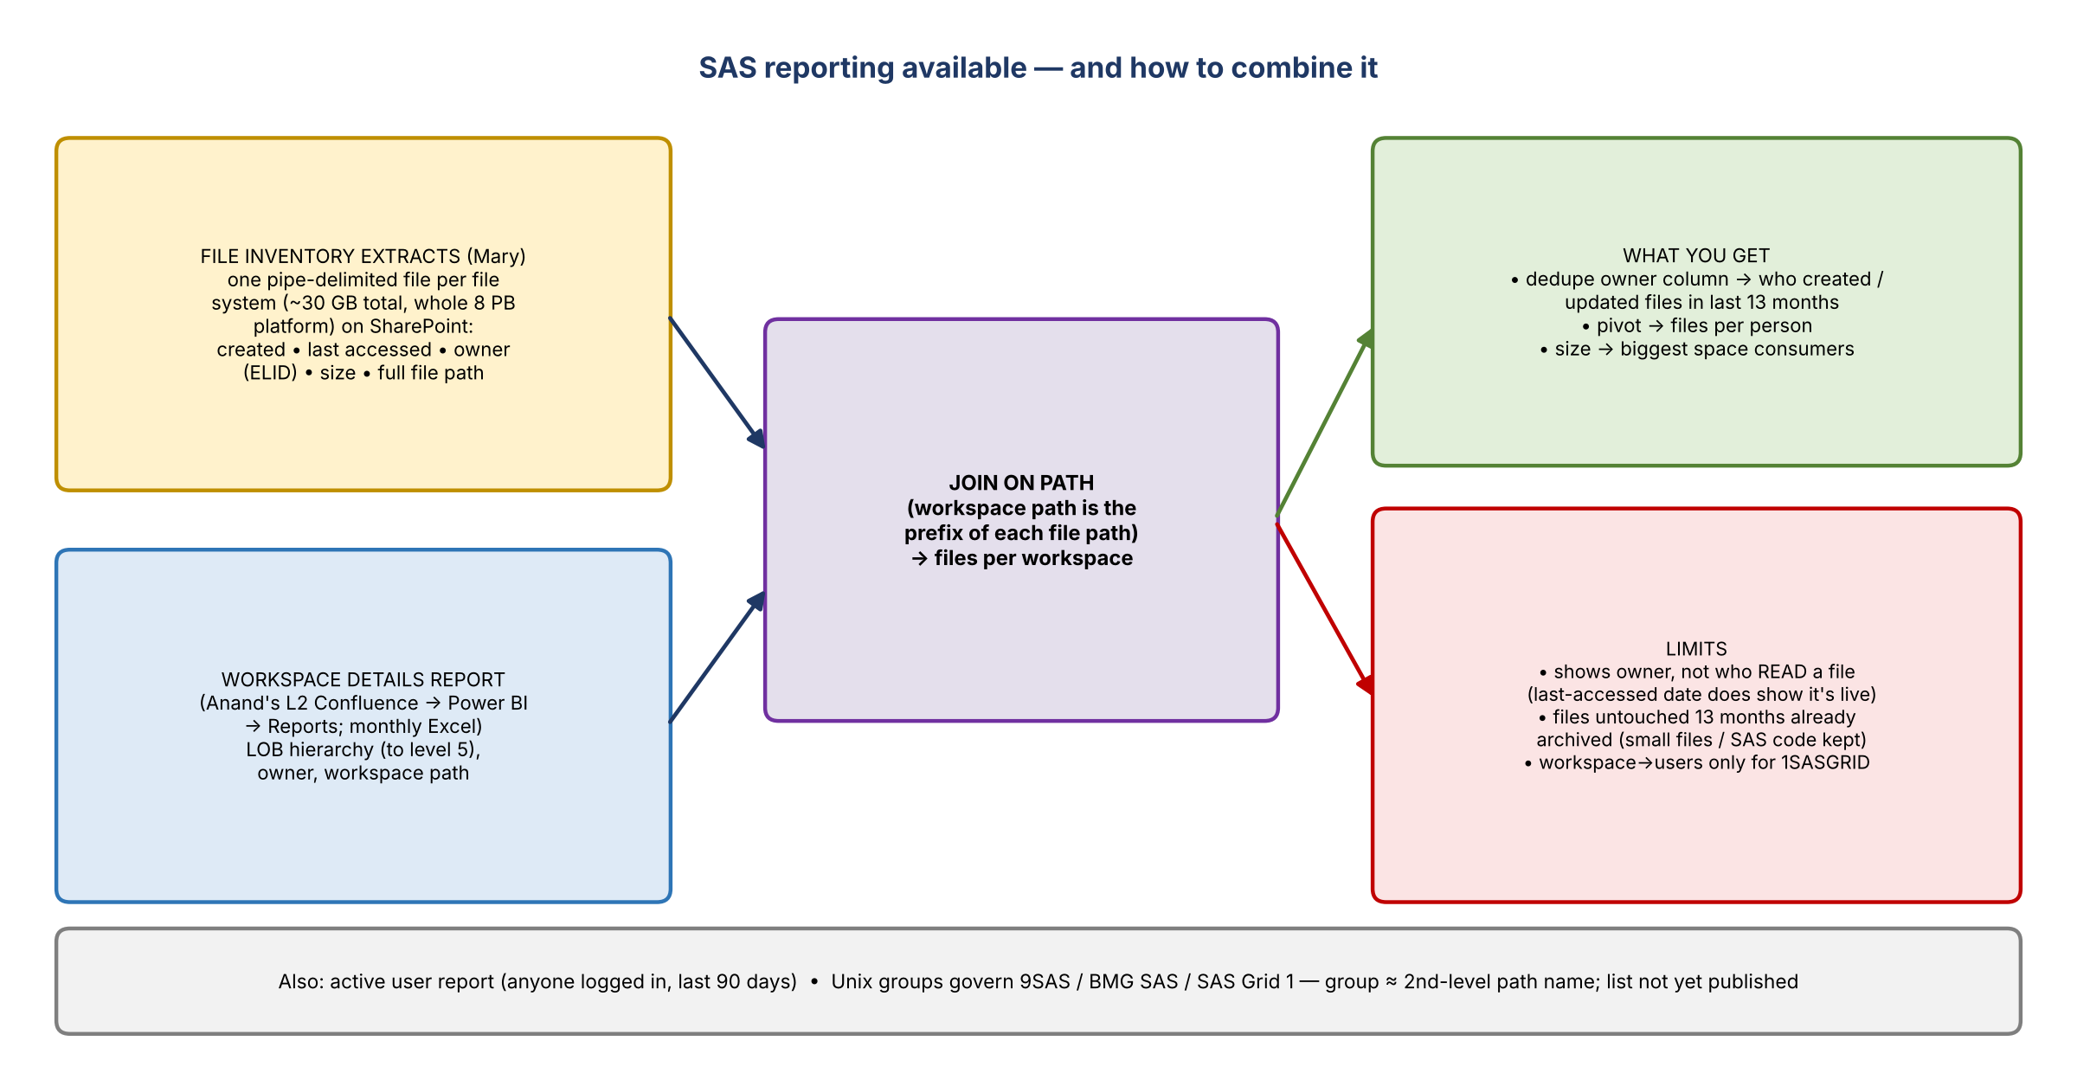
Figure 1. Available reporting and how to combine it
- About 30 GB of extracts cover the entire SAS platform (8 PB): one pipe-delimited file per file system on a SharePoint site. Mary posted the header in chat so the files can be read in.
- Fields include creation date, last-accessed date, owner, size and path. Owners show as UIDs / ELIDs, which convert to people's names.
- Archive policy (1SASGRID and SAS Grid 1): files not accessed in 13 months are archived automatically. Very small files aren't archived, deliberately, so SAS code isn't. Code in the listing can be much older than the data.
- How to use it: import into Excel. Dedupe the user column to get everyone who created or updated files in the last 13 months. A pivot gives files per person, and size shows the biggest consumers.
- Reads aren't captured: AJ asked whether it shows who read files. No, only the owner who created or updated them. But the last-accessed date shows whether a file is live.
- Anand is granting the team access to the file path.

3. Anand's reports (L2 Confluence → Power BI)
- Workspace details report: under Reports (click twice; a known hyperlink issue). Monthly Excel files by LOB hierarchy (down to level 5) with each workspace's path, e.g. workspace2/AICOEVC. The workspace path is the prefix of the file paths in Mary's extracts, so the two can be joined to list all files in a workspace.
- Workspace-to-users: a button above Reports. Only populated for 1SASGRID, the only platform with the SAS metadata layer. The same user can appear twice through different metadata groups. Example: the RDM group had two users.
- Business Direct (BD) shows many single-person subdirectories. Those are shared file system subdirectories under one file system, set up that way for security.
- Active user report: anyone who logged into SAS in the last 90 days.
- Mary: none of this was designed as a unified reporting tool. "No one ever thought we had to get off of it."

4. Unix groups (9SAS, BMG SAS, SAS Grid 1)
- These platforms control file system access through Unix groups. Access via a group is different from actually writing files, which shows in the extracts.
- In general, the Unix group is the second-level name in the path, e.g. users/app/CRLF means the group is CRLF.
- Mary and Norm agree the mapping needs to be published since everyone is asking. It's on their list, but the team is swamped.
- AJ's context: of the 80+ locations, half had owners who didn't know anyone used them, or had moved teams, so the team needs to know who to contact.

5. Retiring workspaces safely
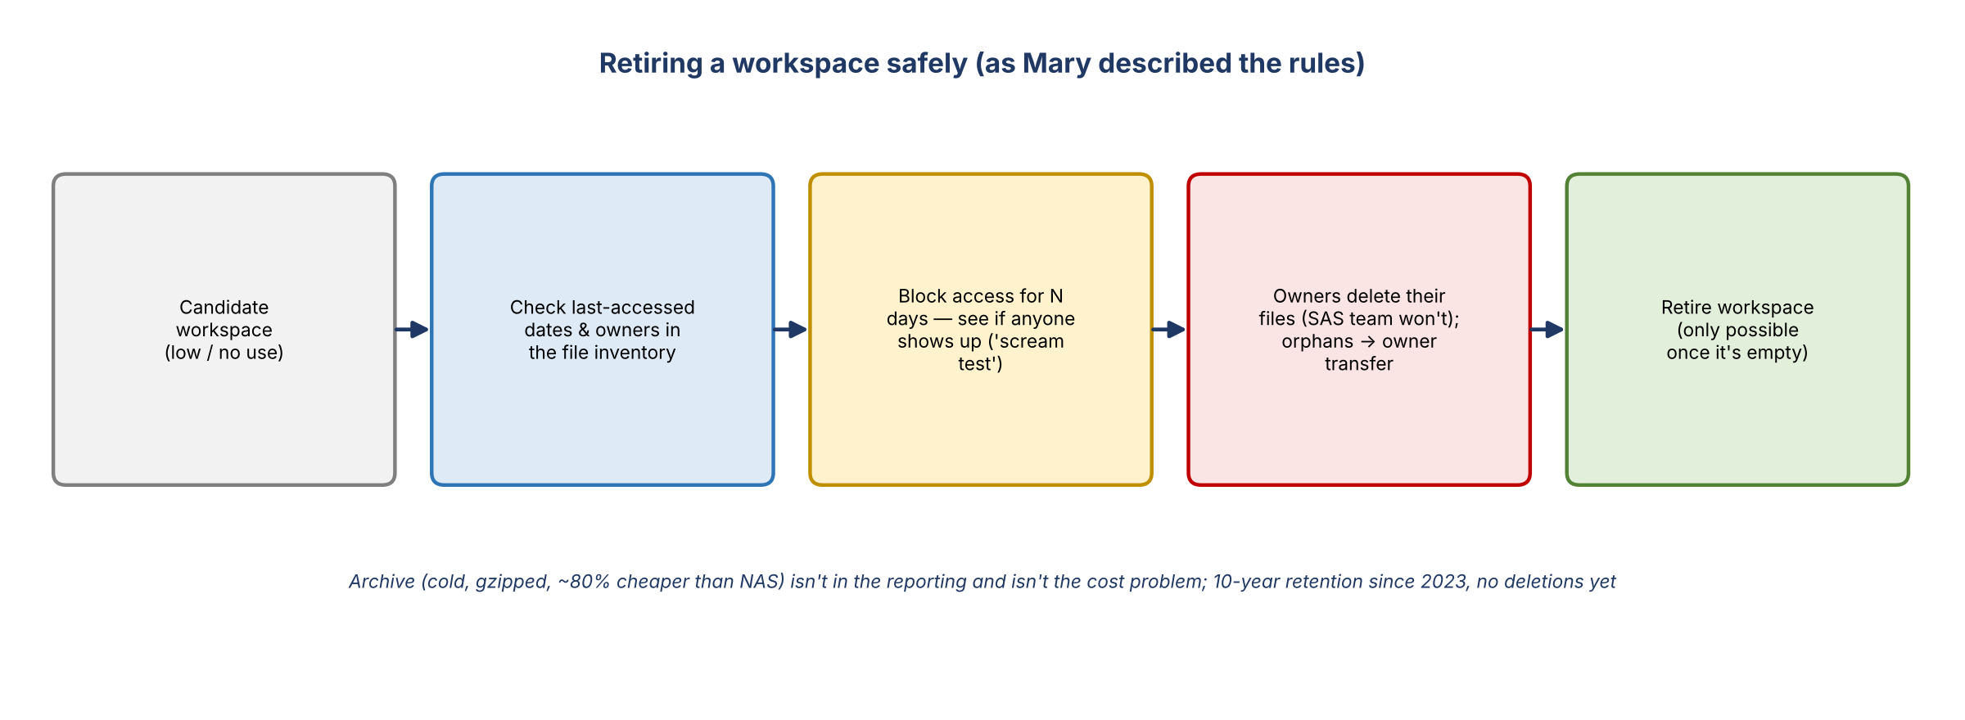
Figure 2. Retirement rules described by Mary
- Kevin: the cleanup is about rationalizing why corporate risk has so many workspaces and so much allocated storage, without turning off something important that a non-owner relies on. The last-accessed data will help a lot.
- Mary: she's spent 24 years trying to clean up SAS and thinks the opportunity may not be large. Unused data is already archived, and empty file systems take no space.
- Standard mitigation: block access for a set number of days and see if anyone shows up before deleting. Kevin hadn't known that was an option.
- The SAS team won't delete files; file owners must. Files without an owner can be transferred to a new owner.
- A workspace can't be retired while it still has files in it.

6. Retention and archive
- Records retention was originally set under CRM 050 (35-year), with a 20-year retention on archive.
- At the 2023 cutover from Oracle ZFS to NetApp, it was changed to 10 years. Only a few file systems have reached that, and nothing has been deleted from archive yet.
- Archive storage isn't in the reporting, is about 80% cheaper than NAS, and is gzipped. It's efficient cold storage, not where the cost is. The cost is in active storage.
- Likely to be revisited, more conservatively, at the move to NGDC (Next Generation Data Center).
- Cost allocation contact: Kim Fisher (CDO) pulls the CDO data and does the allocations. Kevin knows her and will reach out.

7. Ownership clean-up
- Kevin flagged workspaces owned by someone who has left, and some showing "various users".
- Departed owners: someone must submit an ownership transfer request. This happens across all LOBs. Owners who move orgs (e.g. so the workspace now allocates to another LOB) also need to transfer it back to someone in corporate risk.
- When a file system owner leaves, Mary's team emails everyone in that file system asking who will step up.
- Blank owner (column H): these are shared LOB file systems. The real owners sit one level below (e.g. /dark, /EIS) and are tracked in their SharePoint, but the report logic doesn't show them yet; that enhancement is noted. They're small (e.g. 5 GB spaces), so not significant.
- 1SASGRID owner verification survey: a SharePoint survey asks every file system owner to mark "validated" or name the right owner. Steven Schweinfurth manages the list, and updates flow into the monthly reporting. This is now the official route.
- Kelly asked to prioritize the 15–16 owner updates AJ identified. The site refreshes monthly. AJ was told individual owners must request changes. Mary: fastest is to update through the SharePoint survey, and Kelly and AJ can do it on owners' behalf with their email approval.
- Mary doesn't know the SAS Grid 1 process offhand.

8. Action items
Action | Owner | Notes
Share the file inventory report / SharePoint access | Mary | To Kevin, Kelly, Jake
Grant access to the extracts file path | Anand
Email the 1SASGRID owner verification survey link and instructions | Mary | To Kelly and AJ
Update the 15–16 workspace owners through the survey on owners' behalf | Kelly / AJ | With owner email approval
Find out the SAS Grid 1 ownership update process | Mary / Kelly
Join file extracts to workspace details; build user and usage lists per workspace | Kelly / Jake / AJ | Dedupe owners, pivot, size
Use block-access-before-delete for retirement candidates | Kelly / AJ with owners | Owners delete files; empty before retiring
Reach out to Kim Fisher on CDO cost allocation | Kevin
Publish the Unix group to path mapping | Mary / Norm | On their list

9. Open questions
- When will Unix group access lists be available for 9SAS, BMG SAS and SAS Grid 1?
- How long should the access-block period be before deletion?
- What is the SAS Grid 1 owner update process?

