Meeting Notes
SAS Workspace Kickoff: Owners of Two Workspaces
Item | Detail
Meeting date | Tuesday, October 27, 2026 (recording started about 1:00 PM)
Format | Group kickoff; Kelly shared the invite, initiative deck, workspace allocation and usage, and the SharePoint survey
BDL | Kelly (presenter), Vic, Jake
Audience | Owners of two SAS workspaces each: David McCall and Keith Rainey (per Jake; names weren't spoken on the call)
Referenced | Gwen (initiative sponsor), Ben Chen and Andrew Glassford (Business Banking CRO; SAS Viya workshop)
Purpose | Kick off the SAS storage and exit readiness review with two-workspace owners and explain the survey

Note on the transcript
Auto-generated transcript. SAS is transcribed "SaaS"; Viya as "VIA"/"VR". Attendees David McCall and Keith Rainey are per Jake; the transcript doesn't say which of them raised the Viya workshop, so the notes say "the owner". Unsure: Ben Chen, Andrew Glassford, "ADHD I" (where other CBL CRO SAS directories are hosted), and the folder names "users project", "users offshore", "prod offshore".

1. Summary
Kelly ran a kickoff for owners of two SAS workspaces (David McCall and Keith Rainey), who were given more targeted support than the large single-owner group. The structure:
- One long-term goal: possibly migrate off SAS eventually.
- Priority 1, storage and access cleanup (already under way).
- Priority 2, exit readiness: who uses each workspace, for what, its dependencies, and any exit path.
Several of the group's workspaces show under 10% utilization. The SharePoint survey goes out after the call and is due early November. Kelly and Jake will hold optional office hours.
One of the owners, new to the series, pushed back. A recent leadership-run SAS Viya workshop (Business Banking CRO) signaled a long-term SAS relationship, and their team expects a Viya 4 upgrade with Copilot features. Kelly acknowledged the mixed messages: this is preliminary discovery to reduce the footprint, with no overnight exit, and any exit decision sits with senior leadership. Vic stressed that survey answers set criticality, so regulatory and critical uses won't be pivoted away from without a long-term solution. The owner will complete the survey and reconcile the message with their own leadership.

2. What Kelly presented
- A larger kickoff was held for single-workspace owners. Owners with more than one workspace get extra support because there's more nuance. This group each owns two, listed in the invite.
- Long-term goal: enterprise-wide, possibly migrate away from SAS. Not today or tomorrow.
- Priority 1, storage and access cleanup (under way): validate low usage, consolidate allocations, and a separate bulk removal of entitlements for people not using SAS. Driver: SAS costs the enterprise a lot.
- Priority 2, exit readiness: if an exit path to an approved data source exists, capture it. If not, that's fine; capture the number of downstream users, who consumes the data, the workspace's purpose and data, and dependencies such as regulatory reports and models.
- Allocation and usage: some workspaces are used more efficiently than others. Several in this group are under 10% utilization, which is room to reduce allocations or consolidate.
- Survey: SharePoint survey after the call. It's a top-of-house initiative from Gwen, with details wanted by early November (next week). If you aren't the right owner, BDL will help find who is, or work with someone on your team.

3. Pushback: mixed messages on SAS
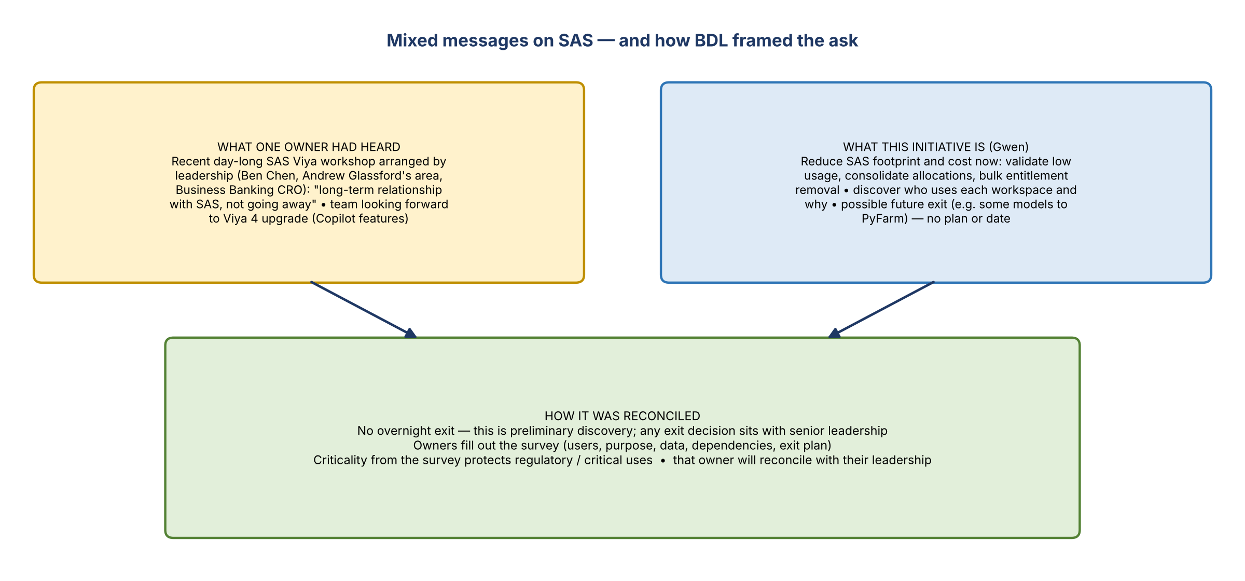
Figure 1. The two messages and how they were reconciled

The owner's concern
- New to the series and couldn't square the message with recent events.
- A few weeks ago, leadership facilitated a day-long SAS Viya workshop with SAS, arranged by Ben Chen from Andrew Glassford's area (Business Banking CRO). The message was a long-term relationship with SAS that isn't going away.
- Their team was looking forward to Viya 4, which has Copilot and other new features.
- Asked: what's the alternative to SAS?
- Their workspaces include users project, users offshore and prod offshore folders. They're also looking at other SAS directories on "ADHD I" for CBL CRO data.
- They can provide the usage survey, but any move needs a vetted alternative and all business stakeholders informed. It can't be done in a month.

Kelly's response
- Senior leaders have sent different messages. There's no plan to move off SAS today or tomorrow.
- First goal: reduce the footprint (allocations) and understand who uses each workspace, so that if moving away later is feasible, there's a path.
- Some models are moving to a Python environment, PyFarm, but there's no exact plan. This is a very preliminary discovery phase tied to the broader approved data source strategy and unraveling lineage for downstream users.
- Some owners don't know they own a workspace or who uses their data. Some workspaces have high allocations with low usage, where data could be consolidated into one surviving workspace.
- This comes up roughly every year when leadership sees what SAS costs each data domain.
- An exit isn't BDL's decision; it's senior leadership's, based on enterprise cost. "If we turned off SAS tonight, the company would struggle."
- The owner said they'll reconcile this with their leadership team.

Vic's addition
- Fill out the survey questions as fully as possible. They answer "what will we do with these?"
- One question asks whether the workspace's use is for reporting, regulatory filing and so on, to determine criticality. Regulatory or highly critical uses won't be pivoted away from without a long-term solution.

4. Next steps
Action | Owner | Notes
Send the SharePoint survey to this group | Kelly | After the call
Forward the optional office hours invites | Kelly | Kelly and Jake host, next few days
Complete the survey for both workspaces | Each workspace owner | Early November
Flag if you aren't the right owner; BDL helps find who is | Owners / BDL
Reconcile the SAS message with their own leadership (Viya 4 plans) | The owner who raised it

