Meeting Notes
How the FCTDS Data Catalog Was Built with Devin AI
Item | Detail
Meeting date | Thursday, October 22, 2026 (recording started about 1:00 PM)
Format | Short walkthrough; Alyssa shared her screen (Devin session and FCTDS repo)
Presenter | Alyssa (analytics consultant, FCTDS / financial crimes; built the catalog)
Risk side | Ryan (host), Manoj (team member with Devin AI access), Michael
Referenced | Kevin Moody (shared the catalog with the team), Chris Salter (owner of related financial crimes applications)
Purpose | Learn how Alyssa produced the FCTDS raw-zone data catalog Kevin sent around, and whether the same approach could work for RFDIR and ORCAP

Note on the transcript
Auto-generated transcript; speakers aren't labeled, so attributions come from context. Readings used: Alyssa (also transcribed "Alisa"), Manoj (transcribed "Minoj"), Devin AI (transcribed "Devon"), RFDIR (transcribed "Rivdor"/"Rifter"), ORCAP (transcribed "RCAP"), DCF PIDs (transcribed "DCFP IDs"). Unsure: "TODA's team" (Alyssa's team), "Financial Crimes Technology Data Services" (FCTDS expansion as heard), GMLP, FCDS, 1BSC, FCP, ECRLT, the "1ADD" source-system example, and the Devin org name ("EFT financial crimes").

1. Summary
Kevin Moody had shared a data catalog Alyssa built with Devin AI. Ryan's team (Manoj has Devin access) wanted to know how she made it. Alyssa has read-only access to FCTDS's production Git code base. She connected that repo in a Devin session and wrote a prompt, shaped by her knowledge of the data model, asking for a raw-zone FCTDS data catalog as a browsable HTML file.
It worked because the FCTDS repo follows the RDS data model and is organized by source system. Each source has its JSON code, INI file, DDL, schema, and profile information, and the DCF parameter configs give each source system a distributed ID (DCF PID).
Manoj noted that RFDIR and ORCAP repos aren't organized that way: there are no per-source folders and no DDLs or descriptions, so the output would be thinner. He'll test Devin on a sample ORCAP repo. This would be a short-term tactical option for Kevin until DPC and DataHub take over. Access is per application, and you need read access to each app's repo.

2. How the catalog was built
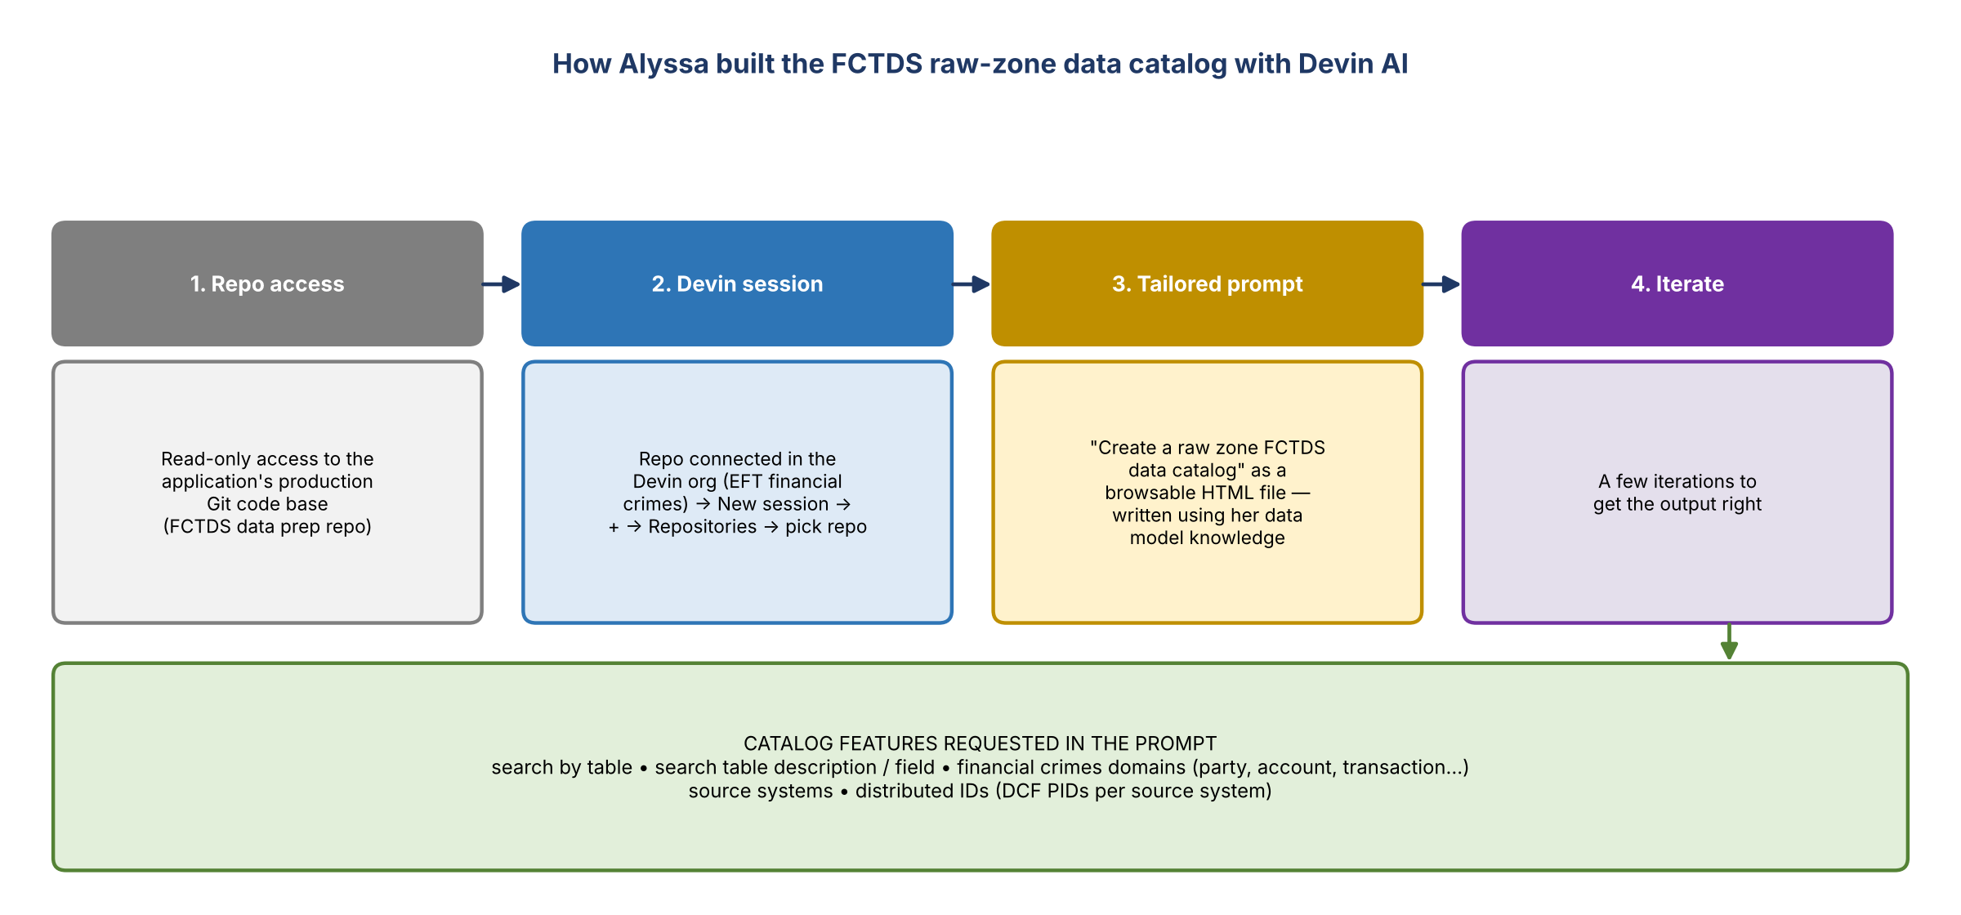
Figure 1. Steps Alyssa followed in Devin

Prerequisites
- Alyssa works on the financial crimes side; FCTDS is the aggregate data sourcer for financial crimes. She has read access to FCTDS's code-based repos, which is all Devin needs.
- You need at least read access to the repo where that application's code base lives.
- The FCTDS data prep repo is connected in the Devin organization for EFT financial crimes.

In Devin
- Start a new session.
- Click the plus button, go to Repositories, and select the repo to point to (here the FCTDS data prep repo).
- Enter the prompt and extract information from the code base.

The prompt
- Simple, but written with her knowledge of how the data model works, which let her shape the output. It took a few iterations.
- Gist: "Create a raw zone FCTDS data catalog" as an HTML file with browsing functions.
- Requested features: search by table; search by table description or field; financial crimes domains (party, account, transaction, and so on); source systems; distributed IDs.
- She had to be very specific about distributed IDs.

3. Where the details come from
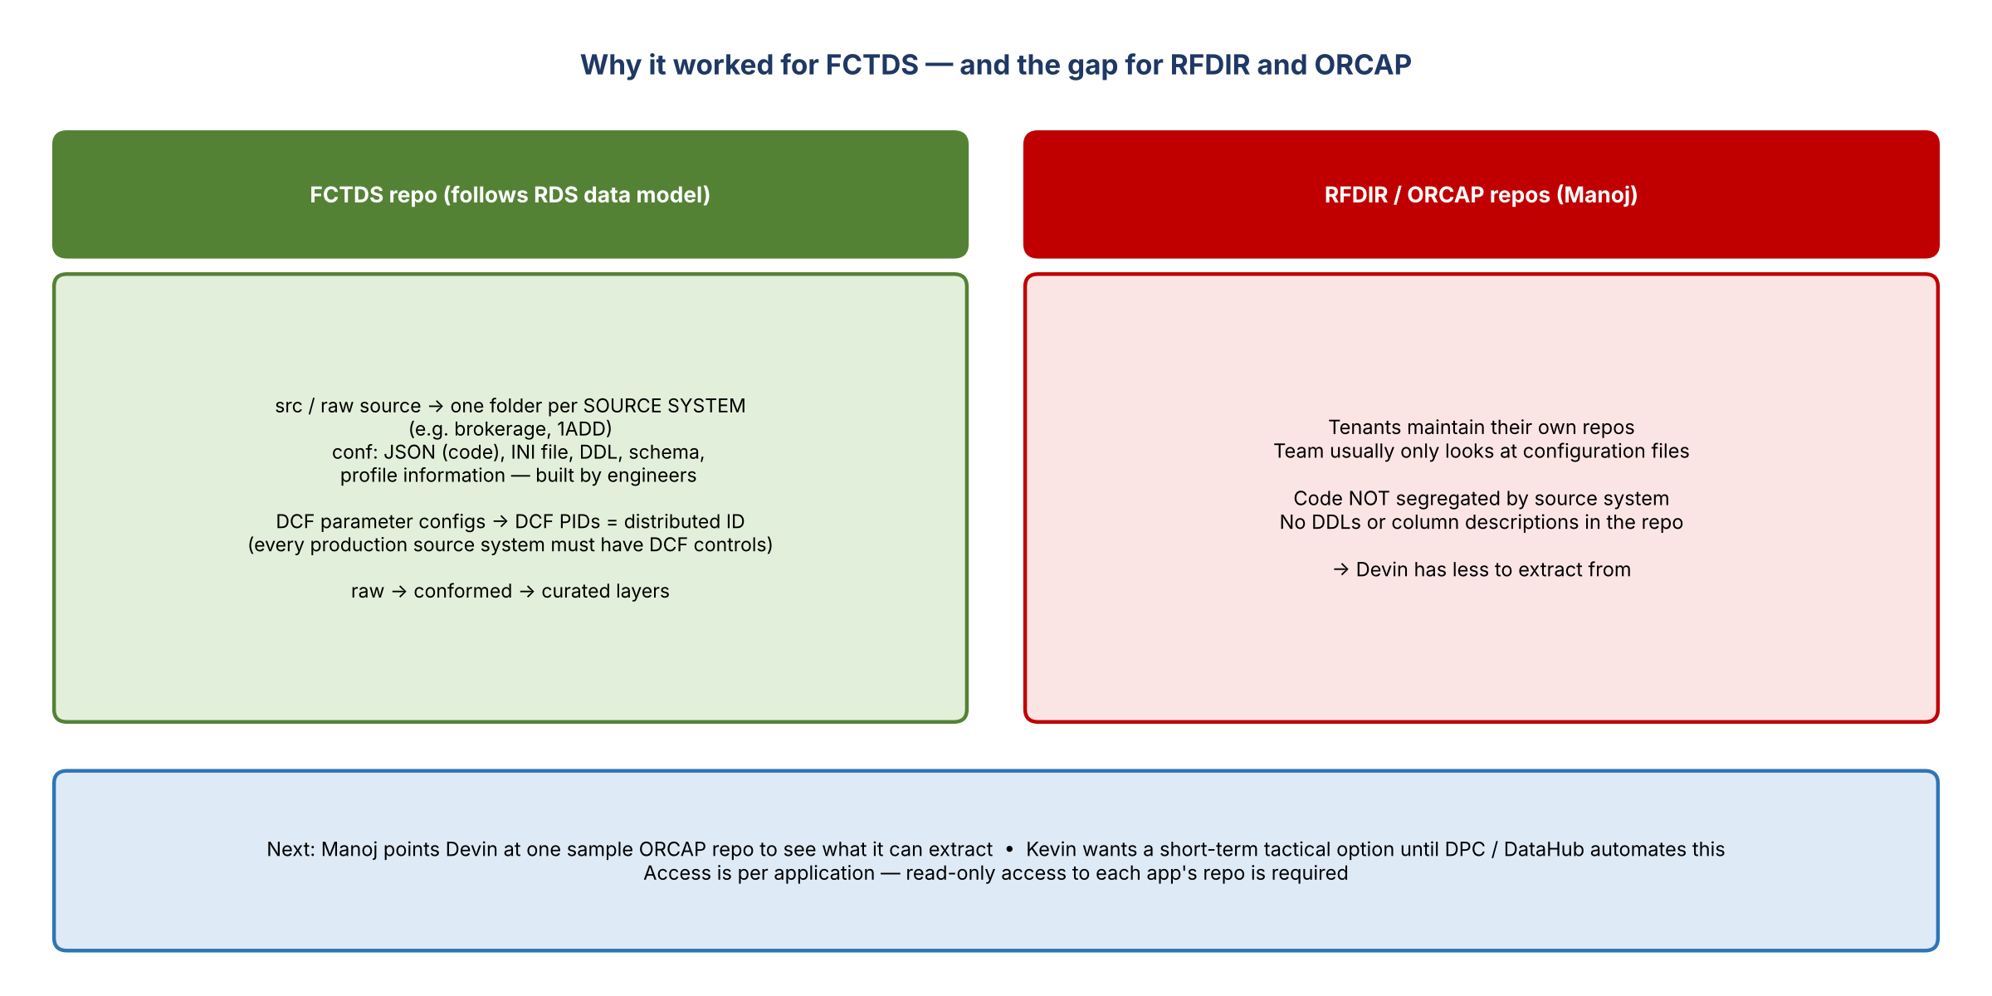
Figure 2. FCTDS repo structure compared with RFDIR and ORCAP
- Manoj asked whether all the fields, descriptions, and source systems already sit in the underlying repos. Yes.
- The FCTDS repo follows the RDS data model: sources, raw source, conformed, curated.
- Under the raw ingestion config, each folder is a source system (e.g. brokerage). The JSON holds the code; there's also the INI file, DDL, schema, and profile information, all built by the engineers. That's what Devin extracts from.

DCF and distributed IDs
- Someone asked whether this is built off DCF. Not directly. Alyssa uses the DCF PIDs to identify the distributed ID per source system, and those are stored in the DCF parameter configurations in the FCTDS code repo.
- She uses them so the catalog aligns with DCF. Every production source system ingested into FCTDS must have DCF controls, so they exist anyway.
- If a source isn't configured in DCF, it won't appear in the report.

4. Applying it to RFDIR and ORCAP
- Gap (Manoj): tenants maintain their own repos, and the team usually looks only at configuration files. Their code isn't split by source system the way FCTDS's is (where e.g. 1ADD is its own folder), and DDLs and column descriptions are missing.
- Next step: Manoj will pick a sample ORCAP repo, authorize it in Devin, and see what it can extract.
- Does this matter once on DPC? Won't DataHub do this automatically? Kevin is looking for a short-term tactical solution. If Devin can do it quickly, that's what he wants to know.
- Per application: it has to be done app by app, connected to each app's code base repo.
- Alyssa's read access covers GMLP (transaction monitoring), FCTDS, and some of Chris Salter's applications (FCDS, 1BSC, FCP). Not all of their code is in this repo.

5. Alyssa's tips
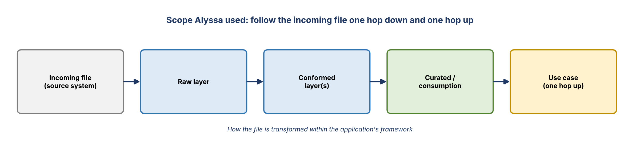
Figure 3. Lineage scope used for the catalog
- Once you have access to an application, look at how it organizes its data. In RDS there's always a raw layer, at least one conformed layer, and then curated layers.
- Follow the incoming file one hop down, see how it's transformed within the application's framework, and look one hop up at which use cases consume the consumption layer. That's what she did.
- With Dremio access you can see how any RDS application organizes its structures (on Hive today; DPC will change that). That helps guide the prompt. Example: ECRLT.
- With read access to the ECRLT repo she could do the same for ECRLT in "basically seven and a half minutes", but she doesn't have it.
- Alyssa called herself an analytics consultant, not an engineer: she has production read access to most of her world and "hacked" her way through. She offered to help Kevin's team any time.

6. Takeaways
# | Takeaway
1 | Devin can produce a searchable HTML data catalog from a repo in minutes, if the repo is well structured
2 | Read-only access to each application's production repo is the prerequisite; it's per application
3 | Output quality depends on repo structure (per-source folders, DDLs, schema, profiles) and a prompt informed by the data model
4 | DCF parameter configs are a reliable source for distributed IDs per source system
5 | RFDIR and ORCAP repos lack that structure; test with a sample ORCAP repo before committing
6 | This is a tactical bridge until DPC and DataHub provide the catalog natively

7. Action items
Action | Owner | Notes
Point Devin at a sample ORCAP repo and test catalog extraction | Manoj | Compare with the FCTDS output
Confirm read-only repo access for RFDIR and ORCAP applications | Manoj / Ryan | Needed per application
Report back to Kevin on whether Devin is a viable tactical option | Ryan | Kevin's ask
Reach out to Alyssa for help with prompts or other apps | Ryan / Manoj | She offered

8. Open questions
- How much can Devin infer from RFDIR and ORCAP repos without per-source folders or DDLs?
- Could the prompt pull descriptions from other sources (e.g. the RDS catalog or Dremio) to fill the gaps?
- How long will it be needed once DPC and DataHub cataloging is live?

