Meeting Notes
Model 14779 Data Sources (10337 & 14998): Building the Case for Conditional Approval
Item | Detail
Meeting date | Thursday, October 22, 2026 (recording started about 1:18 PM)
Format | Consumer domain governance call, about the fourth on this topic; the use case deck was shown on screen
Consumer governance | Srinivas (consumer domain governance lead), Rhupali (consumer BDL / analyst; owns follow-ups)
Model owners | James and Terry (models 14998 / 10337), Anna (new owner of 14998; dropped early)
Others | Eric, Kelly (Risk BDL), Jake. Maksim (Card Services ADS) and Kevin were added but dropped.
Referenced | Bill Wells (cards data owner), Ben Shulman (iCode owner), Soumya Joshi (CDO), Martin Odman (designated owner of the older model)
Purpose | Gather what's needed to push CDO for conditional approval of models 10337 and 14998 as data sources for model 14779, which are handed off manually in Excel and aren't in an approved ADS

Note on the transcript
Auto-generated transcript; speakers aren't labeled, so attributions come from context. Confirmed: Srinivas (transcribed "Srinivas"/"Serena"/"Sreena"/"Shirin Abbas"), Rhupali (transcribed "Rhupali"), Card Services ADS, Card Calpers (model 14779), Eric, Bill Wells, Ben Shulman, Soumya Joshi, Martin Odman, iCode. Readings used: Maksim (transcribed "Maxim"), EUCT ("EUCTs"), SHRP (transcribed "SHARP"), DMP (transcribed "MP policy"), MDD, Minerva, ADMF, CSBB (consumer small business and banking).

1. Summary
Two models, 10337 and 14998, feed model 14779 (Card Calpers) by handing off an Excel worksheet. The risk domain implicated them last year and they were conditionally approved. Now that the data sources have moved to the consumer domain, they're up for annual recertification under consumer's procedures.
The DMP changed on Sept 30 to require OC-1 approval, but a grace period to January 1 lets the team use the existing policy: BDL plus CDO approval for non-standard sources. Consumer also requires data source owner and ABO sign-off.
Two concerns need answering:
- The data isn't in an approved ADS. This is easy to justify, because the forecasts don't exist anywhere else and no ADS plans to hold them.
- It's a manual handoff, which needs mitigating controls.
The model owners (James, Terry) were surprised to be treated as data source owners and had never heard of last year's approval. Kelly clarified that risk was only the impacted use case: the sources were previously owned by CSBB and Finance, and the CDO process may not have existed then.
The plan:
- Rhupali checks the ADMF history for last year's rationale.
- The model owners document their existing checks, using Copilot to find the input and output validation sections in the MDD, plus the Minerva model use checks.
- Srinivas's team assembles the business case for CDO, targeting completion in the system by November 11.

2. Background and purpose
- This is about the fourth call on the topic. The first reviewed lineage sources and the deck.
- Risk domain process mapping established that 10337 and 14998 are the sources for 14779. Consumer was asked to approve them because they're consumer sources.
- From the consumer domain view, these are models feeding a model. They aren't standard applications; they're treated like EUCTs or other non-standard sources that generate forecasts.
- Srinivas can answer approval questions, not process mapping. If the mapping is wrong, Kelly can speak to it. Kelly trusts the mapping.
- Goal of this call: Rhupali gathers what's in the sources, what elements they feed, and whether controls exist, so the team can recommend conditional approval.

3. Policy context
Item | Detail
DMP change | Changed Sept 30. The new policy requires OC-1 approval.
Grace period | Until January 1, the existing requirements can be used
Existing policy | CDO approval plus BDL approval for any non-standard application to be conditionally approved
Consumer domain extras | Consumer also requires data source owner approval and ABO approval, beyond the DMP. That's likely why this felt new to the model owners (federated model, so domains vary).
ADS strategy | Tier 1 and Tier 2 use cases must source from approved data sources. ADSs are still being built, so conditional approval is allowed in the interim.
Forecast = data? | Yes. Per policy, any value consumed (forecast, customer number, balance), even if entered manually, is a data element. James had raised this by email, with a Copilot answer saying the same.

4. The two concerns
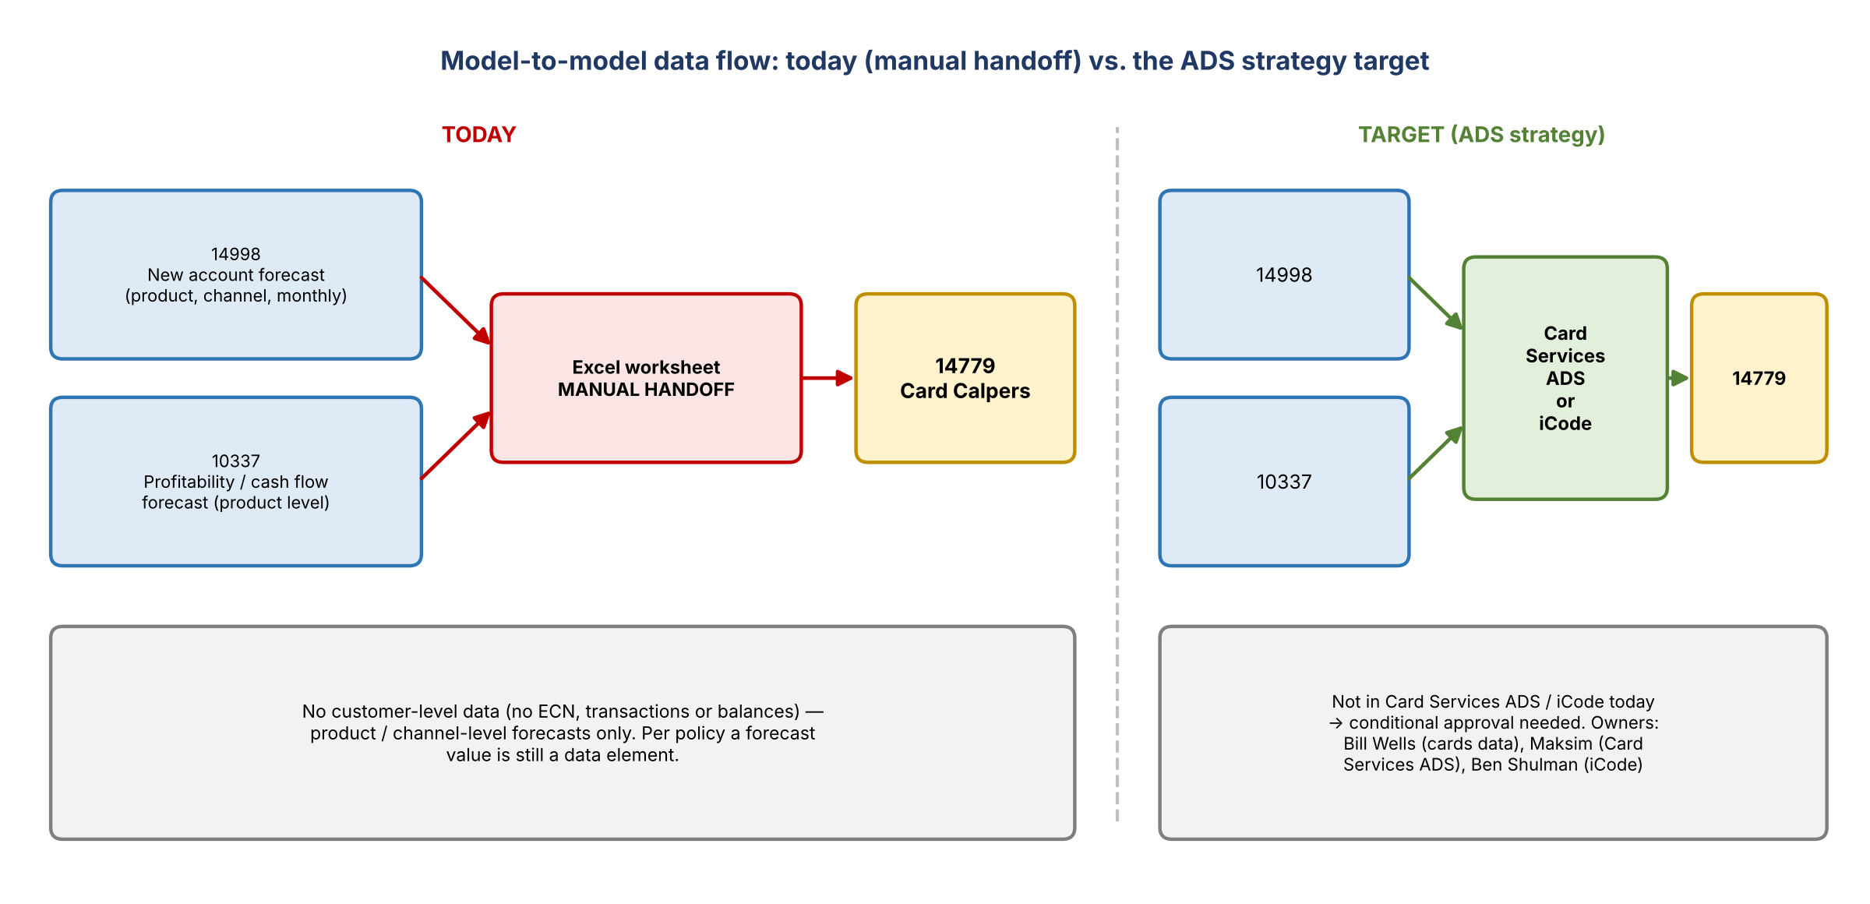
Figure 1. Today's manual handoff vs. the ADS strategy target

1. Not in an approved ADS (justifiable)
- Justification: it's the strategy, but no approved data source holds this data to source from.
- For cards, the approved data sources are Card Services ADS and iCode. The ideal solution is to output the forecasts to one of them and have 14779 source from there.
- The data isn't there today, which is why conditional approval is needed.
- James: it's a forecast; nothing is there. His model would have to move there and create it there, which he feels people keep missing.

2. Manual handoff (needs support)
- Does the data rest in a database before 14779 consumes it? No, it's an Excel spreadsheet handed off manually.
- The team needs evidence of controls in the two upstream models showing the risk is mitigated.

What the data actually is
- 14998: new account forecast. A monthly schedule of forecast account counts by product and channel (e.g. September, October, November). Origination only.
- 10337: expected cash flows and behaviors at product level, i.e. the profitability of those accounts.
- No customer-level detail: no ECN, transactions, or customer information. Eric asked about this; it would support the case.
- James has his own controls to make sure the right figures are handed off when Terry provides them.

5. Model owners' concerns and how to move the data
- James: before going down this road, they want to be 100% sure it's the right treatment. There's a lot more governance work once you're considered a data source owner rather than just a model owner.
- How would they actually put the Excel output into an approved data source? Srinivas: work with the ADS owners; they'll give the solution. This is a domain governance call, not a solutioning call.
- Contacts: Bill Wells owns cards data, Maksim owns Card Services ADS, and Ben Shulman owns iCode.
- James used to be in Bill Wells's group when he built the model, using Bill's data, so Bill knows the work.
- Eric: meet with Bill, with Maksim and Ben in the room.
- For now the ask isn't rewiring. It's helping build the business case and justification for CDO approval under the DMP.

6. Why now? (history)
- Eric asked what brought this into scope now. Srinivas: it was never out of scope. It was implicated last year and conditionally approved by the risk domain. Now it's in the consumer domain for annual recertification under consumer's ADS approval procedures.
- James and Anna had never heard of it.
- Kelly first said risk was comfortable approving a model feeding a model, given model risk management's separate governance and controls.
- Kelly's clarification: one model was previously owned by CSBB and the other by Finance. Those domains would have taken the sources through the CDO process. Risk was only the impacted use case and didn't write a CDO rationale. The CDO process may not have existed then, which is how the sources were conditionally approved in the system.
- So Kelly probably can't provide last year's rationale.
- Action: Rhupali checks the ADMF data set record history, finds who owned and approved it last year, and asks them for any rationale to reuse. If nothing exists, build a new one.

7. Controls
- Both models went through model governance (MDD) and are approved.
- No official controls: no SHRP control IDs, though the owners have their own checks.
- James is due for revalidation at the end of next month. He'll then add model use checks tied to a SHRP control.
- Model use is all approved through model governance and recorded in Minerva, which has a list of approved model use checks.
- Approach: document the existing process (data checks, validation, testing) even without formal SHRP IDs, and reference what's already in Minerva and the MDD instead of duplicating it.
- The MDD is long with many sections, so it can't be covered on the call. Jake suggested putting it into Copilot and asking it to find the sections on input and output data validation checks. Agreed: "let's use our Copilot to do our job."
- James and Terry own 14998. The other model (10337) is older and new to them; Martin Odman is probably its designated owner. They'll check that one too.

8. Timeline and approval path
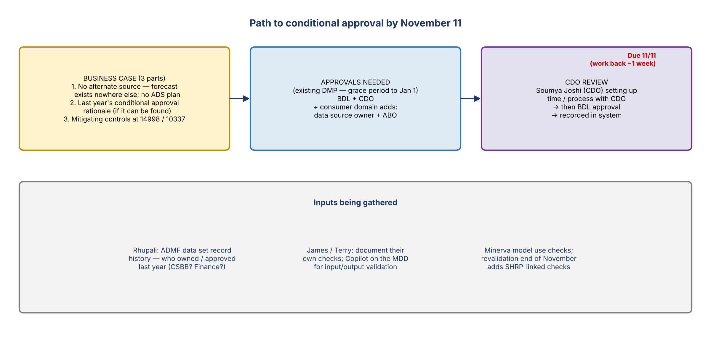
Figure 2. Business case inputs and approval path
- Due: November 11, with everything done in the system. Work back about a week to allow for the CDO step, whether a meeting or an email.
- Soumya Joshi from CDO is helping set up time with CDO for approval.
- CDO approval is needed for both a reset and an initial implication.
- Business case (Srinivas): (1) the data isn't available anywhere else; it's a model forecast, and no ADS has planned for it, so conditional approval is required. (2) Last year's CDO rationale, if found. (3) Mitigating controls at the two source models.

9. Decisions
# | Decision
1 | Pursue conditional approval under the existing DMP (BDL + CDO) during the grace period
2 | Justify the ADS gap: the forecasts aren't available in Card Services ADS or iCode and no ADS plan exists
3 | Document the model owners' existing checks and reference MDD and Minerva model use checks as mitigation
4 | Regroup once the business case is drafted, then take it through the CDO process

10. Action items
Action | Owner | Notes
Check ADMF data set record history; find prior owners and approvers and any rationale | Rhupali | Reuse if found
Run the MDD through Copilot to locate input and output validation sections | Rhupali / James / Terry | Jake's suggestion
Document existing checks for 14998 and 10337, including Minerva model use checks | James / Terry | Check 10337 with Martin Odman
Look for any risk-side rationale from last year | Kelly | Likely none; sources were owned by CSBB / Finance
Draft the business case and regroup with the group | Srinivas / Rhupali
Set up the CDO approval step | Srinivas with Soumya Joshi | Back from 11/11
Meet Bill Wells, Maksim and Ben Shulman about landing forecasts in Card Services ADS / iCode | James / Eric | Longer-term fix

11. Open questions
- Who owned and approved these sources last year, and is there any rationale on record?
- Would CDO accept documented informal checks plus MDD and Minerva references as mitigation?
- Long term: can the forecasts be produced into Card Services ADS or iCode, or does the model need to move?
- Does the November revalidation (SHRP-linked checks) change the case for 14998?

