Meeting Notes
SAS Workspace Review: Leopold's Workspaces & the Brian Schiffer Org
Item | Detail
Meeting date | Thursday, October 22, 2026 (recording started about 11:00 AM)
Format | One-on-one owner call for the SAS cost reduction effort. Kelly shared a slide and the workspace details spreadsheet.
BDL / SAS effort | Kelly (lead), Vic, Jake
Workspace side | Leopold (named owner of 12 workspaces) and AJ (Leopold's SAS point person)
Referenced | Brian Schiffer (org leader), Kelsey, John Crawford, David Blitvich, Jennifer, Yan Peng and Rakesh (Equus Group), "Kent Lay", Anand (CDO SAS contact)
Purpose | Walk Leopold through the SAS storage reduction ask, retire unused workspaces, route the rest to the right owners, and start the exit strategy template

Note on the transcript
Auto-generated transcript; speakers aren't labeled, so attributions come from context. PyFarm was transcribed "by farm". Confirmed: SAS, 1SASGRID (transcribed "1SASGRID"/"One SAS Grid"), 9SAS, SAS Grid NC, SAS Grid 1 ("SAG1"), Viya on 1SASGRID (transcribed "V-I-Y-A"/"VIWA"), CDF, Leopold, AJ, Brian Schiffer (transcribed "Bryant"), David Blitvich, Jennifer (surname not confirmed), John Crawford, Yan Peng, Rakesh, Sean Douglas, William Ren. Unsure: "Equus Group", "Kent Lay", "BLM5", "Brenner", and "Basil / Martho Gough" (said about the workspace with William Ren's name).

1. Summary
Kelly held a one-on-one with Leopold because he's the named owner of 12 SAS workspaces, more than most. Leopold said he can't speak to most of them and has no access to several. He immediately approved retiring the two workspaces that show zero storage used. Kelly will send an email so he can approve it formally.
The rest need research and re-ownership. AJ covers SAS for Leopold's team, but only has access to 1SASGRID. The group mapped who to go to for each platform:
- 9SAS (auto) goes to the Equus Group: Yan Peng and Rakesh.
- SAS Grid NC / SAS Grid 1 (home lending) goes to Kelsey's group. The home lending call is tomorrow.
- The CDF space belongs in the commercial space.
The Brian Schiffer org holds 74 workspaces in total. AJ's main ask is dedicated SAS / Unix admin resources: only admins can read every folder, a Unix admin ticket was cancelled, and the SAS admin team has said it has no capacity until November. The exit strategy template is due in early November.

2. The ask (Kelly)
- There's an enterprise-wide push to reduce storage allocation across all SAS platforms, many of which show low utilization.
- The starting point is workspaces using under 60% of their allocation, to see whether storage can be reduced for each owner.
- Goals: cut allocated storage, learn the downstream use cases (who uses each workspace and why), and consolidate where possible into one or a few surviving workspaces.
- From earlier lineage work with Leopold and the RMG group, the BDL team has information on 2 of his workspaces. For the rest, they don't know who uses them or why.
- Process: any ownership change, reduction, or retirement only needs an email approval from the workspace owner.
- Cost: allocated storage is paid for whether used or not. One PB of allocated SAS storage is about $60K a month, or $720K a year. Leopold: we pay for reserved space, not usage, so even a 30% cut would help.
- End state: get off SAS completely and move the data to an approved data source the whole bank can pull from.

3. Leopold's workspaces
- 12 workspaces are currently in Leopold's name. Some have already moved to other owners.
- Leopold can't say what's in most of them. He has no access to 9SAS and has tried to hand them off.
- Retire: the first two on the list show zero storage used. Leopold: "go, go, go". Kelly will email him for approval to retire those two.
- CDF: not in Leopold's space. It's in the core / commercial space and should go to someone there ("Kent Lay"). Leopold will chase it.
- The workspace with William Ren's name on it is an exception and belongs elsewhere (Basel area).

4. Who to go to, by platform
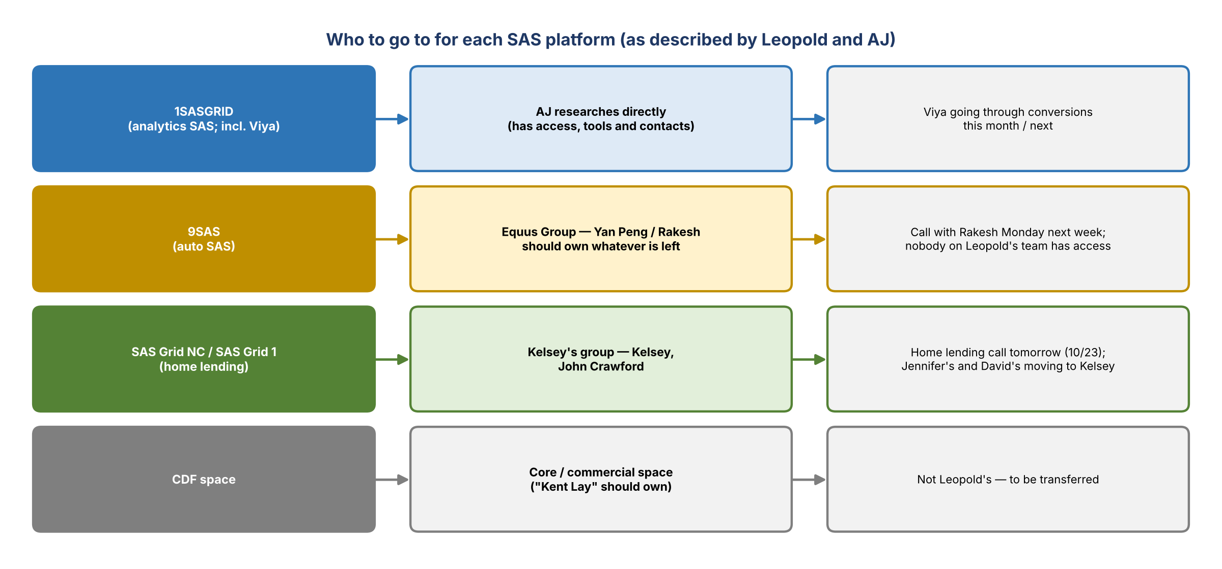
Figure 1. Routing each SAS platform to the people who should own it
Platform | Owner / contact | Notes
1SASGRID (analytics SAS, incl. Viya) | AJ (has access and tools) | Viya is going through conversions this month or next; unclear whether that changes anything
9SAS (auto SAS) | Equus Group: Yan Peng / Rakesh | The only auto group. They should own whatever is left, including the workspaces in Leopold's name. The team has a call with Rakesh Monday next week.
SAS Grid NC / SAS Grid 1 (home lending) | Kelsey's group: Kelsey, John Crawford | Anything under Jennifer or David Blitvich should move. Jennifer's are being moved to Kelsey (formal update expected within about a month); David gave names for his. Many workspaces sit with people who've left.
CDF space | Core / commercial space ("Kent Lay") | To be transferred out of Leopold's name

- Four platforms show up in the environment column.
- Leopold's team does little SAS development in this space.

5. The Brian Schiffer org
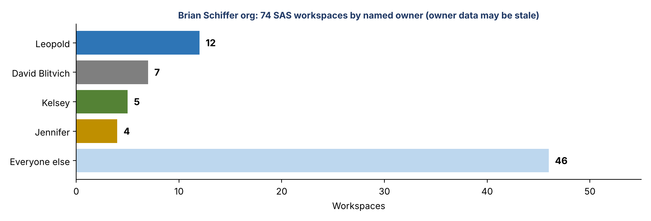
Figure 2. Workspaces in the Brian Schiffer org by named owner
- AJ asked for the full list so he can see everything under Brian Schiffer and work out which access each one needs. Kelly filtered to the org: 74 workspaces.
- Named owners include Leopold (12), David Blitvich (7; should own none, being transferred), Kelsey (5), Jennifer (4), and John. Owner data may be stale because people have moved a lot.
- Leopold: focus only on what's under Brian today.

6. AJ's research and blockers
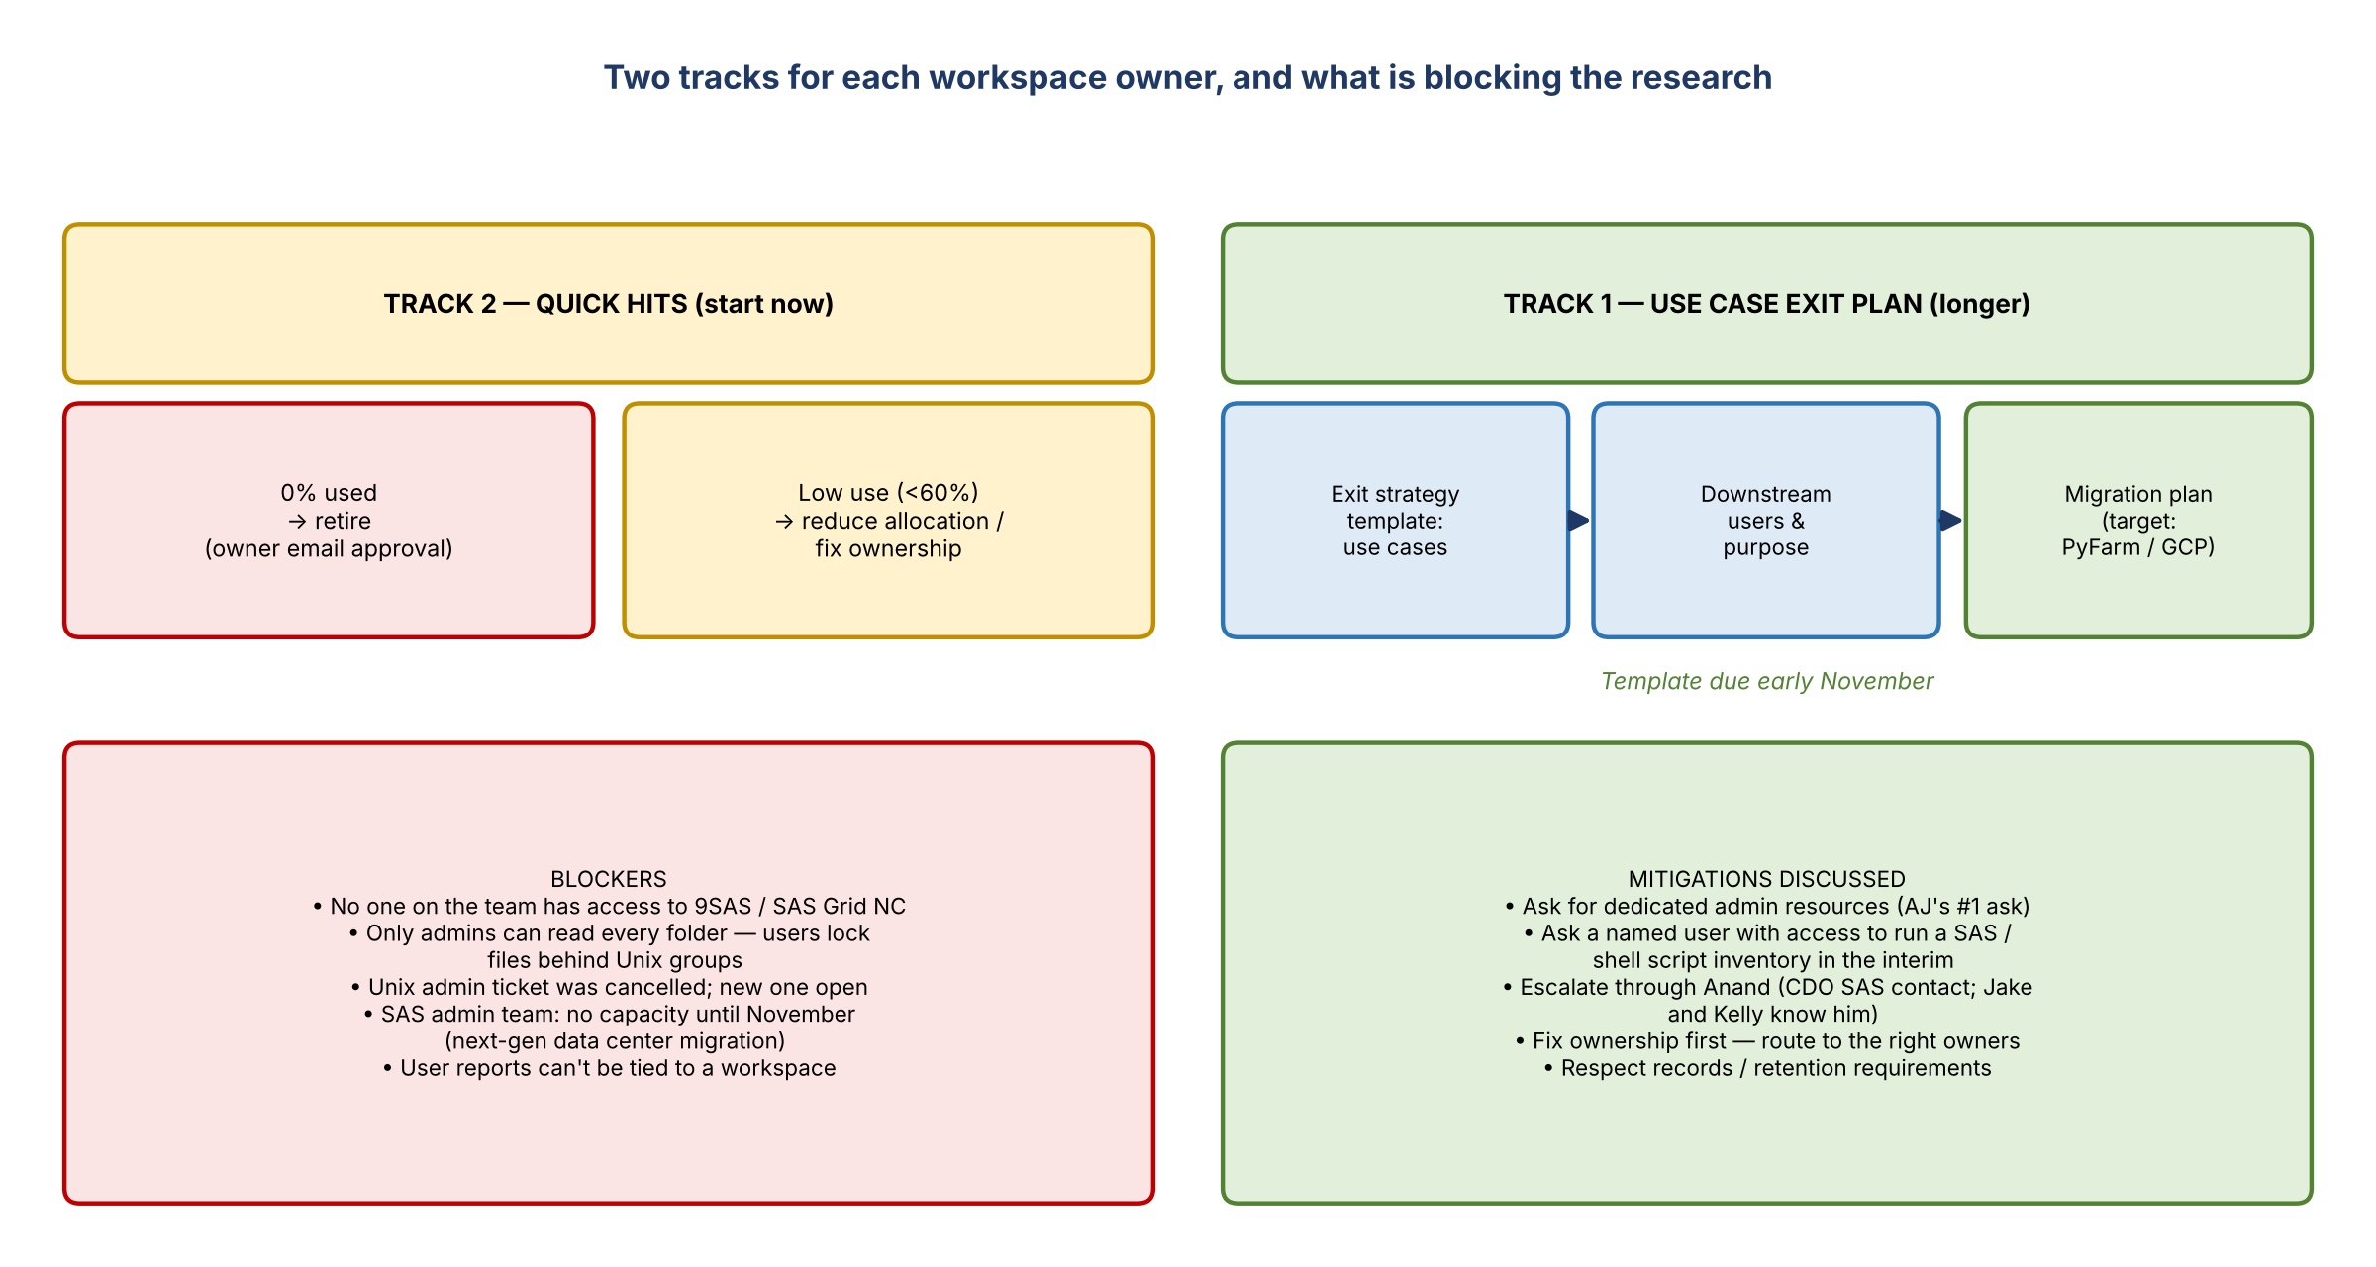
Figure 3. Two-track approach, blockers, and mitigations
- AJ's experience is mainly with 1SASGRID (One Grid). The other platforms grant access and produce user reports differently.
- Last week he opened a ticket for a Unix admin to change ownership and list all user files so they could merge, delete, or consolidate. That ticket was cancelled. He's opened another.
- He's asked the support teams for documentation so his team can pull users, Unix groups with permissions, and file ages themselves and audit everything at once.
- Why file age matters: a workspace showing 17% used might be holding files written four or five years ago.
- Admin access is the real blocker: users lock their files behind their own Unix groups. Even with workspace access, AJ can't read folders without that group, so someone with admin rights must run the inventory.
- The SAS admin team said it can't help until November because of the move to a next-gen data center.
- Kelly and Jake confirmed the reports the team can access (current user views, active vs. inactive) can't tie users to workspaces. That's the missing link.

Mitigations
- AJ's #1 ask: dedicated resources from the SAS / Unix admin groups, plus a ticket per space listing exactly which access and reports are needed. Leopold agreed: we need to inventory this.
- Interim: where an internal person is named on a workspace and has access, ask them to run a SAS or shell script to show what's there.
- Escalate: go to Anand, who runs point on SAS. Jake and Kelly both know him well.
- AJ will try for early November but can't guarantee it.
- Cleaning up ownership first should make later conversations easier.

7. Exit strategy template and timeline
- Track 1, use case exit plan: the template (Kelly will share it) captures the use cases, downstream users and purpose, and any migration plans. No plan yet is fine; the team will help build one. This takes longer.
- Track 2, quick hits: start right away. Retire zero-usage workspaces (like Leopold's two), then reduce low-use ones while the research continues.
- Vic: the waterfall approach takes zero usage first, then lowers allocations based on the analysis, then the longer ADS-strategy-type work on where things migrate and whether they're still needed.
- Target for the template is early November. There's no hard deadline, but work needs to start.

Records and retention (Leopold's question)
- How are records management and retention requirements handled?
- Kelly: the team isn't asking to delete everything. The aim is to understand why there are so many workspaces ("because they were easy to get") and improve utilization. The team will work with the people who know the data and respect retention guardrails.

Target platform
- Leopold asked what to migrate to. For corporate risk it's PyFarm on GCP.
- AJ had heard the firm might build its own platform because GCP costs are rising. Leopold said the tech strategy prioritizes leasing over owning where possible, and noted an internal GPU farm on the AI side. PyFarm has both an internal cloud and a public cloud environment, and the strategy may shift as costs change. Either way, SAS is expensive and the goal is to get off it.

8. Decisions
# | Decision
1 | Retire Leopold's two zero-usage workspaces (pending his email approval)
2 | Route 9SAS workspaces to the Equus Group (Yan Peng / Rakesh) and SAS Grid NC / Grid 1 to Kelsey's home lending group
3 | Transfer the CDF space to the core / commercial space owner
4 | AJ leads research on 1SASGRID and coordinates access for the other platforms
5 | Exit strategy template targeted for early November; quick hits run in parallel

9. Action items
Action | Owner | Notes
Email Leopold to approve retiring the two zero-usage workspaces | Kelly | Email approval is all that's needed
Share the workspace details for the Brian Schiffer org (74 workspaces) | Kelly | To AJ and Leopold
Share the SAS exit strategy template | Kelly | Target early November
Inventory 1SASGRID workspaces: users, files, file ages, Unix groups | AJ | Has access
Contact Yan Peng / Rakesh (Equus Group) about 9SAS ownership and contents | AJ / Kelly | Call with Rakesh Monday
Cover SAS Grid NC / Grid 1 workspaces with Kelsey and John | Kelly / AJ | Home lending call 10/23
Transfer the CDF space out of Leopold's name | Leopold | To the commercial owner
Ask Anand for dedicated SAS / Unix admin support | Jake / Kelly | SAS team says no capacity until November
Ask named users with access to run inventory scripts in the interim | AJ / Kelly

10. Open questions
- Can CDO or the SAS admin team give dedicated admin support before November?
- How can users be tied to workspaces (the missing link in current reports)?
- Does the Viya conversion change anything for 1SASGRID workspaces?
- Which records or retention requirements apply to data in these workspaces?

