Meeting Notes
Data Plane Pillars: Team Review of the Draft Deck
Item | Detail
Meeting date | Thursday, October 15, 2026 (recording started about 11:02 AM)
Format | Team call; Vic shared the deck and Jake edited slides live while Kevin led the walkthrough
Attendees | Kevin (lead), Vic, Jake, Mike G, Ryan, Nick, Jen, Prasanta
Referenced (not present) | Jacqueline, Manav, Glenn, Sean, Taylor
Purpose | Bring the wider team (Jen and Nick for the first time) into the draft data plane plan, walk the three pillars and five phases, collect gaps before it goes to Jacqueline, and set up ownership

Note on the transcript
Auto-generated transcript; speakers aren't labeled, so attributions come from context ("great call out, Mike", "Ryan, go ahead", etc.). Non-work chat at the start (weather) is left out. Slide numbers are the draft deck's numbers as of this call. Readings used: "Prasanta" (transcribed "Prasant"), "Ryan" (transcribed "Ruto" once), "falling on deaf ears" (transcribed "going on death errors"), "risk data" (transcribed "RIS data"), "EGRC" (transcribed "ETRC"). Unsure: "DAT team", "SHARP data", and "Brits" (the person or deck that used the pineapples / kiwis / bananas analogy).

1. Summary
Kevin walked the team through the deck Vic and Jake built over the past few days. It sets out how the team will run the data plane as part of Jacqueline's broader organization. The aim is to show Jacqueline a clear plan with progress, get her feedback, and then assign owners. The team agreed with the structure overall. Prasanta called it great, and Kevin took that as a sign they're on the right track.
The main changes from the review:
- Pillar 2 is renamed "existing data plane sourcing". It now owns finalizing the data plane structure (Mike G's call out) and a control framework for the plane. Kevin expects it to become ongoing "plane management" over time.
- Pillar 1 adds standards and team operating model: data dictionary, metadata, and tech standards such as result-table and rule-name conventions. It also covers how the team organizes itself and escalates.
- Pillar 3 flow gets two new arrows to Pillar 2: one from "map to existing RDS data" and one from "justified tactical". The "legacy to evaluate" box becomes "non-strategic evaluation needed". Jake made these edits live.
- Each pillar gets a worked example: two intro slides plus one example workstream "four-blocker". The intake tool is the Pillar 1 example and organizing ORCAP data is the Pillar 2 example.
- Next steps: Vic sends this version to the small group without the decisions and next-steps slide. Everyone sends feedback and ideas.

2. Framing: why this deck
- Last call, the group discussed how to start executing on the data plane the team will own under Jacqueline. The ask was to show progress, a plan, and work in flight to keep the plane moving.
- Once Jacqueline confirms the direction, the team assigns ownership and responsibilities.
- Vic and Jake spent about two days on the deck, plus time on Monday. Kevin thinks it is in good shape relative to what the group discussed last time.
- Kevin asked everyone to chime in freely. What's missing? What would they do if they were building a data plane from scratch?

3. Early deck changes
Change | Detail
Phase 5 renamed | From an AI use case end state to "enabled data consumption". It now covers AI, reporting, analytics, and any other usage by risk owners. Kevin agreed it doesn't need to be AI-specific.
Slide order | Talk pillars first, then phases. Slide 3 (phases) moves after slide 4 (pillars), between slides 4 and 5.
Slide 2 | High-level overview: goal, pillars, end result, priorities. Kept for now; Kevin isn't sure where it goes yet.

4. The three pillars (slide 4)
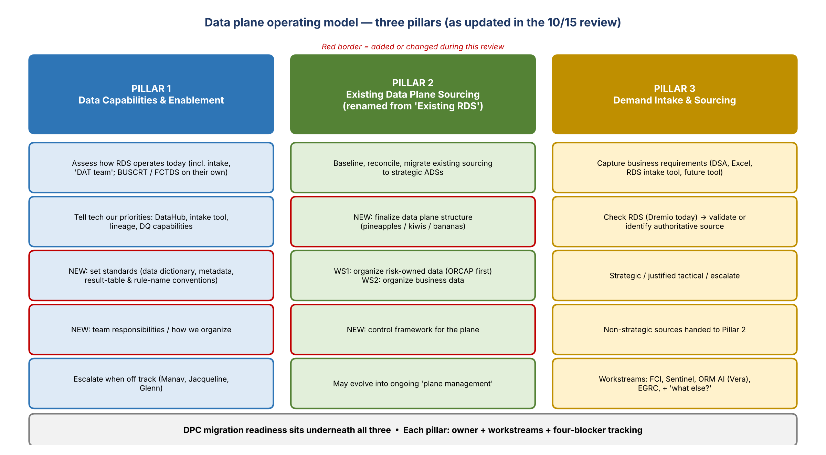
Figure 1. The three pillars with the additions from this review (red borders)
Pillar 1 provides the foundational tools and capabilities that enable and speed up Pillars 2 and 3. The three can run in parallel. The better Pillar 1 goes, the easier Pillars 2 and 3 get.

Pillar 1: Data capabilities and enablement
- First, understand what we have. Then tell technology our priorities to build: DataHub, an intake tool, lineage capabilities, and so on.
- Assess how RDS operates today, including the intake process. Kevin mentioned the "DAT team" pinged the other day; what they do feels like a business function.
- Rethink intake so it reaches beyond legacy RDS intake, which never covered everything. BUSCRT has been doing its own thing, and FCTDS may be too.
- Concern raised: requests and requirements sent to technology have been falling on deaf ears. Kevin's answer is a new Pillar 1 owner who drives the work and escalates when there are issues.
- The Pillar 1 leader takes input from Pillars 2 and 3. As those teams hit needs, the needs become Pillar 1 priorities.
- Pillar 1 may be more than capabilities. It also covers team responsibilities and how the team organizes itself.
- Pillar 1 escalates to Manav, Jacqueline, Glenn, or whoever is needed when things go off track or needed work isn't getting done.

Pillar 2: Existing data plane sourcing (renamed)
- Figure out what's in RDS today and whether it needs to be there. Is there overlap between financial crimes and credit risk? Are they using strategic ADSs? If not, what's the roadmap to migrate existing sourcing to strategic ADSs?
- Start from Ryan's Excel of all the raw tables, then work out how they are used. That needs Pillar 1 capabilities to trace how data moves through RDS. Is the raw data used in a use case, or sourced in and never looked at?
- Kevin kept saying RDS but means the data plane: the broader DPC environment and everything already sourced into it. Scope is baseline, reconcile, then migrate to strategic ADSs.
- Rename: "existing RDS" becomes "existing data plane sourcing". Someone suggested a smiley face for Mike and a frowny face for Ryan.
- Finalizing the data plane structure goes here. Mike G asked where it fits, since it's still undecided. The open question is whether the data plane will be separate from the ADS applications. Kevin's reply: "you ask the good questions, you get to solve them." Use the "pineapples, kiwis, bananas" analogy so it resonates with Jacqueline.
- Pillar 2 workstreams: WS1 organizes risk-owned data (ORCAP / "SHARP" data). WS2 finalizes how business data will be organized, once current sourcing is understood.
- Control framework added: how we control the data on our plane, alongside how we organize it. This goes on slide 3, not slide 5. ("Congratulations, Mike G": one more thing in his bucket.)
- Kevin sees Pillar 2 as partly time-bound. Once the existing RDS data is understood, the baselining work ends and it becomes ongoing management of the plane. It might eventually be renamed something like "plane management".

Pillar 3: Demand intake and sourcing
- All the new demand. Data sourcing requests can't stop while Pillar 2 gets the shop in order.
- It needs owners for deliverables, business requirements from partners, and a check of whether data is in RDS. If not, how is it prioritized against everything else? If the strategic source doesn't have it, use the tactical source or escalate?
- Workstreams already in flight: Nick's FCI and Sentinel work, and the ORM AI work Jake and Vic recently kicked off. EGRC is on the back burner; it will need data, and Taylor is handling everything with Tandems (does it relate or not?).
- Prioritization should come from the firm's critical AI list, critical reports, and other business-partner priorities across corporate risk.

5. Phases 1 to 5 (slides 3 and 5)
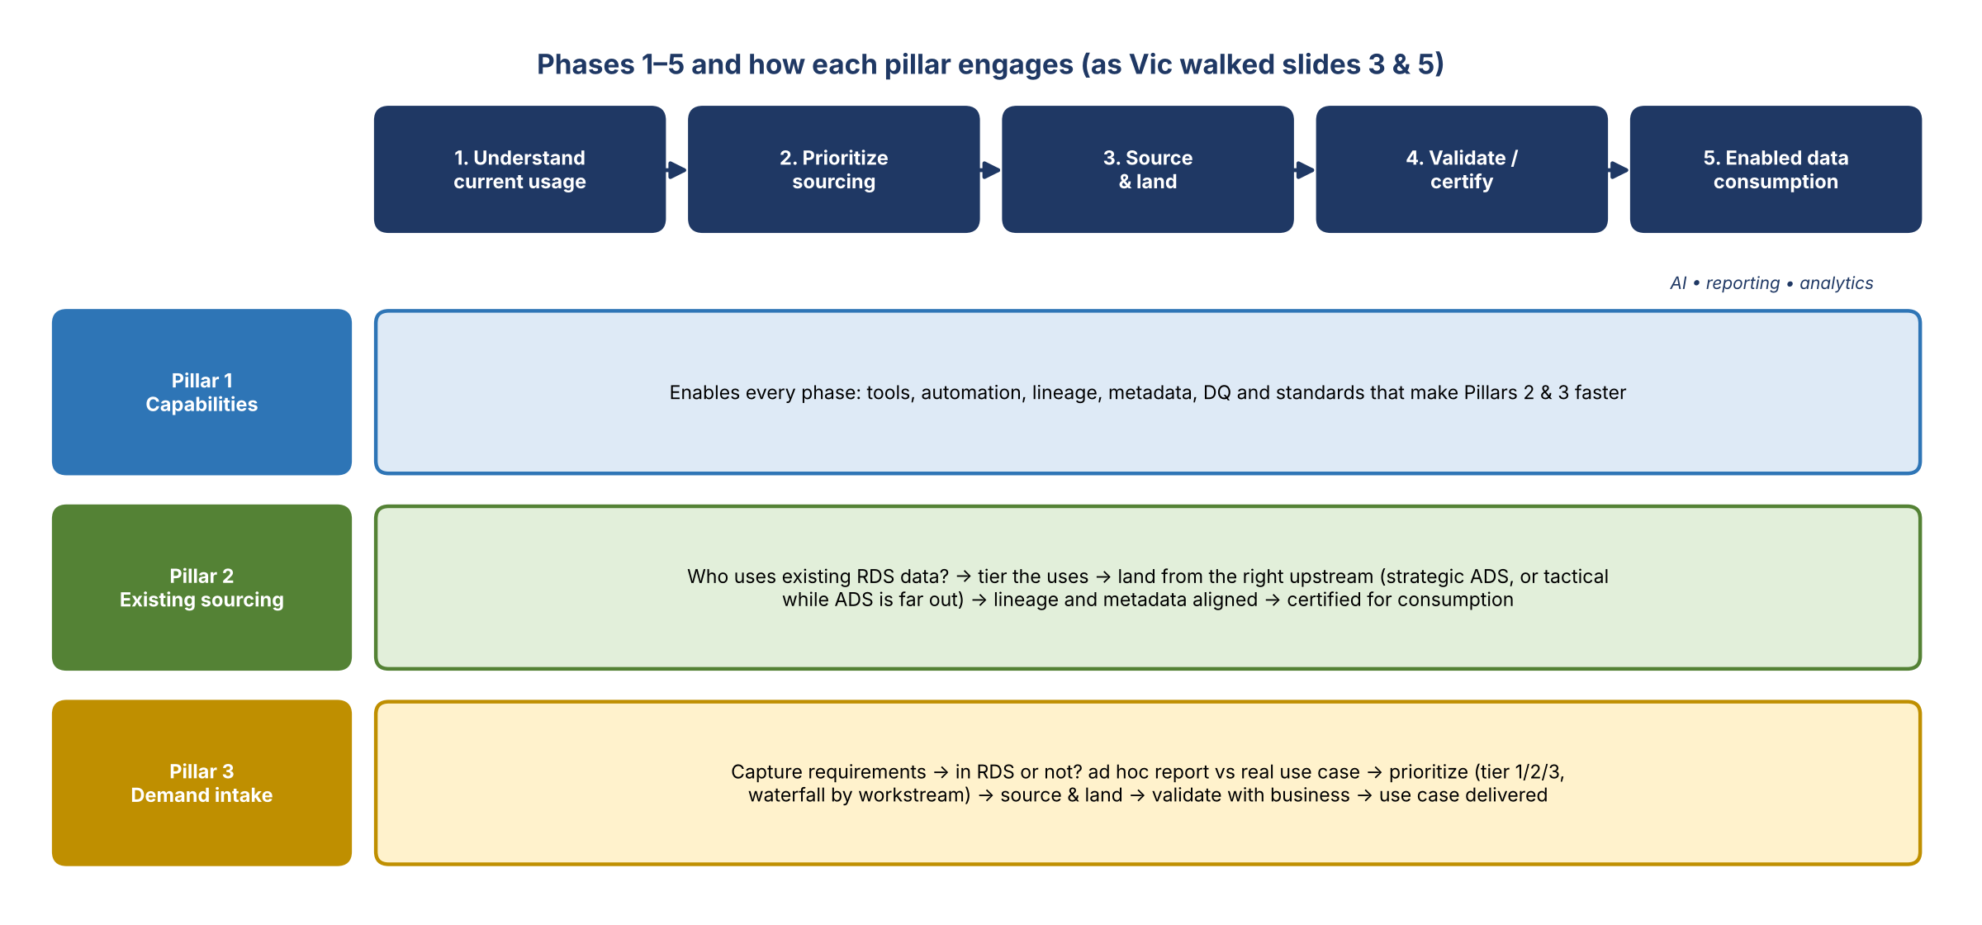
Figure 2. Phases and how each pillar engages, as Vic described them
Vic walked the phases. The end result is data that reaches the point of consumption for all users with proper data quality controls, ready for AI, reporting, analytics, and any other risk use.
Phase | What happens
1. Understand current usage | The book of work for data in RDS today or newly requested. Teams say "we need this" or "we're plumbing it", but do we still need it, who uses it, and why?
2. Prioritize sourcing | Based on requirements or known RDS data, tag uses as tier 1, 2, 3, or non-tier. Work out needs and priorities with each group. Consider waterfall logic across scopes and workstreams rather than doing everything at once. Research and analysis happen up front here.
3. Source and land | Decide the sourcing path and coordinate delivery to the common data plane. This depends on the plane structure (Mike's point), such as whether there are sub-ADSs inside the plane.
4. Validate and certify | Is it fit for purpose and ready to use, with the needed data quality and expected outcomes? Done in tandem with business groups, who set the requirements we deliver against.
5. Enabled data consumption | Data ready for consumption by the use cases.

- Slide 5 shading: each pillar is shown across the phases. A shaded box marks where that pillar leads the work in that phase.
- Pillar 1: all the capabilities being enabled and automated. Needed in every phase, and drives Pillars 2 and 3.
- Pillar 2: for existing RDS data and new needs, make sure data comes from the right upstream. That means the new strategic ADS, or the current "tactical" approach when the ADS is too far out. Lineage and metadata must be aligned to reach Phase 5.
- Pillar 3: capture business requirements, check whether the data is in RDS, and get the fields the business uses today. Is it an ad hoc report or a real use case? Then prioritize, source and land, validate, and deliver the use case.
- Vic confirmed the phases work for all three pillars, since they're interconnected.

6. Standards and controls (Pillar 1 vs. Pillar 2)
- Pillar 1 (or whichever pillar fits) covers more than capabilities. It also sets standards for the data dictionary and metadata. Agreed: standardize everything across the data plane.
- Control standards might belong too. Kevin is open to debate on whether controls go in Pillar 1 or Pillar 2.
- The Pillar 1 slide already has data quality (scalable DQ capabilities to define, monitor, and manage DQ rules, controls, and issues across the plane) and a standardization point.
- Standards go beyond DataHub: technology is building group-specific result tables and rule names. Ryan has seen this too. There should be one standard.
- Kevin: the deck is a working draft, fresh off the AI engine "and some brain power, a little bit". Send feedback after it goes out.

7. Workstreams and four-blocker tracking (slides 14 and 15)
- Each pillar has its own workstreams, each with deliverables, timelines, and an accountable person on the team.
- Example Pillar 1 workstreams: (1) assess RDS current state; (2) prioritize capabilities and enhancements, decide what can get done, and monitor that technology delivers against a roadmap.
- Why it matters: the legacy team is very project-management oriented. Without set deliverables and dates, people assume we're not doing anything.
- Four-blocker (Kevin's term from Bank of America): tracks each workstream's progress, roadblocks, and progress since the last report-out.
- Slide 14 is a mock-up of a pillar's workstream summary. Workstream counts can range from 2 to 10; the count doesn't measure effort. Slide 15 is a high-level project plan to track against.

8. Pillar 1 slides: intake tool (slides 6 to 8)

Where the intake tool came from
- The ORM team came to Jacqueline needing data from 54 sources, with no detail on usage, purpose, or fields.
- The team built a manual Excel spreadsheet that asks the right questions up front and works as a BRD (business requirements).
- Jake built a UI on top of that template.
- Next, take it to technology partners to build. Jacqueline wants tech to build it: we state the requirements and the why.

How it helps each pillar (slide 7)
Pillar | Benefit
Pillar 1 | Capability owner: defines the intake requirements and takes them to technology (Jake has already started).
Pillar 3 | Replaces emails and ad hoc asks. Business partners log requirements in one place, it generates automatically for the team, and items feed into workstreams.
Pillar 2 | During RDS rationalization, data needed elsewhere can go through the same intake process.

- Slide 8 shows what happens today, the pain points, and the target state. Work can still get done with current tooling, but the goal is a target state where it's automated.

Agreed changes
- Build a mock four-blocker workstream for each pillar for the first walkthrough. Pillar 1's example is the intake tool: UI mocked up, about to engage tech, and why it matters.
- Next Pillar 1 example: DataHub. We sent technology our priority list, but they keep canceling the meeting to discuss it. Little can be done on DPC, but the priorities are on record.
- One or two workstreams per pillar is enough; they don't need to be fully built out.
- Reorder so the intro slides sit together: about two slides to introduce each pillar, then one example workstream. Kevin felt slides 6 and 7 go together, with the current-state / target slide moved up.

9. Pillar 2 slides (slides 9 and 10)
- Slide 9 expands Pillar 2. Add the data plane structure decision. Scope: assess the RDS inventory, migrate to the right sources, confirm data comes from the right place, and drop unused data. That includes Credit 360, financial crimes, and everything in the RDS bucket Ryan showed Kevin in Dremio.
- Typo fix: bullet 2 on slide 9 says "RFS"; it should be "RDS". It appears on several pages, so Ctrl+F for "RFS". ("Claude got a little rogue on us.")
- Slide 10 covers alignment on data and the worksheet (e.g. FCTDS / FCI: source strategically, or tactically with justification). It moves after Pillar 3 as a summary of how Pillars 2 and 3 fit together, since Pillar 3 hasn't been introduced at that point.
- New second Pillar 2 slide: reuse the "where risk data lives today" slide. Add arrows down to how we migrate out of ORCAP, BUSCRT, and FCTDS into a structure that makes sense on the plane, and merge in Jake's folder-structure slide. ORCAP is the first target: organize it into sensible folders instead of by application.
- Then add a four-blocker for organizing risk data on the plane (pineapples, kiwis, bananas).
- Vic suggested bucketing by line of business: financial crimes (FCI, Sentinel), NFR (ORM, compliance; ORCAP is all NFR today), and financial risk (Credit 360). The group felt this would clutter the Pillar 3 slide. It fits better in Pillar 2 to explain where data lives today and the next steps.

10. Pillar 3 flow (slide 11)
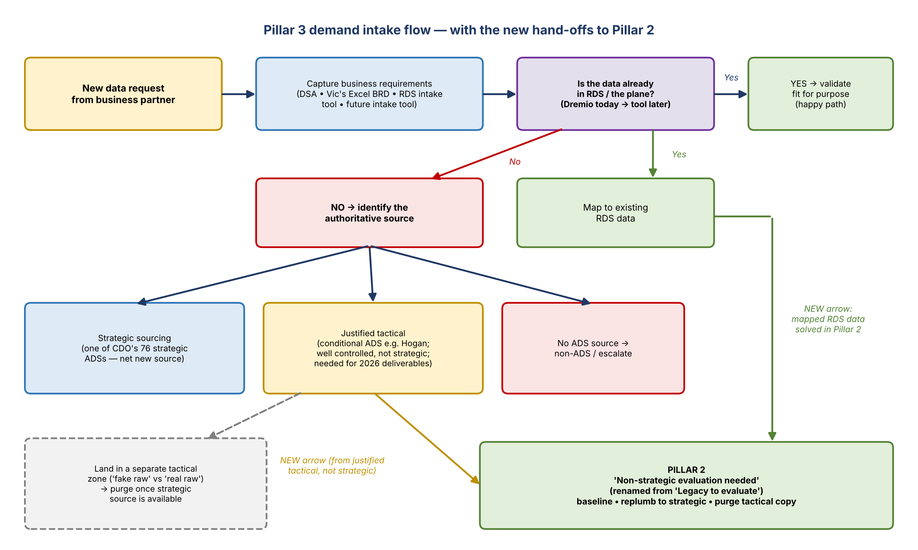
Figure 3. Pillar 3 intake flow with the changes made live in the meeting

How the flow works
- Get the business requirements. Today that can be via the DSA (not always done well), Vic's Excel file, the RDS intake tool, or eventually the new intake tool. How these fold together is a Pillar 1 question.
- Check whether the data is already in RDS. Today that's via Dremio; later it should be built into the tool.
- Yes: validate the data and confirm what it's fit for. This is the easy, happy path.
- No: identify the authoritative source. The options are strategic sourcing (a net new strategic source), justified tactical (not available strategically today), or no source other than a non-ADS (escalate).

Changes agreed (Jake edited live)
- "Legacy to evaluate" doesn't belong as a fourth option now that Pillar 2 is explained first. Instead, an arrow comes out of "map to existing RDS data": once mapped, it gets solved in Pillar 2.
- Strategic or justified, anything already on RDS is Pillar 2's job, including whether it should be strategic.
- Add an arrow from justified tactical (not strategic) to the Pillar 2 bucket. Pillar 3 sources it today, but someone must re-plumb it later, and that sits with Pillar 2.
- Rename: "legacy to evaluate" becomes "non-strategic evaluation needed" (or "evaluation of non-strategic sources needed"). That is Pillar 2.
- Kevin noted Jake made the edits himself, not Copilot.

Justified tactical: Ryan's question
- Ryan asked: does justified tactical mean a tactical zone in the plane, i.e. a separate landing area purged once the strategic source exists?
- Kevin: "100%." That's his "fake raw vs. real raw" idea.
- Justified tactical is what Kevin would call a conditional ADS today. It's the best, well-controlled place to get the data, but not one of the CDO's 76 strategic sources. Example: Hogan, the only place to get certain data needed by end of 2026.
- How to distinguish justified tactical from strategic sourcing in the plane is a Pillar 2 problem.
- When re-plumbed, the data comes back through Pillar 3 as a new request and goes through sourcing again. The interrelation slide helps show this.

11. Slides 12 and 13: business need and workstreams
- Slide 12: explains to the business why identifying the business need matters, i.e. why Pillar 3 is important.
- Slide 13: current Pillar 3 workstreams. There may be one overall Pillar 3 leader, but everyone on the call will eventually lead a workstream.
Workstream | Status / notes
FCI | Led by Nick; getting the extra data the AI use case needs
Sentinel | Led by Nick; same, for the Sentinel AI use case
ORM AI (Vera) | New request from the Vera team / ORM. Probably not super critical, but a good way to work out our process for identifying data
EGRC | Unscheduled; known future priority
NEW: "What else?" | Open question to Jacqueline and others (e.g. Sean). Any other high-priority AI use cases needing data today? Key reports missing data? What else matters going into 2027?

- Today, workstreams are organized by use case, because the team doesn't have subject-matter expertise built in yet.
- Longer term, organize by SME domain. If you become the customer SME, customer data requests route to your workstream; the same goes for commercial loan data and so on.

12. Remaining slides
Slide | Plan
14 and 15 | Tracking per workstream per pillar: four-blocker and project plan (covered earlier)
16 | In-process items
17 | Use Ryan's existing DPC migration slide
18 | Decisions: who does what, once the pillars are agreed. Left out of the version sent today
"Where risk data lives today" | Moves to Pillar 2 as its second slide (see Section 9)
EGRC slide | Keep as an appendix item

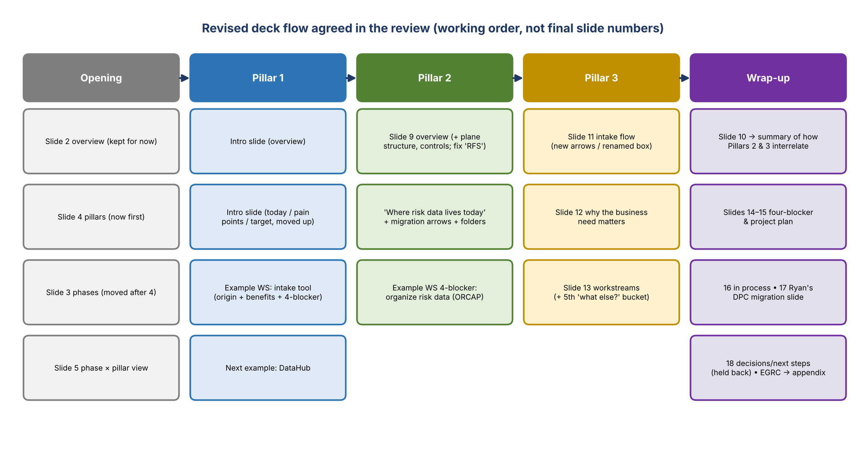
Figure 4. Working deck order after the review

13. Kevin's ask to the team
- Kevin doesn't know everything here and hasn't done this before. He needs everyone's collective brain power.
- Raise ideas, good or bad: what's next, what we're not thinking about, missing pillars, and how to keep this moving. Then decide together whether to include each or set it aside for now.
- Without ideas being thrown out there, "we're not going to get anywhere".

14. Decisions
# | Decision
1 | Phase 5 is "enabled data consumption", not AI-specific
2 | Present pillars before phases (slide 3 moves after slide 4)
3 | Pillar 2 is renamed "existing data plane sourcing" and owns finalizing the data plane structure
4 | Pillar 2 adds a control framework; Pillar 1 adds standards. Whether controls sit in Pillar 1 or 2 is still open
5 | Pillar 3: arrows from "map to existing RDS data" and "justified tactical" to Pillar 2; "legacy to evaluate" becomes "non-strategic evaluation needed"
6 | Justified tactical data lands in a separate zone and is purged once the strategic source exists ("fake raw vs. real raw")
7 | Each pillar gets about two intro slides plus one example workstream four-blocker
8 | Slide 10 becomes a summary after Pillar 3; "where risk data lives today" becomes Pillar 2's second slide; EGRC goes to the appendix
9 | Vic sends this version to the small group, without slide 18 (decisions / next steps)

15. Action items
Action | Owner | Notes
Send the deck to the small group (minus slide 18) | Vic | This version, as-is
Move slide 3 (phases) after slide 4 (pillars) | Vic / Jake
Rename Pillar 2 to "existing data plane sourcing"; add plane structure, the two workstreams, and the control framework (slide 3 and slide 9) | Vic / Jake | Use pineapples / kiwis / bananas framing
Add standards (dictionary, metadata, result tables, rule names) and team operating model to Pillar 1 | Vic / Jake | Controls placement open
Ctrl+F "RFS" → "RDS" across the deck | Vic / Jake | Starts with slide 9, bullet 2
Finish Pillar 3 flow edits: arrows to Pillar 2, rename box | Jake | Mostly done live
Add a fifth "What else?" bucket to slide 13 | Vic | Question for Jacqueline / Sean
Mock a four-blocker per pillar: intake tool (P1), organizing ORCAP risk data (P2), plus a P3 example | Vic / Jake | One or two per pillar is enough; DataHub as the next P1 example
Reorder Pillar 1 slides (6 to 8) so the intro slides sit together | Vic
Make "where risk data lives today" Pillar 2's second slide, with migration arrows and Jake's folder-structure content | Vic / Jake | ORCAP first
Move slide 10 after Pillar 3 as a summary; EGRC slide to the appendix; add Ryan's DPC slide (17) | Vic
Review the deck and send feedback, ideas, and gaps | Everyone | Mike G, Ryan, Nick, Jen, Prasanta
Own finalizing the data plane structure (Pillar 2) | Mike G (implied) | Kevin: "you ask the good questions, you get to solve them"

16. Open questions
- Do controls and control standards belong in Pillar 1 or Pillar 2?
- Will the data plane be separate from the ADS applications, and will there be sub-ADSs inside the plane?
- How do the DSA, Vic's Excel BRD, the RDS intake tool, and the future intake tool fold into one requirements process?
- Who owns each pillar? A new Pillar 1 owner is expected; decisions are held for slide 18.
- What else should Pillar 3 prioritize going into 2027 (AI use cases, key reports)? This is for Jacqueline and others.
- Does EGRC / Tandems work (Taylor) relate to this effort?
- Should Pillar 2 eventually be renamed "plane management"?

