Meeting Notes
CDO Metadata Harvesting Demo: AIDP, Tachyon Enrichment & Lineage
Item | Detail
Meeting date | Friday, October 16, 2026 (recording started about 9:02 AM)
Format | Strategy framing plus live demo of the AIDP harvesting tool (screen share)
CDO side | Ryan (CDO strategic data management; framed the roadmap) and Satya (owns the AIDP harvesting solution; ran the demo)
Risk side | David (model / model-risk data sourcing use case), Kathy (lineage change management), Kevin, Michael, and the BDL team
Referenced | Bridget (CDO data context sponsor), Chris McClendon (hub-and-spoke model), Eric Bland and Dana Parks (risk technology; own harvesting tools), Lori / Lorraine (change management), CO Technology Observe2Agent program
Purpose | Show where CDO's metadata and harvesting capabilities are heading, demo what AIDP can do today, and work out how it can support David's model data source cataloging, Kathy's lineage change management, and Kevin's DPC / DataHub description gap

Note on the transcript
Auto-generated transcript; speakers aren't labeled, so attributions come from context. This Ryan is the CDO presenter, not Ryan on Kevin's team. Readings used: AIDP / AIDP-EMH (Ab Initio product; transcribed "Abitio"), Tachyon (transcribed "TACYAR"/"attack end"), semantic discovery (transcribed "cemented discovery"/"C-Money discovery"), EUCT (transcribed "ECT"), Observe2Agent (transcribed "observed to agent"/"observatory agent"), Oct 21 release (transcribed "1021"/"2021 release"), and Dataplex (transcribed "data plex"). Confirmed: PyFarm (model execution platform), CRMDI, Zoot Analytics. Unsure: Slate, CEG, DSAM, LDML, "Ante" (who Satya thanked), and "Jay Ryan".

1. Summary
Ryan (CDO) opened with a preview of CDO's 2027 strategic data management roadmap. The foundation is metadata plus "data context", which AI needs. On top of that sit three capabilities: ADMF (rebranded around data governance), a new Metadata Portal for data source owners, and a new Information Marketplace for discovering data and automating provisioning (MVP in Q2 2027). Behind it all is automated scanning and harvesting, so lineage and metadata stop going stale through manual documentation.
Satya demoed AIDP-EMH, the Ab Initio harvesting tool. It covers about 36 million harvested elements across 1,000+ apps, harvests whole databases through global service accounts (Oracle and SQL Server today), auto-stitches lineage from ETL code, and enriches business terms and descriptions using data profiling plus Tachyon. The first production release of that enrichment is Oct 21.
Agreed next steps:
- David: CDO extracts the Clarity application into David's model data source template. Later, narrow it to raw input variables, then look at PyFarm and API flows. David is first in line to pilot the Information Marketplace.
- Kathy: gets the list of harvested apps to compare against her tier 1 and tier 2 apps before building a manual lineage change management process. The list includes some AML apps.
- Kevin: sends 20 to 30 DPC fields with sample values as a quick pilot of AI-generated descriptions. Satya is already talking to the DPC team about harvesting DPC metadata.

2. CDO strategic data management direction (Ryan)
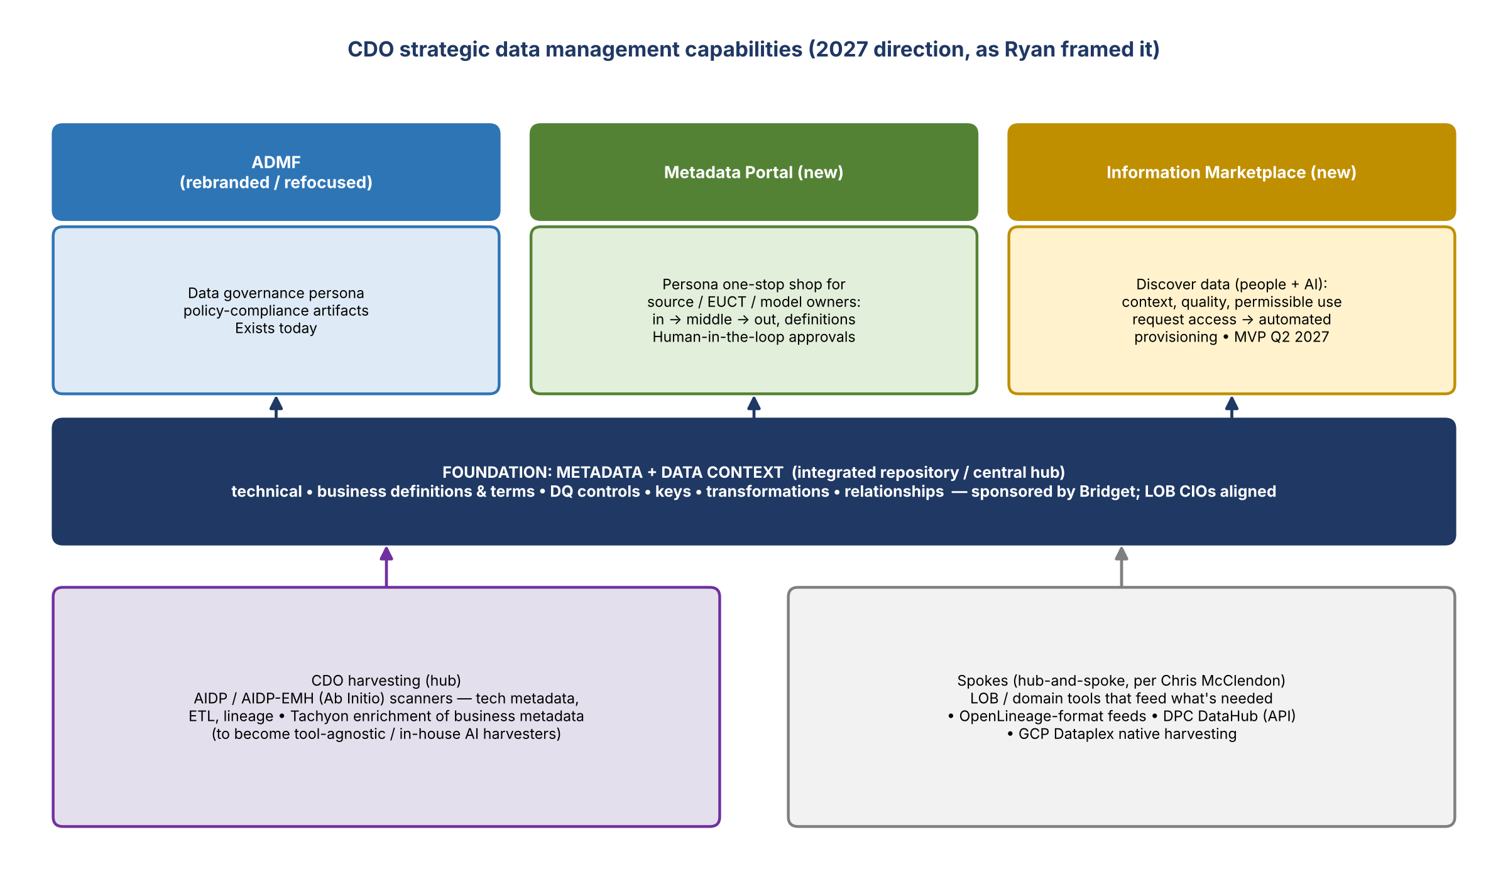
Figure 1. CDO capability stack as presented; slides are heading up to the OC level

Foundation: metadata and data context
- Everything sits on metadata, or more broadly "data context". AI needs it, and that's a big driver. Data context is metadata plus a few other things.
- Bridget is sponsoring CDO to own data context going forward, and the LOB CIOs are aligned.
- Once metadata and context are together, they enable every capability on top. For example, ADMF needs the metadata to create policy compliance artifacts.
- Definition check (David): is metadata the same as what CDO has called key, i.e. the template with the four-part key, descriptions, and in-app transformations? Ryan: yes, aligned. It covers technical metadata (physical schema and element names), business metadata (definitions and terms), DQ controls, and keys, all in one integrated repository, plus some extras.

Capabilities on top
Capability | What Ryan described
ADMF | Not going away. Gets rebranded and refocused on a front-and-center data governance persona and policy compliance.
Metadata Portal (new) | Metadata capture and management moves out of ADMF over time. A persona-based one-stop shop for data source owners (and EUCT owners, model owners) to see what comes in, what happens in the middle, how it's defined, and where it goes. Backed by automated harvesting. This is the human-in-the-loop place to review, approve, and modify AI-generated content, including confidence levels.
Information Marketplace (new) | Makes data discoverable to people and AI, with metadata, context, quality, and permissible use. Source owners define what they'll provision. Users search, request access, and CDO capabilities automate provisioning to the end user. On the 2027 roadmap; MVP in Q2 2027.
Scanning and harvesting | Lineage and metadata go stale as soon as they're documented, so get out of manual documentation. Today that's AIDP (Ab Initio) connected to Tachyon for business metadata enrichment. Eventually tool-agnostic, with CDO building its own AI-based harvesters.

Hub-and-spoke model
- Chris McClendon has been clear that CDO is the hub. If an LOB or domain is set on its own tool, CDO won't force them off it, at least at first, as long as it extracts what's needed and feeds the central repository.
- Satya: no single tool will meet every lineage and harvesting need. CDO is working on ingesting OpenLineage-format feeds from LOBs. Most will still come through AIDP and, later, the Metadata Portal.
- If CDO's tooling does everything an LOB's tool does and more, the LOB should just use it; that saves the enterprise money.
- Kathy's flag: connect CDO (Ryan, Satya) with the local risk technology team, Eric Bland and Dana Parks. Eric covers finance and risk and is building his own automated harvesting tools. The aim is to avoid different tools making competing promises to Bridget and others in 2027. Ryan agreed.

3. David's use case: model data source cataloging
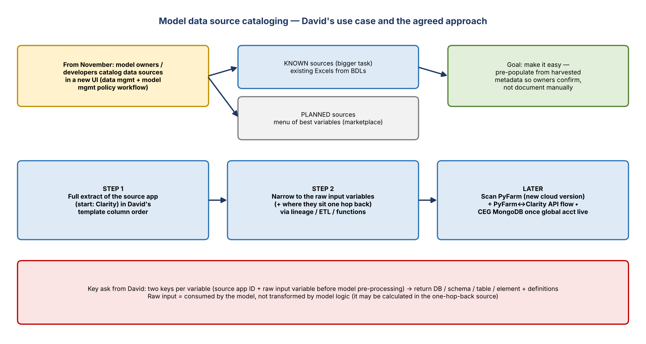
Figure 2. Model data source use case and the stepwise approach agreed

Background
- From November, a new workflow will integrate data management and model management policy for the first time. Model owners and developers will catalog their data sources, known or planned, through a UI screen.
- Known sources: the large inventory of existing models. Owners will reuse the Excels built with the BDLs and enter them into the UI. This is the bigger task, and the group most likely to push back ("we've used this model for 15 years, why is data risk relevant now?").
- Planned sources: optionality on the best variable available. It aligns with the DMP plan and could improve model performance. This is where the Information Marketplace could help later.
- David's aim is to make it easy. If CDO already harvests the source's metadata, present it so the model owner confirms the source and variables instead of documenting by hand.

The one-hop-back gap
- Today, when a model lives in an application, that application is usually treated as the ADS. Nobody goes one hop back past it.
- The model's pre-processing logic (selecting and transforming raw variables) isn't captured. David asked whether CDO could parse it, e.g. from GitHub.
- Ryan: they may get some of it. Functions, processing, and transformations inside applications can already be harvested, and CO Technology's Observe2Agent work needs the same thing. He'll add this to the list of things to harvest.
- David suggested PyFarm, the largest risk platform for model execution, as a pilot. The list Ryan had shows the old, now-inactive PyFarm; there's a new cloud PyFarm with its own BAM ID.

Raw input variables
- Definition (David): a raw input is a variable the model consumes but doesn't transform. It may have been calculated in the one-hop-back source. The goal is those raw variables and where they live one hop back.
- Kevin asked whether scanning PyFarm could identify the input variables automatically from the model logic. David thinks that's a taller order: you'd have to pinpoint the right production GitHub repo with the pre-processing code.
- David thinks model owners know their code well enough to provide the input variable (before pre-processing) and the data source name. He asked whether those two keys would be enough for CDO to return the database, schema, and other details.

Output format
- David shared a template from a proof-of-concept model on PyFarm that sources from Clarity (CRD).
- Ryan estimates at least 80% of the template, including the yellow columns and business data element definitions, can come from AIDP in a similar or identical format through a custom view. Fields like model version number would still be filled in by hand.
- Satya ran a canned report live on the full Clarity application name. It's large, so it took time. CDO will send David a sample.
- Approach agreed: Step 1 is a full extract of the app ("better than nothing"). Step 2 narrows it to what owners actually need, using lineage, ETL, and functions, based on examples from David of which fields mattered.

Information Marketplace pilot
- David asked for a realistic timeline and to be a first adopter. MVP is Q2 2027. Ryan put David at the top of the pilot list.

4. AIDP demo (Satya)
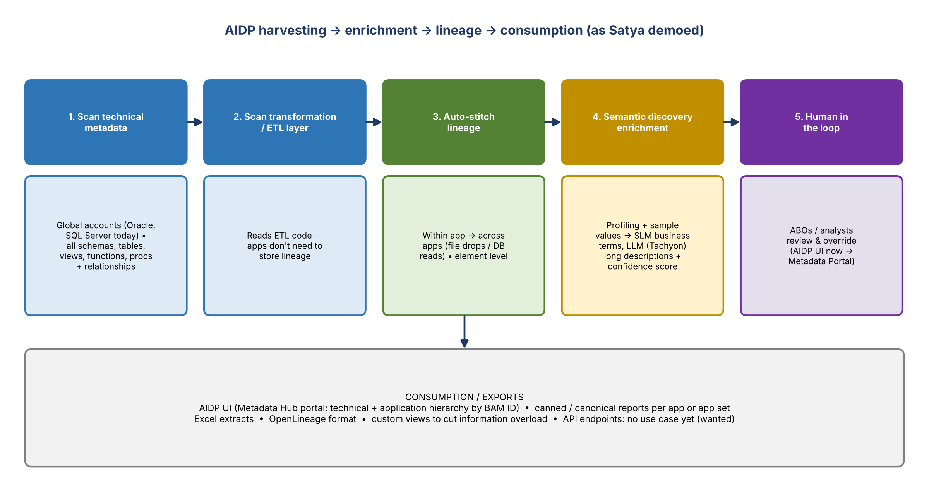
Figure 3. The harvesting pipeline as demoed

Coverage and approach
Point | Detail
Scale | About 36 million elements auto-harvested across 1,000+ apps. The coverage shown was harvested in four days after go-live.
Shift left | The legacy version (11 to 12 years) onboarded only apps feeding tier 1 and tier 2 use cases, and only required elements. The new version (AIDP-EMH) pulls in every app with a database presence, all of it, because AI needs full context including relationships.
Denominator | The 96 apps shown come from DSAM, a database inventory that lists each app's database assets (e.g. Oracle, Teradata), not BAM. Not every BAM app has a database. The count covers Oracle and SQL Server apps only for now.
Global accounts | A crawl account that can scan every SQL Server and Oracle instance in the bank. Global accounts for Postgres, MongoDB, and YugabyteDB are being set up; the Mongo one is in servicing. This replaces slow per-instance local service accounts.
Other sources | Teradata, mainframe copybooks, and DB2 (50+ DB2 apps scanned in production).
Speed | Given the right details, mainly the database name to scan, Satya can harvest a large app overnight and enrich it with business metadata.

Walkthrough
- Metadata Hub portal: the AIDP UI (Ab Initio suite with ETL, DQ, Metadata Hub, and semantic discovery). The technical hierarchy is BAM ID, then DB instance name (UAT instances start with "U0"), then schema, then tables. Apps with several instances show all of them (e.g. one ADA).
- Application hierarchy: objects are also organized by BAM app name (about 3,850 apps in the bank).
- Example, CRMDI: the DBO schema had 241 objects (functions, tables, stored procs). Relationships between objects are captured during the technical scan, before any ETL scan. Drilling into a view showed it built from a base table (the T-Service account), instance CLRTY. This shows movement inside the app, not in and out.
- ORCAP has no database instances in AIDP. Minerva has one instance harvested.
- Example, Zoot Analytics: a Teradata app (EIWU is its UAT instance) with its ETL layer scanned, so lineage expands across apps down to element level.
- Cross-app lineage: if an app drops a file or writes to a database that another app reads, scanning both draws the connection. Ryan suggested scanning related apps together. A multi-app consumer authorization / provisioning / data exchange supply chain was shown rolled up, and it can drill to level 4 (element).

Lineage questions
- Michael: if an app doesn't store its lineage in its own metadata tables, can the tool still get it? Satya: yes. Apps don't need to maintain lineage; the tool reads the ETL code and auto-stitches it.
- Manual steps (extracts, copy and paste, manual files) are not captured.
- Exports: the visual lineage is limited to the tool. It can export to OpenLineage format or Excel (Excel gets complicated). Canned or canonical reports can be built per app or app set.
- API endpoints: no use case yet. Satya wants examples, because if APIs are a key data exchange route they should be in lineage. David named PyFarm and Clarity. Clarity is already scanned; PyFarm (cloud) still needs its BAM ID.

Semantic discovery (business enrichment)
- An example from Slate (shared with CO Technology / TCO for Observe2Agent) shows harvested fields alongside proposed business terms (SLM, based on data profiling and fingerprinting) and long descriptions (LLM via Tachyon).
- Oct 21: first production release of business terms and descriptions. No more manual spreadsheet uploads (to "LDML" or other routes). More columns are planned for Nov 30.
- Users with the right entitlements can override suggestions. The tool also suggests names when a column has no data to profile.
- Confidence: yes, there's a scoring mechanism, viewed per app on a separate screen. The Metadata Portal will surface confidence and editing so business users never need to log into AIDP.
- CO Technology was "blown away" by the first-pass descriptions.

5. Kathy: lineage change management
- Kathy wants to take the manual nature out of lineage change management. A control takes effect this coming year, and every group is building its own process, which is inefficient for data source owners.
- If CDO can automate harvesting in weeks, Kathy won't build a manual process; she'd rely on CDO and build on top.
- She has a meeting with Lori next week on change management. Today, all seven domains would hit each ABO every quarter with all the PDEs feeding the use cases, which isn't workable.
- Ryan: Lorraine knows about the strategic plan and that an interim is needed. CDO is open to manual extracts if they help.
- Action: Ryan re-sends the harvested app list so Kathy can compare it against her tier 1 and tier 2 apps. There are some AML apps on it, which is where Kathy would start.
- Kathy also offered to help choose a risk app to prototype or pilot (Clarity is no longer in risk; PyFarm was suggested).

6. Kevin: DPC, DataHub, and descriptions

Scanning DPC
- Satya's team had its first call with the DPC team yesterday. DPC runs a Postgres database on the back end, but DPC prefers that metadata be harvested through its API. Details will be worked out over the next couple of weeks.
- Principle: don't reinvent the wheel. If DPC tenants' metadata is already harvested, bring it into one place, and eventually into the Metadata Portal. This is the hub-and-spoke model.
- Ryan: cloud platforms have native harvesting, lineage, and enrichment (DataHub on DPC, Dataplex on GCP), so CDO may pull from them rather than rescan.
- Kevin: the DPC migration team says those DataHub capabilities still have to be built, "which is going to take forever". If CDO can do it sooner, that's a win. Ryan agreed: point AIDP at it while native capabilities mature.

Descriptions for DPC fields
- Kevin asked whether non-Oracle / SQL Server technical metadata, e.g. an Excel list, can be loaded in to generate descriptions. Answer: yes, but with less context, because the tool normally profiles actual values and sends them to Tachyon. It would be a starting point instead of a blank page.
- Kevin can include sample values in the Excel.
- Kevin's gap: DPC data needs descriptions to enable DataHub, but DataHub can't create descriptions, which is circular.
- Action: Kevin sends a sample of 20 to 30 fields with sample values for a quick pilot. CDO checks whether the output is close enough to pursue and what the Excel needs, then plans roadmap support if it's valuable.

MongoDB and CEG
- Kevin asked about scraping MongoDB. The extractor is ready, and the global account is in servicing.
- David pointed to CEG (now a finance app) as having a large dependency base, since many models consume its economic variables. CEG has a mart / UI view with Excel export, plus a separate MongoDB that technical teams use through an API.

7. Key dates
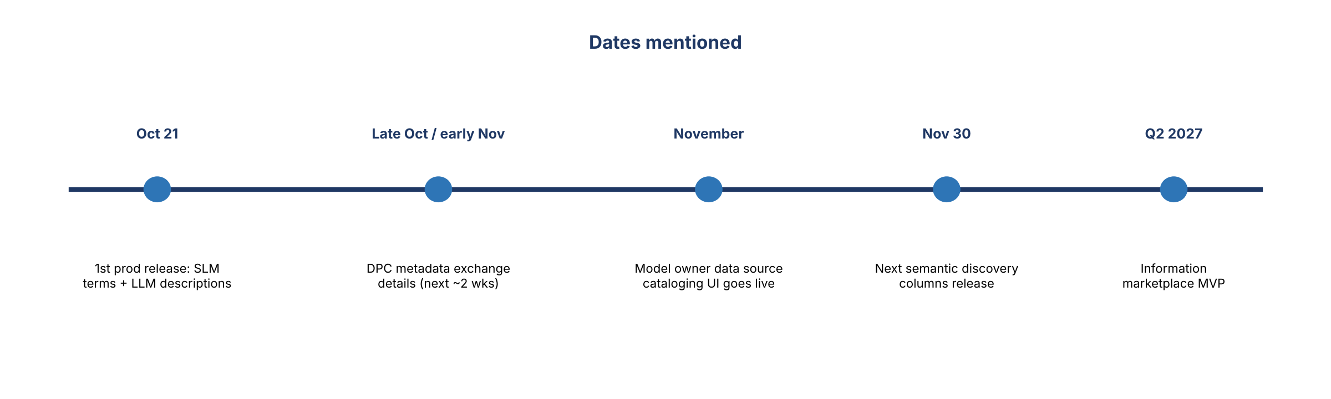
Figure 4. Dates mentioned in the meeting

8. Decisions and agreements
# | Decision / agreement
1 | For David: start with a full extract of Clarity in his template format, then narrow to raw input variables
2 | David's team is first in line to pilot the Information Marketplace (MVP Q2 2027)
3 | Kevin's 20 to 30 field Excel is a quick pilot of description generation with less context
4 | CDO pursues DPC metadata through the DPC API (hub-and-spoke) rather than a separate rescan, while being open to pointing AIDP at DPC if native DataHub capability lags
5 | Pre-processing logic, functions, and API-based data exchange go on the list of things to harvest

9. Action items
Action | Owner | Notes
Send David a sample canned report for Clarity; build a custom view or extract in his template column order | Ryan / Satya | Ask: a few days to coordinate
Send examples of which fields model owners actually needed, to help narrow the extract | David | By email
Post the new cloud PyFarm BAM ID in chat for scanning | David / Kevin | Old PyFarm on the list is inactive
Share examples of apps exchanging data through APIs (PyFarm and Clarity) | David | For API lineage
Re-send the list of harvested apps (the 96) and details or link behind the coverage view | Ryan / Satya | Kathy compares to tier 1 / tier 2; start with AML
Meet Lori on lineage change management | Kathy | Next week
Connect CDO with risk technology (Eric Bland, Dana Parks) on harvesting tools | Kathy / Ryan | Avoid duplicate tooling
Help pick a risk app to prototype or pilot | Kathy / Kevin / David | PyFarm suggested
Send 20 to 30 DPC fields with sample values for a description pilot | Kevin | Then CDO assesses fit and roadmap
Finish the DPC metadata exchange approach (API vs. Postgres back end) | Satya | Next couple of weeks
Stand up the MongoDB global account; consider CEG | Satya | Account in servicing

10. Open questions
- Can CDO harvest model pre-processing logic, e.g. in GitHub, to identify raw input variables automatically?
- Will two keys (source app ID + raw input variable) be enough to return the full set of details for model owners?
- How will change management for human edits work in the Metadata Portal?
- When does AIDP coverage extend beyond Oracle and SQL Server global accounts to Postgres, MongoDB, and YugabyteDB?
- How will DPC metadata flow: the DPC API, native DataHub, or an AIDP scan?
- How do LOB harvesting tools (e.g. Eric Bland's) line up with CDO's hub?

