Meeting Notes
DPC Migration Status Call: Production Parallel Readiness
Item | Detail
Meeting date | Wednesday, October 15, 2026 (recording started about 1:41 PM, partway into the call)
Format | Recurring DPC migration status call with workstream POs, downstream users, and technology
Speakers identified | Prasanta (technology lead), the meeting host (runs the status list), Michelle, Jim (NFR team), Gauri, an NFR team member (RDS upload utility question), a Credit 360 team member, and a Power BI / gateway responder
Referenced (not speaking) | Jeff Ogle (edits and uploads plan; stepped away), Naveen (Power BI gateway), Sam (Power BI follow-up; possibly also NFR), Anna (NFR team), Jan
Purpose | Status ahead of the production parallel run starting Monday, October 19 and the November 19 cutover: downstream comms, Power BI gateway, edits and uploads testing, NFR readiness, and how production testing differs from UAT

Note on the transcript
Auto-generated transcript that starts mid-call, so the opening items are partly cut off. Speakers aren't labeled; attributions come from context. Readings used: "Prasanta" (transcribed "Prashant"), "prod parallel" (transcribed "prop parallel"/"broad parallel"), "Credit 360 / CR360" (transcribed "360"), and "NFR" (non-financial risk). Unsure: "everything except for rare" (may be RADAR or another workstream), which "Sam" owns the Power BI follow-up, and whether "Jan" is a person on the call.

1. Summary
The migration is on track for the November 19 cutover. The production parallel run starts Monday, October 19. The host reported every item at 100% except "rare" (unclear in the transcript). The Power BI production gateway was created this morning. Downstream Dremio users get a communication this afternoon listing the entitlements they need.
Most of the discussion was about testing in production. Jobs run on schedule rather than manually, so validation compares RDS and DPC output cycle over cycle. Edits and uploads are tested by making the same change in both environments on paired data sets (Jeff Ogle's plan). The NFR team is ready to validate from the 19th. They raised one gap: they were told the RDS upload utility can't be tested for NFR. Since the two-data-set approach worked for Credit 360, Gauri will connect Jeff with the NFR team to set it up.

2. Key dates
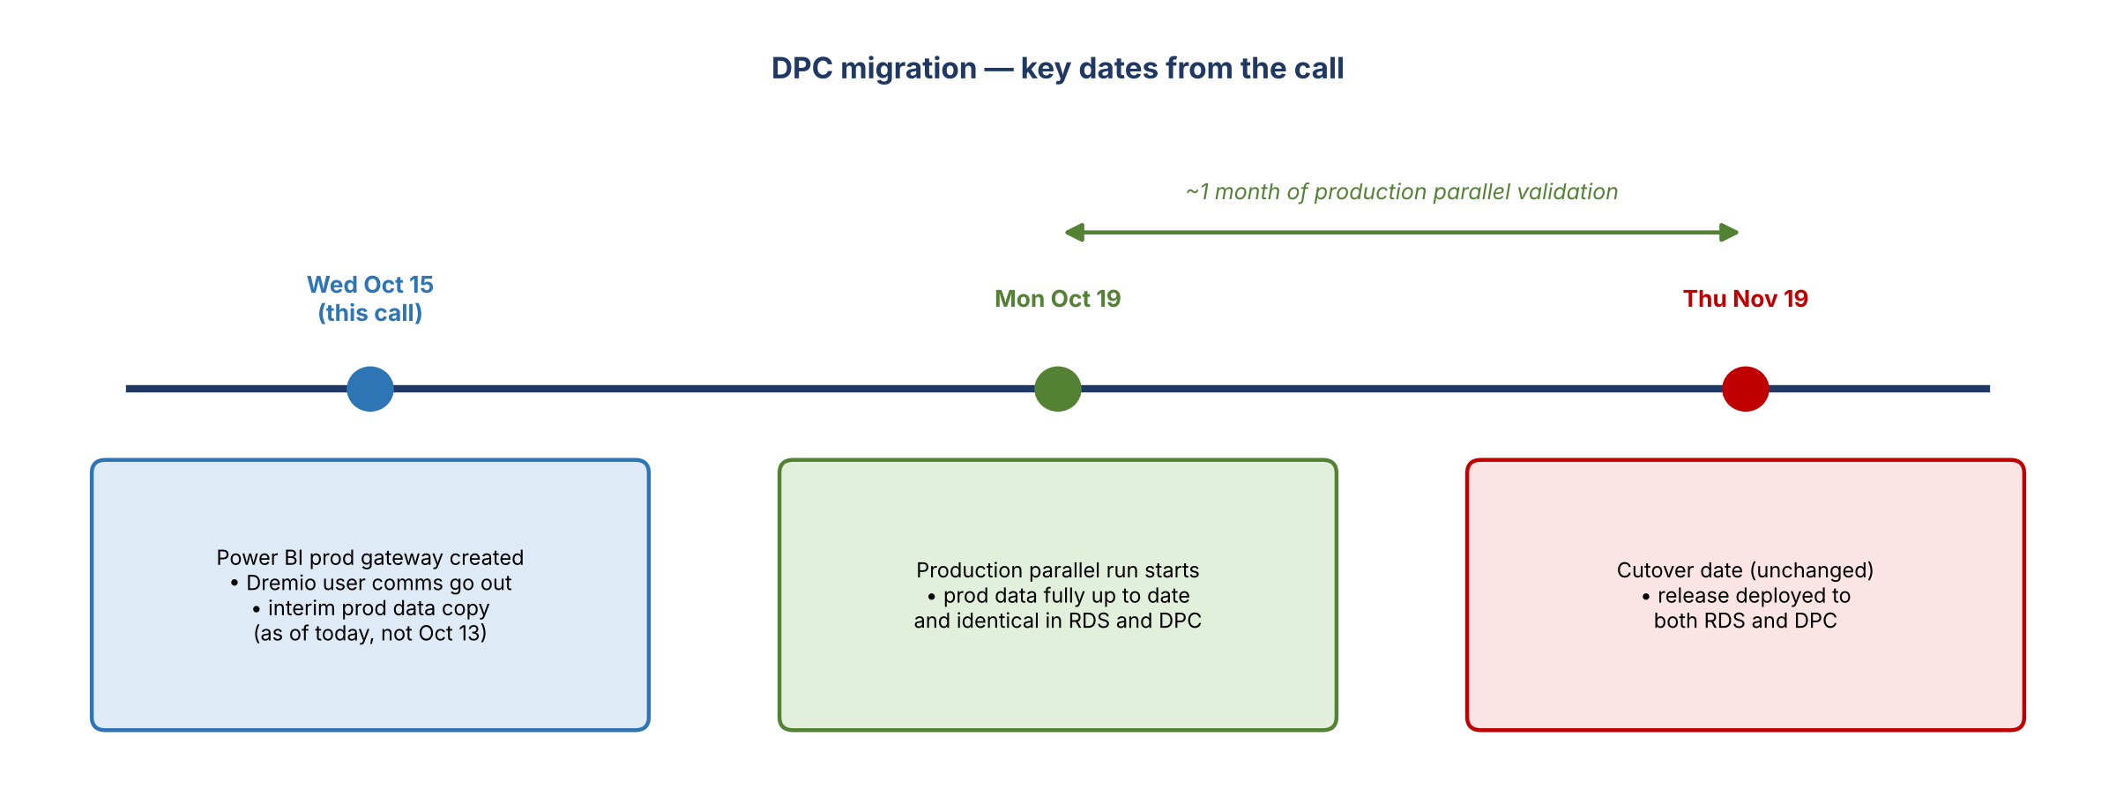
Figure 1. Dates confirmed on the call
Date | What happens
Wed, Oct 15 | Power BI production gateway created (this morning). Dremio downstream user communication goes out this afternoon. Interim production data copy is as of today, not October 13.
Mon, Oct 19 | Production parallel run begins. Production data in RDS and DPC should be up to date and identical by then.
Thu, Nov 19 | Cutover date; still the target and hasn't moved. A planned release that day deploys to both RDS and DPC to keep them in sync.

3. Status updates

Downstream users and Dremio entitlements
- Downstream users on the call should expect a communication this afternoon.
- Dremio users need a few entitlements, which will be listed in that communication.

Power BI gateway
- Prasanta asked whether all the gateway setup information for Power BI users is in place.
- Response: the requests were already raised, and the production gateway was created this morning. It has been routed to Naveen, who has reached out to a couple of the team and is on it.
- Action: Prasanta asked Sam to keep a tab on it and make sure all Power BI consumers are set up.

Overall tracker
- The host's list matched what had already been covered: 100% on everything except "rare".
- Jeff Ogle sent an email yesterday with his plan for edits and uploads in the prod parallel test. The host considers that covered.
- New line item for NFR, since the NFR team is joining these calls from now on.

Cutover date check (Michelle)
- Michelle asked whether cutover had moved. It hasn't: November 19 is still the target. (October was said first, then corrected.)

4. NFR team readiness (Jim)
Item | Status
Validation plan for prod parallel run | In place
Testing requirements | Defined
DPC production connections | Established, including the NGDC SQL Server connection used for the legacy SQL Server comparison test
UAT sign-off | Conditional. Based on user access to DPC and data set availability in DPC pre-prod
Pending conditional item | An edits and uploads job on the platform side. The NFR member said this is still pending (see Section 6)
DQ issue handling | Anna has set up prioritized JIRAs for each NFR, ready if DQ issues come up during the sprint
Start of production validation | Mon, Oct 19; working closely with technology until then

Jim: "All things considered, we're set to go into the production environment and start validation on the 19th."

5. How production testing differs from UAT (Prasanta)
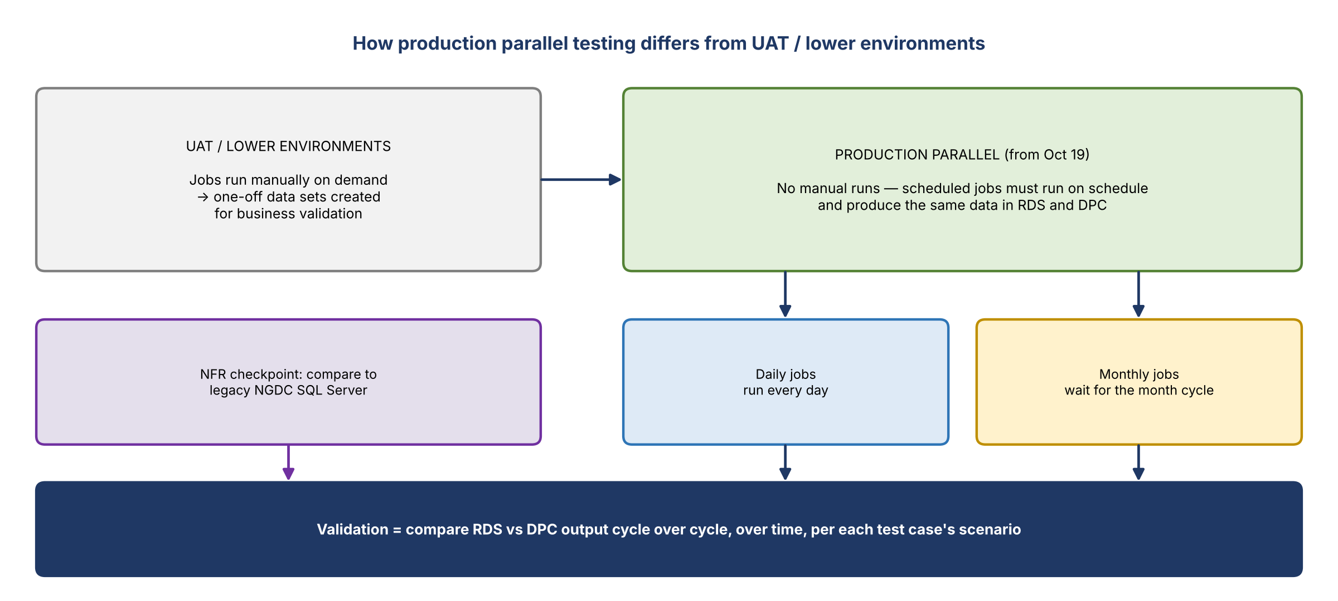
Figure 2. Lower-environment testing vs. production parallel testing
- UAT and lower environments: jobs were run manually to create data sets for business validation.
- Production: no manual runs. All scheduled jobs must run on their schedule and produce exactly the same data.
- Daily jobs are expected to run every day. Monthly jobs have to wait until the month cycle starts.
- Validation focuses on comparing data cycle to cycle and over time, according to what each test case scenario needs.
- Prasanta said all the POs already know this; he was restating it. No one raised other differences.
- Data currency: the production data copy is an interim update as of today, not October 13. By October 19 it should be fully up to date, with both environments identical when validation starts.

6. Edits and uploads
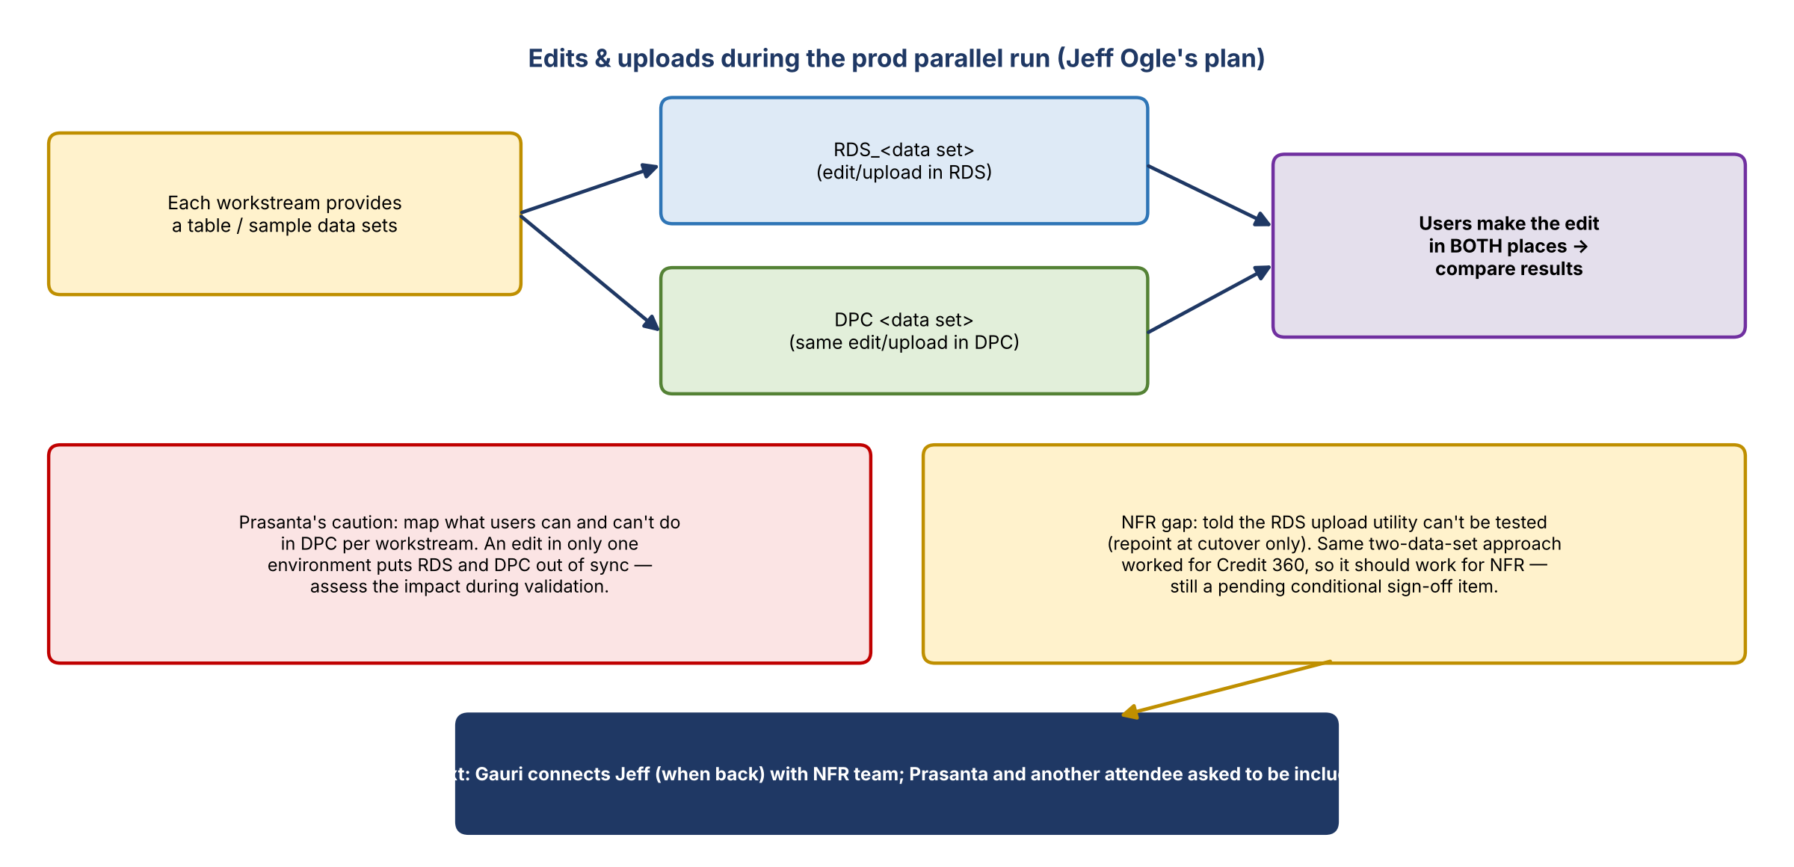
Figure 3. Testing edits and uploads in both environments

Prasanta's caution
- For each workstream that uses edits and uploads, map what users can and cannot do in DPC, and make sure that's followed.
- Any update made in only one environment puts RDS and DPC out of sync. He isn't saying don't do it, but be aware of the impact and assess it during validation.

Jeff Ogle's plan (from his email; Jeff had stepped away)
- Edits are done in both places.
- Each workstream provides a table or sample data sets to use.
- Two data sets: one named like RDS_<data set> and the other in DPC.
- Users make the same edit or upload in both environments, then the results are compared.

Release on November 19
- A team member flagged a release going in on November 19 and checked that Prasanta was OK with it.
- Prasanta was fine with it. The release deploys to both RDS and DPC so they stay in sync.

NFR question on the RDS upload utility
- An NFR team member asked whether edits and uploads means the RDS upload utility. The answer was yes.
- NFR had been told their data couldn't be tested this way "by design". At cutover they would just be repointed from legacy RDS storage to the new DPC storage. This is one of their pending conditional sign-off items on the platform side.
- If parallel testing is possible after all, NFR would add it to their validation plan for the parallel run.
- Prasanta: if it can be done for Credit 360, it can be done for NFR, and he knows of no other limitation. It should be exactly the same as Credit 360.
- A Credit 360 team member confirmed that's how they tested. The two-data-set idea came out of a discussion with one of the developers as a way to run a prod parallel.
- Action: Gauri connects Jeff with the NFR team when he's back. Another attendee asked Gauri to pull them in too.

7. Decisions and confirmations
# | Decision / confirmation
1 | Cutover stays November 19
2 | Production parallel run starts Monday, October 19, with RDS and DPC data identical
3 | Production validation uses scheduled job runs only (no manual runs), comparing output cycle over cycle
4 | Edits and uploads are tested by making the same change in both RDS and DPC on paired data sets
5 | The two-data-set approach used for Credit 360 should also apply to NFR
6 | The November 19 release is deployed to both RDS and DPC

8. Action items
Action | Owner | Notes
Send downstream user communication, including the Dremio entitlements needed | Host / migration team | This afternoon (Oct 15)
Track Power BI gateway setup until all Power BI consumers are set up | Sam (with Naveen) | Prod gateway created Oct 15
Provide tables or sample data sets for edits and uploads prod parallel testing | Each workstream | Per Jeff Ogle's email
Map what users can and can't do in DPC for edits and uploads, and assess out-of-sync impact during validation | Workstream POs | Prasanta's request
Connect Jeff Ogle with the NFR team on edits and uploads and RDS upload utility testing | Gauri | When Jeff returns; include the attendee who asked to join
Add edits and uploads parallel testing to the NFR validation plan if confirmed possible | NFR team (Jim) | Clears a pending conditional sign-off item
Make sure production data is fully current and identical in RDS and DPC by Oct 19 | Technology | Current copy is interim
Start NFR production validation, including the NGDC SQL Server comparison | NFR team (Jim, Anna) | Oct 19; JIRAs ready for DQ issues
Deploy the Nov 19 release to both RDS and DPC | Release owner | Keeps environments in sync

9. Open questions and risks
- What is the one item not at 100% ("rare")?
- Can NFR's RDS upload utility actually be parallel tested? NFR was told no; Prasanta and the Credit 360 team believe yes.
- Monthly jobs only run when the month cycle starts, so monthly comparisons may not happen until November, close to cutover (not raised on the call).
- Edits made in only one environment cause RDS and DPC to drift during the parallel period.

