Meeting Notes
Model 14851: Identifying the Upstream Collections Data Source
Item | Detail
Meeting date | Monday, October 19, 2026 (afternoon; exact start time not captured)
Format | Short call set up by Jake; a model team member shared their screen to show where the data is pulled from
Risk BDL side | Kelly and Jake (organizer)
Model side | Mahesh (model owner; dropped off once it was clear 14851 isn't his), a model team member who showed the data pull and asked about ABOs, and Shani (named as owner of 14851; attendance not clear)
Purpose | Identify the upstream data source behind model 14851 (collections data) so the Risk BDL can confirm it with the source's ABO and link it to the model under the data management policy

Note on the transcript
Auto-generated transcript. Speakers aren't labeled; attributions come from context. Readings used: YOM Interface (transcribed "YOM"/"UOM"/"YAM"), ECAR (Enterprise Collections and Recovery, as Kelly expanded it), ABO (application business owner), and IW (described as Teradata). Unsure: the name of the model team member who shared the screen, the spelling of "Shani", and "a total of elaborate data" (likely a count of files or tables pulled; not clear).

1. Summary
A model team member showed that model 14851 pulls a number of files from an Oracle database the team calls "YOM"/"UOM", along with the pull criteria. Kelly said the next step is to take this to the ABO of either the YOM Interface or ECAR (Enterprise Collections and Recovery), with ECAR more likely, to confirm the source. The Risk BDL would then link ("implicate") that source to the model, as in similar recent discussions. IW was ruled out because it's Teradata and this data is Oracle.
Model 14851 turned out to be Shani's, not Mahesh's, and Mahesh's models don't use this collections source, so he dropped off. Kelly explained the ABO handshake to the model team. They welcomed it: past team transfers lost contacts, and source changes such as redefined or removed variables have broken their downstream production jobs without warning.

2. Where the data comes from (screen share)
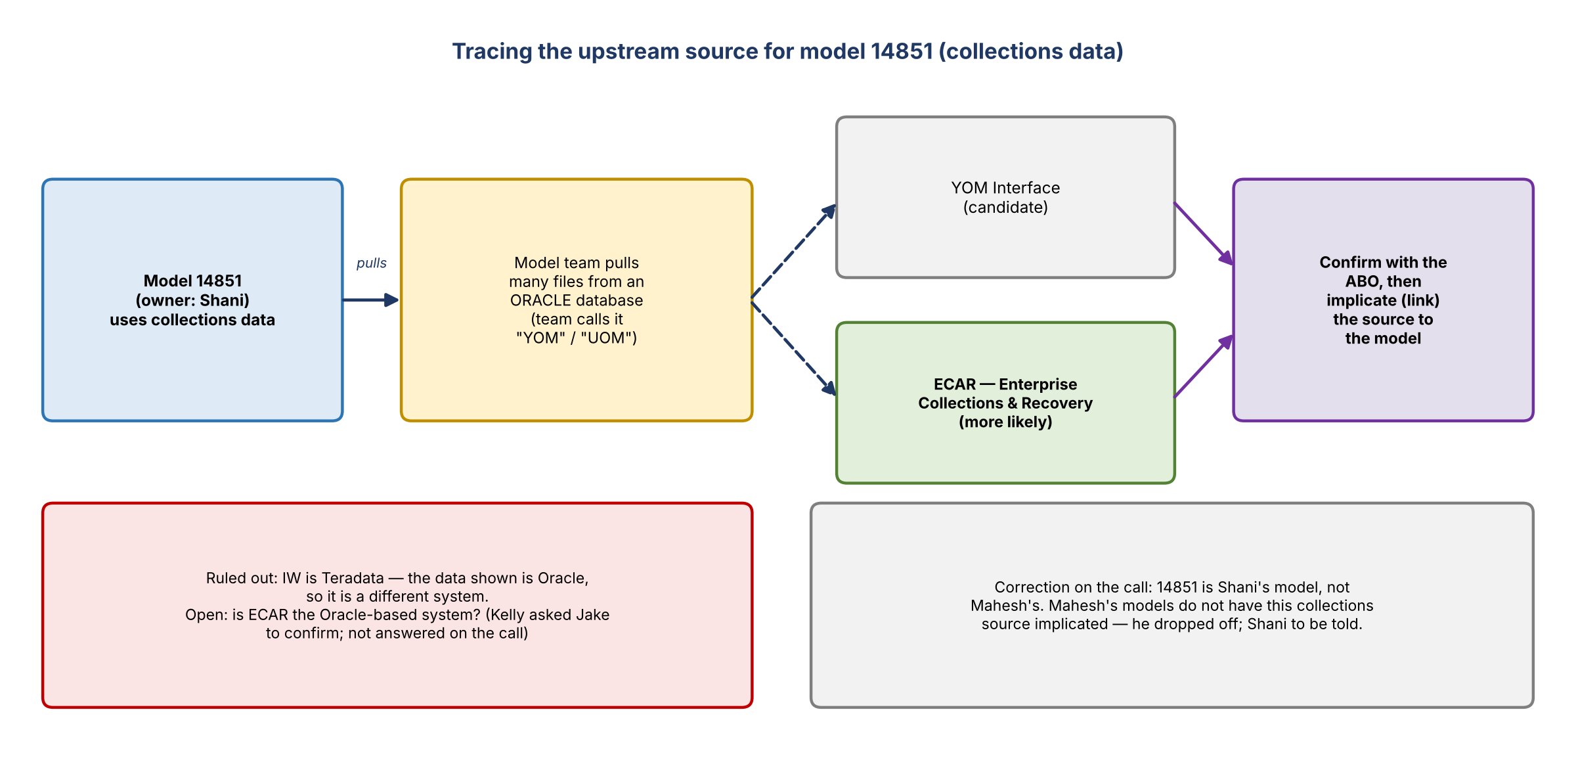
Figure 1. Tracing model 14851's upstream source
- The model team member shared where they pull the data from, which the team calls "YOM" / "UOM".
- It's an Oracle database. The screen showed all the criteria used for the pull and the individual files pulled from that server; several files are pulled in total.
- Kelly: taking this to the YOM Interface or ECAR ABO should point us in the right direction. She asked Jake whether ECAR is the Oracle-based one or whether she had it flipped. This wasn't settled on the call ("no worries").
- IW ruled out: IW is Teradata, and this data is Oracle, so it's a different system.
- The model team member didn't know what feeds into this Oracle database.
- Next step (Kelly): find out whether the source is ECAR or the YOM Interface, escalate the information to the ABO, then implicate the source and tag it to the model.

3. Model ownership correction
- Kelly addressed next steps to Mahesh and Shani as model owners: once the ABO confirms the source, it gets implicated and connected to the model, like the other recent discussions.
- Mahesh: 14851 is not his model. It's Shani's.
- Kelly recalled that Mahesh's models didn't have this collections source implicated, but one or two of Shani's did. Mahesh was probably invited because he was part of the larger conversation.
- Mahesh has nothing to action here and dropped off. The message needs to go to Shani.

4. What an ABO is and why the handshake matters
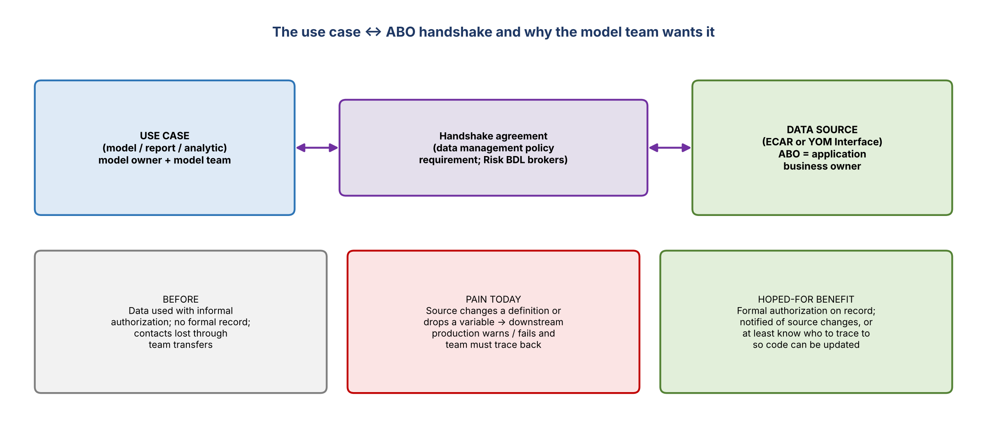
Figure 2. The use case to ABO handshake and the model team's motivation

Kelly's explanation
- ABO = application business owner, the owner of the data source application.
- Use case is a data management term for a model, report, or analytic. All use cases have requirements under the data management policy.
- The aim is to identify the model's upstream data source and get a handshake agreement between the model team (the use case) and the ABO of that source.
- For 14851, the source is probably ECAR, possibly the YOM Interface.

Model team's view
- Their understanding: in the past, data was used with some authorization but nothing was formally recorded. This exercise confirms they're authorized and that the data owner agrees to their use.
- Generational and team transfers lost information, and some contacts became untraceable, so they've had to trace back themselves.
- Pain point: when a source file changes a definition or drops a variable, downstream production hits a warning for the missing variable and the production job can't finish.
- Hope: this exercise means they'll be notified when the source changes, or at least know who to trace back to so they can update their code.
- Kelly confirmed ("for sure").

5. What's needed from the model team
- Nothing more right now. Kelly has enough to start the conversation with the application owner.
- Follow-up questions or requests for more information will come by email.

6. Decisions
# | Decision
1 | Model 14851 belongs to Shani; Mahesh is out of scope for this source
2 | IW (Teradata) is not the source; the data comes from an Oracle database
3 | The Risk BDL takes the screen-share details to the ECAR (more likely) or YOM Interface ABO to confirm the source
4 | Once confirmed, the source is implicated (linked) to model 14851 under the use case to ABO handshake

7. Action items
Action | Owner | Notes
Confirm whether ECAR or the YOM Interface is the Oracle-based source | Jake / Kelly | Kelly asked Jake to confirm
Take the pull details (Oracle server, criteria, files) to the right ABO and get the handshake | Kelly / Jake | Start the upstream conversation
Tell Shani that 14851 is hers and what happens next | Kelly / Jake | Mahesh not involved
Implicate (link) the confirmed source to model 14851 | Risk BDL | After ABO confirmation
Send any follow-up questions to the model team by email | Kelly / Jake | As needed

8. Open questions
- Is ECAR or the YOM Interface the Oracle system the model team pulls from?
- What feeds this Oracle database upstream?
- Will the handshake include a way to notify the model team when the source changes or drops variables?

