Meeting Notes
Semantic Certification on DataHub: Workflow, Scope & Raw Metadata
Item | Detail
Meeting date | Friday, October 16, 2026 (recording started about 3:58 PM, partway into the call)
Format | Working session; the semantic certification lead shared draft user journeys, slides, and sample React screens
Attendees (from context) | Semantic certification / data management lead (presenter), Kevin, Mike, Ryan, Jake
Referenced | CDO (AIDP), the finance data management team, Ashley (set up the PO responsibilities call)
Purpose | Preview how the semantic certification workflow on top of DataHub will work for risk once DPC is live (ORCAP first), agree what gets certified in Release 1 vs. 2, and work out how raw data gets business metadata

Note on the transcript
Auto-generated transcript that starts mid-call, partway through a point about AIDP. Speakers aren't labeled, so attributions come from context; "the presenter" is the semantic certification lead who shared the screens. Readings used: DataHub, ADMF, ORCAP, iHub, FDLZ, Flowmaster, BAM ID. Confirmed: SHRP (transcribed "Sharp"), ERA (also called 1ERA; transcribed "one ERA"), and Mike as the one who built the ORCAP description prompt. Unsure: "FDMO Touchstone" (the label on the sample screens).

1. Summary
The presenter walked the team through draft data steward and data owner user journeys for a semantic certification workflow on top of DataHub. It covers glossary terms and data assets, plus sample React screens for the data glossary and a research agent. The aim is to enable it for ORCAP once DPC is live, hopefully in January or at least in testing by then.
Agreements:
- Only deltas trigger certification. Names and descriptions sourced from ADMF are auto-tagged certified. A new data set, new column, deleted column, or renamed column triggers certification or recertification.
- ADMF sync is one-way at first: an Excel download until ADMF has APIs.
- Release 1 covers the consumption layer: glossary terms, data sets, and their descriptions.
- Release 2 adds data products, grouped from consumption elements.
- Raw data still needs business metadata, flagged as proposed or upstream-based, not certified. The team only certifies its own outputs.
- Contracts should carry the BAM ID so raw data can be matched to ADMF business metadata.
- Filter labels on the screens should use CDO's terms (category group, category, subject area), not domain / subdomain.

2. Opening point: AIDP vs. app metadata
- The recording picks up as the presenter discusses whether to get current metadata through AIDP or keep going through the apps' own metadata to stay close to current.
- Based on Kevin's feedback, the presenter's team will reach out to CDO. (See the 10/16 CDO AIDP demo notes for context.)

3. The certification workflow
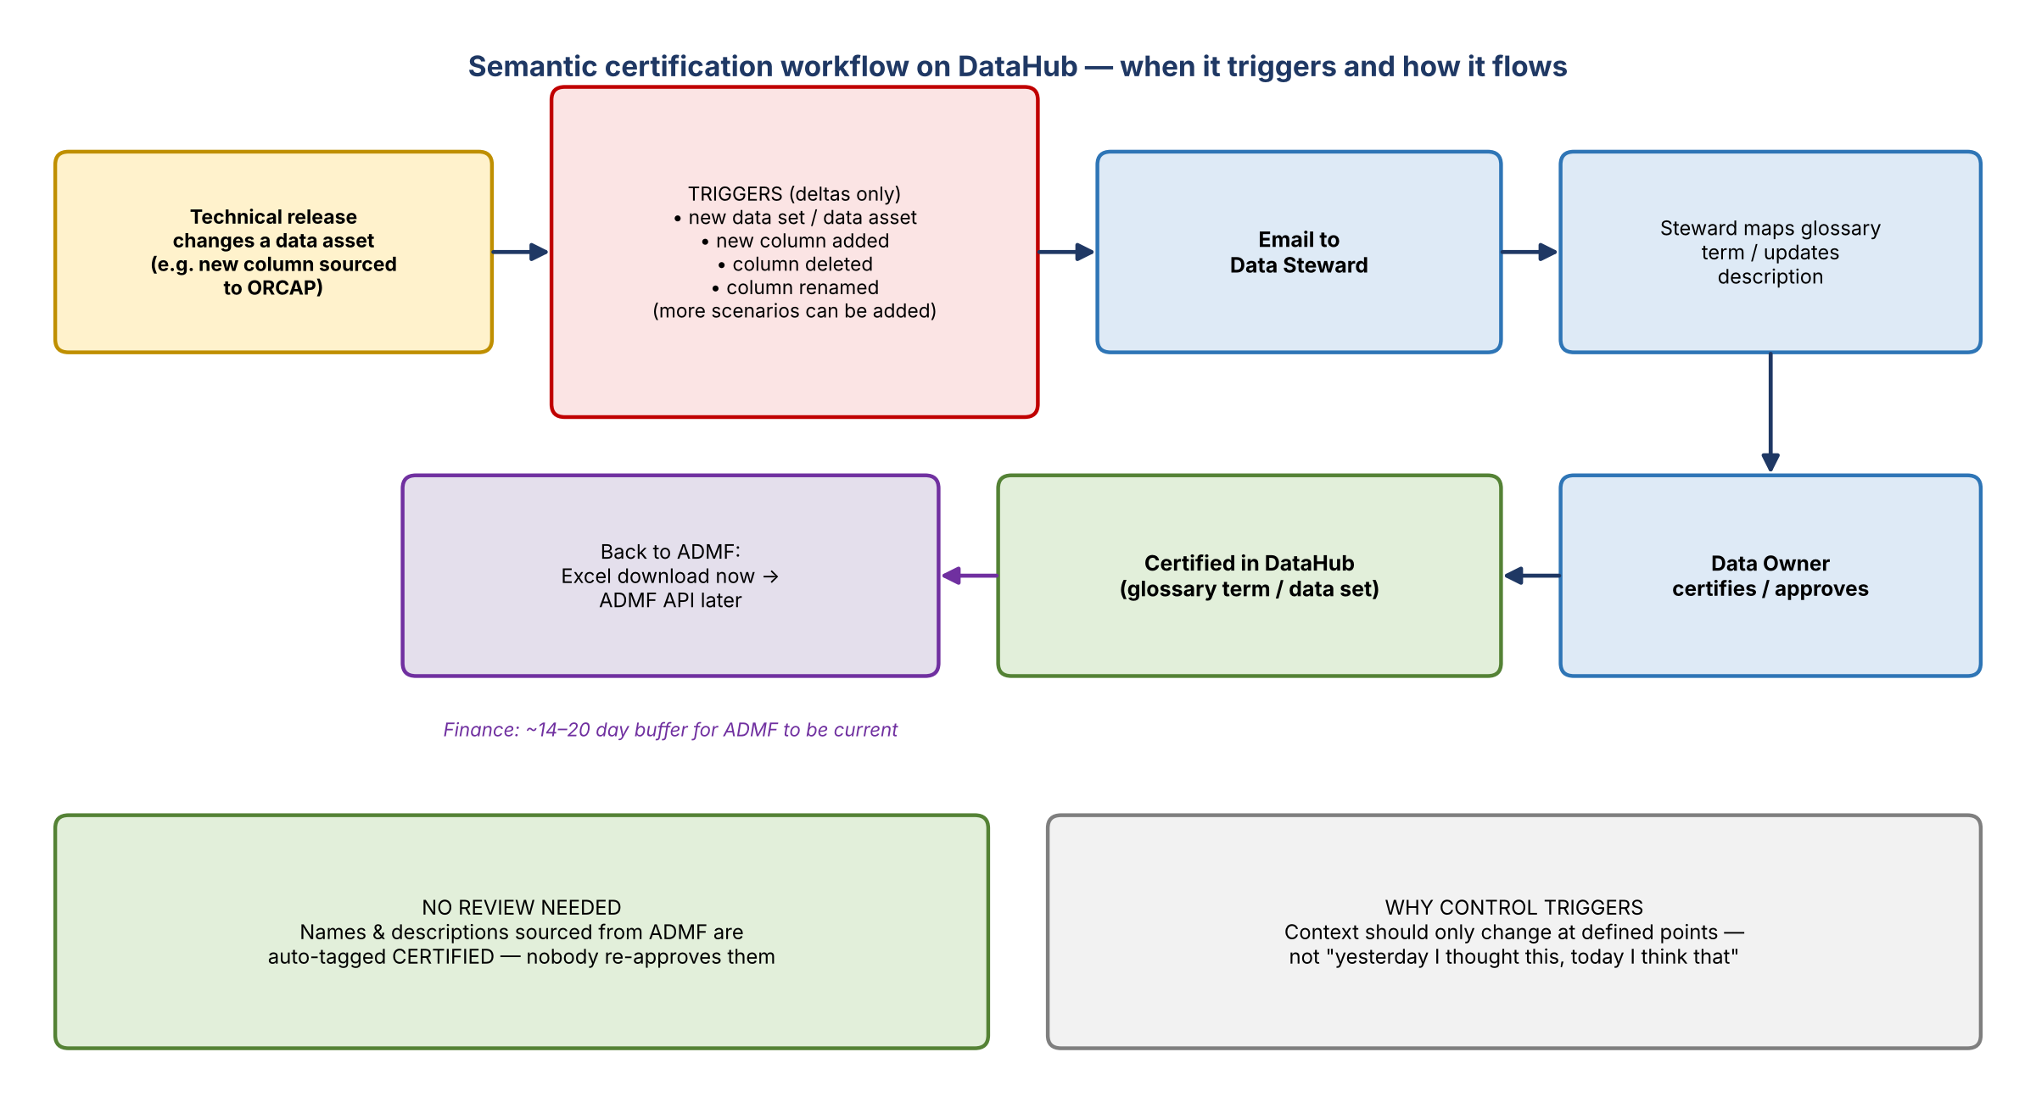
Figure 1. Trigger-based certification workflow as described

User journeys
- Drafted for the Data Steward and Data Owner. They show how a workflow on top of DataHub enables context updates, both for glossary term certification and for data assets.
- Slides 2 to 5 cover adding a new attribute to a certified data asset. Tables and columns already exist in DataHub. If one more column is sourced, e.g. into ORCAP, the right glossary element needs to be mapped to it.
- A technical release is the trigger. An email goes to the data steward, who then follows the steps in order.

What triggers it
Scenario | Behavior
Names and descriptions sourced from ADMF | Always tagged certified. Nobody needs to review them, and the data owner isn't asked to certify them.
New data set or data asset added | Triggers certification
New column added | Triggers certification or recertification
Column deleted | Triggers recertification
Column name changed | Triggers recertification
Other scenarios | Can be added

- Why control it: context should only change at defined points, not because someone thinks differently today than yesterday.
- What starts it (Mike's question): does adding a PDE to a data product kick off the process? No. A technical release that adds or changes a physical element or data set does. PDEs don't have to be assigned to a product in this workflow.

Feeding back to ADMF
- Plan: updates flow back to ADMF. Until ADMF's APIs are ready, there's an Excel download, so it's one-way for now.
- Once the API exists, updates go directly; cadence is still to be decided.
- Finance's guidance: about 14 to 20 days of buffer before ADMF needs to be current.

4. Sample screens and terminology
- The React screens are live with sample data. They show the data glossary and its filters, sitting on top of DataHub, and will get closer to real once details are loaded. More releases are planned.
- Rename filters: the screens said "FDMO Touchstone" and used domain / subdomain. They should use data management terms: category group, category, and subject area, which is what CDO uses for ADS. The presenter will take this back so risk and finance stay consistent; finance may not catch it.
- Finance references in the PPT will be rebranded to "risk data management operations".
- Data products shown are only those established in DataHub, which will be set up with the risk team's help.
- The presenter will share the link and the PPT and asked for thoughts, suggestions, and questions on requirements and look and feel.

5. Loading business metadata not in ADMF
- Question: can existing business metadata be loaded without coming from ADMF? Yes.
- Risk has business metadata outside ADMF, unlike finance. Candidates: the SHRP data source dictionary, the RDS catalog, and AI-generated descriptions for all of ORCAP (Mike built a prompt for this a while ago).
- The first upload sources all ADMF definitions and anything external. From then on, DataHub is the source.
- The platform then handles all updates, certification, and downloads, so there's one place to go instead of two or three. ADMF updates go through a download from the platform until the API exists.

6. Certification scope and releases
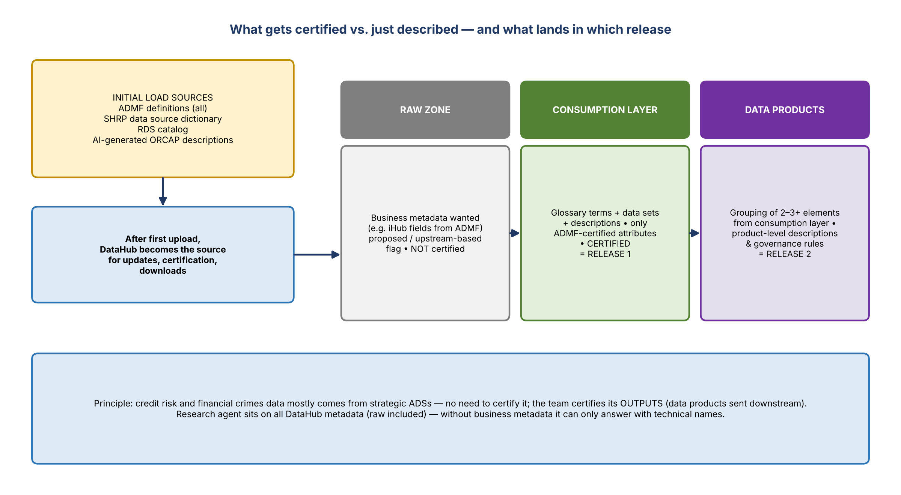
Figure 2. Certified vs. described, and the release split

Only certified consumption attributes in products
- Only ADMF-certified data elements should be in the certified product, i.e. consumption attributes, not raw zone elements. Agreed.
- Do raw elements need ADMF definitions? Raw data can't be certified from a business perspective. But the team still wants ADMF business metadata for raw fields, e.g. everything landed raw from iHub. It doesn't need to be approved; it just needs to be there.
- DataHub data products are where governance rules apply, so they can be used to check that all data management policy requirements are met for a subject area to be ADS certified. Business metadata is still needed for data the team doesn't own.
- Raw metadata: proposed descriptions for raw are fine, not tagged certified, with a flag saying the definition is based on the best available upstream source.
- Principle: most credit risk and financial crimes data will come from a strategic ADS, so it won't need certifying. The team only certifies its outputs, which comes down to data products sent downstream.

Release plan (proposed by the presenter, no disagreement)
Release | Scope
Release 1 | Consumption layer only: glossary terms, data sets, and their descriptions. Proposed descriptions for raw can sit alongside, not certified.
Release 2 | Data products: group consumption-layer elements (a product combines two or three elements, if not taken directly from the consumption layer) and add product-level descriptions.

7. Research agent
- An agent on top of DataHub metadata answers questions like "where is this glossary term sourced from?" or "which physical elements does this term map to?"
- Planned as a static panel on the right side of the dashboard and a pop-up on the data glossary.
- It covers everything in DataHub, including the raw zone.
- Without business metadata it only has technical names and details. Raw data needs ADMF business metadata in DataHub for the agent to be useful there.

8. Tagging raw data at landing
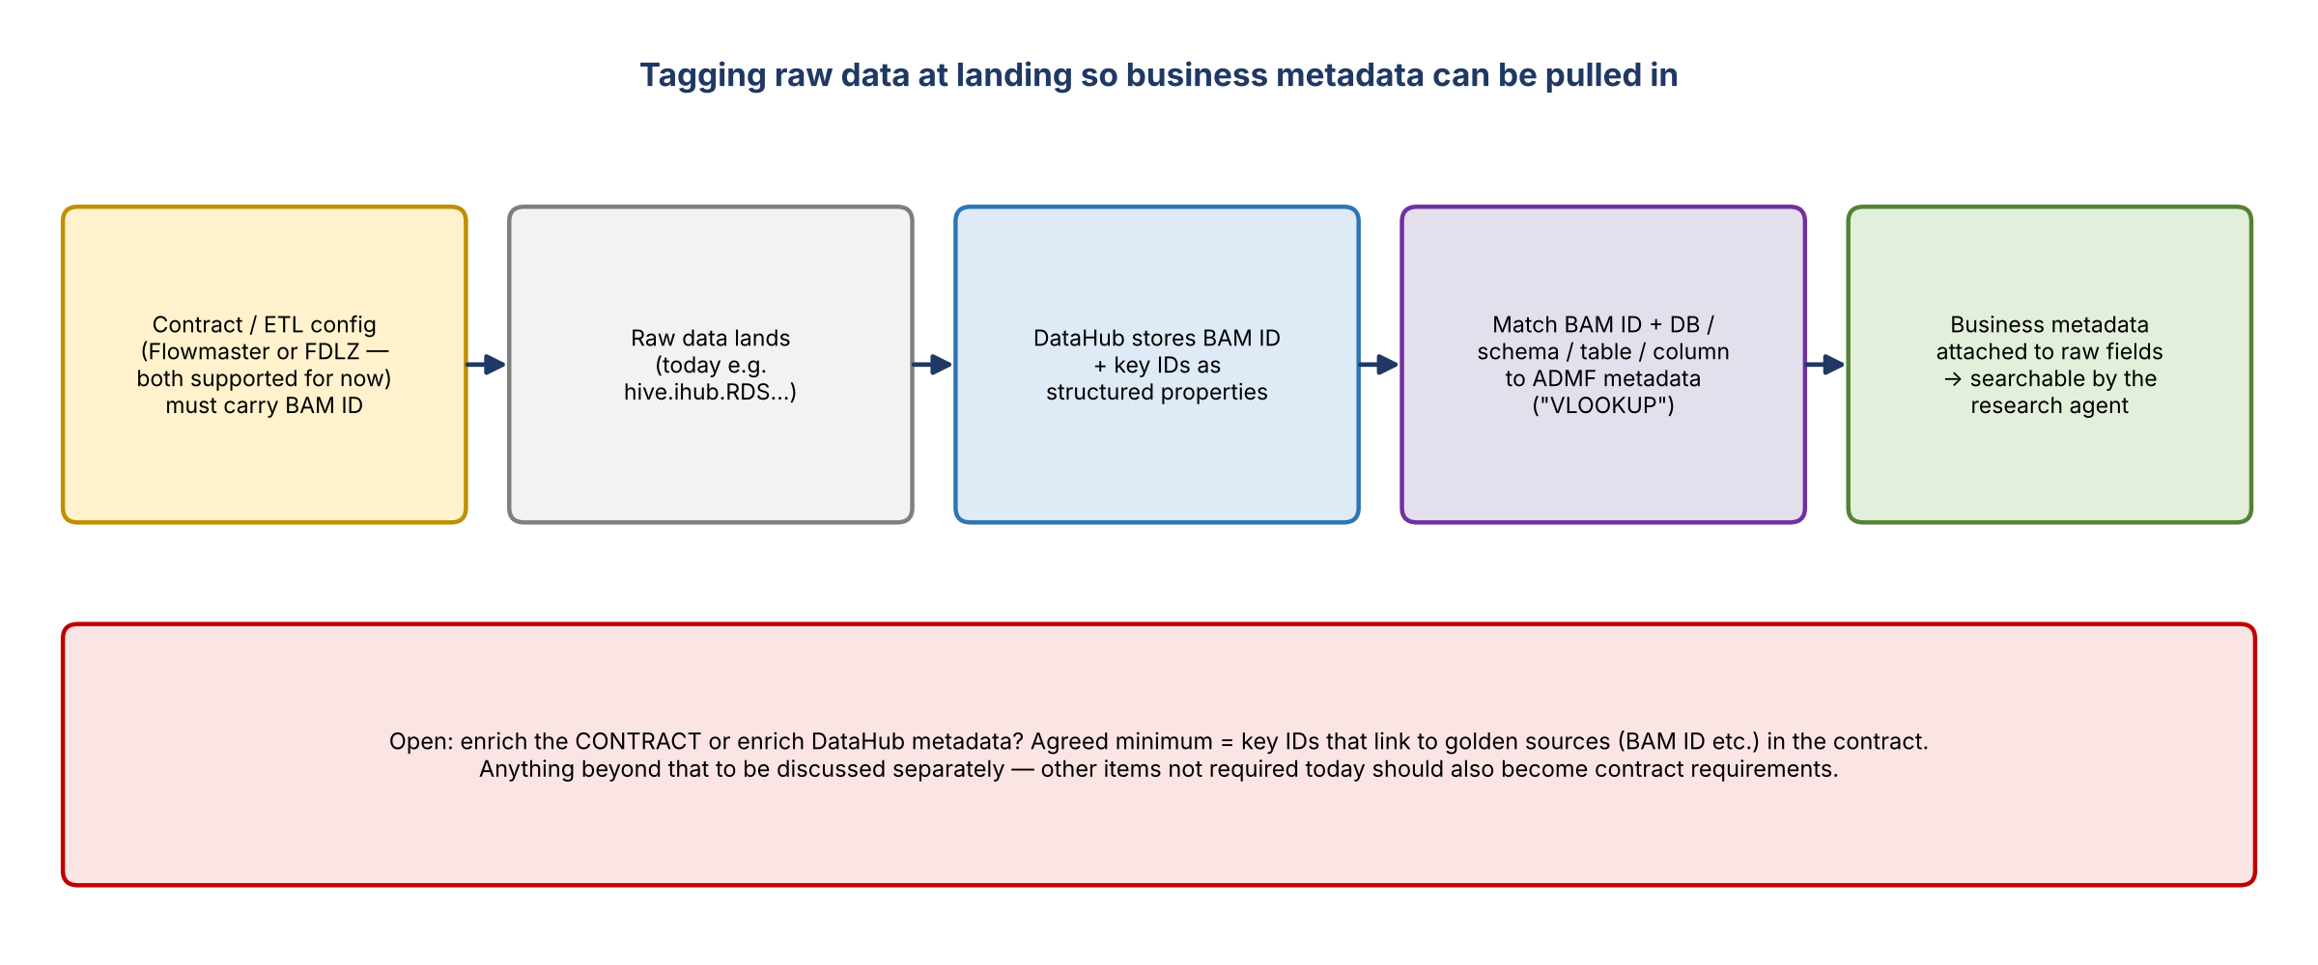
Figure 3. Getting business metadata onto raw data through the contract and DataHub
- Today raw lands as something like hive.ihub.RDS. Can it be tagged on arrival with the BAM application, subject, and so on?
- The presenter: BAM ID and similar details will be in DataHub as structured properties.
- Add it to the contract requirements: agreed ("100%"), otherwise the team will have to work it out again.
- Which contract, Flowmaster or FDLZ? Neither has been picked; both will be supported for now to avoid transition dependencies. Flowmaster didn't really use contracts; it's the ETL configurations, so the ETL config can be required to state the BAM application.
- There are other things not required today that should be added to contracts. To be discussed separately.
- Contract vs. DataHub enrichment: the presenter would require the key IDs that link to golden sources (BAM ID etc.) in the contract. Beyond that, decide whether to enrich the contract or DataHub. To be discussed.
- Proposed approach: if the contract gives the upstream BAM ID, and the database / schema / table / column is known on landing, it can be matched ("VLOOKUP") to existing ADMF metadata to pull in business metadata for the raw data. The presenter agreed: the first upload sources all ADMF definitions, and then you just map.

9. Timeline
- The presenter hopes to enable the capability for ORCAP in January, once DPC is live, or at least get into testing sooner.
- Release 1 covers the consumption layer, glossary terms, and data sets. Release 2 adds data products.

10. Other items
- Kevin asked whether the presenter had reviewed Mike's capabilities list against finance's capability requests. Not yet. Mike, Ryan, and the presenter will connect to make sure they're aligned.
- Monday's call is about PO responsibilities (set up by Ashley), a different topic.
- There's a call Tuesday at 3:30 PM ET.

11. Decisions
# | Decision
1 | ADMF-sourced names and descriptions are auto-certified; only deltas (new or deleted data sets and columns, renames) trigger certification
2 | ADMF sync is one-way (Excel download) until ADMF APIs are available
3 | Release 1 = consumption layer glossary terms, data sets, and descriptions; Release 2 = data products
4 | Only ADMF-certified consumption attributes go into certified products; raw zone gets proposed, non-certified metadata with an upstream-based flag
5 | Risk certifies its outputs, not data from strategic ADSs
6 | Contracts and ETL configs (Flowmaster and FDLZ, both supported for now) must carry the BAM ID and key golden-source IDs
7 | Screen filters use category group / category / subject area, not domain / subdomain; branding becomes risk data management operations
8 | Non-ADMF business metadata (e.g. SHRP dictionary, RDS catalog, ORCAP AI descriptions) can be loaded initially; DataHub is the source after that

12. Action items
Action | Owner | Notes
Share the user journey slides, PPT, and React screens link | Presenter
Review screens and journeys; send feedback on requirements, look and feel, and terms | Kevin, Mike, Ryan, Jake | Especially filter names
Rename filters to category group / category / subject area; rebrand finance references | Presenter | Keep risk and finance consistent
Reach out to CDO about AIDP vs. app metadata | Presenter's team | Based on Kevin's feedback
Add BAM ID / key golden-source IDs to contract and ETL config requirements | Team / Mike | Flowmaster and FDLZ
Discuss other contract requirements and contract vs. DataHub enrichment | Team | Separate session
Gather non-ADMF business metadata for the initial load (SHRP dictionary, RDS catalog, ORCAP AI descriptions) | Risk team | For the ORCAP rollout
Compare Mike's capabilities list with finance's capability requests | Mike, Ryan, presenter | Connect to align
Help establish data products in DataHub | Risk team with presenter | Ahead of Release 2
Target ORCAP enablement or testing | Presenter | January, once DPC is live

13. Open questions
- What cadence will updates follow back to ADMF once its API is available?
- Which extra fields belong in contracts vs. in DataHub enrichment?
- What other trigger scenarios should start recertification?
- How will proposed or upstream-based raw descriptions be flagged and shown, including by the research agent?
- Will AIDP or app-level metadata keep DataHub current (pending the CDO conversation)?

