# Assignment 4: Facial Manipulation Detection

## Chapter 2: Build Faces Dataset

1. code
2. currently, the function load not correctly the images. Sent massage in the forum. There is prints over the file. – need to be clean.

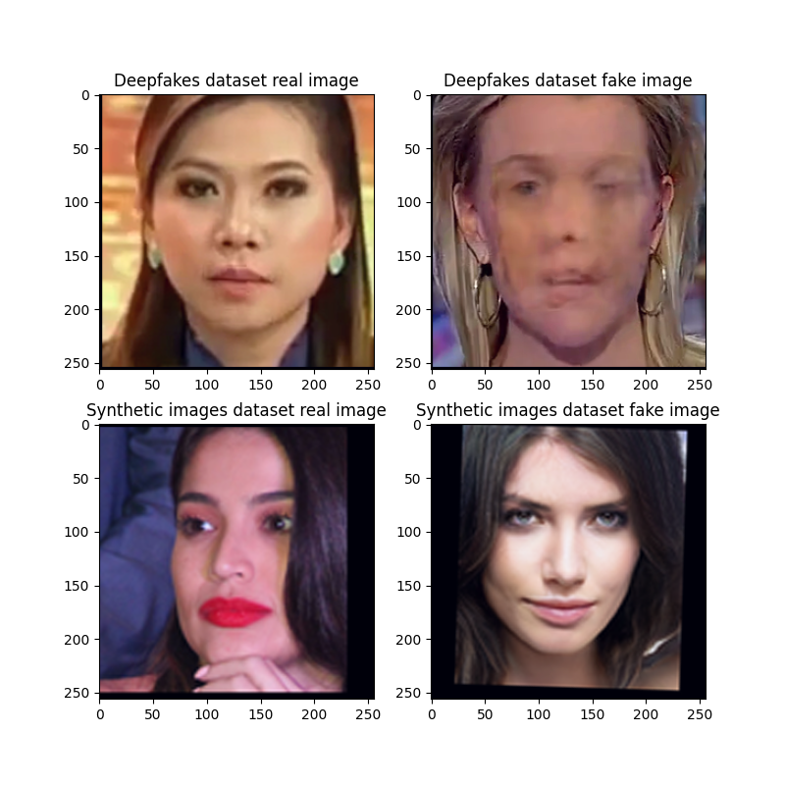

## Chapter 3: Write an Abstract Trainer

1. code
2. code
3. code
4. The training process of the SimpleNet model on the fakes_dataset yielded the following outcomes:

**Training Performance**:

The model showed consistent improvement, with the training loss decreasing steadily and accuracy increasing significantly across epochs. This indicates that the model effectively learned the patterns in the training data.

**Validation Performance**:

The validation accuracy improved but plateaued after the second epoch. Validation loss began to increase slightly, suggesting the onset of overfitting. This indicates that the model's ability to generalize to unseen data may have been slightly compromised after early epochs.

**Test Performance**:

The test accuracy aligned closely with validation accuracy, confirming that the validation set provided a reliable estimate of generalization. The model achieved a reasonable performance on unseen data, although the test loss increased in later epochs.

**Main Outcome**

The training process successfully demonstrated the model's learning capabilities, achieving high accuracy on the training set and reasonable generalization on validation and test sets. However, the increasing validation loss and the plateau in validation accuracy indicate a need for better regularization or early stopping in future iterations to address overfitting and improve generalization further. These findings highlight the importance of monitoring validation metrics during training to optimize model performance.

1. Operate the command:  
   *‘python plot_accuracy_and_loss.py -m SimpleNet -j out\fakes_dataset_SimpleNet_Adam.json -d fakes_dataset’* for creating the graphs based of the .json file

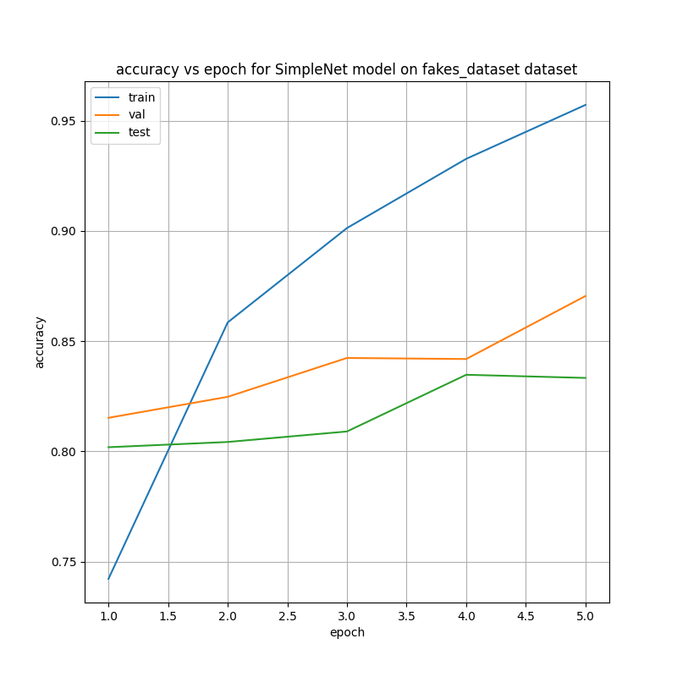

*Figure 1: XXXX*

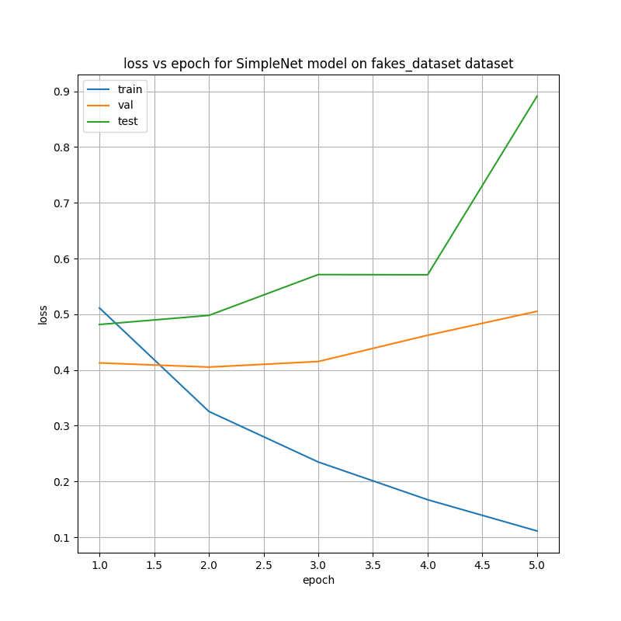

*Figure 2: XXX*

1. According to figure 1, the highest accuracy score acheived for the validation dataset achived in epoch 5 with accuracy of 0.8705. at this epoch the corresponding accuracy for the test dataset was 0.8333.
2. The test set include 1400 real images and 700 fake images and therefore the proportion of the fake images to real images is 0.5.
3. code
4. open question
5. code
6. code
7. open question
8. open question
9. open question
10. open question

## Chapter 4: Fine Tuning a Pre-trained Model

1. open question
2. open question
3. open question
4. open question
5. open question
6. code
7. open question
8. code
9. code
10. open question
11. code

## Chapter 5: Saliency Maps and Grad-CAM analysis

1. open question
2. open question
3. code
4. code
5. code
6. code
7. code

## Chapter 6: Bonus Part