Diabetes model deployment

Aim

Diabetes model deployment using Microsoft Azure ML to predict if an individual is diabetic or not. The model was developed using the Two-class logistic regression model

Data Source

The dataset is from Kaggle: [Diabetes Dataset (kaggle.com)](https://www.kaggle.com/datasets/akshaydattatraykhare/diabetes-dataset?select=diabetes.csv)

Tools

Model name= Diabetes_model.

Model Type= Two-Class Logistic Regression

Platform=Microsoft Azure Machine learning Juypter notebook, Anaconda Jupyter notebook and Kaggle notebook

Creating the model on Kaggle

Step 1

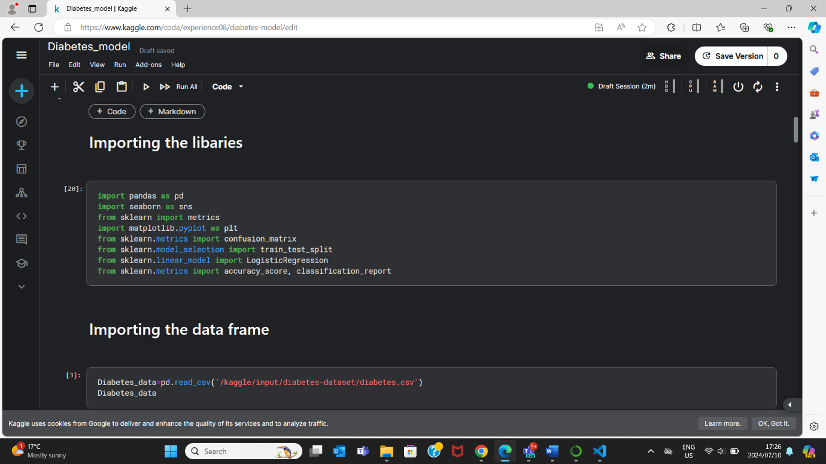

Step 2

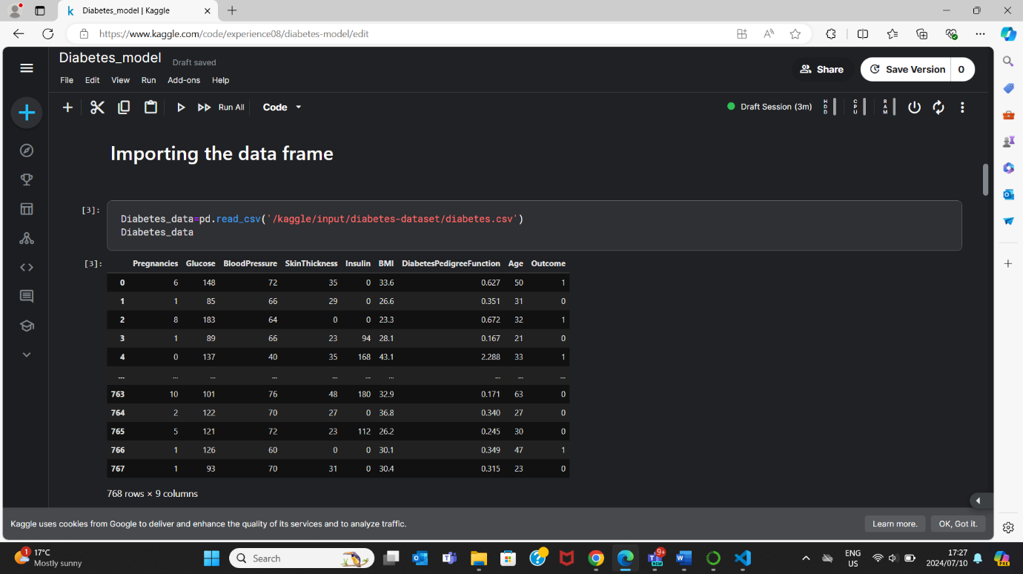

Step 3

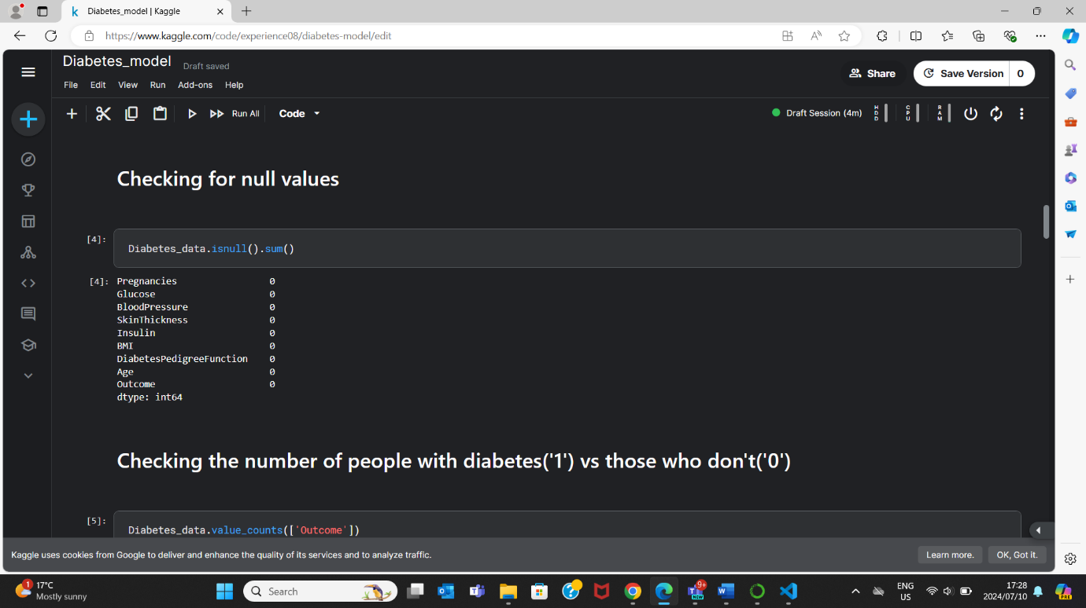

Step 4

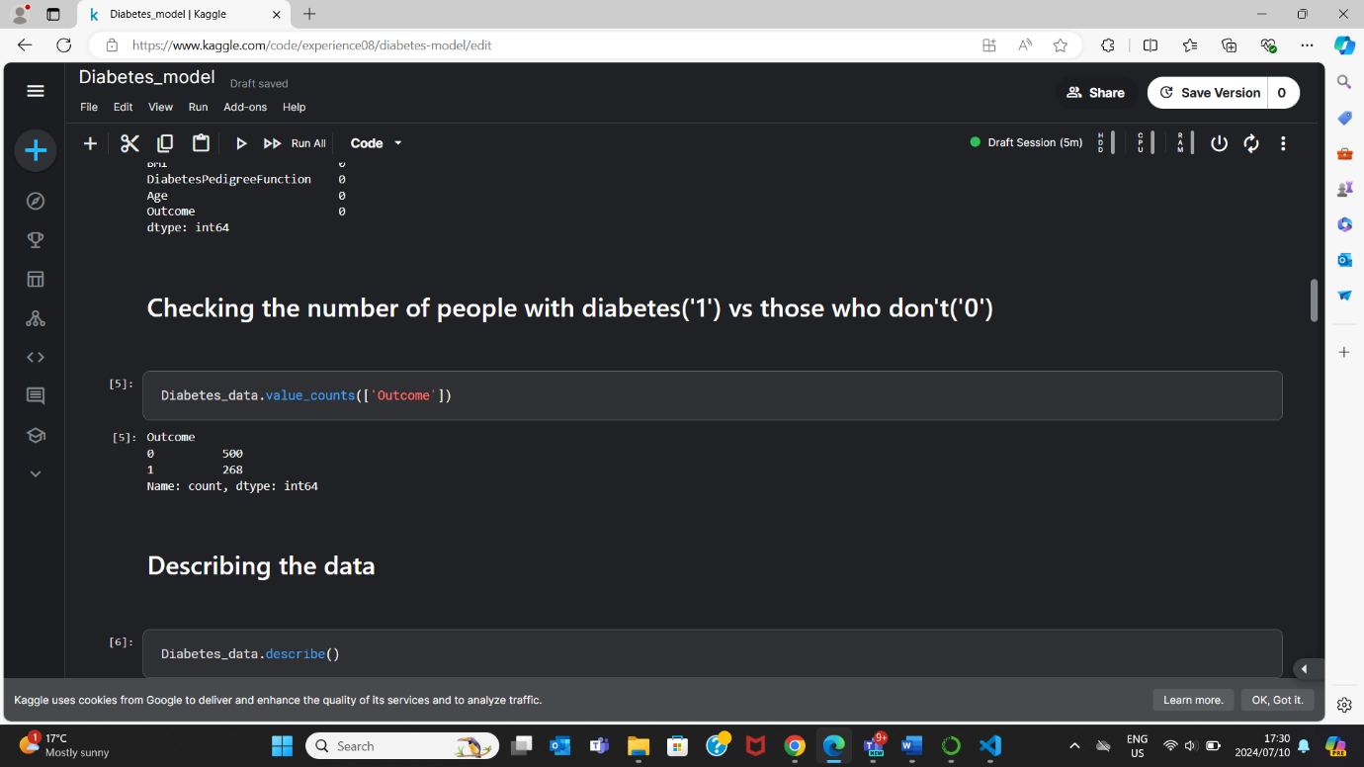

Step 5

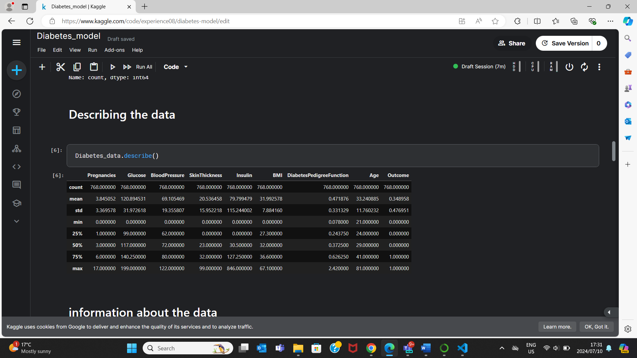

Step 6

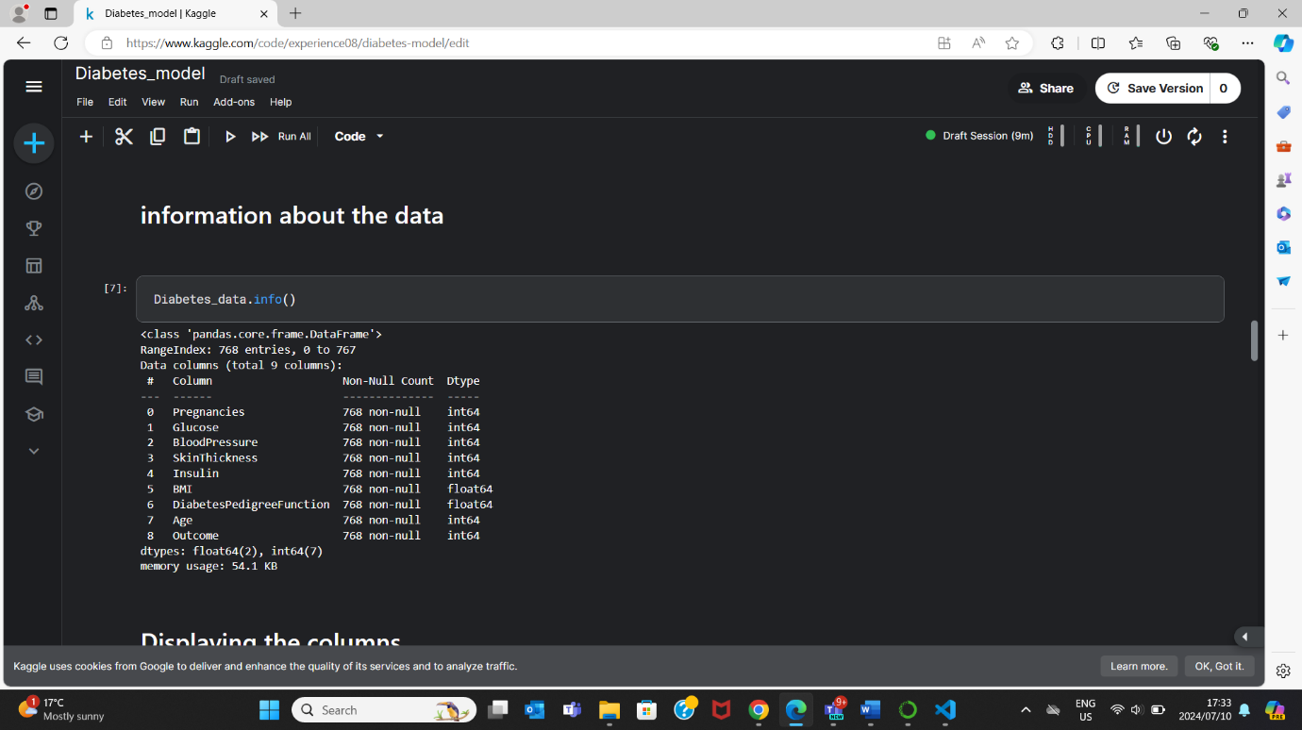

Step 7

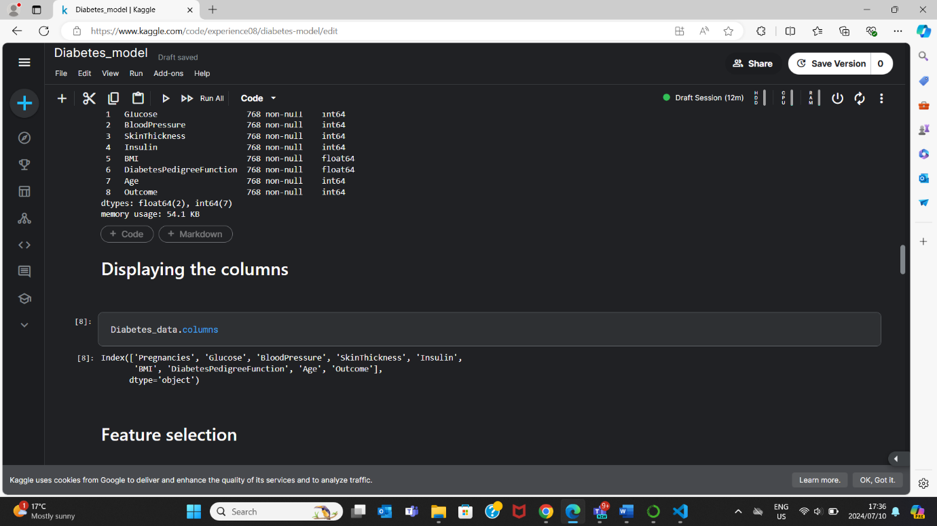

Step 8

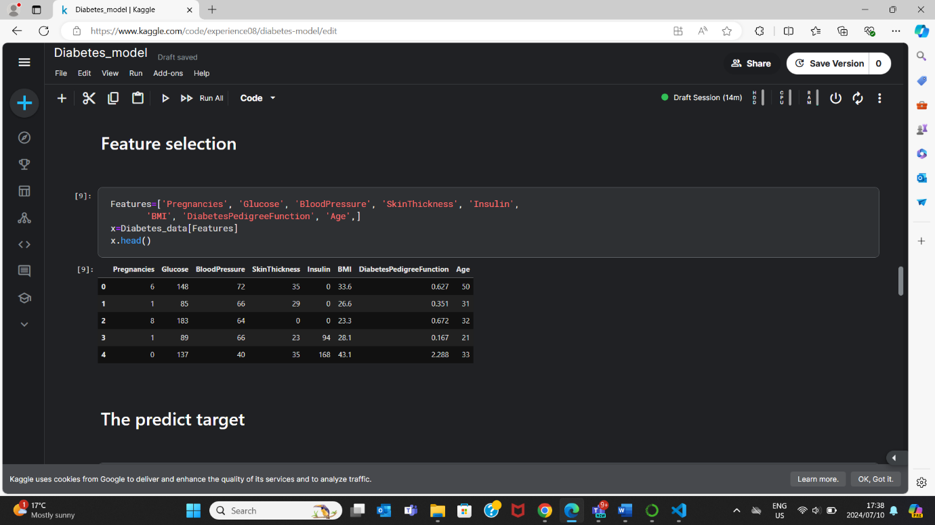

Step 8

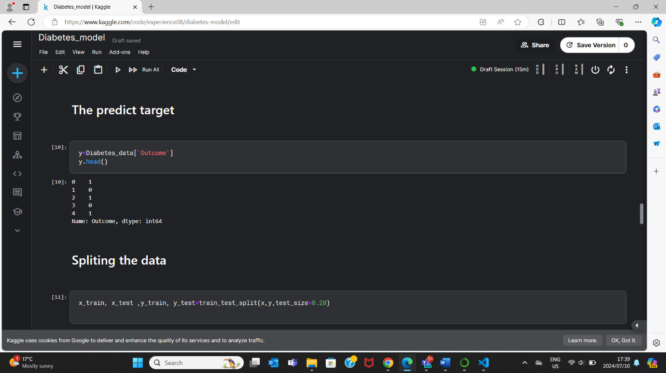

Step 9



Step 10

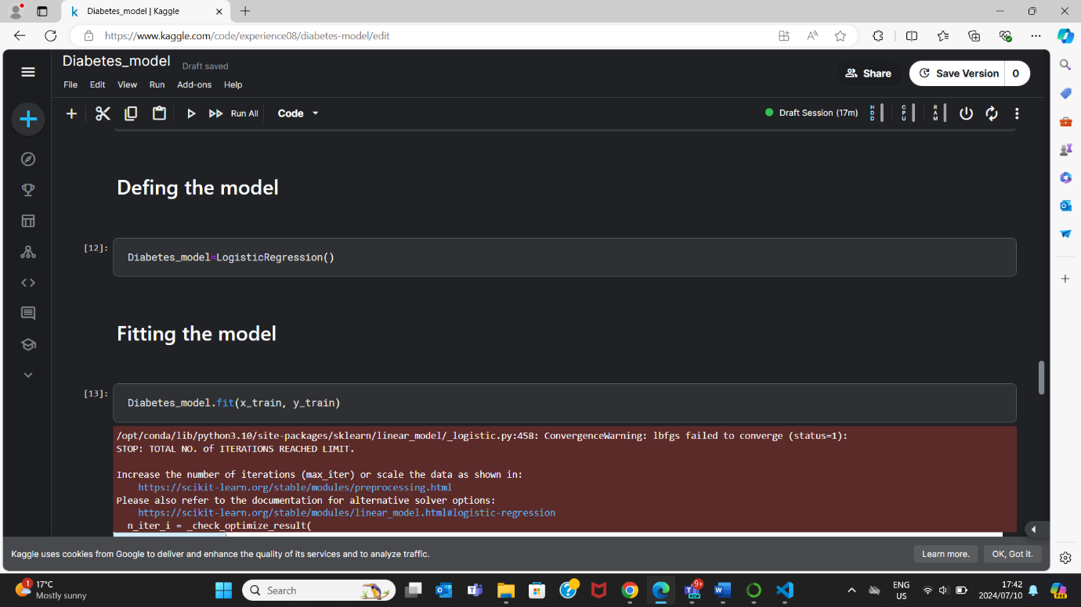

Step 11



Step 12

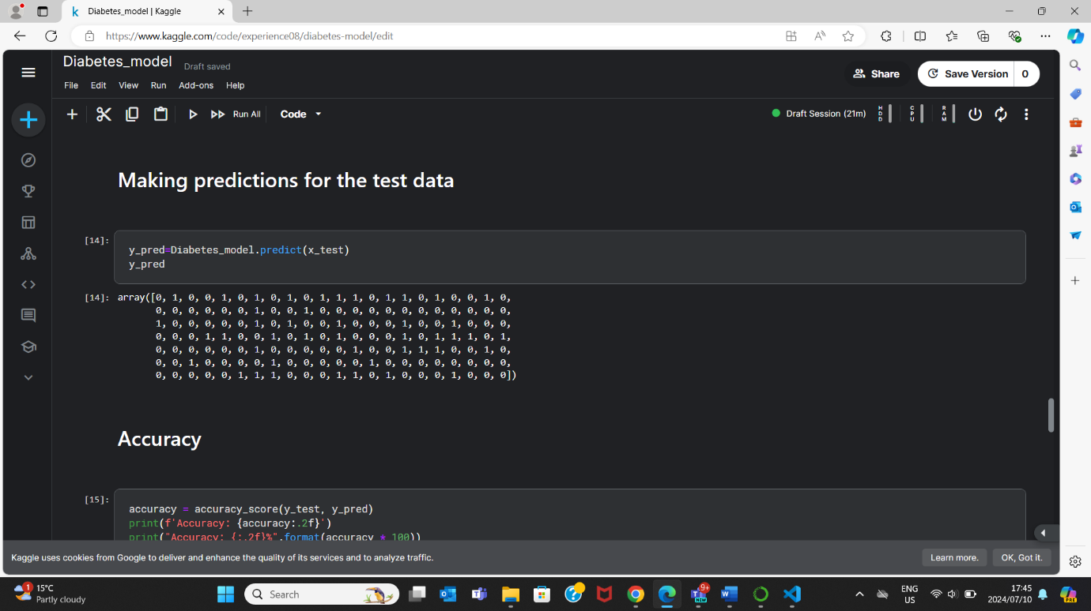

Step 13

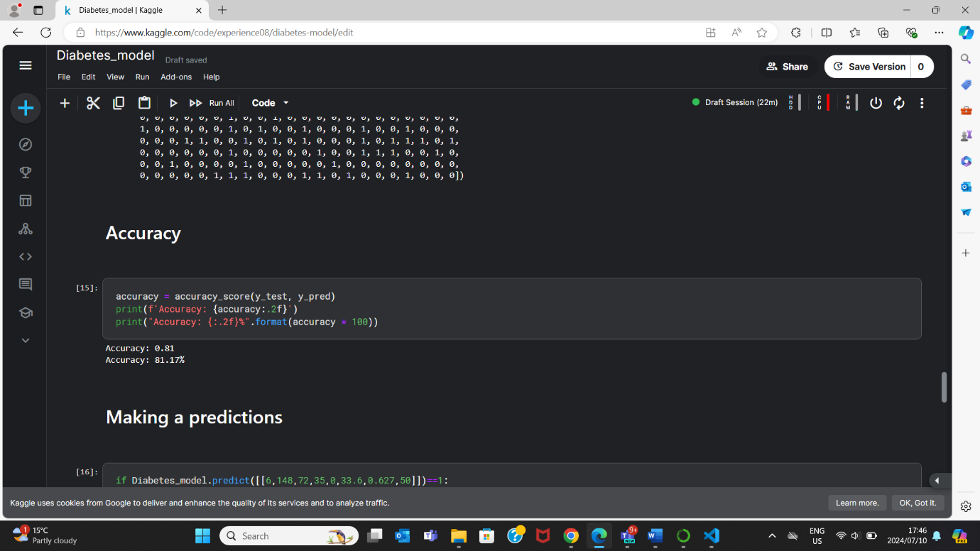

Step 14

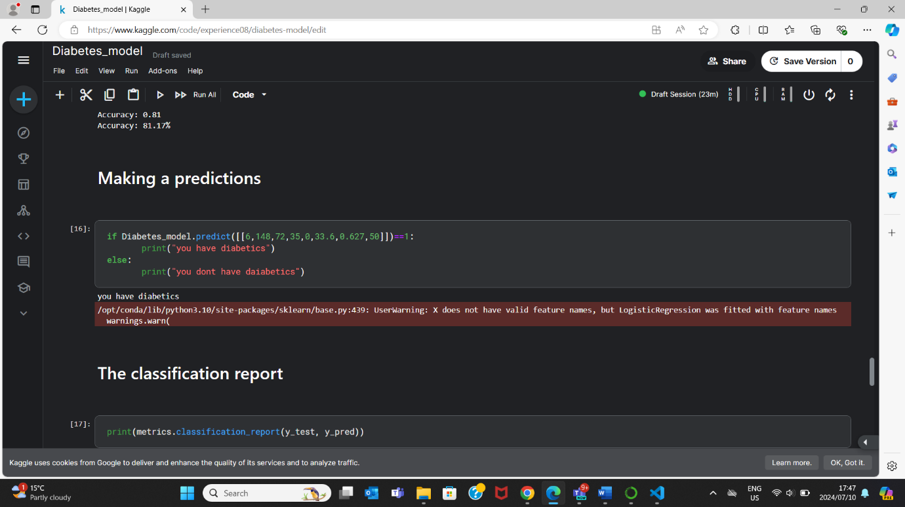

Step 15

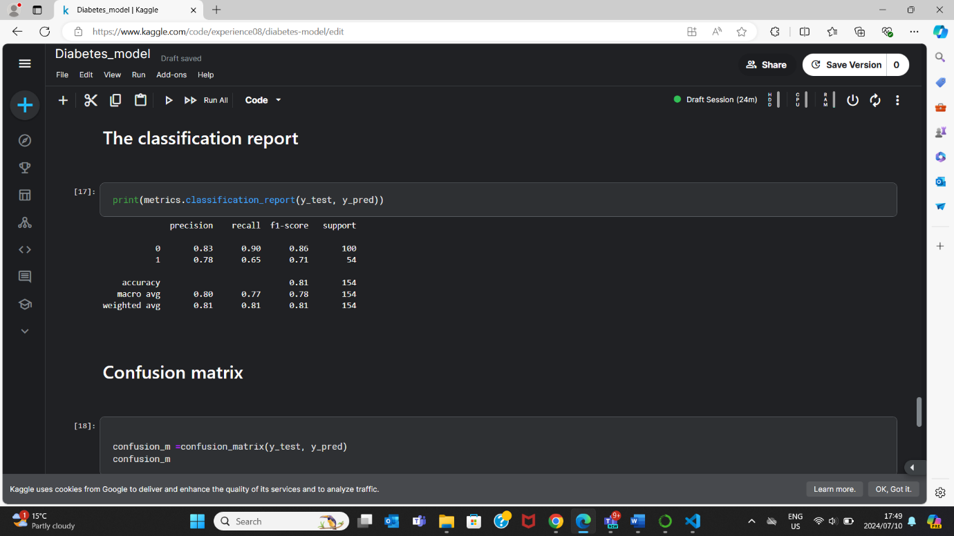

Step 16



Step 17

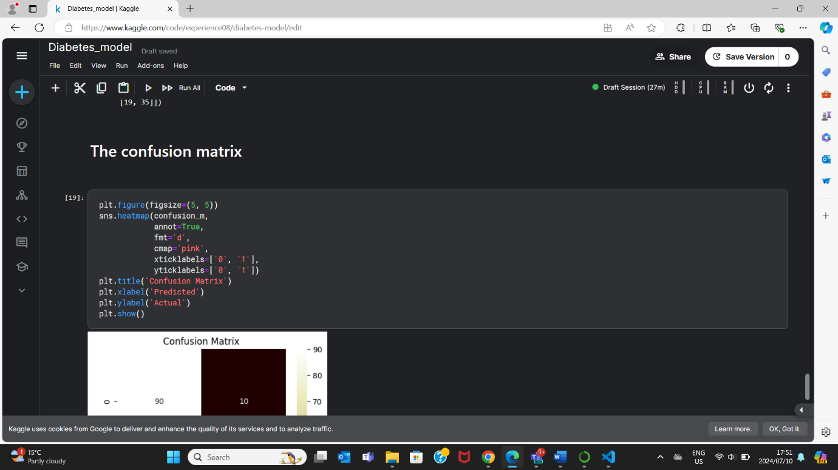

Deployment steps in Microsoft Azure Machine Learning Jupiter notebook

Step 1

* Installing the necessary libraries
* Import libraries

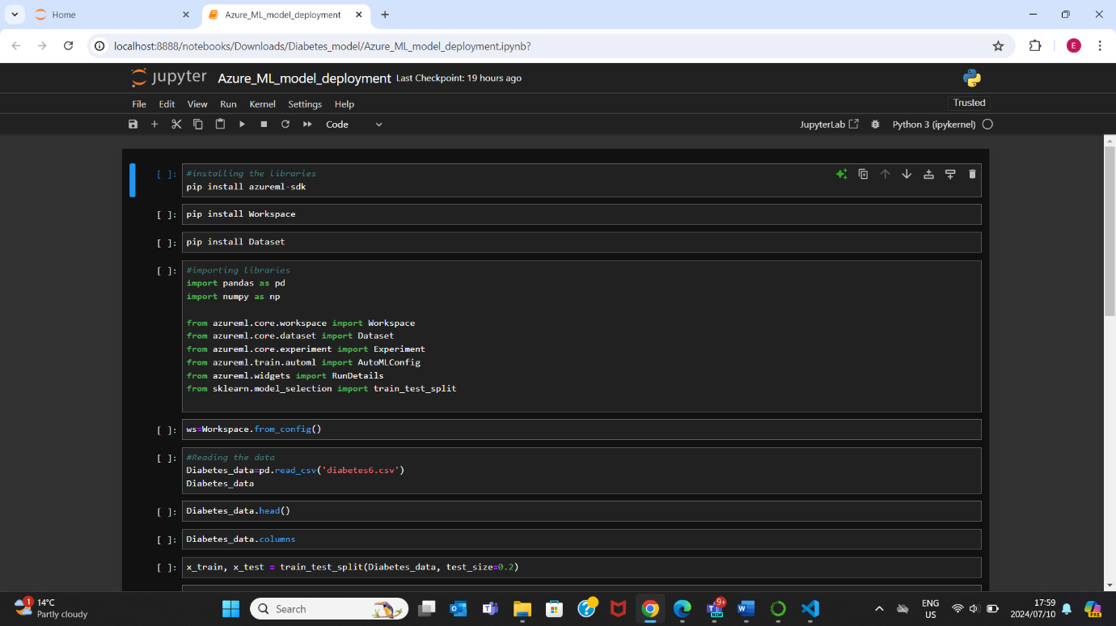

Step 2

Connecting to the workspace.

Step 3

* Importing the dataset
* Exploring the data
* Splitting the dataset into test and train

Step 4

* Setting up the AutoML experiment.
* Setting up the AutoML configuration
* Creating the experiment
* running the experiment
* Outputting the experiment
* Storing the experiment
* Creating a model using the stored experiment

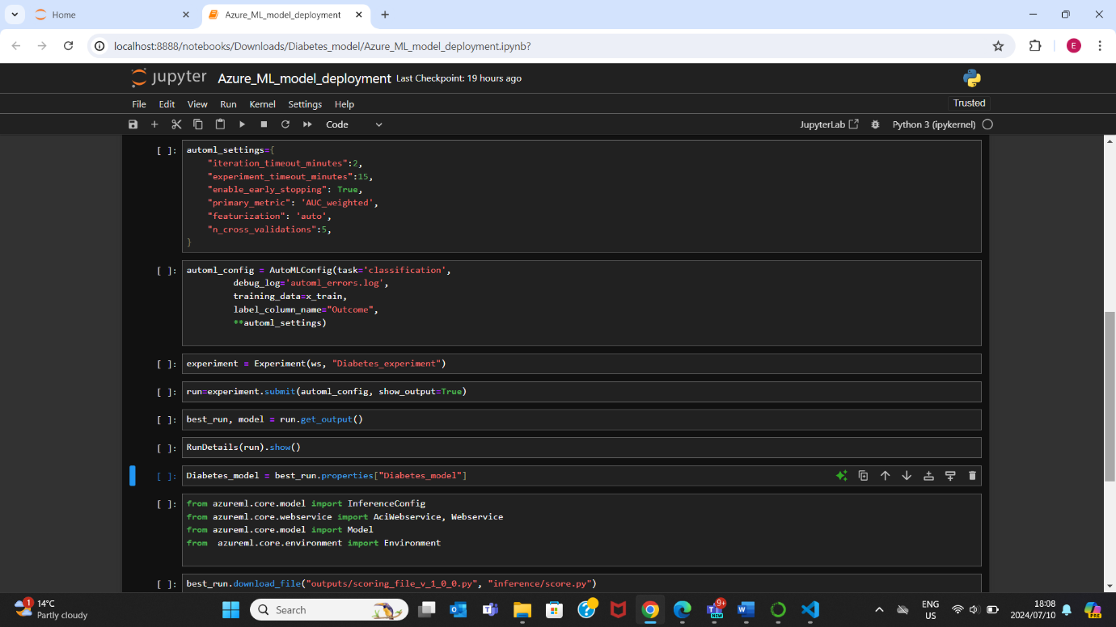

Step 5

* Setting up an Azure Machine Learning environment to deploy the model
* Downloading the scoring file
* Deploying the model

