Evidance Ndlovu

SQL activities

1. list of customers with notes(kcc_customers)

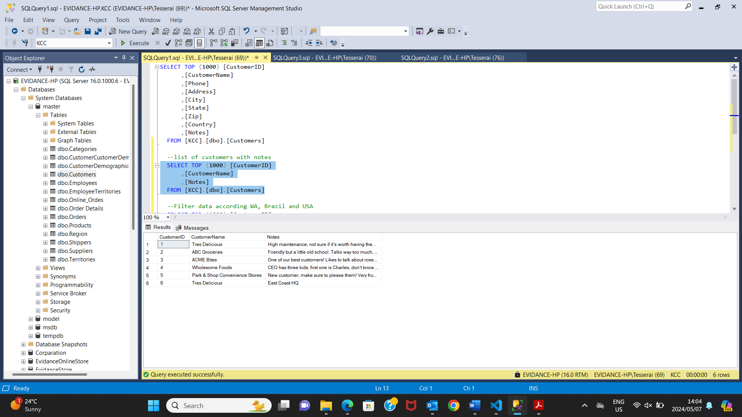

2.Format the columns company name, contact name, postal code, contact title(master_customers)

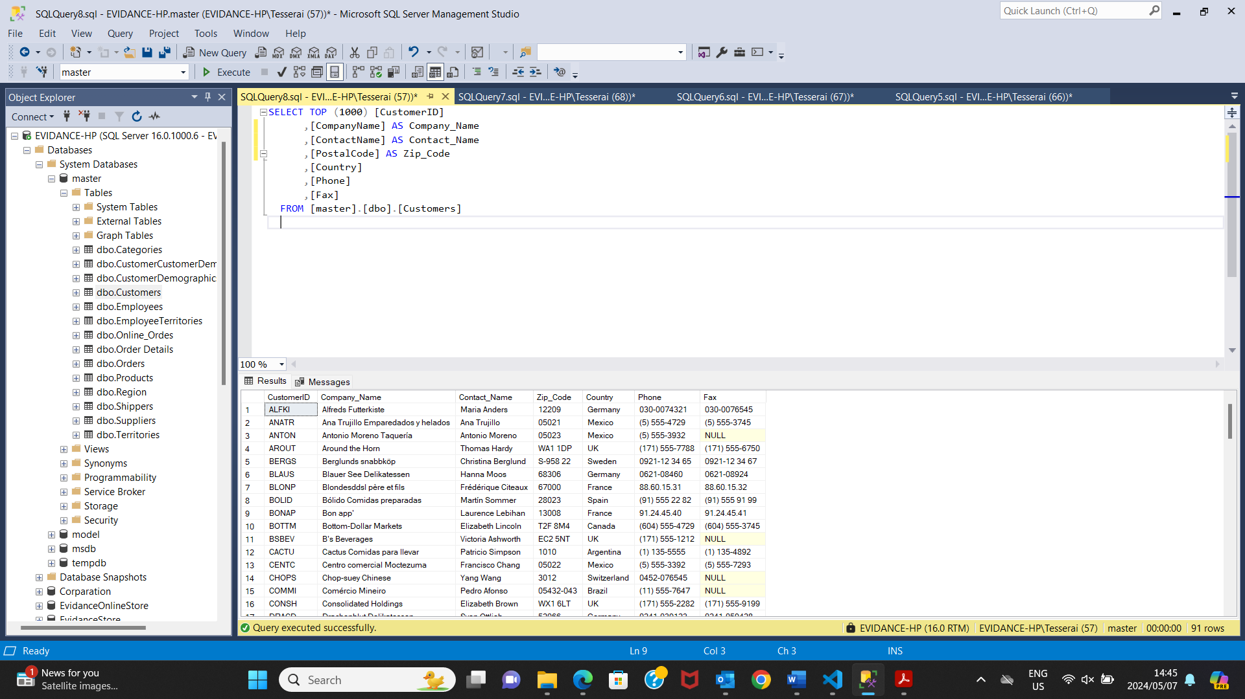

3.format the date (OrderDate,Required_Date,Shipped_date) so that it is understandable to the customer (master_orders)

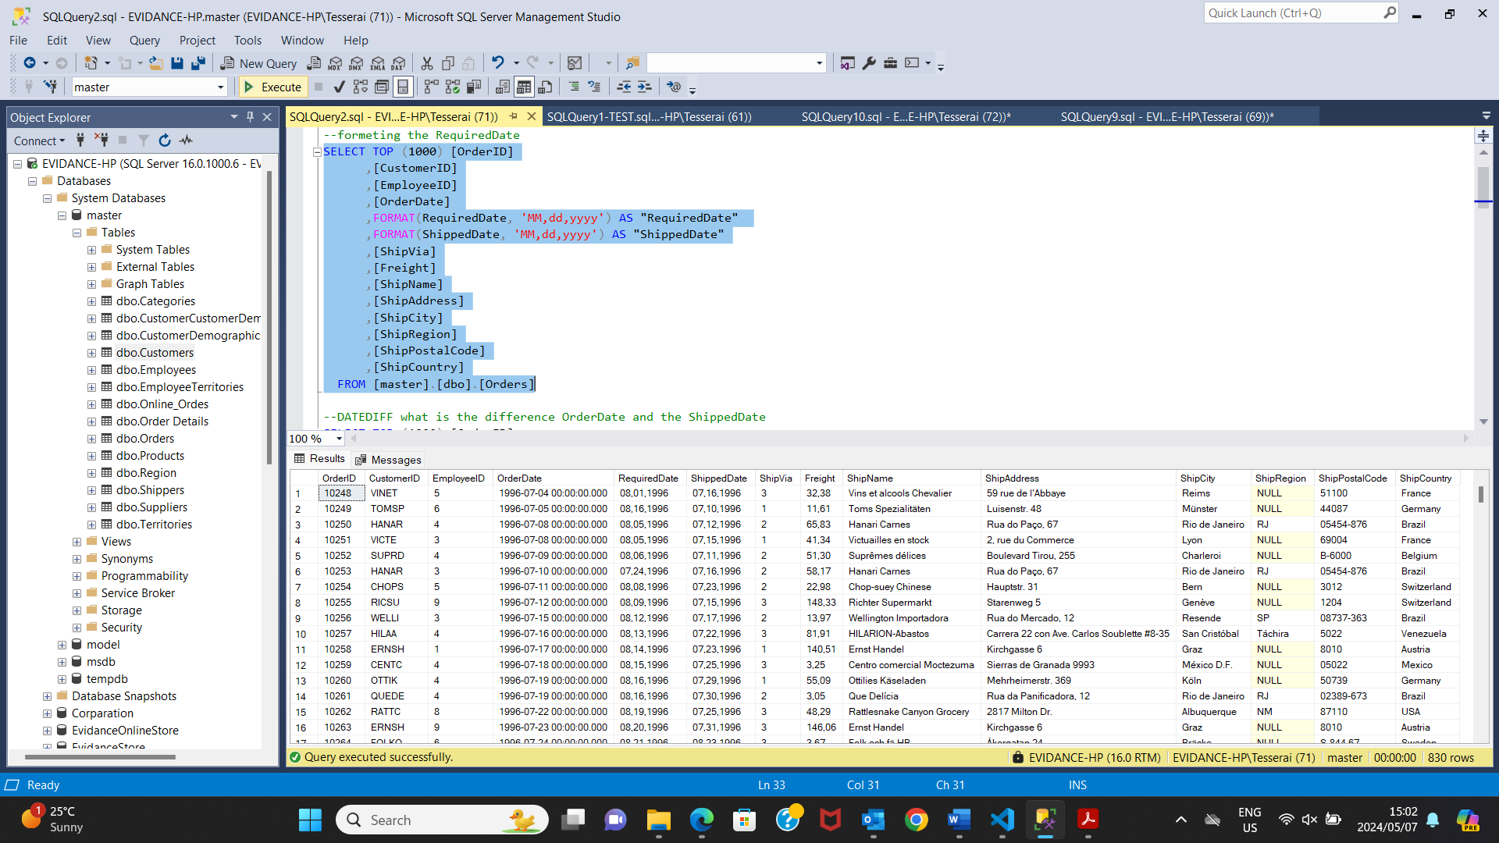

4. filter data according to WA, Brazil and USA (Master.Customers)

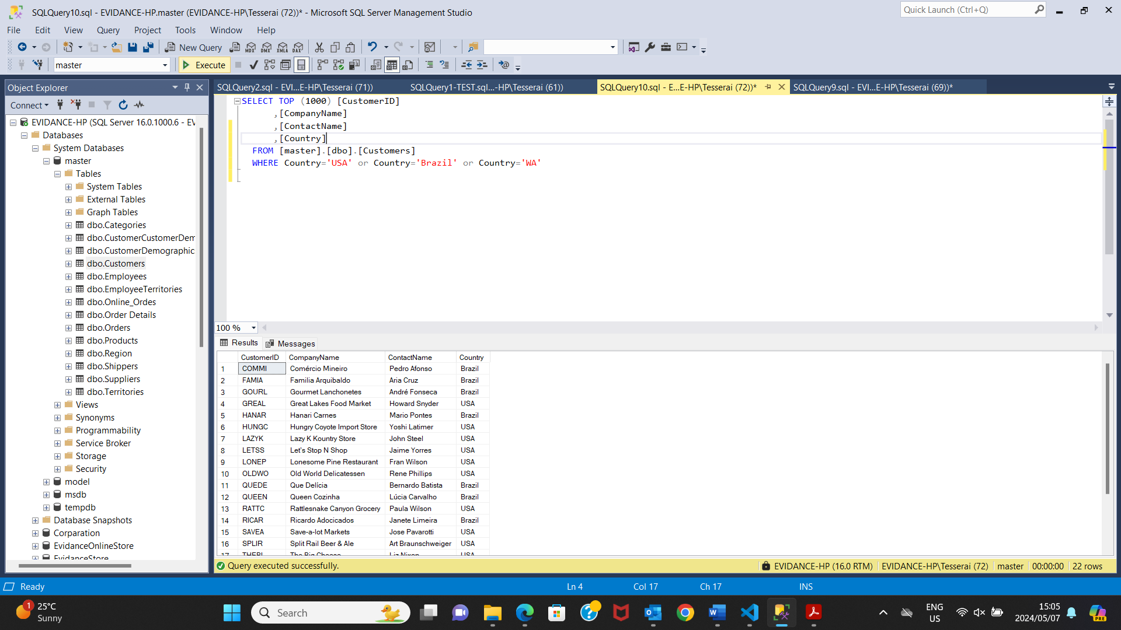

5. Difference between Order date and Required date (Orders.master)

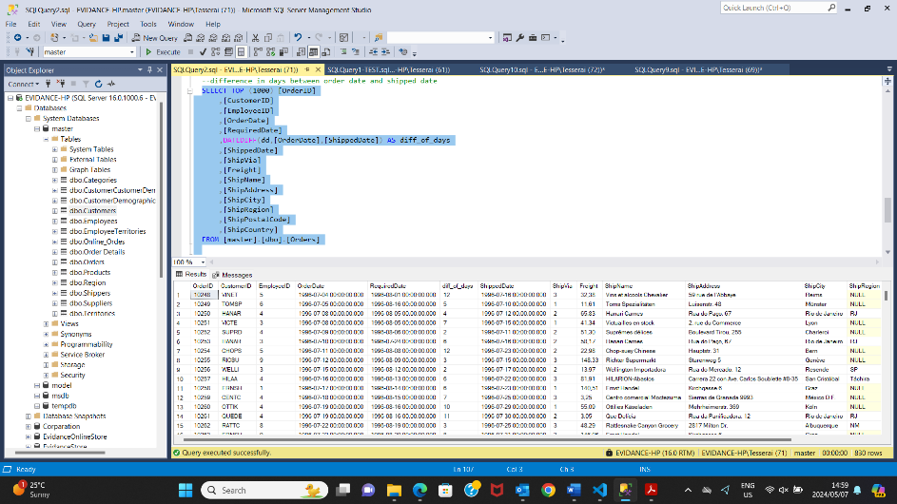

6.add 4 weeks to our order date (orders.master)

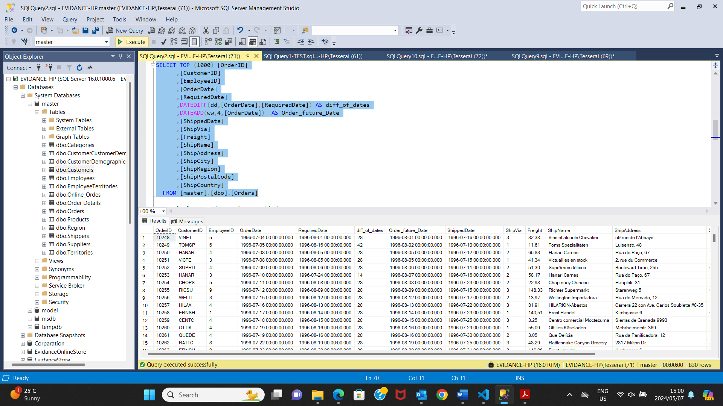

7.Calculate the average price of all our products(products.master)

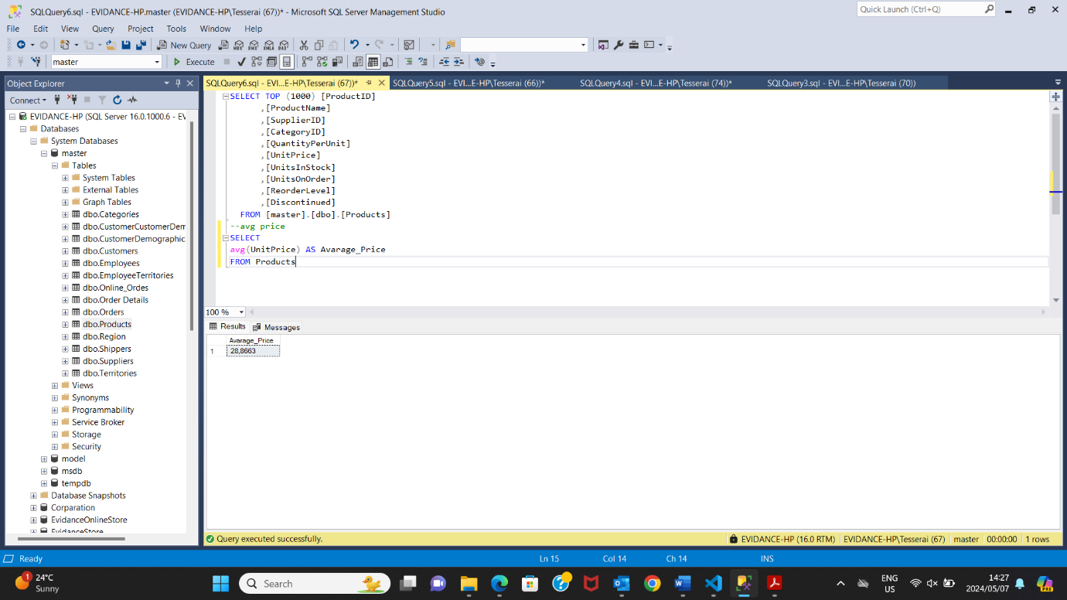

8.How many products do I have(product)

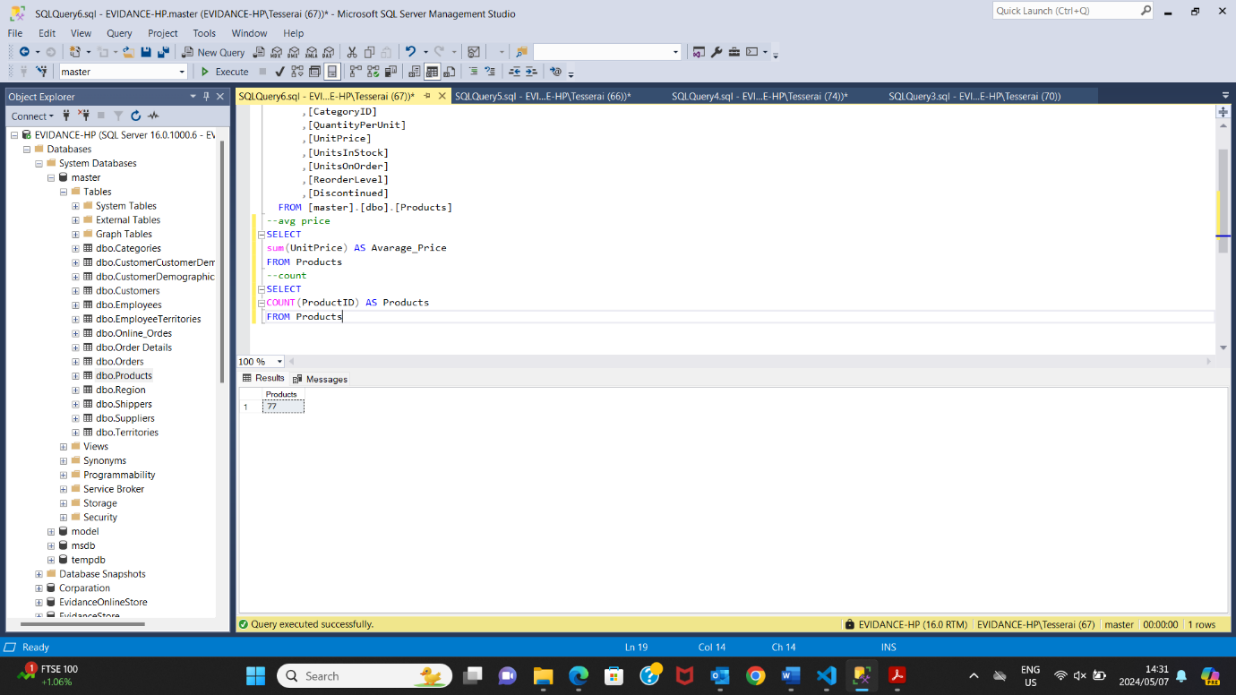

9.concenate the LastName and firstName.

