Side A Active (side A sourcing current)

Voltage across side A bootstrap

Voltage across side B bootstrap

Voltage on low side A FET gate

Voltage on low side B FET gate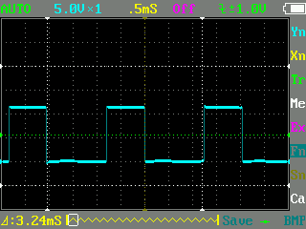

Side B Active (side B sourcing current)

Voltage across side A bootstrap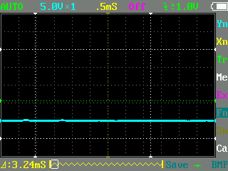

Voltage across side B bootstrap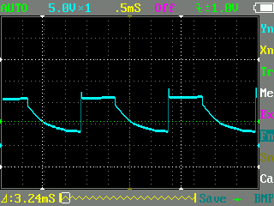

Voltage on low side A FET gate

Voltage on low side A FET gate