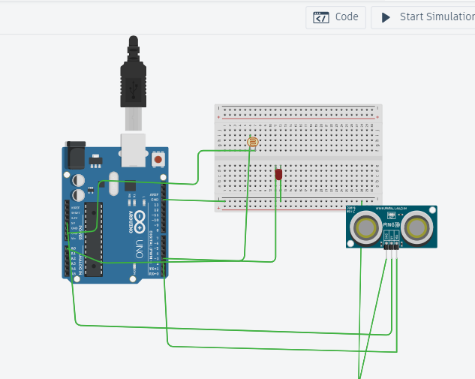

**Aim: Design a system for doors at home, such that whenever a door is opened, a light turns on for 1000 ms if it is day & 2000 ms if it is night.**

**Concept Used:**

When the distance between the Ultrasonic sensor and the door increases the LDR sensor senses light and if it less then a certain amount which indicates Dark/Night the LED blinks with delay of 2000ms and if it senses more light indicating Day/Bright the LED blinks with 1000ms delay.

**Observation:**

When the distance of 2cm is sensed by the ultrasonic sensor the LED will glow and also when more light will fall on LDR i.e. in day LED will blink for 1000ms and when less light will fall on the LDR, LED will blink for 2000ms.

**Precaution:**

1. Connection must be made carefully with the breadboard and Arduino.
2. Wire should be connected to the pin which is defined in the program.
3. Code should be in case sensitive form.
4. While making connections connection of the breadboard should be kept in mind.

**Learning Outcome:**

1. Application of LDR and Ultrasonic sensor in everyday life.
2. We get better understanding of Arduino and its components.
3. We get some skills to use various sensor along with Arduino.