Portfolio Website Analysis
https://ayoub-ka.vercel.app/

Executive Summary
This document provides a comprehensive analysis of Ayoub Kadi's personal portfolio website hosted at https://ayoub-ka.vercel.app/. The website serves as a professional showcase for a Frontend Developer based in Morocco, featuring an impressive collection of 8 projects, professional experience, educational background, certifications, and a contact form. The site demonstrates modern web development practices with a clean, minimalist design that emphasizes user experience and visual appeal. Built with Vite and React, the portfolio showcases proficiency in various frontend technologies including React, Next.js, TypeScript, and Tailwind CSS. The website features smooth animations, responsive design, and an innovative accent color switcher that allows visitors to customize their viewing experience.

Website Screenshots
The following screenshots capture the website's visual design and layout across different sections and viewport sizes:
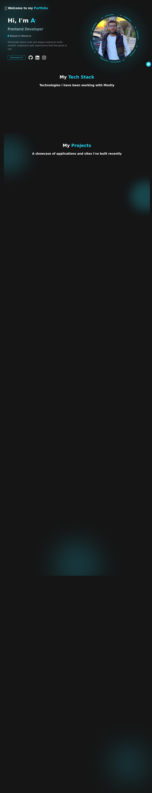
Figure 1: Hero Section with Introduction
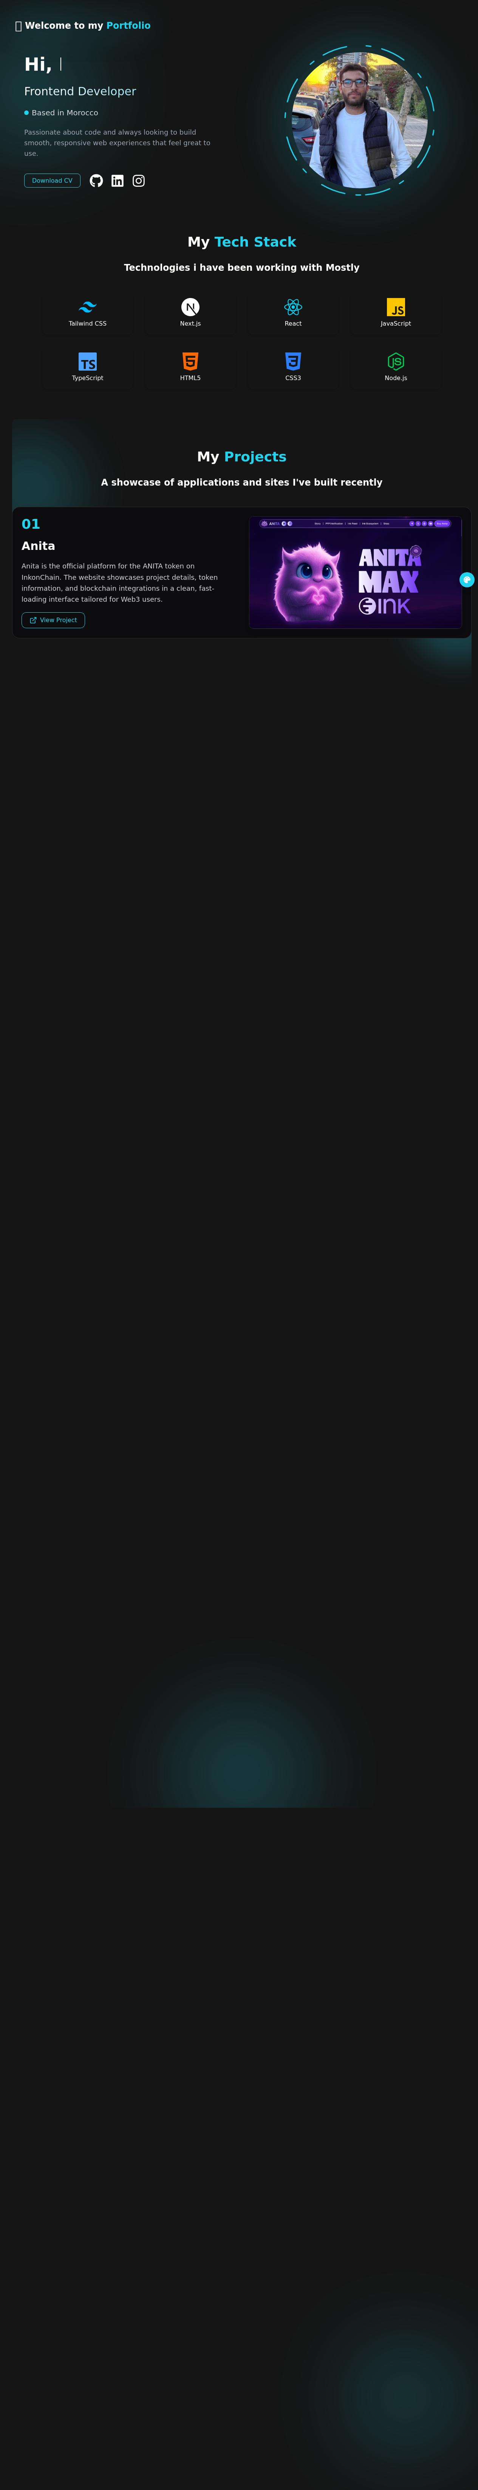
Figure 2: Projects Showcase Section
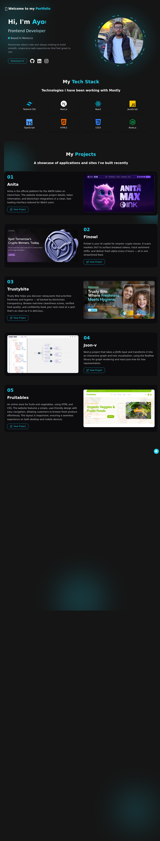
Figure 3: Experience, Certificates & Contact Section
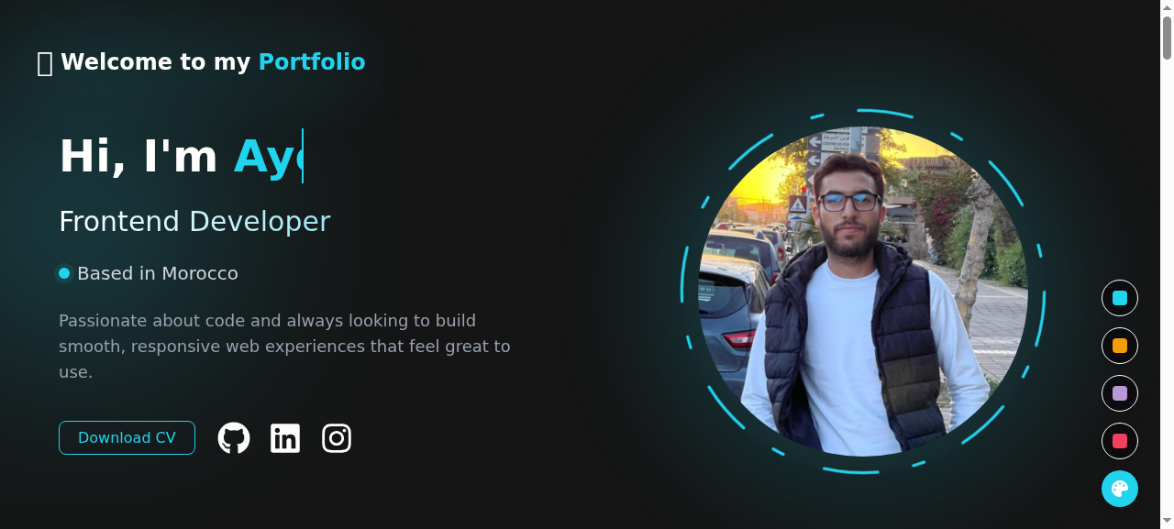
Figure 4: Accent Color Variation
Figure 5: Mobile Responsive View

Website Structure & Sections
The portfolio website is organized into six main sections, each serving a specific purpose in showcasing the developer's skills, experience, and work. The single-page application design ensures smooth navigation and a cohesive user experience without page reloads. The following subsections detail each component of the website structure:

1. Hero Section (Introduction)
The hero section serves as the first impression for visitors, featuring a welcoming message with an emoji wave (👋), the developer's name prominently displayed as "Ayoub Kadi", and the professional title "Frontend Developer". The location "Based in Morocco" provides geographical context, while a brief tagline describes the passion for building smooth, responsive web experiences. The section includes a prominent "Download CV" button that links to a PDF resume, along with social media links to GitHub, LinkedIn, and Instagram. A personal photograph adds a human touch, making the portfolio more personal and approachable. The hero section is designed to capture attention immediately and encourage visitors to explore further.

2. Tech Stack Section
This section displays the developer's technical proficiencies through a visually appealing grid of technology icons with labels. The technologies showcased include Tailwind CSS, Next.js, React, JavaScript, TypeScript, HTML5, CSS3, and Node.js. Each technology is represented by its official logo, creating instant recognition for technical recruiters and potential clients. The section communicates breadth of expertise across the frontend development ecosystem, from foundational web technologies (HTML, CSS) to modern frameworks and tools. The presentation style reinforces technical credibility while maintaining visual consistency with the overall design.

3. Projects Section
The projects section is the centerpiece of the portfolio, showcasing 8 diverse projects that demonstrate practical skills and experience. Each project card features a numbered index (01-08), project title, detailed description, a "View Project" link, and a screenshot preview. The projects range from Web3 applications to e-commerce sites and development tools, demonstrating versatility across different domains. The detailed descriptions highlight technical implementations, user experience considerations, and the specific technologies used in each project. This comprehensive presentation allows potential employers to evaluate the developer's capabilities through concrete examples.

4. Experience & Education Section
This section chronicles the developer's professional journey and educational background through a timeline-style presentation. The experience section highlights an internship at AZNAY TECHNOLOGIES where the developer maintained an ERP system and built scalable interfaces using React.js. The education section lists credentials including an IT Software Developer Certificate from School 1337 (a prestigious coding school), a degree in Industrial Electronics and Computing from Ecole supérieure de technologie, and a Bachelor's degree with Science option. Each entry includes a description of skills gained and work performed, providing context for the qualifications.

5. Professional Certificates Section
The certificates section showcases verified professional credentials through clickable card elements. Featured certifications include Front-end (React.js) from HackerRank (May 2024), Programming in Python from Meta via Coursera (June 2025), and Programming in C from OpenClassroom (December 2021). Each certificate card displays the certification name, issuing organization, and date obtained. The cards link to the actual credential pages, allowing verification by interested parties. This section validates the developer's commitment to continuous learning and professional development.

6. Contact Section
The contact section provides a straightforward way for visitors to reach out through a functional contact form. The form includes three required fields: Name, Email, and Message, each with appropriate input validation. A "Send Message" button with an icon initiates form submission. The section header "Let's Get in Touch" and subtitle "Have a project in mind? Want to collaborate? Just say hello." create a friendly, approachable tone. The form likely integrates with an email service or backend API to process submissions, making it a practical tool for lead generation and professional inquiries.

Key Features & Functionality
The portfolio website incorporates several notable features that enhance user experience and demonstrate advanced frontend development capabilities:
- Accent Color Switcher: A unique floating button allows visitors to customize the website's accent color. This feature uses CSS custom properties (variables) to dynamically change the color scheme, demonstrating proficiency in modern CSS techniques and state management. The color preference could be persisted across sessions using localStorage.
- Smooth Scroll Navigation: The website implements smooth scrolling behavior for navigation, creating a fluid user experience when moving between sections. This is achieved through CSS scroll-behavior property or JavaScript scroll animations.
- Responsive Design: The layout adapts seamlessly to different screen sizes, from desktop monitors to mobile devices. Media queries and flexible grid systems ensure content remains accessible and visually appealing across all viewport sizes.
- Interactive Project Cards: Project cards feature hover effects and clickable links that open live demos or repositories. The visual hierarchy with numbered indices helps visitors track their progress through the portfolio.
- Toast Notifications: The website uses the Sonner library for toast notifications, providing user feedback for actions like form submissions. The toast system supports different notification types (success, error, info) with appropriate styling.
- CV Download: A direct download link for the CV/Resume in PDF format allows recruiters to save the document locally. The CV is stored at /cv.pdf and served directly by the hosting platform.

Design Analysis

Color Scheme
The website employs a modern, dark-themed color palette that appeals to developers and tech professionals. The background uses dark gray/charcoal tones that reduce eye strain and create contrast for content. Accent colors are used strategically for buttons, links, and interactive elements, with the color switcher allowing personalization. The color scheme demonstrates understanding of contemporary web design trends and accessibility considerations, ensuring sufficient contrast for readability.

Typography
The typography system creates clear visual hierarchy through strategic use of font sizes and weights. Large, bold headings capture attention while body text remains highly readable. The font choices align with modern web standards, likely using system fonts or a web font service for optimal loading performance. Line heights and letter spacing are calibrated for comfortable reading, and text contrast against the dark background ensures accessibility compliance.

Layout & Spacing
The single-column layout provides a focused reading experience, guiding visitors through content sequentially. Generous white space (padding and margins) prevents visual clutter and improves content scanning. Section separators create natural breaks between content areas without jarring transitions. The layout adapts fluidly to different screen widths, maintaining proportion and readability across devices. Grid systems are employed for the tech stack icons and project cards, creating visual consistency.

Visual Elements
Project screenshots provide visual evidence of work quality and serve as previews for the linked demos. Icon graphics for technologies and social platforms add visual interest while communicating information quickly. The personal photograph in the hero section humanizes the portfolio, creating an emotional connection with visitors. Subtle animations and transitions enhance interactivity without overwhelming the user interface or affecting performance negatively.

Project Details
The following table provides a comprehensive overview of all 8 projects showcased in the portfolio, including their descriptions, technologies used, and live links:
# | Project | Description | Link
01 | Anita | Official platform for ANITA token on InkonChain - Web3 project showcase | anita.ink
02 | Finowl | AI copilot for crypto - scans markets, tracks sentiment, delivers alpha every 4 hours | External link
03 | Trustybite | Restaurant discovery with blockchain transparency - cleanliness scores & verified quality | External link
04 | Json-v | JSON to interactive graph/tree visualization using Reaflow and react-json-tree | External link
05 | Fruitables | Online fruits & vegetables store - responsive HTML/CSS design | External link
06 | BookSearch | React app for searching books with real-time results and responsive interface | External link
07 | Uoni Watch | Online watch store with clean, minimalist design - HTML/CSS | External link
08 | Digitf | Online furniture store (chairs & tables) - modern, responsive design | External link
Table 1: Complete Projects Overview

Technical Implementation Details

Frontend Technologies Used
The portfolio is built with a modern frontend stack optimized for performance and developer experience:
Technology | Purpose & Implementation
Vite | Build tool and development server - provides fast hot module replacement and optimized production builds
React | UI library for component-based architecture - handles state management, routing, and view rendering
Tailwind CSS | Utility-first CSS framework - enables rapid styling with consistent design tokens and responsive utilities
Sonner | Toast notification library - provides elegant notification components for user feedback
React Icons | Icon library - provides consistent iconography from popular icon sets (Feather, Font Awesome, etc.)
Table 2: Technology Stack

Hosting & Deployment
The website is deployed on Vercel, a cloud platform optimized for frontend frameworks and static sites. Vercel provides automatic HTTPS, global CDN distribution, continuous deployment from Git repositories, and preview deployments for pull requests. The choice of Vercel aligns with modern frontend development practices and ensures optimal performance with edge caching and serverless functions. The domain (ayoub-ka.vercel.app) is a Vercel-provided subdomain, though custom domain configuration is possible for branding purposes.

External Links & Resources
The portfolio connects to various external platforms and resources:
Resource | URL | Purpose
GitHub | github.com/KD-ayoub | Code repositories & projects
LinkedIn | linkedin.com/in/ayoubkadi | Professional network profile
Instagram | instagram.com/ayoub_ka20 | Social media presence
CV/Resume | /cv.pdf | Downloadable resume PDF
Table 3: External Links

Implementation Guide for Recreating the Website
To create a similar portfolio website, follow these implementation steps:
- Project Setup: Initialize a new Vite project with React template using 'npm create vite@latest portfolio -- --template react'. Install Tailwind CSS and configure it according to the official documentation. Set up the project structure with components folder for reusable UI elements.
- Design System: Define CSS custom properties for colors, spacing, and typography in Tailwind configuration. Create a dark theme color palette with accent colors that can be switched dynamically. Implement responsive breakpoints for mobile, tablet, and desktop views.
- Component Architecture: Create modular React components: Hero, TechStack, Projects, Experience, Certificates, Contact, and Footer. Each component should be self-contained with its own styling and logic. Use props for customization and content injection.
- State Management: Implement React useState for local component state (form inputs, UI interactions). Use useEffect for side effects like localStorage persistence for color preferences. Consider Context API for global state like theme settings.
- Animations & Interactions: Add smooth scroll behavior with CSS scroll-behavior: smooth. Implement hover effects on cards and buttons using CSS transitions. Consider using Framer Motion for more complex scroll-triggered animations.
- Form Handling: Create a contact form with controlled inputs. Implement client-side validation for required fields. Set up form submission with a service like EmailJS, Formspree, or a custom backend API endpoint.
- Asset Optimization: Optimize images using modern formats (WebP, AVIF) with fallbacks. Implement lazy loading for images below the fold. Use SVG icons where possible for scalability and small file sizes.
- Deployment: Connect the repository to Vercel for automatic deployments. Configure custom domain if needed. Set up environment variables for any API keys or sensitive configuration.

Summary
Ayoub Kadi's portfolio website represents a well-executed modern portfolio that effectively showcases frontend development skills. The clean design, comprehensive project showcase, and thoughtful features like the accent color switcher demonstrate both technical proficiency and attention to user experience. The single-page application architecture provides smooth navigation, while the responsive design ensures accessibility across devices. For developers looking to create similar portfolios, this website serves as an excellent reference for structure, content organization, and feature implementation. The combination of Vite, React, and Tailwind CSS provides a solid foundation that balances performance, developer experience, and maintainability.

