Artur Gončarov
Secure Internet Technologies
VU MIF
2019

Man-in-the-middle-attack simulation using the ARP – spoothing method
Man-in-the-middle-attack(MitM) is an attack where the attacker secretly relays and possibly alters the communications between two parties who believe that they are directly communicating with each other. One example of a MITM attack is active eavesdropping, in which the attacker makes independent connections with the victims and relays messages between them to make them believe they are talking directly to each other over a private connection, when in fact the entire conversation is controlled by the attacker.

One of methods implemented in the script is called “ARP poisoning(or ARP spoofing)” - is a technique by which an attacker sends (spoofed) Address Resolution Protocol (ARP) messages onto a local area network. Generally, the aim is to associate the attacker's MAC address with the IP address of another host, such as the default gateway, causing any traffic meant for that IP address to be sent to the attacker instead.

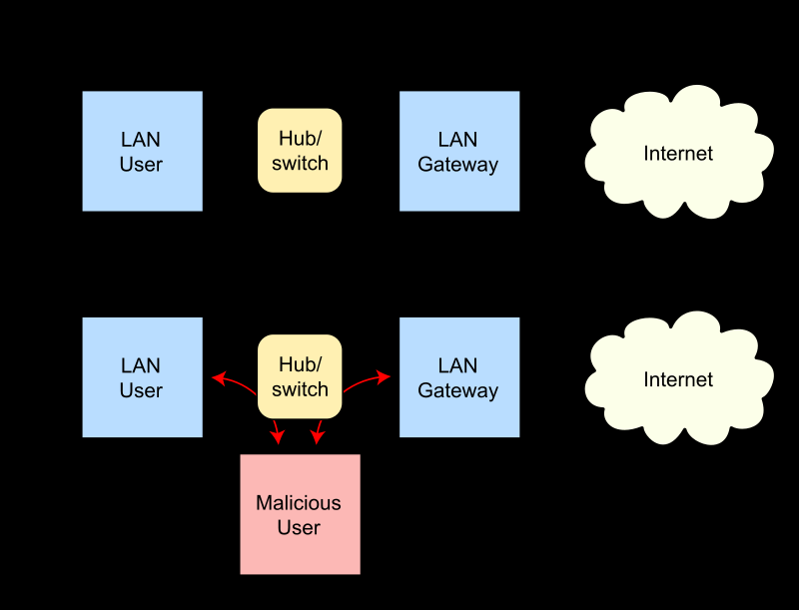

In this project we are going to simulate a MitM attack by using a prepared script written in Python. The script will connect to the IP address of the targeted “victim” and monitor it’s requests of connecting to a web-page and give the information to an “attacker”.
The “attack” is going to be performed from a Linux(Ubuntu) guest host machine on a VM VirtualBox, and the “victim” will be the physical Windows machine.
The program will ask for following user input:
- ip adress of a “victim”
- default gateway
- network interface(e.g. eth0, lo)
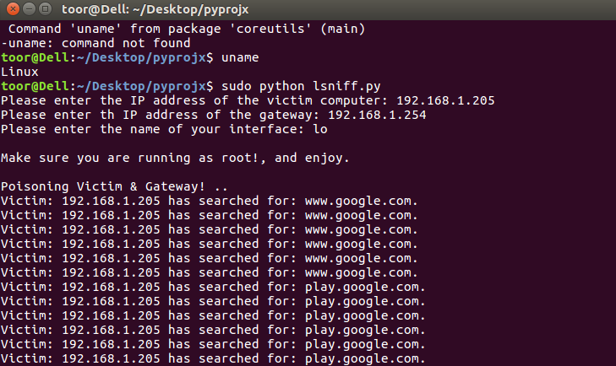
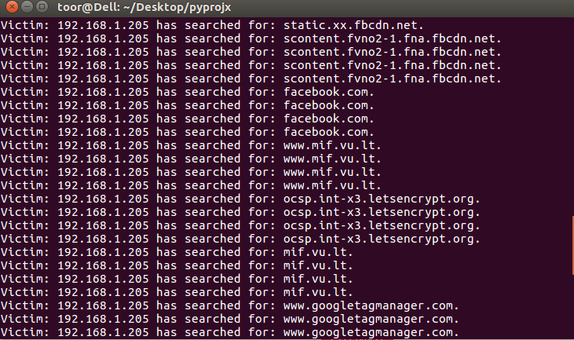
As we can observe, the program keeps tracking everything what the “victim” is searching for in the browser. The script will continue to work until manually stopped or internet connection will be lost.
ARP spoofing may allow an attacker to intercept data frames on a network, modify the traffic, or stop all traffic. Often the attack is used as an opening for other attacks, such as denial of service, man in the middle, or session hijacking attacks.

The attack can only be used on networks that use ARP, and requires attacker have direct access to the local network segment to be attacked.

Source code:
https://pastebin.com/1cMu4kzZ

