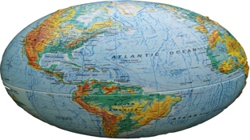
GL BALIZATION?
SOCIAL STUDIES 10-1
TO WHAT EXTENT SHOULD WE EMBRACE


ROARING TWENTIES
*1920’s “Boom” times
in Canada and the U.S.
*economic crisis in Europe
*German hyperinflation

END OF THE
COLD WAR
*1989 Berlin Wall comes down
*1992 collapse of the Soviet Union
*capitalism prevails over communism

WORLD WAR II
*massive devastation to Europe and Russia, Japan
*post war prosperity in Canada, U.S.

GREAT DEPRESSION
*1930’s “Dirty Thirties”
*economic crisis in Europe
*German hyperinflation

UNITED NATIONS
*goal of collective security
*rebuilding of war torn countries
*help with decolonization

FREE TRADE
*free trading blocs set up
* EU, NAFTA,

WORLD WAR I
“War to End All Wars”

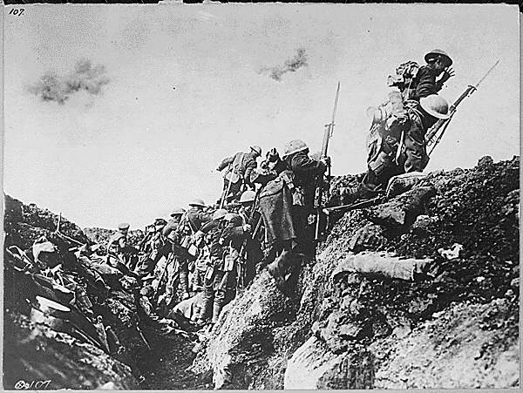

BRETTON WOODS
CONFERENCE
*institutions to guide global economy and rebuilding
*GATT/WTO, IMF,
World Bank

GROUP
OF 7(8)
*born in 1975-76 the G7 (G8) - strongest political and economic nations meet annually
to set global policy

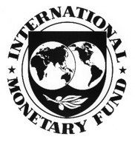

MODERN GLOBALIZATION
*Friedman’s flatteners
*North/South divide
*15% world’s people control 85% of the world’s wealth
*now the rise of China and India as major economic players
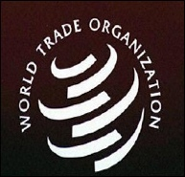

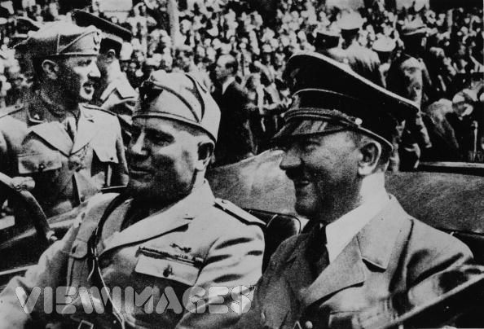

RISE OF DICTATORS
*Mussolini, Hitler, Stalin all rise to power in Europe
*political exploitation of terrible post-WWI conditions
*Treaty of Versailles

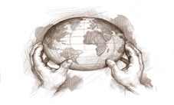
The W rld is Flat?
Book by Thomas L. Friedman

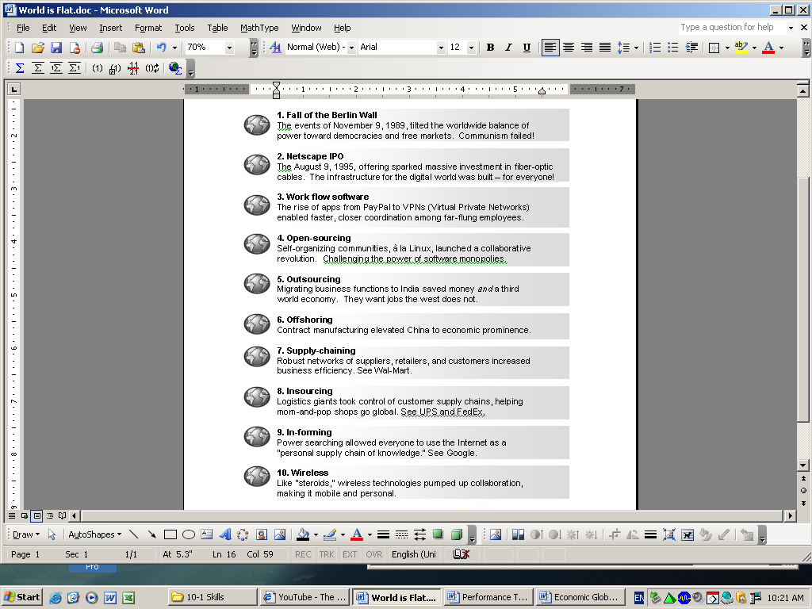

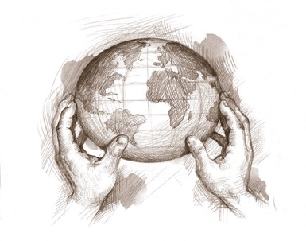
The W rld is Flat?
Book by Thomas L. Friedman

After 9/11, Thomas L. Friedman says, he paid less attention to globalization. He spent the next three years traveling to the Arab and Muslim world trying to get at the roots of the attack on the US. His columns on the subject earned him his third Pulitzer Prize. But Friedman realized that while he was writing about terrorism, he missed an even bigger story: Globalization had gone into overdrive. So in a three-month burst last year, he wrote The World Is Flat to explain his updated thinking on the subject.
Friedman enlisted some impressive editorial assistance. Bill Gates spent a day with him to critique the theory. Friedman presented sections of the book to the strategic planning unit at IBM and to Michael Dell. But his most important tutors were gentlemen from India: Nandan Nilekani, CEO of Infosys, and Vivek Paul, a top executive at Wipro. "They were the guys who really cracked the code for me."
Friedman argues we are in Globalization 3.0. In Globalization 1.0, which began around 1492, the world went from size large to size medium. In Globalization 2.0, the era that introduced us to multinational companies, it went from size medium to size small. And then around 2000 came Globalization 3.0, in which the world went from being small to tiny. There's a difference between being able to make long distance phone calls cheaper on the Internet and walking around Riyadh with a PDA where you can have all of Google in your pocket. It's a difference in degree that's so enormous it becomes a difference in kind.
Friedman builds on interesting ideas like the McDonald's Theory of Conflict Prevention, which states that two countries that have a McDonald's will never go to war with each other - to the Dell Theory of Conflict Prevention. No two countries that are both part of a major global supply chain like Dell's will fight against each other as long as they are both part of that supply chain. When I'm managing your back room, when I'm managing your HR, when I'm doing your accounting - that's way beyond selling you burgers. We are intimately in bed with each other. And that has got to affect my behavior.
Friedman describe ten ‘flatteners’ of the world, which have created a much more interedependent globe – some would say a “global village”.
1. Fall of the Berlin Wall
The events of November 9, 1989, tilted the worldwide balance of power toward democracies and free markets. Communism failed!
2. Netscape IPO
The August 9, 1995, offering sparked massive investment in fiber-optic cables. The infrastructure for the digital world was built – for everyone!
3. Work flow software
The rise of apps from PayPal to VPNs (Virtual Private Networks) enabled faster, closer coordination among far-flung employees.
4. Open-sourcing
Self-organizing communities, à la Linux, launched a collaborative revolution. Challenging the power of software monopolies.
5. Outsourcing
Migrating business functions to India saved money and a third world economy. They want jobs the west does not.
6. Offshoring
Contract manufacturing elevated China to economic prominence.
7. Supply-chaining
Robust networks of suppliers, retailers, and customers increased business efficiency. See Wal-Mart.
8. Insourcing
Logistics giants took control of customer supply chains, helping mom-and-pop shops go global. See UPS and FedEx.
9. In-forming
Power searching allowed everyone to use the Internet as a "personal supply chain of knowledge." See Google.
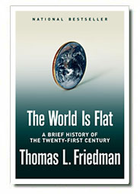
10. Wireless
Like "steroids," wireless technologies pumped up collaboration, making it mobile and personal.

