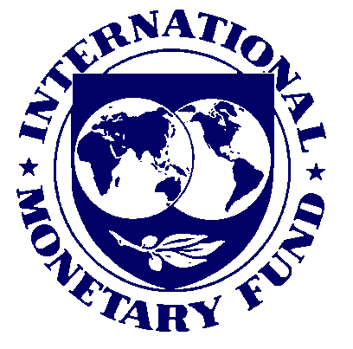


Why were the IMF and the World Bank created?

Using the Venn diagram on the board, highlight 4 major similarities between the World Bank and the IMF:

What are the fundamental differences between the IMF and the World Bank?

Provisions such as reducing corruption, increasing democracy, adopting Western-style free markets and reducing government spending on social programs are often imposed by the World Bank on developing countries who are in need of loans.

Why do you think that the World Bank imposes these types of restrictions?

What value system is being promoted with these restrictions?

In your opinion, are there potential problems with this type of system or is it a positive initiative?

SOURCE 1 SOURCE 2
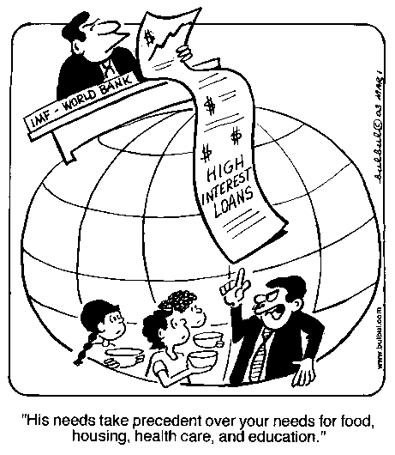
The IMF is the lubricant of world trade. It lends U.S. currency, say, to Costa Rica, so that Costa Rica can buy our computers. Then Costa Rica sells us coffee and bananas and earns dollars to pay the loan back. Without the IMF, trade between every nation and every other nation would have to be balanced at all times -- which would slow things down considerably. However, when Costa Rica hasn't exported enough coffee and bananas and its foreign exchange debt builds up, the IMF essentially steps in and takes over the government. In its wake education, health, and nutrition budgets are decimated. Crops and forest products are diverted from domestic needs to export. The balance of payments improves. The people and environment suffer.” - Donella H. Meadows. Dartmouth College Professor

SOURCE 3
The World Bank has been a major lender to India's massive energy program, financing open-pit mines and coal-burning power plants that pollute an enormous area with acid drainage and smog. The project will soon be the single largest new source of greenhouse gas emissions in the world. It has displaced 140,000 people who were not compensated, who have no place to go, and who are not even served by the electricity the project generates.
The Bank has financed roads through the Amazon that usher in deforestation. Its projects log uplands that sends eroded silt downriver to clog dams. Only after furious opposition has it desisted from funding dams on the Narmada River in India that would have displaced a million people. Nonprofit organizations routinely follow the Bank around analyzing and publicizing the detrimental environmental and social impacts of its projects -- something the Bank would do for itself, if it could look beyond money to the real physical and human aspects of development” www.sustainer.org/dhm_archive/index.php?display_article=vn549brettonwoodsed - 8k -

- Each of the sources above criticizes the IMF. Summarize the MAIN criticism of the IMF highlighted in each of the sources above:

Source 1:

Source 2:

Source 3:

