Install AWS and Terraform into your Jenkins instance you intend on using.

Make sure you have Docker going with containers!!

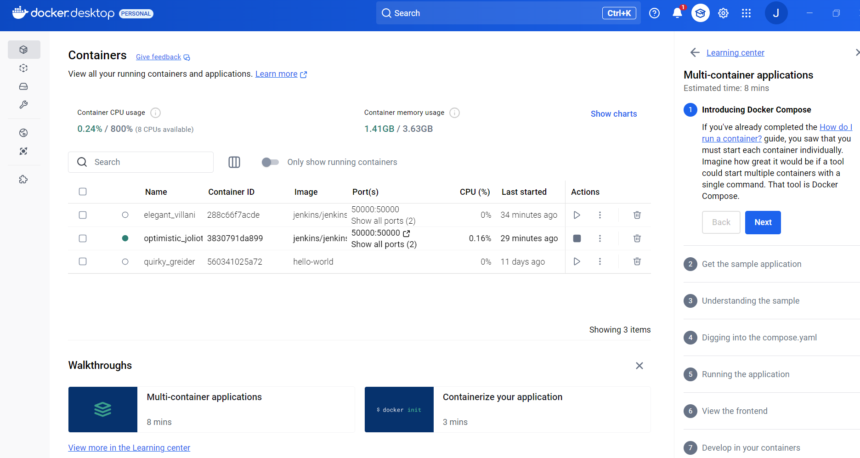

Create a Pipeline in Jenkins. Go to “ + New item” then select pipeline and name the pipeline and save it. “Manage Jenkins” then go to “Credentials”. Put in your AWS keys (access and Secret). In the “Configuration” of the pipeline, copy the URL of your github repository and paste it and change the “*/Master” to “*/Main”.

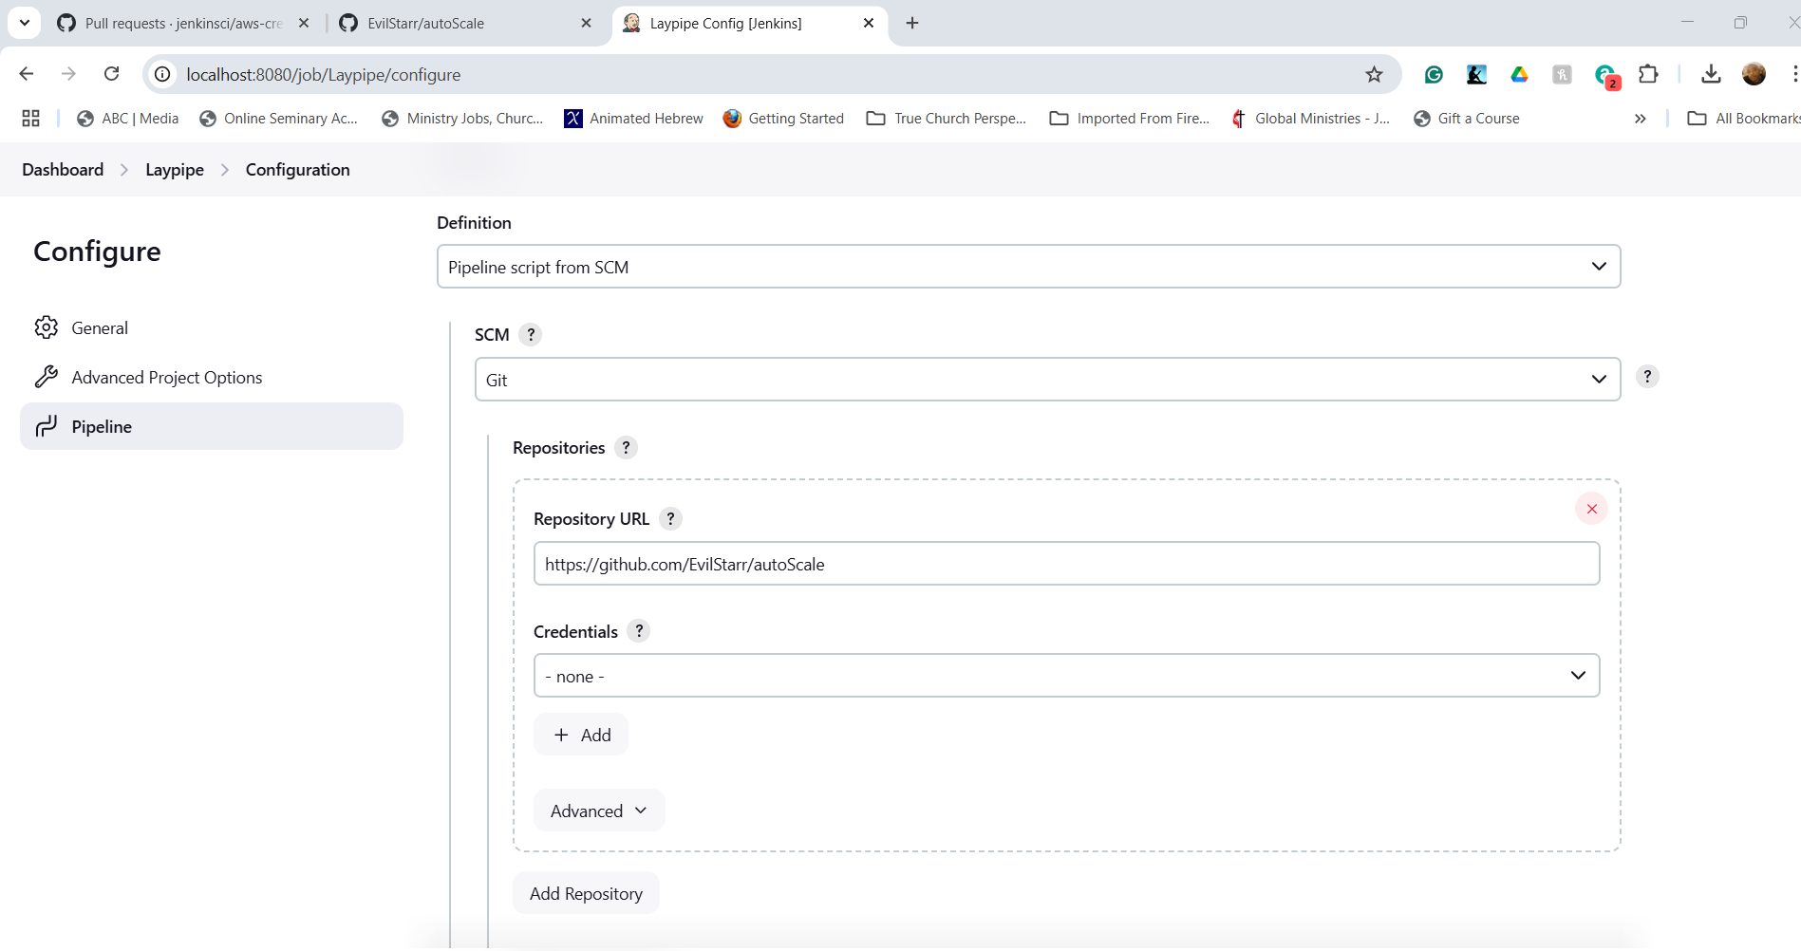

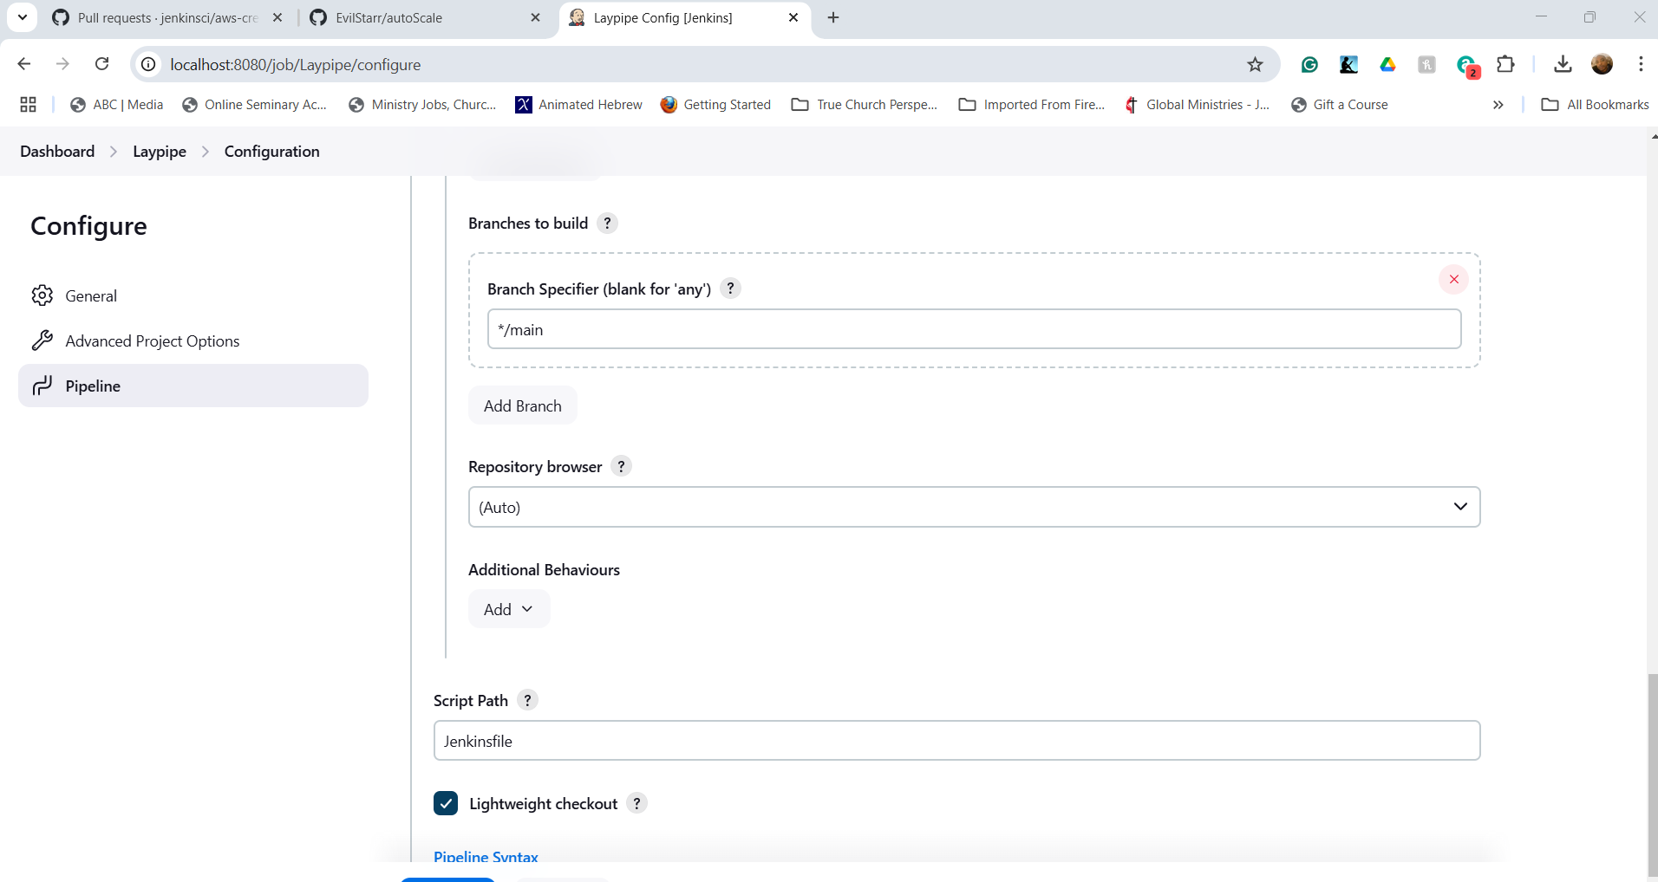

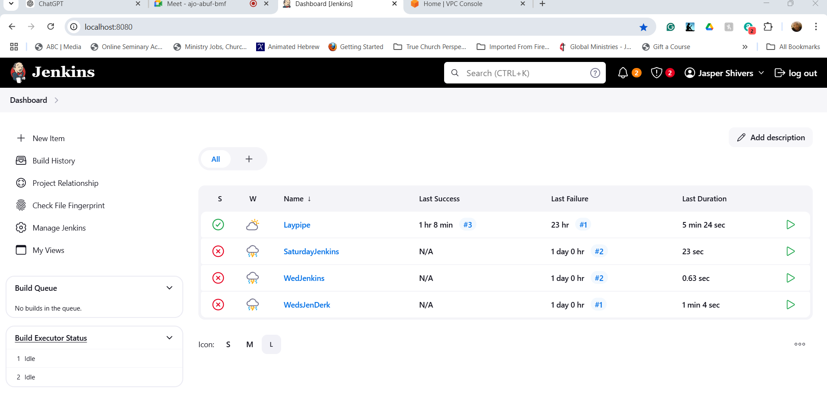

In the Github, make sure you edit the Jenkinsfile by adding your credencials ID

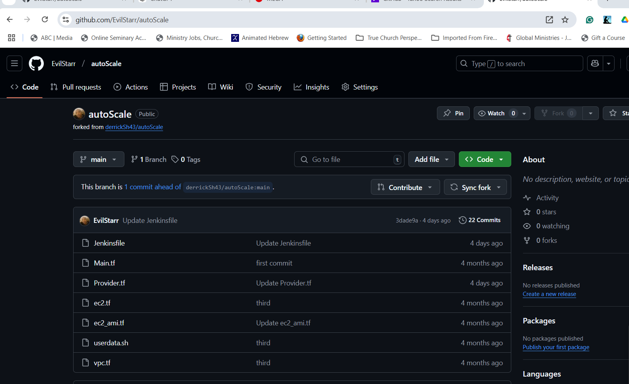

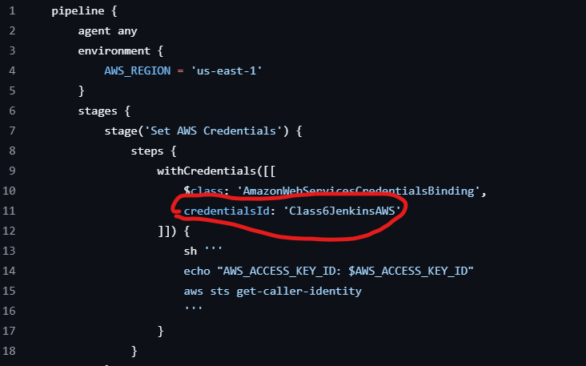

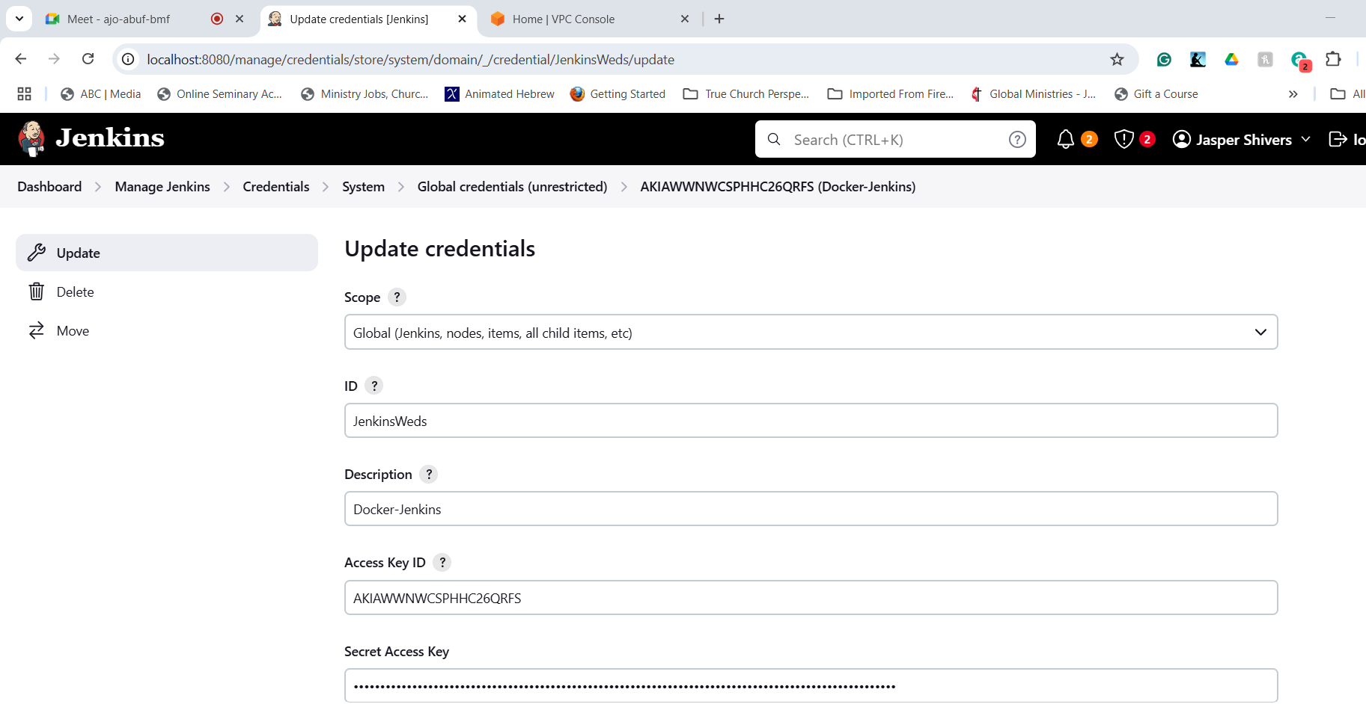



Open up GitBash or Windows PowerShell: It’s fun time!!

--------------------------------------------------------------------------

1. Access the container:

docker exec -it --user root <YOUR-CONTAINER> bash

2. Install AWScli:

apt update && apt install -y awscli

3. Make a new directory for install:

mkdir -p /home/jenkins/bin

4. Curl and install Terraform:

curl -fsSL https://releases.hashicorp.com/terraform/1.5.7/terraform_1.5.7_linux_amd64.zip -o /home/jenkins/terraform.zip

5. Unzip:

unzip /home/jenkins/terraform.zip -d /home/jenkins/bin

6. Cleaning Up Zips:

rm /home/jenkins/terraform.zip

export PATH="/home/jenkins/bin:$PATH"

7. Move terraform to /usr/local/bin:

mv /home/jenkins/bin/terraform /usr/local/bin

8. Check the version to verify:

terraform version

9. To view the terraform files deployed by jenkins follow the path below:

cd /var/jenkins_home/workspace/<PIPELINENAME>

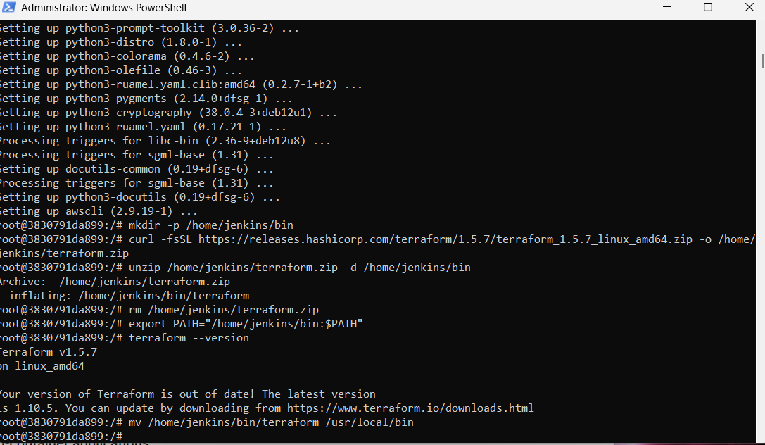

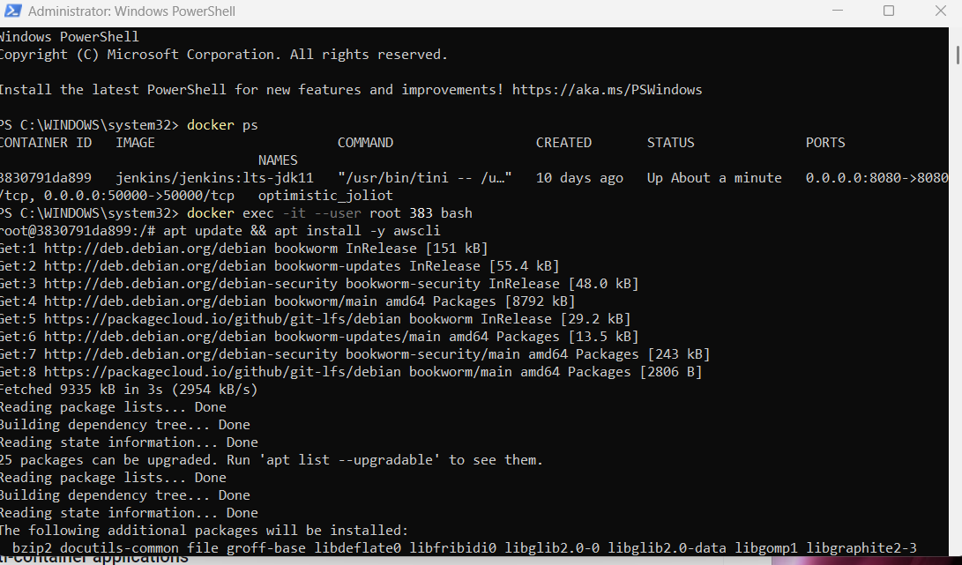

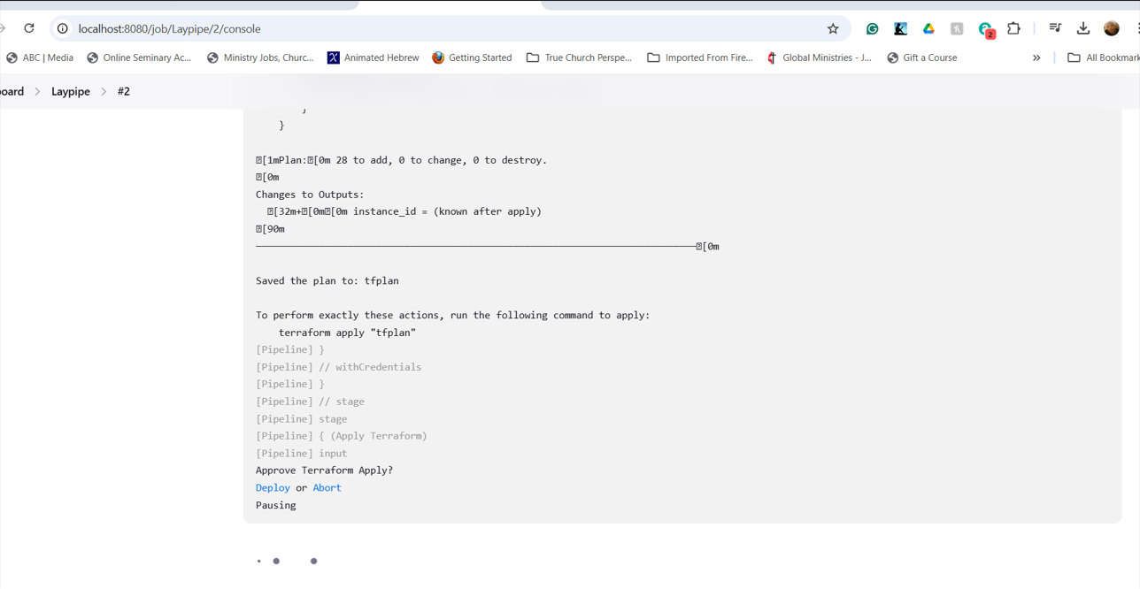

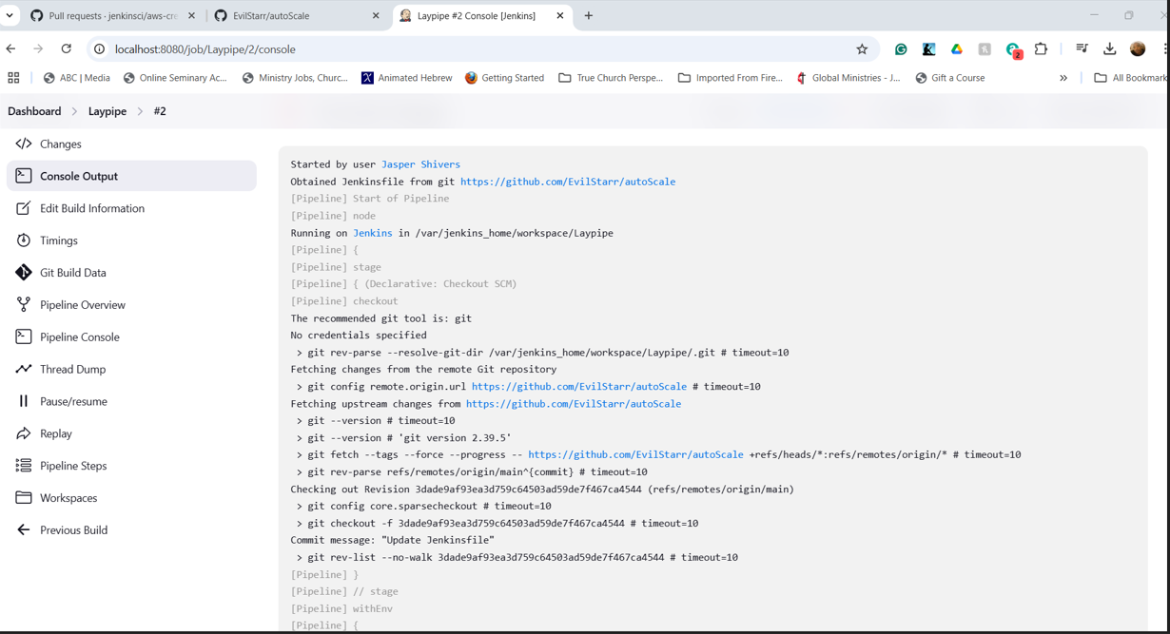

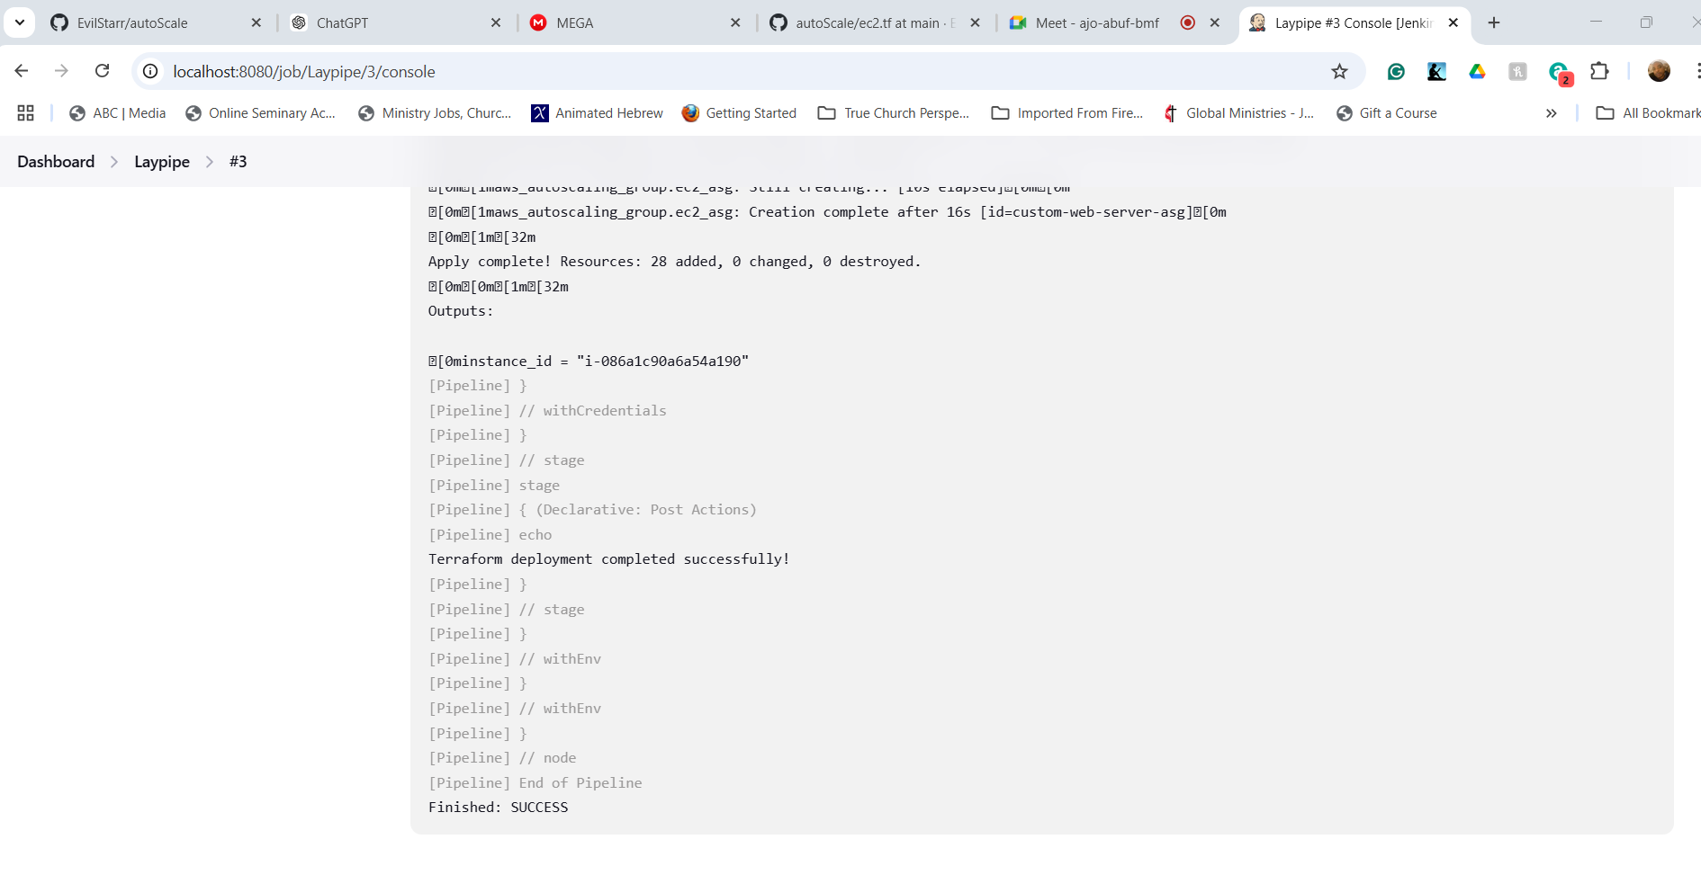

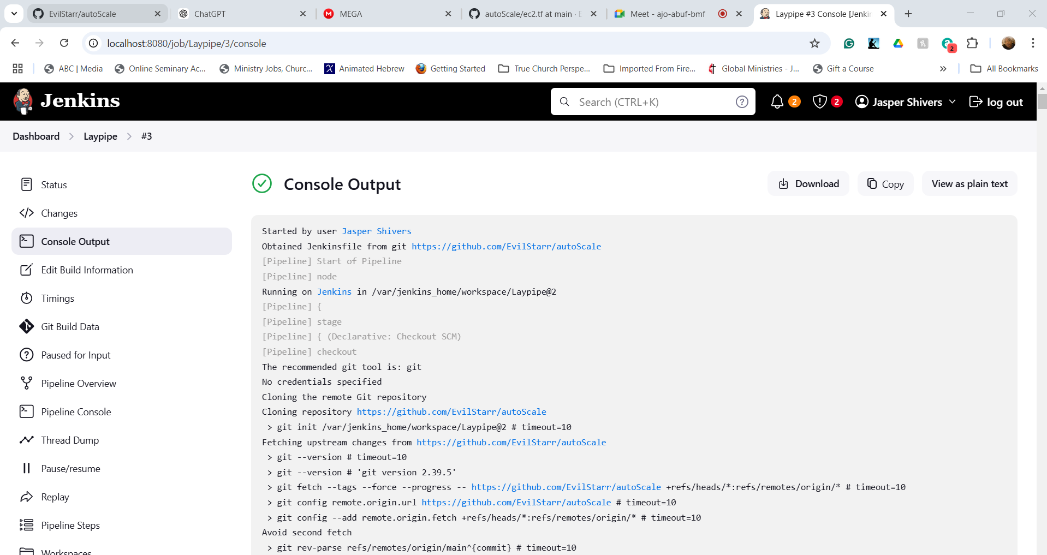

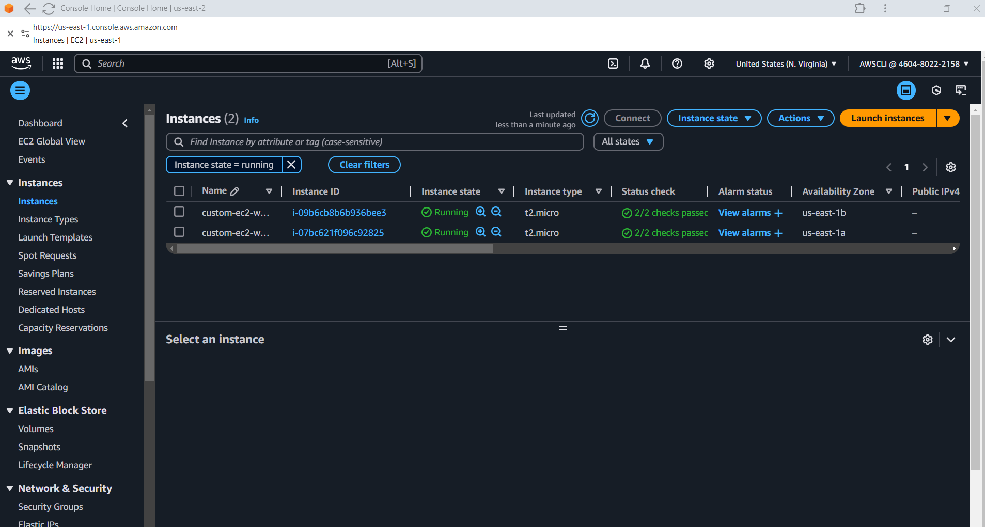

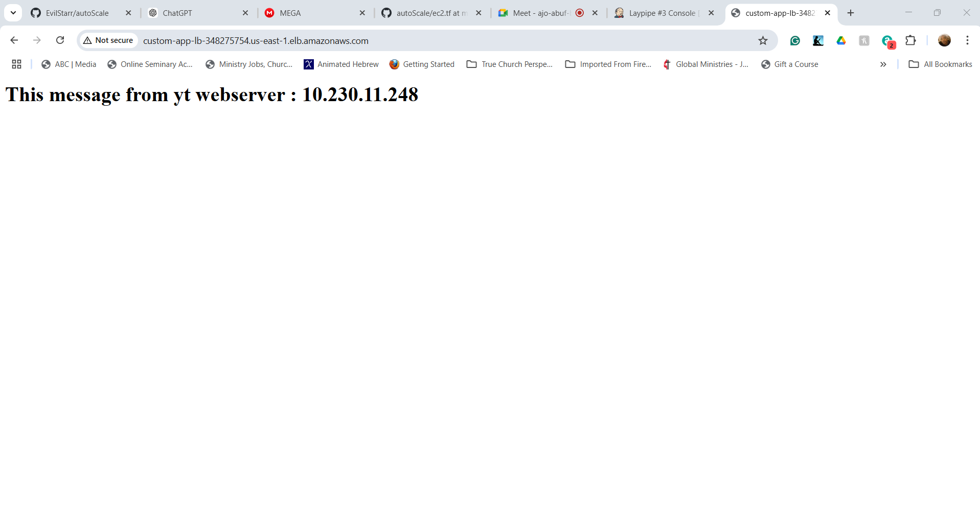

How to tear Down the resources Jenkins deployed using Terraform:

----------

1. To view the active terraform configuration use the exec or ssh of you container and change directories into the path below:

----

cd var/jenkins_home/workspace/<PIPELINENAME>

----------

2. Input AWS Credentials into the CLI of your container Login to destroy:

export AWS_ACCESS_KEY_ID="GOLDDIGGER"

export AWS_SECRET_ACCESS_KEY=" GOLDDIGGER2 "

export AWS_REGION=" GOLDDIGGER4LIFE"

terraform destroy

