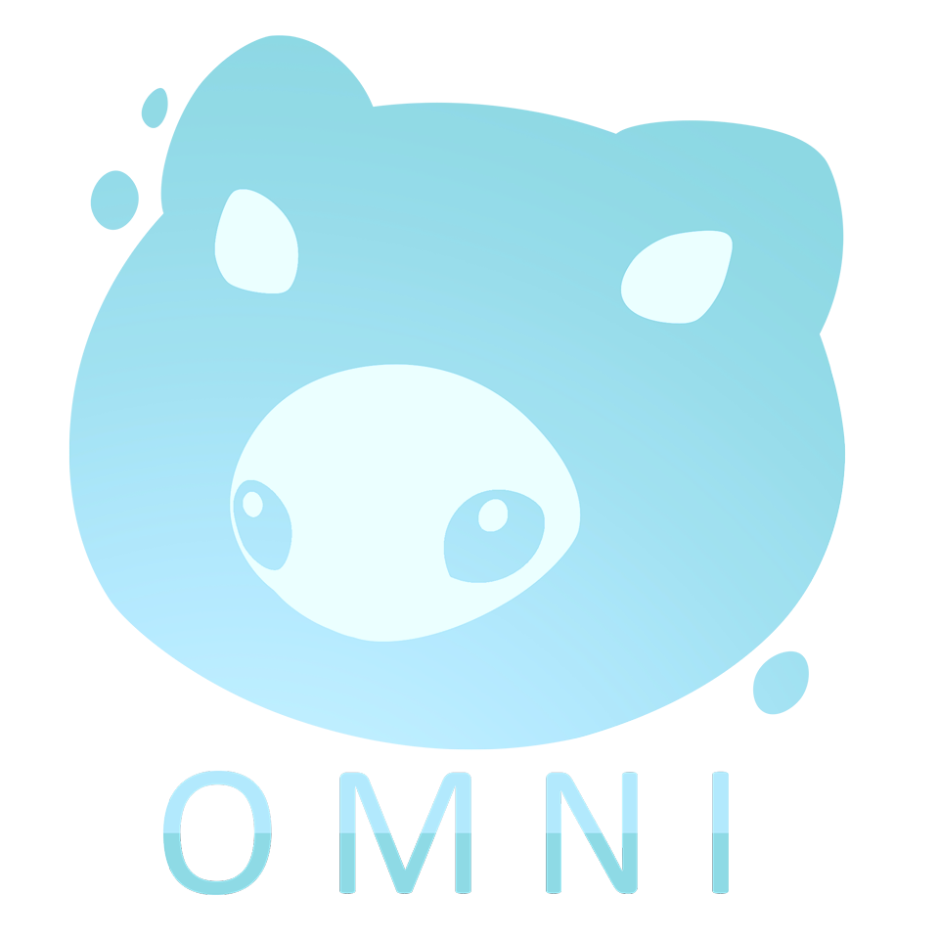

Production Plan
Version 4.0
Last Edited by Mitchell Sayer
13/10/20
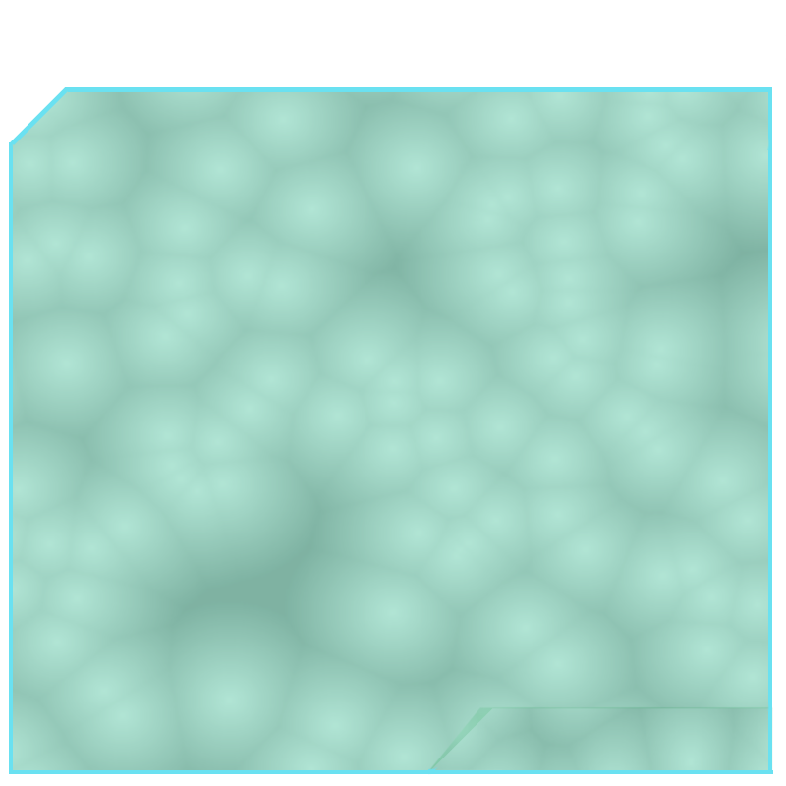
Contents
Tasks, Responsibilities and Assets 2
Team Members & Responsibilities 2
Project Goals 2
Project Burndown 3
Project Timeline/ Schedule 5
Milestones 6
Pre-Production 6
Alpha 6
Beta 6
Gold 6
Lessons Learnt Log 7
Risk Assessment Process 11
SWOT 11
Risk Likelihood 11
Change Log 12
Version 1.0 12
Version 2.0 12
Version3.1- 12

Tasks, Responsibilities and Assets

Team Members & Responsibilities
Name | Role | Responsibility
Mitchell Sayer | Game Designer | - Production Coordinator  - Narrative Design  - UX Feel/ Experience Designer  - Sound Design  - Level Design  - Character balancing
Richard Delamore | Game Programmer | - Mechanic Building  - Source Control monitoring  - Systems Creator
Tiana Knobloch | Character & UI Artist | - Character Modelling  - Character Animation  - UI Art Design  - Cinematic Animator  - Concept Art  - Texturing Assets
Daniel Iaria | Tech Artist | - Particle Effects  - 3D Modelling  - Procedural Texturing  - Texturing Assets
Joshua Freeman | Environmental & Foliage Artist | - Environmental Art/ Set Dressing  - Foliage Modelling and Placement  - Texturing Assets

Project Goals
- To create a memorable experience for the target audience
- Providing the player to create their own innovative comedic moment
- Develop an enjoyable game that has smooth replayablity.
- Design and produce a product from all team members strengths.
- Publish the game on Epic Games Marketplace
- Port to different platforms i.e.: IOS, Android, Nintendo Switch.

Project Burndown
The following graph visually underlines the estimated process of the project’s execution and how well the team will achieve its goals

Project Timeline/ Schedule
Milestone | Sprint & Date
Pre-Production | Week 1PP (20th - 22nd July)  - Concepts Made  Week 2PP (27th - 28th July)  - Grey boxing Prototype building  Week 3PP (3rd - 5th Aug)  - Prototype complete + Pitch
Alpha | Week 1A (10th - 11th Aug)  - Level 1 Grey boxed  - Character Modelling Started  - Environment Level 1 Started Modelling  Week 2A (17th - 19th Aug)  - Character Rigging Started  - Level 2 Grey boxed  - Environment Level 2 Modelling  Week 3A (24th- 25th Aug)  - High Poly Refinement Process Started  - Character Animation Started  - Character Rigged and Modelled  - Set dressing Started  Week 4A (31st Aug- 2nd Sept)  - Level 3 Grey boxed  - Environment Level 3 modelling  Week 5A (7th - 8th Sept)  - UI implemented  Week 6A (14th - 16th Sept)  - Foliage addition 1st pass  - Character Animated  Week 7A (21st - 22nd Sept)  - All levels meet 2nd pass standards  - All Mechanics built  - QA Testing
Beta | Week 1B (6th Oct - 7th Oct)  - Debugging Process Started  - Audio Refined  - QA Testing  Week 2B (5th - 6th Oct)  - Prop Model Texturing Started  Week 3B (12th - 14th Oct)  - Set dressing finalised  - QA Testing  Week 4B (19th - 20th Oct)  - Light Baking  Week 5B (26th - 28th Oct)  - Assets Textured  - All bugs fixed  - Character Animated
Gold | Week 1G (2nd - 3rd Nov)  - Polish Everything  Week 2G (9th - 11th Nov)  - Release Date

Milestones

Pre-Production
- Grey-boxing
- Prototype Mechanics built
- Prototype built

Alpha
- All game levels blocked out, grey boxed, and first passed
- Audio Implemented
- Character Model
- Character Rig
- Character Animated
- Character Textured
- High Poly Refinement Process
- All Mechanics Built

Beta
- Cutscenes Designed
- Set dressing
- Light Baking
- Texturing Overall
- Bug fixing

Gold
- Polish Levels
- Polish Assets
- Polish Mechanics
- Create Teaser Clip

Lessons Learnt Log
Feedback: | How to Improve on it:
Keep your concepts simple and effective. | Keeping ideas simple and easy to execute
Alexandra Mannel:  - Love the idea of the ghost game it sounds fun with the aspect of going around scaring people as ghosts. Would it be better if you were looking through the camera as you move?  - 3rd game not really a fan  Neil Boyd:  - The Hand game I see as being a fun game to run around with the ragdoll movement of the hand physics  - You need to make sure there is a clear line of sequencing for the body building part.  - The Ghosts game I’m confused about the jump scares for a kid’s game, it doesn’t really sit well with that target audience, if it were a mature audience it could work but not for a kid’s game.  - That would need to be focused and designed to work around that limitation.  Paco Casares:  - Ghost game with the multiplayer is a good unique selling point however the setup of multiplayer can take time depending on experience making it.  - Taking into consideration games like Project Zero could be good as reference.  Jesse Donlevy:  - Hand Concept is doable as there’s room to add more art assets and levels and the replayablity is high  - The Ghost game the same as well its safe, and different levels add complexity/ variety to gameplay.  Myles Blasonato:  - Love the hand idea as well it kind of reminds me of Katamari with the whole evolving size aspect, with the items impacting the player.  - The arena fighter is a lot to consider technically and from a designer perspective it would only be a slice of gameplay  - With the ghost idea the theme needs to be fixed as it doesn’t make sense with the pillars in place. | Utilise on the strengths of all ideas and work on the second idea.  Keep concepts simple and work to teams strengths.
Tiana Knobloch:  - Character Model  - Janky movement due to mesh collisions  Daniel Iaria:  - Character Movement won’t be possible because of skeletal mesh errors  Character Mesh & Animation | Find an alternative to showcase the character creation without the need of controlling it.  Making the player feel good about what they made regardless of the result.
- Competitive Market Research  - Emotion in Pillars | Perform further research into competitors and seek why the weakness are what they are and improve of them.  Draw a story from the pillars of the game and make sure they concrete the concepts goal.
- Replayablity, Character movement, Player Goals  - Game Vision | Look for ways to show variety to the player whilst not having to change the game dramatically.
- Don’t detour from original concept: You’re not making a fashion flash game  - The original body building is innovative, stay with that. It’ll lead to good results. | Taking a step back to overlook what has been discussed is a great way to get back on track.
- Make sure version is before not after in UE4 to avoid conflicts in opening the project file. | Take more care in using game engines and prepare before hand to start projects with less launch issues.
- Font text colour needs to be changed  - Too much text on the alpha, beta, gold slide, simplify it.  - Make sure the game titles are fixed | People have short attention spans, keeping info short and simple is key.
- Voice pitch needs to be practiced on  - Change the name of the persona  - Practice on timing | Be louder and prepare more before presenting in future.
- It can be done there is a setting in blueprints that allows you to move without mesh collisions. | Apply newly found information to solve problems.
- Should think about the levels in which your size can dictate where you can go if that unlocks more items or can reach. Can unlock new areas. | Relook at level designs and play with the idea of mechanics.
- Guudo’s UFO concept needs brighter colours closer to what his head looks like, whites and light greys | Brighten up the darker areas of the UFO such as the wings and the cockpit, make them brighter whites and off whites
- Everyone speaks well  - Don’t move hands when presenting its distracting  - Don’t need all art information in the gold section of milestones, nothing should be touched.  - Don’t need to include preferred language of coding  - Narrative setting is required if it's an important element of discussion.  - Slow down  - Explain the item collection further  - Gold should focus on marketing and packaging the product. | Follow given advice
- Art shows a lot of promise  - Would be good to have a prototype of shaders, try swapping out the noise factor in the existing shader.  - Lighting scale is good idea in art  - Proof of foliage in the environment would make a stronger presentation  - Including a finished asset would assist the strength of the presentation  - Physics was unclear how it would be used.  - A clearer and refined schedule would be nice to use as reference to allow a better scope prediction.  - No foliage concepts or block outs to be seen. Mentioned in PowerPoint and would be nice to see concepts of them  - No proof of art, i.e. Art asset completed in chosen style in engine to showcase game look.  - Overall minimum number of concept pieces to showcase environment look. Needed more to show what game looked like before the actual prototype.  - Screenshots of the game environment would have been nice to see the idea of level layout. (paint over ideally)  - Litter throughout presentation screenshots of gameplay mechanics and loops to give a better idea.  - No dates on deliverables  - No age demographic in your target market, this is an issue.  - Theme is good  - Story is nice  - Design element was weak:  - How do I win?  - How do I gain points?  - How do I lose?  - How do I use my abilities?  - What reason do I have to use my abilities?  - Level Design concepts would've been nice to see  - No explanation of goals. | Foliage proof on concept, modelled and added to UE4 scene to test art style  Proof of art Completed  And added to engine scene  Completed additional concepts of all asset types to be completed  Screenshot paint overs added and designed  Add in missing information in future, and discuss clearly about how the game should look, play, and its goals alongside its execution and ending conditions.
Tiana Knobloch:
- UI was simple to learn and navigate

Richard Delamore:
- I learned how to make a Character Customization and Inventory System. I also learned how to debug UE4 better.
Joshua Freeman:
- I learned how to use Substance Designer, more efficient foliage pipeline, optimisation increased.
Daniel Iaria:
- I learned how to tackle my time management and are still learning to correct my pivot points in UE4.
Mitchell Sayer:
- I learned more about Audacity and sound design, additionally using UE4 for the first time.

Risk Assessment Process

SWOT
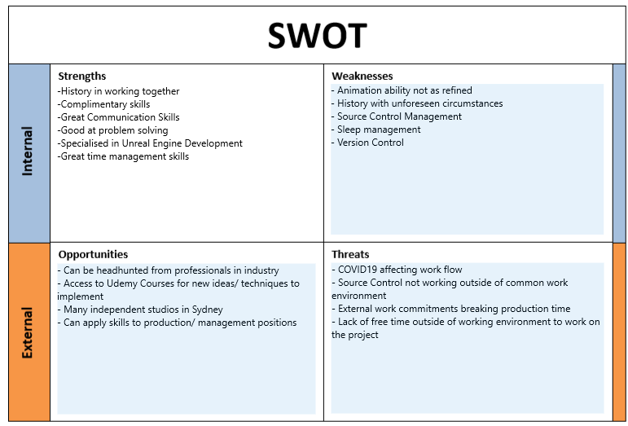

Risk Likelihood
[Low Risk: 1 – High Risk: 5]
Risk | Likelihood | Cause of Risk | Response to Risk
Over Scoping | 3 | High Ambitions | Maintain a simple idea. Create an enjoyable, small project. Wishlist tasks can be added later if need be.
Resistance to Change | 2 | Too attached to an idea or concept | Reach an alternative that simulates both strengths and reasonability for execution.
Stress & Anxiety | 3 | Strict Deadlines/ Difficulty executing ideas and concepts | Maintain appropriate weekly workload and stick to schedule timings. Avoiding unnecessary tasks that detour from original task schedule.
External commitments | 4 | External commitments to the workplace | Proactive planning to avoid missing workdays/ Preparing and updating plans beforehand to avoid having no work to continue with.
Corrupt files | 3 | Not saving/ backing up save data often, incorrect version control, damaged hard drives, source control errors | Frequent checking on Source Control and maintain version control on Engine to make sure projects do not become corrupted
Not meeting deadlines | 1 | Procrastination, distractive environments, lack of confidence | Introduce new activities/ tasks each day that could make working enjoyable. Avoid sites that could lead to distraction, set a timer for how quickly you can complete a task swiftly and efficiently.

Change Log

Version 1.0
Base foundation of documentation including headings and sections for the following:
Tasks, Responsibilities and Roles
- Team Members and Responsibilities
- Project Goals
- Project Burndown
- Project Timeline/Schedule
Milestones
- Pre-Production
- Alpha
- Beta
- Gold
Lessons Learnt Log
Risk Assessment Process
- SWOT
- Risk Likelihood

Version 2.0
All information added to their respective sections. Information provided should be read carefully to fully understand intentions and direction of the project.

Version 3.1
Added:
- Project Burndown Charts; Project Overview, Alpha, Beta, Gold

Version 3.2
Added:
- Documentation Watermark (Background)
Modified:
- Timeline/ Schedule Alpha and Beta tasks changed
  - BETA -> ALPHA
    - Character animation and texture started, and completed
  - ALPHA -> BETA
    - Textures started

Version 3.3
Modified:
Lessons Learnt Log
Burndown Velocity Graph

Version 4.0
Added:
Overall Burndown Chart (Detailed)
Modified:
Overall Burndown Chart + Beta Burndown Chart
- Modified Total Actual amount
- Modified W2 progress

