Mitchell Sayer
Version 1.3
Last Edited by Mitchell Sayer
27/07/20
Guudo
Game Design Document

Table of Contents
Game Overview 3
Summary 3
Theme 3
Player Goals 3
Design Goals 3
Core Unique Features 3
Core Pillars 3
Game Feel/ Experience 3
Target Audience 4
Demographics 4
Age 4
Skill 4
Gender 4
Time 4
Monetisation 4
Feature Appropriate 4
Mechanical Understanding 4
Core Gameplay 5
Core Loops 5
Core Gameplay Loop 5
Feedback Loop: Consuming or Collecting 5
Feedback Loop: Energy 6
Feedback Loop: Timer 7
Mechanics 7
Controls/ Interface 7
Controls 7
Economy 8
Economy Loops 8
Currency 8
Taps 8
Sinks 8
Levers 8
Narrative 8
Context of Gameplay 8
Story 8
Character Information 8
Plot Synopsis 8
Gameplay Synopsis 9
Art Direction 10
Art Style 10
Visual References 10
Audio Direction 12
Music 12
Sound Effects 12
Technical Information 13
Target Platform 13
Engine 13
Limitations 13
Platform Specifications 13
Production Information 14
Production Software 14
Game Engine 14
Programming 14
Art Software 14
Audio Design 14
Milestones 15
Alpha 15
Beta 15
Gold 15
Archive 16
Version History 16
Change Log 16
Version 1.0 16
Version 1.1 16
Version 1.2.0 17
Version 1.2.1 18
Version 1.3 18

Game Overview

Summary
Guudo, an intergalactic alien species has been given the task of searching and spreading life on Planet Earth. However, upon arrival to Earth Guudo crash lands in the middle of the production set of Space Stars Galactica. In panic not to be discovered by the existing life on earth Guudo must blend in to fit in with the humans by any means necessary, even if it means using found objects to make the perfect human body.

Theme
“One person’s trash is another’s treasure”

Player Goals
- Create the perfect humanoid shell
- Create the perfect monstrosity of item combinations
- Collect all the body shape sets
- Traverse levels with bobbly head/ ragdoll physics

Design Goals
- Creating a proud comedic moment
- Creating smooth, enjoyable, wacky physics-based player controls
- Develop aesthetic, funny, and inviting assets

Core Unique Features
- Top-Heavy Movement
- Quick Decision Making
- Humorous Body Part Choices

Core Pillars
- Fast Paced Gameplay
- Scavenging
- Customisation

Game Feel/ Experience
Guudo should present players with a fun but pressuring experience, as they constantly search for the perfect parts to make Guudo’s humanoid shell in a tight time constraint. Additionally, allowing the player to have their creative side shown through the customisation screen, provides variety bringing them back to replay the game to try and create different combinations.

Target Audience

Demographics

Age
Guudo is to be a family friendly game that attracts an audience, objectively, from 11 years old and older.

Skill
The game is to be skilled for those who have a base knowledge of puzzle-platformer titles. I.E Katamari Damarcy, 60 Seconds, I am Bread.

Gender
This title should not be biased towards one gender but both, as the both the gender and gameplay element are neutral regarding player abilities.

Time
The subjected player base should be those that have disposable free time, or those who are looking for a quick entertaining experience.

Monetisation
As for early release purposes, the game should be distributed via the Steam/ Epic Store, prioritising the Epic Store due to its developer cut differences, (12% - Epic VS 30%- Steam). We would be selling the product for $7 on the market. To attract both those in dependant and independent financial states.

Feature Appropriate
Guudo should allow the player to feel welcome

Mechanical Understanding

Persona

User Experience

Interviews

Synthesis

Design Choices

Target Market

Competitors

Market Trends

Audience Characteristics

Core Gameplay

Core Loops

Core Gameplay Loop
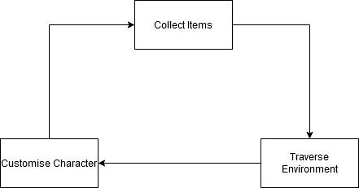

Feedback Loop: Consuming or Collecting

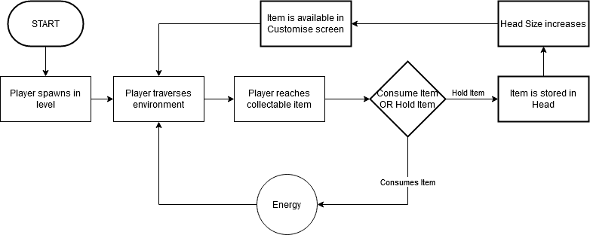

Feedback Loop: Energy

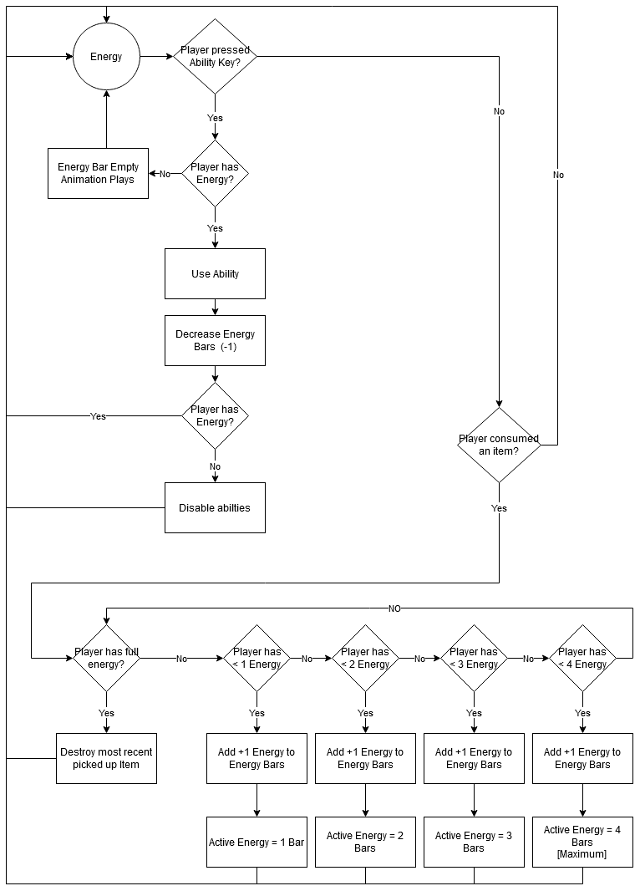

Feedback Loop: Timer

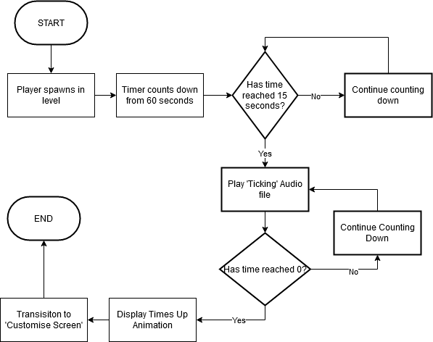

Mechanics
- Player Movement
  - The player can move in 360-degree angled movement using the WASD keys.
- Shrink
  - The player will scale down to a smaller size reaching unreachable places that would normally be an obstacle for them.
- Grow
  - The player will increase the players size allowing the player to knock over big objects allowing to access items that could normally never be reached.
- Eat
  - The player can eat an edible object to either use as energy, or as a customisable object in the customisation scene.
  - If the player has more than 10 objects held as customisable the player will experience top-heavy movement, making them move from side to side more frequently.
- Rating System
  - At the end of the building scene the player will be rated by their performance in two areas:
- Fashion
The player will be rated on their consistent body part choices. The less consistent the lower the rating in this area.
- Parts collected
The player will be rated on how many parts they’ve collected vs how many they’re missing. The more missing the lower the rating in this area.

Controls/ Interface

Controls
- Movement
  - ‘WASD’ Controls
- Camera Movement
  - Mouse Movement
- Jump
  - Spacebar
- Sprint
  - Left Shift
    - Holding Left shift will allow the player to move in a ‘running’ formation
- Abilities
The player can press Tab to cycle through the following abilities:
  - Shrink
    - Pressing MMB on this ability will shrink the player to a smaller size reaching unreachable places that would normally be an obstacle for them
  - Grow
    - Pressing MMB on this ability will increase the players size allowing the player to knock over big objects allowing to access items that could normally never be reached.
  - High Jump
    - Pressing MMB on this ability will allow the player to jump higher the next time they press Spacebar to jump.
- Eat
  - By pressing the E key, the player can eat the edible object and will provide the player with 3 options:
    - Consume
If the player presses the ‘1’ key, Guudo will consume the object and convert it to energy. If the player has maximum energy, the option to consume the object will be taken away.
    - Drop
If the player presses the ‘2’ key, Guudo will regurgitate the eaten object and drop it, doing neither consuming nor collecting it. If energy is at maximum capacity, Drop will replace the Consume option and will be asked to press the ‘1’ key instead.
    - Collect
If the player presses the ‘3’ key, Guudo will keep the object as a collectible to use in the customisation building scene. If Energy is maximised the Drop option will be replaced with Collect and will ask the player to press the ‘2’ key instead.

Economy

Economy Loops

Currency

Taps

Sinks

Levers

Narrative

Context of Gameplay
An Alien has crashed landed on a film set, coincidentally space themed. Guudo needs to create a body to blend in with the soon approaching human actors.

Story
Guudo, an ageless alien lifeform who lives and strives for exploration to the greater unknown. One day on Planet Drool, from the digital noticeboards to billboards to posters in the streets, they all flooded in propaganda looking to enlist those who were willing to serve the planet’s ‘Evolving and Transforming Scouts Unit’ (EATS-U). Those on the EATS-U squad would be sent out on external planetary expositions to explore, populate, and transform any present lifeforms to become one with the local ‘Droolers’. Taking the opportunity at first glance Guudo felt the drive to accomplish something for the people of its’ home planet. With a quick smack of a head on a signature clipboard, Guudo was a member of the EATS-U team. The squadron leader of Guudo’s division had prepared a mission to Pluto, to inhabit the planet and transform its existing non-living conditions into one where the Droolers could live in peace. During Guudo’s launching sequence a Goo leak in the ship’s system had changed the course of travel to Planet Earth causing a crash landing into what was soon to be discovered as extra-terrestrial land… or so Guudo thought. Receiving a transmission from the squadron leader informing Guudo of what’s happened, Guudo soon realises that it isn’t alone, hearing noises from the surrounding environment causes him to grab together what he can to try and blend into place. This was truly the mission that would decide Guudo’s fate in its future career as an EATS-U squad member.

Character Information
Guudo is an alien lifeform, who has a goo-like membrane that allows him to grow and shrink in size. Although, the more he indulges at a time, the bigger his head will grow making his movement very top-heavy and uneasy to control his balance. Guudo just wants to do what is best for his kind and evolve and explore, though this mission of blending in with the humans will be his biggest task.

Plot Synopsis
- Propaganda fills the streets
- Guudo picks up poster
- Registers
- Sent on mission
- Crash lands on Earth by mistake
- Gets out
- -Starts Tutorial-

Gameplay Synopsis
- Place character in tutorial setting
- Teach Movement
- Teach Looking
- Teach Eating
- Teach Abilities
- Teach Collecting
- Level 1 Starts
- Timer starts counting down from 60 seconds
- Player traverses’ level
- Player picks up items
- Timer runs out
- Player is taken to customisation screen
- Player customises Guudo’s ‘Human’ Shell
- Player confirms choice
- Guudo is revealed to Film Set employees
- Guudo is rated on fashion and body parts assembled

Art Direction

Art Style
The art style should consist of clean modelling, with as much detail being added to the chosen assets as feasible. High Details bake can be undertaken to give crisp shapes and lines. Texturing style is flat colours, with subtle procedural noise and gradients to add flair and interest to an otherwise simple colouring scheme. Extra care to be taken in adding detail and story to assets using colour maps. Subtle Roughness and metallic maps will be used but all detail is to be mainly pulled from Albedo mapping.

Visual References
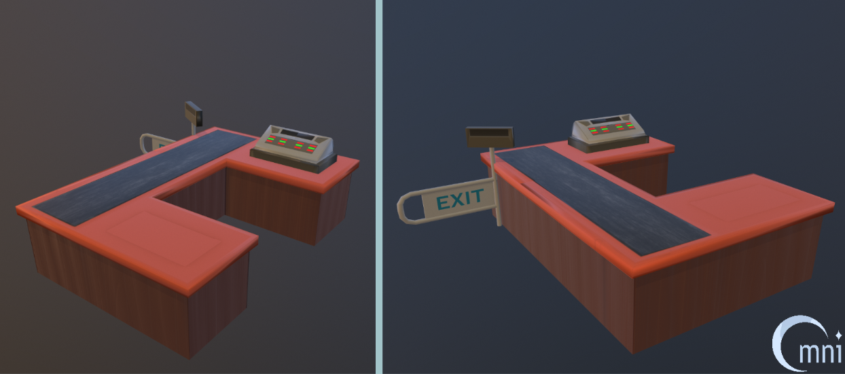
A quick study undertaken to showcase the art style.
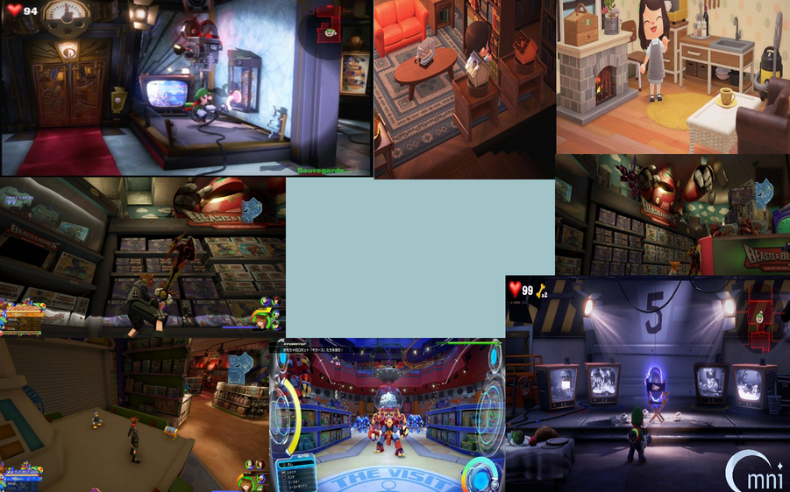
Prop Reference Images: Games included (Kingdom Heats, Animal Crossing and Luigi’s Mansion 3)
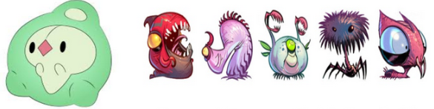
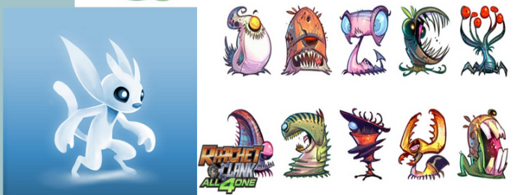
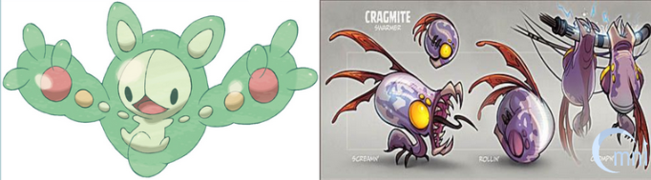
Character Reference Images: Games Included (Ori and the Blind Forest, Pokemon Series, Rachet and Clank All 4 One)

Audio Direction

Music
- Menu BGM
- In-Game BGM
- Rating Scene BGM
- Credits BGM

Sound Effects
- Eating
- Consume
- Regaining Energy
- Collecting
- Movement Wobble
- Player Sprint Sounds
- Timer
- Body Part snapping on sound [Customisation Scene]
- Body part disappearing [Customisation Scene]

Technical Information
Reference TDD

Target Platform
PC

Engine
Unreal Engine 4

Limitations

Platform Specifications
Recommended Hardware
  Operating System | Windows 10 64-bit
  Processor | Quad-core Intel or AMD, 2.5 GHz or faster
  Memory | 8 GB RAM
  Video Card/DirectX Version | DirectX 11 or DirectX 12 compatible graphics card
Minimum Requirements
  Operating System | Windows 7
  DirectX Runtime | DirectX End-User Runtimes (June 2010)
Software Installed by the Prerequisite Installer
  DirectX Components | Visual C++ Redists
  XInput 1.3 (April 2007) | Visual C++ 2010 CRT
  X3DAudio 1.7 (February 2010) | Visual C++ 2010 OpenMP library
  XAudio 2.7 (June 2010) | Visual C++ 2012 CRT
  D3D Compiler 4.3 (June 2010) | Visual C++ 2013 CRT
  D3DCSX 4.3 (June 2010) | Visual C++ 2015 CRT
  D3DX9 4.3 (June 2010) | Visual Studio 2019 redistributable
  D3DX10 4.3 (June 2010)
  D3DX11 4.3 (June 2010)
Typical system used at Epic, for developing games with Unreal Engine 4 | - Windows 10 64-bit  - 64 GB RAM  - 256 GB SSD (OS Drive)  - 2 TB SSD (Data Drive)  - NVIDIA GeForce GTX 970  - Xoreax Incredibuild (Dev Tools Package)  - Six-Core Xeon E5-2643 @ 3.4GHz

Production Information

Production Software

Game Engine
Unreal Engine 4

Programming
Unreal Engine Blueprints
Visual Studio

Art Software
Substance Designer
Autodesk Maya
Adobe Photoshop
Substance Painter
ZBrush
Marmoset Toolbag

Audio Design
Audacity
FMOD

Milestones

Alpha
Art:
- Character Modelled
- Character Rigged
- High Poly Refinement Process
- Props and Environment Modelled
Design:
- Grey-Boxing, 1st passing: Levels 1-3
- UI Implemented
- Audio Implemented
- QA Testing
Programming:
- Mechanics built

Beta
Art:
- Character Animated
- Character Textured
- Environment and Props Textured
- Light Baked
Design:
- Levels refined for Beta Testing
- Cutscenes Designed
- Audio Refined
Programming:
- Debugging Completed

Gold
Art:
- Polish all Assets
Design:
- Polish Character controller
- Polish Level Design
- Create Teaser Trailer and Demo
Programming:
- Polish Mechanics
All:
- Release Game

Archive

Version History

Change Log

Version 1.0
This includes the headings of the documentation

Version 1.1
This includes information added in Theme:


Version 1.2.0
This includes information added into Game Overview:
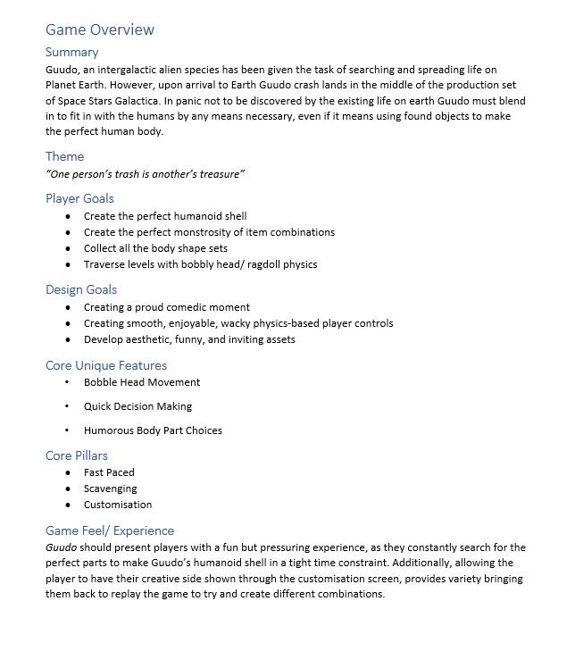

Version 1.2.1
The following sections have been given information:
Core Gameplay
Mechanics
Controls/ Interface
Narrative
Audio Direction
Technical Information
Production Information
Changelog

Version 1.3
The following sections have been given information:
Character Information
Art Direction
Milestones
Added Persona, and Target Market sections to Target Audience

