By Richard Delamore

Proof of Concept
Guudo
Technical Design Document
Omni

Contents
1.0 Revision History 2
2.0 Development Environment 2
2.1 Game Engine 2
2.2 IDE 2
2.3 Source Control Procedures 3
2.4 Third Party Libraries 3
2.5 Other Software 3
3.0 Game Overview 3
3.4 Game Objects and Logic 4
3.5 Technical Goals 5
4.0 Controls 6
5.0 Mechanics 6
5.1 Pickup Functionality 6
5.2 Special Abilities 7
5.3 Inventory 9
5.4 Items 9
6.0 Systems 10
7.0 Graphics 10
8.0 Physics 11
9.0 Game Flow and Interface 12
9.1 Camera 16
10.0 File and Programming Naming Standards 16
11.0 Technical Risks 18
12. Asset List 18

Revision History
Version | Description
1.0 | Initial Document

Development Environment

Game Engine
We are using Unreal Engine 4.23.1.
There were only three possible choices when it came to choose an Engine. These choices were Unity, Unreal and my custom Engine. I decided to use Unreal Engine due to the following reasons:
Shaders
Unreal has an amazing visual shader system that enables artists to take full ownership of the shader system without requiring much input from the programmer. Unity has a strong shader system, but this system is very restrictive and requires a deep understanding of HSL shader code. Our game will be very shader intensive and will need to affect the geometry of our main character, especially as he interacts with his environment.
Particles
Both Unreal and Unity have powerful particle systems, but my experience tells me that Unreal’s particle system is a lot stronger and has a lot more functionality. It is also visually very easy to understand. Again, this enables our artists to take full ownership of the particle system without requiring much input from the programmer.
UI Elements
Unreal’s UI system is a breeze to work with. In essence, it’s a drag-and-drop system with the ability to easily tap into other subsystems without much hassle. I can also easily lock it down so the artists can work on the front end without accidently affecting the underlying logic. Considering that a major part of our game will be the character customizer, I wanted to make this system as logical as possible.
Physics
Unreal’s physics engine is way better than that of Unity’s. Our character will need to have the ability to grow and shrink to access different areas of the map. Their physical form will also need to morph as they interact with their environment. Considering our limited time constraints, I didn’t want to develop a physics system from scratch.

IDE
Visual Studio 2019

Source Control Procedures
Gitkraken with Github (URL: https://github.com/Evildea/Omni)
We will maintain three separate branches:
Master Branch
This will be the production ready branch. Changes will only be merged into this branch when they are production ready.
Development Branch
This will be used exclusively by the programmer to develop new features. When a new feature is ready it will be merged into the master branch.
Artist Branch
This will be used exclusively by the artists. Once they have finished a major update they merge their changes into the master branch.

Third Party Libraries
We aren’t currently using or planning to use third party libraries.

Other Software
The following external software packages will also be used:
- Gitkraken (Source control)
- Maya (3D Modelling)
- Substance Painter (Texturing)
- Substance Designer (Procedural texturing)
- ZBrush (High poly modelling and sculpture)
- Photoshop (Texture editing and concepting)
- Marmoset Toolbag 3.0 (Texture baking)
- Speed Tree (Procedural trees)
- Unreal (Game engine)
- Visual Studio (Programming)
- Microsoft Office Suite (Documentation)

Team Members & Roles
Mitchell Sayer | Richard Delamore | Tiana Knobloch | Joshua Freeman | Daniel Iaria | Nathaniel Dixon
Game Designer | Game Programmer | Character/ UI Artist | Environmental Artist | Prop/ Technical Artist | Prop/ Generalist Artist

Game Overview
  - Genre
At its core, Guudo is a sci-fi, puzzle action game. The player is tasked with navigating a map and collecting specific objects to help them build a human body that fits a specific theme. When picking up objects they need to decide whether to store them (for body creation) or consume them for energy (to try find better objects). This is a fast-paced game as the player needs to race against the clock.
  - Perspective
The entire game operates using a 3rd person camera.
  - Platform
We’re developing for PC because we don’t have access to a Development kit for console. Additionally, this game wouldn’t work well on console and we wouldn’t be able to incorporate the gel features we’re aiming to develop.

Game Objects and Logic
Main game loop
The main game loop has the following class structure.
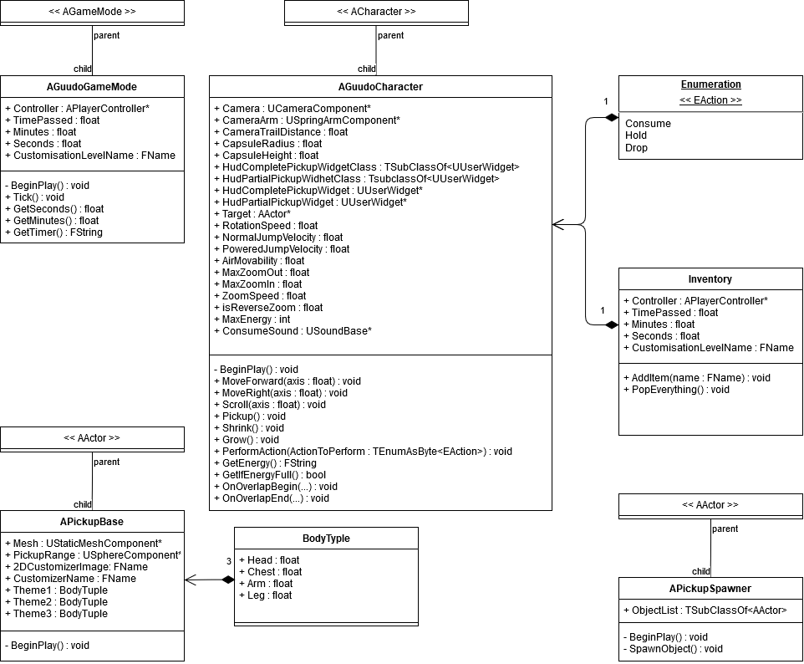

AGuudoGameMode (Guudo Game Mode)
The Guudo Game Mode manages the scene. It has two primary functions:
- It handles the count-down timer and automatically moves the player to the next level when the countdown timer hits zero.
- It directly interfaces with the HUD and handles string formatting for the timer on behalf of the HUD.

APickupBase (Pickup Base)
The Pickup Base is the base object for all pickups in the game. It has a list of components such as a collision sphere and a tag that indicates it is a pickup. Additionally, it contains data structures that tell the customizer what these this object best matches.

AGuudoCharacter (Guudo Character)
The player possesses the Guudo Character when the game first begins. This class is derived from the Character base class provided by Unreal and has been extended to provide additional functionality.

APickupSpawner (Object Spawner)
The Object Spawner is responsible for randomly spawning a Pickup on its location upon level start.
Character Customizer
The character customizer has the following class structure.
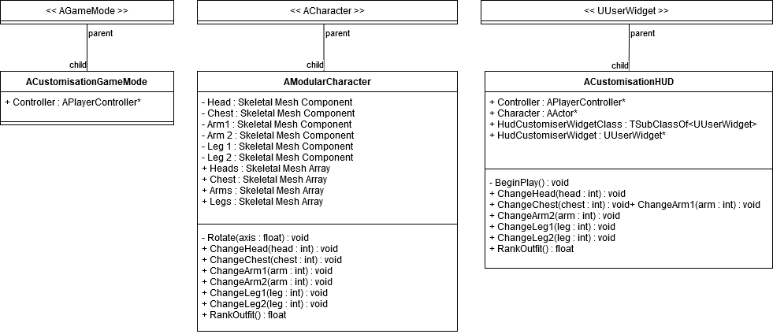

ACustomisationHUD (Guudo Character Customiser)
The customiser is responsible for providing the player with a customisation screen when they are building their character. It is also responsible for ranking the outfit created by the player. This class is derived from the HUD base class provided by Unreal.

AModularCharacter (Guudo Character)
When the player selects an outfit on the CustomisationHUD, this activates different skeletal mesh components of the Modular Character enabling the player to instantly see what their changes have affected.

Technical Goals
The following technical goals have been established:
Gel body
This is probably the biggest technical change. I’ll need to help the artists design a gel / goo-like body for Guudo that can smoothly interact with his / her surroundings. This gel-like body will also need to expand in size and sway backwards and forth as the character picks up more and more objects.
Character customizer
This is the second biggest technical challenge. The character customizer will need to be both intuitive and easy for the designer to update with new models.
Smooth Framerate
A framerate of at least 60fps should be maintained.

Controls
The following key bindings are used to control the movements of Guudo.
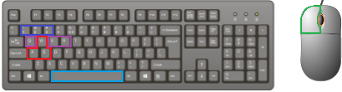
Key Binding | Result
W | Forwards
A | Move left
D | Move right
S | Move backwards
Left mouse button | Interact with object (if within range)
Q | Consume object (if within range)
E | Hold object (if within range)
R | Ignore object (if within range)
Scroll wheel | Zoom in / out
1 | Grow
2 | Shrink
3 | Return to normal
Space | Jump

Mechanics
Besides movement, jump and sprint, the player has the following functionality:

Pickup Functionality
When near an object, the player can choose to pick it up by using the left-mouse button. This will present the player with an interface menu asking them to either consume the object for energy, hold it in their inventory or ignore it. The player’s character movements are then locked until they make a choice.
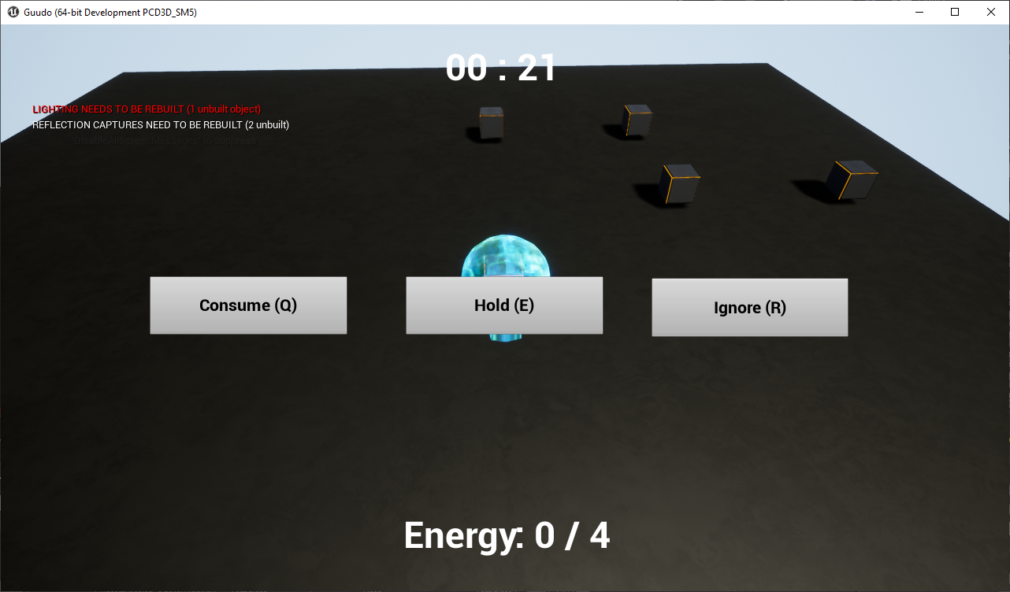

Consuming an Object
Consuming an object will increase the player’s energy points by 1 for a maximum of 4 points. If they already have 4 energy points, then they won’t be able to consume the object.
Holding an Object
Holding an object will place the object in the player’s inventory. These objects only become accessible again at the end of the game when the player needs to use them to build their customized character. Held objects appear as small spheres that orbit inside Guudo’s liquid head. The maximum number of items in the inventory can be modified by the Designer.
Ignoring an Object
Ignoring an object will neither consume it nor store it. This is the same as never having picked up the object in the first place.

Special Abilities
The Player has access to three additional abilities; these are to grow, to shrink and return to normal. To use these abilities, the player needs to use the appropriate keyboard binding as per the Keyboard Bindings mentioned earlier.
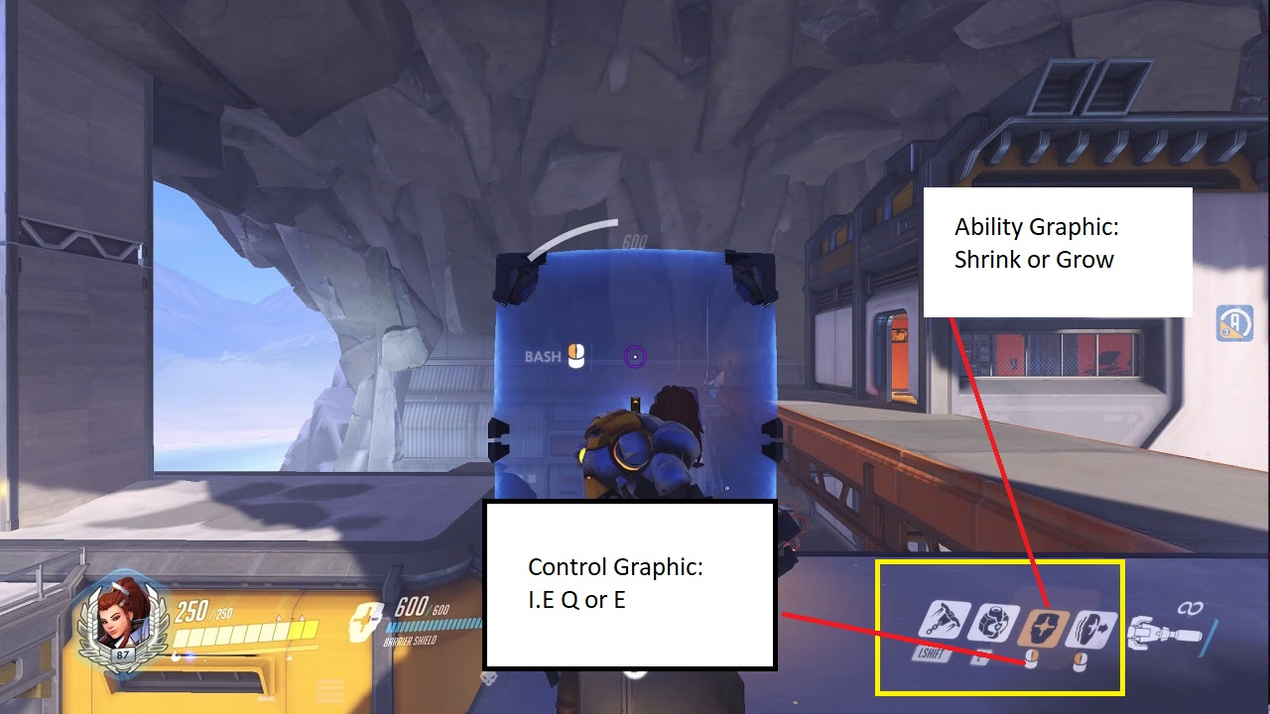
Shrink
This ability costs one energy point. When activated, the player will shrink to half their normal size. They will remain at this size until another ability is activated.
Advantages | Disadvantages
- The player can pass through vents, under objects and inside model houses. | - They player’s speed is reduced by half.  - The player can’t knock over objects.

Grow
This ability costs one energy point. When activated, the player will grow to double their normal size. They will remain at this size until another ability is activated.
Advantages | Disadvantages
- The player can knock over obstacles blocking certain regions of the map. | - The player’s speed is reduced by half.  - The player can’t pass through vents, under objects or inside model houses.

Return to normal
This ability doesn’t cost any energy points. When activated, the player will return to their normal size.
Advantages | Disadvantages
- The player’s speed returns to 100% of their maximum speed. | - The player can’t pass through vents, under objects or inside model houses.  - The player can’t knock over objects.

Inventory
The inventory isn’t accessible to the player during the timed-exploration phase of the game. Once the player pickups the object, it’s added to the inventory stack.
The more items the player collects, the more Guudo begins to sway backwards and forth and the bigger his head becomes. This will affect his forward movement by slightly knocking Guudo off course. The player will need to compensate for this swaying movement. There will also be a visual indicator on the HUD showing the player how many items they have collected.
When passing through a vent, a special animation will play to avoid his large head from clipping through the walls and roof of the vent.
If the player attempts to pick up too many items, Guudo will fall over sideways ejecting everything in his inventory onto the floor. The player will then loose valuable time as they will need to pickup all of these ejected items.

Items
Every item that can be picked up in the game will be a child item of the APickupBase Class. The aesthetic of these objects will generally match one of three themes. What these three themes represent is set by the designer, but an example of three possible themes are human-like, robot-like or food-like. The objective for the player is to try and collect objects that visually match the specified theme.
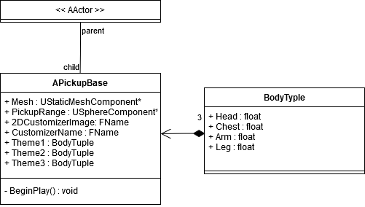
BodyTuple
A custom data type that contains 4 floats. These 4 floats indicate how closely an object matches a specific theme. This is used by the character customizer to rate the quality of your creation. These values are manually set by the Designer.
Variable Name | Data Type | Comment
Head | Float | If the head value is set to ‘0’, then this item can’t be assigned to the head. The higher the value between ‘0’ and ‘1’ the more this item matches the specified theme.
Chest | Float | If the chest value is set to ‘0’, then this item can’t be assigned to the head. The higher the value between ‘0’ and ‘1’ the more this item matches the specified theme.
Arm | Float | If the arm value is set to ‘0’, then this item can’t be assigned to the head. The higher the value between ‘0’ and ‘1’ the more this item matches the specified theme.
Leg | Float | If the leg value is set to ‘0’, then this item can’t be assigned to the head. The higher the value between ‘0’ and ‘1’ the more this item matches the specified theme.

Each item will have the following attributes
Variable Name | Data Type | Use
2DCustomizerImage | FName | The 2D image of the object. This is accessed by the customizer UI so it knows what image to display as a button.
CustomizerName | FName | The unique name of the object. This is accessed by the customizer UI so it knows what model to turn on and off on the skeletal mesh.
Theme1 | BodyTuple | A Tuple that contains that states how closely this object matches to Theme1.
Theme2 | BodyTuple | A Tuple that contains that states how closely this object matches to Theme2.
Theme3 | BodyTuple | A Tuple that contains that states how closely this object matches to Theme3.

Systems
This game uses the following systems:
Random Object Spawner
The random object spawner will spawn an object on its location. The type of object it spawns will be randomly chosen based on an array of possible objects provided to the spawner by the designer.
Character Customisation Ranker
The character customisation ranker will rank the players outfit based on how closely their outfit matches the specified theme of the level. To calculate the ranking, the customiser will average out the values stored in the BodyTuple structures for each pickup. A higher average value will result in a higher score. The specific score required to pass the level will be set by the Designer.

Graphics
Our game will primarily be from the 3rd person perspective. The models, graphics, and textures will generally have a simplistic but over-the-top vibe. The character model will have a strong silhouette with large stylized eyes and a gelatinous body.
Outline Post Processing
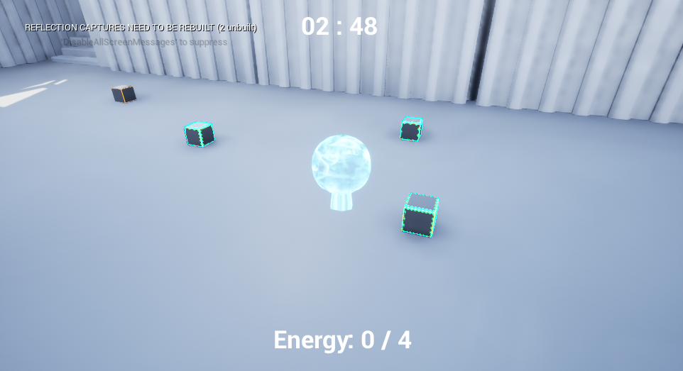
An outline effect will be applied to pickups when they are within a specific radius to help the Player identify pickups from other static models laying around the map. We've decided to include an outline shader because this is a very fast-moving game and we want players to be able to easily identify pickups even at a distance.
Foliage Shader
This shader is used to create the movement of grass as well as create a subsurface scattering of light as it passes through leaves. We've decided to include a Foliage shader because foliage will be used to hide the seams within the map and to also create an environment that is alive.
Goo Shader
This shader will give Guudo a liquid/gel-like appearance the sways, moves, and deforms as the Player traverses the level. This is required because the main character is an alien who has an outer shell of goo. This goo won't look natural if it's completely static, the goo shader will make it look more real.
Volumetric height Fog
This will be used to create light shafts which will create a depth to the level. Without the fog effect, the levels would lack depth and would appear quite bland.

Physics
We will use the built-in physics engine provided by Unreal Engine, however, we will manipulate the physics in the following scenarios:
Shrink
If the Player is using the shrink ability, physics will be turned off for barrier objects. This way Players won’t be able to push over boxes that are blocking doors or other locations.
Grow
If the Player is using the grow ability, physics will be turned on for barrier objects. This way Players can push over boxes that are blockading doors or other locations.
Body Morphing
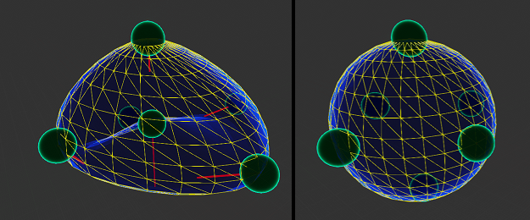
Guudo’s body will be able to slightly morph and change shape as he traverses his / her environment. This morphing will be performed by placing springs nodes around his body that react to things they hit. The Word Position Offset material node will then be applied to the model to stretch the model to fit the morphing created by these nodes. Please see the above picture to visually understand how this works.

Game Flow and Interface
The basic game flow of the entire game is Load level → Traverse Environment → Collect Items → Proceed to Character Customiser → Repeat
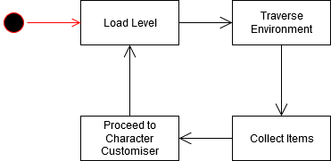
Below I’ve detailed the different stages a player will pass through when playing the game:

Main Menu
When the Player first starts the game, they’ll be presented with three options. If they choose Start Game they’ll instantly move to the Game Start Cinematic
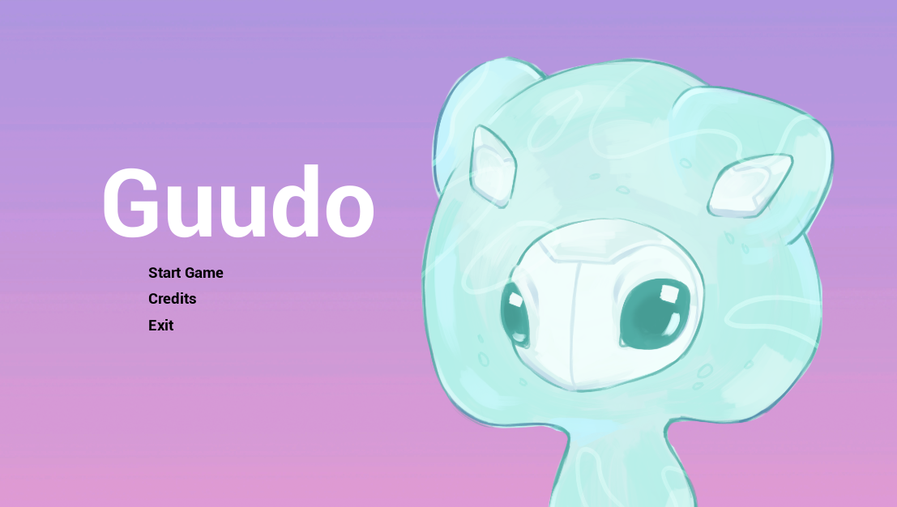
Game Start Cinematic
The Game Start Cinematic will introduce the player to the game backstory. Essentially, you are an alien whose spaceship has crashed on to a film set. The monitor inside your spaceship is faulty and presents you with a picture of a human (which is incorrect).
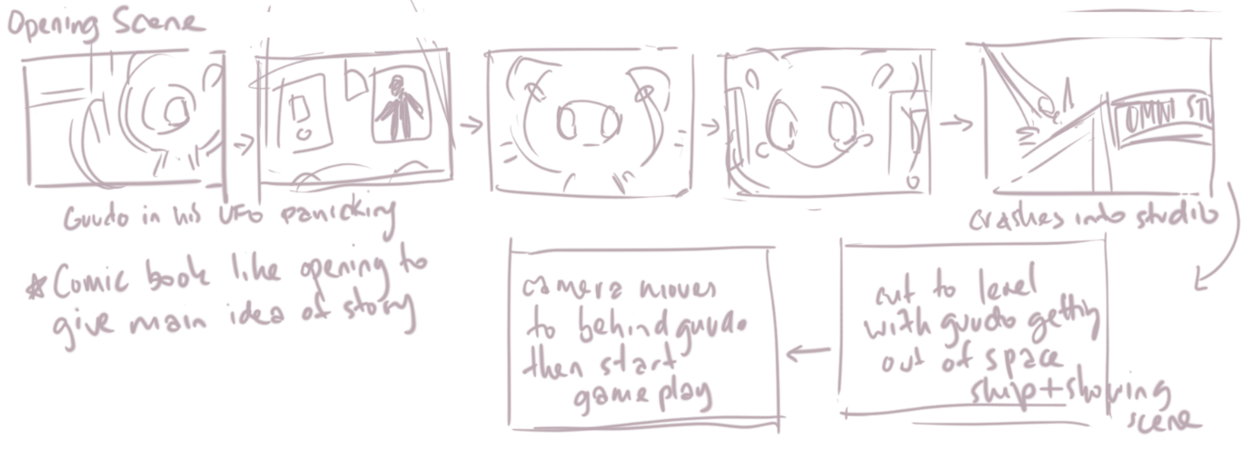

Level
The first thing the Player hears when the level loads is a voice calling over a loud speaker saying, “Filming starts in 3 minutes. Make sure you’re dressed in your [….] theme and be ready for filming!”.
This tells the player what theme they need to match and how long they have to collect items. Essentially, this and the monitor image sets the theme objective for the player.
When the timer hits “00 : 00”, a movie clapper will signal a change of scene to the Character Customisation Screen.
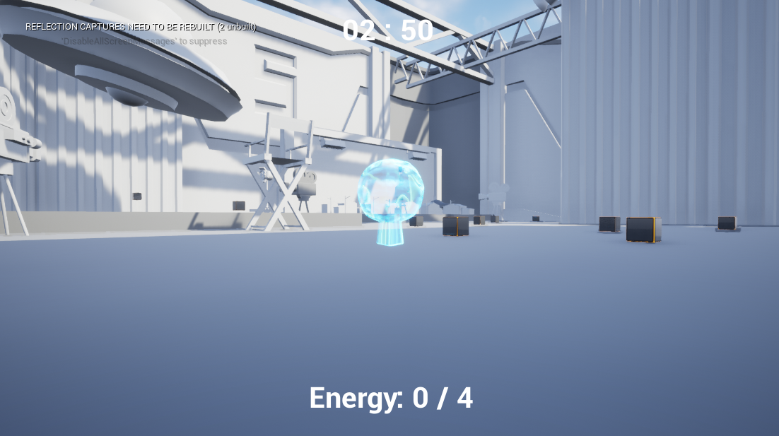

The Character Customisation Screen
In the Character Customisation Screen, the Player can rotate the Guudo Character around to view him / her from different angles. They can also take snapshots and save them to their computer.
On the right-hand side of the screen there will be a menu that the player can open.
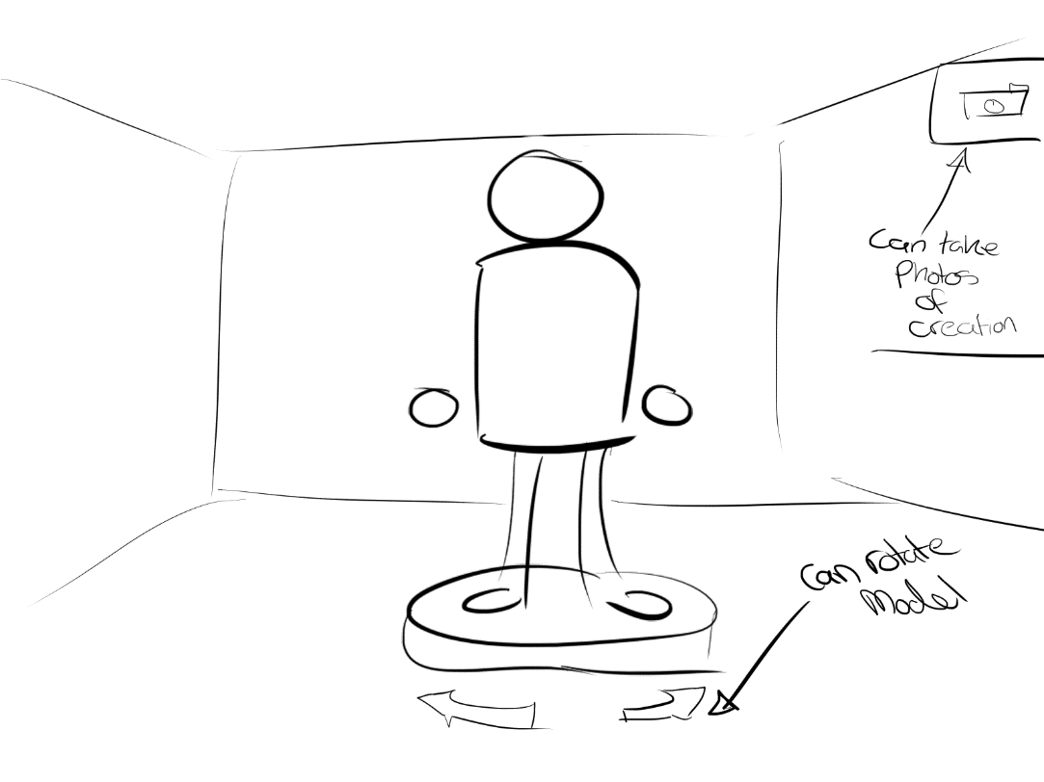
When the menu opens, the Player can choose which body parts they want to swap in / out from the items they have collected. When finished, the Player can then select, “Let’s Go!”
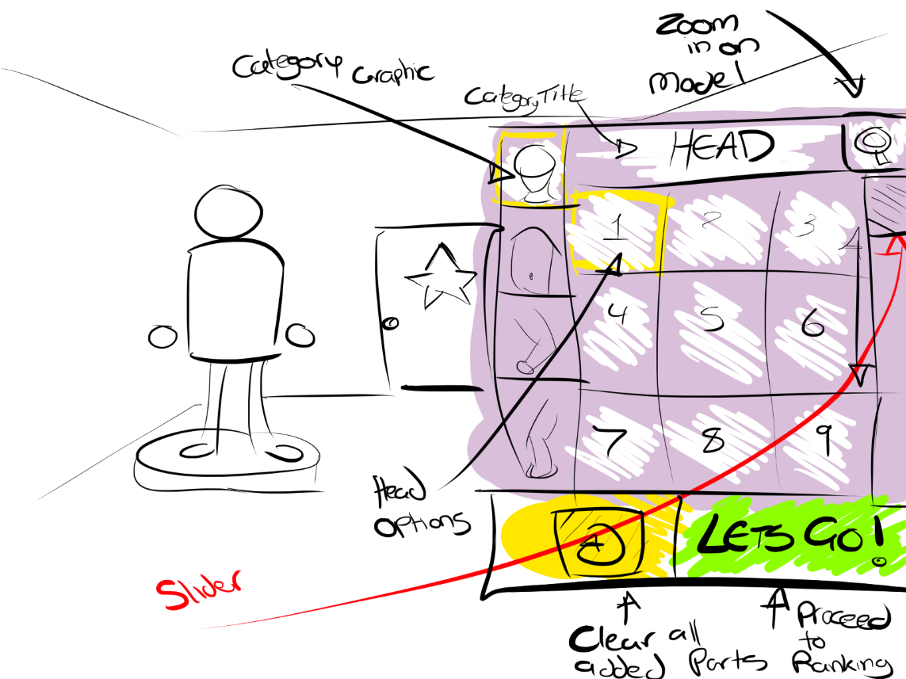

When the Player selects “Let’s Go”, a short cinematic will start playing which shows Guudo in his / her full glory.
The rating system will then take over. If the Player receives a high enough ranking, they’ll be permitted to continue to the next level. If they don’t get a high enough ranking, they’ll only be permitted to repeat the level or return to the main menu.
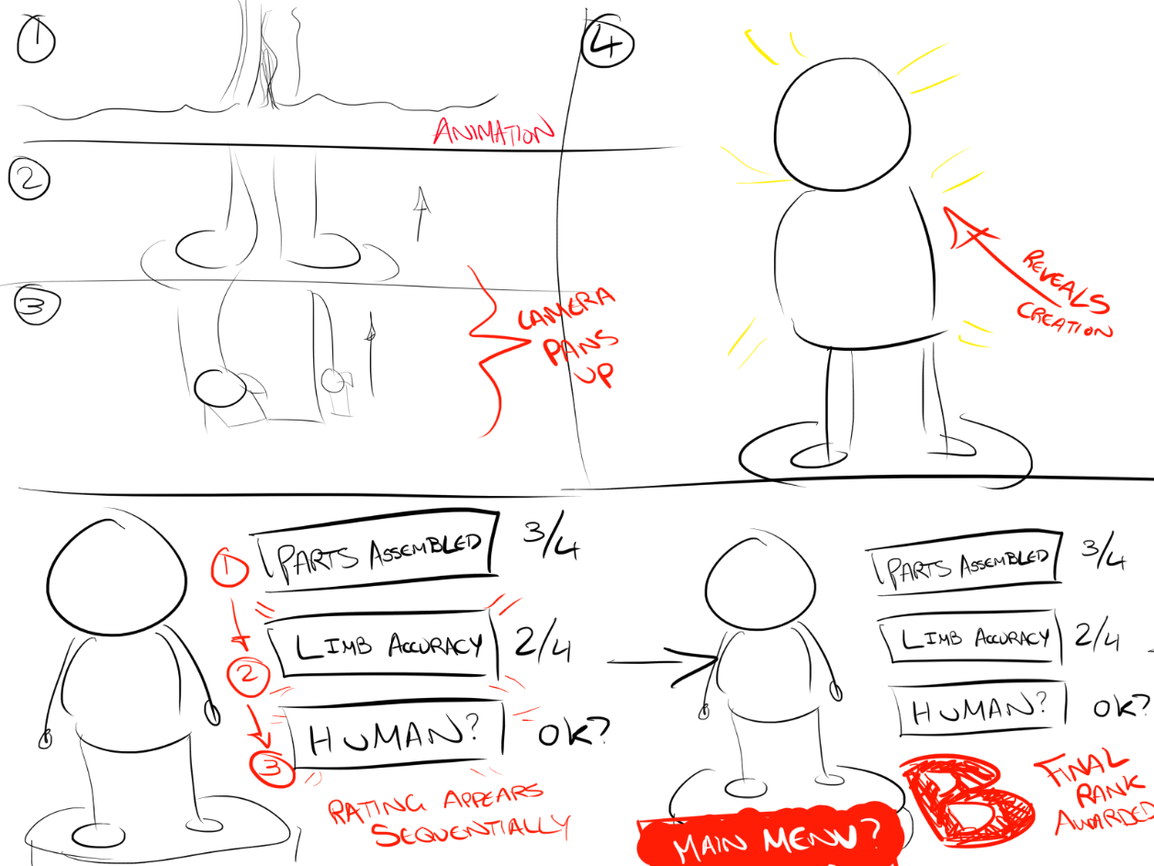

Camera
The camera is locked behind the player in a 3rd person perspective. The Player can zoom the camera in / out by using the Scroll Wheel.

File and Programming Naming Standards
The folder structure will be as follows:
Assets
- Material
- Skeleton Mesh
- Mesh
- Silhouettes
Blueprints
HUD
- Main Menu
- Character Customizer
- In-game HUD
Levels
- Level Templates
- Animation Templates
- Tech Art Templates
Manager
Sound
- Music
- Effects

C++ Classes Folder
- Silhouette
- Inventory

Private variables will be prefixed with ‘m_’
Public variables won’t include any prefix because these are directly visible in the Unreal Editor.
Enumerators will be prefixed with 'E' because this is a requirement set by Unreal.
Structs will be prefixed with 'F' because this is a requirement set by Unreal.
Actor will be prefixed with 'A' because this is a requirement set by Unreal.
An example of a code snippet:
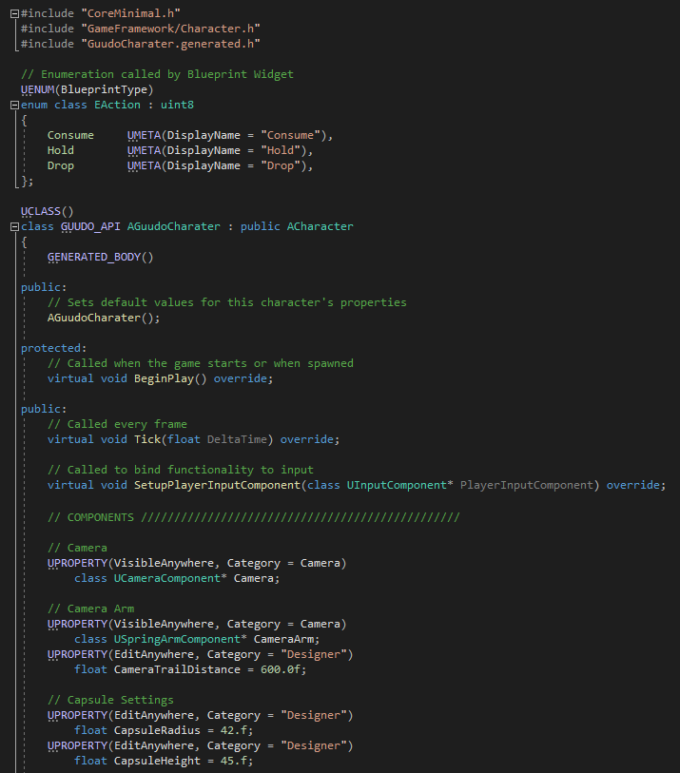

Technical Risks
Time constraints
This one of the biggest concerns as we are working under a tight schedule. To mitigate this issue, I’ll focus on programming the absolute necessary components first such as the inventory system and the customisation screen.
Source Control
One of the main issues we have faced so far is source control. Twice I’ve lost considerable time due to people using source control incorrectly. The only way to mitigate this issue is to train team members in how to correctly use source control.
Rating System
The rating system, which is part of the character customisation screen and pickups, is probably one of the most complex systems in the game to develop. This system is crucial to the success of the game, so I’ll need to focus my efforts on ensuring I finish it first to test whether it works as intended. Currently, I’m planning to give every pick up a data type could, BodyTuples that the Designer can assign weights to. These weights will each affect the overall rating the player can get. The biggest potential problem I can see with this system, is that it might result in unexpected results. The only way we can be sure that it works correctly is to program it.
Gel Body
This is the second biggest potential headache. I’ve watched tutorials on gel systems and Unreal, but I haven’t yet successfully programmed one. In the worst-case scenario, we will fall back to hand animating some of the gel-like movements.

12. Asset List

File Name | File Type | Description of use
SK_Guudo.fbx | Model | Main Character
SK_GuudoCust.fbx | Model | Customiser Character
Anim_Idle.fbx | Model | Animation
Anim_Walk.fbx | Model | Animation
Anim_JumpStart.fbx | Model | Animation
Anim_JumpLoop.fbx | Model | Animation
Anim_JumpEnd.fbx | Model | Animation
Anim_Pickup.fbx | Model | Animation
Anim_Sprint.fbx | Model | Animation
Anim_HjumpStart.fbx | Model | Animation
Anim_HjumpEnd.fbx | Model | Animation
SM_Relic.fbx | Model | Prop / Pickup
UI_Background.png | UI
UI_BGdeco.png | UI
UI_Button.png | UI
UI_Title.png | UI
FT_Guudo.TTF | Texture
UI_Energy.png | UI
UI_Timer.png | UI
Customisation Screen | UI
Menu Screen | UI
Loading Screen | UI
Credit Screen | UI
In Game UI | UI
Opening Cinematic | Animation
SM_ScifiWall.fbx | Model | Set dressing
SM_ScifiWall_Corner .fbx | Model | Set dressing
SM_ScifiWall_Long .fbx | Model | Set dressing
SM_ScifiWall_5.fbx | Model | Set dressing
SM_Stage.fbx | Model | Set dressing
SM_Scifi_Door.fbx | Model | Set dressing
SM_Soundbooth.fbx | Model | Set dressing
SM_Vent.fbx | Model | Set dressing
SM_VentCorner.fbx | Model | Set dressing
SM_WallShelf.fbx | Model | Set dressing
SM_StairCase.fbx | Model | Set dressing
SM_Rubble.fbx | Model | Set dressing
SM_SoundproofingWall.fbx | Model | Set dressing
SM_Column.fbx | Model | Set dressing
SM_BreakRoomWall.fbx | Model | Set dressing
SM_JungleTree.fbx | Model | Foliage
SM_Fern.fbx | Model | Foliage
SM_CrystalTree.fbx | Model | Foliage
SM_AlienFern.fbx | Model | Foliage
SM_MushroomGrp .fbx | Model | Foliage
SM_AlienGrassClump.fbx | Model | Foliage
SM_GroundCloveGrp.fbx | Model | Foliage
SM_Vines.fbx | Model | Foliage
SM_Shrub.fbx | Model | Foliage
SM_PalmTree.fbx | Model | Foliage
SM_Coconut.fbx | Model | Prop / Pickup
A_FoliageAtlas.tga | Texture
N_FoliageAtlas.tga | Texture
ORM_FoliageAtlas.tga | Texture
SM_GuudoUFO.fbx | Model | Set dressing
SM_SetUFO.fbx | Model | Set dressing
SM_TV.fbx | Model | Prop / Pickup
SM_HangLights.fbx | Model | Prop / Pickup
SM_Scaffold.fbx | Model | Prop / Pickup
SM_RoundTable.fbx | Model | Prop / Pickup
SM_Desk.fbx | Model | Prop / Pickup
SM_DirectorChair.fbx | Model | Prop / Pickup
SM_MiniSetBG.fbx | Model | Prop / Pickup
SM_MiniHouse.fbx | Model | Prop / Pickup
SM_MiniLightPole.fbx | Model | Prop / Pickup
SM_MiniStreet.fbx | Model | Prop / Pickup
SM_ClipBoard.fbx | Model | Prop / Pickup
SM_Monitor.fbx | Model | Prop / Pickup
SM_BoatTank.fbx | Model | Prop / Pickup
SM_Computer.fbx | Model | Prop / Pickup
SM_Book.fbx (x3) | Model | Prop / Pickup
SM_Pen.fbx (x3) | Model | Prop / Pickup
SM_Mouse.fbx | Model | Prop / Pickup
SM_Keyboard.fbx | Model | Prop / Pickup
SM_Stereo.fbx | Model | Prop / Pickup
SM_Fan.fbx | Model | Prop / Pickup
SM_BoatModel.fbx | Model | Prop / Pickup
M_Sand | Material
P_Guudo | Material
M_Guudo | Material
M_Master | Material
BP_GuudoFootPrint | Material
M_PickupOutline | Material
M_Water | Material
M_JungleGround | Material
SM_Camera.fbx | Model | Prop / Pickup
SM_LightStand.fbx | Model | Prop / Pickup
SM_BoomMic.fbx | Model | Prop / Pickup
SM_GreenScreen.fbx | Model | Set dressing
SM_CameraDolly.fbx | Model | Set dressing
SM_FoodTable.fbx | Model | Prop / Pickup
SM_WorkChair.fbx | Model | Prop / Pickup
SM_MiniBuilding01.fbx | Model | Set dressing
SM_MiniBuilding02.fbx | Model | Set dressing
SM_Sandwich.fbx | Model | Prop / Pickup
SM_Bowl.fbx | Model | Prop / Pickup
SM_Plate.fbx | Model | Prop / Pickup
SM_Cup.fbx | Model | Prop / Pickup
SM_Bagette.fbx | Model | Prop / Pickup
SM_FruitBowl.fbx | Model | Prop / Pickup
SM_JuiceJug.fbx | Model | Prop / Pickup
SM_Pretzel.fbx | Model | Prop / Pickup
SM_CanteenChair.fbx | Model | Prop / Pickup
SM_Box01.fbx | Model | Prop / Pickup
SM_Box02.fbx | Model | Prop / Pickup
SM_Keg.fbx | Model | Prop / Pickup
SM_RuinsRock01.fbx | Model | Set dressing
SM_RuinsRock02.fbx | Model | Set dressing
SM_RuinsPlinth.fbx | Model | Set dressing
SM_Dock.fbx | Model | Set dressing
SM_PirateLeg.fbx | Model | Set dressing
SM_PirateSword.fbx | Model | Prop / Pickup
SM_GreenScrnStage.fbx | Model | Set dressing

