Omni
Version 1.1
Last Edited by Mitchell Sayer
Game concepts
Concepts Document


Brainstorming Concepts

- Echolocation with deaf protagonist
- Evolution with dinosaurs from raptor to greater
- Education-Language based game
- Robo Arena- Robot custom design fighter
- Prehistoric Spiderman- Caveman supernatural powers fighting ancient animals
- Child in Forest-Explores echolocation with environmental telling, glow mushrooms
- Day Dreamer- Chasing dreams transforming to different creatures. Explores character
- Tiny Vehicles- Tiny vehicles in junkyard grabbing scrap parts to fight bigger cars
- Robo Wars- 1V1 Robot arena
- Portal Shooting Range – Placing portals and shooting targets
- 2V1 Fighter- Arena fighter with one overwatch agent and one on field agent against monster
- Boss Fighter- fighting as a boss against other human players
- Arms and Legs – using torso and legs to navigate puzzle environment
- Alien Hand- player is a hand traversing levels picking up found objects to make human body
- Ghost Hunter- ghost hunters hunt real player ghosts

Triangulating Concepts
- 2V1 Fighter- M Rated
THEME: Communication is what makes a team strong
PILLARS: Evasion | Strategy | Communication
The USSR special squadrons have sent out a recovery team to search and retrieve sensitive intel that could expose their country’s security if landed in the wrong hands. However, a variety of MIA cases have occurred in this area and requires a hands-on team to take extra caution in the extraction of this mission.

- Alien Hand- G Rated
THEME: One man’s trash is another’s treasure
PILLARS: Fashion | Scavenging | Fast-Paced
Mother Phalanges has sent you from Planet Cuticle to evolve on a new planet and integrate with the existing lifeform. Upon arrival to Earth, you have been given a brief shape to what the lifeforms look like and have taken what you have found to fit into the crowd. Passing by a local fashionista, they have enlisted you to their annual fashion runway, where the best dressed wins the competition.

- Ghost Hunter- G Rated
THEME: You must see it to believe it
PILLARS: Party| Ghosts| Sanity
A team of Ghost Hunters have recently been put under the spotlight to present images of extra-terrestrial life they have claimed to have found. If they do not come back with evidence, they will be kicked out of the Ghost Hunting committee. The Ghosts do not want anything to do with the outside world and will do anything to keep the humans out at any cost
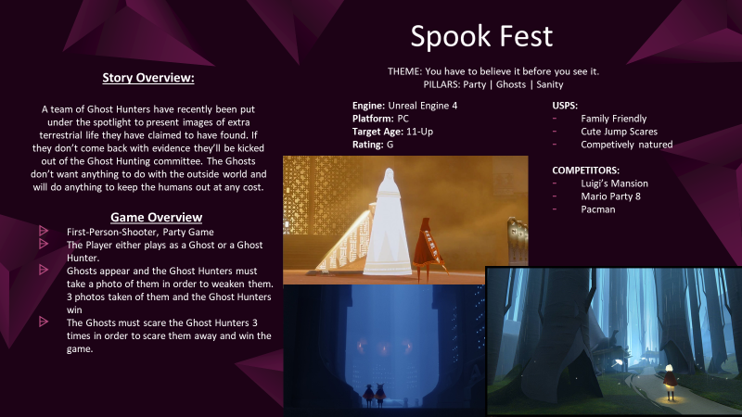
Omni Presentation: Slide 1- Ghost Hunter

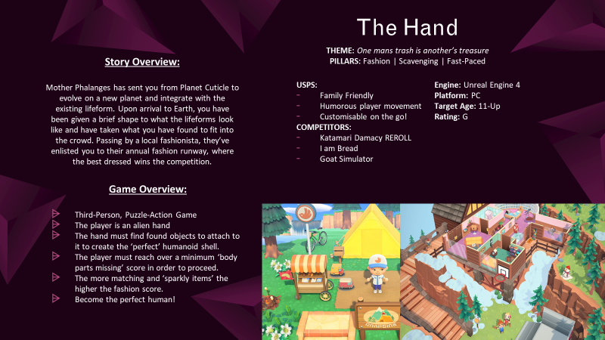
Omni Presentation: Slide 2 – Alien Hand

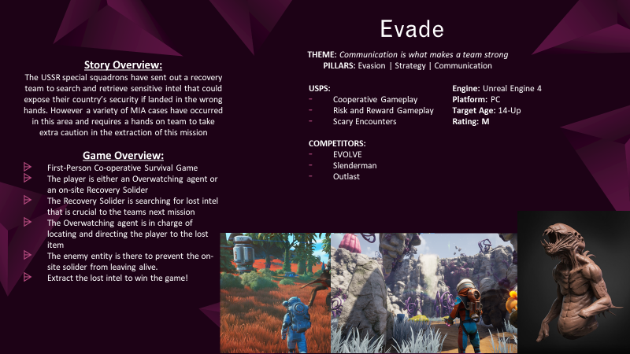
Omni Presentation: Slide 3 – 2v1 Fighter

Pitch Feedback
Person | Feedback
Jesse Donlevy | - Hand Concept is doable as there’s room to add more art assets and levels and the replayablity is high  - The Ghost game the same as well its safe, and different levels add complexity/ variety to gameplay.
Neil Boyd | - The Hand game I see as being a fun game to run around with the ragdoll movement of the hand physics, you need to make sure there is a clear line of sequencing for the body building part.  - The Ghosts I’m confused about the jump scares for a kid’s game, it doesn’t really sit well with that target audience, if it were a mature audience it could work but not for a kid’s game. That would need to be focused and designed to work around that limitation.
Alexandra Mannel | - Love the idea of the ghost game it sounds fun with the aspect of going around scaring people as ghosts. Would it be better if you were looking through the camera as you move?  - 3rd game not really a fan
Paco Casares | - Ghost game with the multiplayer is a good unique selling point however the setup of multiplayer can take time depending on experience making it. Taking into consideration games like Project Zero could be good as reference.
Myles Blasonato | - Love the hand idea as well it kind of reminds me of Katamari with the whole evolving size aspect, with the items impacting the player.  - The arena fighter is a lot to consider technically and from a designer perspective it would only be a slice of gameplay  - With the ghost idea the theme needs to be fixed as it doesn’t make sense with the pillars in place.

