Mitchell Sayer
Version 2.0
Last Edited by Mitchell Sayer
10/08/20
Guudo
Game Design Document

Table of Contents
Game Overview 3
Summary 3
Theme 3
Player Goals 3
Design Goals 3
Core Unique Features 3
Core Pillars 3
Game Feel/ Experience 3
Target Audience 4
Demographics 4
Age 4
Skill 4
Gender 4
Time 4
Monetisation 4
Feature Appropriate 4
Mechanical Understanding 4
Target Market 9
Competitors 9
Market Trends 10
Audience Characteristics 10
Core Gameplay 11
Core Loops 11
Core Gameplay Loop 11
Feedback Loop: Consuming or Collecting 11
Feedback Loop: Energy 12
Feedback Loop: Timer 13
Mechanics 14
Controls/ Interface 15
Controls 15
Economy 16
Economy Based Features 16
Energy 16
Item Collection 16
Scoring 16
Narrative 17
Context of Gameplay 17
Story 17
Character Information 17
Plot Synopsis 17
Gameplay Synopsis 18
Art Direction 19
Art Style 19
Visual References 19
Audio Direction 21
Music 21
Sound Effects 21
Technical Information 22
Target Platform 22
Engine 22
Limitations 22
Platform Specifications 22
Production Information 24
Production Software 24
Game Engine 24
Programming 24
Art Software 24
Audio Design 24
Milestones 25
Alpha 25
Beta 25
Gold 25
Archive 26
Version History 27
Change Log 27
Version 1.0 27
Version 1.1 27
Version 1.2.0 27
Version 1.2.1 29
Version 1.3 29
Version 1.4 29

The Team

Mitchell Sayer | Richard Delamore | Tiana Knobloch | Joshua Freeman | Daniel Iaria | Nathaniel Dixon
Game Designer | Game Programmer | Character Artist,  Animator,  UI Artist | Environmental Artist, Foliage Artist | Technical Artist, 3D Modeller | Generalist Artist

Game Overview

Summary
Guudo, an intergalactic alien species has been given the task of searching and spreading life on Planet Earth. However, upon arrival to Earth Guudo crash lands in the middle of the production set of Space Stars Galactica. In panic not to be discovered by the existing life on earth Guudo must blend in to fit in with the humans by any means necessary, even if it means using found objects to make the perfect human body… or so it hopes.

Theme
“One person’s trash is another’s treasure”

Player Goals
- Create the perfect humanoid shell
- Create the perfect monstrosity of item combinations
- Collect all the body shape sets
- Traverse levels with bobbly head/ ragdoll physics

Design Goals
- Creating a proud comedic moment
- Creating smooth, enjoyable, wacky physics-based player controls
- Develop aesthetic, funny, and inviting assets

Core Unique Features
- Top-Heavy Movement
- Quick Decision Making
- Humorous Body Part Choices

Core Pillars
- Fast Paced Gameplay
- Scavenging
- Customisation

Game Feel/ Experience
Guudo should present players with a fun but pressuring experience, as they constantly search for the perfect parts to make Guudo’s humanoid shell in a tight time constraint. Additionally, allowing the player to have their creative side shown through the customisation screen, provides variety bringing them back to replay the game to try and create different combinations.

Target Audience

Demographics

Age
Guudo is to be a family friendly game that attracts an audience, objectively, from 11 years old and older.

Skill
The game is to be skilled for those who have a base knowledge of puzzle-platformer titles. I.E Katamari Damacy, 60 Seconds, I am Bread.

Gender
This title should not be biased towards one gender but both, as the both the gender and gameplay element are neutral regarding player abilities.

Time
The subjected player base should be those that have disposable free time, or those who are looking for a quick entertaining experience.

Monetisation
As for early release purposes, the game should be distributed via the Steam/ Epic Store, prioritising the Epic Store due to its developer cut differences, (12% - Epic VS 30%- Steam). We would be selling the product for $7 on the market. To attract both those in dependant and independent financial states.

Feature Appropriate
Guudo should allow the player to feel welcome to the idea of being able to eat anything, to then become what they eat. It should be light hearted and comedic, where once the player has customised what they will look like, their creation will be showcased and will emphasise their efforts to make the best-looking model or the best-looking monstrosity.

Mechanical Understanding
The player should have a basic understanding of PC gaming with both keyboard and mouse controls, utilising the game’s full potential. In future development when porting to new platforms where this will introduce controller support making it easier for those who are comfortable with console gaming.

Interview Questions
- Do you like the idea of hoarding?
- What do you personally do under time pressure, do you have a personality tick dealing with it?
- Do you consider what you like wearing on a regular basis?
- If Aliens were to invade earth, what would they look like?
- Do you think Aliens can blend in with humans?

Interview Answers
 | Do you like the idea of hoarding? | What do you do under time pressure, do you have a personality tick dealing with it? | Do you consider what you like wearing on a regular basis? | If Aliens were to invade earth, what would they look like? | Do you think Aliens can blend in with humans?
Person A | Yes hoarding items in games is usually a fun mechanic, and i enjoy games where you collect as much stuff as possible, it gets addicting. | Usually i panic and jump in my seat upwards to focus more aha | yes, i find it something i always consider. i make sure it all matches and has a common theme, and flows. | They would look different to the stereotypical one i imagine. They would probably be completely different to us, and have a unique body set to cope with an alien world | yes, if given time and the right technology. (maybe they already are.....)
Person B | No | Under time pressure i tend to fidget more (finger tapping, leg shaking), | No | Aliens would probably look like typical 80s Martians, skinny body, larger head, big eyes, glossy skin | Definitely
Person C | I don't really like hoarding; however, I tend to do it a lot. | I laser focus on one specific issue and solve that issue. I try to block out everything else in the process. | No really, I usually just put on whatever clothes are clean. However, if I need to dress for a specific occasion then I will consider what I'm wearing. | They probably wouldn't be carbon-based in nature. The fact that you've asked about invasion signifies that they have intent. This means they have come to our planet for some specific reason. I imagine it would be a similar situation to that of the first British ships landing in Australia. They would technologically outperform us in everyday and wouldn't consider us a threat. They would probably ignore us and accidentally kill us in the process. So, they'd probably look like whatever planet they came from. They could be giant squids for all we know. | No, and they wouldn't bother.
Person D | It really depends on what you're hoarding, if it's things one likes then sure. | I mainly stress but I find I get a lot more done in the heat of the moment, usually when I'm like that I don't like too much interaction because I don't want any disruption to me in the zone. | Yeah, I'm very conscious of what I'm wearing and what outfits to put on at all times, like what looks good and what fits together with my body type, a lot of that. | I feel like they'd be something very symbiotic. | I don't think they'd be able to, they'd blend more towards plant life or sea life in my eyes.

Affinity Map
Hoarding | Time Pressure | Fashion | Alien
Yes, hoarding items in games is usually a fun mechanic, and I enjoy games where you collect as much stuff as possible, it gets addicting. | Usually i panic and jump in my seat upwards to focus more aha | yes, i find it something i always consider. i make sure it all matches and has a common theme, and flows. | yes, if given time and the right technology. (maybe they already are....)
No | Under time pressure i tend to fidget more (finger tapping, leg shaking), | No | Definitely
I don't really like hoarding; however, I tend to do it a lot. | I laser focus on one specific issue and solve that issue. I try to block out everything else in the process. | No really, I usually just put on whatever clothes are clean. However, if I need to dress for a specific occasion then I will consider what I'm wearing. | No, and they wouldn't bother.
It really depends on what you're hoarding, if it's things one likes then sure. | I mainly stress but I find I get a lot more done in the heat of the moment, usually when I'm like that I don't like too much interaction because I don't want any disruption to me in the zone. | Yeah, I'm very conscious of what I'm wearing and what outfits to put on always, like what looks good and what fits together with my body type, a lot of that. | I don't think they'd be able to, they'd blend more towards plant life or sea life in my eyes.
 |  |  | They would look different to the stereotypical one I imagine. They would probably be completely different to us, and have a unique body set to cope with an alien world
 |  |  | Aliens would probably look like typical 80s Martians, skinny body, larger head, big eyes, glossy skin
 |  |  | They probably wouldn't be carbon-based in nature. The fact that you've asked about invasion signifies that they have intent. This means they have come to our planet for some specific reason. I imagine it would be a similar situation to that of the first British ships landing in Australia. They would technologically outperform us in everyday and wouldn't consider us a threat. They would probably ignore us and accidentally kill us in the process. So, they'd probably look like whatever planet they came from. They could be giant squids for all we know.
 |  |  | I feel like they'd be something very symbiotic.

Persona
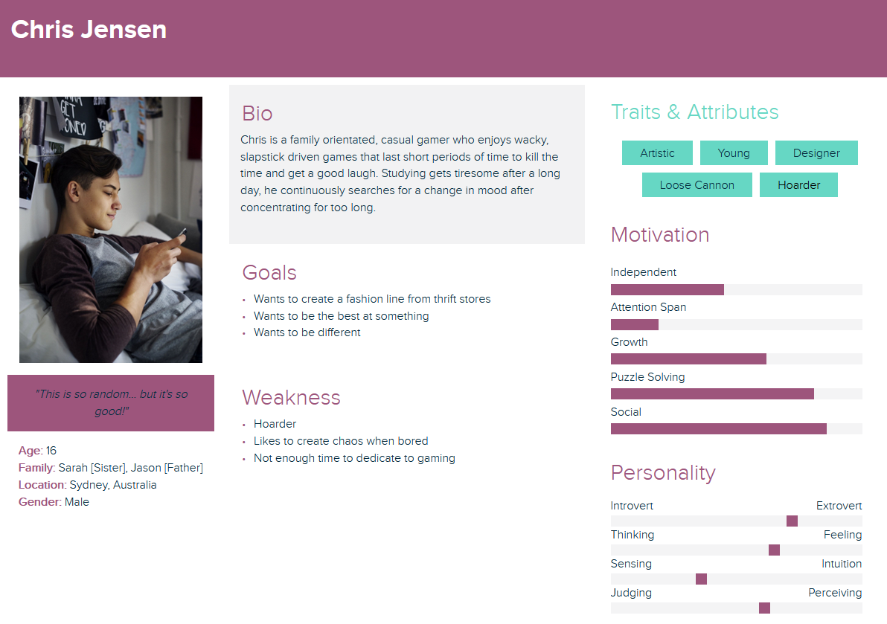

Target Market

Competitors
Game | Strengths | Weaknesses
Katamari Damacy REROLLED | - Simple game loop  - Colourful  - Attracts all ages  - Provides comedic emphasis on characters | - Can become monotonous  - Repetitive gameplay  - Little to no variety (only change of scene environment)
Goat Simulator | - Sandbox freedom  - Lots of variety in activities  - Funny & Wacky physics  - Memorable  - Lots of things to discover and reveal | - No direction  - Easy to lose interest after short gameplay experience  - Too many choices cause confusion  - Points are meaningless
I Am Bread | - Simple game loop  - Simple concept to grasp  - Controls are easy to adapt to | - High Difficulty curve  - Long gameplay sessions can lead to rage quitting, hence no drive to complete game to entirety  - Ranking system serves no purpose

Market Trends
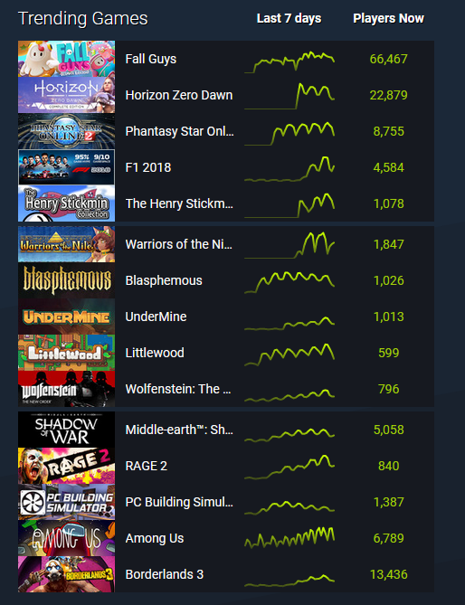
10/08/20 SteamDB Trending Games
As of right now the most popular genre in trending is Action & Adventure where story/ co-op gameplay is a popular trend across the games marketplace.

Project Feasibility
With the market favouring Action/ Adventure games, advertising Guudo on the current market would be an appropriate decision as Guudo identifies as an action-puzzle title introducing a new sense of ‘Action’ to the markets choice. With no puzzle games trending at the moment that may be the only downfall Guudo could have to attract a new audience however introducing a new option than an action-adventure title could be a positive influence on the project’s overall feasibility.

Audience Characteristics
The target audience should have the following characteristics:
- Family Orientated
- Interest in Casual gaming
- Interest in wacky physic-based gameplay
- Has disposable time to dedicate to playing games.

Core Gameplay

Core Loops

Core Gameplay Loop
The core gameplay loop consists of the following routine.
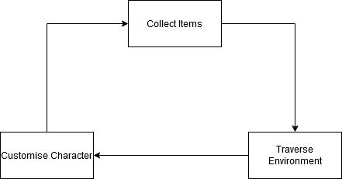
Start
Player is given silhouette

Feedback Loop: Consuming or Collecting
The consuming or collecting feedback loop consists of a quick decision-making process against the clock. The loop consists of the following:
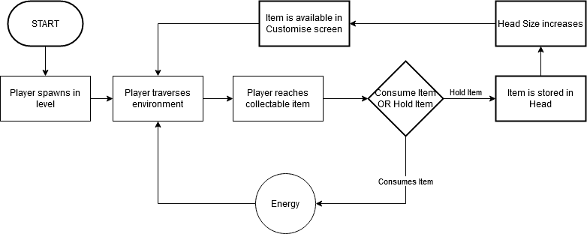
Player is given silhouette

Feedback Loop: Energy
The following loop consists of the process of constantly checking for whether the player has energy or not, and whether they have used an ability or not

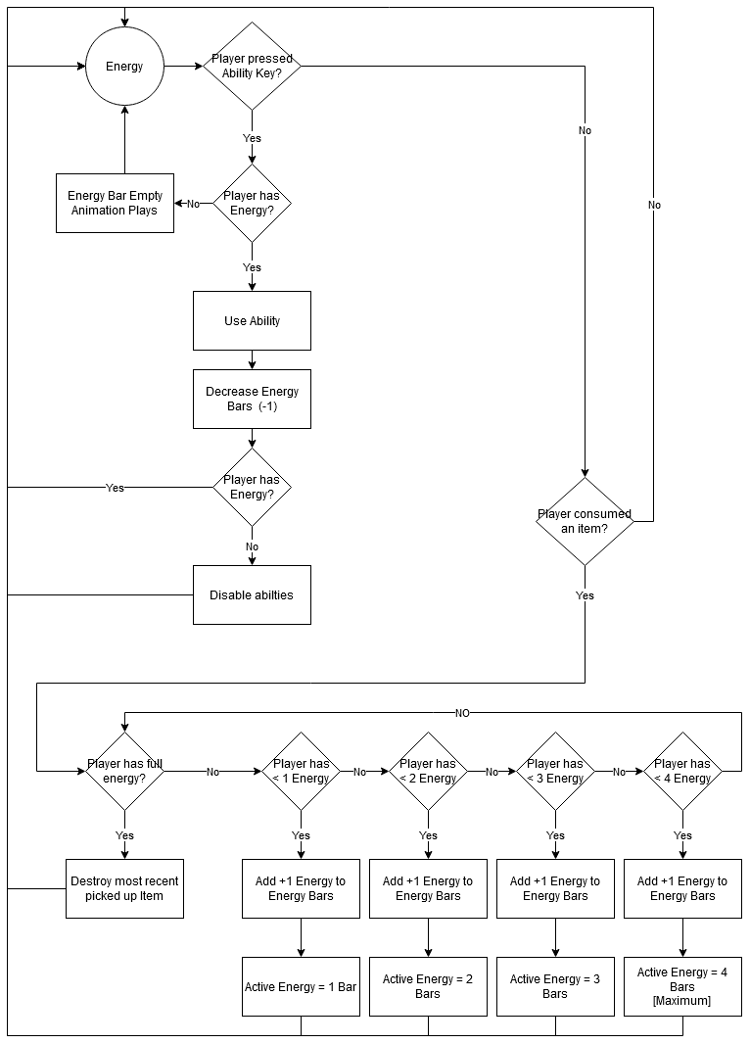

Feedback Loop: Timer
The timer will continue to count down from the set time from when the player begins the initial gameplay.

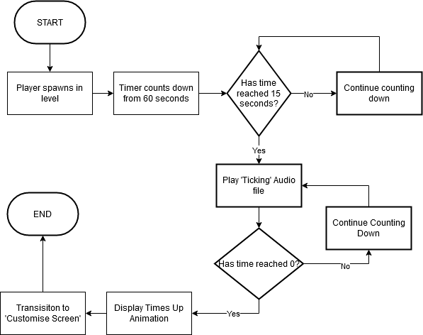

Mechanics

Player Movement
  - The player can move in 360-degree angled movement using the WASD keys.

Shrink
  - The player will scale down to a smaller size reaching unreachable places that would normally be an obstacle for them.

Grow
  - The player will increase the players size allowing the player to knock over big objects allowing to access items that could normally never be reached.

Eat
  - The player can eat an edible object to either use as energy, or as a customisable object in the customisation scene.
  - If the player has more than 10 objects held as customisable the player will experience top-heavy movement, making them move from side to side more frequently.

Rating System
  - At the end of the building scene the player will be rated by their performance in three areas:
- Silhouette Matching
The player will be rated on their consistent body part choices. The less consistent the lower the rating in this area. The scoring system for this section will be scored out of (0/4)
- Parts collected
The player will be rated on how many parts they’ve collected vs how many they’re missing. The more missing the lower the rating in this area. The scoring system for this section will be scored out of (0/4).

Controls/ Interface

Controls

Movement
  - ‘WASD’ Controls

Camera Movement
  - Mouse Movement

Jump
  - Spacebar

Sprint
  - Left Shift
    - Holding Left shift will allow the player to move in a ‘running’ formation

Abilities
  - Shrink
    - By pressing the Q key, it will shrink the player to a smaller size reaching unreachable places that would normally be an obstacle for them
  - Grow
    - By pressing the E key, it will increase the players size allowing the player to knock over big objects allowing to access items that could normally never be reached.

Eat
  - By pressing the LMB, the player can eat the edible object and will provide the player with 3 options:
    - Consume
If the player presses the ‘Q’ key, Guudo will consume the object and convert it to energy. If the player has maximum energy, the option to consume the object will be taken away.
    - Drop
If the player presses the ‘R’ key, Guudo will regurgitate the eaten object and drop it, doing neither consuming nor collecting it. If energy is at maximum capacity, Drop will replace the Consume option and will be asked to press the ‘Q’ key instead.
    - Collect
If the player presses the ‘E’ key, Guudo will keep the object as a collectible to use in the customisation building scene.

Economy

Economy Based Features

Energy
Energy in Guudo will consist of providing the player the opportunity to use abilities such as Shrink or Grow. With a maximum of 4 energy bars, the player can use energy sequentially until the energy depletes entirely, or refill with items on the go. Once all the energy bars are depleted, the option to use an ability will be greyed out and will disable the use of abilities. On the other hand, if energy is maxed at 4, the player will not be able to consume more items as energy but given the option to hold the object in Guudo’s head for the following customisation section of gameplay.

Item Collection
Item Collection in Guudo will consist of holding consumed items which will be visually represented in game by revolving inside Guudo’s head, where the more objects it consumes, the bigger Guudo’s head will grow, and the more difficult Guudo will be to control. When the player consumes an item, it will be recorded and will become an option to customise in the building the human shell section of gameplay. During this section, the player will be able to look back at all the items they had consumed during their play through and personally pick and choose which parts they want.

Scoring
Scoring will be treated as an overall rank calculated by three factors:
- Silhouette Consistency
If the player has matched all items to their collective silhouette, the player will score more for their coherent limb choice. The less coherent, the lower the score to which will be accounted for their rank.
- Parts Obtained
If the player has obtained all parts of the body successfully, they will be rewarded with a higher ranking. If they have little/ more missing parts at the end of the customising scene, the player will receive less points which may result in a lower rank.

Narrative

Context of Gameplay
An Alien has crashed landed on a film set, coincidentally space themed. Guudo needs to create a body to blend in with the soon approaching human actors.

Story
Guudo, an ageless alien lifeform who lives and strives for exploration to the greater unknown. One day on Planet Drool, from the digital noticeboards to billboards to posters in the streets, they all flooded in propaganda looking to enlist those who were willing to serve the planet’s ‘Evolving and Transforming Scouts Unit’ (EATS-U). Those on the EATS-U squad would be sent out on external planetary expositions to explore, populate, and transform any present lifeforms to become one with the local ‘Droolers’. Taking the opportunity at first glance Guudo felt the drive to accomplish something for the people of its’ home planet. With a quick smack of a head on a signature clipboard, Guudo was a member of the EATS-U team. The squadron leader of Guudo’s division had prepared a mission to Pluto, to inhabit the planet and transform its existing non-living conditions into one where the Droolers could live in peace. During Guudo’s launching sequence a Goo leak in the ship’s system had changed the course of travel to Planet Earth causing a crash landing into what was soon to be discovered as extra-terrestrial land… or so Guudo thought. Receiving a transmission from the squadron leader informing Guudo of what’s happened, Guudo soon realises that it isn’t alone, hearing noises from the surrounding environment causes him to grab together what he can to try and blend into place. This was truly the mission that would decide Guudo’s fate in its future career as an EATS-U squad member.

Character Information
Guudo is an alien lifeform, who has a goo-like membrane that allows him to grow and shrink in size. Although, the more he indulges at a time, the bigger his head will grow making his movement very top-heavy and uneasy to control his balance. Guudo just wants to do what is best for his kind and evolve and explore, though this mission of blending in with the humans will be his biggest task.

Plot Synopsis
- Propaganda fills the streets
- Guudo picks up poster
- Registers
- Sent on mission
- Crash lands on Earth by mistake
- Gets out
- -Starts Tutorial-

Gameplay Synopsis
- Place character in tutorial setting
- Teach Movement
- Teach Looking
- Teach Eating
- Teach Abilities
- Teach Collecting
- Level 1 Starts
- Timer starts counting down from 60 seconds
- Player traverses’ level
- Player picks up items
- Timer runs out
- Player is taken to customisation screen
- Player customises Guudo’s ‘Human’ Shell
- Player confirms choice
- Guudo is revealed to Film Set employees
- Guudo is rated on fashion and body parts assembled

Art Direction

Art Style
The art style should consist of clean modelling, with as much detail being added to the chosen assets as feasible. High Details bake can be undertaken to give crisp shapes and lines. Texturing style is flat colours, with subtle procedural noise and gradients to add flair and interest to an otherwise simple colouring scheme. Extra care to be taken in adding detail and story to assets using colour maps. Subtle Roughness and metallic maps will be used but all detail is to be mainly pulled from Albedo mapping.

Visual References
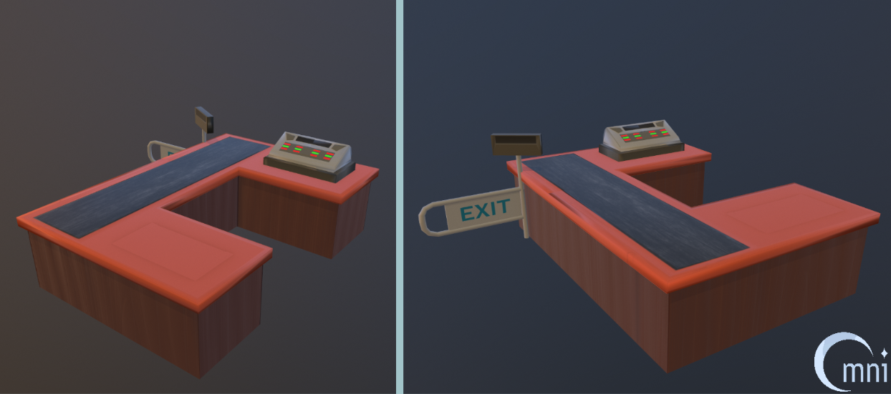
A quick study undertaken to showcase the art style.
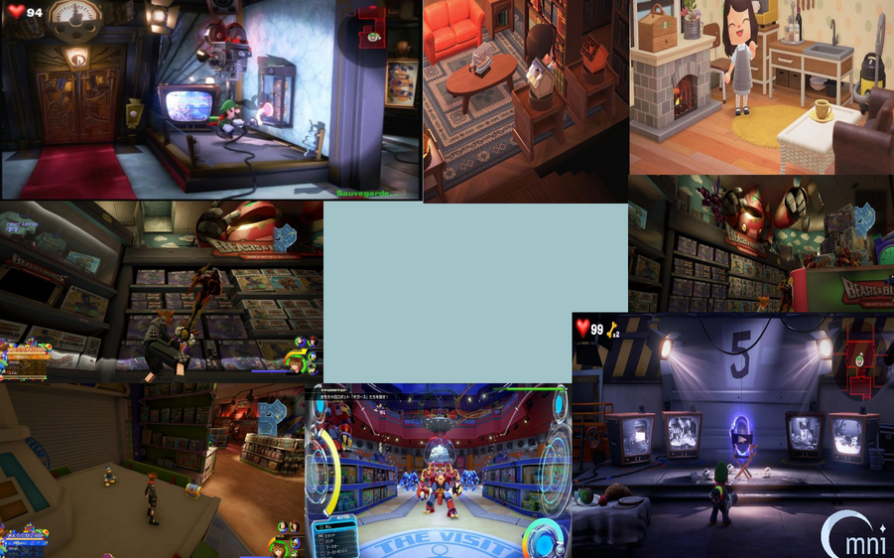
Prop Reference Images: Games included (Kingdom Heats, Animal Crossing and Luigi’s Mansion 3)

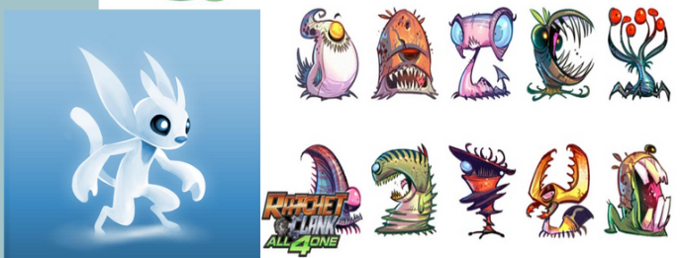
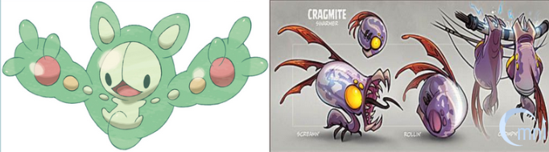
Character Reference Images: Games Included (Ori and the Blind Forest, Pokemon Series, Rachet and Clank All 4 One)

Audio Direction

Music
- Menu BGM
- In-Game BGM
- Rating Scene BGM
- Credits BGM

Sound Effects
- Eating
- Consume
- Regaining Energy
- Collecting
- Movement Wobble
- Player Sprint Sounds
- Timer
- Body Part snapping on sound [Customisation Scene]
- Body part disappearing [Customisation Scene]

Technical Information

Target Platform
PC

Engine
Unreal Engine 4

Limitations
- Must have OpenGl installed
- 900MB space must be free
- No support of Vuforia AR platform
- Poorer optimization for mobile (poor performance on older mobile phones and bigger binary size).
- A mandatory license that requires you to pay 5% of your product revenue to Epic Games (Unreal Engine developer).
- Liquid materials used need to be optimised.

Platform Specifications
Recommended Hardware
  Operating System | Windows 10 64-bit
  Processor | Quad-core Intel or AMD, 2.5 GHz or faster
  Memory | 8 GB RAM
  Video Card/DirectX Version | DirectX 11 or DirectX 12 compatible graphics card
Minimum Requirements
  Operating System | Windows 7
  DirectX Runtime | DirectX End-User Runtimes (June 2010)
Software Installed by the Prerequisite Installer
  DirectX Components | Visual C++ Redists
  XInput 1.3 (April 2007) | Visual C++ 2010 CRT
  X3DAudio 1.7 (February 2010) | Visual C++ 2010 OpenMP library
  XAudio 2.7 (June 2010) | Visual C++ 2012 CRT
  D3D Compiler 4.3 (June 2010) | Visual C++ 2013 CRT
  D3DCSX 4.3 (June 2010) | Visual C++ 2015 CRT
  D3DX9 4.3 (June 2010) | Visual Studio 2019 redistributable
  D3DX10 4.3 (June 2010)
  D3DX11 4.3 (June 2010)
Typical system used at Epic, for developing games with Unreal Engine 4 | - Windows 10 64-bit  - 64 GB RAM  - 256 GB SSD (OS Drive)  - 2 TB SSD (Data Drive)  - NVIDIA GeForce GTX 970  - Xoreax Incredibuild (Dev Tools Package)  - Six-Core Xeon E5-2643 @ 3.4GHz

Controller/ Input Diagrams
The following key bindings are used to control the movements of Guudo.
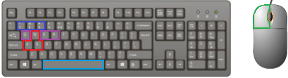
Key Binding | Result
W | Forwards
A | Move left
D | Move right
S | Move backwards
Left mouse button | Interact with object (if within range)
Q | Consume object (if within range)
E | Hold object (if within range)
R | Ignore object (if within range)
Scroll wheel | Zoom in / out
1 | Grow
2 | Shrink
3 | Return to normal
Space | Jump

Production Information

Production Software

Game Engine
Unreal Engine 4

Programming
Unreal Engine Blueprints
Visual Studio

Art Software
Substance Designer
Autodesk Maya
Adobe Photoshop
Substance Painter
ZBrush
Marmoset Toolbag

Audio Design
Audacity
FMOD

Milestones

Alpha
Art:
- Character Modelled
- Character Rigged
- High Poly Refinement Process
- Props and Environment Modelled
Design:
- Grey-Boxing, 1st passing: Levels 1-3
- UI Implemented
- Audio Implemented
- QA Testing
Programming:
- Mechanics built

Beta
Art:
- Character Animated
- Character Textured
- Environment and Props Textured
- Light Baked
Design:
- Levels refined for Beta Testing
- Cutscenes Designed
- Audio Refined
Programming:
- Debugging Completed

Gold
Art:
- Polish all Assets
Design:
- Polish Character controller
- Polish Level Design
- Create Teaser Trailer and Demo
Programming:
- Polish Mechanics
All:
- Release Game

Archive

Version 1.4
The player can press Tab to cycle through the following abilities:
  - Shrink
    - Pressing MMB on this ability will shrink the player to a smaller size reaching unreachable places that would normally be an obstacle for them
  - Grow
    - Pressing MMB on this ability will increase the players size allowing the player to knock over big objects allowing to access items that could normally never be reached.
  - High Jump
    - Pressing MMB on this ability will allow the player to jump higher the next time they press Spacebar to jump.

Version 1.5
- Human Like
If the player has collected all items that have a high ‘Human rating’ they will be rewarded with a higher ranking. If they have little/more missing human-like features, the player will receive a lower rank.

Human like
The player will be rated on how human they are depending on their choice of body part. If the limb is like a human, the better the human score is.
The scoring system for this section will be scored out of (0/5).
However, on screen should display the following titles:
  - Human-ish = 5/5
  - Getting there! = 4/5
  - Ok? = 3/5
  - Are you feeling ok? =2/5
f. ALIEN?! = < 1/5

Version History

Change Log

Version 1.0
This includes the headings of the documentation

Version 1.1
This includes information added in Theme:


Version 1.2.0
This includes information added into Game Overview:
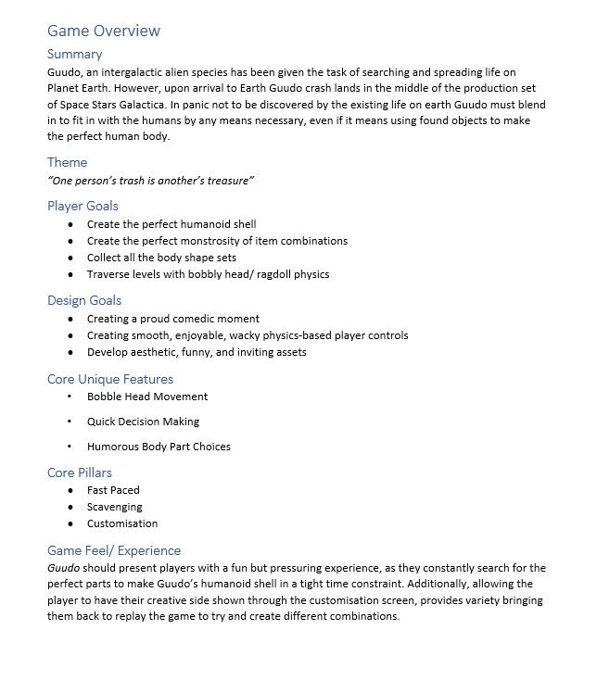

Version 1.2.1
The following sections have been given information:
Core Gameplay
Mechanics
Controls/ Interface
Narrative
Audio Direction
Technical Information
Production Information
Changelog

Version 1.3
The following sections have been given information:
Character Information
Art Direction
Milestones
Added Persona, and Target Market sections to Target Audience

Version 1.4
The document has all necessary information required for their given sections. The information provided is considered the base concept and should be read carefully to ensure no chances of detouring from the original idea of gameplay and design.

Version 1.5
Refer to Archive for previous design.
Changed:
- Controls: Ability Control binding: Tab to cycle -> Q, to shrink & E, to grow
- Rating System: Added Human Like category
- Economy- Scoring: Added Human Like category
Removed:
- High Jump Ability.

Version 1.5.1
Refer to Archive for previous design.
Removed:
- Mechanics: Rating System + Economy: Scoring - Human Like Category

