Omni
Version 1.2
Last Edited by Mitchell Sayer
27/07/20
Guudo
Game Design Document

Table of Contents
Game Overview 3
Summary 3
Theme 3
Player Goals 3
Design Goals 3
Core Unique Features 3
Core Pillars 3
Game Feel/ Experience 3
Target Audience 3
Demographics 4
Age 4
Skill 4
Gender 4
Time 4
Monetisation 4
Feature Appropriate 4
Mechanical Understanding 4
Core Gameplay 3
Core Loops 4
Mechanics 4
Controls/ Interface 4
Economy 3
Economy Loops 3
Currency 3
Taps 3
Sinks 3
Levers 3
Narrative 3
Context of Gameplay 3
Story 3
Character Information 3
Plot Synopsis 3
Gameplay Synopsis 3
Art Direction 3
Art Style 4
Visual References 4
Audio Direction 4
Music 4
Sound Effects 4
Technical Information 4
Platform Specifications 4
Engine 4
Limitations 4
Production Information 4
Production Software 4
Game Engine 544
Programming 544
Art Software 544
Audio Design 544
Milestones 544
Archive 544
Version History 544
Change Log 544

Game Overview

Summary
Guudo, an intergalactic alien species has been given the task of searching and spreading life on Planet Earth. However, upon arrival to Earth Guudo crash lands in the middle of the production set of Space Stars Galactica. In panic not to be discovered by the existing life on earth Guudo must blend in to fit in with the humans by any means necessary, even if it means using found objects to make the perfect human body.

Theme
“One person’s trash is another’s treasure”

Player Goals
- Create the perfect humanoid shell
- Create the perfect monstrosity of item combinations
- Collect all the body shape sets
- Traverse levels with bobbly head/ ragdoll physics

Design Goals
- Creating a proud comedic moment
- Creating smooth, enjoyable, wacky physics-based player controls
- Develop aesthetic, funny, and inviting assets

Core Unique Features
- Bobble Head Movement
- Quick Decision Making
- Humorous Body Part Choices

Core Pillars
- Fast Paced
- Scavenging
- Customisation

Game Feel/ Experience
Guudo should present players with a fun but pressuring experience, as they constantly search for the perfect parts to make Guudo’s humanoid shell in a tight time constraint. Additionally, allowing the player to have their creative side shown through the customisation screen, provides variety bringing them back to replay the game to try and create different combinations.

Target Audience

Demographics

Age

Skill

Gender

Time

Monetisation

Feature Appropriate

Mechanical Understanding

Core Gameplay

Core Loops

Core Gameplay Loop
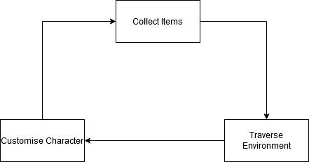

Feedback Loop: Consuming or Collecting

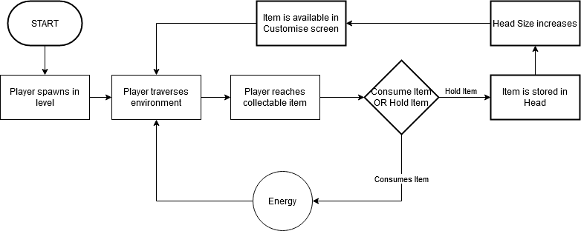

Feedback Loop: Energy
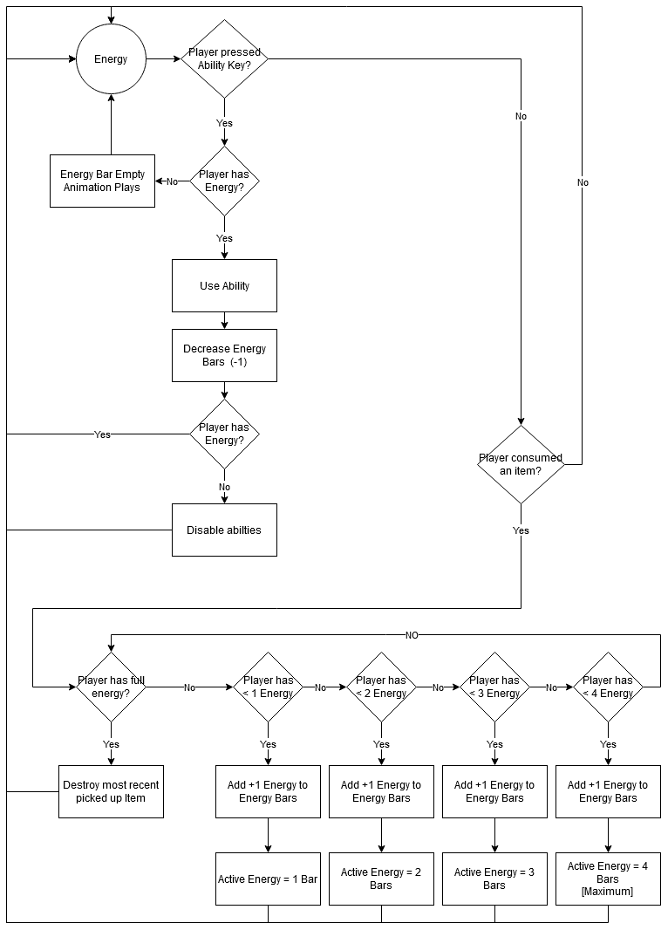

Feedback Loop: Timer
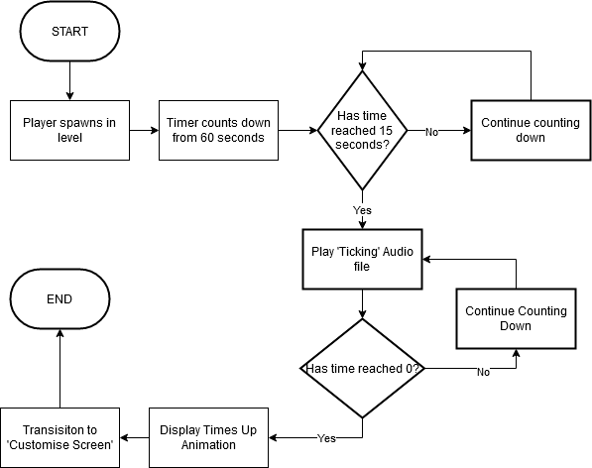

Mechanics

Controls/ Interface

Economy

Economy Loops

Currency

Taps

Sinks

Levers

Narrative

Context of Gameplay

Story

Character Information

Plot Synopsis

Gameplay Synopsis

Art Direction
Reference Art Bible

Art Style

Visual References

Audio Direction

Music

Sound Effects

Technical Information
Reference TDD

Platform Specifications

Engine
Unreal Engine 4

Limitations

Production Information

Production Software

Game Engine

Programming

Art Software

Audio Design

Milestones

Alpha

Beta

Gold

Archive

Version History

Change Log

Version 1.0
This includes the headings of the documentation

Version 1.1
This includes information added in:
- Theme 3

Version 1.2
This includes information added into:

