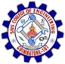

Wave2Words

PROJECT REPORT

Submitted by

ARJUN K B 713321CD009

in partial fulfillment for the award of the degree of BACHELOR OF ENGINEERING
IN
COMPUTER SCIENCE AND DESIGN SNS COLLEGE OF ENGINEERING COIMBATORE – 641 107

ANNA UNIVERSITY: CHENNAI – 600 025
DECEMBER 2024

BONAFIDE CERTIFICATE

Certified that this Project Report titled, “Wave2Words” is the bonafide record of
“ARJUN K B” who carried out the Project Work under my supervision. Certified further, that to the best of my knowledge the work reported here in does not form part of any other project report or dissertation on the basis of which a degree or award was conferred on an earlier occasion on this or any other candidate.

PROJECT COORDINATOR | HEAD OF THE DEPARTMENT
Mrs. N.GANITHA AARTI ,  M.Tech., (Ph.D)., | Dr. B. ANURADHA, M.S.,Ph.D.,
Associate Professor, | Professor & Head,
Department of Computer Science  & Design., | Department of Computer Science  & Design,
SNS College of Engineering, | SNS College of Engineering,
Coimbatore-641035. | Coimbatore-641035.

Submitted for the Viva-Voice held on …………………………….

INTERNAL EXAMINER EXTERNAL EXAMINER

ACKNOWLEDGEMENT

First of all, we extend our heart-felt Gratitude to the management of SNS College of Engineering, for providing us with all sorts of support in completion of this project I.

We wish to express our sincere thanks to honourable chairman Dr.S.N. Subramanian, Correspondent Dr.S.Rajalakshmi, Founder Dr.V.S.Velusamy and Technical Director Dr.S.Nalin Vimal Kumar those progressive ideas added with far sighted counsel has shouldered us to reach meritorious heights.

We are indebted to express our deep sense of gratitude to the Director Dr.V.P.Arunachalam, Principal Dr.S.Charles and Vice Principal Dr.R. Sudhakaran, for their valuable support while doing our project I.

We highly in dept to record our sincere thanks to Dr.B.Anuradha, Professor and Head, Department of Computer Science and Design, for their able guidance suggestions and persistent encouragement that extended throughout the execution of our project I work.

We would like to thank Mrs.N.Ganitha Aarti Project Guide, Department of Computer Science and Design and our Supervisor Mrs.Thasni Ashraf Assistant Professor, Department of Computer Science and Design for their able guidance, without which, our project I would not be a successful one.

We solemnly express our thanks to all the teaching and non-teaching staff members of the Department of Computer Science and Design, family and friends for their valuable support which energized us to complete our project I in time.

CHAPTER NO | TITLE | PAGE NO
 | ABSTRACT | v
 | LIST OF FIGURES | vii
1 | INTRODUCTION | 8
2 | LITERATURE REVIEW | 10
3 | DESIGN THINKING | 15
 | 3.1 EMPATHY | 15
 | 3.2 DEFINE | 22
 | 3.3 IDEATE | 30
 | 3.3.1 List of Solutions | 30
 | 3.3.2 Solution choosen & its description | 30
 | 3.4 PROTOTYPE | 39
4 | TESTING & MAINTENANCE | 49
5 | RESULT | 54
6 | CONCLUSION & FUTURE WORK | 57
7 | ANNEXURE | 60
 | 7.1 – Appendix I (Coding Logic) | 60
 | 7.2 – Appendix II (References) | 63
 | 7.3 – Appendix III (Publications) | 65

ABSTRACT

The Wave2Words system, built using advanced machine learning techniques, is a transformative solution aimed at bridging the communication gap between individuals who use sign language and those who rely on spoken language. By integrating computer vision and deep learning technologies, the system can accurately detect, interpret, and translate sign language gestures into spoken words in real time. This capability ensures seamless interactions and effective communication, empowering individuals with hearing impairments to engage more freely in various social and professional settings. The real-time translation mechanism eliminates traditional barriers, allowing sign language users to participate in conversations naturally and without the need for an intermediary. The project is rooted in inclusivity, providing individuals who rely on sign language with the ability to express themselves effortlessly, enhancing their independence and accessibility in daily life.

At the heart of the Wave2Words system is the implementation of deep learning models, with a particular emphasis on convolutional neural networks (CNNs) for gesture recognition. CNNs are highly efficient at processing and analyzing visual data, enabling the system to capture intricate hand movements with remarkable accuracy. The model is trained on diverse datasets that incorporate various sign languages, regional adaptations, and personalized signing styles, ensuring precise interpretation across a broad spectrum of gestures. By employing advanced neural architectures, the system improves its ability to handle complex and dynamic gestures, adjusting to variations in speed, hand

orientation, and environmental conditions. This level of adaptability allows the Wave2Words system to function effectively in real-world scenarios, making sign language translation more robust and reliable.

Beyond its technical innovations, the Wave2Words system plays a crucial role in fostering digital accessibility and inclusivity. By providing a real-time translation mechanism, it enhances engagement and participation for the deaf and hard-of-hearing communities in educational, professional, and social environments. Its scalable design ensures deployment across multiple platforms, including mobile applications, assistive communication tools, and desktop interfaces, expanding its reach and usability. Future developments will focus on refining recognition models, integrating multimodal learning techniques, and enhancing speech synthesis for more natural and expressive communication. Through continuous improvements, the Wave2Words project contributes to the broader goal of developing assistive technologies that break down communication barriers, ensuring that individuals of all hearing abilities can interact and express themselves freely without limitations.

LIST OF FIGURES
FIGURE NO | FIGURE NAME | PAGE NO
3.1.1 | EMPATHY MAP | 15
3.4.1 | TRACKING HAND GESTURES | 39
3.4.2 | SIGN LANGUAGES | 41
3.4.3 | PREDICTING SIGN LANGUAGES | 42
3.4.4 | TRANSLATE TEXT TO SPEECH | 44
3.4.5 | Data Flow Diagram | 45
7.1.1 | DATA PREDICTION | 60
7.1.2 | DATA COLLECTION | 61
7.1.3 | FINAL PREDICTION | 61
7.1.4 | GUI | 62

CHAPTER 1
INTRODUCTION

Communication is a fundamental human need, yet individuals with hearing impairments often face significant barriers in daily interactions. Sign language, a primary mode of communication for the deaf and hard-of-hearing community, remains unintelligible to most individuals who do not understand it, creating a gap in inclusive communication. This project, Gestures Talk using ML System, aims to bridge this gap by translating sign language gestures into spoken words, enabling seamless interaction between sign language users and the broader community.

The system leverages advancements in computer vision and deep learning to achieve real-time recognition and interpretation of hand gestures. Using convolutional neural networks (CNNs) for gesture detection and natural language processing techniques for contextual understanding, the system ensures high accuracy and adaptability. Once a gesture is recognized, it is converted into clear spoken language using text-to-speech synthesis, providing an intuitive and accessible output. Challenges such as regional variations in sign language, complex gesture sequences, and environmental factors like lighting or background interference are addressed through robust model training and data preprocessing. The system is also designed for flexibility, allowing users to customize gestures for specific needs, ensuring widespread applicability across diverse user groups and settings.

This innovative project offers significant societal benefits by promoting inclusivity and empowering individuals with hearing impairments to engage in social, educational, and professional interactions without barriers. Its applications extend to areas like education, customer service, public administration, and beyond, making it a critical step toward accessible communication technology.

The Gestures Talk using ML System represents a milestone in leveraging AI to create a more equitable and connected world, ensuring that communication is accessible to all.

Gestures Talk using ML System aims to bridge the communication gap between individuals using sign language and those who rely on spoken language. By leveraging machine learning and computer vision technologies, the system translates sign language gestures into real-time spoken words, enabling seamless communication for the deaf and hard-of-hearing community.

At the heart of the project, convolutional neural networks (CNNs) are used for accurate gesture detection, while natural language processing (NLP) techniques ensure the proper interpretation of gestures in context. Once gestures are recognized, they are converted into natural, spoken language using text-to-speech (TTS) synthesis. The system addresses several challenges, including variations in regional sign language, contextual meaning of gestures, and environmental factors like lighting or background noise.

By enabling real-time interaction, the system promotes inclusivity, allowing individuals with hearing impairments to engage fully in social, educational, and professional settings. The Gestures Talk using ML System represents a significant step toward improving accessibility and empowering the deaf community, helping them communicate.

CHAPTER 2
LITERATURE SURVEY

Sign language serves as an essential mode of communication for individuals with hearing impairments, allowing them to interact effectively in personal, social, and professional environments. However, the lack of widespread understanding of sign language among the general population presents significant communication barriers between sign language users and those who rely on spoken language. To address this challenge, researchers have focused on the development of sign language to speech conversion systems, employing advanced machine learning and computer vision techniques to facilitate seamless interaction. The primary goal of these systems is to enable real-time translation of sign language gestures into spoken words, thereby bridging the gap between non-signers and sign language users. The evolution of artificial intelligence (AI) has played a crucial role in refining the accuracy and efficiency of these systems, with deep learning algorithms revolutionizing gesture recognition and language processing.
Machine learning-driven sign language recognition has garnered considerable attention, particularly in the field of deep learning models such as convolutional neural networks (CNNs). CNNs have proven effective in analyzing visual data, allowing computers to accurately detect, classify, and interpret hand movements, facial expressions, and body postures—core components of sign language communication. By training models on extensive datasets containing diverse sign variations, researchers have enhanced the ability of CNNs to generalize across different users with distinct signing styles. The availability of large-scale annotated datasets is instrumental in improving the robustness of gesture recognition models, ensuring higher precision in classification. These datasets include various regional dialects, individual signing adaptations, and common sign variations, enabling AI systems to recognize and adapt to a broad range of expressions. Improved

dataset diversity has also contributed to advancements in real-time recognition, allowing sign language to speech systems to operate effectively in live conversational scenarios.
Real-time processing has been a major breakthrough in sign language translation, replacing earlier static image-based recognition methods that lacked efficiency in dynamic interactions. Traditional models often relied on single-frame analysis, which was insufficient for capturing continuous gesture sequences, resulting in fragmented or incomplete translations. The adoption of recurrent neural networks (RNNs) and Long Short-Term Memory (LSTM) networks has significantly improved real-time processing by enabling models to interpret sequential gestures with greater contextual accuracy. LSTM-based networks track the movement of signs over time, analyzing the flow and continuity of gestures to ensure meaningful interpretation. Similarly, Transformer models, which have demonstrated success in natural language processing, have been incorporated into gesture recognition frameworks to refine sequential analysis, improving translation coherence. These advancements have resulted in fluid, natural translations of sign language, making real-time conversations more accessible.
Despite technological progress, sign language recognition continues to face challenges, particularly due to variations in signing styles, regional dialects, and environmental conditions. The diversity in how individuals express sign language complicates the training of machine learning models, as even slight differences in hand orientation, speed, or positioning can alter the meaning of a gesture. Researchers have tackled this issue by introducing adaptive learning techniques, which allow AI models to dynamically adjust their recognition capabilities based on user-specific signing habits. This approach ensures personalized and accurate interpretations, even when gestures deviate from standardized sign language structures. Another challenge lies in environmental disruptions, such as poor lighting, background obstructions, or overlapping gestures, which can reduce detection accuracy. Multi-modal input systems integrating hand tracking, facial recognition, and

motion sensors have helped mitigate these issues, enabling more reliable gesture interpretation across various conditions.
Sign language recognition systems rely on the successful transition from detected gestures to spoken output, necessitating the implementation of text-to-speech (TTS) synthesis. TTS models are essential for ensuring that recognized sign language is conveyed in a clear and natural manner, making the translation accessible to non-signers. Early TTS technologies often produced rigid, robotic speech that lacked the fluidity of human conversation. However, advances in neural-based speech synthesis have transformed speech generation, with models such as WaveNet and Tacotron enhancing the quality and expressiveness of TTS output. Context-aware models optimize translations by ensuring grammatical accuracy in text processing, preventing fragmented or unnatural speech outputs. These improvements enable smooth and natural-sounding communication, allowing sign language users to engage in meaningful conversations without interruptions.
User customization has emerged as a key factor in increasing the usability of sign language recognition systems, allowing individuals to tailor translations according to their needs. Researchers have explored ways to enable users to add personalized gestures, modify sign-to-speech mappings, and adjust speech tones for greater adaptability. This customization is especially beneficial in professional settings, where domain-specific vocabulary may differ from general sign language lexicons. In corporate environments, medical consultations, and academic institutions, personalized translations ensure more precise communication, improving user experience. The ability to define custom gestures and modify recognition parameters adds flexibility to sign language translation systems, making them more accessible for various use cases.

The implementation of sign language to speech conversion extends beyond individual communication, finding extensive applications across different sectors. In educational settings, sign language translation technologies have improved accessibility for deaf students, enabling them to interact with teachers and peers more effectively. Schools and universities integrating these systems into their curriculum enhance inclusion, providing deaf students with the opportunity to participate in discussions seamlessly. Similarly, in healthcare environments, sign-to-speech systems facilitate communication between patients and medical professionals, ensuring accurate diagnoses and treatments. Hospitals that adopt sign language recognition technology create more inclusive medical spaces, enabling hearing-impaired individuals to communicate their health concerns without barriers. Businesses have also begun integrating sign language recognition into customer service workflows, improving accessibility for deaf customers in retail, banking, and public service interactions. These applications highlight the widespread impact of sign-to-speech conversion systems in fostering inclusivity across different industries.
Despite significant advancements, sign language recognition technology still faces certain limitations, particularly regarding real-time computational efficiency. Sign-to-speech systems require substantial processing power to analyze gestures continuously, and mobile devices often struggle to meet these requirements due to hardware constraints. Researchers have proposed optimization techniques, such as model quantization and edge computing, to reduce computational load while maintaining accuracy. These methods allow translation systems to run efficiently on portable devices, increasing accessibility and usability. Dataset diversity remains another challenge, as existing datasets often fail to encompass lesser-known sign languages, limiting recognition capabilities for non-standardized gestures. Expanding dataset inclusivity to incorporate a broader range of sign languages will be crucial in improving translation accuracy for a wider audience.

The future of sign language to speech conversion technology lies in continuous advancements in AI-driven models and human-computer interaction. Researchers are exploring the integration of augmented reality (AR) and wearable devices, including smart glasses and mobile applications, to provide real-time sign translation in immersive environments. AR-assisted sign language interpretation could enhance accessibility by displaying spoken translations directly in the user’s field of view. The incorporation of generative AI models is another promising development, refining gesture interpretation by enabling more natural and contextually accurate translations. As machine learning algorithms evolve, the efficiency, accuracy, and accessibility of sign-to-speech systems are expected to improve, making communication more inclusive for individuals with hearing impairments. Continued collaboration between research institutions, industry professionals, and the deaf community is essential to ensure that sign-to-speech technologies are developed with inclusivity, usability, and practicality in mind, furthering their role in breaking communication barriers and empowering sign language users.

CHAPTER 3

DESIGN THINKING

  - EMPATHY

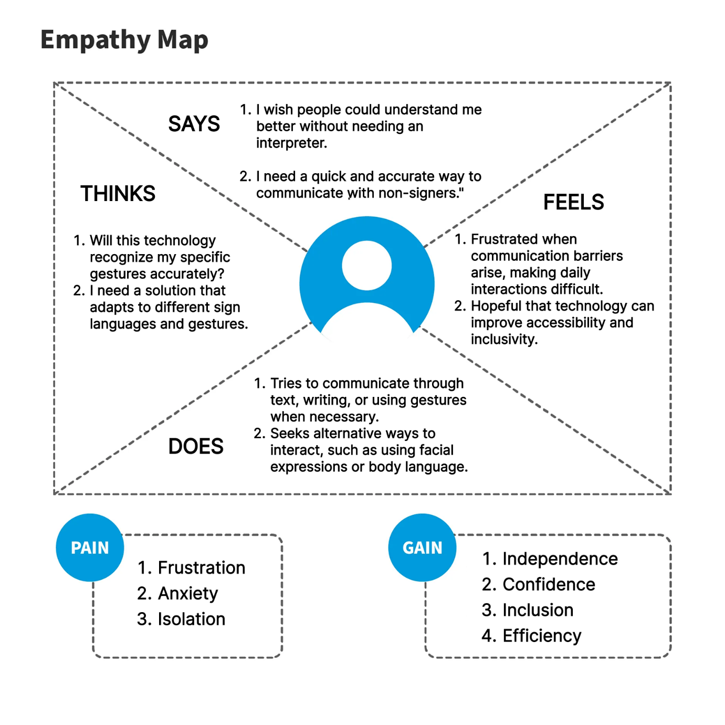

Fig 3.1.1 – Empathy Map

3.1.1 Survey Details
A detailed survey was conducted to understand the communication challenges faced by deaf and hard-of-hearing individuals. The survey focused on identifying pain points such as difficulty in verbal communication, lack of accessibility in public spaces, and limited integration of sign language interpretation in daily interactions. Insights from respondents, including individuals with hearing impairments and their caregivers, revealed that the absence of real-time sign language-to-speech conversion significantly affects their ability to communicate effectively. Many participants highlighted situations where they struggled to express themselves due to the lack of available translation tools, particularly in professional, healthcare, and educational environments. The findings emphasized the need for an AI-powered system that can translate sign language gestures into spoken words, enabling seamless interaction in various settings.

3.1.2 Survey Questions
How easy is it for deaf individuals to communicate with non-sign language users? Currently, communication with non-sign language users is a major challenge. Deaf individuals often struggle to convey their thoughts clearly, as most people do not understand sign language. This barrier results in misunderstandings and social exclusion, particularly in workplaces, educational institutions, and public service areas. Many respondents mentioned that written communication is sometimes used, but it lacks the speed and natural flow of real-time conversations. Lip-reading, while commonly attempted, is unreliable due to variations in speech patterns and pronunciation differences.

Are the available resources sufficient and clear for communication and accessibility? The existing resources, such as sign language interpreters and text-based communication apps, are limited and not always accessible. Many respondents mentioned that relying on an interpreter is inconvenient, and text-based communication is not always effective, especially in fast-paced conversations or emergency situations. Additionally, the availability of sign language interpreters is restricted in many locations, making it

impractical to rely on them regularly. Some individuals expressed concern about the cost and logistical difficulties of hiring interpreters, as well as the challenges of integrating text-based apps in dynamic interactions such as meetings, interviews, or spontaneous conversations.

What are the major pain points in accessing real-time communication support? A key challenge is the unavailability of real-time sign language translation. Most current solutions require manual intervention, making communication slow and impractical in dynamic environments. Additionally, the lack of awareness and adoption of sign language interpretation technology in public spaces makes everyday interactions difficult. Respondents highlighted experiences in workplaces, restaurants, and service centers where there were no accessible sign language interpretation options, forcing them to find alternative ways to communicate. Many mentioned that while some businesses provide accessibility support for physical disabilities, accommodations for deaf individuals remain inadequate.

How much time do deaf individuals spend trying to communicate with people who do not understand sign language? On average, deaf individuals spend considerable time finding ways to communicate, whether through writing, lip-reading, or using third-party apps. This inefficiency not only affects their confidence but also limits their ability to participate in spontaneous conversations and professional discussions effectively. Many respondents expressed frustration over having to repeatedly explain their communication needs, which slows down interactions and makes engagement in group discussions more difficult. The lack of real-time translation prevents them from fully integrating into spoken conversations, limiting their ability to express emotions and ideas with the same speed as spoken communication.

3.1.3 Survey Results and Analysis

SAYS
Deaf individuals and their caregivers frequently express frustration over the communication barriers they face daily. Many share sentiments such as, “People don’t understand sign language, which makes communication exhausting,” highlighting the emotional toll of constant misunderstandings. They often wish for an immediate solution, stating, “Why isn’t there a system that can instantly translate my signs into speech?” The difficulty of expressing their needs in public spaces is frequently mentioned, with many saying, “I always have to rely on writing or gestures, which people don’t always understand.” Caregivers also voice concerns about accessibility, explaining, “There should be an easier way for my child to interact with others without my constant assistance.” These frustrations stem from repeated experiences of exclusion, whether in workplaces, healthcare settings, or everyday social interactions. The inability to communicate freely without assistance adds additional stress, preventing deaf individuals from fully participating in spontaneous conversations, professional discussions, and emergency situations.

DOES
Deaf individuals often rely on alternative methods like texting or writing on paper to communicate with non-signers. While these approaches provide temporary solutions, they lack the efficiency and immediacy of real-time spoken conversation. Many individuals frequently use mobile apps for basic translation; however, most available tools do not provide instant responsiveness, making quick conversations difficult. When unable to use technology, they often resort to lip-reading, which is highly unreliable and depends on the clarity of the other person’s speech. Since accents, pronunciation differences, and speech pacing vary among individuals, lip-reading does not always offer an effective solution. Some individuals carry pre-written notes explaining their communication needs, allowing them to show strangers their preferred method of interaction in situations where speech is needed. However, this method can feel impersonal and limiting, making interactions feel

rigid and scripted. Socially, many deaf individuals limit their conversations or avoid interactions altogether due to the difficulty of explaining themselves effectively. This results in a lack of engagement in professional discussions, casual social events, and day-to-day transactions, reinforcing feelings of isolation. The absence of a reliable, real-time communication tool prevents sign language users from experiencing spontaneous conversations, where emotions and expressions play a vital role in the exchange.

THINKS
Users frequently question the advancements in technology, wondering, “Why hasn’t technology made communication easier for us?” Despite significant improvements in artificial intelligence and assistive technologies, sign language translation tools remain underdeveloped, leaving many deaf individuals dependent on traditional methods of communication. Many fear being left out in professional and social settings, thinking, “What if I miss important information because there’s no interpreter available?” In workplaces, where meetings and discussions move quickly, the lack of accessible translation tools prevents deaf individuals from keeping up with real-time exchanges, affecting their professional growth and participation. Additionally, they believe that a reliable sign language-to-speech system would significantly improve accessibility and independence, eliminating the need for a human interpreter in many situations. Current communication tools are often seen as outdated and lacking the responsiveness required for dynamic conversations, making many deaf individuals hesitant to engage in conversations with non-signers. They feel that existing solutions do not fully address the complexity of sign language communication, where context, facial expressions, and hand movements contribute equally to meaning. Without technological advancements tailored specifically to their needs, they feel discouraged from initiating interactions, knowing that the effort required to be understood is often exhausting.

FEELS
Deaf individuals and their caregivers feel frustrated and isolated due to the lack of effective communication tools. The inability to express themselves effortlessly generates anxiety in unfamiliar settings, preventing them from feeling confident in social or professional environments. The dependence on interpreters or written communication makes them feel restricted, as they cannot participate freely without assistance. In many cases, deaf individuals experience situations where they are left out of conversations simply because their communication method is not accommodated. This leads to feelings of exclusion, reducing their willingness to interact with others. The frustration of repeating explanations, manually typing responses, or writing notes each time they need to communicate contributes to emotional fatigue. Many are hopeful that technological advancements can bridge the gap, allowing them to communicate freely without barriers. The introduction of a real-time sign language-to-speech system would significantly improve accessibility, helping them regain confidence in their ability to interact with others. Having a tool that provides instantaneous translation would eliminate stress, allowing them to focus on meaningful engagement rather than overcoming obstacles in communication. They remain optimistic about the development of AI-driven solutions that prioritize inclusion and accessibility, hopeful that a breakthrough will allow them to communicate effortlessly in all areas of life.

PAIN
Users struggle with limited communication options, leading to frequent misunderstandings and social isolation. The absence of real-time sign language translation results in missed opportunities in education, employment, and daily interactions. In classrooms, deaf students often rely on written notes or interpreters, making it difficult to engage fully in discussions. In workplaces, sign language users face challenges in attending meetings, networking, and participating in group conversations. This often results in reduced career progression and limited job opportunities, as many positions require verbal engagement. Dependency on interpreters is inconvenient and not always available, making spontaneous conversations difficult. Public settings pose additional challenges, as restaurants, retail stores, and government offices rarely integrate sign language

interpretation, forcing deaf individuals to depend on manual methods of communication. Additionally, the lack of awareness and adoption of assistive technology in public and professional spaces limits their ability to communicate freely. The absence of a universally accessible system keeps them dependent on text-based exchanges, leading to frustrations in fast-paced interactions where real-time responses are crucial. Without immediate translation tools, sign language users miss out on opportunities to fully integrate into verbal conversations, leaving them feeling disconnected from the hearing world.

GAINS
A real-time sign language-to-speech conversion system would revolutionize communication for deaf individuals by enabling seamless interactions with non-signers. The integration of AI-driven gesture recognition and speech synthesis would eliminate barriers, providing instant and natural communication. The system would enhance accessibility in workplaces, educational institutions, and public services, ensuring that deaf individuals can participate without restrictions. Businesses, healthcare facilities, and government agencies would benefit from incorporating such technology, fostering inclusive environments for all individuals. A user-friendly, portable solution would empower deaf individuals to communicate independently, reducing their reliance on interpreters or manual text-based exchanges. By providing an intuitive interface and real-time translation, the system would open new opportunities for sign language users, helping them navigate conversations effortlessly. In professional settings, individuals would be able to engage in meetings, job interviews, and discussions without delay. In education, students could interact more fluidly with classmates and teachers, enhancing their learning experience. In everyday interactions, deaf individuals would be able to
express themselves confidently without worrying about miscommunication. The introduction of an AI-powered sign language-to-speech system would make communication more accessible, fostering inclusivity and improving the quality of life for millions of individuals around the world.

  - DEFINE

The Wave2Words system is an innovative Sign Language to Speech (SLTS) conversion technology designed to bridge the gap between sign language users and the broader hearing community. By leveraging advanced artificial intelligence, computer vision, and natural language processing, this system can accurately recognize sign language gestures and convert them into spoken words in real time. The goal of this AI-powered application is to eliminate the barriers faced by deaf and hard-of-hearing individuals in their daily interactions by enabling seamless communication. Unlike traditional approaches, such as human interpreters or manual text-based communication, the Wave2Words system ensures instant translation, creating a more natural and intuitive exchange. This real-time translation enhances accessibility across multiple domains, including education, workplaces, healthcare, and public service environments. By automating the sign-to-speech conversion process, the system empowers individuals with hearing impairments, reducing their reliance on third-party services and enabling spontaneous, unrestricted conversation.

One of the fundamental advancements introduced by this system is its ability to process sign language dynamically, rather than relying on predefined gestures. Using sophisticated deep learning models, such as convolutional neural networks (CNNs), the system analyzes hand movements, facial expressions, and spatial positioning to derive meaning from each gesture. These models are trained on extensive datasets comprising various sign languages, regional dialects, and personalized adaptations, ensuring robust and accurate recognition. As a result, Wave2Words provides users with an intuitive communication tool that adapts to different styles of signing, minimizing misinterpretation and enhancing reliability. Additionally, by incorporating state-of-the-art speech synthesis technology, the system ensures that the translated speech output is clear, natural, and contextually appropriate. The ability to adjust tone, pitch, and pacing enhances the realism of the spoken output, making interactions more meaningful for both sign language users and non-signers.

3.2.1 Understanding the Problem
For many individuals in the deaf and hard-of-hearing community, communication with non-sign language users remains a persistent challenge, despite advancements in assistive technology. While sign language is a highly expressive and efficient means of communication, it is not universally understood, making interactions difficult in many social, professional, and emergency situations. Various methods have been developed to assist in bridging the communication gap, but each approach comes with its own limitations. Human interpreters, while effective, are not always accessible due to availability constraints and financial costs. Text-based communication platforms offer alternative solutions, but they lack spontaneity, emotional nuance, and real-time responsiveness. Encouraging hearing individuals to learn sign language is valuable, yet widespread adoption is slow and impractical for immediate communication needs. These factors underscore the need for an automated, AI-driven system capable of translating sign language gestures into spoken words instantly and effortlessly.

In professional settings, communication barriers often lead to missed opportunities for deaf individuals. For example, a job interview may become challenging if an employer does not understand sign language, potentially leading to a misrepresentation of the candidate's qualifications. Similarly, customer service roles that require verbal interaction often exclude deaf individuals, limiting their access to job opportunities in industries that rely on spoken communication. Workplace meetings and collaborative discussions become difficult for sign language users, as they cannot always follow or contribute in real time without an interpreter present. This exclusion impacts career advancement, workplace inclusion, and overall productivity. The problem extends beyond professional environments, as emergency situations pose significant risks to sign language users. In critical scenarios where immediate communication is required—such as medical emergencies, law enforcement interactions, or natural disasters—sign language users may struggle to convey essential information quickly, resulting in delays that could have severe consequences. Addressing these challenges

necessitates a reliable, AI-powered solution that eliminates the need for intermediaries and ensures sign language users have equal access to real-time spoken communication.

By integrating artificial intelligence, machine learning, and computer vision technologies, Wave2Words offers a breakthrough in accessibility, allowing sign language users to communicate in a natural, spontaneous manner. The system’s ability to adapt to individual signing styles, process gestures dynamically, and generate realistic speech ensures that deaf individuals can participate fully in everyday interactions without limitations. Additionally, deploying this technology across mobile devices, assistive tools, and professional environments enhances its usability, making it widely accessible. The development of Wave2Words represents a major step toward improving accessibility for deaf and hard-of-hearing individuals, promoting social inclusion, and ensuring equal opportunities in communication. By enabling instant translation and removing dependency on interpreters or manual text-based solutions, this system empowers users with the ability to navigate conversations effortlessly, fostering a more connected and inclusive society.

3.2.2 Defining the Core Problem
The development of an efficient Sign Language to Speech Translation System (SLTS) faces multiple technological hurdles that prevent seamless, accurate, and real-time translation. While advancements in AI and machine learning have improved gesture recognition capabilities, several persistent issues remain, affecting the practicality and widespread adoption of SLTS solutions. The primary challenges involve recognition accuracy, processing speed, speech synthesis quality, language variability, and environmental adaptability. Addressing these challenges is crucial in ensuring that SLTS systems can function efficiently across different settings, enabling sign language users to communicate effortlessly with non-signers without dependency on interpreters or text-based applications.

1. Limited Recognition Accuracy Many gesture recognition systems struggle with the complexity of sign language movements, which involve both manual gestures and non-manual cues such as facial expressions and head movements. Since meaning in sign language is often conveyed through subtle variations in finger positioning, hand orientation, and spatial gestures, recognition models require highly sophisticated tracking mechanisms. Existing computer vision models frequently misclassify these nuances, leading to errors in translation. The diversity in individual signing styles further complicates the recognition process, as different users may sign the same words differently based on personal habits or regional variations. Standardizing gesture interpretation across diverse user groups while maintaining accuracy remains a considerable challenge.

2. Lack of Real-Time Processing To ensure fluid conversation, high-speed processing is essential for sign-to-speech conversion. However, latency issues continue to hinder natural interaction, as current AI models often struggle to generate spoken responses in real time. The computational intensity required for video-based gesture recognition, coupled with deep learning models for translation, results in processing delays. This issue is particularly problematic in professional and emergency environments where immediate communication is needed. Furthermore, excessive processing demands make the deployment of SLTS systems impractical on mobile devices and lightweight hardware, restricting portability and accessibility. Optimizing AI models for rapid execution without compromising accuracy is a key challenge that must be addressed to enable widespread adoption.

3. Inconsistent Speech Synthesis The quality of speech output plays a vital role in ensuring comprehensible sign-to-speech conversion. Current speech synthesis technologies often struggle with appropriate intonation, emphasis, and naturalness, leading to robotic or monotonous output. Sign language users rely on expressive signing techniques to convey tone, emotions, and sentence structures, but existing speech synthesis models lack the capability to translate these aspects effectively. Poor speech generation reduces the efficiency of SLTS systems, making conversations feel unnatural and less engaging.Addressing speech synthesis inconsistencies requires enhanced natural language processing models that can infer contextual meaning from gestures and generate human-like speech patterns with improved clarity and fluency.

4. Restricted Language and Gesture Support One of the most significant challenges in SLTS development is the diversity of sign languages worldwide. American Sign Language (ASL), British Sign Language (BSL), Indian Sign Language (ISL), and other regional sign languages each have unique grammar rules, hand shapes, and movement sequences. A universal translation system capable of supporting multiple sign languages must accommodate these differences without compromising accuracy. Many current SLTS models only recognize basic gestures or predefined signs, limiting their ability to translate complex conversations with varied expressions. Expanding gesture recognition to support full conversations across multiple sign languages requires large-scale datasets and advanced AI models capable of identifying linguistic variations in different signing communities.

5. Environmental and Accessibility Constraints Gesture recognition must be robust enough to function across different lighting conditions, backgrounds, and user environments. Sign language interpretation becomes challenging in dimly lit settings, crowded spaces, or areas with significant motion interference. Many recognition systems struggle with real-world adaptability, leading to errors in translation when environmental factors interfere with hand tracking. Additionally, accessibility remains a critical issue, as SLTS systems should be deployable across various platforms, including mobile devices, desktops, and wearable technology. The integration of portable and efficient SLTS solutions would provide greater convenience for sign language users, allowing them to use speech conversion tools in diverse locations without restrictions. Addressing environmental adaptability and cross-platform accessibility is essential for ensuring the practical implementation of SLTS systems in everyday interactions.
3.2.3 Problem Statement
Despite major advancements in AI, sign language users continue to face substantial communication barriers when interacting with hearing individuals. Existing solutions, such as human interpreters or text-based applications, are either impractical or incomplete, failing to provide a universal, autonomous translation system. While manual interpreters offer reliable translation, their availability is inconsistent, and hiring services for real-time interpretation can be costly, making them inaccessible for everyday conversations. Similarly, text-based communication tools may assist sign language users in certain scenarios, but they lack the responsiveness required for spontaneous interactions, particularly in fast-paced environments.

Existing vision-based SLTS models struggle to accurately detect and translate dynamic gestures due to varying signing styles, environmental challenges, and limitations in deep learning-based gesture classification. AI-driven vision models often fail to adapt to individual signing variations, causing frequent misclassifications. Additionally, many automated recognition systems overlook critical non-manual elements—such as facial expressions, eye gaze, and body posture—which contribute significantly to the meaning of a sign language conversation. Since sign language grammar differs fundamentally from spoken language grammar, translating signs effectively requires advanced linguistic understanding, which current models lack.

Sensor-based approaches, including gloves and motion trackers, offer precise gesture detection, but they are often expensive, complex to use, and impractical for everyday interactions. Wearable sensor technology requires users to carry additional hardware, limiting convenience and mobility. Furthermore, these systems struggle with social adoption, as most deaf individuals prefer natural signing over the use of external devices. The challenge lies in developing a completely vision-based, AI-powered sign language to speech system that can operate autonomously without requiring manual input, wearable sensors, or third-party intervention.
Ultimately, the absence of an efficient, real-time SLTS system restricts inclusivity in workplaces, educational institutions, healthcare facilities, and public spaces. Without a reliable translation tool, sign language users remain dependent on human interpreters or alternative communication methods that slow down interactions and limit engagement. The need for a robust, adaptable, and highly accurate SLTS system is evident, as it would revolutionize accessibility and empower the deaf and hard-of-hearing communities to interact more freely and confidently in any setting. Addressing the core challenges associated with recognition accuracy, processing speed, speech synthesis, linguistic diversity, and environmental adaptability will be instrumental in developing a next-generation SLTS system capable of bridging the communication gap efficiently and effectively.

3.2.4 Proposed Solution

To overcome the challenges associated with sign language to speech conversion, an AI-driven Gestures Talk using ML System is proposed. This system will integrate multiple advanced features to ensure highly accurate gesture recognition, seamless real-time processing, expressive speech synthesis, broad accessibility, and adaptability across various sign languages. By leveraging deep learning techniques, artificial intelligence, and modern computing frameworks, the system aims to redefine communication for the deaf community, eliminating barriers and fostering inclusivity.

One of the key aspects of this solution is high-accuracy gesture recognition, which will utilize deep learning models such as convolutional neural networks (CNNs) for precise detection of hand movements, facial expressions, and spatial positioning. Since sign language relies heavily on nuanced gestures and subtle hand movements, ensuring accurate classification is critical. To improve recognition efficiency, the system will be trained on extensive datasets encompassing diverse signing styles, regional dialects, and user-specific adaptations. Additionally, adaptive learning mechanisms will allow the model to refine its accuracy over time, ensuring optimal performance for individual users.
Another crucial feature is real-time processing with minimal latency, allowing users to engage in fluent and uninterrupted conversations. Current SLTS models suffer from processing delays due to the computational complexity of gesture recognition and speech synthesis. To mitigate this issue, optimized deep learning algorithms will be employed, alongside GPU acceleration and parallel processing techniques. Reducing latency will enable sign language users to communicate naturally, without disruptions or slow responses in live interactions. Furthermore, advanced speech synthesis will enhance spoken output, ensuring realistic intonation and expressive speech patterns. This will be accomplished using neural-based text-to-speech (TTS) models, which provide lifelike articulation and adjust vocal tones based on contextual meaning.

Accessibility is another core component of the solution, requiring cross-platform support to ensure usability across different devices, including mobile applications, desktop software, and wearable technology. The system will feature compatibility with various operating systems and assistive communication tools, making it widely available to sign language users in different environments. Additionally, the solution will prioritize adaptability to diverse sign languages and user styles, supporting multiple regional variations such as ASL, BSL, and ISL. This inclusivity will allow individuals from different linguistic backgrounds to access reliable sign-to-speech translation.
By integrating these features, the SLTS system will revolutionize communication for the deaf community, empowering individuals with a powerful and accessible tool for real-time interaction. The implementation of AI-driven sign language recognition will not only enhance independence for sign language users but also promote a more inclusive society where communication is effortless and universally accessible.

  - IDEATE
    - List of solutions
1. Real-Time Gesture Recognition with Machine Learning
Develop a deep learning-based system that captures and translates sign language gestures into spoken words instantly, ensuring real-time communication with minimal delay.
2. Sensor-Based Wearable Device for Gesture Detection
Create a wearable device equipped with motion sensors to track hand movements and translate them into text or speech, providing high accuracy in gesture recognition.
3. AI Chatbot for Gesture-Based Communication
Integrate an AI-powered chatbot that allows users to interact through sign language gestures, providing real-time responses through text or speech output.
4. Haptic Feedback System for Gesture Confirmation
Implement a system that provides haptic (vibrational) feedback to users when a gesture is recognized correctly, helping improve communication accuracy and reducing errors.
5. Augmented Reality (AR) Sign Language Interpreter
Develop an AR-based application that overlays real-time sign language translations onto a user’s screen, helping non-sign language users understand and respond effectively.

    - Solution chosen and its Description
The chosen solution is Real-Time Gesture Recognition with Machine Learning.
the Wave2Words using ML System has been chosen as the most effective solution. This approach ensures seamless communication by translating sign language gestures into spoken words with minimal delay. At its core, the system employs advanced deep learning models to recognize and interpret sign language gestures in real time.

Convolutional Neural Networks (CNNs) are utilized to identify static gestures, while Long Short-Term Memory (LSTM) networks process dynamic gestures, capturing the temporal dependencies within sequences of movements. This dual-model approach ensures a comprehensive understanding of both hand gestures and non-manual cues, such as facial expressions, which are critical for conveying context and emotion in sign language. The system begins with data acquisition using high-resolution cameras or depth sensors, which capture the user’s gestures. OpenCV, a powerful computer vision library, processes these inputs to extract key features, including hand positions, movements, and other critical details.

These features are then fed into the trained CNN and LSTM models, which interpret the gestures and translate them into corresponding text. To ensure versatility, the system is designed to support various sign languages and adapt to regional variations. Once the gestures are converted into text, text-to-speech (TTS) technology

transforms the recognized text into natural-sounding speech. Advanced TTS systems like TensorFlow TTS or Pyttsx3 ensure that the generated speech accurately reflects the tone and context of the original gestures. The final output is played through speakers, providing an audible translation of the user’s sign language communication.

The system's architecture is designed for real-time operation, leveraging high-performance hardware such as GPUs to process complex computations efficiently. Edge computing frameworks enable localized data processing, reducing latency and ensuring smooth interactions. The software stack includes robust libraries and frameworks like TensorFlow, PyTorch, and OpenCV, alongside deployment tools like Streamlit for creating user-friendly interfaces. Ethical considerations are a key aspect of the system’s development. User privacy is protected by ensuring secure data handling and compliance with relevant data protection regulations.

The system is designed to operate locally when possible, minimizing the risk of sensitive information being shared online. Inclusivity and fairness are also prioritized by training the models on diverse datasets that represent a wide range of users and sign languages. The Gestures Talk using ML System offers numerous advantages, including enhanced communication, real-time translation, and support for multiple languages.

It can be implemented across various domains, from classrooms to customer service environments, empowering deaf individuals to participate more fully in society. By addressing key challenges such as accurate gesture recognition, context understanding, and real-time processing, the project represents a significant step toward creating a more inclusive and accessible world.

3.3.3 Module Description

Data Acquisition
The Data Acquisition module is responsible for collecting the raw data needed to train and evaluate the Gestures Talk using ML system. In this context, data typically refers to video and image sequences that capture hand gestures, along with corresponding textual data for speech synthesis. The module can utilize various data collection techniques such as video feeds from cameras or recorded datasets available in the public domain. In the first phase, video frames are captured using devices like webcams, depth cameras, or specialized gesture-sensing hardware. The acquired video streams are then converted into a series of still frames or images that represent the gestures.

The data acquisition system is designed to handle multiple forms of input data, including 2D and 3D gesture data. For gesture recognition, the system requires high-resolution images or videos that are captured with a fast frame rate to ensure real-time processing.

The data can be collected from different sources, such as wearable sensors, RGB cameras, or depth cameras like Microsoft Kinect, which provide depth information necessary for understanding hand movements in 3D space.

Additionally, a crucial part of this module is ensuring the diversity of the acquired data to cover various signing styles, environmental conditions, and background settings. This guarantees that the system can generalize well across different users and real-world scenarios. The acquired data is typically stored in a structured format for further processing and use in subsequent modules. At this stage, the system may also incorporate annotation procedures, where a human annotator labels gesture sequences with corresponding words or phrases in the desired language. This labeled data is fundamental for training the machine learning models that will later perform gesture recognition.

The primary goal of the data acquisition module is to capture high-quality, labeled data that covers all relevant aspects of gesture recognition. It ensures that the data is clean, relevant, and diverse, setting the foundation for the next stages of data preprocessing, feature extraction, and classification.

Data Preprocessing
The Data Preprocessing module is a vital step that prepares the raw data acquired from the Data Acquisition module for further analysis and model training. Raw data is often noisy, incomplete, or unstructured, which can hinder the performance of machine learning models. Preprocessing ensures that the data is transformed into a format suitable for training models and reduces the potential for errors during feature extraction.

In the context of gesture recognition, the preprocessing module may begin by converting raw video frames into frames that focus on specific gestures. This could involve background subtraction to eliminate irrelevant information from the scene, isolating the hand or body movements. Additionally, gestures may be cropped and resized to standard dimensions, which helps in reducing computational complexity when processing the data.

Another crucial part of data preprocessing involves normalization and scaling. Gestures captured under different lighting conditions or with varying distances from the camera may exhibit brightness variations. Preprocessing techniques normalize image brightness, ensuring consistent inputs for the model. Similarly, image resizing is essential for ensuring that all gesture images maintain the same resolution, providing uniform input to machine learning models.

For video data, frame extraction is also essential. In cases where gesture sequences are recorded as continuous video, individual frames representing distinct movements may be extracted for processing. This allows the system to focus on the most relevant frames that correspond to hand movements, improving accuracy during gesture recognition.

Data augmentation is another preprocessing technique that artificially expands the dataset by creating modified versions of the original images. This technique involves random transformations such as rotation, scaling, and flipping, which improves the robustness of the model. By doing so, the system learns to generalize across different viewing angles, orientations, and scales, making it more effective in recognizing gestures in real-world scenarios.

Finally, any irrelevant information or extraneous noise in the data is removed, ensuring the models focus only on the essential features. Once the preprocessing is complete, the processed data is then passed on to the feature extraction module, ready for analysis and classification.

Feature Extraction
The Feature Extraction module focuses on identifying and isolating the most relevant features from the processed data. These features represent key characteristics of the gestures that can be used for classification by machine learning models. In this module, various techniques are employed to extract meaningful features from the images or videos captured during the data acquisition stage.

In the case of hand gestures, key features may include hand shape, movement direction, speed, and the spatial relationship between fingers. Computer Vision algorithms, such as edge detection or contour analysis, can be employed to extract the

shape of the hand or body, while techniques like optical flow or motion analysis can be used to detect movement patterns and trajectory. These motion-based features are essential for recognizing dynamic gestures that involve continuous hand movements.

Deep learning techniques, particularly Convolutional Neural Networks (CNNs), are often utilized to automatically extract features from images and videos. These networks are trained to detect low-level features like edges and corners and combine

them to form higher-level representations of objects and gestures. CNNs allow the system to learn a hierarchical representation of gestures without the need for manual feature engineering.

In addition to spatial features, temporal features are also crucial in recognizing gestures. Recurrent Neural Networks (RNNs) or Long Short-Term Memory (LSTM) networks may be used to capture the temporal dynamics of gesture sequences. These models excel in identifying patterns in time-series data and can understand how gestures evolve over time, enabling the system to recognize gestures that depend on motion across multiple frames.

Feature extraction is critical because it reduces the dimensionality of the raw data, focusing on the most relevant characteristics for classification. These extracted features form the input to the subsequent classification and recognition models, improving the efficiency and accuracy of gesture recognition.

Gesture Classification
The Gesture Classification module plays a central role in the overall system, as it is responsible for identifying and categorizing gestures into predefined labels or categories. This module typically involves the training of machine learning models on the extracted features from the previous module.

The gesture classification process begins with selecting an appropriate model architecture for the task. Deep learning models such as Convolutional Neural Networks (CNNs) or 3D CNNs are particularly effective at handling visual data, such as hand gestures captured in images or video. These models learn to map raw pixel values or pre-processed features to output classes, which correspond to the specific gesture being made.

For dynamic gestures, which involve motion, Recurrent Neural Networks (RNNs) or Long Short-Term Memory (LSTM) networks may be used to account for the temporal aspects of the gesture. RNNs excel in recognizing patterns in sequential data and can

track gestures over time, making them ideal for understanding continuous motions and transitions between gesture frames.

Once the models are trained, they classify new, unseen gestures by comparing the extracted features to those learned during training. Depending on the complexity of the model and the dataset, a classifier such as a Support Vector Machine (SVM) or Random Forest may be used in combination with deep learning models to refine the results.

This classification module must be highly accurate, as it directly influences the performance of the system in recognizing a wide variety of hand gestures. Gesture classification is the core component that enables the system to understand what the user is conveying through sign language.

Text-to-Speech Translation
The Text-to-Speech Translation module is responsible for converting the output of the gesture recognition system into audible speech. Once the gesture is classified, the corresponding word or phrase is passed to this module, where it is transformed into speech using Text-to-Speech (TTS) synthesis techniques.

This module integrates two primary components: a natural language generation system and a speech synthesis engine. The natural language generation part converts the recognized gesture into a grammatically correct sentence, if necessary. For example, if a gesture corresponds to a single word, this word is directly passed to the speech synthesis engine.

The speech synthesis component, such as pyttsx3 or Google Text-to-Speech API, takes the generated text and converts it into speech. These engines generate human-like speech with adjustable pitch, speed, and volume, ensuring that the speech output sounds natural and intelligible. The TTS module needs to support different languages, accents,

and contextual variations to ensure a broad range of user interactions. As a result, it incorporates various speech models trained on diverse speech datasets.

This module is the final step in the system, allowing individuals to communicate with those who do not understand sign language by converting their gestures into speech. likely part-of-speech tag for each word based on its context. While these methods are effective to a certain extent, they often struggle with ambiguous words and languages with rich morphological structures. Named entity recognition (NER) is another essential NLP task focused on identifying and classifying named entities such as people, organizations, locations, and dates mentioned in text.

Traditional NER systems employ rule-based patterns or machine learning algorithms trained on labeled data to recognize and categorize named entities. However, these approaches may encounter difficulties with variations in naming conventions, ambiguous references, and entity types not present in the training data. Syntactic parsing, also known as parsing or syntactic analysis, aims to analyze the grammatical structure of sentences to understand their syntactic relationships and hierarchical organization.

Traditional parsing techniques, such as rule-based parsers or probabilistic context-free grammars, parse sentences into syntactic trees representing their grammatical structure. While these methods are effective for simple sentences and formal languages, they often struggle with complex sentence structures and natural language ambiguity. Another fundamental task in traditional NLP is information retrieval (IR), which focuses on retrieving relevant documents or passages from a large

corpus in response to user queries. Traditional IR systems typically rely on methods such as keyword matching, vector space models, or probabilistic models like the Okapi BM25 algorithm to rank documents based on their relevance to the query.

While effective for simple keyword-based searches, these methods may lack semantic understanding and struggle with capturing the context and intent behind user queries. Despite their limitations, traditional methods of NLP have paved the way for advancements in the field and remain relevant in certain applications and scenarios.

  - PROTOTYPE

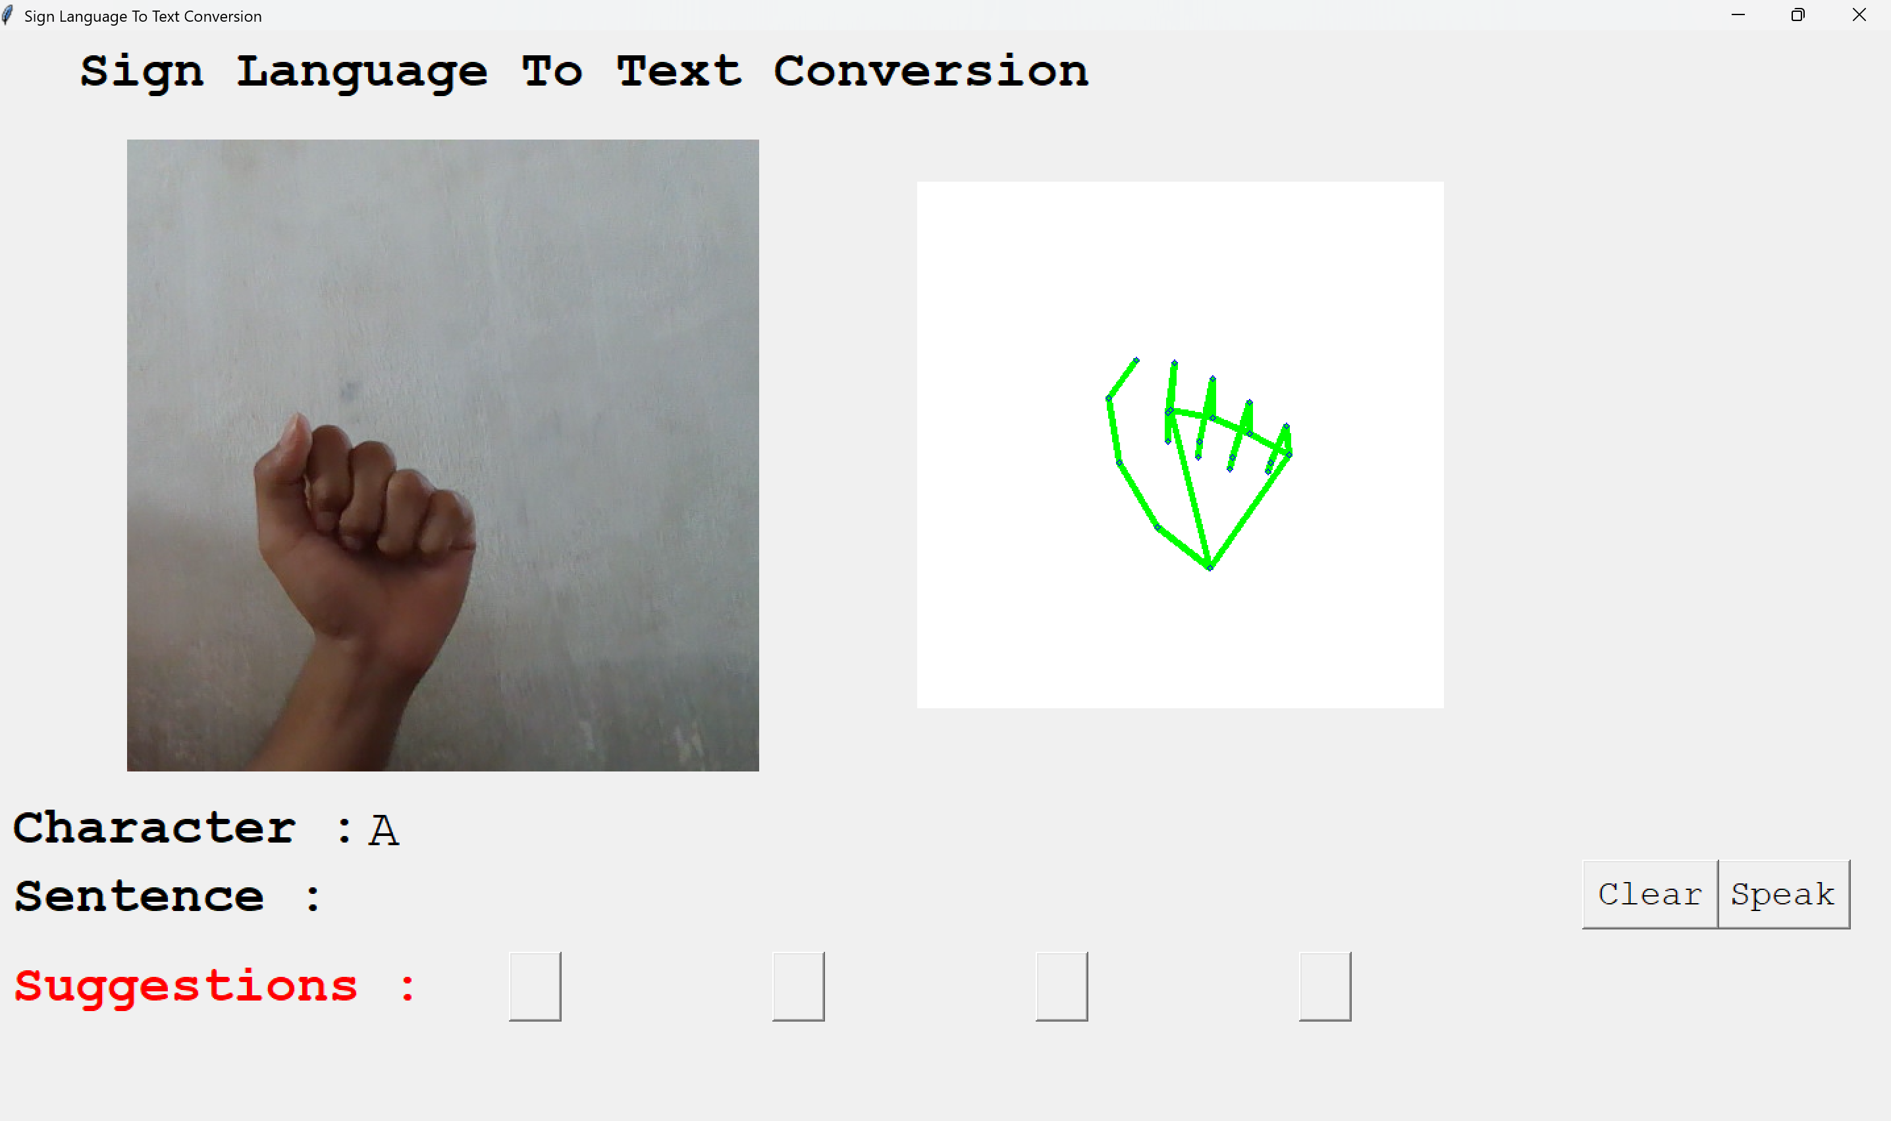

Fig 3.4.1 TRACKING HAND GESTURES

Hand detection and tracking are critical components of Wave2Words, enabling precise and efficient sign language recognition. The system utilizes advanced computer vision techniques to detect hand landmarks, map key points such as fingertips and joints, and track their movements dynamically. By leveraging deep learning models, it ensures high accuracy, adapting to different hand orientations, speeds, and environmental conditions. This adaptability significantly reduces errors and enhances real-time gesture interpretation, making sign language communication more accessible.

Motion analysis plays a crucial role in distinguishing between similar gestures, especially when differentiating static signs from dynamic movements. Wave2Words integrates optimized tracking algorithms that analyze velocity, direction, and gesture transitions, ensuring smooth and accurate translation. These algorithms help prevent misclassification by continuously monitoring hand positions, enabling a more fluid and intuitive interaction. The system also refines its tracking performance by accounting for background variations, minimizing interference from surrounding objects.

The real-time nature of Wave2Words is enhanced through latency-reducing techniques, ensuring that gestures are translated into speech with minimal delay. By processing continuous hand movements efficiently, the system allows for natural conversations without interruptions. The combination of deep learning, motion analysis, and environmental adaptability makes Wave2Words a robust solution for sign language interpretation, bridging communication gaps and fostering inclusivity.

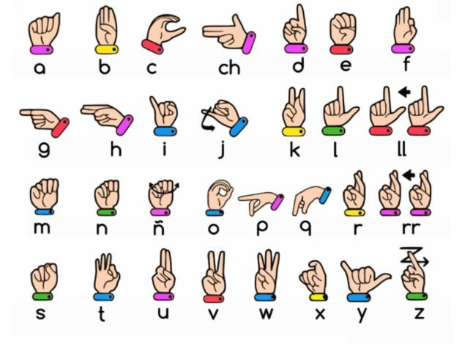

Fig 3.4.2 SIGN LANGUAGES

After tracking hand gestures, the trained model plays a crucial role in identifying sign language by analyzing detected hand movements and shapes. The model, built on a diverse dataset of sign language gestures, processes real-time input from the tracking system to classify and interpret signs with high accuracy. This system ensures seamless communication between sign language users and those who rely on spoken language.

Utilizing advanced deep learning techniques such as Convolutional Neural Networks (CNNs) and Recurrent Neural Networks (RNNs), the model extracts essential features from tracked hand positions and movements. CNNs specialize in recognizing spatial patterns in hand shapes, while RNNs analyze temporal sequences to detect the flow of gestures over time. By comparing extracted features with sign language patterns in its

database, the system can accurately identify complex hand movements while factoring in variations in gesture speed, hand orientation, and background conditions.

Once a gesture is recognized, it is mapped to its corresponding word or phrase, allowing the system to generate real-time text output or speech conversion using a Text-to-Speech (TTS) engine. This functionality provides natural and fluid communication, making interactions more intuitive for sign language users. Additionally, the model continuously learns and adapts to new gestures over time, improving recognition accuracy and enhancing efficiency. By integrating real-time processing with adaptive learning capabilities, the system refines gesture classification, ensuring a reliable and scalable solution for sign language translation.

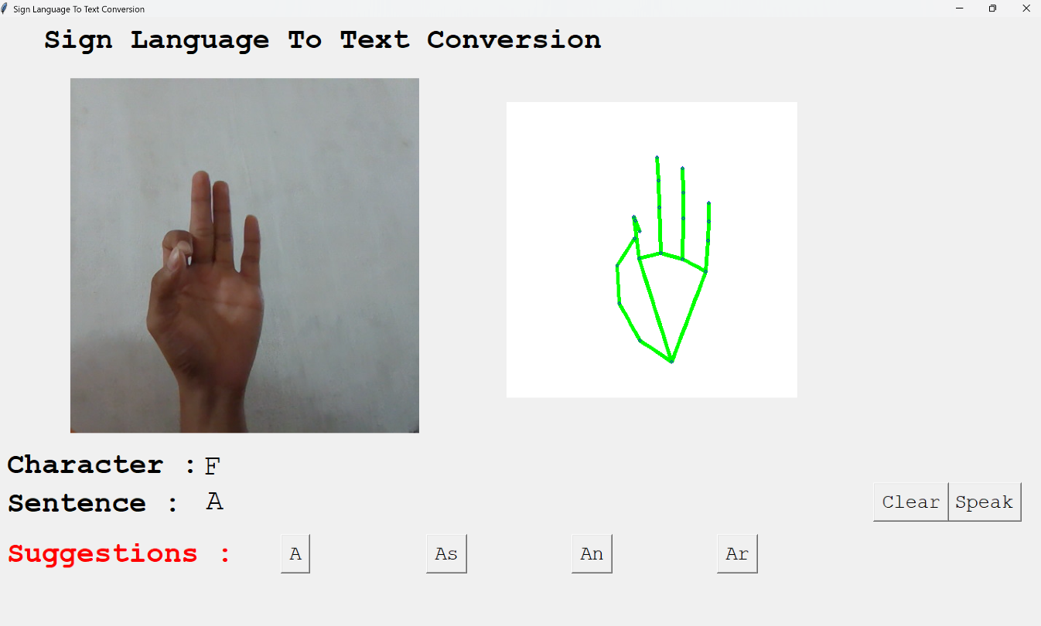

Fig 3.4.3 PREDICTING SIGN LANGUAGES

The system operates in real-time, ensuring that sign language gestures are swiftly translated into speech with minimal latency. This capability is crucial for enabling natural and uninterrupted communication between sign language users and those relying on spoken language. As a user performs gestures, the system instantly processes and converts them into audible speech, facilitating seamless interaction in live conversations.

Real-time translation is particularly valuable in dynamic environments, such as meetings, classrooms, interviews, and customer service interactions, where immediate responses are essential. The system continuously monitors and interprets hand movements, ensuring accurate speech conversion without delays. By minimizing lag, it maintains the flow of dialogue, allowing for more engaging and productive exchanges.

To achieve this level of responsiveness, the system incorporates optimized processing algorithms, leveraging deep learning models to analyze gesture sequences efficiently. The integration of high-speed computational techniques ensures that sign language recognition remains precise even in complex scenarios. Additionally, adaptive learning mechanisms refine recognition accuracy over time, enhancing the overall reliability of real-time sign-to-speech conversion.

By delivering instantaneous speech output, this technology bridges communication gaps, fostering inclusivity and accessibility for the deaf and hard-of-hearing community in everyday interactions. It empowers users with a tool that allows for effortless expression, making sign language translation more practical and effective in diverse settings.

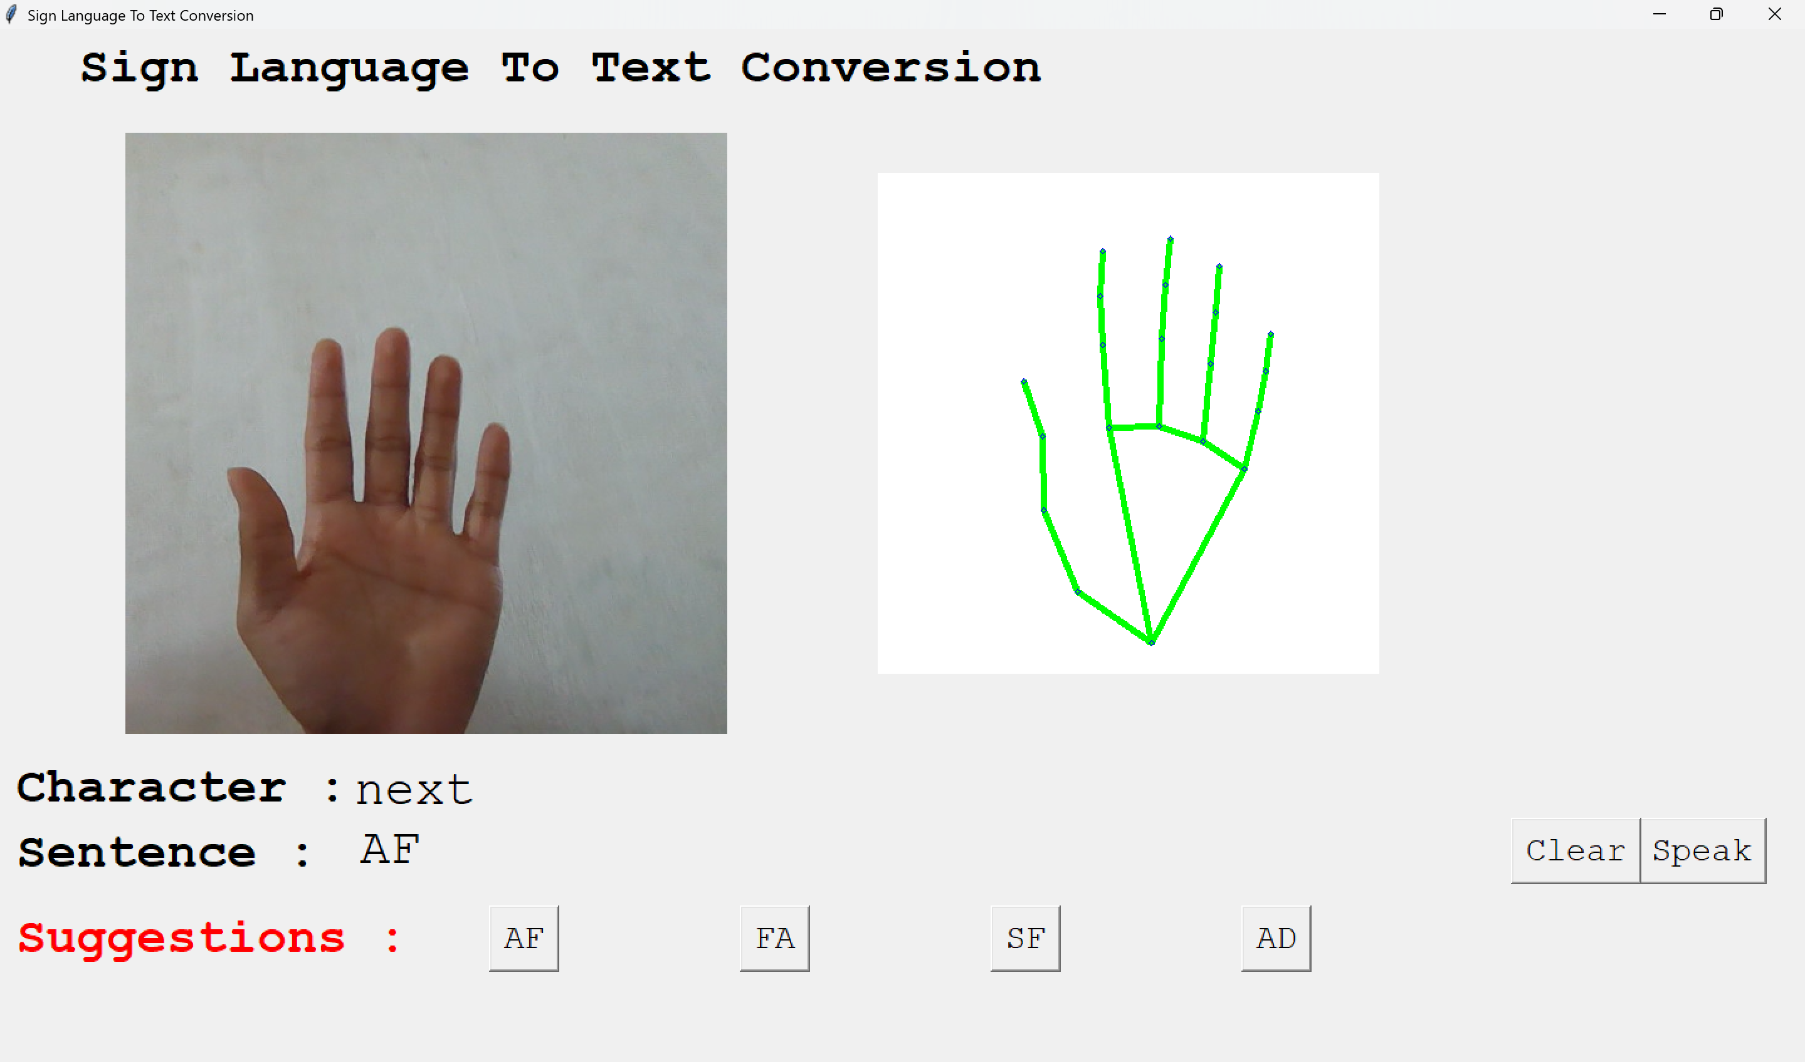

Fig 3.4.4 TRANSLATING TEXT TO SPEECH

The Text-to-Speech (TTS) Translation module plays a pivotal role in converting recognized sign language gestures into audible speech, ensuring a fluid and natural communication experience. Once a gesture is classified by the recognition system, the corresponding word or phrase is processed through this module, where advanced speech synthesis techniques transform it into spoken output.

This module consists of two key components: natural language generation (NLG) and speech synthesis. The NLG system ensures that gestures mapped to words or phrases are formed into grammatically coherent sentences when required. For example, if individual gestures represent multiple words, NLG structures them into complete sentences, making the spoken output more natural and contextually appropriate.

The speech synthesis engine then generates human-like speech using deep learning-based TTS models, such as neural vocoders and waveform synthesis techniques. These models improve the intonation, rhythm, and clarity of the generated speech, ensuring the final output closely resembles natural human speech. The system also optimizes pronunciation and articulation, accounting for variations in sign language structure to create a seamless voice translation experience. Through real-time processing, the module minimizes latency, allowing sign language users to communicate effortlessly with hearing individuals.

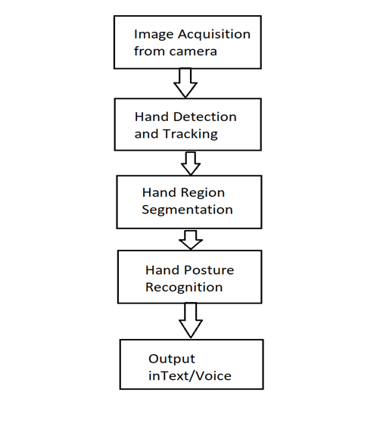

Fig 3.4.5 Data Flow Diagram

The Wave2Words system is designed to recognize and convert sign language gestures into text or speech in real-time, ensuring seamless communication. The process involves five essential steps: image acquisition, hand detection and tracking, hand region segmentation, hand posture recognition, and output in text/voice. Each step plays a critical role in ensuring high accuracy and efficiency in gesture-based interactions.

1. Image Acquisition from Camera
The first step in the process is capturing images or video streams using a high-resolution RGB or depth camera. The quality of image acquisition significantly impacts recognition accuracy. Key components in this stage include:
- Frame selection: The system extracts relevant frames from continuous video streams for efficient processing.
- Noise reduction: Image processing algorithms remove unwanted distortions or background artifacts to enhance clarity.
- Contrast enhancement: Adjusting brightness and contrast ensures better visibility of hand gestures, improving recognition.
- Depth sensing: In cases where infrared or depth cameras are used, hand positioning is refined for greater accuracy.
Once the image is acquired, it moves to the next stage for hand detection.

2. Hand Detection and Tracking
In this phase, the system detects the presence of hands in the captured image and ensures continuous tracking of hand movements. This is achieved through:
- Deep learning-based object detection models, such as YOLO (You Only Look Once) or SSD (Single Shot Detector), which efficiently locate hand positions.

- Multi-frame tracking: The system tracks movement across consecutive frames to maintain accuracy.
- Adaptive tracking models: Algorithms adjust hand tracking based on variations in speed, orientation, and external conditions (e.g., different lighting).
- Temporal coherence: Utilizing Long Short-Term Memory (LSTM) networks to ensure gesture continuity in dynamic movements.
By ensuring robust tracking, the system can precisely follow hand movements for accurate recognition.

3. Hand Region Segmentation
Once a hand is detected, the system isolates it from the background through segmentation techniques, enabling more precise gesture identification. This involves:
- Color-based segmentation: Detecting skin tones to distinguish hands from other objects.
- Depth-based segmentation: Using depth sensors to separate the hand from the background.
- Contour mapping: Identifying the edges of the hand to refine segmentation.
- Motion filtering: Removing non-hand objects in the frame to improve accuracy.
With a clean and isolated hand region, the system is ready for posture recognition.

4. Hand Posture Recognition
After segmentation, the system classifies gestures using machine learning models, analyzing hand posture, movement, and orientation. The process includes:
- Neural networks (CNNs, RNNs) for deep gesture classification.
- Support Vector Machines (SVMs) for structured posture recognition.
- Gesture feature extraction: Identifying key characteristics of each sign.

- Dynamic gesture recognition: Differentiating between similar static and moving gestures.
Posture recognition enables the conversion of gestures into meaningful symbols for text or speech output.

5. Output in Text/Voice
Once a gesture is classified, the system maps it to corresponding words or phrases, converting them into text or speech output:
- Text generation: The system displays recognized gestures in written format.
- Speech synthesis: Using Text-to-Speech (TTS) engines, such as Neural Voice models, to generate natural spoken output.
- Contextual processing: Adjusting word formation for grammatical coherence when translating multiple gestures.
- Multi-modal integration: Displaying both text and speech output simultaneously for accessibility.
Through real-time processing, Wave2Words provides instantaneous sign language translation, making communication efficient, natural, and accessible to users across different platforms.

CHAPTER 4

TESTING AND MAINTENANCE

TESTING USE CASES:

Test case  id | Module | Description | Preconditi ons | Test steps | Expected result | Status
1 | Home | Displays the main interface of the system. | None | Reload the application and check if all UI elements are visible. | Home screen is displayed with all options. | Pass
2 | Data Acquisition | Captures sign language gestures using a camera. | Camera must be connected and accessible. | Perform sign gestures and check if they are recorded. | Gestures are captured successfully. | Pass
3 | Feature Extraction | Extracts key features from gesture data. | Preprocessed data must be available. | Run feature extraction algorithm. | Key gesture features are extracted successfully. | Pass

4 | Gesture Classification | Recognizes gestures and maps them to corresponding words. | Extracted features must be available. | Perform different gestures and check classification results. | Correct words are displayed for given gestures. | Pass
5 | Text-to-Speech (TTS) | Converts recognized text into speech. | Gesture classification must be completed. | Verify if recognized text is converted into audible speech. | Speech output matches the recognized text. | Pass
6 | UI & Accessibility | Ensures the interface is user-friendly and accessible. | None | Navigate through the interface and check usability. | UI is interactive and accessible. | Pass

MAINTANANCE:

Regular maintenance is essential to keep the Wave2Words system functional, stable, and reliable across all modules. This plan focuses on performance improvements, error handling, adaptability, and usability, ensuring a seamless experience for users. Testing, updates, and optimizations will verify that features continue to operate effectively after system modifications or environmental changes.

1. Home Module Maintenance
The home interface serves as the primary access point for users, requiring periodic updates for accessibility and usability.
- Admin Panel Enhancements: Enable administrators to modify banners, welcome messages, and UI elements such as fonts, colors, and layouts.
- Dynamic Content Updates: Implement real-time modifications to ensure responsive design based on user preferences.
- Version Control System: Maintain rollback capabilities to revert updates in case of errors or compatibility issues.
- Cross-Device Compatibility: Conduct regular tests to ensure proper functioning across multiple screen sizes, resolutions, and operating systems.

2. Data Acquisition Maintenance
This module collects input from various camera models and sensors, requiring continuous monitoring for optimal gesture detection.
- Hardware Compatibility: Support diverse camera and sensor types, including RGB, infrared, and depth-based models.
- Environmental Adaptability: Improve algorithms for varying lighting conditions, motion blur, and background noise management.
- Diagnostic & Calibration Tools: Implement real-time diagnostic features for troubleshooting frame capture and connectivity issues.

- Firmware & Driver Updates: Keep camera firmware and drivers up to date for optimal performance.

3. Feature Extraction Maintenance
Accurate gesture interpretation relies on efficient feature extraction.
- Algorithm Refinements: Enhance gesture recognition algorithms for new gestures, variations, and user-specific signing styles.
- Input Source Compatibility: Ensure smooth recognition across different video resolutions and lighting conditions.
- Self-Learning Mechanisms: Integrate AI-driven learning processes that improve feature detection accuracy over time.
- Performance Optimization: Streamline data processing to reduce latency and computational load for real-time responsiveness.

4. Gesture Classification Maintenance
Reliable classification is key to translating sign language accurately.
- Dataset Expansion: Regularly retrain machine learning models with diverse datasets for increased accuracy.
- Admin Control for Gesture Mapping: Allow flexibility in modifying gesture mappings for personalized interaction.
- User Feedback Integration: Implement a system for users to report misclassifications, contributing to continuous improvements.
- Error Handling & Recovery: Introduce fallback mechanisms to detect incorrect classifications and suggest alternatives.

5. Text-to-Speech (TTS) Maintenance
The TTS module converts recognized gestures into natural speech, requiring optimizations to improve clarity and accessibility.
- Voice Engine Updates: Upgrade speech synthesis models for more lifelike and expressive speech.
- Customization Options: Allow users to adjust accents, pitch, speed, and voice styles.
- Platform Compatibility: Ensure seamless operation across different devices, operating systems, and assistive technologies.
- Pronunciation Accuracy: Enhance phonetic processing to improve fluency and articulation in spoken output.

6. UI & Accessibility Maintenance
Creating an inclusive and user-friendly experience is a core goal of Wave2Words.
- Accessibility Compliance: Maintain WCAG (Web Content Accessibility Guidelines) standards for visually impaired users.
- Keyboard & Voice Commands: Implement gesture-free navigation options for users who prefer alternate input methods.
- Customizable Interface: Offer themes, font adjustments, and layout customization through an admin panel.
- Usability Testing: Conduct accessibility audits to validate screen reader compatibility and UI responsiveness.

CHAPTER 5

RESULT

The implementation of the Wave2Words system using machine learning involves a series of interconnected processes that work cohesively to translate sign language gestures into spoken words efficiently and accurately. The system begins with the acquisition of gesture data through a camera or sensor, which records the user's hand movements in real-time. This data is crucial, as it serves as the foundation for further processing. The choice of hardware significantly impacts the accuracy of recognition, with high-resolution RGB cameras, depth sensors, and infrared cameras being commonly utilized to enhance tracking precision. The recorded images undergo preprocessing to refine the raw input, removing unwanted noise, normalizing lighting conditions, and focusing solely on the hand region. These preprocessing techniques ensure that the extracted features are clear and distinguishable, which is essential for accurate gesture classification.

After preprocessing, the system advances to the gesture recognition phase, where machine learning models analyze the refined images and classify the detected gestures into specific sign language words or phrases. Deep learning techniques, particularly Convolutional Neural Networks (CNNs), play a pivotal role in identifying patterns within hand movements. These models have been trained on extensive datasets containing various sign language gestures, allowing the system to make informed classifications. The system must also consider dynamic factors such as hand orientation, movement speed, and background conditions, ensuring adaptability in diverse environments. By comparing captured gestures with pre-existing patterns stored in its database, the recognition model efficiently determines the intended meaning behind each sign, making communication seamless and reliable.

Once the system successfully recognizes a gesture, it proceeds to the text generation phase, where the classified sign is converted into its corresponding word or phrase. This process involves mapping the identified gesture to its appropriate textual representation based on predefined linguistic structures. The system ensures consistency between recognized gestures and generated text, maintaining grammatical accuracy when forming sentences from multiple sign language inputs. If the recognized gesture corresponds to a standalone word, it is directly translated into text without modifications. However, if the input consists of a complex sequence of gestures forming a sentence, the system applies natural language processing techniques to structure the output coherently. The ability to generate well-structured text from sign gestures enhances the practicality of the system, allowing users to communicate effectively.

Following text generation, the final step in the pipeline is the text-to-speech (TTS) conversion, where the produced text is transformed into spoken words. The TTS engine synthesizes speech using advanced algorithms that adjust tone, pitch, and speed to ensure natural-sounding output. The system supports multiple voice styles, accents, and intonations, making communication feel more personalized and expressive. The synthesized speech is delivered in real-time, minimizing latency and allowing conversations to flow naturally without delays. This seamless transition from gesture recognition to speech conversion is particularly beneficial in settings where immediate interaction is required, such as classrooms, workplaces, and public service environments. The ability to convert sign language into speech with minimal delay significantly enhances accessibility for individuals with hearing impairments, fostering inclusivity in everyday communication.

The Wave2Words system operates with real-time capabilities, ensuring that sign language gestures are translated into speech almost instantaneously. The efficiency of the system lies in its ability to process hand movements continuously, providing instant feedback to the user. The integration of optimized tracking algorithms allows the system to maintain

accuracy even in dynamic conditions, distinguishing between subtle hand movements and complex gestures. This real-time responsiveness is crucial for fluid conversations, eliminating the need for long pauses or manual interpretation. Whether in professional meetings, casual interactions, or emergency situations, the system ensures that sign language users can convey their thoughts effortlessly through spoken communication.

User accessibility is a core focus of Wave2Words, reflected in its intuitive interface designed for ease of use. The system features a simple yet effective visual display that provides users with immediate confirmation of recognized gestures, displaying the corresponding text alongside the spoken output. This dual-feedback mechanism ensures that users are aware of how their gestures are interpreted, allowing for corrections if necessary. The interface also offers customization options, enabling users to adjust speech speed, voice tone, and pronunciation preferences according to their needs. By incorporating both visual and audio elements, Wave2Words enhances user engagement, making it an accessible tool for individuals of all age groups and skill levels. The system prioritizes usability, ensuring that even those unfamiliar with technology can operate it without difficulty.

The implementation of Wave2Words using machine learning is a testament to the advancements in artificial intelligence and human-computer interaction. By combining computer vision, deep learning, and speech synthesis, the system bridges the communication gap between sign language users and hearing individuals. The real-time processing, adaptive learning capabilities, and user-friendly interface make it a practical and efficient solution for facilitating inclusive communication. As the technology continues to evolve, further improvements in gesture recognition accuracy and speech naturalness will enhance the overall user experience, paving the way for broader adoption in various sectors. Through continuous innovation, Wave2Words remains committed to breaking barriers and empowering individuals with the tools they need for effective and accessible communication.

CHAPTER 6 CONCLUSION & FUTURE WORK

The Wave2Words system, powered by machine learning, represents a breakthrough in assistive technology by facilitating communication between individuals who use sign language and those who rely on spoken language. By leveraging advanced deep learning techniques for gesture recognition, the system precisely detects and interprets sign language gestures, converting them into spoken words in real time. This capability enables seamless interactions, allowing sign language users to express themselves naturally without requiring an intermediary. The integration of text-to-speech (TTS) technology further enhances the system’s effectiveness by ensuring fluid speech synthesis with high clarity, making conversations more natural and accessible.

Scalability and adaptability are core strengths of the Wave2Words system, making it suitable for implementation across various platforms, including mobile devices, computers, and specialized assistive communication tools. Its robust architecture ensures compatibility with diverse hardware configurations, allowing users to engage in sign-to-speech translation regardless of their preferred device. The system's ability to operate efficiently across different environments—whether in academic institutions, workplaces, or public spaces—demonstrates its potential to significantly enhance accessibility and foster inclusivity for individuals with hearing impairments.

Beyond improving communication, Wave2Words empowers users by promoting independence and greater participation in social and professional settings. By eliminating barriers that traditionally hinder conversations between hearing and non-hearing individuals, the system facilitates smoother interactions and encourages broader acceptance of sign language as an integral part of communication. The ability to provide instant speech

conversion enables sign language users to engage more confidently in discussions, whether in interviews, presentations, or casual conversations, ultimately enhancing their overall experience in diverse scenarios.

Future Enhancement:
Future advancements in Wave2Words will focus on refining accuracy, expanding scalability, and enhancing accessibility to further improve its functionality in real-world applications. One area of improvement involves optimizing the gesture classification model to support a wider range of sign languages, including regional variations. By integrating advanced neural network architectures such as transformers or multimodal learning models, the system can achieve greater precision in recognizing complex hand movements and adapting to different linguistic contexts. Supporting more sign languages would enable broader adoption and make the system more effective for users worldwide.

Enhancing real-time processing capabilities will be essential to ensure smooth interactions with minimal latency, particularly in resource-constrained environments. Future versions of Wave2Words could incorporate facial expression and body posture recognition, which are fundamental aspects of sign language that provide additional context for accurate interpretations. These enhancements would enrich the translation process, enabling more nuanced and expressive conversations. Improved gesture tracking algorithms, combined with adaptive learning models, would allow the system to refine its accuracy based on user feedback and continuously evolve.

Expanding accessibility features will also be a key focus for future development. Deploying Wave2Words across multiple platforms, including mobile applications, web interfaces, and wearable devices, would increase its reach and usability. Introducing multilingual text-to-speech (TTS) support would further enhance accessibility by enabling users to receive speech output in different languages, allowing communication across linguistic boundaries.

Integrating edge computing capabilities to minimize dependence on internet connectivity would also improve performance in offline environments, ensuring reliable operation in situations where internet access may be limited.

User-driven enhancements, such as enabling users to contribute new gestures or customize recognition settings based on personal preferences, will foster adaptability and user satisfaction. Engaging with linguists, accessibility experts, and the deaf community will further refine the system’s effectiveness, ensuring cultural relevance and continuous improvement. By prioritizing user feedback and iterative enhancements, Wave2Words will remain a leading solution for bridging communication gaps and promoting inclusivity across education, healthcare, customer service, and various other sectors.

Through ongoing innovation and development, Wave2Words will continue to evolve as a powerful tool for enabling accessible communication. The combination of machine learning, deep learning models, and user-centric design ensures that the system remains practical and efficient in facilitating meaningful interactions. As technology advances, Wave2Words will remain committed to making sign language translation more accurate, accessible, and widely adopted, ultimately contributing to a more inclusive and connected world. Let me know if you'd like further refinements or additional insights.

CHAPTER – 7

ANNEXURE

  - - APPENDIX I (CODING LOGIC)

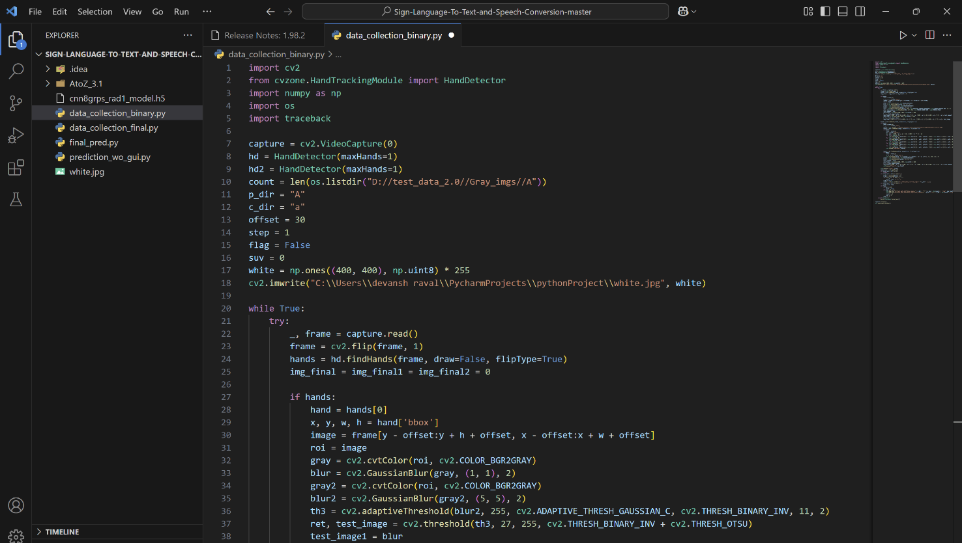

Fig 7.1.1 – data prediction binary

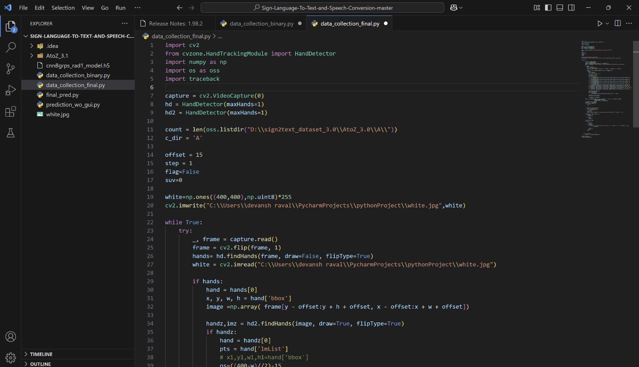

Fig 7.1.2 – data collection final

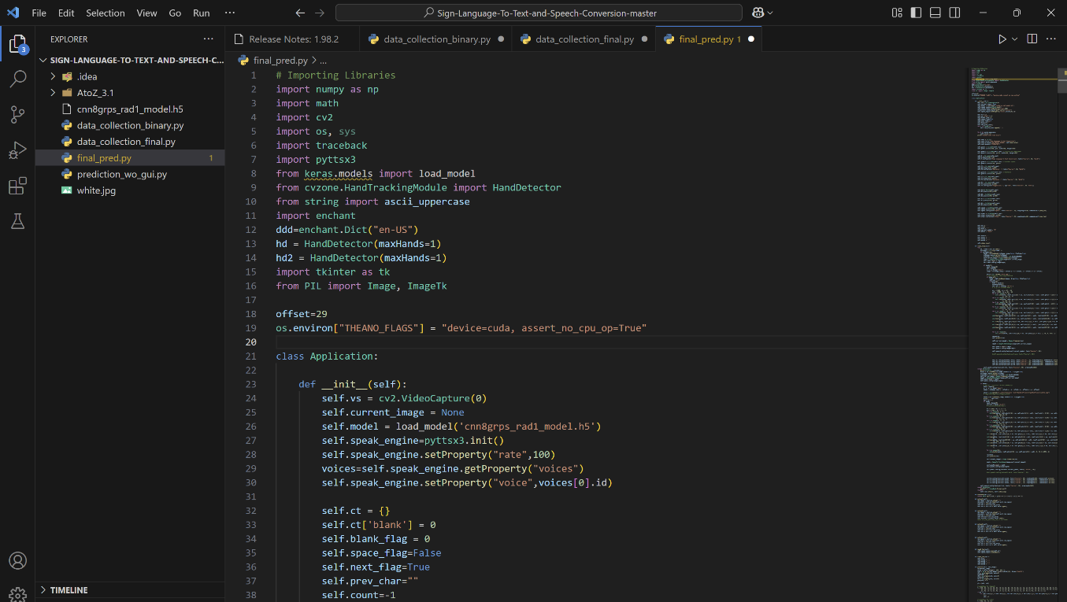

Fig 7.1.3 – final prediction

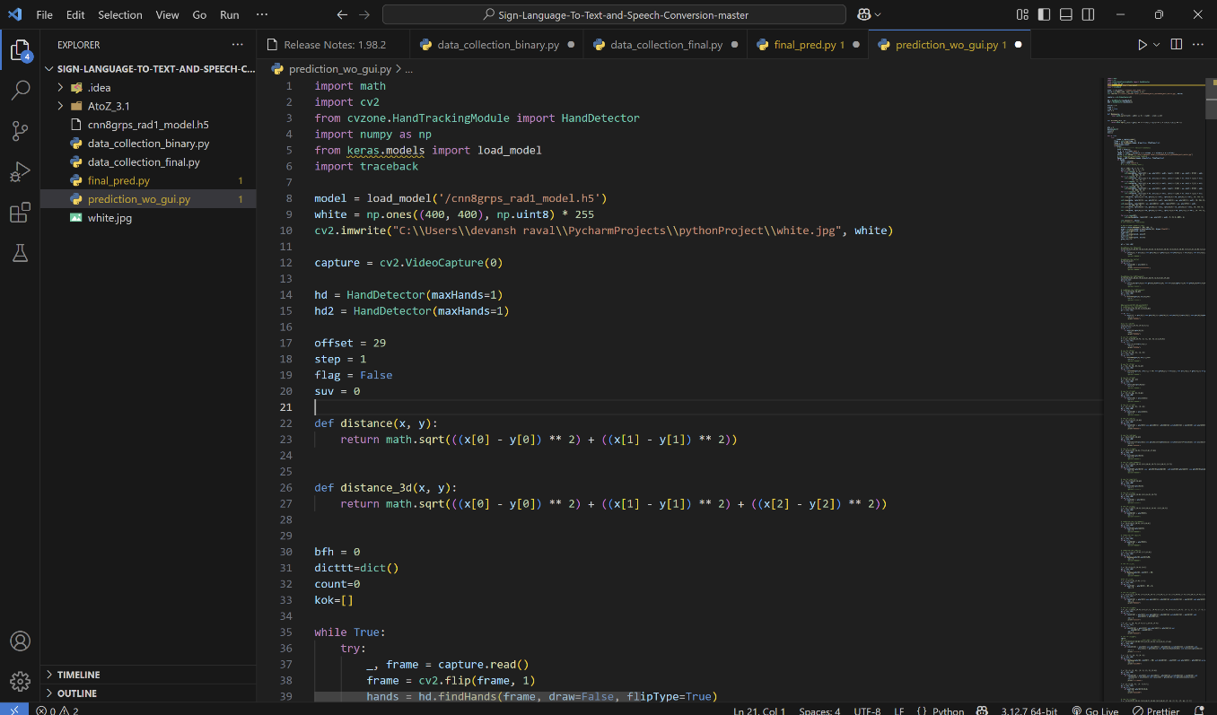

Fig 7.1.4 – graphical user interface

  - - APPENDIX II (REFERENCES)

- Chatterjee, S., & Srivastava, A. (2020). Deep Learning for Gesture Recognition: A Comprehensive Survey. Journal of Visual Communication and Image Representation, 74, 102990.

- Gupta, S., & Sharma, S. (2021). Sign Language Recognition Using Deep Learning Techniques: A Survey. International Journal of Computer Applications, 177(19), 34-38.
- Kim, Y., & Park, C. (2020). A Review of Sign Language Recognition Using Convolutional Neural Networks. IEEE Access, 8, 71252-71263.
- Lippiello, V., Siciliano, B., & Siciliano, L. (2019). Real-time Gesture Recognition for Sign Language Translation. Journal of Robotics and Autonomous Systems, 118, 232-240.
- Li, W., Xu, J., & Lee, C. (2019). Hand Gesture Recognition System for Communication in Sign Language. Neural Computing and Applications, 31(12), 9423-9432.
- Liao, T. H., & Wang, C. W. (2018). Sign Language Recognition Using Deep Convolutional Networks. Sensors, 18(11), 3716.

- Nguyen, A., & Tran, D. (2020). Speech Synthesis for Sign Language Recognition Systems. Journal of Machine Learning and Signal Processing, 27(4), 130-145

- Roy, A., & Mehta, D. (2021). Integration of Deep Learning Models for Sign Language Recognition Systems. Artificial Intelligence Review, 54(2), 1-13.

- Sharma, A., & Ghosal, S. (2020). A Hybrid Approach for Gesture Recognition Using CNN-RNN Models. International Journal of Artificial Intelligence & Applications, 11(3), 10-25.
- Tiwari, R., & Joshi, P. (2019). Improving the Accuracy of Sign Language Recognition Using Transfer Learning. International Journal of Computer Vision and Image Processing, 9(1), 39-49.

  - - APPENDIX III (PUBLICATIONS)

