《机器学习》实验报告

年级、专业、班级 |  |  |  |  | 姓名
实验题目 | BP算法实践
实验时间 | 2026年4月26日 |  | 实验地点 | DS1402
实验成绩 |  |  | 实验性质 | □验证性 ☑设计性 □综合性
教师评价：
□算法/实验过程正确； □源程序/实验内容提交 □程序结构/实验步骤合理；
□实验结果正确； □语法、语义正确； □报告规范；
其他：
评价教师签名：
一、实验目的
掌握BP算法原理并编程实践。
二、实验项目内容
1.理解并描述BP算法原理。
2.编程实践，将算法应用于合适的分类数据集 (如鸢尾花、UCI数据集、Kaggle数据集)，要求算法至少用于两个数据集。
三、实验过程或算法（源程序）
1. Iris数据集
from pathlib import Path
import numpy as np
import matplotlib.pyplot as plt
import pandas as pd
DATA_ROOT = Path("/Users/previous_rium/Desktop/PY/ml_exp2/datasets/iris")
TRAIN_CSV = DATA_ROOT / "train" / "iris.csv"
# 高斯标准化
def standardize_fit_transform(x):
mean = x.mean(axis=0)
std = x.std(axis=0)
std[std == 0] = 1.0
return (x - mean) / std, mean, std
def standardize_transform(x, mean, std):
std_safe = std.copy()
std_safe[std_safe == 0] = 1.0
return (x - mean) / std_safe
def softmax(z):
z_shift = z - np.max(z, axis=1, keepdims=True)
exp_z = np.exp(z_shift)
return exp_z / np.sum(exp_z, axis=1, keepdims=True)
# 独热编码
def one_hot(y, n_classes):
out = np.zeros((len(y), n_classes), dtype=float)
out[np.arange(len(y)), y] = 1.0
return out
def indices(y, n_splits=10, seed=42):
rng = np.random.RandomState(seed)
y = np.asarray(y)
classes = np.unique(y)
chunks = {}
for c in classes:
idx = np.where(y == c)[0]
rng.shuffle(idx)
chunks[c] = np.array_split(idx, n_splits)
for fold in range(n_splits):
val_idx = np.concatenate([chunks[c][fold] for c in classes])
train_idx = np.setdiff1d(np.arange(len(y)), val_idx, assume_unique=True)
yield train_idx, val_idx
def multiclass_metrics(y_true, y_pred, n_classes):
cm = np.zeros((n_classes, n_classes), dtype=int)
for t, p in zip(y_true, y_pred):
cm[t, p] += 1
acc = np.trace(cm) / np.sum(cm)
precisions = []
recalls = []
f1s = []
for i in range(n_classes):
tp = cm[i, i]
fp = np.sum(cm[:, i]) - tp
fn = np.sum(cm[i, :]) - tp
precision = tp / (tp + fp) if (tp + fp) else 0.0
recall = tp / (tp + fn) if (tp + fn) else 0.0
f1 = 2 * precision * recall / (precision + recall) if (precision + recall) else 0.0
precisions.append(precision)
recalls.append(recall)
f1s.append(f1)
return acc, float(np.mean(precisions)), float(np.mean(recalls)), float(np.mean(f1s))
class model:
def __init__(self, n_features, n_classes, hidden_dim=16, lr=0.05, epochs=200, seed=42):
# BP 神经网络: input -> hidden(ReLU) -> softmax
rng = np.random.RandomState(seed)
self.w1 = rng.randn(n_features, hidden_dim) * np.sqrt(2.0 / n_features)
self.b1 = np.zeros((1, hidden_dim), dtype=float)
self.w2 = rng.randn(hidden_dim, n_classes) * np.sqrt(2.0 / hidden_dim)
self.b2 = np.zeros((1, n_classes), dtype=float)
self.lr = lr
self.epochs = epochs
self.losses = []
def fit(self, x, y):
n_classes = self.b2.shape[1]
y_oh = one_hot(y, n_classes)
best_loss = float("inf")
best_epoch = -1
best_w1 = self.w1.copy()
best_b1 = self.b1.copy()
best_w2 = self.w2.copy()
best_b2 = self.b2.copy()
for epoch in range(self.epochs):
# forward
z1 = x @ self.w1 + self.b1
a1 = np.maximum(0.0, z1) # ReLU
logits = a1 @ self.w2 + self.b2
probs = softmax(logits)
eps = 1e-12
loss = -np.mean(np.sum(y_oh * np.log(probs + eps), axis=1))
self.losses.append(loss)
# backward
grad_logits = (probs - y_oh) / len(y)
grad_w2 = a1.T @ grad_logits
grad_b2 = np.sum(grad_logits, axis=0, keepdims=True)
grad_a1 = grad_logits @ self.w2.T
grad_z1 = grad_a1 * (z1 > 0).astype(float)
grad_w1 = x.T @ grad_z1
grad_b1 = np.sum(grad_z1, axis=0, keepdims=True)
# update
self.w2 -= self.lr * grad_w2
self.b2 -= self.lr * grad_b2
self.w1 -= self.lr * grad_w1
self.b1 -= self.lr * grad_b1
if loss < best_loss:
best_loss = loss
best_epoch = epoch + 1
best_w1 = self.w1.copy()
best_b1 = self.b1.copy()
best_w2 = self.w2.copy()
best_b2 = self.b2.copy()
self.w1 = best_w1
self.b1 = best_b1
self.w2 = best_w2
self.b2 = best_b2
return best_loss, best_epoch
def predict(self, x):
z1 = x @ self.w1 + self.b1
a1 = np.maximum(0.0, z1)
logits = a1 @ self.w2 + self.b2
return np.argmax(logits, axis=1)
def train_one_fold(x_train, y_train, x_val, y_val, epochs=200, lr=0.05, seed=42):
clf = model(
n_features=x_train.shape[1], n_classes=3, lr=lr, epochs=epochs, seed=seed
)
best_loss, best_epoch = clf.fit(x_train, y_train)
save_path = Path("checkpoints") / "Iris.npz"
save_path.parent.mkdir(parents=True, exist_ok=True)
np.savez(save_path, w1=clf.w1, b1=clf.b1, w2=clf.w2, b2=clf.b2)
y_pred = clf.predict(x_val)
acc, precision, recall, f1 = multiclass_metrics(y_val, y_pred, n_classes=3)
return acc, precision, recall, f1, clf.losses, best_loss, best_epoch
def plot_loss_curve(losses, save_path):
epochs = np.arange(1, len(losses) + 1)
plt.figure(figsize=(8, 5))
plt.plot(epochs, losses, label="train_loss")
plt.xlabel("Epoch")
plt.ylabel("Loss")
plt.title("BP Network Training Loss (Iris)")
plt.grid(True, linestyle="--", alpha=0.4)
plt.legend()
plt.tight_layout()
plt.savefig(save_path, dpi=150)
plt.close()
def main():
np.random.seed(42)
df = pd.read_csv(TRAIN_CSV)
feature_cols = ["Sepal.Length", "Sepal.Width", "Petal.Length", "Petal.Width"]
target_col = "Species"
x = df[feature_cols].to_numpy(dtype=float)
y = (
df[target_col]
.map({"setosa": 0, "versicolor": 1, "virginica": 2})
.to_numpy(dtype=int)
)
# 使用分层 10 折中的第一折进行训练与验证
train_idx, val_idx = next(indices(y, n_splits=10, seed=42))
x_train, y_train = x[train_idx], y[train_idx]
x_val, y_val = x[val_idx], y[val_idx]
x_train, mean, std = standardize_fit_transform(x_train)
x_val = standardize_transform(x_val, mean, std)
acc, precision, recall, f1, losses, best_loss, best_epoch = train_one_fold(
x_train, y_train, x_val, y_val, epochs=200, lr=0.05, seed=42
)
curve_path = Path("checkpoints") / "Iris_loss_curve.png"
plot_loss_curve(losses, curve_path)
print("Validation results:")
print(
f"acc={acc:.4f}, precision(macro)={precision:.4f}, "
f"recall(macro)={recall:.4f}, f1(macro)={f1:.4f}"
)
print(
f"best_epoch={best_epoch}, best_train_loss={best_loss:.4f}, "
f"loss_curve={curve_path}"
)
if __name__ == "__main__":
main()

2.Winequality数据集（from Kaggle）
from pathlib import Path
import matplotlib.pyplot as plt
import numpy as np
import pandas as pd
from sklearn.metrics import accuracy_score, classification_report
from sklearn.model_selection import train_test_split
from sklearn.preprocessing import StandardScaler
DATA_ROOT = Path("/Users/previous_rium/Desktop/PY/ml_exp2/datasets/wine")
TRAIN_CSV = DATA_ROOT / "winequality-red.csv"
def softmax(z):
z_shift = z - np.max(z, axis=1, keepdims=True)
exp_z = np.exp(z_shift)
return exp_z / np.sum(exp_z, axis=1, keepdims=True)
def one_hot(y, n_classes):
out = np.zeros((len(y), n_classes), dtype=float)
out[np.arange(len(y)), y] = 1.0
return out
class BPMLP:
def __init__(
self, input_dim, hidden_dim, num_classes, lr=5e-4, epochs=180, seed=42
):
rng = np.random.RandomState(seed)
self.w1 = rng.randn(input_dim, hidden_dim) * np.sqrt(2.0 / input_dim)
self.b1 = np.zeros((1, hidden_dim), dtype=float)
self.w2 = rng.randn(hidden_dim, num_classes) * np.sqrt(2.0 / hidden_dim)
self.b2 = np.zeros((1, num_classes), dtype=float)
self.lr = lr
self.epochs = epochs
def fit(
self,
x_train,
y_train,
x_val,
y_val,
class_weights=None,
patience=30,
batch_size=64,
sample_probs=None,
):
y_train_oh = one_hot(y_train, self.b2.shape[1])
train_losses = []
val_losses = []
best_val_loss = float("inf")
best_epoch = -1
no_improve_epochs = 0
best_params = (self.w1.copy(), self.b1.copy(), self.w2.copy(), self.b2.copy())
for epoch in range(self.epochs):
# mini-batch SGD for better convergence than full-batch update
if sample_probs is None:
idx = np.random.permutation(len(y_train))
else:
# Weighted sampling helps minority classes appear more often.
idx = np.random.choice(
len(y_train), size=len(y_train), replace=True, p=sample_probs
)
epoch_loss_sum = 0.0
for start in range(0, len(y_train), batch_size):
batch_idx = idx[start : start + batch_size]
xb = x_train[batch_idx]
yb = y_train[batch_idx]
yb_oh = y_train_oh[batch_idx]
z1 = xb @ self.w1 + self.b1
a1 = np.maximum(0.0, z1)
logits = a1 @ self.w2 + self.b2
probs = softmax(logits)
eps = 1e-12
sample_ce = -np.sum(yb_oh * np.log(probs + eps), axis=1)
if class_weights is not None:
sample_ce = sample_ce * class_weights[yb]
batch_loss = float(np.mean(sample_ce))
epoch_loss_sum += batch_loss * len(batch_idx)
grad_logits = (probs - yb_oh) / len(batch_idx)
if class_weights is not None:
grad_logits = grad_logits * class_weights[yb][:, None]
grad_w2 = a1.T @ grad_logits
grad_b2 = np.sum(grad_logits, axis=0, keepdims=True)
grad_a1 = grad_logits @ self.w2.T
grad_z1 = grad_a1 * (z1 > 0).astype(float)
grad_w1 = xb.T @ grad_z1
grad_b1 = np.sum(grad_z1, axis=0, keepdims=True)
self.w2 -= self.lr * grad_w2
self.b2 -= self.lr * grad_b2
self.w1 -= self.lr * grad_w1
self.b1 -= self.lr * grad_b1
train_loss = epoch_loss_sum / len(y_train)
train_losses.append(float(train_loss))
val_probs = softmax(np.maximum(0.0, x_val @ self.w1 + self.b1) @ self.w2 + self.b2)
y_val_oh = one_hot(y_val, self.b2.shape[1])
eps = 1e-12
val_loss = float(-np.mean(np.sum(y_val_oh * np.log(val_probs + eps), axis=1)))
val_losses.append(val_loss)
if (epoch + 1) % 30 == 0:
train_probs = softmax(np.maximum(0.0, x_train @ self.w1 + self.b1) @ self.w2 + self.b2)
train_pred = np.argmax(train_probs, axis=1)
val_pred = np.argmax(val_probs, axis=1)
train_acc = np.mean(train_pred == y_train)
val_acc = np.mean(val_pred == y_val)
print(
f"Epoch {epoch + 1:03d} | train_loss={train_loss:.4f} | train_acc={train_acc:.4f} "
f"| val_loss={val_loss:.4f} | val_acc={val_acc:.4f}"
)
if val_loss < best_val_loss:
best_val_loss = val_loss
best_epoch = epoch + 1
best_params = (self.w1.copy(), self.b1.copy(), self.w2.copy(), self.b2.copy())
no_improve_epochs = 0
else:
no_improve_epochs += 1
if no_improve_epochs >= patience:
print(
f"Early stopping at epoch {epoch + 1}, no val_loss improvement for {patience} epochs."
)
break
self.w1, self.b1, self.w2, self.b2 = best_params
return best_val_loss, best_epoch, train_losses, val_losses
def predict(self, x):
logits = np.maximum(0.0, x @ self.w1 + self.b1) @ self.w2 + self.b2
return np.argmax(logits, axis=1)
def save_loss_curve(train_losses, val_losses, save_path: Path):
epochs = np.arange(1, len(train_losses) + 1)
plt.figure(figsize=(8, 5))
plt.plot(epochs, train_losses, label="train_loss")
plt.plot(epochs, val_losses, label="val_loss")
plt.xlabel("Epoch")
plt.ylabel("Loss")
plt.title("Wine Training Loss Curve")
plt.legend()
plt.grid(True, linestyle="--", alpha=0.4)
plt.tight_layout()
plt.savefig(save_path, dpi=150)
plt.close()
def train_once(
X_train,
y_train,
X_val,
y_val,
num_classes,
epochs=180,
lr=5e-3,
batch_size=64,
patience=30,
):
# Mild class reweighting for imbalanced wine quality labels.
class_counts = np.bincount(y_train, minlength=num_classes).astype(np.float64)
class_inv = 1.0 / np.maximum(class_counts, 1.0)
class_weights = np.power(class_inv, 0.5) # softer than inverse-frequency
class_weights = class_weights / class_weights.mean()
class_weights = np.clip(class_weights, 0.7, 2.5)
sample_weights = class_weights[y_train]
sample_probs = sample_weights / sample_weights.sum()
model = BPMLP(
input_dim=X_train.shape[1],
hidden_dim=64,
num_classes=num_classes,
lr=lr,
epochs=epochs,
seed=42,
)
save_dir = Path("checkpoints")
save_dir.mkdir(parents=True, exist_ok=True)
save_path = save_dir / "wine_best.npz"
best_val_loss, best_epoch, train_losses, val_losses = model.fit(
X_train,
y_train,
X_val,
y_val,
class_weights=class_weights,
patience=patience,
batch_size=batch_size,
sample_probs=sample_probs,
)
np.savez(save_path, w1=model.w1, b1=model.b1, w2=model.w2, b2=model.b2)
save_loss_curve(train_losses, val_losses, save_dir / "wine_loss_curve.png")
final_val_pred = model.predict(X_val)
val_acc = accuracy_score(y_val, final_val_pred)
print(
f"best_epoch={best_epoch}, best_val_loss={best_val_loss:.4f}, val_acc={val_acc:.4f}"
)
return val_acc, final_val_pred
def main():
np.random.seed(42)
df = pd.read_csv(TRAIN_CSV)
feature_cols = [col for col in df.columns if col != "quality"]
target_col = "quality"
X = df[feature_cols].to_numpy(dtype=np.float32)
y_raw = df[target_col].to_numpy(dtype=np.int64)
classes = np.sort(np.unique(y_raw))
class_to_idx = {c: i for i, c in enumerate(classes)}
idx_to_class = {i: c for c, i in class_to_idx.items()}
y = np.array([class_to_idx[v] for v in y_raw], dtype=np.int64)
X_train, X_val, y_train, y_val = train_test_split(
X, y, test_size=0.2, random_state=42, stratify=y
)
scaler = StandardScaler()
X_train = scaler.fit_transform(X_train)
X_val = scaler.transform(X_val)
val_acc, val_pred = train_once(
X_train,
y_train,
X_val,
y_val,
num_classes=len(classes),
epochs = 300,
lr=5e-3,
batch_size=64,
patience=30,
)
y_val_label = np.array([idx_to_class[i] for i in y_val])
y_pred_label = np.array([idx_to_class[i] for i in val_pred])
print("\nValidation results:")
print(f"Accuracy: {val_acc:.4f}")
print("\nValidation classification report:")
print(
classification_report(
y_val_label,
y_pred_label,
labels=classes,
digits=4,
zero_division=0,
)
)
if __name__ == "__main__":
main()

四、实验结果及分析

1.训练情况概览
图1: Iris数据集训练损失变化曲线
图2: winequality数据集训练损失变化曲线
图3: winequality数据集训练损失变化曲线（十折交叉验证，效果不如图2训练策略，只做对比，代码未作展示）

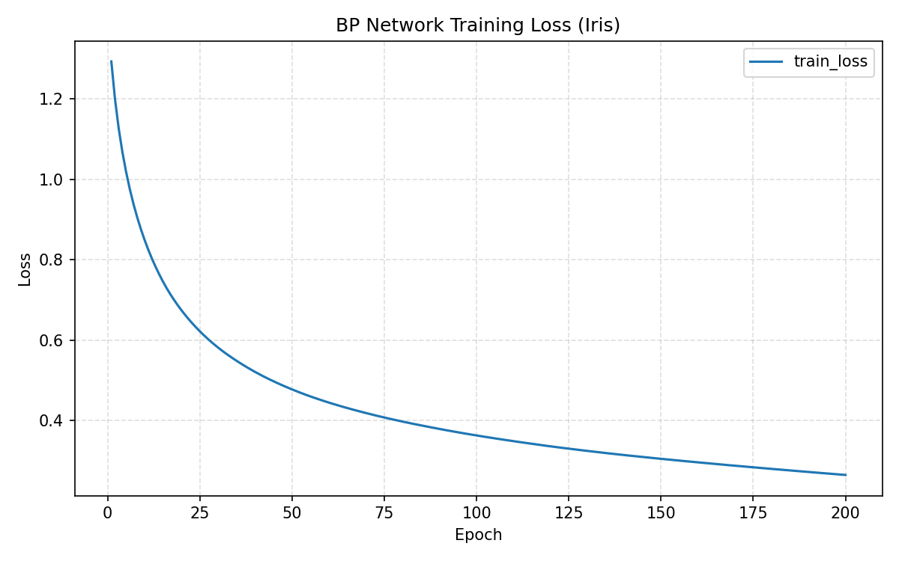
图1

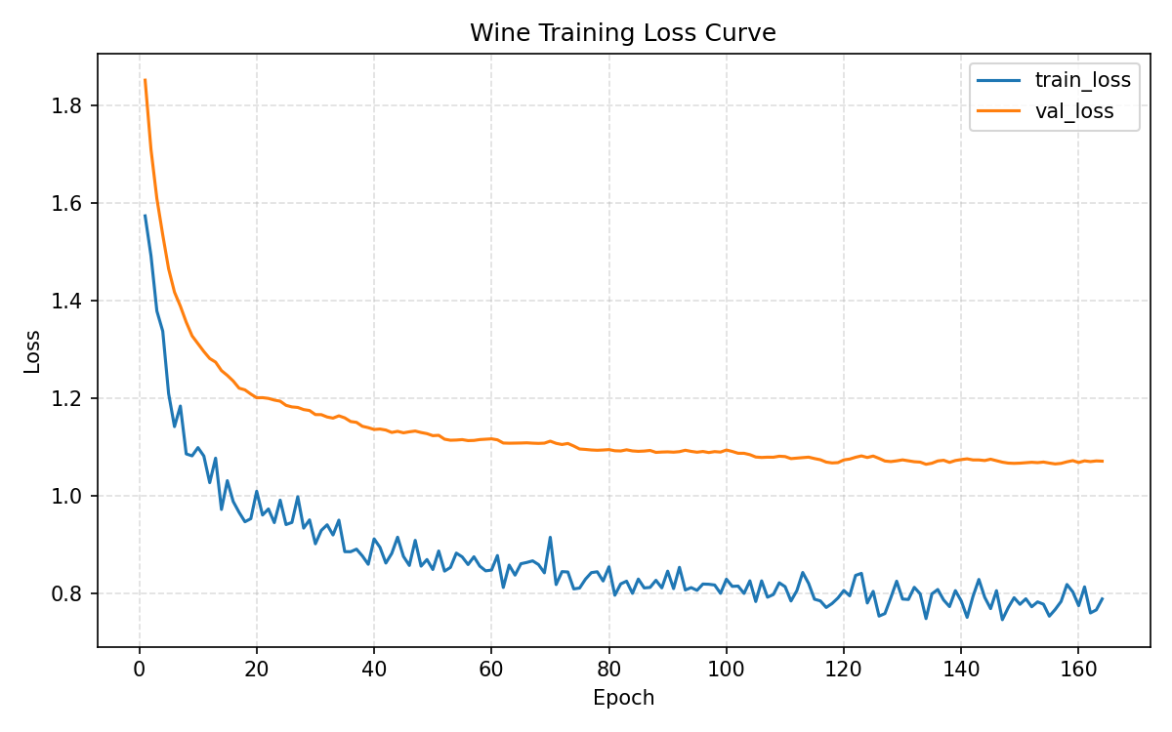
图2
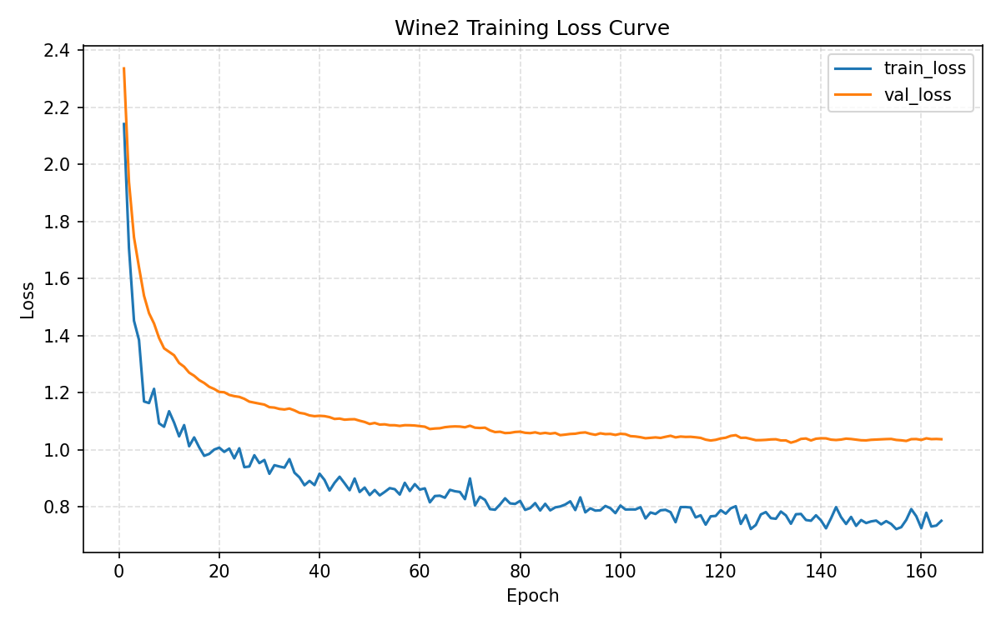
图3

2.Iris分类学习器训练结果

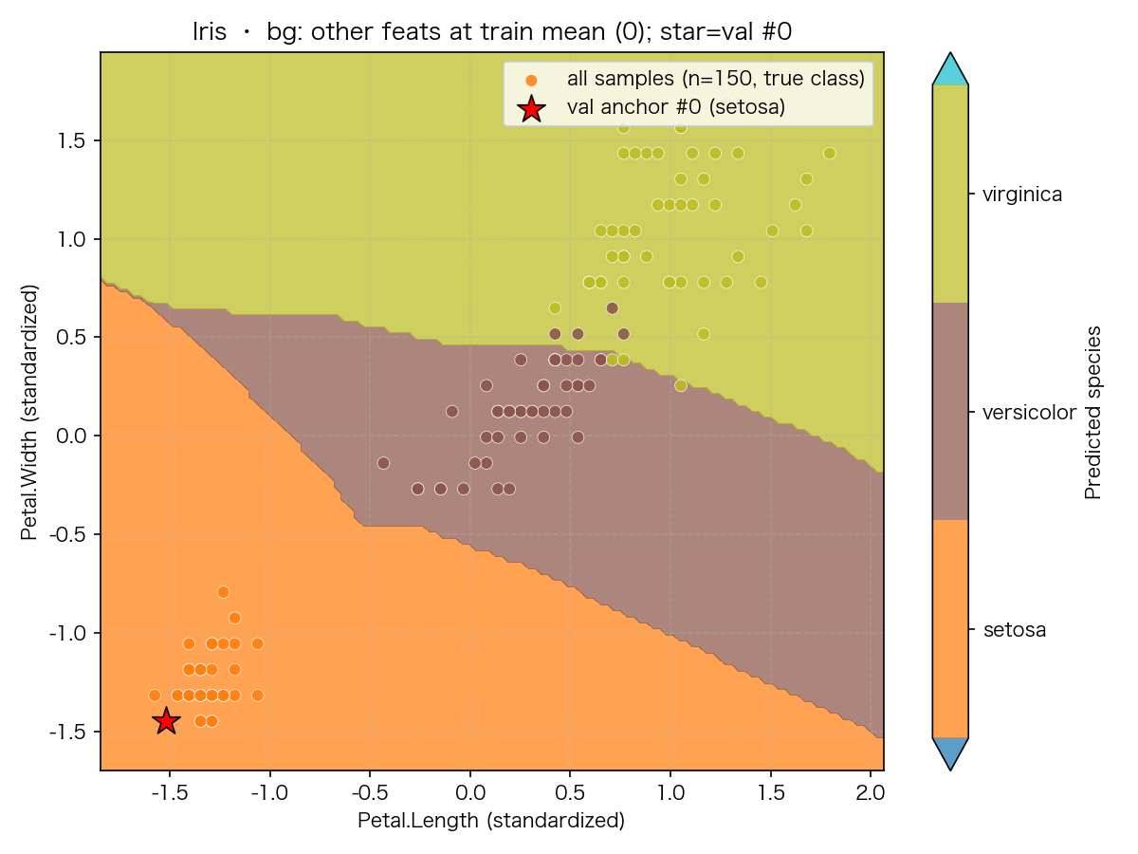
二维特征切片上的决策区域图（iris）

验证结果
指标 | Iris  （BP神经网络） | Iris  （对率回归，实验1）
Precision(mean) | 0.9444 | 0.9139
Recall(mean) | 0.9333 | 0.9000
F1(mean) | 0.9327 | 0.8973
3.wine_quality六分类学习器训练结果
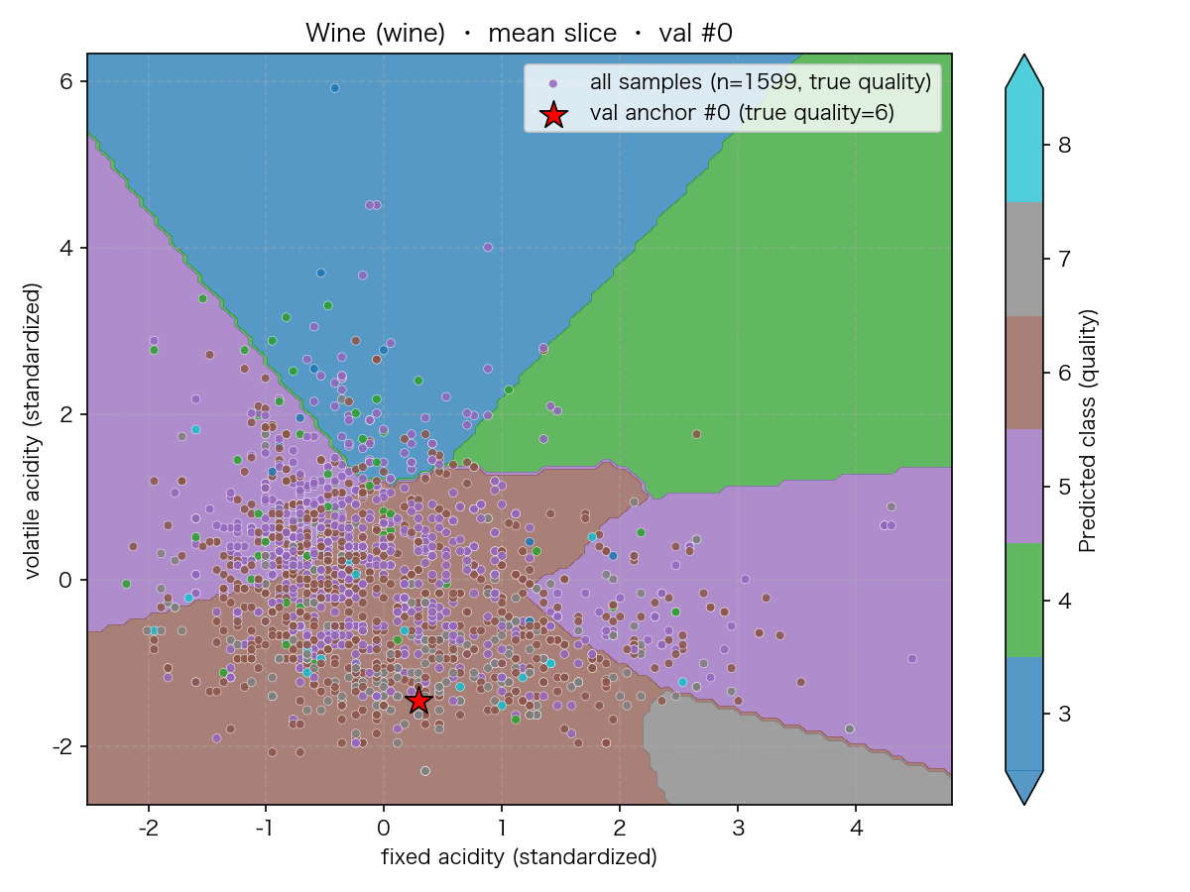
二维特征切片上的决策区域图（wine_quality）

*该数据集训练样本标签极度不平衡，导致占比极小的样本标签难以训练。
类别 | Quality = 3 |  | Quality = 4
类别 | Baseline | 十折交叉 | Baseline | 十折交叉
Precision | 0 | 0 | 0.2000 | 0
Recall | 0 | 0 | 0.0909 | 0
F1 | 0 | 0 | 0.1250 | 0
Support | 2 |  | 11

类别 | Quality = 5 |  | Quality = 6
类别 | Baseline | 十折交叉 | Baseline | 十折交叉
Precision | 0.6338 | 0.6329 | 0.5324 | 0.5538
Recall | 0.6618 | 0.7353 | 0.5781 | 0.5625
F1 | 0.6475 | 0.6803 | 0.5543 | 0.5581
Support | 136 |  | 128

类别 | Quality = 7 |  | Quality = 8
类别 | Baseline | 十折交叉 | Baseline | 十折交叉
Precision | 0.6000 | 0.6190 | 0 | 0
Recall | 0.3000 | 0.3250 | 0 | 0
F1 | 0.4000 | 0.4262 | 0 | 0
Support | 40 |  | 3

